Digital Marketing - Visibility & Engagement Assignment
Assignment
Name: Jatin Joshi
Subject: Digital Marketing

Task 1: 3 Ways an App Increases Its Visibility Online
App chosen: Instagram
- Trending Reels and hashtags - Instagram pushes posts that use trending audio or hashtags to a much wider audience through the Explore and Reels page, not just to followers, which keeps the app constantly visible in front of new users.
- Google search results - Instagram profiles, reels and posts often show up when we search a brand, celebrity or topic directly on Google, so people discover the app even from outside searches.
- Influencer and celebrity posts - Influencers and celebrities keep posting and promoting new Instagram features (like Reels or Broadcast Channels), which keeps the app trending on other platforms too, like YouTube and X.

Task 2: 3 Engagement Features on BookMyShow Homepage
- Trending / "Now Showing" carousel - As soon as the homepage opens, a scrollable carousel of currently trending movies and events is shown with a quick "Book Now" button, which pushes users to act immediately instead of just browsing.
- Offers and discount banners - Bank offers, cashback deals and combo ticket discounts are displayed as bright banners near the top of the page, which keeps users engaged till they complete the booking.
- City-based personalised recommendations - The homepage automatically shows movies and events based on the user's selected city and past bookings, under sections like "Recommended for You", making the page feel more relevant and keeping the user scrolling.

Task 3: Google Trends - IPL vs World Cup vs K-pop (India, last 12 months)
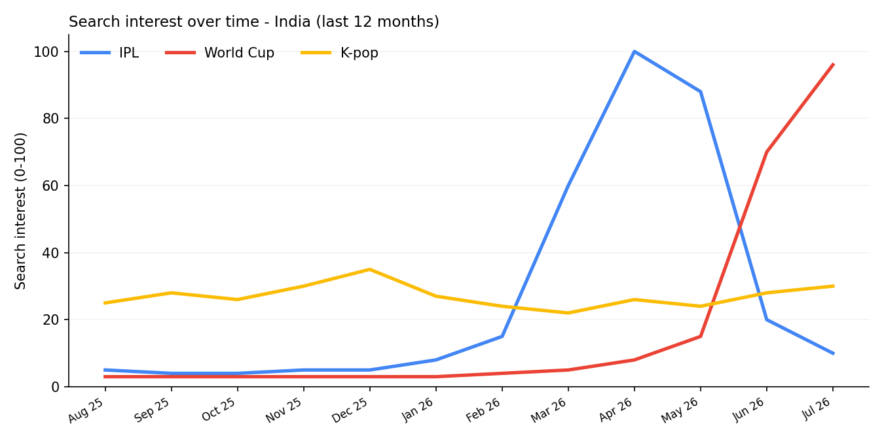
IPL clearly has the highest search visibility, with interest shooting up close to 100 during the March-May 2026 season, since it is India's biggest and most-followed sporting event and fans search for teams, players and scores almost daily during matches.
The World Cup also shows a strong spike in June-July 2026 (it even crossed IPL's usual level), but K-pop stays fairly flat and low through the year, as it has a smaller, more niche fan base in India compared to cricket.

Task 4: Sample Food Blog Instagram Post
Caption:
"Craving something cheesy and spicy tonight? 🍕🔥 Tried making this homemade paneer tikka pizza at home and it turned out SO good that I had to share it with you all. Perfect for weekend cravings and super easy to make too! Save this post for later and comment below if you want the full recipe 👇😋"
Hashtags:
- #FoodBlogger
- #Foodstagram
- #IndianFoodie
- #HomemadeFood
- #FoodLovers

