Lead Generation - Assignment
Assignment
Name: Jatin Joshi
Subject: Digital Marketing

Task 1: Google Form to Collect Leads (Food Delivery App)
Below is the form design for ZoomBite's early-access lead form, with the four required fields plus a short intro.
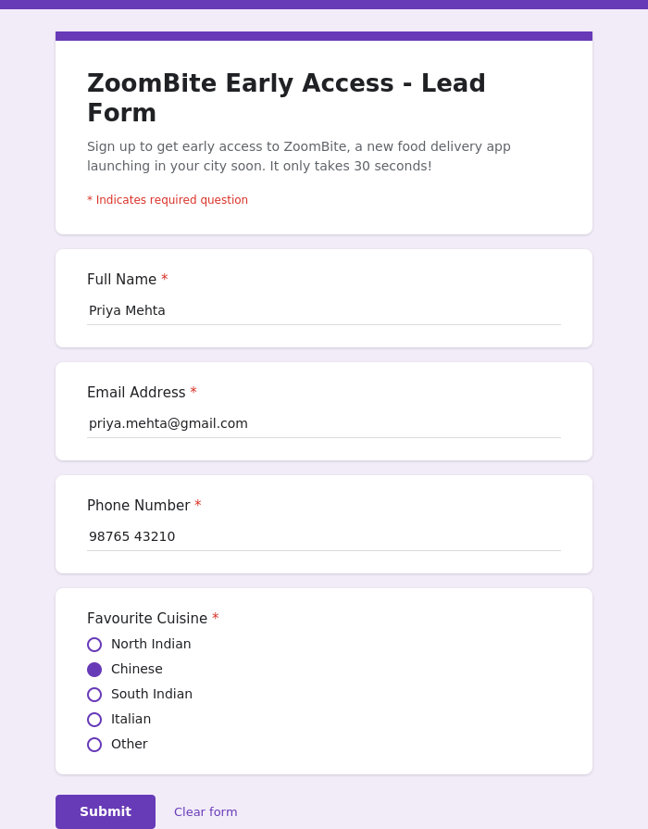
Sample test entry submitted:
- Full Name: Priya Mehta
- Email Address: priya.mehta@gmail.com
- Phone Number: 98765 43210
- Favourite Cuisine: Chinese
Steps to set this up as a real, shareable Google Form:
- 1. Go to forms.google.com and click "+ Blank form".
- 2. Add the title "ZoomBite Early Access - Lead Form" and the four questions shown above, marking each as required.
- 3. Click "Send" (top right), copy the shareable link, and paste it here once created.
- 4. Open the link yourself and submit one test entry, exactly like the sample shown above.

Task 2: Landing Page Mockup for a Zomato-Style Offer
Fictional brand used: "Zesto". The mockup below highlights a 50% off deal and a clear email sign-up call-to-action button.
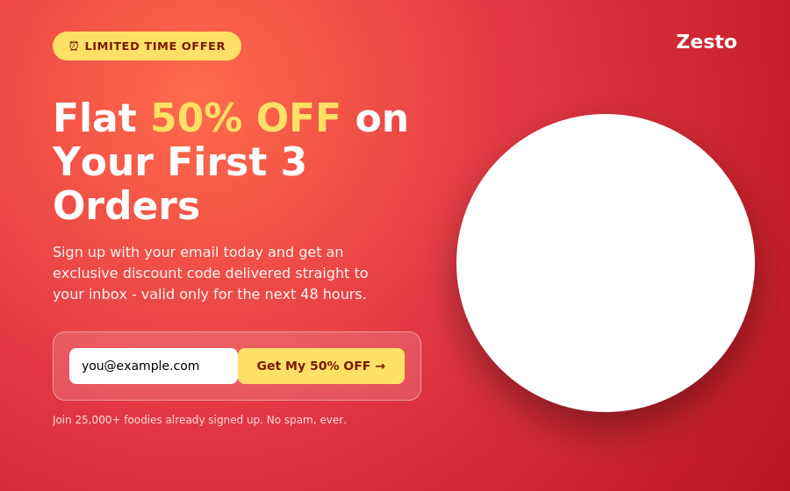

Task 3: 3 Lead Magnets for a Music Streaming App (Spotify-style)
- Free 3-month Premium trial - Users must enter their email (and payment details for after the trial) to activate it, which captures a verified lead.
- Exclusive curated playlist ("artist's private mixtape") - The playlist unlocks only after the user signs up with their email, directly capturing a new lead.
- First-month discount coupon code - The code is sent only after users submit their email or phone number, growing the lead list with every claim.

Task 4: WhatsApp Follow-Up Message (IPL Fantasy League App Lead)
"Hi [Name] 👋 Thanks for signing up on [App Name] - India's easiest way to build your IPL fantasy team and win real cash prizes! 🏏 Your account is all set. Tap the link below to create your first team before today's match starts: [App Link]. Need any help? Just reply here, we've got you covered!"

Task 5: 5 AI-Generated Headlines for a Flipkart-Style Electronics Sale Landing Page
Prompt used: "Write 5 headlines to attract users to sign up for early access to a big online electronics sale."
- 1. Get First Dibs: Unlock Early Access to India's Biggest Electronics Sale
- 2. Your Favourite Gadgets, Up to 80% Off - Before Anyone Else Sees It
- 3. Be First In Line: Exclusive Early Access to the Electronics Sale of the Year
- 4. Don't Wait for the Crowd - Reserve Your Spot for Early Sale Access Now
- 5. VIP Access: Shop the Electronics Sale 24 Hours Before Everyone Else

