Website Architecture - Assignment
Assignment
Name: Jatin Joshi
Subject: Digital Marketing

Task 1: Sitemap Diagram for a Food Delivery Website
Fictional site modelled on Zomato. Home leads to Search and Profile. Search leads into a Restaurant Details page, which leads to Cart, and Cart leads into Orders (which is also directly reachable from Profile).
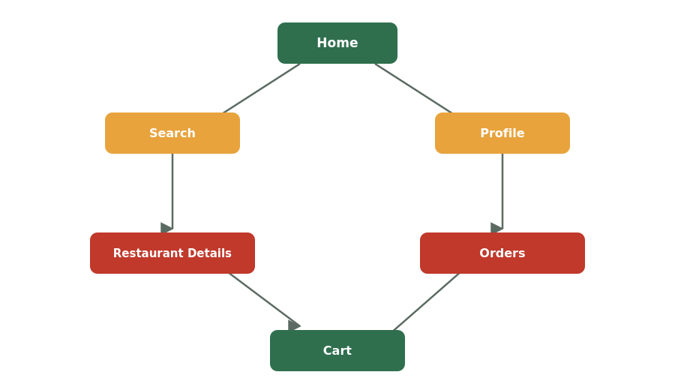

Task 2: Folder Structure for a Movie Review Website
moviereview-website/
|-- index.html
|
|-- pages/
| |-- home.html
| |-- movie-details.html
| |-- reviews.html
| |-- showtimes.html
| |-- booking.html
| `-- login.html
|
|-- images/
| |-- logo.png
| |-- banners/
| `-- movie-posters/
|
|-- css/
| |-- style.css
| `-- responsive.css
|
`-- scripts/
|-- main.js
`-- booking.js

Task 3: Why Clear Website Architecture Matters for UX (Flipkart)
Clear website architecture matters because it lets users find what they're looking for quickly, without getting lost between categories, search results and checkout. On a site as large as Flipkart, with millions of products, a confusing structure would mean users give up and leave before buying anything. A logical structure also helps users build a mental map of the site, so returning visitors instantly know where to go for orders, wishlists or support. In short, good architecture directly affects how easy - and how likely - it is for a visitor to actually complete a purchase.

Task 4: Website Version of a Daily-Use App
App chosen: Spotify
- Home - Shows personalised recommendations, recently played tracks and playlists, so returning users land straight on content relevant to them.
- Search - Lets users look up songs, artists, albums or podcasts directly, for the times they know exactly what they want to hear.
- Browse/Genres - Organised by genre and mood (workout, chill, party), helping users discover new music when they don't have something specific in mind.
- Your Library - A personal space listing saved songs, playlists and followed artists, so users can quickly get back to music they've already curated.
- Playlist/Album Detail Page - Shows the full track list, cover art and play controls for a specific playlist or album a user has clicked into.
- Account/Profile - Where users manage subscription plans, devices and account settings.

