User Engagement in Apps - Assignment
Assignment
Name: Jatin Joshi
Subject: Digital Marketing

Task 1: 3 Ways an App Keeps You Engaged
App chosen: Instagram
- Push notifications - Alerts for likes, comments, DMs and someone going live pull users back into the app multiple times a day.
- Personalised Explore/Reels feed - The algorithm shows content matched to what a user has liked or watched before, so the feed always feels relevant and keeps people scrolling.
- Interactive story stickers (polls, quizzes) - Features like polls invite users to actively participate instead of just scrolling, which increases time spent and brings people back to check the results.

Task 2: Instagram-Style Story Poll
Question: "What's your go-to comfort food right now?" | Options: Pizza vs Noodles
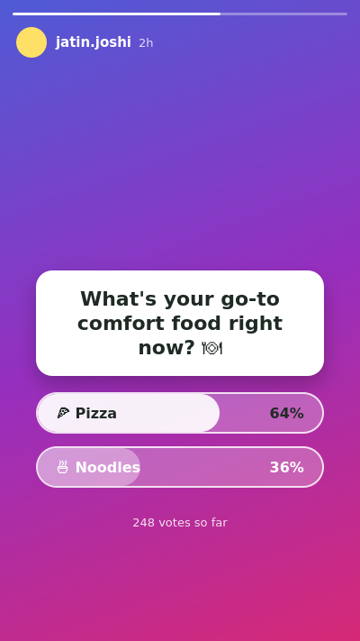
Plan to collect and display votes:
Each time someone taps an option, that tap is recorded against their account and added to that option's running total. As more people vote, the app recalculates the percentage split between the two options in real time and shows it as a filled progress bar on each option - visible to the poll creator right away, and to voters once they have tapped one of the options themselves.

Task 3: Push Notification for a Food Delivery App (3 Days Inactive)
"😋 We miss you! Your favourite butter chicken is waiting - get 40% OFF your next order today only. Tap to reorder in one click!"

Task 4: 2 Engagement Features on Flipkart's Product Page
- Wishlist (heart icon) - This lets users save products they like but aren't ready to buy yet, which brings them back to the app later specifically to check for price drops or finish the purchase, increasing repeat visits.
- "Customers who bought this also bought" - This carousel nudges users to keep browsing related products instead of leaving after viewing just one item, which increases the time spent per session and the chance of an extra purchase.

Task 5: 3 AI-Generated Ideas to Increase Engagement in a Music Streaming App
- Personalised weekly recap notifications - A "your week in music" style summary that reminds users what they listened to, giving them a reason to open the app and share their stats with friends.
- Collaborative playlists with friends - Letting multiple people add songs to the same playlist in real time turns listening into a shared activity, which keeps everyone coming back to it together.
- Mood-based quick-start stations - One-tap mood buttons like Study, Workout or Chill on the home screen let users start listening instantly without searching, which lowers friction and increases how often they open the app.

