Wireframing & Layout - Assignment
Assignment
Name: Jatin Joshi
Subject: Digital Marketing

Task 1: Wireframe Sketch for a Food Delivery App Homepage
Low-fidelity wireframe showing the main sections and their layout, from top to bottom: header (logo, delivery location, profile), search bar, promo banner/carousel, category icons, and a restaurant listing section, followed by a footer.
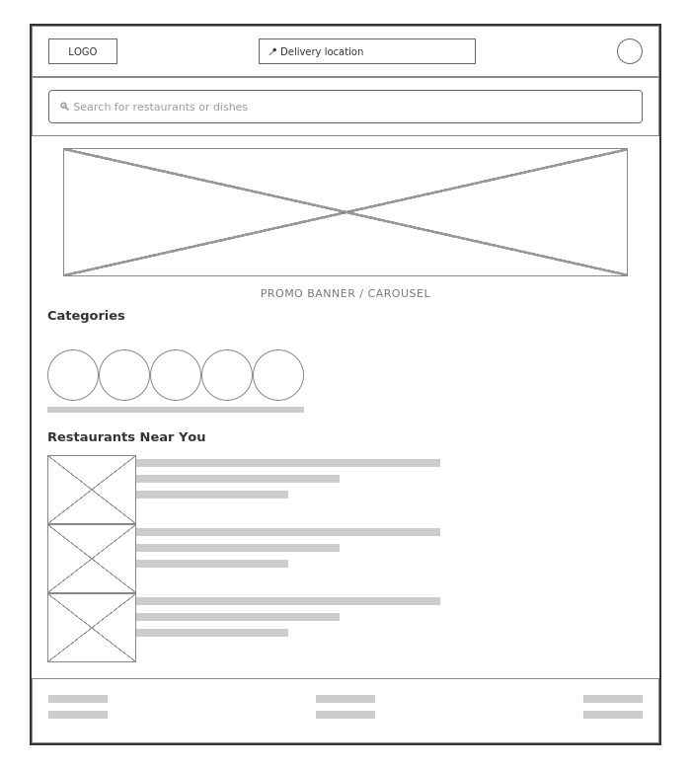

Task 2: HTML Structure for a Music Streaming App Homepage (No CSS)
Fictional brand used: "Tunely". Full file submitted separately as spotify_structure.html - only structural HTML tags are used, with no CSS and no images:
<header>
<h1>Tunely</h1>
<p>Your music, your mood.</p>
</header>

<nav>
<ul>
<li><a href="#home">Home</a></li>
<li><a href="#browse">Browse</a></li>
<li><a href="#library">Your Library</a></li>
<li><a href="#search">Search</a></li>
</ul>
</nav>

<main>
<section id="featured-playlists">
<h2>Featured Playlists</h2>
<article>
<h3>Chill Study Beats</h3>
<p>Lo-fi tracks to help you focus while studying.</p>
</article>
... (3 more playlist articles)
</section>
</main>

<footer>
<p>&copy; 2026 Tunely. All rights reserved.</p>
<ul> ... </ul>
</footer>

Task 3: 5 Above-the-Fold Elements for an E-commerce Homepage (Flipkart)
- Search bar - lets users jump straight to a specific product without scrolling or browsing categories.
- Main navigation/categories - gives users an immediate sense of what's sold here and how to start browsing.
- Hero banner with current offers - communicates the biggest ongoing deal right away, which is often the reason a user clicked through in the first place.
- Account/cart icons - reassures returning users that their login, orders and cart are just one click away.
- Trust signals (delivery promise, return policy badges) - builds confidence quickly for new visitors who haven't shopped on the site before.

Task 4: First 3 Sections Seen on a Popular App's Homepage
App chosen: Swiggy
The first three things I notice, in order, are: 1) the delivery address bar at the very top, confirming where my order will be delivered, 2) a search bar right below it for finding a specific restaurant or dish, and 3) a large offers/banner carousel showcasing current discounts.
This order helps engagement because it follows what a user actually needs, in sequence. Before anything else, the app has to confirm it can deliver to you at all, so the address bar comes first. Once that's settled, the search bar lets people with a specific craving go straight there. Only after those two functional needs are addressed does the app show promotional banners - by that point, the user is already engaged and more likely to browse offers instead of bouncing off a page that opened straight into ads.

