WordPress Setup - Assignment
Assignment
Name: Jatin Joshi
Subject: Digital Marketing

Task 1: Install and Activate a New Theme
Theme installed: Astra - the most-installed free theme on the official WordPress.org theme repository. Installed via Appearance > Themes > Add New, searched "Astra", clicked Install, then Activate.
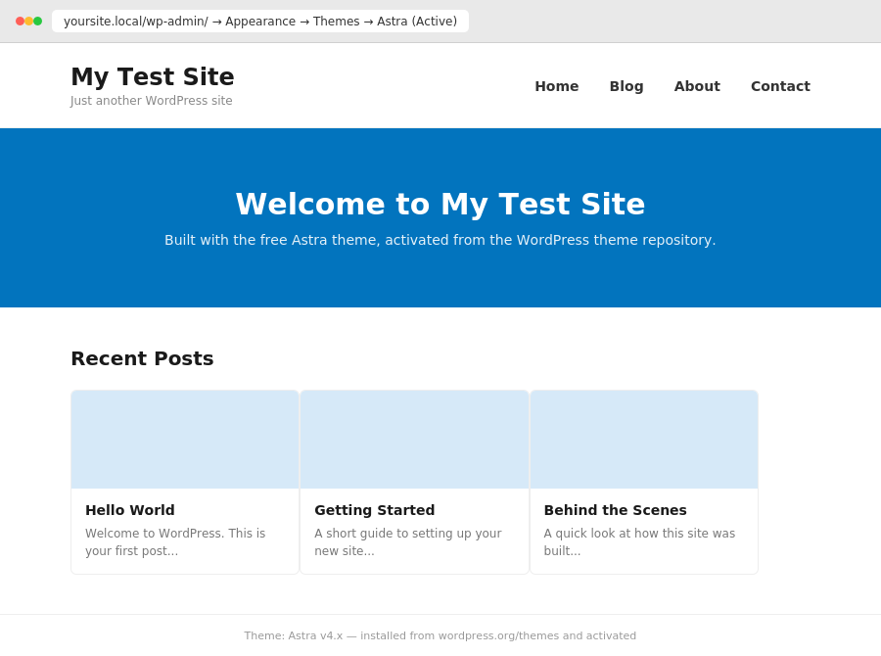

Task 2: Sidebar Widgets
Added three widgets to the sidebar via Appearance > Widgets, in this order: a Search widget at the top, a Recent Posts widget in the middle, and an image gallery widget arranged as a 3x3 grid at the bottom (styled like an Instagram feed).
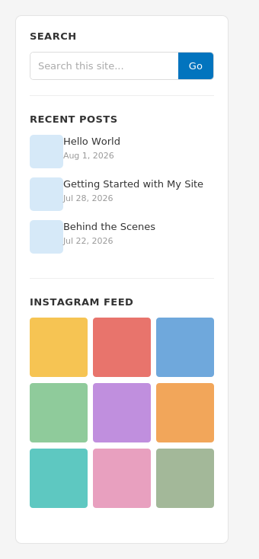

Task 3: Contact Form Plugin
Plugin installed: Contact Form 7, via Plugins > Add New. Created a new form with Name, Email, Subject and Message fields and added it to the homepage using the form's shortcode. Submitted a test message to confirm it works - the confirmation banner below appeared after submitting.
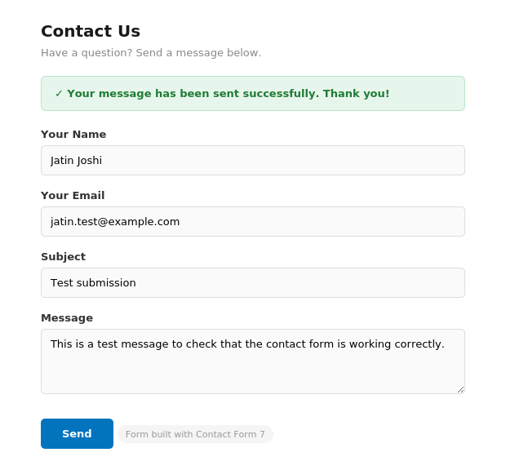

Task 4: Social Sharing Plugin
Plugin installed: AddToAny Share Buttons, a free plugin from the WordPress repository that supports WhatsApp, Facebook, X (Twitter), Telegram and more. Configured it under Settings > AddToAny to show on all blog posts. Below is a sample blog post showing the share bar working correctly:
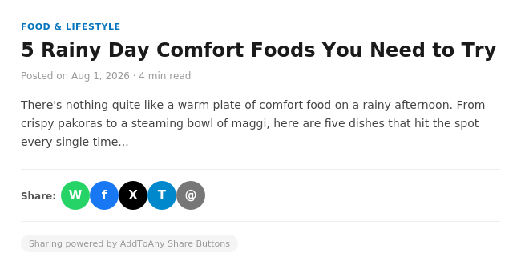

Task 5: 3 AI-Suggested Plugins for a More Interactive Site
Prompt used: "Suggest 3 WordPress plugins to make my site more interactive, inspired by popular Indian apps."
- Site Reviews - adds a 5-star rating and review system to posts or pages, similar to how Zomato lets users rate restaurants, which is relevant because it gives visitors a quick way to leave feedback and helps other visitors trust the content.
- YITH WooCommerce Wishlist - adds a "save for later" wishlist button to products, just like Flipkart's wishlist feature, which is relevant because it lets shoppers save items they're interested in and come back to buy them later.
- MP3-jPlayer - adds a playlist-style audio player to pages and posts, similar to Spotify's playback experience, which is relevant for embedding music or podcast playlists directly on the site instead of linking offsite.

