Sitemap & WordPress Basics - Assignment
Assignment
Name: Jatin Joshi
Subject: Digital Marketing

Task 1: Sitemap Diagram for a Food Delivery Website
Home leads to Menu, Contact Us and Profile. Menu leads into Restaurant Details, which leads to Cart, and Cart leads back into Profile (where orders and account details live).
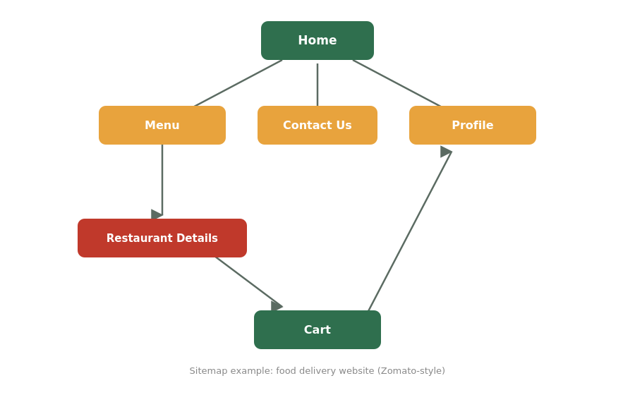

Task 2: 5 Key Homepage Components (Flipkart)
- Navigation bar - gives quick access to major categories and account/cart icons from anywhere on the page.
- Search bar - lets users jump straight to a specific product instead of browsing manually.
- Banner/carousel - highlights the biggest current offers and sales right at the top, where it's impossible to miss.
- Product grid - shows a scannable set of recommended or trending products so users can start browsing immediately.
- Footer - holds supporting links (help, policies, company info) that aren't needed often but should stay easy to find.

Task 3: WordPress.com Account + Music Blog Theme
Site name used: "The Weekly Setlist". Below is the theme selection screen, filtered to music/podcast-style themes, with "Soundcheck" (a bold, dark theme built for music blogs) selected.
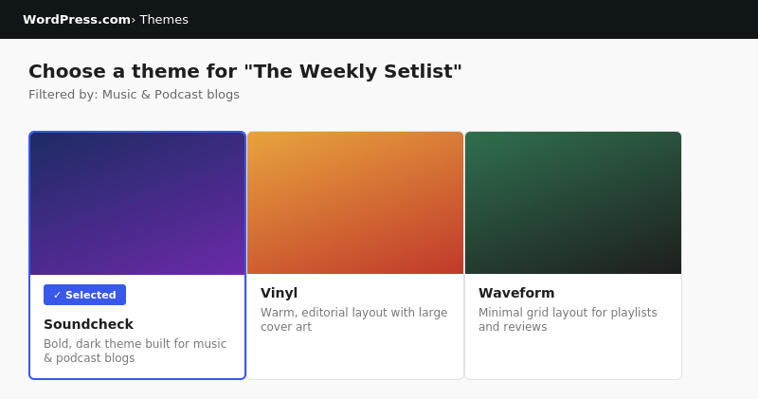

Task 4: Add 'Upcoming Events' Page to the Main Menu
Created and published a new page titled "Upcoming Events" from Pages > Add New, then added it to the site's Primary Menu under Appearance > Menus, alongside the existing Home and About items.
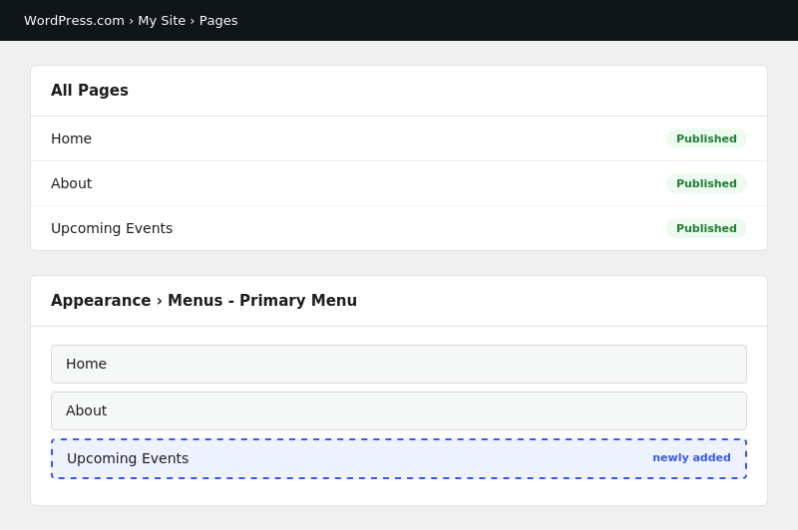

Task 5: Customize Header Image & Site Title (Movie Review Blog)
Site name used: "The Reel Review". Updated the Site Title, Tagline and Header Image under the Customizer's Site Identity settings, and previewed the result before publishing:
