***Login.jsp***

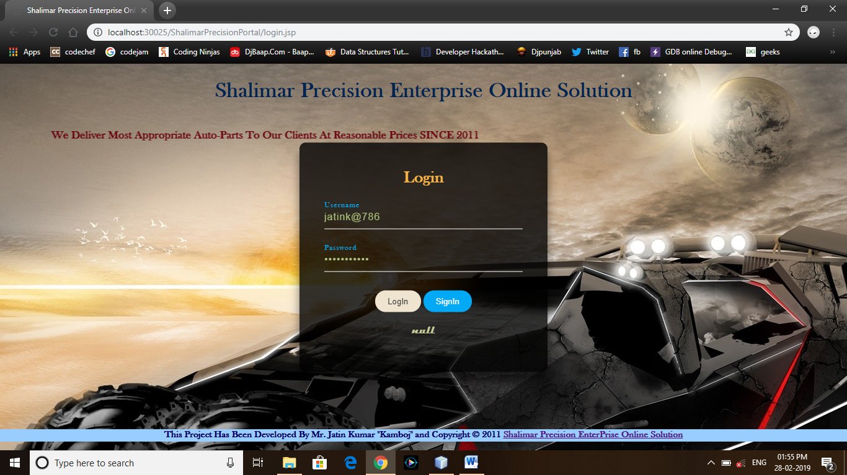

<%@page contentType="text/html" pageEncoding="UTF-8"%>

<!DOCTYPE html>

<html>

<head>

<meta http-equiv="Content-Type" content="text/html; charset=UTF-8">

<title>Shalimar Precision Enterprise Online Solution</title>

<link rel="stylesheet" type="text/css" href="lgnstyls.css">

</head>

<body>

<div class="header">

<center><h1>Shalimar Precision Enterprise Online Solution</h1></center>

</div>

<div class="bck">

<marquee direction="right"><h3>We Deliver Most Appropriate Auto-Parts To Our Clients At Reasonable Prices SINCE 2011</h3></marquee>

</div>

<div class="box">

<h2>Login</h2>

<form name="myfrm" action="Wel" method="post">

<div class="inputbox">

<input type="text" name="Usrnm" required>

<label>Username</label>

</div>

<div class="inputbox">

<input type="password" name="psswd" required>

<label>Password</label>

</div>

<center>

<input id="sbmt" type="Submit" name="Submit" value="LogIn" >

<a href="UserReg.jsp"><input id="sgn" type="button" name="signin" value="SignIn"></a>

</center>

</form>

<center><h3><%=request.getAttribute("errmsg") %></h3></center>

</div> <br/><br/><br/><br/><br/><br/><br/><br/><br/><br/><br/><br/><br/><br/><br/><br/><br/><br/><br/><br/><br/><br/>

<div class="foot">

<h2>This Project Has Been Developed By Mr. Jatin Kumar "Kamboj" and Copyright © 2011 <a href="#">Shalimar Precision EnterPrise Online Solution</a></h2>

</div>

</body>

</html>

***LoginOperation.java***

import java.io.*;

import javax.servlet.*;

import javax.servlet.http.*;

import java.sql.*;

public class loginOperation extends HttpServlet {

protected void processRequest(HttpServletRequest request, HttpServletResponse response)

throws ServletException, IOException {

response.setContentType("text/html;charset=UTF-8");

try (PrintWriter out = response.getWriter()) {

String usrnm = request.getParameter("Usrnm");

String usrpswd = request.getParameter("psswd");

try{

Class.forName("oracle.jdbc.driver.OracleDriver");

Connection con=DriverManager.getConnection("jdbc:oracle:thin:@localhost:1521:xe","shalimaresol","shalimaresol");

Statement stmt=con.createStatement();

ResultSet rs = stmt.executeQuery("select * from userreg where U_ID='"+usrnm+"' and U_PASS='"+usrpswd+"'");

if(rs.next()){

response.sendRedirect("Welcome.jsp");

}else{

request.setAttribute("errmsg","Invalid Username or Password");

RequestDispatcher rd = request.getRequestDispatcher("/login.jsp");

rd.forward(request, response);

}

}catch(Exception ex){

ex.printStackTrace();

request.setAttribute("errmsg","Link Not Established !");

RequestDispatcher rsd = request.getRequestDispatcher("/login.jsp");

rsd.forward(request, response);

}

}

}

@Override

protected void doGet(HttpServletRequest request, HttpServletResponse response)

throws ServletException, IOException {

processRequest(request, response);

}

@Override

protected void doPost(HttpServletRequest request, HttpServletResponse response)

throws ServletException, IOException {

processRequest(request, response);

}

@Override

public String getServletInfo() {

return "Short description";

}// </editor-fold>

}

***UserReg.jsp***

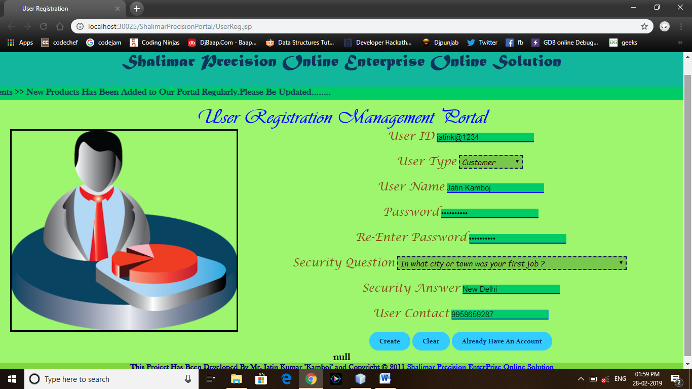

<%@page contentType="text/html" pageEncoding="UTF-8"%>

<!DOCTYPE html>

<html>

<head>

<meta http-equiv="Content-Type" content="text/html; charset=UTF-8">

<title>User Registration</title>

<link rel="stylesheet" type="text/css" href="regis.css">

</head>

<body bgcolor="#9df66e">

<div class="header1">

<center><h2>Shalimar Precision Online Enterprise Online Solution</h2></center>

</div>

<div style="background-color:#00cc66;clear:both;text-align:center">

<marquee><b><font color="#12335b">Announcements >> New Products Has Been

Added to Our Portal Regularly.Please Be Updated........</font></b></marquee>

</div>

<div class="subhd">

<center><h2>User Registration Management Portal</h2></center>

</div>

<div id="images">

<img src="images/usrReg.jpg" height="400px" width="450px" border="3">

</div>

<div class="dtls">

<center>

<form action="ureg" name="myfrm">

<font size="4px" face="Lucida Calligraphy" color="#894d10">User ID</font> <input type="text" name="uid" placeholder="Enter User ID" required/><br/><br/>

<font size="4px" face="Lucida Calligraphy" color="#894d10">User Type</font>

<select name="usrtyp">

<option value="customer" selected>Customer</option>

<option value="employee">Employee</option>

<option value="administrator">Administrator</option>

<option value="manager">Manager</option>

<option value="supplier">Supplier</option>

</select>

<br/><br/>

<font size="4px" face="Lucida Calligraphy" color="#894d10">User Name</font> <input type="text" name="unm" placeholder="Enter User Name" required/><br/><br/>

<font size="4px" face="Lucida Calligraphy" color="#894d10">Password</font> <input type="password" name="upsswd1" placeholder="Enter password" required/><br/><br/>

<font size="4px" face="Lucida Calligraphy" color="#894d10">Re-Enter Password</font> <input type="password" name="upsswd2" placeholder="Enter password" required/><br/><br/>

<font size="4px" face="Lucida Calligraphy" color="#894d10">Security Question</font>

<select name="secques">

<option value="What was your Childhood nickname ?">What was your Childhood nickname ?</option>

<option value="What is the middle name of your youngest child ?">What is the middle name of your youngest child ?</option>

<option value="What is your oldest sibling's middle name ?">What is your oldest sibling's middle name ?</option>

<option value="What was your childhood phone number including area code ?">What was your childhood phone number including area code ?</option>

<option value="In what city or town was your first job ?">In what city or town was your first job ?</option>

<option value="What was your favourite place to visit as a Child ?">What was your favourite place to visit as a Child ?</option>

</select>

<br/><br/>

<font size="4px" face="Lucida Calligraphy" color="#894d10">Security Answer</font> <input type="text" name="sans" placeholder="Enter Your Answer" required/><br/><br/>

<font size="4px" face="Lucida Calligraphy" color="#894d10">User Contact</font> <input type="text" name="ucon" placeholder="Enter User Contact No" required/><br/><br/>

<input type="submit" name="sgn" value="Create">

<input type="reset" name="rst" value="Clear">

<a href="login.jsp"><input type="button" value="Already Have An Account"></a>

<center><h3><%=request.getAttribute("errmsg") %></h3></center>

</form>

</center>

</div>

<div class="foot">

<h2>This Project Has Been Developed By Mr. Jatin Kumar "Kamboj" and Copyright © 2011 <a href="#">Shalimar Precision EnterPrise Online Solution</a></h2>

</div>

</body>

</html>

***RegistrationOperation.java***

import java.io.*;

import javax.servlet.*;

import javax.servlet.annotation.WebServlet;

import javax.servlet.http.*;

import java.sql.*;

@WebServlet(urlPatterns = {"/RegistraionOperation"})

public class RegistrationOperation extends HttpServlet {

protected void processRequest(HttpServletRequest request, HttpServletResponse response)

throws ServletException, IOException {

response.setContentType("text/html;charset=UTF-8");

try (PrintWriter out = response.getWriter()) {

String action,usrid,usrtp,usrnm,upass1,upass2,sques,san,con;

action = request.getParameter("sgn");

usrid = request.getParameter("uid");

usrtp = request.getParameter("usrtyp");

upass1 = request.getParameter("upsswd1");

upass2 = request.getParameter("upsswd2");

sques = request.getParameter("secques");

san = request.getParameter("sans");

con = request.getParameter("ucon");

usrnm = request.getParameter("unm");

try{

Class.forName("oracle.jdbc.driver.OracleDriver");

Connection conn=DriverManager.getConnection("jdbc:oracle:thin:@localhost:1521:xe","shalimaresol","shalimaresol");

Statement stmt=conn.createStatement(); if((!"".equals(usrid))&&(!"".equals(usrtp))&&(!"".equals(usrnm))&&(!"".equals(upass1))&&(!"".equals(upass2))&&(!"".equals(sques))&&(!"".equals(san))&&(!"".equals(con))){

if(upass1.equals(upass2)){

int a = stmt.executeUpdate("insert into userreg values('"+usrid+"','"+usrtp+"','"+upass1+"','"+sques+"','"+san+"','"+con+"','"+usrnm+"')");

if(a > 0){

request.setAttribute("errmsg","User Created Successfully !");

RequestDispatcher rsd = request.getRequestDispatcher("/UserReg.jsp");

rsd.forward(request, response);

}else{

request.setAttribute("errmsg","User Doesn't Created !");

RequestDispatcher rsd = request.getRequestDispatcher("/UserReg.jsp");

rsd.forward(request, response);

}

}else{

request.setAttribute("errmsg","Password Didn't Match !");

RequestDispatcher rsd = request.getRequestDispatcher("/UserReg.jsp");

rsd.forward(request, response);

}

}else{

request.setAttribute("errmsg","Some of the Given Fields is Empty !");

RequestDispatcher rsd = request.getRequestDispatcher("/UserReg.jsp");

rsd.forward(request, response);

}

}catch(Exception ex){

request.setAttribute("errmsg","An Error Has Been Occurred While Creating A New User !");

RequestDispatcher rsd = request.getRequestDispatcher("/UserReg.jsp");

rsd.forward(request, response);}}}

@Override

protected void doGet(HttpServletRequest request, HttpServletResponse response)

throws ServletException, IOException {

processRequest(request, response);

}

@Override

protected void doPost(HttpServletRequest request, HttpServletResponse response)

throws ServletException, IOException {

processRequest(request, response);

}

@Override

public String getServletInfo() {

return "Short description";

}// </editor-fold>

}

***Welcome.jsp***

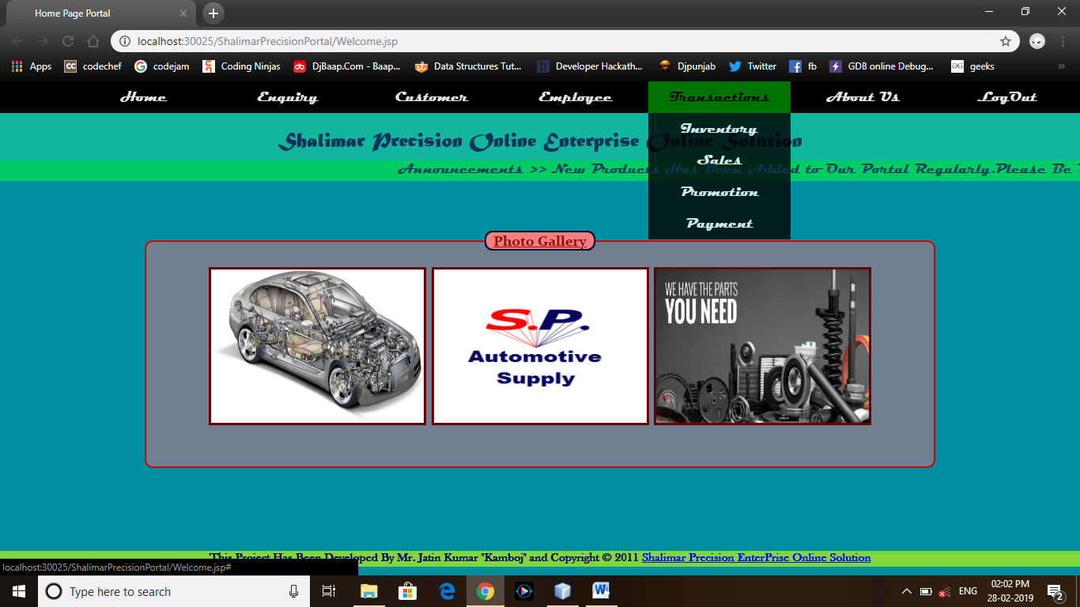

<%@page contentType="text/html" pageEncoding="UTF-8"%>

<!DOCTYPE html>

<html>

<head>

<meta http-equiv="Content-Type" content="text/html; charset=UTF-8">

<title>Home Page Portal</title>

<link rel="stylesheet" type="text/css" href="remstyls.css">

</head>

<body bgcolor="#0090a2">

<div class="navbar">

<ul>

<li><a href="Welcome.jsp">Home</a></li>

<li><a href="Enquiry.jsp">Enquiry</></li>

<li><a href="Customer.jsp">Customer</a></li>

<li><a href="Employee.jsp">Employee</a></li>

<li><a href="#">Transactions</a>

<ul>

<li><a href="Inventory.jsp">Inventory</a></li>

<li><a href="Sales.jsp">Sales</a></li>

<li><a href="Promotion.jsp">Promotion</a></li>

<li><a href="Payment.jsp">Payment</a></li>

</ul>

</li>

<li><a href="about.jsp">About Us</a></li>

<li><a href="login.jsp">LogOut</a></li>

</ul>

</div>

<div class="header">

<center><h2>Shalimar Precision Online Enterprise Online Solution</h2></center>

</div>

<div style="background-color:#00cc66;clear:both;text-align:center">

<marquee><b><font color="#12335b">Announcements >> New Products Has Been Added to Our Portal Regularly.Please Be Updated........</font></b></marquee>

</div><br/><br/><br/>

<center>

<div class="Slider">

<fieldset><legend><b><u>Photo Gallery</u></b></legend><br>

<img src="images/atprts.jpg" width="275px" height="200px" align="center" border="3">

<img src="images/Logo.jpg" width="275px" height="200px" align="center" border="3">

<img src="images/autoprts.jpg" width="275px" height="200px" align="center" border="3">

</fieldset>

</div>

</center><br/><br/><br/><br/><br/>

<div class="foot">

<h2>This Project Has Been Developed By Mr. Jatin Kumar "Kamboj" and Copyright © 2011 <a href="#">Shalimar Precision EnterPrise Online Solution</a></h2>

</div>

</body>

</html>

***Enquiry.jsp***

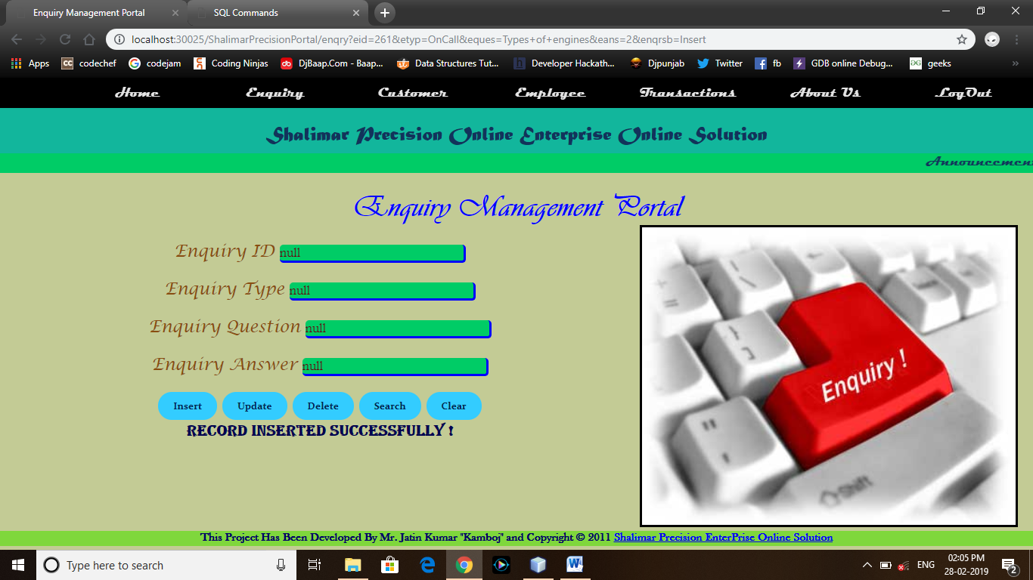

<%@page contentType="text/html" pageEncoding="UTF-8"%>

<!DOCTYPE html>

<html>

<head>

<meta http-equiv="Content-Type" content="text/html; charset=UTF-8">

<title>Enquiry Management Portal</title>

<link rel="stylesheet" type="text/css" href="remstyls.css">

</head>

<body bgcolor="#c3cb95">

<div class="navbar">

<ul>

<li><a href="Welcome.jsp">Home</a></li>

<li><a href="Enquiry.jsp">Enquiry</></li>

<li><a href="Customer.jsp">Customer</a></li>

<li><a href="Employee.jsp">Employee</a></li>

<li><a href="#">Transactions</a>

<ul>

<li><a href="Inventory.jsp">Inventory</a></li>

<li><a href="Sales.jsp">Sales</a></li>

<li><a href="Promotion.jsp">Promotion</a></li>

<li><a href="Payment.jsp">Payment</a></li>

</ul>

</li>

<li><a href="about.jsp">About Us</a></li>

<li><a href="login.jsp">LogOut</a></li>

</ul>

</div>

<div class="header">

<center><h2>Shalimar Precision Online Enterprise Online Solution</h2></center>

</div>

<div style="background-color:#00cc66;clear:both;text-align:center">

<marquee><b><font color="#12335b">Announcements >> New Products Has Been Added to Our Portal Regularly.Please Be Updated........</font></b></marquee>

</div><br/>

<div class="subhd">

<center><h2>Enquiry Management Portal</h2></center>

</div>

<div id="imagesR">

<img src="images/enquiry.jpg" height="400px" width="500px" border="3">

</div>

<br/>

<div class="dtls">

<center>

<form action="enqry" name="myfrm">

<font size="4px" face="Lucida Calligraphy" color="#894d10">Enquiry ID</font> <input type="text" name="eid" placeholder="Enter Enquiry ID" value='<%=request.getAttribute("enqid")%>' /><br/><br/>

<font size="4px" face="Lucida Calligraphy" color="#894d10">Enquiry Type</font> <input type="text" name="etyp" placeholder="Enter Enquiry Type" value='<%=request.getAttribute("enqtyp")%>'/><br/><br/>

<font size="4px" face="Lucida Calligraphy" color="#894d10">Enquiry Question</font> <input type="text" name="eques" placeholder="Enter Enquiry Question" value='<%=request.getAttribute("enques")%>'/><br/><br/>

<font size="4px" face="Lucida Calligraphy" color="#894d10">Enquiry Answer</font> <input type="text" name="eans" placeholder="Enter Enquiry Answer" value='<%=request.getAttribute("enans")%>'/><br/><br/>

<input type="submit" name="enqrsb" value="Insert">

<input type="submit" name="enqrsb" value="Update">

<input type="submit" name="enqrsb" value="Delete">

<input type="submit" name="enqrsb" value="Search">

<input type="reset" value="Clear">

<center><h3><%=request.getAttribute("errmsg") %></h3></center>

</form>

</center>

</div>

<br/>

<div class="foot">

<h2>This Project Has Been Developed By Mr. Jatin Kumar "Kamboj" and Copyright © 2011 <a href="#">Shalimar Precision EnterPrise Online Solution</a></h2>

</div>

</body>

</html>

***EnquiryOperation.java***

import java.io.*;

import javax.servlet.*;

import javax.servlet.annotation.WebServlet;

import javax.servlet.http.*;

import java.sql.*;

@WebServlet(urlPatterns = {"/EnquiryOperation"})

public class EnquiryOperation extends HttpServlet {

protected void processRequest(HttpServletRequest request, HttpServletResponse response)

throws ServletException, IOException {

response.setContentType("text/html;charset=UTF-8");

try (PrintWriter out = response.getWriter()) {

String action,id,typ,ques,ans;

action = request.getParameter("enqrsb");

System.out.println("Your Action : "+action);

id = request.getParameter("eid");

typ = request.getParameter("etyp");

ques = request.getParameter("eques");

ans = request.getParameter("eans");

try{

Class.forName("oracle.jdbc.driver.OracleDriver");

Connection conn=DriverManager.getConnection("jdbc:oracle:thin:@localhost:1521:xe","shalimaresol","shalimaresol");

Statement stmt=conn.createStatement();

if(action.equals("Insert")){ if((!"".equals(id))&&(!"".equals(typ))&&(!"".equals(ques))&&(!"".equals(ans))){

int a = stmt.executeUpdate("insert into enquiry values('"+id+"','"+typ+"','"+ques+"','"+ans+"')");

if(a > 0){

request.setAttribute("errmsg","Record Inserted Successfully !");

RequestDispatcher rsd = request.getRequestDispatcher("/Enquiry.jsp");

rsd.forward(request, response);

}else{

request.setAttribute("errmsg","Record Doesn't Inserted !");

RequestDispatcher rsd = request.getRequestDispatcher("/Enquiry.jsp");

rsd.forward(request, response);

}

}else{

request.setAttribute("errmsg","Some of the Given Fields is Empty !");

RequestDispatcher rsd = request.getRequestDispatcher("/Enquiry.jsp");

rsd.forward(request,response);

}

}else if(action.equals("Update")){ if((!"".equals(id))&&(!"".equals(typ))&&(!"".equals(ques))&&(!"".equals(ans))){

int a = stmt.executeUpdate("update enquiry set c_type='"+typ+"' ,c_ques='"+ques+"',c_ans='"+ans+"' where c_id='"+id+"' ");

if(a > 0){

request.setAttribute("errmsg","Record Updated Successfully !");

RequestDispatcher rsd = request.getRequestDispatcher("/Enquiry.jsp");

rsd.forward(request, response);

}else{

request.setAttribute("errmsg","Record Doesn't Updated !");

RequestDispatcher rsd = request.getRequestDispatcher("/Enquiry.jsp");

rsd.forward(request, response);

}

}else{

request.setAttribute("errmsg","Some of the Given Fields is Empty !");

RequestDispatcher rsd = request.getRequestDispatcher("/Enquiry.jsp");

rsd.forward(request, response);

}

}else if(action.equals("Delete")){

if(!"".equals(id)){

int a = stmt.executeUpdate("delete from enquiry where c_id='"+id+"'");

if(a > 0){

request.setAttribute("errmsg","Record Deleted Successfully !");

RequestDispatcher rsd = request.getRequestDispatcher("/Enquiry.jsp");

rsd.forward(request, response);

}else{

request.setAttribute("errmsg","Record Doesn't Deleted !");

RequestDispatcher rsd = request.getRequestDispatcher("/Enquiry.jsp");

rsd.forward(request, response);

}

}else{

request.setAttribute("errmsg","Please Fill The Enquiry ID First !");

RequestDispatcher rsd = request.getRequestDispatcher("/Enquiry.jsp");

rsd.forward(request, response);

}

}else if(action.equals("Search")){

if(!"".equals(id)){

ResultSet rs = stmt.executeQuery("select * from enquiry where c_id='"+id+"'");

if(rs.next()){

System.out.println(rs.getString(1));

System.out.println(rs.getString(2));

System.out.println(rs.getString(3));

System.out.println(rs.getString(4));

request.setAttribute("enqid",rs.getString(1));

request.setAttribute("enqtyp",rs.getString(2));

request.setAttribute("enques",rs.getString(3));

request.setAttribute("enans",rs.getString(4));

request.setAttribute("errmsg","Record Found !");

RequestDispatcher rsd = request.getRequestDispatcher("/Enquiry.jsp");

rsd.forward(request, response);

}else{

request.setAttribute("errmsg","Record Not Found !");

RequestDispatcher rsd = request.getRequestDispatcher("/Enquiry.jsp");

rsd.forward(request, response);

}

}else{

request.setAttribute("errmsg","Please Fill The Enquiry ID First !");

RequestDispatcher rsd = request.getRequestDispatcher("/Enquiry.jsp");

rsd.forward(request, response);

}

}

}catch(Exception ex){

request.setAttribute("errmsg","An Error Occurred While Establishing The Connection!!");

RequestDispatcher rsd = request.getRequestDispatcher("/Enquiry.jsp");

rsd.forward(request, response);

}

}

}

@Override

protected void doGet(HttpServletRequest request, HttpServletResponse response)

throws ServletException, IOException {

processRequest(request, response);

}

@Override

protected void doPost(HttpServletRequest request, HttpServletResponse response)

throws ServletException, IOException {

processRequest(request, response);

}

@Override

public String getServletInfo() {

return "Short description";

}// </editor-fold>

}

***Customer.jsp***

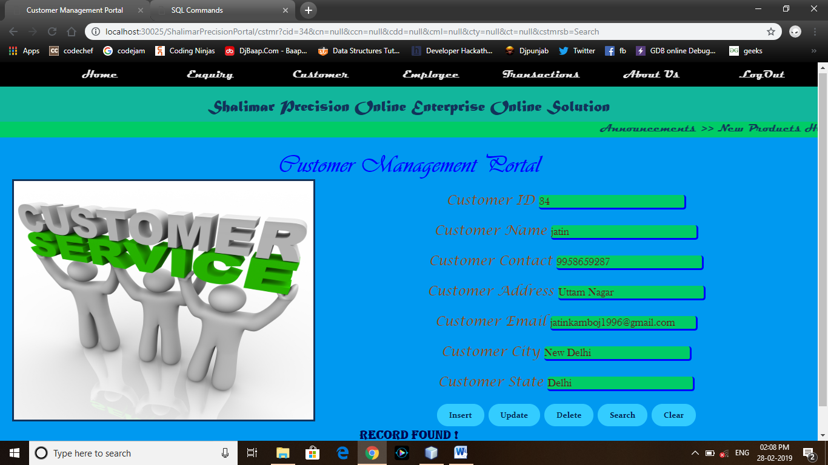

<%@page contentType="text/html" pageEncoding="UTF-8"%>

<!DOCTYPE html>

<html>

<head>

<meta http-equiv="Content-Type" content="text/html; charset=UTF-8">

<title>Customer Management Portal</title>

<link rel="stylesheet" type="text/css" href="remstyls.css">

</head>

<body bgcolor="##0099ff" text="#12335b">

<div class="navbar">

<ul>

<li><a href="Welcome.jsp">Home</a></li>

<li><a href="Enquiry.jsp">Enquiry</></li>

<li><a href="Customer.jsp">Customer</a></li>

<li><a href="Employee.jsp">Employee</a></li>

<li><a href="#">Transactions</a>

<ul>

<li><a href="Inventory.jsp">Inventory</a></li>

<li><a href="Sales.jsp">Sales</a></li>

<li><a href="Promotion.jsp">Promotion</a></li>

<li><a href="Payment.jsp">Payment</a></li>

</ul>

</li>

<li><a href="about.jsp">About Us</a></li>

<li><a href="login.jsp">LogOut</a></li>

</ul>

</div>

<div class="header">

<center><h2>Shalimar Precision Online Enterprise Online Solution</h2></center>

</div>

<div style="background-color:#00cc66;clear:both;text-align:center">

<marquee><b><font color="#12335b">Announcements >> New Products Has Been Added to Our Portal Regularly.Please Be Updated........</font></b></marquee>

</div><br/>

<div class="subhd">

<center><h2>Customer Management Portal</h2></center>

</div>

<div id="images">

<img src="images/customer_servic.jpg" height="400px" width="500px" border="3">

</div>

<br/>

<div class="dtls">

<center>

<form action="cstmr" name="myfrm">

<font size="4px" face="Lucida Calligraphy" color="#894d10">Customer ID</font> <input type="text" name="cid" placeholder="Enter Customer ID" value='<%=request.getAttribute("csid")%>' /><br/><br/>

<font size="4px" face="Lucida Calligraphy" color="#894d10">Customer Name</font> <input type="text" name="cn" placeholder="Enter Customer Name" value='<%=request.getAttribute("cusnm")%>'/><br/><br/>

<font size="4px" face="Lucida Calligraphy" color="#894d10">Customer Contact</font> <input type="text" name="ccn" placeholder="Enter Customer Contact" value='<%=request.getAttribute("cuscon")%>'/><br/><br/>

<font size="4px" face="Lucida Calligraphy" color="#894d10">Customer Address</font> <input type="text" name="cdd" placeholder="Enter Your Address Here" value='<%=request.getAttribute("cusadd")%>'/><br/><br/>

<font size="4px" face="Lucida Calligraphy" color="#894d10">Customer Email</font> <input type="text" name="cml" placeholder="Enter Customer Email" value='<%=request.getAttribute("cuseml")%>'/><br/><br/>

<font size="4px" face="Lucida Calligraphy" color="#894d10">Customer City</font> <input type="text" name="cty" placeholder="Enter Customer City" value='<%=request.getAttribute("cuscty")%>'/><br/><br/>

<font size="4px" face="Lucida Calligraphy" color="#894d10">Customer State</font> <input type="text" name="ct" placeholder="Enter Customer State" value='<%=request.getAttribute("cusst")%>'/><br/><br/>

<input type="submit" name="cstmrsb" value="Insert">

<input type="submit" name="cstmrsb" value="Update">

<input type="submit" name="cstmrsb" value="Delete">

<input type="submit" name="cstmrsb" value="Search">

<input type="reset" value="Clear">

<center><h3><%=request.getAttribute("errmsg") %></h3></center>

</form>

</center>

</div>

<br/>

<div class="foot">

<h2>This Project Has Been Developed By Mr. Jatin Kumar "Kamboj" and Copyright © 2011 <a href="#">Shalimar Precision EnterPrise Online Solution</a></h2>

</div>

</body>

</html>

***CustomerOperation.java***

import java.io.*;

import javax.servlet.*;

import javax.servlet.annotation.WebServlet;

import javax.servlet.http.*;

import java.sql.*;

@WebServlet(urlPatterns = {"/CustomerOperation"})

public class CustomerOperation extends HttpServlet {

protected void processRequest(HttpServletRequest request, HttpServletResponse response)

throws ServletException, IOException {

response.setContentType("text/html;charset=UTF-8");

try (PrintWriter out = response.getWriter()) {

String id,nm,cont,add,eml,cty,st,action;

action = request.getParameter("cstmrsb");

System.out.println("Your Action is : "+action);

id = request.getParameter("cid");

nm = request.getParameter("cn");

cont = request.getParameter("ccn");

add = request.getParameter("cdd");

eml = request.getParameter("cml");

cty = request.getParameter("cty");

st = request.getParameter("ct");

try{

Class.forName("oracle.jdbc.driver.OracleDriver");

Connection conn=DriverManager.getConnection("jdbc:oracle:thin:@localhost:1521:xe","shalimaresol","shalimaresol");

Statement stmt=conn.createStatement();

if(action.equals("Insert")){ if((!"".equals(id))&&(!"".equals(nm))&&(!"".equals(cont))&&(!"".equals(add))&&(!"".equals(eml))&&(!"".equals(cty))&&(!"".equals(st))){

int a = stmt.executeUpdate("insert into customer values ('"+id+"','"+nm+"','"+cont+"','"+add+"','"+eml+"','"+cty+"','"+st+"')");

if(a>0){

request.setAttribute("errmsg","Record Successfully Inserted!");

RequestDispatcher rsd = request.getRequestDispatcher("/Customer.jsp");

rsd.forward(request, response);

}else{

request.setAttribute("errmsg","Record Doesn't Inserted!");

RequestDispatcher rsd = request.getRequestDispatcher("/Customer.jsp");

rsd.forward(request, response);

}

}else{

request.setAttribute("errmsg","Some of the Field is Empty!!");

RequestDispatcher rsd = request.getRequestDispatcher("/Customer.jsp");

rsd.forward(request, response);

}

}else if(action.equals("Update")){ if((!"".equals(id))&&(!"".equals(nm))&&(!"".equals(cont))&&(!"".equals(add))&&(!"".equals(eml))&&(!"".equals(cty))&&(!"".equals(st))){

int a = stmt.executeUpdate("update customer set c_name='"+nm+"',c_con='"+cont+"',c_add='"+add+"',c_eml='"+eml+"',c_cty='"+cty+"',c_state='"+st+"' where c_id='"+id+"' ");

if(a > 0){

request.setAttribute("errmsg","Record Updated Successfully !");

RequestDispatcher rsd = request.getRequestDispatcher("/Customer.jsp");

rsd.forward(request,response);

}else{

request.setAttribute("errmsg","Record Doesn't Updated !");

RequestDispatcher rsd = request.getRequestDispatcher("/Customer.jsp");

rsd.forward(request,response);

}

}else{

request.setAttribute("errmsg","Some of the Field is Empty !");

RequestDispatcher rsd = request.getRequestDispatcher("/Customer.jsp");

rsd.forward(request,response);

}

}else if(action.equals("Delete")){

if(!"".equals(id)){

int a = stmt.executeUpdate("delete from customer where c_id='"+id+"' ");

if(a > 0){

request.setAttribute("errmsg","Record Deleted Successfully !");

RequestDispatcher rsd = request.getRequestDispatcher("/Customer.jsp");

rsd.forward(request,response);

}else{

request.setAttribute("errmsg","Record Doesn't Deleted !");

RequestDispatcher rsd = request.getRequestDispatcher("/Customer.jsp");

rsd.forward(request,response);

}

}else{

request.setAttribute("errmsg","Please Fill The Customer ID !");

RequestDispatcher rsd = request.getRequestDispatcher("/Customer.jsp");

rsd.forward(request, response);

}

}else if(action.equals("Search")){

if(!"".equals(id)){

ResultSet rs = stmt.executeQuery("select * from customer where c_id='"+id+"' ");

if(rs.next()){

System.out.println(rs.getString(1));

System.out.println(rs.getString(2));

System.out.println(rs.getString(3));

System.out.println(rs.getString(4));

System.out.println(rs.getString(5));

System.out.println(rs.getString(6));

System.out.println(rs.getString(7));

request.setAttribute("errmsg","Record Found !");

request.setAttribute("csid",rs.getString(1));

request.setAttribute("cusnm",rs.getString(2));

request.setAttribute("cuscon",rs.getString(3));

request.setAttribute("cusadd",rs.getString(4));

request.setAttribute("cuseml",rs.getString(5));

request.setAttribute("cuscty",rs.getString(6));

request.setAttribute("cusst",rs.getString(7));

RequestDispatcher rsd = request.getRequestDispatcher("/Customer.jsp");

rsd.forward(request, response);

}else{

request.setAttribute("errmsg","Record Not Found !");

RequestDispatcher rsd = request.getRequestDispatcher("/Customer.jsp");

rsd.forward(request,response);

}

}else{

request.setAttribute("errmsg","Please Fill The Customer ID !");

RequestDispatcher rsd = request.getRequestDispatcher("/Customer.jsp");

rsd.forward(request, response);

} }

}catch(Exception ex){

//ex.printStackTrace();

request.setAttribute("errmsg","An Error Occurred !");

RequestDispatcher rsd = request.getRequestDispatcher("/Customer.jsp");

rsd.forward(request,response); }}}

@Override

protected void doGet(HttpServletRequest request, HttpServletResponse response)

throws ServletException, IOException {

processRequest(request, response); }

@Override

protected void doPost(HttpServletRequest request, HttpServletResponse response)

throws ServletException, IOException {

processRequest(request, response); }

@Override

public String getServletInfo() {

return "Short description";

}// </editor-fold>}

***Employee.jsp***

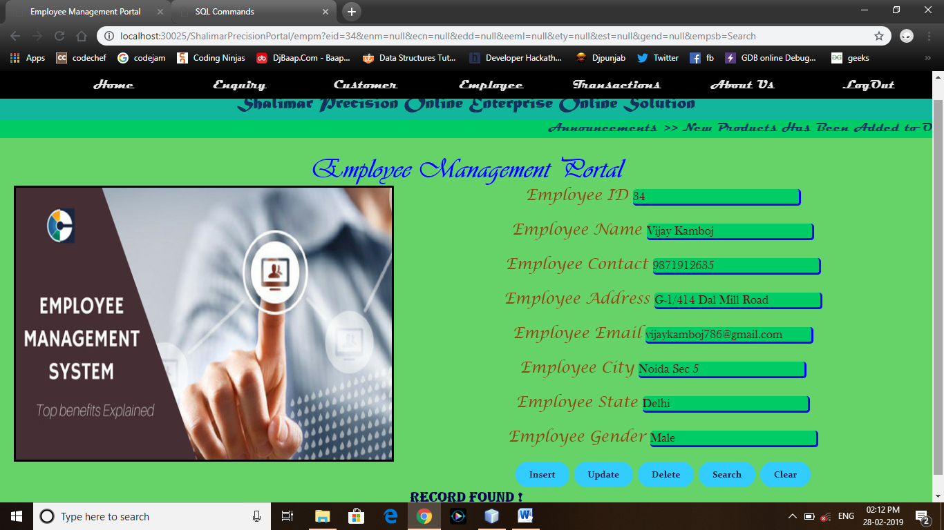

<%@page contentType="text/html" pageEncoding="UTF-8"%>

<!DOCTYPE html>

<html>

<head>

<meta http-equiv="Content-Type" content="text/html; charset=UTF-8">

<title>Employee Management Portal</title>

<link rel="stylesheet" type="text/css" href="remstyls.css">

</head>

<body bgcolor="#66d368">

<div class="navbar">

<ul>

<li><a href="Welcome.jsp">Home</a></li>

<li><a href="Enquiry.jsp">Enquiry</></li>

<li><a href="Customer.jsp">Customer</a></li>

<li><a href="Employee.jsp">Employee</a></li>

<li><a href="#">Transactions</a>

<ul>

<li><a href="Inventory.jsp">Inventory</a></li>

<li><a href="Sales.jsp">Sales</a></li>

<li><a href="Promotion.jsp">Promotion</a></li>

<li><a href="Payment.jsp">Payment</a></li>

</ul>

</li>

<li><a href="about.jsp">About Us</a></li>

<li><a href="login.jsp">LogOut</a></li>

</ul>

</div>

<div class="header">

<center><h2>Shalimar Precision Online Enterprise Online Solution</h2></center>

</div>

<div style="background-color:#00cc66;clear:both;text-align:center">

<marquee><b><font color="#12335b">Announcements >> New Products Has Been Added to Our Portal Regularly.Please Be Updated........</font></b></marquee>

</div><br/>

<div class="subhd">

<center><h2>Employee Management Portal</h2></center>

</div>

<div id="images">

<img src="images/employee.jpg" height="400px" width="550px" border="3">

</div>

<div class="dtls">

<center>

<form action="empm" name="myfrm">

<font size="4px" face="Lucida Calligraphy" color="#894d10">Employee ID</font> <input type="text" name="eid" placeholder="Enter Employee ID" value='<%=request.getAttribute("empid")%>'/><br/><br/>

<font size="4px" face="Lucida Calligraphy" color="#894d10">Employee Name</font> <input type="text" name="enm" placeholder="Enter Employee Name" value='<%=request.getAttribute("empnm")%>'/><br/><br/>

<font size="4px" face="Lucida Calligraphy" color="#894d10">Employee Contact</font> <input type="text" name="ecn" placeholder="Enter Customer Contact" value='<%=request.getAttribute("empcon")%>'/><br/><br/>

<font size="4px" face="Lucida Calligraphy" color="#894d10">Employee Address</font> <input type="text" name="edd" placeholder="Enter Your Address Here" value='<%=request.getAttribute("empadd")%>'/><br/><br/>

<font size="4px" face="Lucida Calligraphy" color="#894d10">Employee Email</font> <input type="text" name="eeml" placeholder="Enter Customer Email" value='<%=request.getAttribute("empeml")%>'/><br/><br/>

<font size="4px" face="Lucida Calligraphy" color="#894d10">Employee City</font> <input type="text" name="ety" placeholder="Enter Customer City" value='<%=request.getAttribute("empcty")%>'/><br/><br/>

<font size="4px" face="Lucida Calligraphy" color="#894d10">Employee State</font> <input type="text" name="est" placeholder="Enter Customer State" value='<%=request.getAttribute("empst")%>'/><br/><br/>

<font size="4px" face="Lucida Calligraphy" color="#894d10">Employee Gender</font> <input type="text" name="gend" placeholder="Enter Gender(Mal/Fem)" value='<%=request.getAttribute("empgend")%>' /><br/><br/>

<input type="submit" name="empsb" value="Insert">

<input type="submit" name="empsb" value="Update">

<input type="submit" name="empsb" value="Delete">

<input type="submit" name="empsb" value="Search">

<input type="reset" value="Clear">

<center><h3><%=request.getAttribute("errmsg") %></h3></center>

</form>

</center>

</div>

<div class="foot">

<h2>This Project Has Been Developed By Mr. Jatin Kumar "Kamboj" and Copyright © 2011 <a href="#">Shalimar Precision EnterPrise Online Solution</a></h2>

</div>

</body>

</html>

***EmployeeOperation.java***

import java.io.*;

import javax.servlet.*;

import javax.servlet.annotation.WebServlet;

import javax.servlet.http.*;

import java.sql.*;

@WebServlet(urlPatterns = {"/EmployeeOperation"})

public class EmployeeOperation extends HttpServlet {

protected void processRequest(HttpServletRequest request, HttpServletResponse response)

throws ServletException, IOException {

response.setContentType("text/html;charset=UTF-8");

try (PrintWriter out = response.getWriter()) {

String action,id,nm,con,add,eml,ty,st,gen;

action = request.getParameter("empsb");

id = request.getParameter("eid");

nm = request.getParameter("enm");

con = request.getParameter("ecn");

add = request.getParameter("edd");

eml = request.getParameter("eeml");

ty = request.getParameter("ety");

st = request.getParameter("est");

gen = request.getParameter("gend");

try{

Class.forName("oracle.jdbc.driver.OracleDriver");

Connection conn=DriverManager.getConnection("jdbc:oracle:thin:@localhost:1521:xe","shalimaresol","shalimaresol");

Statement stmt=conn.createStatement();

if(action.equals("Insert")){ if((!"".equals(id))&&(!"".equals(nm))&&(!"".equals(con))&&(!"".equals(add))&&(!"".equals(eml))&&(!"".equals(ty))&&(!"".equals(st))&&(!"".equals(gen))){

int a = stmt.executeUpdate("insert into employee values('"+id+"','"+nm+"','"+eml+"','"+add+"','"+ty+"','"+st+"','"+gen+"','"+con+"')");

if(a > 0){

request.setAttribute("errmsg","Record Inserted Successfully !");

RequestDispatcher rsd = request.getRequestDispatcher("/Employee.jsp");

rsd.forward(request, response);

}else{

request.setAttribute("errmsg", "Record Doesn't Inserted !");

RequestDispatcher rsd = request.getRequestDispatcher("/Employee.jsp");

rsd.forward(request, response);

}

}else{

request.setAttribute("errmsg","Some of the Fields is Empty !");

RequestDispatcher rsd = request.getRequestDispatcher("/Employee.jsp");

rsd.forward(request, response);

}

} else if(action.equals("Update")) { if((!"".equals(id))&&(!"".equals(nm))&&(!"".equals(con))&&(!"".equals(add))&&(!"".equals(eml))&&(!"".equals(ty))&&(!"".equals(st))&&(!"".equals(gen))){

int a = stmt.executeUpdate("update employee set e_name='"+nm+"', e_email='"+eml+"', e_add='"+add+"', e_city='"+ty+"', e_state='"+st+"', e_gen='"+gen+"', e_contact='"+con+"' where e_id='"+id+"' ");

if(a > 0) {

request.setAttribute("errmsg","Record Successfully Updated !");

RequestDispatcher rsd = request.getRequestDispatcher("/Employee.jsp");

rsd.forward(request, response);

}else {

request.setAttribute("errmsg","Record Doesn't Updated !");

RequestDispatcher rsd = request.getRequestDispatcher("/Employee.jsp");

rsd.forward(request, response);

}

}else {

request.setAttribute("errmsg","Some of The Fields is Empty !");

RequestDispatcher rsd = request.getRequestDispatcher("/Employee.jsp");

rsd.forward(request, response);

}

}else if(action.equals("Delete")) {

if(!"".equals(id)){

int a = stmt.executeUpdate("delete from employee where e_id='"+id+"' ");

if(a > 0){

request.setAttribute("errmsg","Record Deleted Successfully !");

RequestDispatcher rsd = request.getRequestDispatcher("/Employee.jsp");

rsd.forward(request, response);

}else{

request.setAttribute("errmsg","Record Doesn't Deleted !");

RequestDispatcher rsd = request.getRequestDispatcher("/Employee.jsp");

rsd.forward(request, response);

}

}else{

request.setAttribute("errmsg","Please Fill The Employee ID!");

RequestDispatcher rsd = request.getRequestDispatcher("/Employee.jsp");

rsd.forward(request, response);

}

}else if(action.equals("Search")){

if(!"".equals(id)){

ResultSet rs = stmt.executeQuery("select * from employee where e_id='"+id+"' ");

if(rs.next()){

System.out.println(rs.getString(1));

System.out.println(rs.getString(2));

System.out.println(rs.getString(3));

System.out.println(rs.getString(4));

System.out.println(rs.getString(5));

System.out.println(rs.getString(6));

System.out.println(rs.getString(7));

System.out.println(rs.getString(8));

request.setAttribute("empid",rs.getString(1));

request.setAttribute("empnm",rs.getString(2));

request.setAttribute("empcon",rs.getString(8));

request.setAttribute("empadd",rs.getString(4));

request.setAttribute("empeml",rs.getString(3));

request.setAttribute("empcty",rs.getString(5));

request.setAttribute("empst",rs.getString(6));

request.setAttribute("empgend",rs.getString(7));

request.setAttribute("errmsg","Record Found !");

RequestDispatcher rsd = request.getRequestDispatcher("/Employee.jsp");

rsd.forward(request,response);

}else{

request.setAttribute("errmsg","Record Doesn't Found !");

RequestDispatcher rsd = request.getRequestDispatcher("/Employee.jsp");

rsd.forward(request,response);

}

}else{

request.setAttribute("errmsg","Please Fill The Employee ID !");

RequestDispatcher rsd = request.getRequestDispatcher("/Employee.jsp");

rsd.forward(request, response);

}

}

}catch(Exception ex){

System.out.println(ex);

request.setAttribute("errmsg", "An Error Occurred");

RequestDispatcher rsd = request.getRequestDispatcher("/Employee.jsp");

rsd.forward(request, response);

}

}

}

@Override

protected void doGet(HttpServletRequest request, HttpServletResponse response)

throws ServletException, IOException {

processRequest(request, response);

}

@Override

protected void doPost(HttpServletRequest request, HttpServletResponse response)

throws ServletException, IOException {

processRequest(request, response);

}

@Override

public String getServletInfo() {

return "Short description";

}// </editor-fold>

}

***Inventory.jsp***

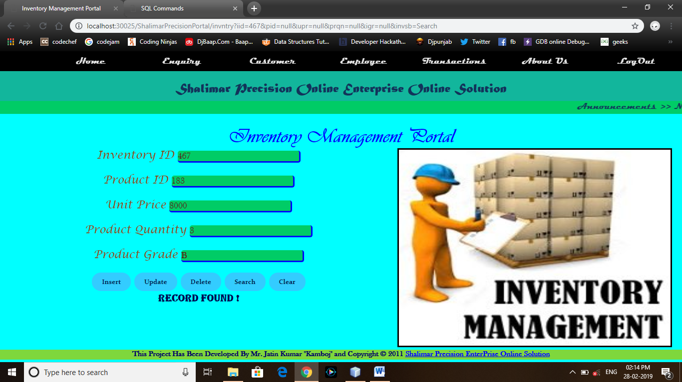

<%@page contentType="text/html" pageEncoding="UTF-8"%>

<!DOCTYPE html>

<html>

<head>

<meta http-equiv="Content-Type" content="text/html; charset=UTF-8">

<title>Inventory Management Portal</title>

<link rel="stylesheet" type="text/css" href="remstyls.css">

</head>

<body bgcolor="#00ffff">

<div class="navbar">

<ul>

<li><a href="Welcome.jsp">Home</a></li>

<li><a href="Enquiry.jsp">Enquiry</></li>

<li><a href="Customer.jsp">Customer</a></li>

<li><a href="Employee.jsp">Employee</a></li>

<li><a href="#">Transactions</a>

<ul>

<li><a href="Inventory.jsp">Inventory</a></li>

<li><a href="Sales.jsp">Sales</a></li>

<li><a href="Promotion.jsp">Promotion</a></li>

<li><a href="Payment.jsp">Payment</a></li>

</ul>

</li>

<li><a href="about.jsp">About Us</a></li>

<li><a href="login.jsp">LogOut</a></li>

</ul>

</div>

<div class="header">

<center><h2>Shalimar Precision Online Enterprise Online Solution</h2></center>

</div>

<div style="background-color:#00cc66;clear:both;text-align:center">

<marquee><b><font color="#12335b">Announcements >> New Products Has Been Added to Our Portal Regularly.Please Be Updated........</font></b></marquee>

</div><br/>

<div class="subhd">

<center><h2>Inventory Management Portal</h2></center>

</div>

<div id="imagesR">

<img src="images/invntry.jpg" height="400px" width="550px" border="3">

</div>

<div class="dtls">

<center>

<form action="invntry" name="myfrm">

<font size="4px" face="Lucida Calligraphy" color="#894d10">Inventory ID</font> <input type="text" name="iid" placeholder="Enter Inventory ID" value='<%=request.getAttribute("invid")%>'/><br/><br/>

<font size="4px" face="Lucida Calligraphy" color="#894d10">Product ID</font> <input type="text" name="pid" placeholder="Enter Product ID" value='<%=request.getAttribute("prid")%>'/><br/><br/>

<font size="4px" face="Lucida Calligraphy" color="#894d10">Unit Price</font> <input type="text" name="upr" placeholder="Enter Unit Price" value='<%=request.getAttribute("unprc")%>'/><br/><br/>

<font size="4px" face="Lucida Calligraphy" color="#894d10">Product Quantity</font> <input type="text" name="prqn" placeholder="Enter Product Quantity" value='<%=request.getAttribute("prqty")%>'/><br/><br/>

<font size="4px" face="Lucida Calligraphy" color="#894d10">Product Grade</font> <input type="text" name="igr" placeholder="Enter Product Grade" value='<%=request.getAttribute("prgrd")%>'/><br/><br/>

<input type="submit" name="invsb" value="Insert">

<input type="submit" name="invsb" value="Update">

<input type="submit" name="invsb" value="Delete">

<input type="submit" name="invsb" value="Search">

<input type="reset" value="Clear">

<center><h3><%=request.getAttribute("errmsg") %></h3></center>

</form>

</center>

</div>

<div class="foot">

<h2>This Project Has Been Developed By Mr. Jatin Kumar "Kamboj" and Copyright © 2011 <a href="#">Shalimar Precision EnterPrise Online Solution</a></h2>

</div>

</body>

</html>

***ProductOperation.java***

import java.io.*;

import javax.servlet.*;

import javax.servlet.annotation.WebServlet;

import javax.servlet.http.*;

import java.sql.*;

@WebServlet(urlPatterns = {"/ProductOperation"})

public class ProductOperation extends HttpServlet {

protected void processRequest(HttpServletRequest request, HttpServletResponse response)

throws ServletException, IOException {

response.setContentType("text/html;charset=UTF-8");

try (PrintWriter out = response.getWriter()) {

String action,id,pid,prc,qn,grd;

action = request.getParameter("invsb");

System.out.println("Your Action : "+action);

id = request.getParameter("iid");

pid = request.getParameter("pid");

prc = request.getParameter("upr");

qn = request.getParameter("prqn");

grd = request.getParameter("igr");

try{

Class.forName("oracle.jdbc.driver.OracleDriver");

Connection conn=DriverManager.getConnection("jdbc:oracle:thin:@localhost:1521:xe","shalimaresol","shalimaresol");

Statement stmt=conn.createStatement();

if(action.equals("Insert")){ if((!"".equals(id))&&(!"".equals(pid))&&(!"".equals(prc))&&(!"".equals(grd))){

int a = stmt.executeUpdate("insert into inventory values ('"+id+"','"+pid+"','"+prc+"','"+qn+"','"+grd+"')");

if(a > 0){

request.setAttribute("errmsg","Record Inserted Successfully !");

RequestDispatcher rsd = request.getRequestDispatcher("/Inventory.jsp");

rsd.forward(request, response);

}else{

request.setAttribute("errmsg","Record Doesn't Inserted !");

RequestDispatcher rsd = request.getRequestDispatcher("/Inventory.jsp");

rsd.forward(request, response);

}

}else{

request.setAttribute("errmsg","Some of the Given Fields is Empty !");

RequestDispatcher rsd = request.getRequestDispatcher("/Inventory.jsp");

rsd.forward(request,response);

}

}else if(action.equals("Update")){ if((!"".equals(id))&&(!"".equals(pid))&&(!"".equals(prc))&&(!"".equals(grd))){

int a = stmt.executeUpdate("update inventory set p_id='"+pid+"' ,i_price='"+prc+"',i_qty='"+qn+"' ,i_grd='"+grd+"' where i_id='"+id+"'");

if(a > 0){

request.setAttribute("errmsg","Record Updated Successfully !");

RequestDispatcher rsd = request.getRequestDispatcher("/Inventory.jsp");

rsd.forward(request, response);

}else{

request.setAttribute("errmsg","Record Doesn't Updated !");

RequestDispatcher rsd = request.getRequestDispatcher("/Inventory.jsp");

rsd.forward(request, response);

}

}else{

request.setAttribute("errmsg","Some of the Given Fields is Empty !");

RequestDispatcher rsd = request.getRequestDispatcher("/Inventory.jsp");

rsd.forward(request,response);

}

}else if(action.equals("Delete")){

if(!"".equals(id)){

int a = stmt.executeUpdate("delete from inventory where i_id='"+id+"'");

if(a > 0){

request.setAttribute("errmsg","Record Successfully Deleted !");

RequestDispatcher rsd = request.getRequestDispatcher("/Inventory.jsp");

rsd.forward(request,response);

}else{

request.setAttribute("errmsg","Record Doesn't Deleted !");

RequestDispatcher rsd = request.getRequestDispatcher("/Inventory.jsp");

}

}else{

request.setAttribute("errmsg","Please Fill The Inventory ID");

RequestDispatcher rsd = request.getRequestDispatcher("/Inventory.jsp");

rsd.forward(request,response);

}

}else if(action.equals("Search")){

if(!"".equals(id)){

ResultSet rs = stmt.executeQuery("select * from inventory where i_id='"+id+"'");

if(rs.next()){

System.out.println(rs.getString(1));

System.out.println(rs.getString(2));

System.out.println(rs.getString(3));

System.out.println(rs.getString(4));

System.out.println(rs.getString(5));

request.setAttribute("invid",rs.getString(1));

request.setAttribute("prid",rs.getString(2));

request.setAttribute("unprc",rs.getString(3));

request.setAttribute("prqty",rs.getString(4));

request.setAttribute("prgrd",rs.getString(5));

request.setAttribute("errmsg","Record Found !");

RequestDispatcher rsd = request.getRequestDispatcher("/Inventory.jsp");

rsd.forward(request,response);

}else{

request.setAttribute("errmsg","Record Doesn't Found !");

RequestDispatcher rsd = request.getRequestDispatcher("/Inventory.jsp");

rsd.forward(request,response);

}

}else{

request.setAttribute("errmsg","Please Fill The Inventory ID");

RequestDispatcher rsd = request.getRequestDispatcher("/Inventory.jsp");

rsd.forward(request,response);

}

}

}catch(Exception ex){

ex.printStackTrace();

request.setAttribute("errmsg","An Error Occurred While Establishing The Connection !");

RequestDispatcher rsd = request.getRequestDispatcher("/Inventory.jsp");

rsd.forward(request, response);

}}}

@Override

protected void doGet(HttpServletRequest request, HttpServletResponse response)

throws ServletException, IOException {

processRequest(request, response);

}

@Override

protected void doPost(HttpServletRequest request, HttpServletResponse response)

throws ServletException, IOException {

processRequest(request, response);

}

@Override

public String getServletInfo() {

return "Short description";

}// </editor-fold>

}

***Sales.jsp***

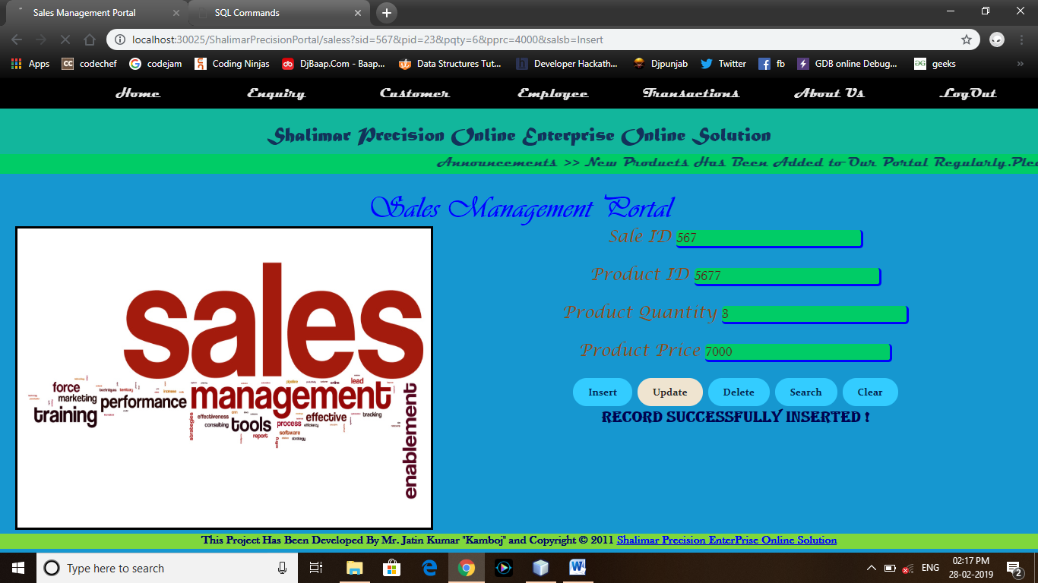

<%@page contentType="text/html" pageEncoding="UTF-8"%>

<!DOCTYPE html>

<html>

<head>

<meta http-equiv="Content-Type" content="text/html; charset=UTF-8">

<title>Sales Management Portal</title>

<link rel="stylesheet" type="text/css" href="remstyls.css">

</head>

<body bgcolor="#1697d0">

<div class="navbar">

<ul>

<li><a href="Welcome.jsp">Home</a></li>

<li><a href="Enquiry.jsp">Enquiry</></li>

<li><a href="Customer.jsp">Customer</a></li>

<li><a href="Employee.jsp">Employee</a></li>

<li><a href="#">Transactions</a>

<ul>

<li><a href="Inventory.jsp">Inventory</a></li>

<li><a href="Sales.jsp">Sales</a></li>

<li><a href="Promotion.jsp">Promotion</a></li>

<li><a href="Payment.jsp">Payment</a></li>

</ul>

</li>

<li><a href="about.jsp">About Us</a></li>

<li><a href="login.jsp">LogOut</a></li>

</ul>

</div>

<div class="header">

<center><h2>Shalimar Precision Online Enterprise Online Solution</h2></center>

</div>

<div style="background-color:#00cc66;clear:both;text-align:center">

<marquee><b><font color="#12335b">Announcements >> New Products Has Been Added to Our Portal Regularly.Please Be Updated........</font></b></marquee>

</div><br/>

<div class="subhd">

<center><h2>Sales Management Portal</h2></center>

</div>

<div id="images">

<img src="images/saless.jpg" height="400px" width="550px" border="3">

</div>

<div class="dtls">

<center>

<form action="saless" name="myfrm">

<font size="4px" face="Lucida Calligraphy" color="#894d10">Sale ID</font> <input type="text" name="sid" placeholder="Enter Sales ID" value='<%=request.getAttribute("slid")%>'/><br/><br/>

<font size="4px" face="Lucida Calligraphy" color="#894d10">Product ID</font> <input type="text" name="pid" placeholder="Enter Product ID" value='<%=request.getAttribute("prid")%>'/><br/><br/>

<font size="4px" face="Lucida Calligraphy" color="#894d10">Product Quantity</font> <input type="text" name="pqty" placeholder="Enter Product Quantity" value='<%=request.getAttribute("prqty")%>'/><br/><br/>

<font size="4px" face="Lucida Calligraphy" color="#894d10">Product Price</font> <input type="text" name="pprc" placeholder="Enter Product Price" value='<%=request.getAttribute("prprc")%>'/><br/><br/>

<input type="submit" name="salsb" value="Insert">

<input type="submit" name="salsb" value="Update">

<input type="submit" name="salsb" value="Delete">

<input type="submit" name="salsb" value="Search">

<input type="reset" value="Clear">

<center><h3><%=request.getAttribute("errmsg") %></h3></center>

</form>

</center>

</div>

<div class="foot">

<h2>This Project Has Been Developed By Mr. Jatin Kumar "Kamboj" and Copyright © 2011 <a href="#">Shalimar Precision EnterPrise Online Solution</a></h2>

</div>

</body>

</html>

***SalesOperation.java***

import java.io.*;

import javax.servlet.*;

import javax.servlet.annotation.WebServlet;

import javax.servlet.http.*;

import java.sql.*;

@WebServlet(urlPatterns = {"/SalesOperation"})

public class SalesOperation extends HttpServlet {

protected void processRequest(HttpServletRequest request, HttpServletResponse response)

throws ServletException, IOException {

response.setContentType("text/html;charset=UTF-8");

try (PrintWriter out = response.getWriter()) {

String action,slid,prid,qty,prc;

action = request.getParameter("salsb");

System.out.println("Your Action : "+action);

slid = request.getParameter("sid");

prid = request.getParameter("pid");

qty = request.getParameter("pqty");

prc = request.getParameter("pprc");

try{

Class.forName("oracle.jdbc.driver.OracleDriver");

Connection conn=DriverManager.getConnection("jdbc:oracle:thin:@localhost:1521:xe","shalimaresol","shalimaresol");

Statement stmt=conn.createStatement();

if(action.equals("Insert")){ if((!"".equals(slid))&&(!"".equals(prid))&&(!"".equals(qty))&&(!"".equals(prc))){

int a = stmt.executeUpdate("insert into sales values('"+slid+"','"+prid+"','"+qty+"','"+prc+"')");

if(a > 0){

request.setAttribute("errmsg","Record Successfully Inserted !");

RequestDispatcher rsd = request.getRequestDispatcher("/Sales.jsp");

rsd.forward(request, response);

}else{

request.setAttribute("errmsg","Record Doesn't Inserted !");

RequestDispatcher rsd = request.getRequestDispatcher("/Sales.jsp");

rsd.forward(request, response);

}

}else{

request.setAttribute("errmsg","Some of the Given Fields is Empty !");

RequestDispatcher rsd = request.getRequestDispatcher("/Sales.jsp");

rsd.forward(request, response);

}

}else if(action.equals("Update")){ if((!"".equals(slid))&&(!"".equals(prid))&&(!"".equals(qty))&&(!"".equals(prc))){

int a = stmt.executeUpdate("update sales set p_id='"+prid+"' ,p_qty='"+qty+"' ,p_prc='"+prc+"' where s_id='"+slid+"' ");

if(a > 0){

request.setAttribute("errmsg","Record Successfully Updated !");

RequestDispatcher rsd = request.getRequestDispatcher("/Sales.jsp");

rsd.forward(request, response);

}else{

request.setAttribute("errmsg","Record Doesn't Updated !");

RequestDispatcher rsd = request.getRequestDispatcher("/Sales.jsp");

rsd.forward(request, response);

}

}else{

request.setAttribute("errmsg","Some of the Given Fields is Empty !");

RequestDispatcher rsd = request.getRequestDispatcher("/Sales.jsp");

rsd.forward(request, response);

}

}else if(action.equals("Delete")){

if(!"".equals(slid)){

int a = stmt.executeUpdate("delete from sales where s_id='"+slid+"' ");

if(a > 0){

request.setAttribute("errmsg","Record Successfully Deleted !");

RequestDispatcher rsd = request.getRequestDispatcher("/Sales.jsp");

rsd.forward(request, response);

}else{

request.setAttribute("errmsg","Record Doesn't Deleted !");

RequestDispatcher rsd = request.getRequestDispatcher("/Sales.jsp");

rsd.forward(request, response);

}

}else{

request.setAttribute("errmsg","Please Fill The Sales ID !");

RequestDispatcher rsd = request.getRequestDispatcher("/Sales.jsp");

rsd.forward(request, response);

}

}else if(action.equals("Search")){

if(!"".equals(slid)){

ResultSet rs = stmt.executeQuery("Select * from sales where s_id='"+slid+"'");

if(rs.next()){

System.out.println(rs.getString(1));

System.out.println(rs.getString(2));

System.out.println(rs.getString(3));

System.out.println(rs.getString(4));

request.setAttribute("slid",rs.getString(1));

request.setAttribute("prid",rs.getString(2));

request.setAttribute("prqty",rs.getString(3));

request.setAttribute("prprc",rs.getString(4));

request.setAttribute("errmsg","Record Found !");

RequestDispatcher rsd = request.getRequestDispatcher("/Sales.jsp");

rsd.forward(request, response);

}else{

request.setAttribute("errmsg","Record Not Found !");

RequestDispatcher rsd = request.getRequestDispatcher("/Sales.jsp");

rsd.forward(request, response);

}

}else{

request.setAttribute("errmsg","Please Fill The Sales ID !");

RequestDispatcher rsd = request.getRequestDispatcher("/Sales.jsp");

rsd.forward(request, response);

}

}

}catch(Exception ex){

System.out.println(ex);

request.setAttribute("errmsg","An Error Has Been Occurred While Establishing The Connection !");

RequestDispatcher rsd = request.getRequestDispatcher("/Sales.jsp");

rsd.forward(request, response);

}

}

}

@Override

protected void doGet(HttpServletRequest request, HttpServletResponse response)

throws ServletException, IOException {

processRequest(request, response);

}

@Override

protected void doPost(HttpServletRequest request, HttpServletResponse response)

throws ServletException, IOException {

processRequest(request, response);

}

@Override

public String getServletInfo() {

return "Short description";

}// </editor-fold>

}

***Promotion.jsp***

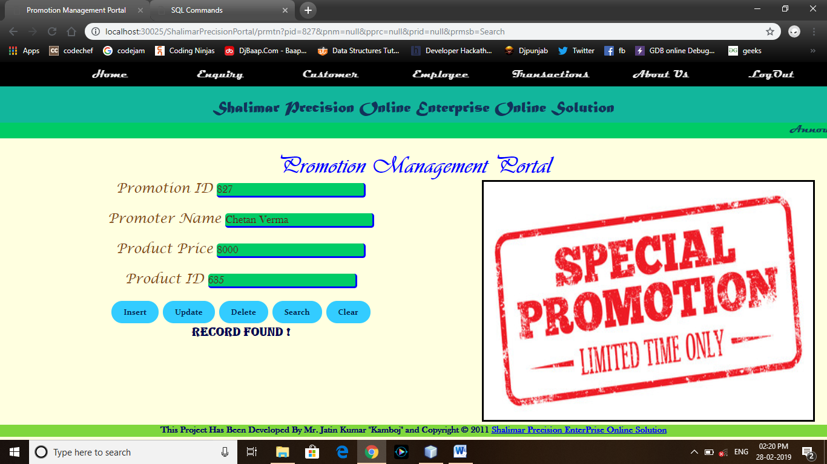

<%@page contentType="text/html" pageEncoding="UTF-8"%>

<!DOCTYPE html>

<html>

<head>

<meta http-equiv="Content-Type" content="text/html; charset=UTF-8">

<title>Promotion Management Portal</title>

<link rel="stylesheet" type="text/css" href="remstyls.css">

</head>

<body bgcolor="lightyellow">

<div class="navbar">

<ul>

<li><a href="Welcome.jsp">Home</a></li>

<li><a href="Enquiry.jsp">Enquiry</></li>

<li><a href="Customer.jsp">Customer</a></li>

<li><a href="Employee.jsp">Employee</a></li>

<li><a href="#">Transactions</a>

<ul>

<li><a href="Inventory.jsp">Inventory</a></li>

<li><a href="Sales.jsp">Sales</a></li>

<li><a href="Promotion.jsp">Promotion</a></li>

<li><a href="Payment.jsp">Payment</a></li>

</ul>

</li>

<li><a href="about.jsp">About Us</a></li>

<li><a href="login.jsp">LogOut</a></li>

</ul>

</div>

<div class="header">

<center><h2>Shalimar Precision Online Enterprise Online Solution</h2></center>

</div>

<div style="background-color:#00cc66;clear:both;text-align:center">

<marquee><b><font color="#12335b">Announcements >> New Products Has Been

Added to Our Portal Regularly.Please Be Updated........</font></b></marquee>

</div><br/>

<div class="subhd">

<center><h2>Promotion Management Portal</h2></center>

</div>

<div id="imagesR">

<img src="images/promotion.jpg" height="400px" width="550px" border="3">

</div>

<div class="dtls">

<center>

<form action="prmtn" name="myfrm">

<font size="4px" face="Lucida Calligraphy" color="#894d10">Promotion ID</font> <input type="text" name="pid" placeholder="Enter Promotion ID" value='<%=request.getAttribute("prmid")%>'/><br/><br/>

<font size="4px" face="Lucida Calligraphy" color="#894d10">Promoter Name</font> <input type="text" name="pnm" placeholder="Enter Promoter Name" value='<%=request.getAttribute("prmnm")%>'/><br/><br/>

<font size="4px" face="Lucida Calligraphy" color="#894d10">Product Price</font> <input type="text" name="pprc" placeholder="Enter Product Price" value='<%=request.getAttribute("prprc")%>'/><br/><br/>

<font size="4px" face="Lucida Calligraphy" color="#894d10">Product ID</font> <input type="text" name="prid" placeholder="Enter Product ID" value='<%=request.getAttribute("prid")%>'/><br/><br/>

<input type="submit" name="prmsb" value="Insert">

<input type="submit" name="prmsb" value="Update">

<input type="submit" name="prmsb" value="Delete">

<input type="submit" name="prmsb" value="Search">

<input type="reset" value="Clear">

<center><h3><%=request.getAttribute("errmsg") %></h3></center>

</form>

</center>

</div>

<div class="foot">

<h2>This Project Has Been Developed By Mr. Jatin Kumar "Kamboj" and Copyright © 2011 <a href="#">Shalimar Precision EnterPrise Online Solution</a></h2>

</div>

</body>

</html>

***PromotionOperation.java***

import java.io.*;

import javax.servlet.*;

import javax.servlet.annotation.WebServlet;

import javax.servlet.http.*;

import java.sql.*;

@WebServlet(urlPatterns = {"/PromotionOperation"})

public class PromotionOperation extends HttpServlet {

protected void processRequest(HttpServletRequest request, HttpServletResponse response)

throws ServletException, IOException {

response.setContentType("text/html;charset=UTF-8");

try (PrintWriter out = response.getWriter()) {

String action,prmid,prnnm,prprc,prpid;

action = request.getParameter("prmsb");

System.out.println("Your Action : "+action);

prmid = request.getParameter("pid");

prnnm = request.getParameter("pnm");

prprc = request.getParameter("pprc");

prpid = request.getParameter("prid");

try{

Class.forName("oracle.jdbc.driver.OracleDriver");

Connection conn=DriverManager.getConnection("jdbc:oracle:thin:@localhost:1521:xe","shalimaresol","shalimaresol");

Statement stmt=conn.createStatement();

if(action.equals("Insert")){ if((!"".equals(prmid))&&(!"".equals(prnnm))&&(!"".equals(prprc))&&(!"".equals(prpid))){

int a = stmt.executeUpdate("insert into promotion values ('"+prmid+"','"+prnnm+"','"+prprc+"','"+prpid+"') ");

if(a > 0){

request.setAttribute("errmsg","Record Inserted Successfully !");

RequestDispatcher rsd = request.getRequestDispatcher("/Promotion.jsp");

rsd.forward(request, response);

}else{

request.setAttribute("errmsg","Record Doesn't Inserted !");

RequestDispatcher rsd = request.getRequestDispatcher("/Promotion.jsp");

rsd.forward(request, response);

}

}else{

request.setAttribute("errmsg","Some of the Given Fields is Empty !");

RequestDispatcher rsd = request.getRequestDispatcher("/Promotion.jsp");

rsd.forward(request, response);

}

}else if(action.equals("Update")){ if((!"".equals(prmid))&&(!"".equals(prnnm))&&(!"".equals(prprc))&&(!"".equals(prpid))){

int a = stmt.executeUpdate("update promotion set pr_name='"+prnnm+"' ,pr_prc='"+prprc+"' ,pro_id='"+prpid+"' where pr_id='"+prmid+"' ");

if(a > 0){

request.setAttribute("errmsg","Record Successfully Updated !");

RequestDispatcher rsd = request.getRequestDispatcher("/Promotion.jsp");

rsd.forward(request, response);

}else{

request.setAttribute("errmsg","Record Doesn't Updated !");

RequestDispatcher rsd = request.getRequestDispatcher("/Promotion.jsp");

rsd.forward(request, response);

}

}else{

request.setAttribute("errmsg", "Some of the Given Fields is Empty !");

RequestDispatcher rsd = request.getRequestDispatcher("/Promotion.jsp");

rsd.forward(request, response);

}

}else if(action.equals("Delete")){

if(!"".equals(prmid)){

int a = stmt.executeUpdate("delete from promotion where pr_id='"+prmid+"' ");

if(a > 0){

request.setAttribute("errmsg","Record Successfully Deleted !");

RequestDispatcher rsd = request.getRequestDispatcher("/Promotion.jsp");

rsd.forward(request, response);

}else{

request.setAttribute("errmsg","Record Doesn't Deleted !");

RequestDispatcher rsd = request.getRequestDispatcher("/Promotion.jsp");

rsd.forward(request, response);

}

}else{

request.setAttribute("errmsg","Plesae Fill The Promotion ID !");

RequestDispatcher rsd = request.getRequestDispatcher("/Promotion.jsp");

rsd.forward(request, response);

}

}else if(action.equals("Search")){

if(!"".equals(prmid)){

ResultSet rs = stmt.executeQuery("select * from promotion where pr_id='"+prmid+"' ");

if(rs.next()){

System.out.println(rs.getString(1));

System.out.println(rs.getString(2));

System.out.println(rs.getString(3));

System.out.println(rs.getString(4));

request.setAttribute("prmid",rs.getString(1));

request.setAttribute("prmnm",rs.getString(2));

request.setAttribute("prprc",rs.getString(3));

request.setAttribute("prid",rs.getString(4));

request.setAttribute("errmsg","Record Found !");

RequestDispatcher rsd = request.getRequestDispatcher("/Promotion.jsp");

rsd.forward(request,response);

}else{

request.setAttribute("errmsg","Record Not Found !");

RequestDispatcher rsd = request.getRequestDispatcher("/Promotion.jsp");

rsd.forward(request,response);

}

}else{

request.setAttribute("errmsg","Plesae Fill The Promotion ID !");

RequestDispatcher rsd = request.getRequestDispatcher("/Promotion.jsp");

rsd.forward(request, response);

}

}

}catch(Exception ex){

request.setAttribute("errmsg","An Error Occurred While Establishing The Connection !");

RequestDispatcher rsd = request.getRequestDispatcher("/Promotion.jsp");

rsd.forward(request, response);

}

}

}

@Override

protected void doGet(HttpServletRequest request, HttpServletResponse response)

throws ServletException, IOException {

processRequest(request, response); }

@Override

protected void doPost(HttpServletRequest request, HttpServletResponse response)

throws ServletException, IOException {

processRequest(request, response); }

@Override

public String getServletInfo() {

return "Short description";

}// </editor-fold>}

***Payment.jsp***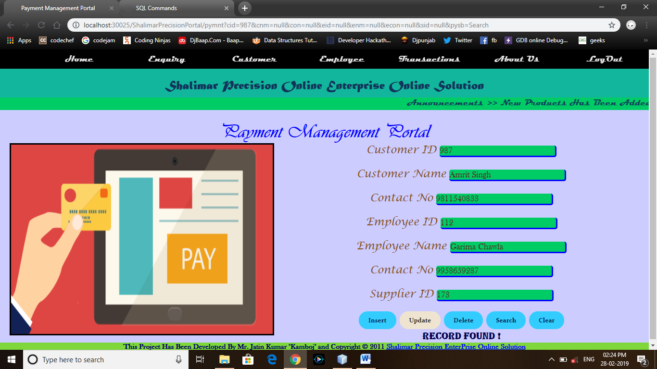

<%@page contentType="text/html" pageEncoding="UTF-8"%>

<!DOCTYPE html>

<html>

<head>

<meta http-equiv="Content-Type" content="text/html; charset=UTF-8">

<title>Payment Management Portal</title>

<link rel="stylesheet" type="text/css" href="remstyls.css">

</head>

<body bgcolor="#ccccff">

<div class="navbar">

<ul>

<li><a href="Welcome.jsp">Home</a></li>

<li><a href="Enquiry.jsp">Enquiry</></li>

<li><a href="Customer.jsp">Customer</a></li>

<li><a href="Employee.jsp">Employee</a></li>

<li><a href="#">Transactions</a>

<ul>

<li><a href="Inventory.jsp">Inventory</a></li>

<li><a href="Sales.jsp">Sales</a></li>

<li><a href="Promotion.jsp">Promotion</a></li>

<li><a href="Payment.jsp">Payment</a></li>

</ul>

</li>

<li><a href="about.jsp">About Us</a></li>

<li><a href="login.jsp">LogOut</a></li>

</ul>

</div>

<div class="header">

<center><h2>Shalimar Precision Online Enterprise Online Solution</h2></center>

</div>

<div style="background-color:#00cc66;clear:both;text-align:center">

<marquee><b><font color="#12335b">Announcements >> New Products Has Been Added to Our Portal Regularly.Please Be Updated........</font></b></marquee>

</div><br/>

<div class="subhd">

<center><h2>Payment Management Portal</h2></center>

</div>

<div id="images">

<img src="images/payment.png" height="400px" width="550px" border="3">

</div>

<div class="dtls">

<center>

<form action="pymnt" name="myfrm">

<font size="4px" face="Lucida Calligraphy" color="#894d10">Customer ID</font> <input type="text" name="cid" placeholder="Enter Customer ID" value='<%=request.getAttribute("cusid")%>'/><br/><br/>

<font size="4px" face="Lucida Calligraphy" color="#894d10">Customer Name</font> <input type="text" name="cnm" placeholder="Enter Customer Name" value='<%=request.getAttribute("cusnm")%>'/><br/><br/>

<font size="4px" face="Lucida Calligraphy" color="#894d10">Contact No</font> <input type="text" name="con" placeholder="Enter Conatct No" value='<%=request.getAttribute("cuscon")%>'/><br/><br/>

<font size="4px" face="Lucida Calligraphy" color="#894d10">Employee ID</font> <input type="text" name="eid" placeholder="Enter Employee ID" value='<%=request.getAttribute("empid")%>'/><br/><br/>

<font size="4px" face="Lucida Calligraphy" color="#894d10">Employee Name</font> <input type="text" name="enm" placeholder="Enter Employee Name" value='<%=request.getAttribute("empnm")%>'/><br/><br/>

<font size="4px" face="Lucida Calligraphy" color="#894d10">Contact No</font> <input type="text" name="econ" placeholder="Enter Contact No" value='<%=request.getAttribute("empcon")%>'/><br/><br/>

<font size="4px" face="Lucida Calligraphy" color="#894d10">Supplier ID</font> <input type="text" name="sid" placeholder="Enter Supplier ID" value='<%=request.getAttribute("supid")%>'/><br/><br/>

<input type="submit" name="pysb" value="Insert">

<input type="submit" name="pysb" value="Update">

<input type="submit" name="pysb" value="Delete">

<input type="submit" name="pysb" value="Search">

<input type="reset" value="Clear">

<center><h3><%=request.getAttribute("errmsg") %></h3></center>

</form>

</center>

</div>

<div class="foot">

<h2>This Project Has Been Developed By Mr. Jatin Kumar "Kamboj" and Copyright © 2011 <a href="#">Shalimar Precision EnterPrise Online Solution</a></h2>

</div>

</body>

</html>

***PaymentOperation.java***

import java.io.*;

import javax.servlet.*;

import javax.servlet.annotation.WebServlet;

import javax.servlet.http.*;

import java.sql.*;

@WebServlet(urlPatterns = {"/PaymentOperation"})

public class PaymentOperation extends HttpServlet {

protected void processRequest(HttpServletRequest request, HttpServletResponse response)

throws ServletException, IOException {

response.setContentType("text/html;charset=UTF-8");

try (PrintWriter out = response.getWriter()) {

String action,cid,cnm,con,id,enm,sid,econ;

action = request.getParameter("pysb");

cid = request.getParameter("cid");

cnm = request.getParameter("cnm");

con = request.getParameter("con");

id = request.getParameter("eid");

enm = request.getParameter("enm");

econ = request.getParameter("econ");

sid = request.getParameter("sid");

try{

Class.forName("oracle.jdbc.driver.OracleDriver");

Connection conn=DriverManager.getConnection("jdbc:oracle:thin:@localhost:1521:xe","shalimaresol","shalimaresol");

Statement stmt=conn.createStatement();

if(action.equals("Insert")){ if((!"".equals(cid))&&(!"".equals(enm))&&(!"".equals(con))&&(!"".equals(id))&&(!"".equals(enm))&&(!"".equals(econ))&&(!"".equals(sid))){

int a = stmt.executeUpdate("insert into payment values ('"+cid+"','"+cnm+"','"+con+"','"+id+"','"+enm+"','"+econ+"','"+sid+"')");

if(a > 0){

request.setAttribute("errmsg","Record Inserted Successfully !");

RequestDispatcher rsd = request.getRequestDispatcher("/Payment.jsp");

rsd.forward(request,response);

}else{

request.setAttribute("errmsg","Record Doesn't Inserted !");

RequestDispatcher rsd = request.getRequestDispatcher("/Payment.jsp");

rsd.forward(request,response);

}

}else{

request.setAttribute("errmsg","Some of the Given Fields is Empty !");

RequestDispatcher rsd = request.getRequestDispatcher("/Payment.jsp");

rsd.forward(request,response);

}

}else if(action.equals("Update")){ if((!"".equals(cid))&&(!"".equals(enm))&&(!"".equals(con))&&(!"".equals(id))&&(!"".equals(enm))&&(!"".equals(econ))&&(!"".equals(sid))){

int a = stmt.executeUpdate("update payment set c_name='"+cnm+"' ,c_con='"+con+"' ,e_id='"+id+"' ,e_name='"+enm+"' ,e_con='"+econ+"' ,s_id='"+sid+"' where c_id='"+cid+"'");

if(a > 0){

request.setAttribute("errmsg","Record Updated Successfully !");

RequestDispatcher rsd = request.getRequestDispatcher("/Payment.jsp");

rsd.forward(request, response);

}else{

request.setAttribute("errmsg","Record Updated Successfully !");

RequestDispatcher rsd = request.getRequestDispatcher("/Payment.jsp");

rsd.forward(request, response);

}

}else{

request.setAttribute("errmsg","Some of the Given Fields is Empty !");

RequestDispatcher rsd = request.getRequestDispatcher("/Payment.jsp");

rsd.forward(request,response);

}

}else if(action.equals("Delete")){

if(!"".equals(cid)){

int a = stmt.executeUpdate("delete from payment where c_id='"+cid+"'");

if(a > 0){

request.setAttribute("errmsg","Record Successfully Deleted !");

RequestDispatcher rsd = request.getRequestDispatcher("/Payment.jsp");

rsd.forward(request, response);

}else{

request.setAttribute("errmsg","Record Doesn't Deleted !");

RequestDispatcher rsd = request.getRequestDispatcher("/Payment.jsp");

rsd.forward(request, response);

}

}else{

request.setAttribute("errmsg","Please Fill The Payment ID!");

RequestDispatcher rsd = request.getRequestDispatcher("/Payment.jsp");

rsd.forward(request,response);

}

}else if(action.equals("Search")){

if(!"".equals(cid)){

ResultSet rs = stmt.executeQuery("select * from payment where c_id='"+cid+"'");

if(rs.next()){

System.out.println(rs.getString(1));

System.out.println(rs.getString(2));

System.out.println(rs.getString(3));

System.out.println(rs.getString(4));

System.out.println(rs.getString(5));

System.out.println(rs.getString(6));

System.out.println(rs.getString(7));

request.setAttribute("cusid", rs.getString(1));

request.setAttribute("cusnm",rs.getString(2));

request.setAttribute("cuscon",rs.getString(3));

request.setAttribute("empid",rs.getString(4));

request.setAttribute("empnm",rs.getString(5));

request.setAttribute("empcon",rs.getString(6));

request.setAttribute("supid",rs.getString(7));

request.setAttribute("errmsg","Record Found !");

RequestDispatcher rsd = request.getRequestDispatcher("/Payment.jsp");

rsd.forward(request,response);

}else{

request.setAttribute("errmsg","Record Not Found !");

RequestDispatcher rsd = request.getRequestDispatcher("/Payment.jsp");

rsd.forward(request,response);

}

}else{

request.setAttribute("errmsg","Please Fill The Payment ID!");

RequestDispatcher rsd = request.getRequestDispatcher("/Payment.jsp");

rsd.forward(request,response);

}

}

}catch(Exception ex){

request.setAttribute("errmsg","An Error Occurred While Establishing The Connection !");

RequestDispatcher rsd = request.getRequestDispatcher("/Payment.jsp");

rsd.forward(request, response);

}

}

}

@Override

protected void doGet(HttpServletRequest request, HttpServletResponse response)

throws ServletException, IOException {

processRequest(request, response);

}

@Override

protected void doPost(HttpServletRequest request, HttpServletResponse response)

throws ServletException, IOException {

processRequest(request, response);

}

@Override

public String getServletInfo() {

return "Short description";

}// </editor-fold>

}

***about.jsp***

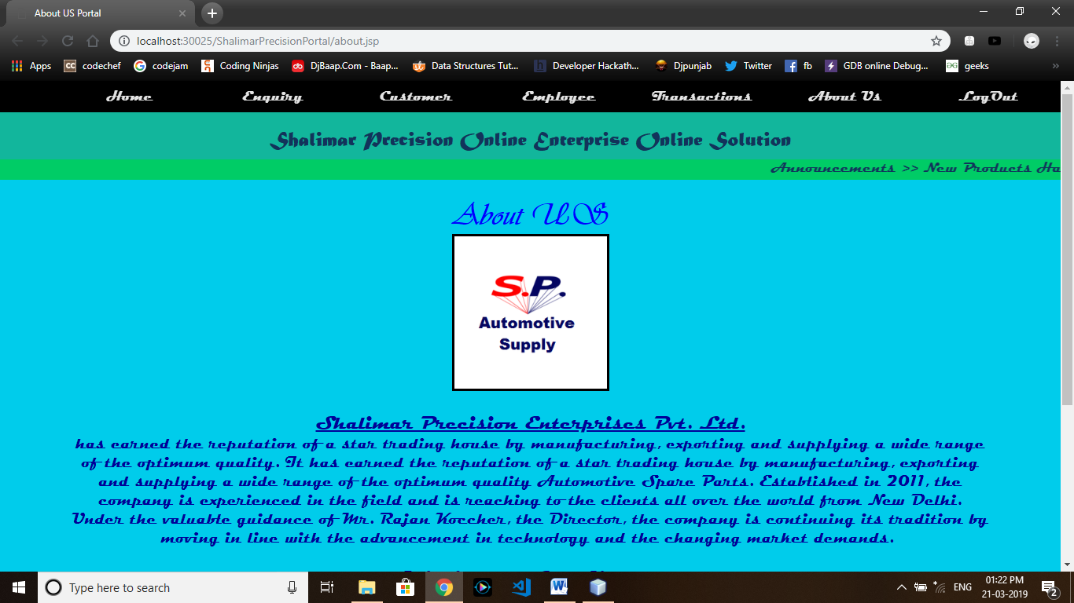

<%@page contentType="text/html" pageEncoding="UTF-8"%>

<!DOCTYPE html>

<html>

<head>

<meta http-equiv="Content-Type" content="text/html; charset=UTF-8">

<title>About US Portal</title>

<link rel="stylesheet" type="text/css" href="remstyls.css">

</head>

<body bgcolor="#00cceb">

<div class="navbar">

<ul>

<li><a href="Welcome.jsp">Home</a></li>

<li><a href="Enquiry.jsp">Enquiry</></li>

<li><a href="Customer.jsp">Customer</a></li>

<li><a href="Employee.jsp">Employee</a></li>

<li><a href="#">Transactions</a>

<ul>

<li><a href="Inventory.jsp">Inventory</a></li>

<li><a href="Sales.jsp">Sales</a></li>

<li><a href="Promotion.jsp">Promotion</a></li>

<li><a href="Payment.jsp">Payment</a></li>

</ul>

</li>

<li><a href="about.jsp">About Us</a></li>

<li><a href="login.jsp">LogOut</a></li>

</ul>

</div>

<div class="header">

<center><h2>Shalimar Precision Online Enterprise Online Solution</h2></center>

</div>

<div style="background-color:#00cc66;clear:both;text-align:center">

<marquee><b><font color="#12335b">Announcements >> New Products Has Been

Added to Our Portal Regularly.Please Be Updated........</font></b></marquee>

</div><br/>

<div class="subhd">

<center><h2>About US</h2></center>

</div>

<div class="imagesR">

<center><img src="images/Logo.jpg" height="200px" width="200px" border="3"></center>

</div>

<br/>

<div class="introd">

<p><big><u>Shalimar Precision Enterprises Pvt. Ltd.</u></big><br/> has earned the reputation of a star trading house by manufacturing, exporting and supplying a wide range of the optimum quality. It has earned the reputation of a star trading house by manufacturing, exporting and supplying a wide range of the optimum quality Automotive Spare Parts.

Established in 2011, the company is experienced in the field and is reaching to the clients all over the world from New Delhi. Under the valuable guidance of Mr. Rajan Koccher, the Director, the company is continuing its tradition by moving in line with the advancement in technology and the changing market demands. <br/><br/>

<big><u>Mission and Core Values</u></big><br/>

Owing to the teamwork and proper training and motivation of our employees, we offer value solution to the auto need of our clients. Every employee works with the policy of offering complete satisfaction to the clients by making available quality products on a consistent basis. Reasonable pricing & timely delivery further adds to the delight of the clients, and our motto is "Quality at<br/><br/>

<big><u>Quality</u></big><br/>

We follow a strict quality inspection methodology. Our in-house testing facility ensures complete testing of the Automotive Spare parts for quality. Our products pass through multiplerounds of testing before finally reaching the client’s end. Modern measuring instruments, computerized testing facility, steel testing and heat treatment facility ensures perfection in terms of quality.

</p>

</div>

<br/>

<div class="foot">

<h2>This Project Has Been Developed By Mr. Jatin Kumar "Kamboj" and Copyright © 2011 <a href="#">Shalimar Precision EnterPrise Online Solution</a></h2>

</div>

</body>

</html>

***Web.xml***

<?xml version="1.0" encoding="UTF-8"?>

<web-app version="3.1" xmlns="http://xmlns.jcp.org/xml/ns/javaee" xmlns:xsi="http://www.w3.org/2001/XMLSchema-instance" xsi:schemaLocation="http://xmlns.jcp.org/xml/ns/javaee http://xmlns.jcp.org/xml/ns/javaee/web-app_3_1.xsd">

<servlet>

<servlet-name>RegistrationOperation</servlet-name>

<servlet-class>RegistrationOperation</servlet-class>

</servlet>

<servlet-mapping>

<servlet-name>RegistrationOperation</servlet-name>

<url-pattern>/ureg</url-pattern>

</servlet-mapping>

<servlet>

<servlet-name>loginOperation</servlet-name>

<servlet-class>loginOperation</servlet-class>

</servlet>

<servlet-mapping>

<servlet-name>loginOperation</servlet-name>

<url-pattern>/Wel</url-pattern>

</servlet-mapping>

<servlet>

<servlet-name>CustomerOperation</servlet-name>

<servlet-class>CustomerOperation</servlet-class>

</servlet>

<servlet-mapping>

<servlet-name>CustomerOperation</servlet-name>

<url-pattern>/cstmr</url-pattern>

</servlet-mapping>

<servlet>

<servlet-name>EmployeeOperation</servlet-name>

<servlet-class>EmployeeOperation</servlet-class>

</servlet>

<servlet-mapping>

<servlet-name>EmployeeOperation</servlet-name>

<url-pattern>/empm</url-pattern>

</servlet-mapping>

<servlet>

<servlet-name>EnquiryOperation</servlet-name>

<servlet-class>EnquiryOperation</servlet-class>

</servlet>

<servlet-mapping>

<servlet-name>EnquiryOperation</servlet-name>

<url-pattern>/enqry</url-pattern>

</servlet-mapping>

<servlet>

<servlet-name>ProductOperation</servlet-name>

<servlet-class>ProductOperation</servlet-class>

</servlet>

<servlet-mapping>

<servlet-name>ProductOperation</servlet-name>

<url-pattern>/invntry</url-pattern>

</servlet-mapping>

<servlet>

<servlet-name>PaymentOperation</servlet-name>

<servlet-class>PaymentOperation</servlet-class>

</servlet>

<servlet-mapping>

<servlet-name>PaymentOperation</servlet-name>

<url-pattern>/pymnt</url-pattern>

</servlet-mapping>

<servlet>

<servlet-name>PromotionOperation</servlet-name>

<servlet-class>PromotionOperation</servlet-class>

</servlet>

<servlet-mapping>

<servlet-name>PromotionOperation</servlet-name>

<url-pattern>/prmtn</url-pattern>

</servlet-mapping>

<servlet>

<servlet-name>SalesOperation</servlet-name>

<servlet-class>SalesOperation</servlet-class>

</servlet>

<servlet-mapping>

<servlet-name>SalesOperation</servlet-name>

<url-pattern>/saless</url-pattern>

</servlet-mapping>

</web-app>

***Lgnstyls.css***

/*login Styles*/

body {

margin: 0px;

padding: 0px;

font-family: sans-serif;

/* background-color: rgba(.9,.2,.3,.8);*/

background: url('images/Futures.jpg') no-repeat;

bakground-size: cover;

}

.header {

padding-top: -20px;

/* background-color: #5c79d2;*/

}

.header h1 {

padding-top: 0px;

font-family: Matura MT Script Cpitals;

font-size: 35px;

color: #002451;

}

.box {

position: absolute;

top: 50%;

left: 50%;

transform: translate(-50%,-50%);

width: 400px;

padding: 40px;

background: rgba(0,0,0,.8);

box-sizing: border-box;

box-shadow: 0 15px 25px rgba(0,0,0,.5);

border-radius: 10px;

}

.box h3{

font-family: magneto;

font-size: 18px;

color: #c3cb95;

}

.box h2{

margin: 0 0 30px;

padding: 0;

color: #fab345;

text-align: center;

}

.box .inputbox{

position: relative;

}

.box .inputbox input{

width: 100%;

padding: 10px 0;

font-size: 16px;

color: #adc37b;

letter-spacing: 1px;

margin-bottom: 30px;

border: none;

border-bottom: 1px solid #fff;

outline: none;

background: transparent;

}

.box .inputbox label{

position: absolute;

top: 0;

letter-spacing: 1px;

left: 0;

padding: 10px 0;

font-size: 16px;

color: #fff;

pointer-events: none;

transition: .5s;

}

.box .inputbox input:valid ~ label,

.box .inputbox input:focus ~ label{

top: -18px;

left: 0;

color: #03a9f4;

font-size: 12px;

}

.box input[type="submit"],

.box input[type="button"]{

background: transparent;

border: none;

outline: none;

color: #fff;

background: #03a9f4;

padding: 10px 20px;

cursor: pointer;

border-radius: 20px;

}

.box input[type="submit"]:hover,

.box input[type="button"]:hover{

background: #efe4d0;

color: #262626;

}

.box a{

font-weight: bold;

color: #fff;

font-size: 16px;

text-align: center;

}

.bck{

padding-top: 0px;

width: 100%;

height: 30px;

/* background-color: #adc37b;*/

}

.bck h3 {

font-family: sans-serif;

font-size: 18px;

color: #66030e;

}

/*footer*/

.foot{

background-color: #99ccff;

padding-bottom: 0px;

width: 100%;

clear: both;

text-align: center;

height: 20px;

}

.foot h2{

font-family: Baskerville Old Face;

font-size: 15px;

color: #000066;

padding-bottom: 0px;

}

***Regis.css***

/*Registration Details*/

*{

margin: 0px;

padding: 0px;

box-sizing: border-box;

}

.header1{

width: 100%;

height: 100px;

background-color: #12b69c;

padding-top: 0px;

}

.header1 h2{

padding-top: 30px;

color: #12335b;

font-family: Matura MT Script Capitals;

font-size: 34px;

}

.subhd h2{

color: blue;

font-family: Vivaldi;

font-size: 40px;

padding-top: 10px;

font-weight: bold;

}

#images{

display: inline-block;

float: left;

padding-left: 20px;

}

/*footer*/

.foot{

background-color: #7fd73c;

padding-bottom: 0px;

width: 100%;

clear: both;

text-align: center;

height: 20px;

}

.foot h2{

font-family: Baskerville Old Face;

font-size: 15px;

color: #000066;

padding-bottom: 0px;

}

/*forms*/

.dtls input[type="button"],

.dtls input[type="submit"],

.dtls input[type="reset"]{

background-color: #33ccff;

font-family: Constantia;

color: #002451;

font-weight: bold;

cursor: pointer;

border-radius: 20px;

outline: none;

border: none;

padding: 10px 20px;

cursor: pointer;

}

.dtls select{

background-color: #78c84e;

font-family: cursive;

font-style: italic;

border: #000251 dashed 2px;

font-size: 15px;

}

.dtls input[type="text"]{

border: none;

border-bottom: solid Blue 2px;

background-color: #00cc66;

border-radius: 2px;

position: relative;

font-size: 15px;

}

.dtls input[type="password"]{

border: none;

border-bottom: solid Blue 2px;

background-color: #00cc66;

border-radius: 2px;

position: relative;

font-size: 15px;

}

.dtls input[type="button"]:hover,

.dtls input[type="submit"]:hover,

.dtls input[type="reset"]:hover{

background: #efe4d0;

color: #262626;

}

***Remstyls.css***

/*menu-styles*/

*{

margin: 0px;

padding: 0px;

box-sizing: border-box;

}

ul li a{

text-decoration: none;

color: white;

display: block;

}

ul li a:hover{

background-color: green;

color: black;

}

ul li ul li{

display: none;

}

ul li:hover ul li{

display: block;

color: black;

}

.navbar ul li ul{

display: none;

}

.navbar ul li:hover > ul{

display: block;

}

.navbar ul li ul li{

position: relative;

}

.navbar ul li:hover{

background-color: green;

opacity: 0.9;

}

.navbar ul li ul li{

position: relative;

}

.navbar ul li ul li ul{

position: absolute;

left: 200px;

top: 0px;

}

.navbar{

width: 100%;

background-color: black;

display: flex;

justify-content: flex-end;

position: fixed;

top: 0px;

}

.navbar a{

text-align: center;

font-weight: bold;

padding-top: 20px 28px;

}

ul{

list-style: none;

margin: 0px;

padding: 0px;

}

ul li{

float: left;

width: 180px;

height: 40px;

background-color: black;

opacity: 0.9;

line-height: 40px;

text-align: center;

font-size: 18px;

margin-right: 2px;

}

ul li a{

text-decoration: none;

color: white;

display: block;

}

ul li a:hover{

background-color: green;

color: black;

}

ul li ul li{

display: none;

}

ul li:hover ul li{

display: block;

color: black;

}

.navbar ul li ul{

display: none;

}

.navbar ul li:hover > ul{

display: block;

}

.navbar ul li ul li{

position: relative;

}

.navbar ul li:hover{

background-color: green;

opacity: 0.9;

}

.navbar ul li ul li{

position: relative;

}

.navbar ul li ul li ul{

position: absolute;

left: 200px;

top: 0px;

}

body{

background-size: cover;

font-family: Magneto;

margin: 0px;

padding: 0px;

box-sizing: border-box;

}

/*Heading*/

.header{

width: 100%;

height: 100px;

background-color: #12b69c;

}

.header h2{

padding-top: 60px;

color: #12335b;

font-family: Matura MT Script Capitals;

font-size: 26px;

}

/*sub-heading*/

.subhd h2{

color: blue;

font-family: Vivaldi;

font-size: 40px;

font-weight: bold;

}

/*Buttons*/

.dtls input[type="submit"],

.dtls input[type="reset"]{

background-color: #33ccff;

font-family: Constantia;

color: #002451;

font-weight: bold;

cursor: pointer;

border-radius: 20px;

outline: none;

border: none;

padding: 10px 20px;

cursor: pointer;

}

.dtls input[type="text"]{

border: none;

border-bottom: solid Blue 3px;

border-right: solid Blue 3px;

background-color: #00cc66;

border-radius: 5px;

position: relative;

font-size: 18px;

font-family: sans-serif;

color: #66030e;

width: 18%;

}

.dtls input[type="submit"]:hover,

.dtls input[type="reset"]:hover{

background: #efe4d0;

color: #262626;

}

/*Images*/

#images{

display: inline-block;

float: left;

padding-left: 20px;

}

#imagesR{

display: inline-block;

float: right;

padding-right: 20px;

}

/*Form's'*/

.dtls{

color: #b55834;

}

.dtls h3{

color: #000251;

font-family: Algerian;

}

/*AboutUS*/

.introd{

padding-left: 40px;

padding-right: 40px;

}

.introd p{

color: #000099;

font-family: Magneto;

font-size: 20px;

padding-left: 50px;

padding-right: 50px;

text-align: center;

}

/*footer*/

.foot{

background-color: #7fd73c;

padding-bottom: 0px;

width: 100%;

clear: both;

text-align: center;

height: 20px;

}

.foot h2{

font-family: Baskerville Old Face;

font-size: 15px;

color: #000066;

padding-bottom: 0px;

}

/*Home Slider*/

.Slider fieldset {

border: 2px ridge red;

height: 300px;

border-radius: 10px;

color: #660000;

width: 1000px;

background-color: slategray;

}

.Slider legend {

border: 2px groove #000251;

width: 140px;

height: 25px;

background-color: lightcoral;

font-family: Constantia;

font-weight: bolder;

border-radius: 10px;

color: #990000;

}