Act as Azure Copilot expert with Architect AI Solutions for Business Productivity
Architect AI solutions for business productivity
Generative AIData analyticsData managementData engineeringData integration
Discover how to design and implement AI-powered business solutions using agents, generative AI, and Microsoft Copilot. Gain the skills to analyze requirements and create innovative solutions that enhance productivity and efficiency.
Prerequisites
• Basic understanding of AI concepts
• Familiarity with business process analysis
• Knowledge of Microsoft tools and platforms
All module assessments passed
Introduction to agentic AI business solutions
align AI solutions with business goals and scale AI adoption using Microsoft technologies.
Analyze requirements for AI-powered business solutions
analyze, design, and implement AI-powered business solutions using agents, generative AI, and Microsoft Copilot for productivity.
Design overall AI strategy for business solutions
design an enterprise AI strategy using Azure's Cloud Adoption Framework, aligning AI agent lifecycle with business goals for operational excellence.
Evaluate costs and benefits of AI solutions
assess costs, benefits, and ROI of AI solutions while deciding whether to build, buy, or extend AI components for business processes.
Design AI agents for business solutions
design AI agents tailored to business needs using Dynamics 365 and Copilot.
Design extensibility of AI solutions
design scalable, secure, and customizable AI solutions using Microsoft platforms.
Orchestrate configuration of prebuilt agents and apps
orchestrate, configure, and extend AI-driven experiences in Dynamics 365 and Microsoft 365 Copilot.
Monitor, analyze, and tune AI agents
ensure AI agents operate reliably, deliver high-quality outcomes, and continuously improve in enterprise environments.
Manage testing AI-powered business solutions
validate and maintain AI-powered business solutions with structured testing frameworks, metrics, and governance.
Design ALM process for AI-powered business solutions
design ALM processes for AI solutions, ensuring governance, security, and consistency across environments.
Design responsible AI security, governance, risk management, and compliance
design secure, governed, and compliant AI systems that align with organizational policies and Responsible AI principles.

Could you please provide the expected answers of the below questions.
Below Questions:
- A company has a Microsoft Power Platform environment that contains Microsoft Dataverse data.
You create a Microsoft Copilot Studio agent named Agent1 that processes the Dataverse data.
You discover that Agent1 fails to return relevant or accurate results.
You need to improve the quality and reliability of data grounding.
What should you do?
A. Retrain Agent1.
B. Verify and cleanse the Dataverse data.
C. Use an adaptive card in Agent1.
D. Add example user inputs to the training data of Agent1.
Expected Result:

- A company has two Microsoft Power Platform environments named Dev1 and Prod1. A Microsoft Copilot Studio agent named Agent1 is built into a solution in the Dev1 environment.
You plan to deploy Agent1 to Prod1.
You need to make Agent1 available to the users in Prod1. The solution must minimize administrative effort.
What should you do?
A. Share Agent1 with the users in Prod1.
B. Export the solution as an unmanaged solution and import the solution into Prod1.
C. Export the solution as a managed solution and import the solution into Prod1.
D. Create a new Copilot Studio agent in Prod1 by replicating the configuration of Agent1.

Expected Result:

- HOTSPOT
You are designing a testing solution for Microsoft Copilot Studio agents.
You need to validate prompt engineering best practices to ensure that the agents generate accurate and contextually relevant responses.
Which prompt validation techniques and metrics should you include in the solution? To answer, select the appropriate options in the answer area.
NOTE: Each correct selection is worth one point.
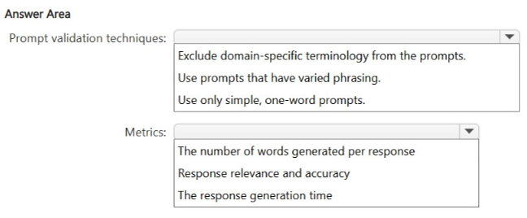
Expected Result:

- HOTSPOT
-
A company has a Microsoft Copilot Studio agent for customer support.
You are reviewing and validating the following prompts:
•A prompt that has instructions to "help the customer as best you can"
•A prompt that helps retrieve product information from a knowledge base
You need to ensure that the agent delivers consistent and accurate responses.
What should you do for each prompt? To answer, select the appropriate options in the answer area.
NOTE: Each correct selection is worth one point.
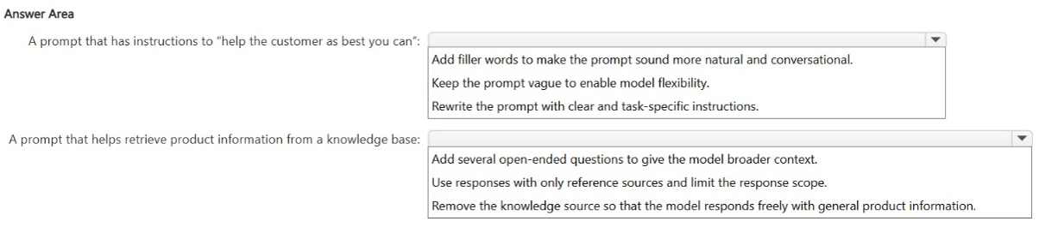
Expected Result:

- A company has a Microsoft 365 tenant in Canada and multiple Microsoft Power Platform environments in Canada and the United States.
The company plans to deploy a Microsoft Copilot Studio agent to the Canadian environment that will use:
•Microsoft Dataverse data stored in Canada
•A connector that connects to an Azure OpenAI instance in the United States
You need to ensure that the agent adheres to data residency and data movement policies before being deployed.
What should you do?
A. Ensure that the data processed by Azure OpenAI is stored in the United States.
B. From the Microsoft Purview portal, validate the Data loss prevention settings.
C. Migrate the tenant to the United States.
D. Ensure that cross-region data movement is enabled for the Canadian environment and connector dependencies.

Expected Result:

- DRAG DROP
-
You are designing end-to-end test scenarios for a business solution that uses Microsoft Dynamics 365 Sales and Dynamics 365 Finance.
You need to ensure that the business solution meets the following test requirements:
•Properly exchanges data between the Dynamics 365 apps
•Aligns with defined user workflows and business processes
Which type of testing should you use for each requirement? To answer, drag the appropriate testing types to the correct requirements. Each testing type may be used once, more than once, or not at all. You may need to drag the split bar between panes or scroll to view content.
NOTE: Each correct selection is worth one point.
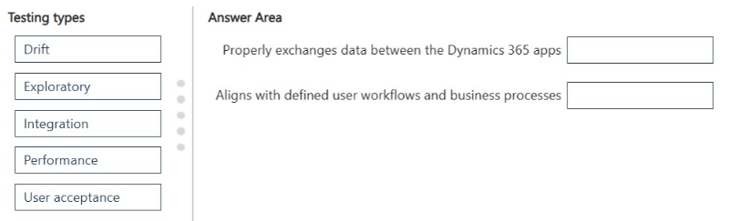
Expected Result:
7.A company plans to deploy an AI-based customer service app that will autonomously manage interactions, escalate complex cases, and learn from historical ticket data.
You need to perform a return on AI investment (ROAI) analysis of the app deployment. The solution must ensure that the analysis is accurate.
What should you do first?
A. Establish the AI performance metrics.
B. Conduct an AI market benchmarking study.
C. Model the customer experience.
D. Identify and quantify all the development, deployment, and operating costs.

Expected Result:

8. You need to recommend a Microsoft Power Platform business solution that consolidates data from multiple internal and external data sources. The solution must meet the following requirements:
Provide the data as a centralized source for multiple AI systems, including Microsoft Copilot Studio agents, Dynamics 365 applications, and external AI models.
Support built-in data classification and protection policies.
Provide data for grounding and analytics.
What should you include in the recommendation?
A. Microsoft Dataverse
B. Azure Data Lake Storage
C. a Microsoft Power BI semantic model
D. Azure Cosmos DB
Expected Result:

9. A company has a portfolio of AI initiatives at different stages of development.
You need to recommend a structured approach to evaluating the return on AI investment (ROAI) across all the initiatives. The solution must balance immediate results with long-term values and strategic innovations.
What should you include in the recommendation?
A. a simple cost and benefit analysis
B. a horizon-based framework
C. the internal rate of return (IRR) function
D. a prioritization grid

Expected Result:

10. A retail company plans to deploy Microsoft Copilot Studio agents to support:
Microsoft Dynamics 365 Commerce scenarios.
A Microsoft Power Apps inventory management solution.
You need to recommend a solution to organize product catalog data as a consistent source for multiple AI systems.
What should you recommend?
A. Let each agent scrape product details from Microsoft SharePoint Online libraries.
B. Store the product catalog data in a separate custom table for each agent.
C. Configure prompts to pull product details from the PDFs of external vendors.
D. Centralize the product catalog data in Microsoft Dataverse and expose the data to both agents.
Expected Result:

11. A company plans to deploy a Microsoft Copilot Studio agent that will analyze historical business data to predict customer behavior.
The data is currently stored in an Azure SQL database, flat files, APIs, and logs.
You need to organize the data into a format that can be used as a knowledge source in Copilot Studio.
What should you include in the solution?
A. Azure AI Search
B. Azure Data Lake Storage
C. Azure Cosmos DB
D. Azure Translator in Foundry Tools

Expected Result:

12. A financial services company uses Microsoft Dynamics 365 Finance.
Currently, the company's support staff manually reviews customer transaction histories to detect potential fraud cases before escalating the cases.
You need to recommend an automation solution for the review process. The solution must ensure that escalations reach a human analyst for final decision making. What should you recommend?
A. Deploy an autonomous agent that closes non-fraud cases automatically.
B. Use Microsoft 365 Copilot in Word to automatically finalize fraud detection policies.
C. Configure a task agent to generate fraud risk scores for the human analyst to review.
D. Export the data to a data lake for analysis in Microsoft Power BI.

Expected Result:

13. DRAG DROP -
A company has a Microsoft Foundry project that uses a single agent and a single prompt to complete a series of tasks.
The agent encounters the following issues:
It frequently produces incomplete results.
It struggles with domain-specific reasoning.
Agent response times are remarkably slow.
You need to recommend a solution to improve the overall performance and accuracy of the agent.
What should you include in the recommendation? To answer, drag the appropriate actions to the correct requirements. Each action may be used once, more than once, or not at all. You may need to drag the split bar between panes or scroll to view content.
NOTE: Each correct selection is worth one point.
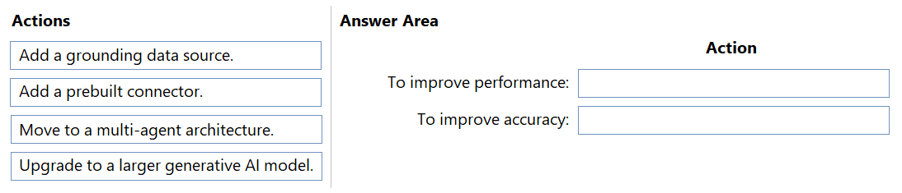
Expected Result:

14. HOTSPOT -
You need to design a shared prompt library that will be used across multiple business units. The solution must meet the following requirements:
Ensure consistent AI responses with reusable formats.
Support governance and version control.
Minimize administrative effort.
Minimize ongoing costs.
What should you recommend for each requirement? To answer, select the appropriate options in the answer area.
NOTE: Each correct selection is worth one point.
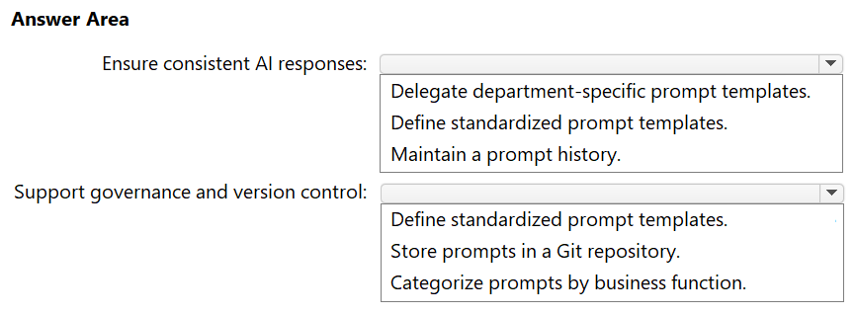
Expected Result:

15. A company has an AI business solution.
You need to extend the solution so that Microsoft 365 Copilot can invoke external logic hosted in Azure services.
What should you include in the solution?
A. Microsoft Copilot Studio skills
B. Microsoft Power Platform connectors
C. custom engine agents

Expected Result:

16. A company uses Microsoft Dynamics 365 finance and operations apps.
The company plans to use Microsoft Copilot in-app help and guidance to generate responses for internal business processes.
You need to add an additional knowledge source for the business processes. The solution must NOT add new topics to the Copilot agent for the finance and operations apps.
Which knowledge source should you add?
A. Microsoft Dataverse
B. a public website
C. Azure AI Search
D. a file upload
Expected Result:

17. DRAG DROP -
You are designing two Microsoft Copilot Studio agents named Agent1 and Agent2. Each agent must meet the following requirements:
Each agent must use a standard model.
Each agent must NOT use generative orchestration.
Agent1 must support simple and short phrases for a given topic.
Agent2 must integrate with Microsoft Dynamics 365 Contact Center voice channel.
You need to recommend language models for the agents.
What should you recommend for each agent? To answer, drag the appropriate language models to the correct agents. Each language model may be used once, more than once, or not at all. You may need to drag the split bar between panes or scroll to view content.
NOTE: Each correct selection is worth one point.
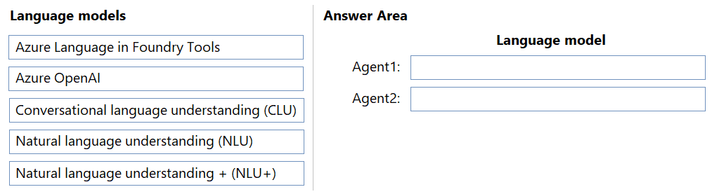

Expected Result:

18. A company uses Microsoft Dynamics 365 Sales to manage leads that are stored in a Microsoft Dataverse table named Lead and use non-standard terminology and custom columns.
You need to configure business terms in the Lead table so that Microsoft Copilot controls can summarize the leads efficiently. The solution must minimize administrative effort.
How should you configure the business terms?
A. Combine all the fields into one custom field.
B. Map the field display names as business terms.
C. Add the schema names as business terms.
D. Create new business terms for each field.
19. Case study -
Any sensitive information, such as user IDs and names, shared via the AI agent must be tracked for future auditing.
Which framework should you use for the infrastructure migration?
A. Microsoft Cloud Adoption Framework for Azure
B. Success by Design
C. Microsoft Power Platform Center of Excellence (CoE)
D. Microsoft Power Platform Project Setup Wizard

Expected Result:
  - Microsoft Cloud Adoption Framework for Azure

20. Case study -
Any sensitive information, such as user IDs and names, shared via the AI agent must be tracked for future auditing.
Which framework should you use to meet the AI agent requirements for the sales cycle enablement? To answer, select the appropriate options in the answer area.
NOTE: Each correct selection is worth one point.
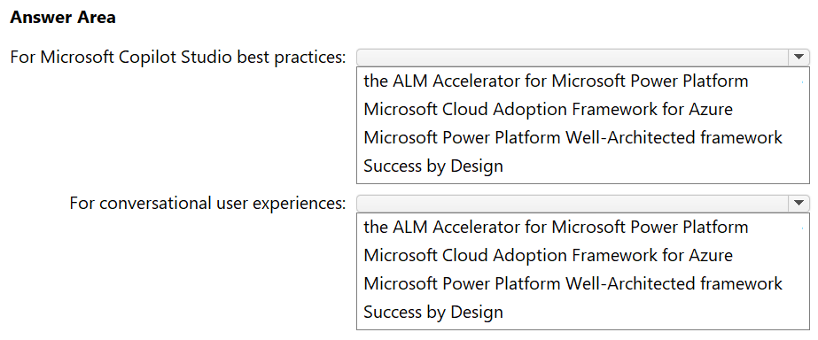

Expected Result:
For Microsoft Copilot studio best practices: the ALM Accelerator for Microsoft Power Platform.
For conversational user experiences: Microsoft Power Platform Well-Architected framework.
- Provide the 10 HOTSPOT
- Provide the 10 Case study
- Provide the 10 dropdown
- Provide the 10 generics
- Provide the yes and No Questions and expected answers with reason.

Here are the expected answers to your 20 questions, followed by 50 additional practice questions (10 each of HOTSPOT, Case Study, Dropdown, Generic, and Yes/No) covering the same "Architect AI Solutions for Business Productivity" domains.
Answers to your 20 questions
1. B — Verify and cleanse the Dataverse data. Poor grounding results usually trace back to poor source data quality, not agent retraining or UI elements.
2. C — Export as a managed solution and import into Prod1. Managed solutions are the standard, low-effort way to promote Copilot Studio/Power Platform components across environments (Dev → Prod).
3. HOTSPOT
- Prompt validation techniques: Use prompts that have varied phrasing.
- Metrics: Response relevance and accuracy.
4. HOTSPOT
- "Help the customer as best you can" → Rewrite the prompt with specific, clear instructions.
- Retrieve product info from knowledge base → Add several open-ended variations of the question to validate retrieval.
5. D — Ensure cross-region data movement is enabled for the Canadian environment and connector dependencies. Data resides in Canada; the OpenAI connector call to the US requires cross-region movement to be explicitly permitted under residency policy — you don't move the tenant or force OpenAI storage to the US.
6. DRAG DROP
- Properly exchanges data between the Dynamics 365 apps → Integration testing
- Aligns with defined user workflows and business processes → User acceptance testing
7. D — Identify and quantify all the development, deployment, and operating costs. You must establish the cost baseline before ROAI can be calculated accurately.
8. A — Microsoft Dataverse. Dataverse provides a governed, centralized data store with built-in classification/protection and serves multiple consumers (Copilot Studio, Dynamics 365, external AI via connectors).
9. B — A horizon-based framework (e.g., McKinsey's Three Horizons). Balances near-term returns against long-term/strategic value across a portfolio.
10. D — Centralize the product catalog data in Microsoft Dataverse and expose it to both agents. Avoids duplication/inconsistency from per-agent scraping or custom tables.
11. A — Azure AI Search. Indexes heterogeneous sources (SQL, files, APIs, logs) into a searchable knowledge index usable by Copilot Studio.
12. C — Configure a task agent to generate fraud risk scores for the human analyst to review. Keeps a human in the loop for final decisions, unlike an autonomous closing agent.
13. DRAG DROP
- To improve performance: Move to a multi-agent architecture (splits the single overloaded agent/prompt, reducing latency).
- To improve accuracy: Add a grounding data source and Upgrade to a larger generative AI model (addresses incomplete results and weak domain-specific reasoning).
14. HOTSPOT
- Ensure consistent AI responses: Define standardized prompt templates.
- Support governance and version control: Store prompts in a Git repository.
- (Minimize administrative effort / minimize ongoing costs rows were cut off in your PDF — typically these map to reusing existing templates rather than building custom tooling, and using built-in/free governance features rather than paid add-ons.)
15. A — Microsoft Copilot Studio skills. Skills are the mechanism for extending Microsoft 365 Copilot to call external/Azure-hosted logic.
16. D — A file upload. Adding a file-based knowledge source lets Copilot answer from internal process documents without creating new topics in the F&O Copilot.
17. DRAG DROP
- Agent1 (simple/short phrases, standard model, no generative orchestration) → Natural language understanding (NLU)
- Agent2 (Dynamics 365 Contact Center voice channel) → Natural language understanding + (NLU+) (NLU+ is required for voice/telephony channel support.)
18. B — Map the field display names as business terms. Lowest-effort way to align non-standard schema names with meaningful terms Copilot can use for summarization.
19. A — Microsoft Cloud Adoption Framework for Azure.
20.
- Copilot Studio best practices → The ALM Accelerator for Microsoft Power Platform
- Conversational user experiences → Microsoft Power Platform Well-Architected Framework
Now let me build the 50 additional practice questions as a downloadable study document.One flag: a few of your original questions (3, 4, 6, 13, 14, 17) had dropdown/drag-drop option lists that were cropped in the PDF screenshots, so I answered them based on the visible options and standard Microsoft guidance rather than guaranteed exact wording — if you can share the full option lists for those, I can tighten those specific answers.
Architect AI Solutions for Business Productivity — Extended Practice Bank
Covers: Generative AI, Copilot Studio, Dynamics 365 Copilot, Power Platform, ALM, Responsible AI, ROAI, Data Governance

SECTION 1 — 10 HOTSPOT Questions
H1. You are configuring grounding for a Copilot Studio agent. You need to select the correct action for each scenario.
- Agent returns outdated pricing data → Refresh/re-sync the knowledge source
- Agent returns answers outside the approved topic scope → Restrict the agent to specific knowledge sources/topics
Reasoning: Stale data needs a refresh; scope creep needs source/topic restriction, not retraining the base model.
H2. You are designing agent governance controls.
- Prevent agents from accessing sensitive Dataverse tables → Apply column-level/table-level security roles
- Track who published changes to an agent → Enable solution history/audit logging
Reasoning: Security roles control data access; audit logs provide traceability of changes.
H3. You are choosing orchestration types for two agents.
- Agent needs deterministic, rule-based conversation flow → Classic (topic-based) orchestration
- Agent needs to dynamically reason across multiple actions/tools → Generative orchestration
H4. You are validating a RAG (retrieval-augmented generation) knowledge source.
- Ensure retrieved chunks are relevant → Test with varied real-world queries and review relevance scores
- Ensure answers stay grounded (no hallucination) → Enable/require citations and restrict to knowledge-source-only answers
H5. You are designing a multi-environment ALM strategy.
- Isolate in-development agent changes → Use a Dev environment with unmanaged solutions
- Promote tested changes safely → Use Test/Prod environments with managed solutions via pipelines
H6. You are selecting a testing type for each requirement.
- Confirm the agent still works after a model/config update → Regression testing
- Confirm response quality degradation over time → Drift testing
H7. You are designing Responsible AI controls.
- Prevent agents from generating harmful/off-brand content → Configure content moderation and topic boundaries
- Ensure explainability of AI-driven decisions → Enable transparency notes / document model behavior
H8. You are choosing a scaling approach for AI adoption.
- Standardize reusable components across teams → Center of Excellence (CoE) starter kit
- Track solution health and usage at scale → CoE Governance and telemetry dashboards
H9. You are selecting cost-optimization actions.
- Reduce token usage for high-volume simple queries → Use a smaller/standard language model
- Reduce latency for complex reasoning tasks → Use a larger model only where needed (selective routing)
H10. You are validating an agent prior to go-live.
- Confirm functional accuracy → User acceptance testing (UAT)
- Confirm the agent performs under expected load → Performance/load testing

SECTION 2 — 10 Case Study Questions
(Case study scenario: A financial services company is deploying Copilot Studio agents across sales, support, and finance. Sensitive customer data (IDs, names) must be tracked for auditing. The company wants to scale responsibly while minimizing admin overhead.)
C1. Which framework should govern the overall AI adoption strategy?
Answer: A. Microsoft Cloud Adoption Framework for Azure — provides enterprise-wide strategy, governance, and landing zone guidance.
C2. Which tool should be used to track agent usage and health across the organization?
Answer: Microsoft Power Platform Center of Excellence (CoE) Starter Kit — gives centralized visibility and governance.
C3. Which approach ensures sensitive data shared via agents is auditable?
Answer: Enable Microsoft Purview auditing / DLP policies on the environment.
C4. Which solution type should be used to promote the finance agent from Dev to Prod with minimal effort?
Answer: Managed solution via a deployment pipeline.
C5. Which testing approach validates that the sales and finance agents don't return conflicting information from shared data?
Answer: Integration testing.
C6. Which knowledge source strategy avoids duplicated/inconsistent product or policy data across agents?
Answer: Centralize in Microsoft Dataverse and reference it from each agent.
C7. Which framework guides conversational design quality (tone, clarity, escalation paths)?
Answer: Microsoft Power Platform Well-Architected Framework (or Success by Design, depending on phase).
C8. Which mechanism should escalate high-risk fraud cases to a human instead of auto-closing them?
Answer: A task/approval agent that routes high-risk scores to a human analyst.
C9. Which control minimizes the risk of the agent going out of approved topic scope?
Answer: Restrict orchestration to approved topics/actions and disable open-ended generative fallback where not needed.
C10. Which approach should be used to evaluate ROI as the company scales from pilot to enterprise-wide deployment?
Answer: A horizon-based framework, balancing quick wins with long-term strategic value.

SECTION 3 — 10 Dropdown Questions
D1. To minimize hallucination in a customer-facing agent, you should restrict responses to ▢▢▢
. Answer: only the configured knowledge sources (grounded answers only).
D2. To reduce agent response latency for simple FAQ-style queries, you should use ▢▢▢.
Answer: a smaller/standard language model instead of a larger generative model.
D3. To promote an agent solution with the least administrative effort, you should export it as a(n) ▢▢▢.
Answer: managed solution.
D4. To validate that prompts behave consistently under different phrasing, you should use ▢▢▢.
Answer: varied-phrasing test prompts (prompt validation testing).
D5. To centralize product/customer data for multiple AI systems with built-in classification, you should use ▢▢▢.
Answer: Microsoft Dataverse.
D6. To index unstructured and semi-structured data (files, logs, APIs) as a Copilot Studio knowledge source, you should use ▢▢▢.
Answer: Azure AI Search.
D7. To ensure sensitive data shared by an agent is tracked for auditing, you should enable ▢▢▢.
Answer: Microsoft Purview auditing / data loss prevention (DLP) policies.
D8. To support voice-channel integration for an agent, the recommended language model is ▢▢▢.
Answer: Natural language understanding + (NLU+).
D9. To calculate ROAI accurately, the first step is to ▢▢▢.
Answer: identify and quantify all development, deployment, and operating costs.
D10. To keep a human in the loop for high-risk decisions, you should configure a(n) ▢▢▢.
Answer: task agent that generates recommendations/scores for human review, not autonomous action.

SECTION 4 — 10 Generic Multiple-Choice Questions
G1. What is the primary purpose of grounding in a generative AI agent?
A. Reduce hosting costs B. Anchor responses to verified, relevant data C. Improve UI design D. Simplify licensing Answer: B
G2. Which Power Platform component enforces row-level and column-level data security?
A. Power Automate B. Dataverse security roles C. Power BI workspace roles D. Copilot Studio topics Answer: B
G3. What is the main benefit of a managed solution over an unmanaged solution when deploying to production?
A. Easier to edit in place B. Prevents unintended customization and simplifies lifecycle management C. Cheaper licensing D. Faster agent responses Answer: B
G4. Which testing type is best suited to confirm an agent still behaves correctly after a model version upgrade?
A. Exploratory testing B. Regression testing C. Load testing D. Unit testing Answer: B
G5. Which factor most directly indicates whether to build, buy, or extend an AI component?
A. Marketing trends B. Cost-benefit and ROI analysis relative to existing capabilities C. Number of competitors D. Developer preference Answer: B
G6. What is a key Responsible AI consideration when deploying an autonomous agent that can take real-world actions?
A. Response speed B. Human oversight/escalation for high-impact decisions C. UI branding D. Number of supported languages Answer: B
G7. Which Microsoft framework is most relevant for designing a resilient, secure, and cost-optimized Power Platform architecture?
A. ITIL B. Microsoft Power Platform Well-Architected Framework C. TOGAF D. Zachman Framework Answer: B
G8. What should you do first when an agent gives inconsistent answers to differently phrased but equivalent questions?
A. Increase the model size B. Review and standardize the underlying prompt/topic instructions C. Disable the topic D. Add more connectors Answer: B
G9. Which component allows Microsoft 365 Copilot to call custom logic hosted in Azure?
A. Power BI dataflow B. Copilot Studio skills / plugins C. SharePoint list D. Dataverse view Answer: B
G10. What is the primary risk of using an unmanaged solution in a production environment?
A. Higher licensing cost B. Uncontrolled customization that can break the solution or complicate updates C. Slower agent responses D. Reduced data security Answer: B

SECTION 5 — 10 Yes/No Questions (with reasoning)
Y1. Does retraining an agent always fix poor grounding results?
No — grounding issues are usually caused by poor-quality or missing source data, not the model itself; cleansing/verifying the data source is the correct fix.
Y2. Should managed solutions be used when deploying a tested agent from Dev to Prod?
Yes — managed solutions minimize administrative effort and prevent unintended edits in production.
Y3. Is it acceptable for an autonomous fraud-detection agent to auto-close all non-fraud cases without human review?
No — Responsible AI and audit requirements typically require a human analyst to make the final decision, especially for financial risk cases.
Y4. Can Microsoft Dataverse serve as a centralized data source for multiple AI systems, including external AI models?
Yes — Dataverse supports built-in classification/protection and can expose data via connectors to Copilot Studio, Dynamics 365, and external AI systems.
Y5. Is a simple cost-and-benefit analysis sufficient to evaluate ROAI across a full portfolio of AI initiatives at different maturity stages?
No — a horizon-based framework is recommended to balance short-term returns with long-term/strategic value across a portfolio.
Y6. Should cross-region data movement be disabled by default when a Canadian environment connects to a US-based Azure OpenAI instance?
No (in context of the scenario) — it must be explicitly enabled for the required connector dependency to function, while still governed by residency policy.
Y7. Does adding a grounding data source generally improve an agent's domain-specific reasoning accuracy?
Yes — grounding provides authoritative reference data that reduces hallucination and improves domain accuracy.
Y8. Is it best practice to store shared prompt templates only in individual users' personal notes for a multi-business-unit prompt library?
No — best practice is centralized storage (e.g., a Git repository or managed template library) to support governance and version control.
Y9. Should Azure AI Search be used to make heterogeneous data (SQL, flat files, APIs, logs) usable as a Copilot Studio knowledge source?
Yes — Azure AI Search indexes and unifies heterogeneous data into a searchable format Copilot Studio can query.
Y10. Is the ALM Accelerator for Microsoft Power Platform the recommended tool specifically for designing conversational user experience quality?
No — the ALM Accelerator governs application lifecycle management (build/release pipelines); conversational UX quality is guided by the Power Platform Well-Architected Framework / Success by Design.

Note: Items in Section 3 of the original PDF (Q3, Q4, Q6, Q13, Q14, Q17) were partially cut off in the source screenshots (dropdown/drag-drop option lists extended beyond the visible page). Answers above reflect the most defensible choice based on visible options and standard Microsoft Copilot Studio / Power Platform guidance — if you can share the full, un-cropped option lists for those items, I can confirm or refine those specific answers.

Good catch — the second PDF gave the full option lists, which confirms nearly all of my earlier answers. One correction based on the now-visible full options:
Q4 (second prompt — retrieve product info from KB): The correct choice is "Use responses with only reference sources and limit the response scope" — not the open-ended-questions option I gave earlier. That option is a testing technique, but the question asks what to do to the prompt to ensure consistency/accuracy, and restricting responses to reference sources is the direct fix. (Everything else — Q3, Q6, Q14, Q17 — matches what I gave.)
Now building the additional question set on the topics you listed.This second set (37 questions) covers all the topic areas you listed — agentic AI architecture, Copilot/agents, Azure AI capabilities, governance/Responsible AI, process automation, adoption strategy, stakeholder engagement, risk/compliance, data strategy, and lifecycle management — plus scenario-based and multi-select questions in the exam style. It also includes the Q4 correction flagged above.

Architect AI Solutions for Business Productivity — Practice Bank Part 2
Covering: Agentic AI, AI transformation strategy, Microsoft AI ecosystem, Copilot & Agents, Azure AI, Governance/Security/Responsible AI, Process automation, Solution planning, Enterprise adoption, Stakeholder engagement, Implementation planning, Risk/compliance, Data strategy, AI-powered apps, Lifecycle management, Scenarios, Multi-select.
Correction to Part 1: Q4 (second prompt, "retrieve product info from a knowledge base") — the correct choice, now that full options are visible, is "Use responses with only reference sources and limit the response scope" (not the open-ended-questions option). This directly enforces grounded, consistent answers, whereas adding open-ended questions is a testing technique, not a fix.

1. Agentic AI Concepts and Architectures
1.1 What primarily distinguishes an "agentic" AI solution from a traditional single-turn generative AI prompt? A. It uses a larger language model B. It can autonomously plan, take multi-step actions, and use tools/data to complete a goal C. It only works within Microsoft 365 D. It requires no grounding data Answer: B — Agentic AI is defined by autonomous, goal-driven, multi-step reasoning and action-taking (often via tools/connectors), not just single-response generation.
1.2 In a multi-agent architecture, what is the role of an "orchestrator" agent? A. Generates the underlying language model B. Routes tasks to specialized sub-agents and coordinates their outputs C. Stores all Dataverse data D. Replaces the need for grounding Answer: B
1.3 (Multi-select) Which of the following are core components of an agentic AI architecture? (Choose all that apply) A. Planning/reasoning layer B. Tool/action invocation (connectors, APIs, skills) C. Memory/state management D. A fixed, non-configurable UI Answer: A, B, C — A fixed UI is not a defining architectural component of agentic systems.

2. AI Business Transformation Strategies
2.1 A company wants to move from isolated AI pilots to enterprise-wide adoption. What should be established first? A. A large marketing campaign B. A clear AI strategy aligned to business goals with executive sponsorship C. Purchasing the most powerful available model D. Disabling all pilot projects Answer: B
2.2 Which approach best supports scaling AI adoption while managing risk incrementally? A. Deploy all AI initiatives simultaneously across the company B. Use a phased rollout — pilot, validate, then scale with governance checkpoints C. Skip pilots and go straight to production D. Only use AI in one department indefinitely Answer: B

3. Microsoft AI Ecosystem and Services
3.1 Which Microsoft service is best suited for building low-code conversational AI agents grounded in enterprise data? A. Azure Machine Learning B. Microsoft Copilot Studio C. Azure Databricks D. Power BI Answer: B
3.2 Which Azure service provides foundation models and orchestration for building custom generative AI solutions with more code-level control than Copilot Studio? A. Power Automate B. Azure AI Foundry C. Dataverse D. Microsoft Purview Answer: B

4. Microsoft Copilot and AI Agents
4.1 What is the difference between a "declarative agent" and a "custom engine agent" in the Microsoft 365 Copilot ecosystem? A. There is no difference B. A declarative agent configures/extends the existing Copilot orchestrator and model; a custom engine agent brings its own orchestration and/or model C. Declarative agents cannot use knowledge sources D. Custom engine agents cannot be published to Teams Answer: B
4.2 Which Copilot Studio feature allows an agent to call an external Azure Function to complete a business task? A. Adaptive Cards B. Actions/Connectors (custom or prebuilt) C. Topics only D. Entities Answer: B
4.3 (Multi-select) Which of the following are valid knowledge sources for a Copilot Studio agent? (Choose all that apply) A. Dataverse B. SharePoint/public websites C. Uploaded files D. A Power BI report screenshot pasted as an image Answer: A, B, C

5. Azure AI Capabilities
5.1 Which Azure AI capability should you use to extract structured data (fields, tables) from scanned invoices? A. Azure AI Search B. Azure AI Document Intelligence C. Azure AI Speech D. Azure AI Translator Answer: B
5.2 Which Azure AI service provides vector search and hybrid semantic ranking to support RAG-based grounding? A. Azure Cosmos DB (default configuration) B. Azure AI Search C. Azure Data Factory D. Azure Logic Apps Answer: B

6. AI Governance, Security, Privacy, and Responsible AI
6.1 Which Microsoft framework/tooling should you use to monitor and prevent sensitive data (e.g., PII) from leaving approved boundaries via an AI agent? A. Azure Monitor only B. Microsoft Purview (DLP, sensitivity labels, auditing) C. Power Automate approvals D. Copilot Studio analytics Answer: B
6.2 Which Responsible AI principle is most directly addressed by requiring human review before an autonomous agent finalizes a high-impact decision? A. Inclusiveness B. Accountability C. Reliability & safety only D. Privacy Answer: B — Human-in-the-loop for high-impact decisions is primarily an accountability control (though it also supports safety).
6.3 (Multi-select) Which actions help mitigate the risk of an AI agent generating harmful, biased, or off-brand content? (Choose all that apply) A. Configure content moderation/safety filters B. Restrict the agent to approved topics and grounding sources C. Regularly review transcripts/logs for drift D. Disable all logging to reduce data footprint Answer: A, B, C — Disabling logging removes the ability to audit and detect issues, which works against governance.

7. Business Process Automation
7.1 A company wants to automate invoice approval routing based on amount thresholds, combined with an AI agent that flags anomalies. Which combination of Microsoft tools fits best? A. Power BI + Excel only B. Power Automate (workflow/approvals) + Copilot Studio or Azure AI agent (anomaly detection/flagging) C. SharePoint only D. Teams chat only Answer: B
7.2 What is a key risk of fully automating a business process end-to-end without any human checkpoint? A. Increased administrative overhead B. Errors or edge cases may go undetected and compound before being caught C. Slower processing time D. Reduced scalability Answer: B

8. AI Solution Planning and Architecture
8.1 When architecting an AI solution, which activity should occur before selecting specific tools/technologies? A. Provisioning Azure infrastructure B. Defining business requirements, success criteria, and constraints C. Writing the agent's system prompt D. Choosing the UI framework Answer: B
8.2 (Multi-select) Which factors should influence the "build vs. buy vs. extend" decision for an AI component? (Choose all that apply) A. Cost and time to market B. Availability of a fitting Microsoft/partner solution C. Required customization and differentiation D. The personal preference of a single developer Answer: A, B, C

9. Enterprise AI Adoption Strategies
9.1 Which structure helps an enterprise maintain consistent standards, reusable components, and governance as AI adoption scales across business units? A. Ad hoc departmental scripts B. A Center of Excellence (CoE) C. A single developer owning all AI projects D. No shared standards, to maximize flexibility Answer: B
9.2 What is a common barrier to enterprise AI adoption that a CoE model directly addresses? A. Too much available compute B. Inconsistent governance and duplicated effort across teams C. Excess documentation D. Overly fast deployment cycles Answer: B

10. Stakeholder Engagement and Requirements Gathering
10.1 During requirements gathering for an AI agent, which technique best surfaces real user needs and edge cases? A. Guessing based on similar past projects only B. Structured interviews/workshops with business stakeholders and end users C. Reviewing competitor marketing material D. Skipping requirements and iterating in production Answer: B
10.2 Why is it important to involve compliance/legal stakeholders early when designing an AI agent that processes customer PII? A. It is not necessary if the agent is internal-only B. Early involvement identifies regulatory/privacy constraints before architecture decisions are locked in C. It only matters after go-live D. Compliance review only applies to financial data Answer: B

11. AI Implementation Planning
11.1 Which of the following should be included in an AI solution implementation plan? A. Only the go-live date B. Environment strategy (Dev/Test/Prod), ALM approach, testing plan, rollback plan, and success metrics C. Just the model selection D. Marketing collateral only Answer: B
11.2 What is the purpose of a pilot phase before full-scale AI agent rollout? A. To delay the project indefinitely B. To validate assumptions, gather real usage data, and reduce risk before wider deployment C. To avoid writing documentation D. To bypass stakeholder sign-off Answer: B

12. Risk Assessment and Compliance
12.1 Which activity should be performed to identify potential harms (bias, privacy, security) before deploying a customer-facing AI agent? A. Skip directly to deployment and monitor afterward only B. Conduct a Responsible AI impact assessment C. Only test with internal employees forever D. Rely solely on the vendor's marketing claims Answer: B
12.2 (Multi-select) Which risks should be assessed when an AI agent will process regulated data (e.g., financial or health data)? (Choose all that apply) A. Data residency and cross-border transfer B. Access control and least-privilege data exposure C. Auditability of AI-driven decisions D. The color scheme of the agent's UI Answer: A, B, C

13. Data Strategy for AI Solutions
13.1 Why is data quality assessment a critical first step before deploying grounding data to an AI agent? A. It has no real impact on agent output B. Poor-quality source data directly degrades the relevance and accuracy of agent responses C. It only matters for structured data D. It is only relevant for training custom models Answer: B
13.2 Which approach ensures a single, consistent version of business data is available to multiple AI systems (agents, apps, analytics)? A. Let each system maintain its own copy B. Establish a centralized, governed data layer (e.g., Dataverse) as the source of truth C. Export data to spreadsheets for each team D. Avoid data governance to increase speed Answer: B

14. AI-Powered Business Applications
14.1 A sales team wants an AI agent embedded in Dynamics 365 Sales to summarize customer interactions and suggest next steps. Which capability should be used? A. Power BI report subscriptions B. Copilot in Dynamics 365 Sales (embedded AI capabilities) C. A standalone Power App with no AI D. Manual email templates Answer: B
14.2 Which factor most determines whether an AI-powered business application should use a prebuilt Copilot vs. a custom-built agent? A. The color of the app icon B. Whether the required scenario/workflow is already covered by prebuilt capabilities vs. needing custom logic/data C. The number of app users D. The app's release date Answer: B

15. Monitoring, Optimization, and AI Lifecycle Management
15.1 Which practice helps detect gradual degradation in an AI agent's response quality over time (model or data drift)? A. One-time testing at launch only B. Ongoing monitoring with drift/quality metrics and periodic re-evaluation C. Disabling logging to save storage D. Ignoring user feedback Answer: B
15.2 After identifying that an agent's model has degraded in accuracy, what is an appropriate lifecycle action? A. Immediately decommission the entire solution B. Re-evaluate grounding data, refine prompts, and/or retrain/update the model as needed C. Ignore it since usage will decline naturally D. Increase the agent's response length Answer: B

16. Real-World Business Scenarios / Case Study Style
Scenario: A global retailer wants to deploy an AI agent to help store associates check inventory across regions, with data residency requirements varying by country, and requires human approval for any inventory transfer above a set value.
16.1 Which Microsoft component should store and govern the multi-region inventory data used by the agent? Answer: Microsoft Dataverse, configured per regional environment/data residency requirements.
16.2 Which control ensures high-value inventory transfers are not executed autonomously by the agent? Answer: A human-in-the-loop approval step (e.g., Power Automate approval or a task agent that routes the decision to a manager) rather than autonomous execution.
16.3 Which testing type validates that the agent correctly retrieves inventory data across multiple regional Dataverse environments without errors? Answer: Integration testing.

17. Multi-Select Scenario-Based Questions
17.1 Scenario: A healthcare provider is deploying a Copilot Studio agent to help staff answer patient scheduling questions, using data that includes some PHI (protected health information).
Which actions should be included in the solution? (Choose all that apply) A. Apply data classification/sensitivity labels and DLP policies to restrict PHI exposure B. Restrict the agent's knowledge sources to only what's needed for scheduling (least privilege) C. Log and audit all agent interactions involving PHI for compliance D. Allow the agent unrestricted access to all clinical records to "future-proof" it Answer: A, B, C — Option D violates least-privilege and Responsible AI/compliance principles.
17.2 Scenario: A manufacturing company's AI agent frequently gives incomplete answers and is slow, and stakeholders also want better long-term governance as more departments adopt it.
Which actions should be included in the recommendation? (Choose all that apply) A. Add a relevant grounding data source to reduce incomplete answers B. Establish a Center of Excellence to govern adoption across departments C. Move to a multi-agent architecture to reduce response latency for complex tasks D. Remove all knowledge sources to speed up responses Answer: A, B, C — Removing knowledge sources would speed responses at the cost of accuracy, which contradicts the goal.
17.3 Scenario: A company is evaluating ROAI across a mix of a mature production AI agent, a mid-stage pilot, and an early-stage experimental use case.
Which elements should the ROAI evaluation approach include? (Choose all that apply) A. A horizon-based view balancing near-term ROI (mature agent) against long-term strategic value (experimental use case) B. Full cost quantification (development, deployment, operating) for each initiative C. Differentiated success metrics appropriate to each initiative's maturity stage D. Applying the exact same ROI formula and timeline expectations to all three regardless of maturity Answer: A, B, C — Option D ignores that initiatives at different maturity stages need different evaluation approaches.

As with Part 1, any drag-drop/hotspot style question here that would normally show a bounded dropdown list is written out in full since no source PDF constrained the options for this set.

