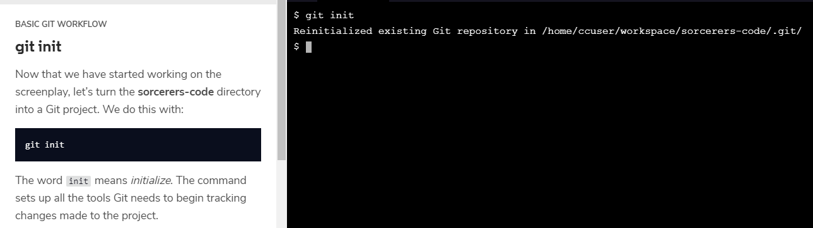

_________________________________________________________________________________________________

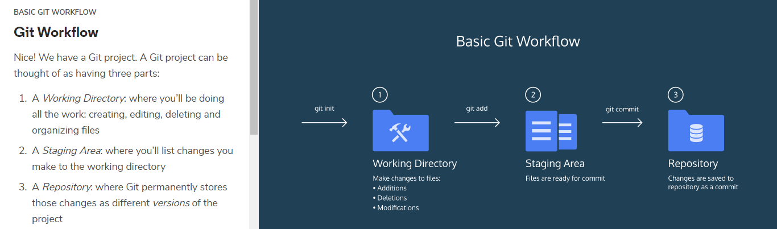

_________________________________________________________________________________________________

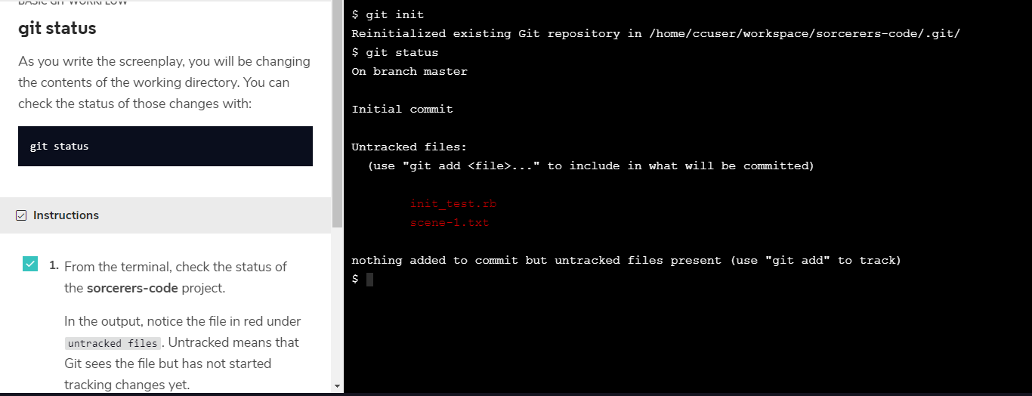

_________________________________________________________________________________________________

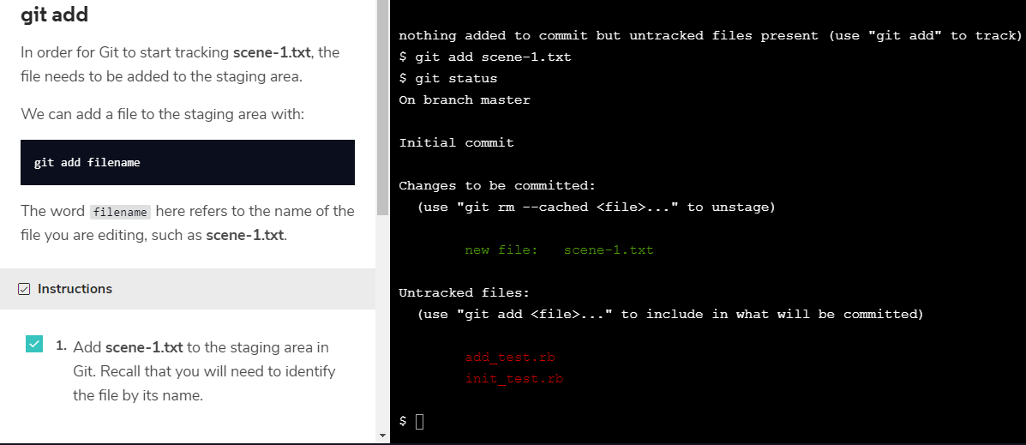

_________________________________________________________________________________________________

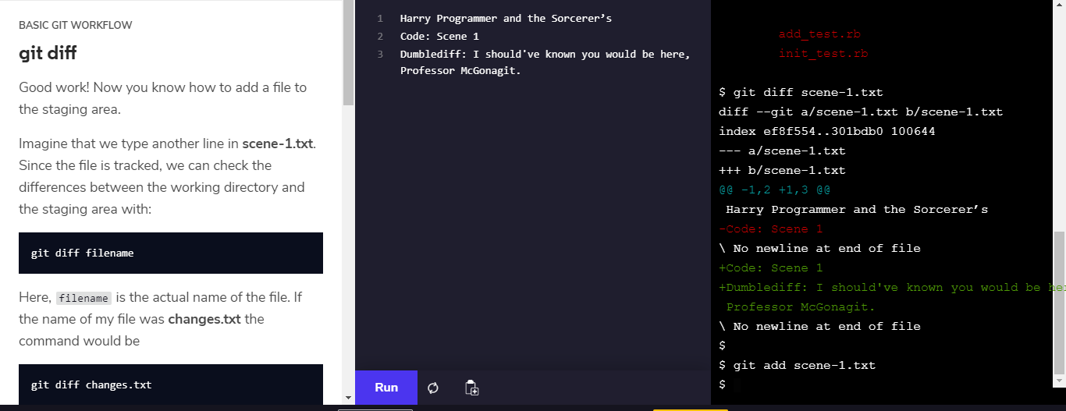

_________________________________________________________________________________________________

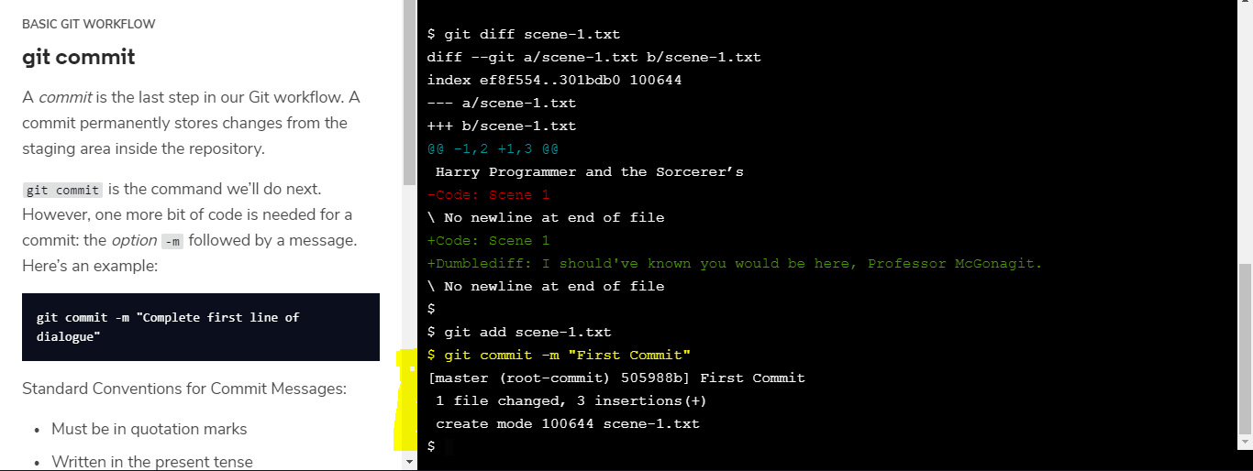

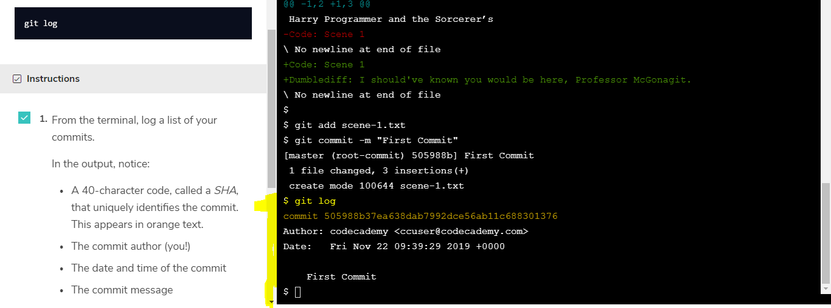

_________________________________________________________________________________________________

* git init creates a new Git repository
* git status inspects the contents of the working directory and staging area
* git add adds files from the working directory to the staging area
* git diff shows the difference between the working directory and the staging area
* git commit permanently stores file changes from the staging area in the repository
* git log shows a list of all previous commits

_________________________________________________________________________________________________

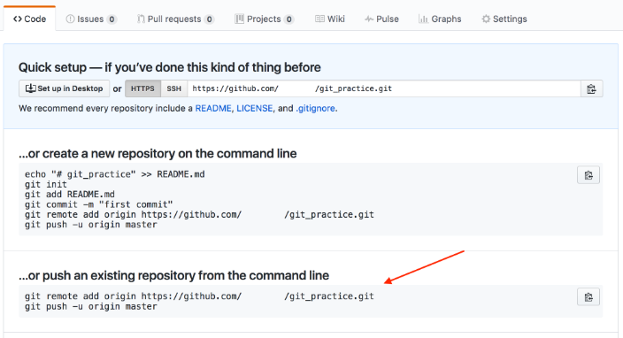

_________________________________________________________________________________________________

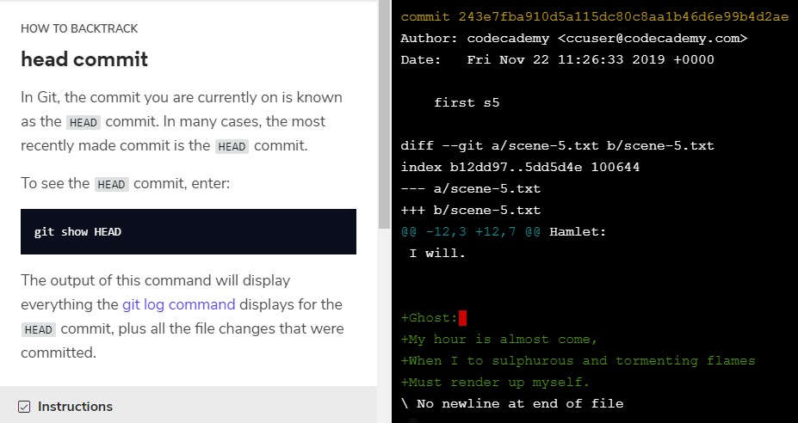

_________________________________________________________________________________________________

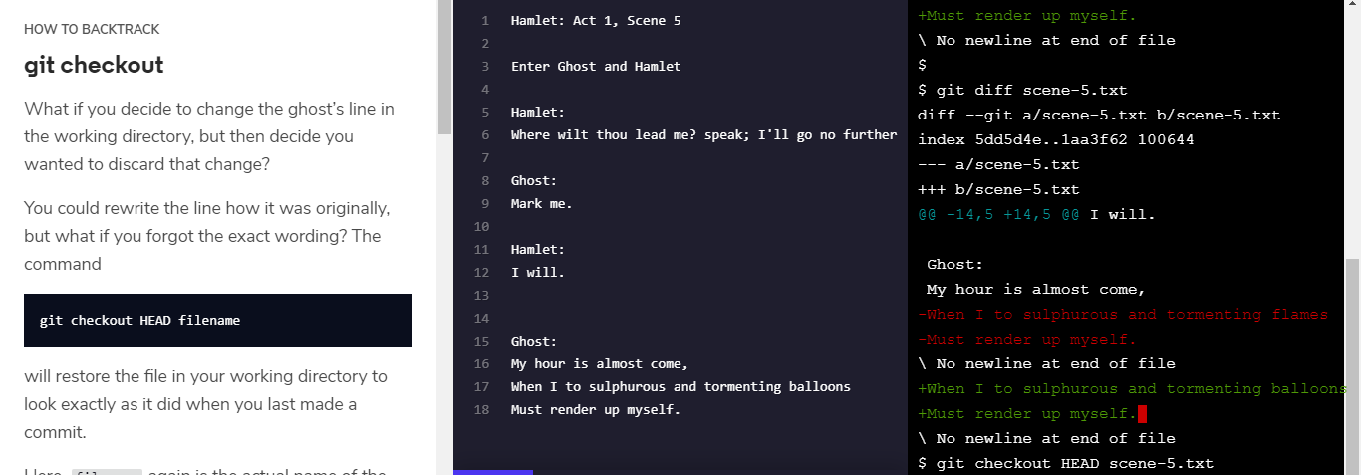

_________________________________________________________________________________________________

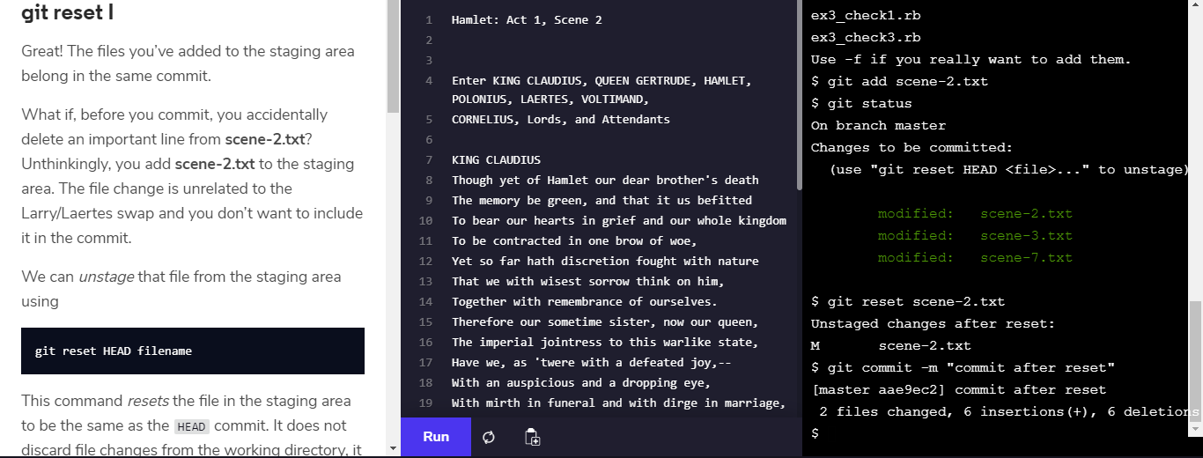

_________________________________________________________________________________________________

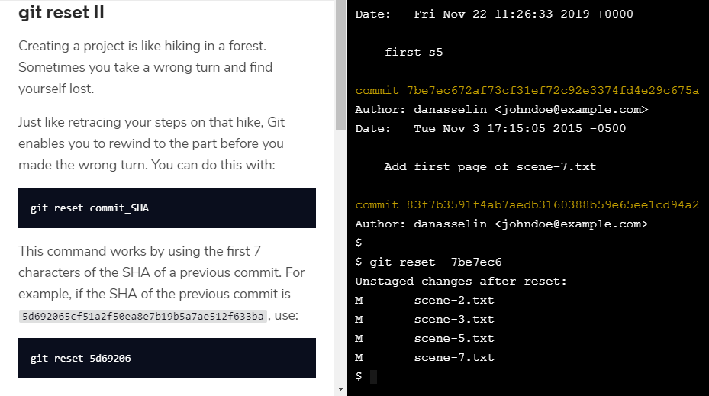

_________________________________________________________________________________________________

* git checkout HEAD filename: Discards changes in the working directory.
* git reset HEAD filename: Unstages file changes in the staging area.
* git reset commit_SHA: Resets to a previous commit in your commit history.

git checkout -- filename

It does the same exact thing that git checkout HEAD filename does.

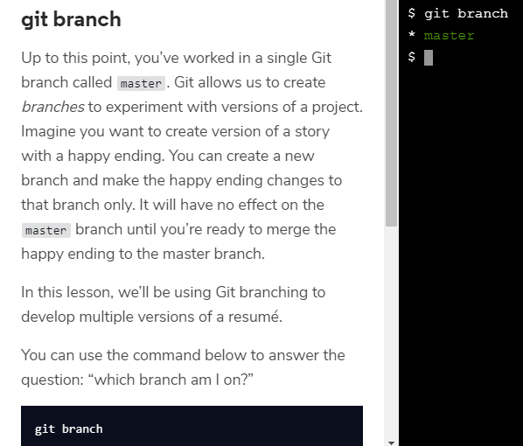

_________________________________________________________________________________________________

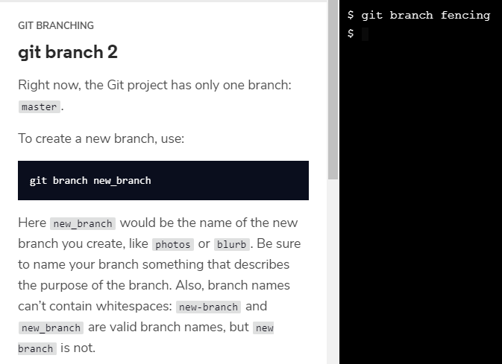_________________________________________________________________________________________________

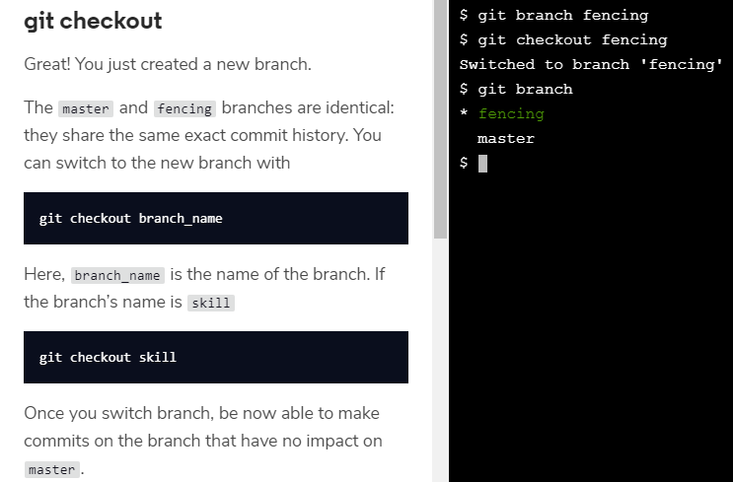_________________________________________________________________________________________________

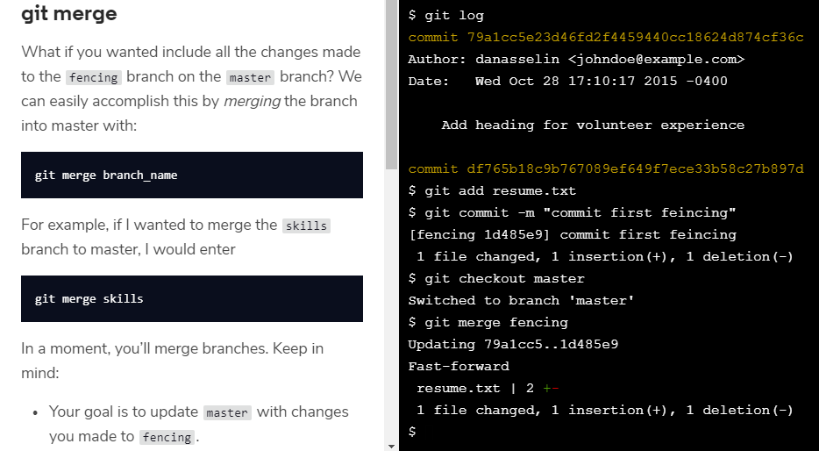

**merge conflict I**

The merge was successful because master had not changed since we made a commit on fencing. Git knew to simply update master with changes on fencing.

What would happen if you made a commit on master *before* you merged the two branches? Furthermore, what if the commit you made on master altered the same exact text you worked on in fencing? When you switch back to master and ask Git to merge the two branches, Git doesn’t know which changes you want to keep. This is called a *merge conflict*.

**merge conflict II**

Let’s say you decide you’d like to merge the changes from fencing into master.

Here’s where the trouble begins!

You’ve made commits on separate branches that alter the same line in conflicting ways. Now, when you try to merge fencing into master, Git will not know which version of the file to keep.

**Instructions**

**1.**

Switch to the master branch.

**2.**

From the terminal, enter the command below:

git merge fencing

This will try to merge fencing into master.

In the output, notice the lines:

CONFLICT (content): Merge conflict in resumé.txt

Automatic merge failed; fix conflicts and then commit the result.

**3.**

We must fix the merge conflict.

In the code editor, look at **resume.txt**. Git uses markings to indicate the HEAD (master) version of the file and the fencing version of the file, like this:

<<<<<<< HEAD

master version of line

=======

fencing version of line

>>>>>>> fencing

**Note**: If the markings are not showing in resume.txt, please close resume.txt and re-open via the folder icon at the top left corner of the editor.

Git asks us which version of the file to keep: the version on master or the version on fencing. You decide you want the fencing version.

From the code editor:

Delete the content of the line as it appears in the master branch

Delete **all of Git’s special markings** including the words HEAD and fencing. If any of Git’s markings remain, for example, >>>>>>> and =======, the conflict remains.

**4.**

Add **resume.txt** to the staging area.

**5.**

Now, make a commit. For your commit message, type “Resolve merge conflict” to indicate the purpose of the commit.

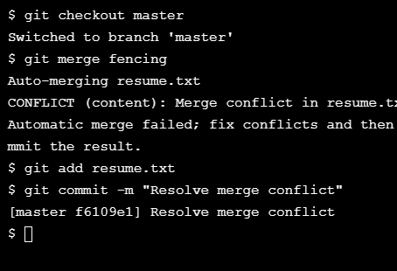

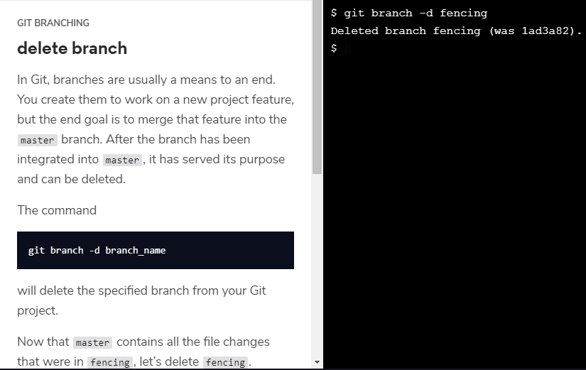_________________________________________________________________________________________________

Git *branching* allows users to experiment with different versions of a project by checking out separate *branches* to work on.

The following commands are useful in the Git branch workflow.

* git branch: Lists all a Git project’s branches.
* git branch branch_name: Creates a new branch.
* git checkout branch_name: Used to switch from one branch to another.
* git merge branch_name: Used to join file changes from one branch to another.
* git branch -d branch_name: Deletes the branch specified.

**git clone**

Sally has created the remote repository, **science-quizzes** in the directory **curriculum**, which teachers on the school’s shared network have access to. In order to get your own replica of **science-quizzes**, you’ll need to *clone* it with:

git clone remote_location clone_name

In this command:

* remote_location tells Git where to go to find the remote. This could be a web address, or a filepath, such as:

/Users/teachers/Documents/some-remote

* clone_name is the name you give to the directory in which Git will clone the repository.

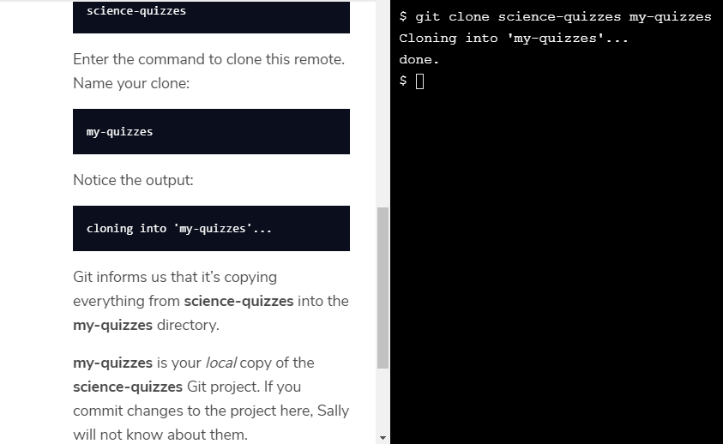

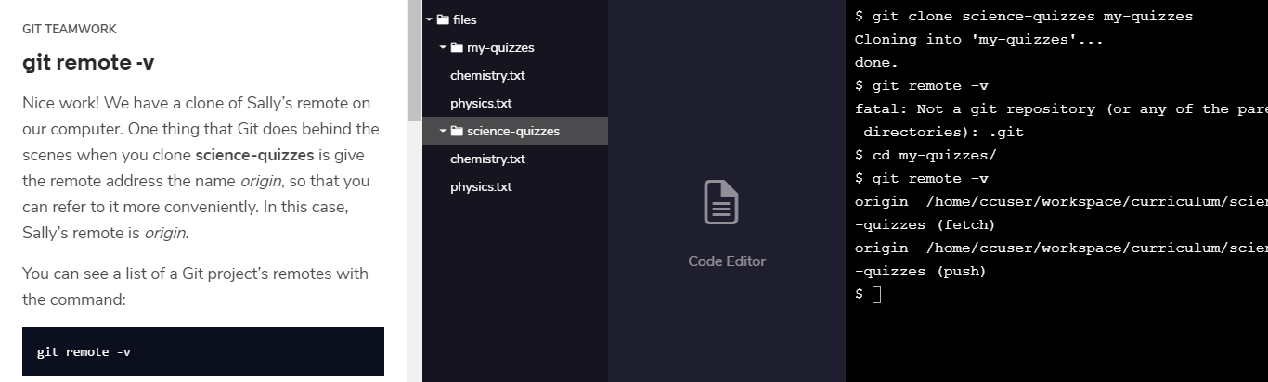

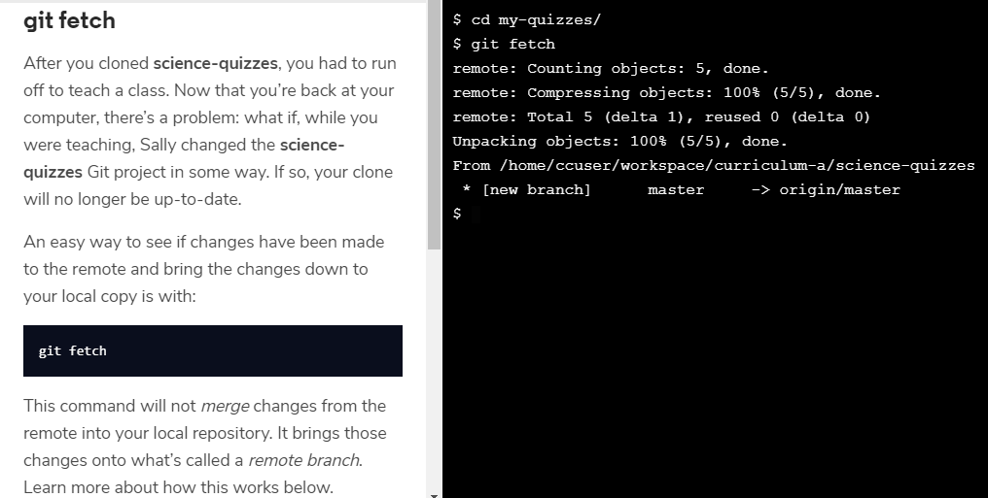

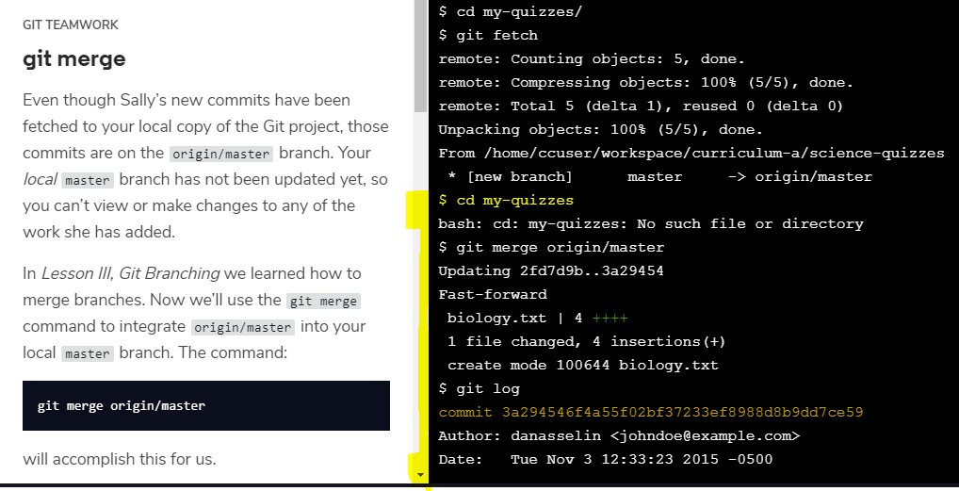

The workflow for Git collaborations typically follows this order:

1. Fetch and merge changes from the remote
2. Create a branch to work on a new project feature
3. Develop the feature on your branch and commit your work
4. Fetch and merge from the remote again (in case new commits were made while you were working)
5. *Push* your branch up to the remote for review

**git push**

Now it’s time to share our work with Sally.

The command:

git push origin your_branch_name

will push your branch up to the remote, origin. From there, Sally can review your branch and merge your work into the master branch, making it part of the definitive project version.

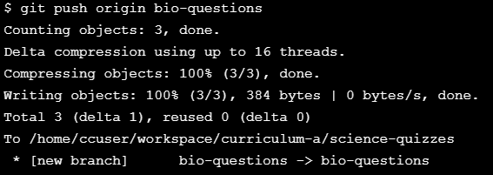

A remote is a Git repository that lives outside your Git project folder. Remotes can live on the web, on a shared network or even in a separate folder on your local computer.

* git clone: Creates a local copy of a remote.
* git remote -v: Lists a Git project’s remotes.
* git fetch: Fetches work from the remote into the local copy.
* git merge origin/master: Merges origin/master into your local branch.
* git push origin <branch_name>: Pushes a local branch to the origin remote.