Multimodal Skin Cancer Detection System
  - Independent Dual-Model Implementation — Updated Technical Project Report
Author: Jatin Mahadik
Programme: B.Tech, Artificial Intelligence and Data Science
Department: Electronics and Telecommunication Engineering
Institution: Jawaharlal Nehru Engineering College, MGM University, Chh. Sambhajinagar
Report date: 5 November 2026
Document status: updated technical report
Repository: multimodal-skin-cancer-detection-1

Document Control
Version | Date | Description | Author
2.0 | 5 November 2026 | Updated to describe the implemented independent dual-model system and its verified results. | Jatin Mahadik
1.0 | 26 October 2026 | Historical report describing an earlier three-model fusion design. Preserved unchanged as project_report.docx / project_report.pdf. | Jatin Mahadik

This document supersedes the architecture, model-inventory, training-methodology and evaluation sections of the historical report. The historical report is retained for academic provenance and must not be read as a description of the current implementation.
Accuracy rule applied throughout this report: a statement is included only when it can be traced to source code, a saved configuration file, or an evaluation artifact in the repository. Where evidence does not exist, the report says so rather than estimating a value.

Abstract
This report describes the implemented version of a doctor-facing skin-lesion assessment prototype. The system combines two independent machine-learning models. The first is an EfficientNetB0 convolutional neural network trained on the ISIC 2019 image dataset to produce a cancer-pattern score from a dermoscopic lesion image. The second is a clinical-only XGBoost classifier trained on PAD-UFES-20 metadata to produce a cancer-risk score from 21 raw patient, history, symptom and lesion fields encoded into 53 features.
Both models are loaded once by a FastAPI backend and exposed to a static HTML/CSS/JavaScript doctor portal. The portal supports image upload, clinical form entry, patient records, report persistence and PDF export. The API returns two separate scores under pipeline identifier dual_model_independent and explicitly reports ensemble_available as false.
No validated multimodal fusion model is implemented. The original project explored a three-model design that included ResNet50 and a 23-feature fusion classifier; that design is not present in the current code or artifacts. This report documents the two models that actually run, reports only the metrics recorded in the repository, and states the conditions that would be required before a fusion model could be introduced responsibly.
The verified held-out results are: EfficientNetB0 accuracy 0.8049, cancer recall 0.8053 and ROC-AUC 0.8956 on 2,522 ISIC 2019 test images; clinical-only XGBoost accuracy 0.8863, cancer recall 0.8834 and ROC-AUC 0.9596 on 343 PAD-UFES-20 test records at the validation-selected threshold of 0.56. These values belong to different datasets and different tasks and must not be combined into a single system accuracy.

Contents
- Introduction
- Problem statement and objectives
- System overview and architecture
- Data sources
- EfficientNetB0 image model
- Clinical-only XGBoost model
- Backend and frontend integration
- Why no fusion model is implemented
- Evaluation summary and traceability
- Limitations
- Future scope
- Reproducibility and verification
- Conclusion
- References
- Appendix A — API endpoint summary
- Appendix B — Artifact inventory and hashes
- Appendix C — Claim-to-source traceability

1. Introduction

1.1 Background
Skin lesions vary in appearance and may be benign, precancerous or malignant. Their visual characteristics can overlap, and accurate assessment depends on clinical expertise and, when indicated, histopathology. Computer vision can learn patterns from lesion images, while structured patient and lesion information can provide contextual signals. Deep learning is well suited to image classification, and gradient-boosted decision trees are effective for small tabular datasets.

1.2 Purpose of this updated report
The original project report described an intended three-model architecture: EfficientNetB0, ResNet50 and an XGBoost fusion classifier receiving two CNN probabilities plus 21 clinical features. During final integration the active pipeline changed: ResNet50 was disconnected, XGBoost was trained as a clinical-only model with 53 encoded features, and no fusion artifact was produced. The historical report was therefore no longer an accurate description of the software.
This report replaces those sections with a description of the code that runs today. It is written for academic review, technical placement evaluation and repository documentation.

1.3 Relationship to the historical report
The historical report (project_report.docx and project_report.pdf, dated 26 October 2026) is preserved unchanged. It remains useful as a record of the original design exploration and literature review. Its statements about ResNet50, a three-model pipeline, a 23-feature fusion schema, and fusion-model performance do not describe the current system. The updated architecture is shown in Figure 1 and in documentation/architecture_final.png.

2. Problem Statement and Objectives

2.1 Problem statement
A single image classifier can miss useful patient context, while a purely tabular model cannot learn visual patterns. The engineering problem addressed here is to serve two complementary assessments through one reproducible clinical workflow: an image-based assessment from a lesion photograph and a clinical-risk assessment from structured patient information.
The problem is not to build an autonomous diagnostic system. It is to build a modular, reproducible prototype that validates inputs, runs both models safely, presents their outputs separately, and documents their limitations honestly.

2.2 Implemented objectives
- Prepare and use ISIC 2019 images for EfficientNetB0 binary classification.
- Train and evaluate a clinical-only XGBoost classifier on PAD-UFES-20 metadata.
- Preserve the exact training-time feature order, categorical vocabularies and missing-value policy at inference.
- Load both models once at FastAPI startup and expose validated prediction, patient, report and PDF endpoints.
- Provide a doctor-facing HTML/CSS/JavaScript portal with patient records, report history and PDF export.
- Persist demonstration records in SQLite without presenting the portal as production authentication.
- Keep the two model outputs separate and report no combined score unless a fusion model is validated on paired data.
- Report only metrics that exist in the saved evaluation artifacts.

2.3 Non-goals
- No claim of clinical validation, diagnostic equivalence or regulatory approval.
- No validated multimodal fusion or ensemble score.
- No lesion segmentation, histopathology prediction or treatment recommendation.
- No production-grade authentication, encryption, audit logging or multi-user deployment.

3. System Overview and Architecture

3.1 Architecture
The implemented system has two independent prediction branches and a serving layer. The branches share an HTTP request but do not share model inputs or outputs. Figure 1 is the code-accurate architecture; the historical diagram remains available as documentation/architecture.png for provenance only.
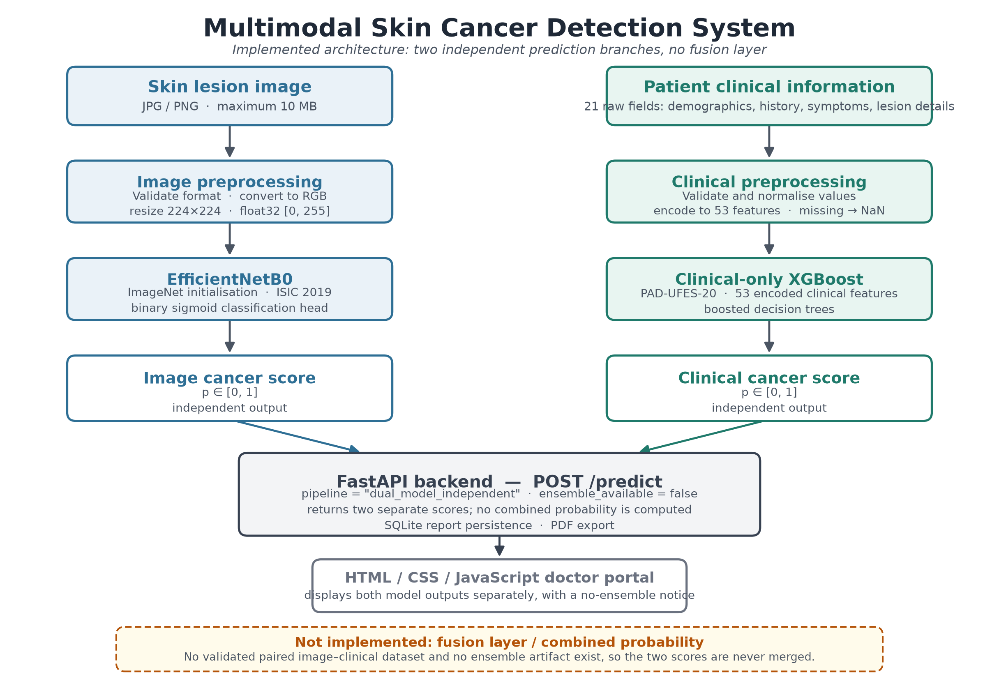
Figure 1 — Implemented architecture: two independent prediction branches and no fusion layer.

3.2 Image branch
The clinician uploads a JPEG or PNG lesion image. The backend verifies that the bytes decode as a genuine image, checks the format and pixel count, converts the image to RGB, resizes it to 224×224 with bilinear interpolation, and converts it to float32 pixels in the range [0, 255]. EfficientNet preprocessing is then applied before inference. The model returns one sigmoid score for the project-defined cancer class.

3.3 Clinical branch
The clinician enters 21 raw fields covering age, lesion diameters, Fitzpatrick skin type, smoking, alcohol, pesticide exposure, personal cancer history, household water and sewage indicators, six lesion symptoms, family ancestry, gender and body region. The preprocessor validates the values, normalises booleans and categories, preserves missing values as NaN, and expands the categorical fields into dummy columns using vocabularies frozen from the training split. The resulting matrix has exactly 53 columns in the order stored in feature_schema.json.

3.4 Serving layer
FastAPI loads the EfficientNetB0 model, the clinical XGBoost model, the feature schema and the clinical preprocessor once during application startup. The prediction endpoint runs both branches under an inference lock and returns a structured response containing two independent model objects. SQLite stores demonstration patients and reports. A pure-Python PDF writer generates downloadable report summaries.

3.5 Explicit no-fusion statement
The system does not compute a fused or ensemble probability. EfficientNetB0 and clinical XGBoost are evaluated independently and returned as two separate assessments. The response contains pipeline = "dual_model_independent" and dual_model_status.ensemble_available = false. No combined score, merged class or fusion model is present in the repository.

4. Data Sources

4.1 ISIC 2019 — image branch
EfficientNetB0 was trained on a cleaned, resized ISIC 2019 working set at 224×224 pixels. The test split used for the reported metrics contains 2,522 images: 452 cancer and 2,070 non-cancer. The training and validation counts below are the working-split counts recorded in the historical project notes; the test counts are corroborated by the evaluation classification report.
Split | Total | Cancer | Non-cancer | Purpose
Train | 20,231 | 3,610 | 16,621 | Model fitting
Validation | 2,526 | 450 | 2,076 | Checkpoint selection
Test | 2,522 | 452 | 2,070 | Held-out evaluation

The datasets themselves are not distributed with the repository. Obtain ISIC 2019 from its official source and comply with its licence and terms of use.

4.2 PAD-UFES-20 — clinical branch
The clinical model uses the PAD-UFES-20 metadata table, which contains 2,298 records and 26 columns, with 1,373 unique patients and 1,641 unique lesion identifiers. The project-defined binary label maps basal cell carcinoma, squamous cell carcinoma and melanoma to cancer, and actinic keratosis, nevus and seborrheic keratosis to non-cancer.
Diagnosis | Records | Binary label
BCC (basal cell carcinoma) | 845 | Cancer (1)
SCC (squamous cell carcinoma) | 192 | Cancer (1)
MEL (melanoma) | 52 | Cancer (1)
ACK (actinic keratosis) | 730 | Non-cancer (0)
NEV (nevus) | 244 | Non-cancer (0)
SEK (seborrheic keratosis) | 235 | Non-cancer (0)

After mapping, the dataset contains 1,089 cancer and 1,209 non-cancer records, a positive rate of 0.4739. Actinic keratosis can be precancerous. Grouping it with the negative class is a project-specific simplification for a binary experiment, not a statement that it is harmless.

4.3 HAM10000 — historical only
HAM10000 was used only by the retired ResNet50 branch. It is not used by the active architecture, and its images are not included in this repository. It is mentioned here only to explain the provenance of the historical report and diagram.

4.4 Data availability
No dataset images, metadata CSV files or archives are tracked by Git. The repository contains only code, configuration, evaluation summaries and documentation. Dataset licences and access conditions remain with the original providers.

5. EfficientNetB0 Image Model

5.1 Inference preprocessing
- Accept only genuine JPEG or PNG uploads up to the configured size limit (10 MB by default).
- Reject empty, corrupt, truncated, unsupported or excessively large images.
- Convert the decoded image to RGB and resize it to 224×224 using bilinear interpolation.
- Convert the array to float32 with pixel values in [0, 255].
- Apply tensorflow.keras.applications.efficientnet.preprocess_input.
- Run a single-image batch and clamp the sigmoid output to [0, 1].

5.2 Training methodology
The training source is training/scripts/efficientnet_training.py. The saved artifact was produced with the following recorded procedure:
- EfficientNetB0 initialised with ImageNet weights, without the original classification top.
- Global average pooling, dropout and a one-unit sigmoid classification head.
- Phase 1: frozen backbone, head training for up to 10 epochs at learning rate 1e-4.
- Phase 2: final 30 backbone layers unfrozen (BatchNorm layers kept frozen), fine-tuning for up to 10 epochs at learning rate 1e-5.
- Adam optimiser, binary cross-entropy, batch size 16, seed 42.
- Checkpoint selection by validation ROC-AUC, early stopping with patience 3, and ReduceLROnPlateau with factor 0.5 and patience 2.
- One final evaluation of the selected checkpoint on the held-out test split.
The script retains the original absolute dataset paths and does not include the dataset. See training/scripts/README.md before rerunning it.

5.3 Artifact and integrity
Property | Value
Filename | efficientnet_b0_best.keras
Location | training/models/efficientnet_b0_best.keras
Size | 28,956,745 bytes
SHA-256 | 6FD74D96F47446E10581C9E7BF775E4385362C4124C68B44B763BBDC73A9558D
Framework | TensorFlow 2.19.0 / Keras 3.15.1
Input | 224 × 224 × 3 RGB
Output | One sigmoid cancer score

The weight file is excluded from Git by .gitignore because of its size. It can be placed manually or loaded from another directory with the SKIN_MODELS_DIR environment variable. training/models/README.md records the expected hash and placement instructions.

5.4 Held-out test results
Source: training/models/evaluation/test_metrics.csv and classification_report.txt, evaluated on 2,522 held-out images.
Metric | Value
Accuracy | 0.8049
Precision (cancer) | 0.4740
Recall / sensitivity (cancer) | 0.8053
F1 (cancer) | 0.5967
ROC-AUC | 0.8956
Macro F1 | 0.7340
Weighted F1 | 0.8221

 | Predicted non-cancer | Predicted cancer
Actual non-cancer | 1,666 (TN) | 404 (FP)
Actual cancer | 88 (FN) | 364 (TP)

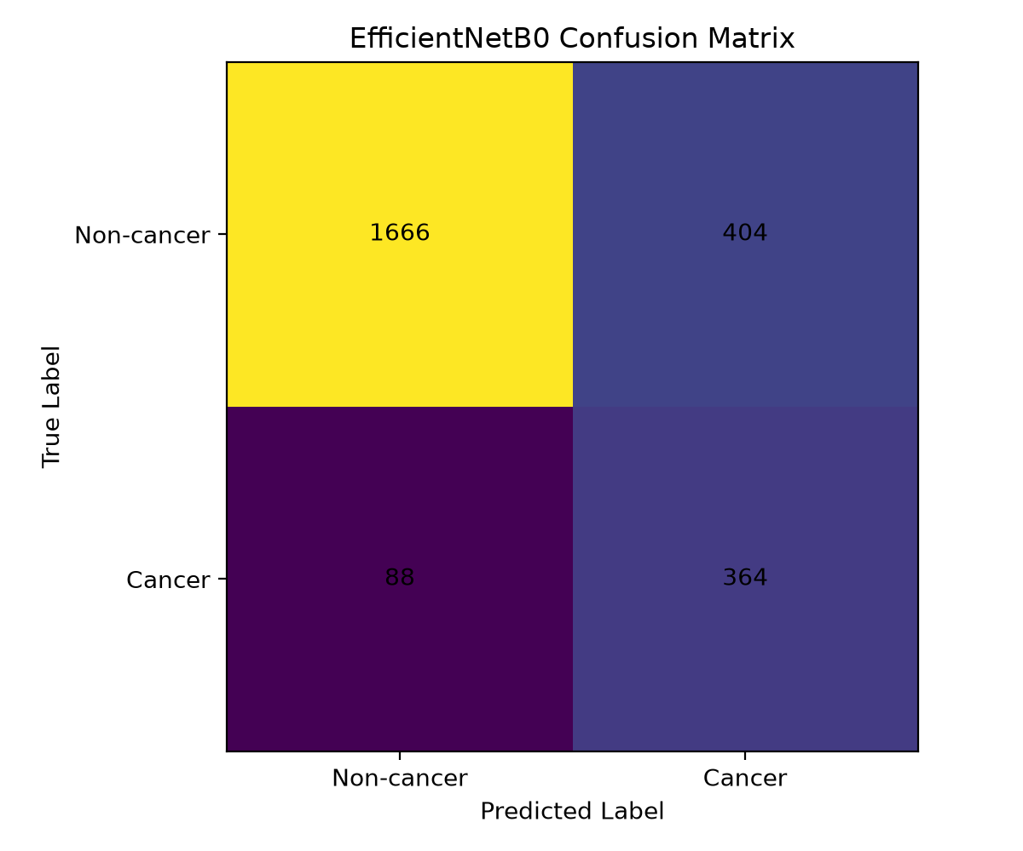
Figure 2 — EfficientNetB0 confusion matrix from the held-out test evaluation (source artifact).

5.5 Interpretation
The model achieves high cancer recall (0.8053) but low cancer precision (0.4740), reflecting class imbalance and a substantial false-positive burden: 404 non-cancer images were flagged as cancer, compared with 88 missed cancers. Accuracy alone (0.8049) would obscure this trade-off. The score is a discriminative model output and is not a calibrated medical probability.

6. Clinical-Only XGBoost Model

6.1 Input features
The model receives 21 raw clinical fields. Four are numeric, seven are boolean survey fields, six are symptom fields, and four are categorical fields expanded into training-fitted dummy columns. The final matrix contains 53 features. The model receives no image, no CNN probability, no embedding and no pixel data.
Group | Raw fields | Encoded form
Numeric (4) | age, diameter_1, diameter_2, fitspatrick | 4 numeric columns
Boolean (7) | smoke, drink, pesticide, skin_cancer_history, cancer_history, has_piped_water, has_sewage_system | 7 boolean columns
Symptoms (6) | itch, grew, hurt, changed, bleed, elevation | 6 boolean columns
Categorical (4) | background_father, background_mother, gender, region | 36 training-fitted dummy columns
Total | 21 raw fields | 53 model features

6.2 Preprocessing and missing values
- Required fields are age and lesion body region.
- Numeric values are range-checked; Fitzpatrick type must be between 1 and 6.
- Boolean and symptom values are normalised to TRUE or FALSE.
- Categorical values are upper-cased and matched to the saved training vocabulary.
- Blank, UNK, UNKNOWN, NONE, NAN, NA, N/A, '-' and '?' are treated as missing.
- Missing values are preserved as NaN; no imputation is applied, and XGBoost handles them natively.
- Unseen categories produce an all-zero dummy block rather than a silent category change.

6.3 Training and validation protocol
Training uses a patient-grouped stratified split generated with StratifiedGroupKFold at row level, using patient_id as the grouping key. Folds 0–2 form the test set, folds 3–5 the validation set and folds 6–19 the training set (approximately 70/15/15). No patient appears in more than one split. lesion_id is not used for grouping because 250 lesion identifiers are reused across different patients.
Split | Records | Cancer | Non-cancer | Patients
Train | 1,609 | 762 | 847 | 949
Validation | 346 | 164 | 182 | 210
Test | 343 | 163 | 180 | 214

The test split was not used for training, early stopping, threshold selection or preprocessing fits. Patient overlap between train/validation, train/test and validation/test is zero in the saved split-integrity report.

6.4 Configuration
Property | Value
Algorithm | XGBClassifier
Artifact | training/xgboost_fusion/clinical_xgboost.json
Features | 53
Max depth | 3
Learning rate | 0.05
Estimators | 2,000 with early stopping (50 rounds)
Subsample / colsample | 0.8 / 0.8
Minimum child weight | 3
Regularisation | reg_alpha 0.0, reg_lambda 1.0, gamma 0.0
Seed | 42
Threshold selection | Validation-only F1 sweep; selected 0.56

6.5 Held-out test results
Source: training/xgboost_fusion/evaluation/metrics_test.json, evaluated on 343 held-out records (163 cancer, 180 non-cancer).
Metric | At threshold 0.56 (selected) | At threshold 0.50 (reference)
Accuracy | 0.8863 | 0.8921
Precision (cancer) | 0.8780 | 0.8706
Recall / sensitivity (cancer) | 0.8834 | 0.9080
Specificity | 0.8889 | 0.8778
F1 (cancer) | 0.8807 | 0.8889
Macro F1 | 0.8860 | 0.8920
ROC-AUC | 0.9596 | 0.9596

Threshold | TN | FP | FN | TP
0.56 (selected) | 160 | 20 | 19 | 144
0.50 (reference) | 158 | 22 | 15 | 148

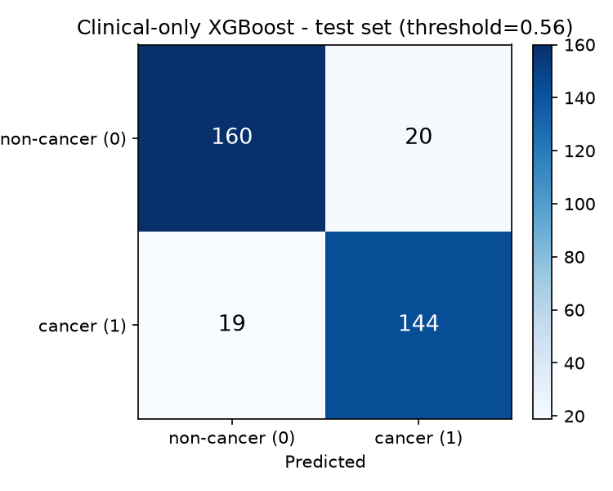
Figure 3 — Clinical-only XGBoost confusion matrix from the held-out test evaluation at the selected threshold (source artifact).
The API displays the clinical assessment using a fixed 0.50 cut-off for the label "High-Risk Clinical Profile", while the evaluation reports 0.56 as the validation-selected threshold. The raw score is returned, and the difference is documented rather than hidden.

6.6 Missingness caveat
In PAD-UFES-20, the 11-field survey block is missing for 804 of 2,298 records, and every one of those records is a non-cancer diagnosis. Missingness can therefore act as a proxy for the negative class. In the test subset, the 136 survey-absent records are all non-cancer, so overall metrics partly reflect dataset collection patterns. The survey-present subgroup (n = 207) has accuracy 0.8116, cancer recall 0.8834 and ROC-AUC 0.8348. These subgroup values are the more informative signal for judging clinical discrimination.

6.7 Interpretation
The clinical model performs strongly on the internal test split, but the missingness structure means the headline accuracy should not be interpreted as pure clinical signal. The scores are XGBoost discriminative outputs, not calibrated probabilities. Calibration, external validation and subgroup analysis have not been performed.

7. Backend and Frontend Integration

7.1 FastAPI backend
The backend is implemented in backend/main.py and loads its artifacts during the application lifespan. It exposes health, clinical schema, prediction, patient, report, PDF and demo authentication endpoints. CORS origins are configurable, upload size is capped, validation errors return structured responses, and internal exceptions are not leaked to clients.

7.2 Prediction workflow
- The clinician uploads a lesion image and submits the clinical form to POST /predict.
- FastAPI checks that both models and the feature schema are loaded.
- The image bytes are read, size-checked, decoded and validated as JPEG or PNG.
- Required clinical fields and numeric bounds are validated.
- EfficientNetB0 preprocessing and inference produce the image cancer score.
- The clinical preprocessor builds the ordered 53-feature row and XGBoost produces the clinical cancer score.
- Both scores are returned as separate model objects with an explicit no-ensemble notice.
- The portal may persist the assessment as a report and request a PDF download.

7.3 Response contract
The response is deliberately explicit about model independence. An abridged example is shown below.
{
"pipeline": "dual_model_independent",
"models": {
"efficientnet_b0": {
"model_name": "EfficientNetB0 (ISIC 2019)",
"cancer_score": 0.2937,
"assessment": "Benign Lesion Pattern"
},
"clinical_xgboost": {
"model_name": "Clinical-Only XGBoost (PAD-UFES-20)",
"cancer_score": 0.9054,
"assessment": "High-Risk Clinical Profile",
"features_used": 53
}
},
"dual_model_status": {
"ensemble_available": false,
"notice": "Independent dual-model outputs..."
},
"score_disclaimer": "These scores are model estimates and are not calibrated medical diagnostic probabilities."
}
The example scores are the values recorded during the live verification run described in Section 12. They are illustrative of the response shape, not a performance claim.

7.4 Persistence and PDF export
SQLite stores demonstration clinicians, patients and reports. The database is created automatically on first startup and is ignored by Git. New reports store the image score, clinical score and the independent-model status; they do not create a combined score. The PDF writer renders new two-model reports normally and can still render archived historical records that contain legacy ResNet50 and ensemble fields, clearly labelled as archived.

7.5 Frontend
The frontend is a static HTML/CSS/JavaScript portal served over HTTP. It includes login, signup, dashboard, patient directory, new assessment, prediction, results, reports and profile pages. Asset paths are relative, and the API base defaults to http://127.0.0.1:8000 with an optional window.SKIN_API_BASE override. The results page presents both model outputs separately and displays a no-ensemble notice.
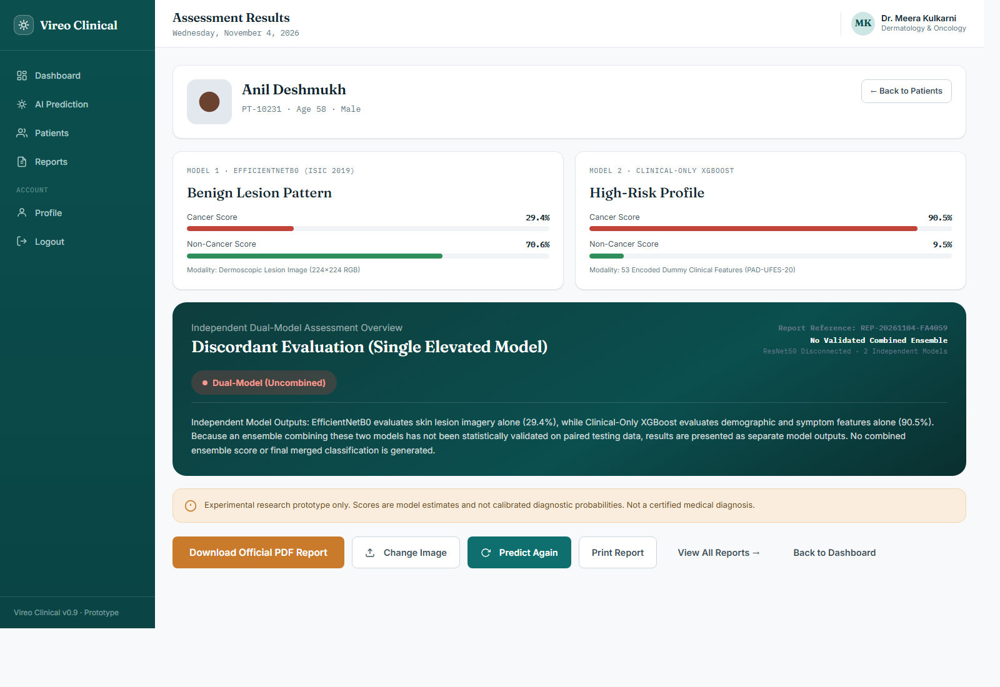
Figure 4 — Results page showing the two independent model outputs (screenshot from the corrected build).

7.6 Security and deployment limitations
The login uses plain-text demo credentials and browser storage. It is not production authentication. There is no role-based access control, audit logging, encryption at rest, secure transport configuration or multi-user data isolation. The portal must not be used with real patient-identifiable data.

8. Why No Fusion Model Is Implemented

8.1 Artifact evidence
The repository contains exactly one XGBoost artifact: training/xgboost_fusion/clinical_xgboost.json, a clinical-only model with 53 features. No fusion_xgboost.json, no paired multimodal feature schema and no fusion evaluation report exist in the source project or in this repository. The backend does not load a ResNet50 model and does not compute a combined score.

8.2 Requirements for a valid fusion model
- Paired image and clinical records from the same patients, with a documented linkage.
- Out-of-fold CNN predictions for the fusion training rows, so image probabilities do not leak from rows the CNN already saw.
- A frozen fusion feature schema that includes the image score and clinical features.
- A patient-grouped train/validation/test split that prevents leakage across all modalities.
- Held-out evaluation of the combined model, including calibration and subgroup analysis.
- A versioned fusion artifact and a reproducible evaluation report.
None of these conditions is met by the current artifacts. Inventing weights or averaging the two scores would create an unvalidated number that looks like a clinical probability but has no supporting evidence.

8.3 If fusion is added later
A future fusion model should be a new versioned artifact with its own schema and evaluation report, not a silent replacement of the independent pipeline. The API, frontend, README and this report should be updated together, and the independent-mode results should remain reproducible for comparison.

9. Evaluation Summary and Traceability

9.1 Summary of verified results
Model | Dataset | Test size | Accuracy | Cancer recall | ROC-AUC | Source
EfficientNetB0 | ISIC 2019 | 2,522 images | 0.8049 | 0.8053 | 0.8956 | training/models/evaluation/test_metrics.csv
Clinical XGBoost (0.56) | PAD-UFES-20 | 343 records | 0.8863 | 0.8834 | 0.9596 | training/xgboost_fusion/evaluation/metrics_test.json

9.2 What is not claimed
- No fusion or ensemble metric exists; none is reported.
- No paired image/clinical test set exists, so the two models cannot be compared as one system.
- No calibration, Brier score or expected calibration error has been computed.
- No external validation, prospective study or subgroup performance analysis has been performed.
- No claim is made that either score is a diagnosis or a calibrated medical probability.
- No claim is made that the reported metrics transfer to other populations, cameras or clinical settings.

9.3 Why the metrics cannot be combined
EfficientNetB0 was evaluated on dermoscopic ISIC 2019 images with a binary cancer label derived from that dataset. Clinical XGBoost was evaluated on PAD-UFES-20 smartphone/clinical metadata with a different binary mapping and a different patient population. The datasets, inputs, label definitions and intended tasks differ. Averaging or multiplying the two metrics would be mathematically meaningless and clinically misleading.

10. Limitations

10.1 Model and data limitations
- No validated fusion model and no paired multimodal evaluation.
- Dataset shift between dermoscopic ISIC 2019 images and PAD-UFES-20 clinical records.
- Uncalibrated scores that are not medical probabilities.
- EfficientNetB0 has low cancer precision (0.4740) and a high false-positive count on the recorded test split.
- PAD-UFES-20 missingness acts as a proxy for the negative class; 804 survey-absent records are all non-cancer.
- Limited demographic and skin-tone analysis; subgroup performance is not established.
- Binary label simplification, including mapping actinic keratosis to non-cancer.
- No external validation.

10.2 Engineering limitations
- Demo authentication stores plain-text credentials in SQLite; it is not production security.
- SQLite and local files are not suitable for multi-user clinical deployment.
- No audit logging, encryption at rest, role-based access control or TLS configuration.
- The frontend is a static prototype, not a hardened clinical application.
- Training scripts retain original absolute Windows dataset paths and require adaptation before rerunning.
- The historical report and architecture image describe a retired design; they are retained only for provenance.

11. Future Scope
- Build a paired image/clinical dataset with documented patient linkage and governance approval.
- Generate out-of-fold CNN probabilities and train a fusion model on a patient-grouped split.
- Evaluate the fusion model on a strictly held-out paired test set and report calibration and subgroup metrics.
- Calibrate both existing models and report reliability diagrams, Brier score and expected calibration error.
- Perform external validation across institutions, cameras and populations.
- Audit and mitigate the PAD-UFES-20 survey-missingness shortcut.
- Add image saliency and tabular feature attribution with appropriate reliability caveats.
- Replace demo authentication with hashed credentials, RBAC, audit logs, TLS and encrypted storage.
- Add containerisation, automated tests, a model registry, structured logging, monitoring and rollback.
- Obtain ethics and regulatory approval before any prospective clinical evaluation.

12. Reproducibility and Verification

12.1 Environment
Component | Verified version
Python | 3.12.10
TensorFlow / Keras | 2.19.0 / 3.15.1
XGBoost | 3.4.1
NumPy / pandas / scikit-learn | 2.1.3 / 3.0.6 / 1.9.1
FastAPI / Uvicorn | 0.143.0 / 0.54.0
Pillow | 12.3.0

The saved .keras and XGBoost artifacts are version-sensitive. Use the pinned versions in backend/requirements.txt rather than upgrading packages independently.

12.2 Installation
py -3.12 -m venv .venv
.\.venv\Scripts\Activate.ps1
python -m pip install --upgrade pip
python -m pip install -r backend\requirements.txt

12.3 Model placement and integrity verification
The EfficientNetB0 weight file is not tracked by Git. Place the verified artifact at training/models/efficientnet_b0_best.keras, or point SKIN_MODELS_DIR at the directory that contains it. The XGBoost artifact, feature schema and training configuration are already included.
Get-FileHash .\training\models\efficientnet_b0_best.keras -Algorithm SHA256
Expected SHA-256: 6FD74D96F47446E10581C9E7BF775E4385362C4124C68B44B763BBDC73A9558D. A mismatch means the file is not the artifact that produced the reported EfficientNetB0 metrics. The clinical XGBoost artifact hash is 5EF9A01EFDBB31EA227EEAE930343256339C1952A8EE58440C594837ADDEB56A.

12.4 Backend and frontend startup
cd backend
python -m uvicorn main:app --host 127.0.0.1 --port 8000
cd ..\frontend
python -m http.server 5500 --bind 127.0.0.1
Open http://127.0.0.1:5500/index.html for the portal and http://127.0.0.1:8000/docs for the interactive API documentation.

12.5 Health check
Invoke-RestMethod http://127.0.0.1:8000/health
A healthy response reports efficientnet_b0, clinical_xgboost and feature_schema as true, resnet50_loaded as false and ensemble_validated as false. During repository preparation the backend was started, both models loaded, a live prediction was executed, and the reporting workflow was exercised. The exact artifact hashes were recalculated from the local files and matched the documented values.

13. Conclusion
This project delivers a working, reproducible two-model skin-lesion assessment prototype. EfficientNetB0 analyses lesion images, clinical-only XGBoost analyses structured patient information, and FastAPI serves both assessments through a doctor-facing web portal. The implementation preserves training-time preprocessing, validates inputs, stores demonstration records and generates PDF reports.
The original three-model fusion design, including ResNet50 and a fusion classifier, is not present in the current code or artifacts. The system therefore returns two independent scores and explicitly states that no validated ensemble exists. This is a deliberate accuracy decision, not a missing UI feature.
The verified metrics support internal discriminative performance on the original datasets, but they do not establish clinical safety or effectiveness. Calibration, external validation, subgroup analysis, a paired multimodal dataset and prospective clinical evaluation remain necessary before any clinical use. The prototype is intended for academic research, technical demonstration and decision-support experimentation only.

14. References
[1] A. Esteva, B. Kuprel, R. A. Novoa, J. Ko, S. M. Swetter, H. M. Blau, and S. Thrun, "Dermatologist-level classification of skin cancer with deep neural networks," Nature, vol. 542, pp. 115–118, 2017. doi: 10.1038/nature21056.
[2] P. Tschandl, C. Rosendahl, and H. Kittler, "The HAM10000 dataset, a large collection of multi-source dermatoscopic images of common pigmented skin lesions," Scientific Data, vol. 5, article 180161, 2018. doi: 10.1038/sdata.2018.161.
[3] N. C. F. Codella et al., "Skin Lesion Analysis Toward Melanoma Detection 2018: A Challenge Hosted by the International Skin Imaging Collaboration (ISIC)," 2019.
[4] A. G. C. Pacheco et al., "PAD-UFES-20: A skin lesion dataset composed of patient data and clinical images collected from smartphones," Data in Brief, vol. 32, article 106221, 2020. doi: 10.1016/j.dib.2020.106221.
[5] M. Tan and Q. V. Le, "EfficientNet: Rethinking model scaling for convolutional neural networks," in Proceedings of the 36th International Conference on Machine Learning (ICML), PMLR 97, pp. 6105–6114, 2019.
[6] T. Chen and C. Guestrin, "XGBoost: A scalable tree boosting system," in Proceedings of the 22nd ACM SIGKDD International Conference on Knowledge Discovery and Data Mining, pp. 785–794, 2016. doi: 10.1145/2939672.2939785.
[7] International Skin Imaging Collaboration (ISIC), "ISIC Archive and Challenge datasets." Available: https://www.isic-archive.com/ (accessed October 2026).
[8] TensorFlow, "Keras Applications: EfficientNet." Available: https://www.tensorflow.org/api_docs/python/tf/keras/applications (accessed October 2026).
[9] XGBoost Developers, "XGBoost documentation." Available: https://xgboost.readthedocs.io/ (accessed October 2026).
[10] FastAPI, "FastAPI documentation." Available: https://fastapi.tiangolo.com/ (accessed October 2026).

Appendix A — API Endpoint Summary
Method | Endpoint | Purpose
GET | / | Service metadata and active model listing
GET | /health | Model readiness, ResNet50 status and ensemble status
GET | /clinical-options | 53-feature clinical form schema, bounds and vocabularies
POST | /predict | Image + clinical form → two independent scores
GET | /patients | List or search demonstration patients
POST | /patients | Create a demonstration patient
GET | /patients/{patient_id} | Patient details and report history
PUT | /patients/{patient_id} | Update a patient record
GET | /patients/{patient_id}/reports | Reports for one patient
POST | /reports | Persist an assessment report
GET | /reports | List reports
GET | /reports/{report_id} | Retrieve one report
GET | /reports/{report_id}/pdf | Download a generated PDF report
GET | /stats | Dashboard counts
POST | /auth/login | Demo clinician login
POST | /auth/signup | Demo clinician registration

Appendix B — Artifact Inventory and Hashes
Artifact | Purpose | Size | SHA-256
efficientnet_b0_best.keras | EfficientNetB0 image model | 28,956,745 bytes | 6FD74D96F47446E10581C9E7BF775E4385362C4124C68B44B763BBDC73A9558D
clinical_xgboost.json | Clinical-only XGBoost model | 282,677 bytes | 5EF9A01EFDBB31EA227EEAE930343256339C1952A8EE58440C594837ADDEB56A
feature_schema.json | 53-feature contract | tracked | n/a
training_config.json | Training and threshold configuration | tracked | n/a

The EfficientNetB0 weight file is excluded from Git by .gitignore. The XGBoost JSON, feature schema and training configuration are tracked. No fusion artifact exists.

Appendix C — Claim-to-Source Traceability
Claim in this report | Source of truth
Two independent models; no fusion | backend/prediction.py; backend/main.py; backend/model_loader.py
pipeline = dual_model_independent | backend/prediction.py
ensemble_available = false | backend/prediction.py
53 clinical features from 21 raw fields | training/xgboost_fusion/feature_schema.json; clinical_features.py
EfficientNetB0 metrics | training/models/evaluation/test_metrics.csv; classification_report.txt
XGBoost metrics and threshold | training/xgboost_fusion/evaluation/metrics_test.json; metrics_validation.json
Patient-grouped split, zero overlap | training/xgboost_fusion/evaluation/split_integrity.json
Missingness caveat | training/xgboost_fusion/evaluation/dataset_inspection.json; missingness_analysis.json
Model size and hashes | training/models/README.md; files in training/
No fusion artifact | Repository artifact inventory; no fusion_xgboost.json

