### What is Maven?

Maven is a powerful project management tool that is based on POM (project object model), used for projects build, dependency and documentation. It is a tool that can be used for building and managing any Java-based project. Maven makes the day-to-day work of Java developers easier and helps with the building and running of any Java-based project.

### What maven does?

Maven does a lot of helpful task like

1. We can easily build a project using maven.
2. We can add jars and other dependencies of the project easily using the help of maven.
3. Maven provides project information (log document, dependency list, unit test reports etc.)
4. Maven is very helpful for a project while updating central repository of JARs and other dependencies.
5. With the help of Maven we can build any number of projects into output types like the JAR, WAR etc without doing any scripting.
6. Using maven we can easily integrate our project with source control system (such as Subversion or Git).

### How maven works?

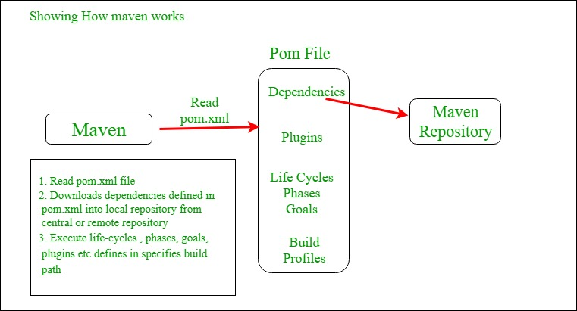

### Maven Lifecycle:

Below is a representation of the default Maven lifecycle and its 8 steps: Validate, Compile, Test, Package, Integration test, Verify, Install and Deploy.

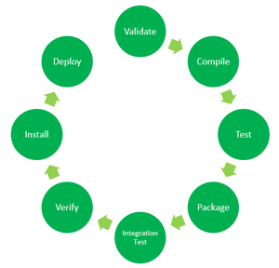

*8 Phases of the Default Maven Lifecycle*

The default Maven lifecycle consists of 8 major steps or phases for compiling, testing, building and installing a given Java project as specified below:

1. **Validate:** This step validates if the project structure is correct. For example – It checks if all the dependencies have been downloaded and are available in the local repository.
2. **Compile:** It compiles the source code, converts the .java files to .class and stores the classes in target/classes folder.
3. **Test:** It runs unit tests for the project.
4. **Package:** This step packages the compiled code in distributable format like JAR or WAR.
5. **Integration test:** It runs the integration tests for the project.
6. **Verify:** This step runs checks to verify that the project is valid and meets the quality standards.
7. **Install:** This step installs the packaged code to the local Maven repository.
8. **Deploy:** It copies the packaged code to the remote repository for sharing it with other developers.

Maven follows a sequential order to execute the commands where if you run step *n*, all steps preceding it (Step 1 to *n-1*) are also executed. For example – if we run the Installation step (Step 7), it will validate, compile, package and verify the project along with running unit and integration tests (Step 1 to 6) before installing the built package to the local repository.

**Maven Commands:**

* **mvn clean:** Cleans the project and removes all files generated by the previous build.
* **mvn compile:** Compiles source code of the project.
* **mvn test-compile:** Compiles the test source code.
* **mvn test:** Runs tests for the project.
* **mvn package:** Creates JAR or WAR file for the project to convert it into a distributable format.
* **mvn install:** Deploys the packaged JAR/ WAR file to the local repository.
* **mvn deploy:** Copies the packaged JAR/ WAR file to the remote repository after compiling, running tests and building the project.

Generally when we run any of the above commands, we add the **mvn clean** step so that the target folder generated from the previous build is removed before running a newer build. This is how the command would look on integrating the *clean* step with *install* phase: **mvn clean install**

### Core Concepts of Maven:

1. **POM Files:** Project Object Model(POM) Files are XML file that contains information related to the project and configuration information such as dependencies, source directory, plugin, goals etc. used by Maven to build the project. When you should execute a maven command you give maven a POM file to execute the commands. Maven reads pom.xml file to accomplish its configuration and operations.
2. **Dependencies and Repositories:** Dependencies are external Java libraries required for Project and repositories are directories of packaged JAR files. The local repository is just a directory on your machine hard drive. If the dependencies are not found in the local Maven repository, Maven downloads them from a central Maven repository and puts them in your local repository.
3. **Build Life Cycles, Phases and Goals:** A build life cycle consists of a sequence of build phases, and each build phase consists of a sequence of goals. Maven command is the name of a build lifecycle, phase or goal. If a lifecycle is requested executed by giving maven command, all build phases in that life cycle are executed also. If a build phase is requested executed, all build phases before it in the defined sequence are executed too.
4. **Build Profiles:** Build profiles a set of configuration values which allows you to build your project using different configurations. For example, you may need to build your project for your local computer, for development and test. To enable different builds you can add different build profiles to your POM files using its profiles elements and are triggered in the variety of ways.
5. **Build Plugins:** Build plugins are used to perform specific goal. you can add a plugin to the POM file. Maven has some standard plugins you can use, and you can also implement your own in Java.

**Maven Repository**

Maven repositories are directories of packaged JAR files with some metadata. The metadata are POM files related to the projects each packaged JAR file belongs to, including what external dependencies each packaged JAR has. This metadata enables Maven to download dependencies of your dependencies recursively until all dependencies are download and put into your local machine.

Maven has three types of repository:

1. **Local repository**
2. **Central repository**
3. **Remote repository**

Maven searches for dependencies in this repositories. First maven searches in Local repository then Central repository then Remote repository if Remote repository specified in the POM.

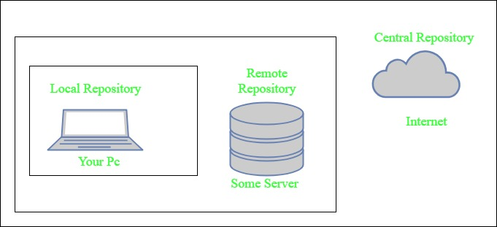

1. **Local repository-** A local repository is a directory on the machine of developer. This repository contains all the dependencies Maven downloads. Maven only needs to download the dependencies once, even if multiple projects depends on them (e.g. ODBC).  
   By default, maven local repository is user_home/m2 directory.  
   example – **C:\Users\<user_name>\.m2**
2. **Central repository-** The central Maven repository is created Maven community. Maven looks in this central repository for any dependencies needed but not found in your local repository. Maven then downloads these dependencies into your local repository. You can view central repository by going to (<https://search.maven.org/#browse>)
3. **Remote repository-** remote repository is a repository on a web server from which Maven can download dependencies.it often used for hosting projects internal to organization. Maven then downloads these dependencies into your local repository (**mvnrepository.com**.)