Institute of Computer Technology

B. Tech. Computer Science and Engineering

Sub: DS Branch: BDA Class: A

Name: Jatin Patel

Enrolment No.: 23162121029

Sem: 3

Class: A

Subject: DS

Practical: 02

Date: 04/08/24

Practical: 02

1. Calculator

Write a program that asks the user to enter two numbers, obtains them from the user and prints their sum, product, difference, quotient and remainder.

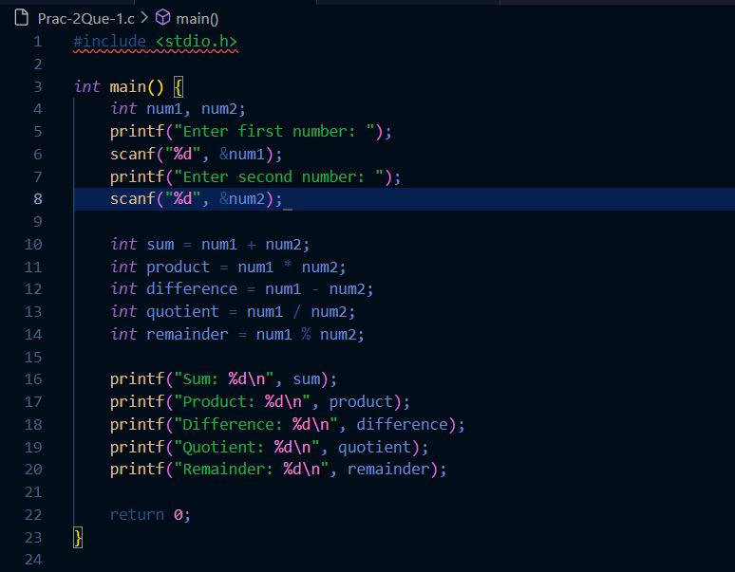

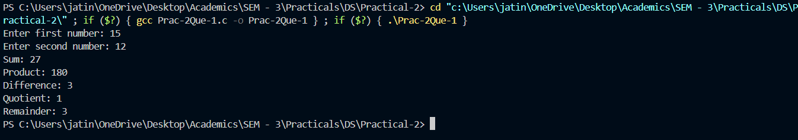

1. Cost Price Problem

Suppose, a user enters the total selling price of 15 items and the profit earned on the total. Write a program to find out the cost price of one item.

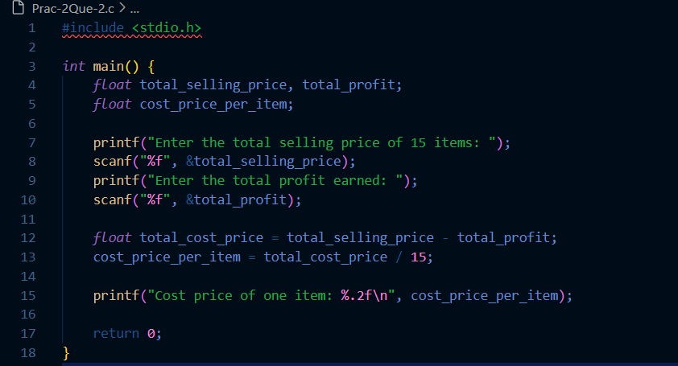

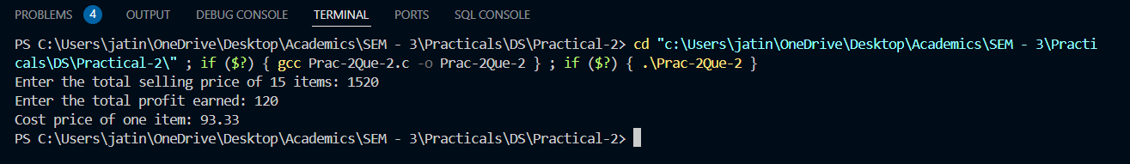

1. Separating Digits in an Integer

Write a program that inputs one five-digit number, separates the number into its individual digits and prints the digits separated from one another by three spaces each. [Hint: Use combinations of integer division and the remainder operation.]

For example, if the user types in 42139, the program should print Output: 4 2 1 3 9

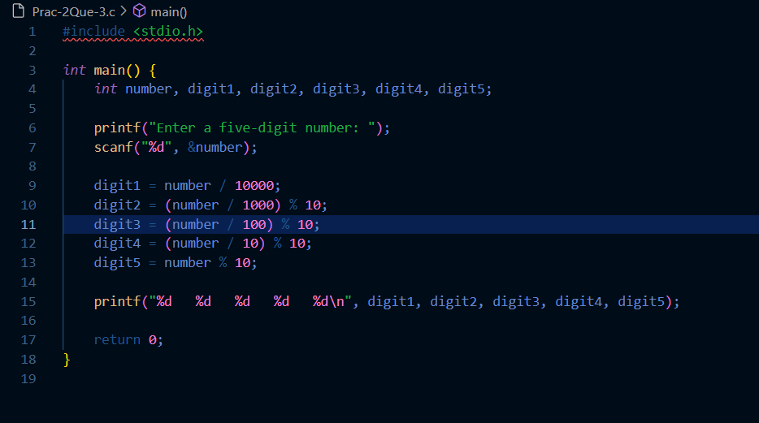

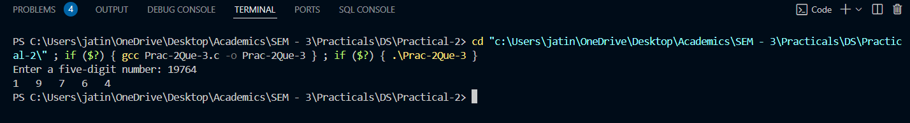

1. 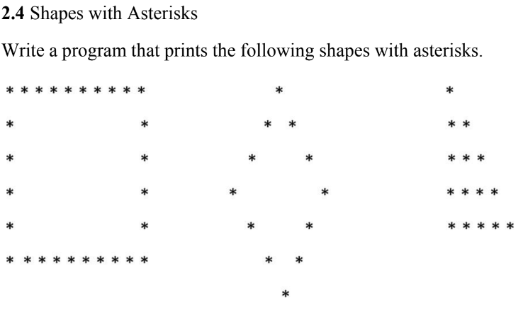

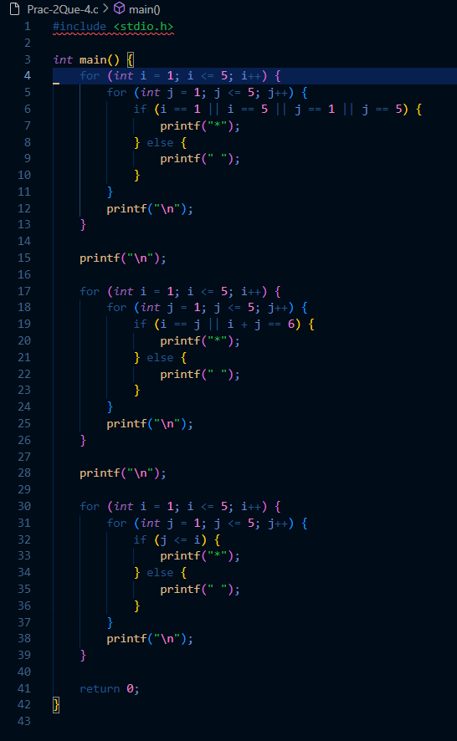

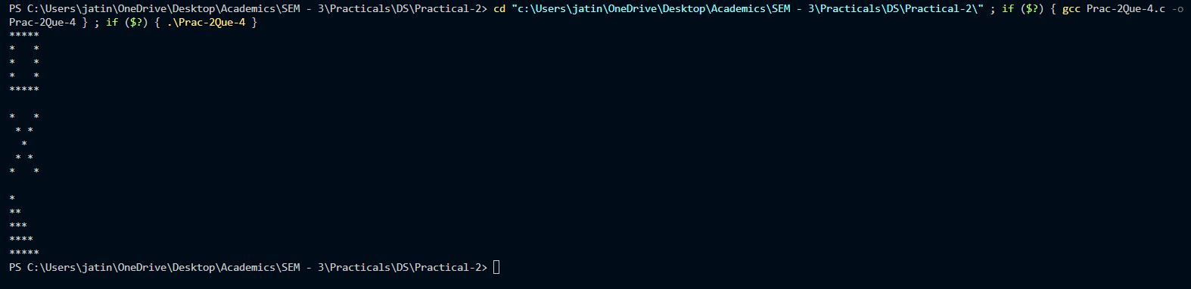

1. Diameter, Circumference and Area of a Circle Write a program that reads in the radius of a circle and prints the circle’s diameter, circumference and area. Use the constant value 3.14159 for π.

