Institute of Computer Technology

B. Tech. Computer Science and Engineering

Sub: DS Branch: BDA Class: A

Name: Jatin Patel

Enrolment No.: 23162121029

Sem: 3

Class: A

Subject: DS

Practical: 07

Date: 31/08/24

# **TOH**

Tower of Hanoi is a mathematical puzzle where we have three rods and n disks. The objective of

the puzzle is to move the entire stack to another rod, obeying the following simple rules:

1. Only one disk can be moved at a time.

2. Each move consists of taking the upper disk from one of the stacks and placing it on top of another stack i.e. a disk can only be moved if it is the uppermost disk on a stack.

3. No disk may be placed on top of a smaller disk. Design a program for Tower of Hanoi using recursion.

No of Disk =3 and no. of rod = 3

Take an example for 2 disks:

Let rod 1 = &#39;A&#39, rod 2 = &#39;B&#39, rod 3 = &#39;C&#39.

Step 1 : Shift first disk from &#39;A&#39; to &#39;C&#39.

Step 2 : Shift second disk from &#39;A&#39; to &#39;B&#39.

Step 3 : Shift first disk from &#39;C&#39; to &#39;B&#39.

The pattern here is :

Top Disk moved from A to C

Top Disk moved from A to B

Top Disk moved from C to B

**Input Format:**

3

**Output Format:**

Top Disk moved from A to B

Top Disk moved from A to C

Top Disk moved from B to C

Top Disk moved from A to B

Top Disk moved from C to A

Top Disk moved from C to B

Top Disk moved from A to B

**Input Code:**

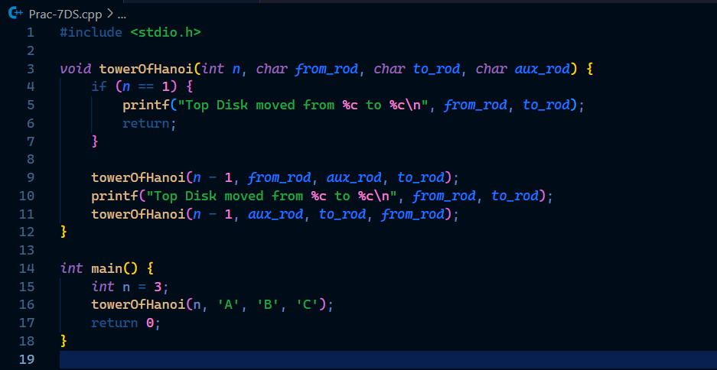

**Output:**

Here I entered 5 on the place of the numbers of disks and got this output that is shown in image.

