**Web Development Node.js Minor Project**

Now that you have learned quite a few things in Node, Express and MongoDB, its time for your Minor Project!

You have to build a TODO List app. In this app, users can create to-do lists, where they can add list of Tasks. The Task created by user then should be stored in the Database.

Under each list, you can add "Cards," which are items in a list. You can add a due date, a checklist and labels to each card.

You are free to explore more and add interesting features to your TODO app.

You can refer to the below image (Feel free to add additional features)

[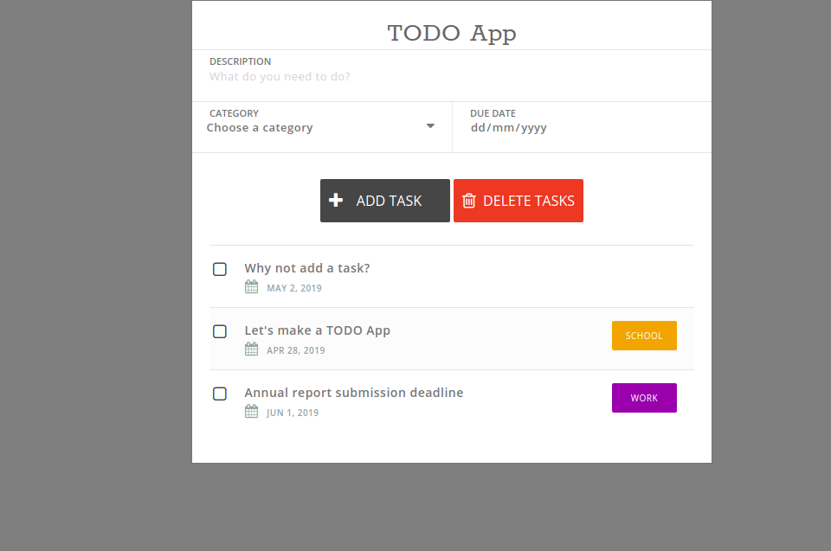](https://ninjasfiles.s3.amazonaws.com/0000000000002059.png)

[](https://ninjasfiles.s3.amazonaws.com/0000000000002063.gif)

Once you complete and submit your project, you will be scored according to the parameters provided below.

**Your project will be evaluated on following parameters -**

• Innovation (Max Score 10)

• Comments (Max Score 10)

• Code Quality - Setting up proper directory structure and neat code (Max Score 10)

• Basic Functionality (Max Score 20)