NIT HAMIRPUR

MOS Project (ME-211)
Final Report
Code in Python to analyse columns subjected to concentric loading based on various theories. The programme should be capable of identifying long and short columns, use various end conditions and comparing results based on different theories.
Group-10
23BME050- Jatin Sharma
23BME051 – Kashyap Saksham
23BME053 – Khushi Pandey
23BME054 – Komal Sharma
23BME055 – Krish Singhal
~Under the guidance of Prof. Rakesh Sehgal
Abstract

This project presents the development of a Python-based program for analyzing columns subjected to concentric axial loading, incorporating various buckling theories and accommodating different column end conditions. The program provides a comprehensive tool for engineers and researchers to assess column stability by calculating the critical buckling load for both long and short columns. The system classifies columns based on their slenderness ratio and applies classical and advanced buckling theories such as Euler’s theory, Rankine’s theory, and Johnson's empirical formula. The program is designed to handle a range of end conditions, including fixed, pinned, and free ends, offering flexibility for real-world scenarios. Python libraries such as NumPy and Matplotlib are utilized for numerical computations and plotting, respectively. By enabling the comparison of results across different theories and end conditions, the program assists in determining the most suitable design approach based on specific column parameters, such as length, cross-sectional area, material properties, and boundary conditions. The tool provides a user-friendly interface for fast and accurate calculations, helping optimize column design and improve safety and efficiency in structural engineering applications. Through this project, the program demonstrates its effectiveness in aiding the analysis of column stability, offering practical insights for both theoretical study and applied engineering design.

Introduction

Columns:
Columns are essential vertical members that carry compressive loads. They transfer loads from beams or slabs down to the foundation. Columns play a vital role in maintaining the stability and integrity of a structure. Depending on the load, columns are designed to resist buckling and crushing. The capacity of a column to support loads depends on its material properties, cross-sectional dimensions, length, and the way it is restrained at the ends
Categories of columns:
Columns can generally be categorized based on their slenderness ratio into short columns and long (or slender) columns. The behaviour of these two types under loading conditions differs significantly, which affects how they are designed and analysed.
• Short columns: Have a slenderness ratio of less than 32 or a length to diameter ratio of less than 8. Short columns are stiffer than long columns and are more likely to support more load. They are also less likely to buckle and are designed based on crushing strength.
• Long columns: Have a slenderness ratio of more than 120 or a length to diameter ratio of more than 30. Long columns are more likely to buckle and less likely to support more load. Their design is adjusted using a reduction coefficient to account for buckling.
Slenderness Ratio (λ): It is ratio of length of column and least radius of gyration of its cross section. It is used extensively for finding out the design load as well as in classifying various columns in short/intermediate/long columns.
λ = L/r Where, L = the length of the column, r=radius of gyration.
Short columns have a slenderness ratio of less than 32. such columns are always subjected to direct compressive stresses only and fails by crushing.
Medium columns have a slenderness ratio between 32 to 120.
Long columns have a slenderness ratio of more than 120 it fails by buckling.

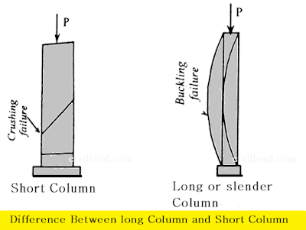
Different theories used:
. Euler's Buckling Theory (Elastic Buckling)
- Description: Euler's theory is used for long, slender columns where the material behaves elastically. It describes the critical load (also known as the buckling load) at which the column will fail due to buckling. This load is calculated based on the column's length, cross-sectional moment of inertia, and the material's Young's modulus.
- Formula: $Pcr=\frac{π^{2}EI}{\left(KL\right) ^{2}}$

Where:
  - Pcr​ = Critical buckling load
  - E = Young’s modulus
  - I = Moment of inertia of the column cross-section
  - L = Effective length of the column
- Assumptions: The column is perfectly straight, the material is homogeneous and isotropic, and the loading is perfectly axial.
2. Rankine's Formula (Empirical Theory)
- Description: Rankine's formula is a combination of Euler's formula and an empirical correction for short columns. It accounts for both the axial compressive strength and the buckling tendency. This formula is used when the column's length is relatively short, where the effects of axial load and material strength cannot be neglected.
- Formula: $Pcr=\frac{Aσy}{1+{\left(L/r\right)}^{2}}$Where:
  - A = Cross-sectional area
  - σy ​= Yield strength of the material
  - L = Length of the column
  - r = Radius of gyration (r= sqrt{I/A})
- Assumptions: Rankine's formula is valid for both short and long columns, and it is a useful approximation when detailed analysis isn't required.
3. Johnson’s Parabolic Formula
- Description: This is another empirical formula that is often used to predict the buckling strength of short columns, particularly when neither pure compression nor pure buckling is the primary failure mode.
- Formula: $Pcr =σy​⋅A\left(1-c\left(\frac{L}{r}\right)\right)$ Where:
  - l/r= Effective length /radius of gyration
- Assumptions: It's based on a parabolic curve that transitions from yielding to elastic buckling.
Various end conditions:
- Both ends pinned/hinged.
Le=L
- one end fixed and other free.
Le=2L
- Both ends fixed.
Le=L/2
- One end fixed and other pinned.
Le=l/sqrt2

Code Overview
The code written is a Column Analysis Program built using Python, where the user can input parameters for a column (length, cross-section, material properties, etc.), and it will calculate the critical loads (Euler, Rankine, and Johnson) and display the results in a user-friendly graphical interface. Additionally, the program can plot the critical loads for multiple columns to compare their buckling capacities.
Libraries
- Matplotlib: Used for plotting graphs.
- Numpy: Used for numerical calculations.
- Tkinter: It is used for creating interactive applications with graphical interfaces.
Class Column
A central class to represent the Column and its attributes.
Attributes:
- length: The length of the column (in meters).
- Outer radius: The outer radius of the column (in meters), used for circular cross-sections.
- Inner radius: The inner radius of the column (in meters), used for hollow circular cross-sections.
- modulus: The modulus of elasticity (in Pascals), representing the material stiffness.
- Yield strength: The yield strength of the material (in Pascals).
- End condition: Defines the boundary conditions at the ends of the column (e.g., pinned, fixed).
- Cross section: Specifies the column's cross-sectional shape (e.g., circular, hollow circular, I, hollow I).

Methods:
1.__init__(self, length, outer_radius, inner_radius, modulus, yield_strength, end_condition, cross_section, h=None, b=None, t_f=None, t_w=None)
Initializes the column with given attributes such as length, radii, material properties, end condition, and cross-section type. Also sets optional parameters for an I-section if applicable. Automatically calculates the column's properties upon initialization.
2.calculate_properties(self)
Calculates the column's cross-sectional area and moment of inertia based on the specified cross-section type (e.g., circular, hollow circular, or I-section). These properties are used in further calculations.
3.critical_load_euler(self)
Calculates the Euler critical load, which is the maximum load a column can bear before buckling, based on the modulus of elasticity, moment of inertia, length, and end condition.
3.get_effective_length_factor(self)
Returns the effective length factor (k) based on the end condition of the column. This factor adjusts the column's length for critical load calculations.
4.radius_of_gyration(self)
Calculates and returns the radius of gyration for the column, which is a measure of how the cross-section is distributed around its centroid.
5.critical_load_rankine(self, rankine_constant)Calculates the Rankine critical load, which considers both material strength and column geometry for intermediate-length columns. Uses the Rankine constant in the formula.
6.critical_load_johnson(self)
Calculates the Johnson critical load for short, compact columns using an empirical approach based on the yield strength and slenderness ratio.
7.slenderness_ratio(self)
Calculates and returns the slenderness ratio of the column, a dimensionless number that indicates the likelihood of buckling based on column length and radius of gyration.
8.column_type(self)
Classifies the column as "Short," "Intermediate," or "Long" based on its slenderness ratio.
9.analyze(self, rankine_constant, factor_of_safety)
Analyzes the column by calculating critical loads (Euler, Rankine, and Johnson), slenderness ratio, and radius of gyration. Also computes safe loads for each method by applying the specified factor of safety. Returns a tuple containing all results for further use.
10.plot_critical_loads(column)
Plots a bar chart comparing the critical loads calculated by Euler, Rankine, and Johnson theories for the given column.
11.ColumnAnalysisApp.__init__(self, master)
Initializes the Tkinter-based application window for column analysis. Sets up UI components for user inputs, analysis, and plotting options.
12.ColumnAnalysisApp.create_widgets(self)
Creates UI input fields and buttons for the column analysis application. Sets up widgets dynamically based on the chosen cross-section type.
13.ColumnAnalysisApp.create_i_section_widgets(self)
Defines additional UI widgets specifically for I-section columns (e.g., height, flange width, thicknesses). These fields are displayed only if the I-section cross-section is selected.
14.ColumnAnalysisApp.analyze_column(self)
Fetches user inputs, initializes a Column object, and calculates the column's properties. Displays a detailed analysis result in a popup message.
15.ColumnAnalysisApp.plot_column(self)
Generates a plot comparing critical loads if the column has been analyzed. Alerts the user if no data is available.
16.ColumnAnalysisApp.get_float_value(self, value)
Converts a string value to a float. Raises an error if the input is invalid, ensuring correct data entry.
17.ColumnAnalysisApp.on_cross_section_change(self, *args)
Updates the UI based on the selected cross-section. Displays or hides I-section input fields dynamically.
Input Section:
- Length (m):
- The user is prompted to enter the column's length in meters. This input is converted to a floating-point number and stored in the length variable. The length is used in calculations related to column stability and load capacity.
- Outer Radius (m):
The user inputs the outer radius of the column in meters, which is converted to a floating-point number and stored in the outer_radius variable. This radius is used to calculate the cross-sectional area and moment of inertia, especially for circular cross-sections.
- Inner Radius (m):
The user provides the inner radius of the column (for hollow circular sections) in meters, converted to a floating-point number and stored in the inner_radius variable. This is used to calculate the properties of hollow circular cross-sections.
- Modulus (Pa):
The user enters the modulus of elasticity of the column material in Pascals. The value is converted to a floating-point number and stored in the modulus variable. This modulus is crucial for determining the column's stiffness and critical load.
- Yield Strength (Pa):
The yield strength of the column material, in Pascals, is entered by the user. This value is converted to a floating-point number and stored in the yield_strength variable. It helps calculate the critical load for different failure theories.
end_condition variable and is used to adjust the effective length factor in buckling calculations.

- Cross-Section Type:
The user selects the cross-section type (e.g., "circular," "hollow_circular," or "i_section") from a dropdown menu. This selection is stored in the cross_section variable and determines which formula to use for calculating the area and moment of inertia.
- Rankine Constant:
The Rankine constant, used in the Rankine formula for critical load, is entered by the user, converted to a floating-point number, and stored in the rankine_constant variable.
- Factor of Safety:
The user inputs the factor of safety for the analysis, converted to a floating-point number and stored in the factor_of_safety variable. This factor is used to calculate safe loads for each buckling theory.
- I-Section Parameters (if applicable):
If the cross-section type is set to "i_section," additional inputs are required:
- Height (m): The user enters the I-section height, stored in h.
- Flange Width (m): The flange width is entered and stored in b.
- Flange Thickness (m): The flange thickness is entered and stored in t_f.
- Web Thickness (m): The web thickness is entered and stored in t_w.
These inputs are essential end_condition variable and is used to adjust the effective length factor in buckling calculations.
Execution of code
The steps followed to execute the code are as follows:

Step 1: Setup the Environment
Ensure that you have numpy, matplotlib, and tkinter installed. numpy and matplotlib are typically installed with most Python installations, but you can install them via pip if needed:
pip install numpy/matplotlib

Step 2: Define and Correct Initialization
- Check the __init__ function name in the Column and ColumnAnalysisApp classes. Replace _init_ with __init__ so that Python recognizes them as initializer methods.

Step 3: Review and Run the Code
- Import the Required Libraries: The code uses numpy for mathematical calculations, matplotlib for plotting, and tkinter for the GUI interface.
- Define Classes:
  - Column for the properties and calculations related to the column.
  - ColumnAnalysisApp for the GUI app to input data, run the analysis, and display results.
- Input Data:
- Launch the application by running the script in a Python environment.
- Fill out each input field in the GUI:
  - Length, Outer Radius, Inner Radius: Basic column dimensions.
  - Modulus, Yield Strength: Material properties.
  - End Condition: Type of column support (choose from "pinned", "fixed", etc.).
  - Cross-Section: Column cross-section type (e.g., "circular", "hollow_circular", or "i_section").
  - Rankine Constant, Factor of Safety: Additional parameters for analysis.
- Optional I-Section Parameters:
- If using an I-section cross-section, fill in additional fields such as height, flange width, flange thickness, and web thickness.
- Analyze the Column:
- Press Analyze to calculate critical loads, slenderness ratio, column type, and other properties.
- Results will be displayed in a message box with values for each parameter.
- Plot the Results:
- After analysis, press Plot to generate a bar chart comparing the critical loads based on Euler, Rankine, and Johnson theories.

Step 4: Interpret Results
The output includes critical loads, slenderness ratio, column type, cross-sectional area, and other properties. The plot visually compares the loads calculated by different buckling theories
Step 5 : Visual Representation :
- The output is visually represnt by the plotting of graph .
- Tkinter: It is used for creating interactive applications with graphical interfaces.

Analysis and results:
Solving a question from the python code to verify the code:

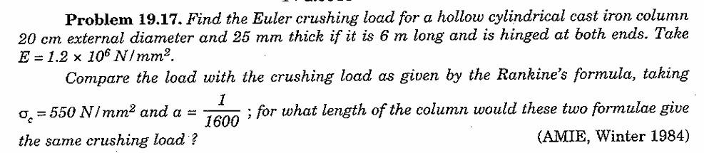

Let’s solve this question for the hollow cylindrical cast iron to verify our code.
Now first fill up all the data for the column in the code as shown below:
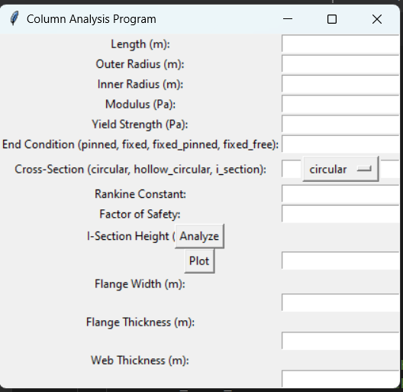
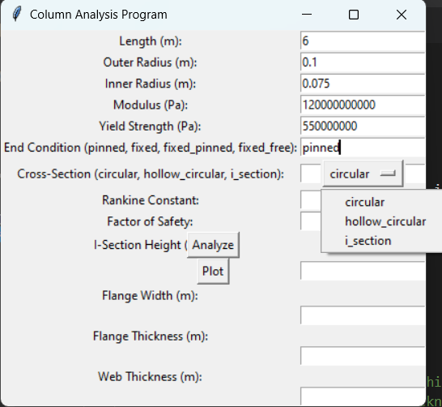
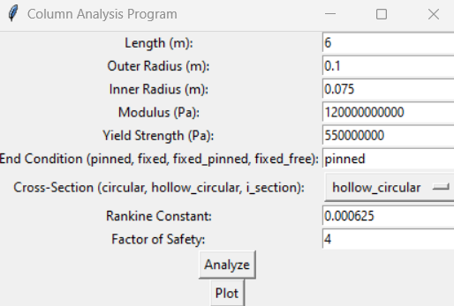
As we fill the above data accordingly in all the respective columns and click on Analyze button we get output as message box giving the output as critical loads for all theories, slenderness ratio and other results.
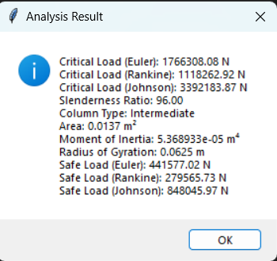

Now after analysing if we click on plot button, the code will generate graph for comparison of loads by various theories for the data provided as shown in the figure:
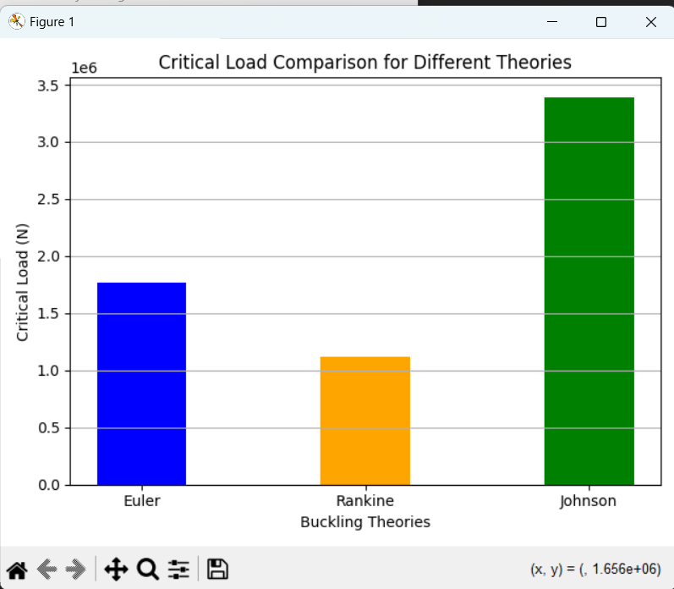

Bibliography

1.Class Notebook
Description: Course notes for Mechanics of Solids.
Citation: Theory of column analysis , Mechanics of Solids, Class Notes, National Institute of Technology, Hamirpur.

2.YouTube Channel
Description: Python programming tutorials related to shear force and bending moment diagrams.
Citation: CodeWithHarry, "Plotting graphs in python”," YouTube”

3.Python Documentation
Description: Official Python documentation for understanding Python libraries used in the project.
Citation: Python Software Foundation, "Python Documentation," Available at: https://docs.python.org

4. Textbook Reference (for structural analysis)
Description: A reference book on mechanics of materials that provides theoretical background for beam analysis.
Citation: Hibbeler, R.C., Mechanics of Materials, 10th ed., Pearson, 2017.

Contributions for the project
- Logic building of the code and basic structure of the code –Jatin Sharma(23bme050)
- Modifications and editing in the code –Khushi Pandey(23bme053)

- Interactive interface building and resolving errors in code Jatin Sharma(23bme050) & Kashyap Saksham (23bme051)
- Pen and paper work for the calculations involved in the code and help in building interactive interface of the code – Jatin Sharma(23bme050)
- Report writing – Komal Sharma (23BME054)
- Modification and editing of the report and suggesting additions in report – Krish Singhal (23bme055)

