Mini-Trello Kanban Board
Task Management Application
Project Report
____________________________________________________________

Student ID: 230390116025
Course: Agile Development & UI/UX Design
Date: September 2026

Project | Mini-Trello Kanban Board
Student Name | Jatinsinh Solanki
Enrollment Number | 230390116025
Team | Individual
Semester | 7th Semester

1. Project Overview
Mini-Trello is a simple, modern, responsive single-page Kanban task-management application. Users can create tasks, view them grouped by status, move tasks between columns using button controls or drag-and-drop, and delete tasks with an inline confirmation. A live animated gradient background shifts through a purple colour palette, and the app supports both Light and Dark themes.
The project was developed as a full-stack application: a React frontend (Vite, port 5173) communicates with a Flask REST API backend (port 5000) via a Vite dev proxy. Tasks are stored in a relational database (SQLite for local development, MySQL for production) using SQLAlchemy. All CRUD operations are persisted; refreshing the browser preserves state.

2. Objectives
- Build a task-management board with three columns (To Do, In Progress, Done) and create/move/delete flows.
- Implement drag-and-drop between columns (HTML5 DnD) and animated card transitions.
- Implement a RESTful API (GET, POST, PUT, DELETE) with JSON request/response.
- Store tasks in a real database with persistence across restarts.
- Add a live animated gradient background that shifts through a purple colour palette.
- Provide a one-click startup experience (INSTALL.bat / START.bat) for Windows.
- Integrate a React frontend with a Flask backend over HTTP.
- Apply Agile/Scrum methodology with two one-week sprints.

3. Technology Stack
Layer | Technology
Frontend | React 19, JavaScript (ES2020+), CSS3 (custom properties, animations), Vite 6
Backend | Python 3.13, Flask 3, Flask-CORS, Flask-SQLAlchemy
Database | SQLite (local dev) / MySQL (production), SQLAlchemy ORM
API | RESTful, JSON request/response
Testing | Pytest (26 backend cases), Playwright (23 browser E2E checks)

4. System Architecture
The application follows a two-tier client-server architecture with a clear separation of concerns:
Browser (React SPA)
| fetch() -> http://localhost:5173/api/* (Vite proxy -> Flask)
v
Flask REST API (backend, port 5000)
| SQLAlchemy
v
Database (SQLite / MySQL)
In development, the Vite dev server proxies /api/* requests to the Flask backend at port 5000, so the frontend only needs to call /api/tasks without worrying about cross-origin issues.

5. Database Design
The application uses a single tasks table:
Column | Type | Notes
id | INT (PK, AI) | auto-increment primary key
title | VARCHAR(200) | required
description | TEXT | required
status | VARCHAR(20) | todo / in_progress / done
created_at | DATETIME | set automatically
updated_at | DATETIME | updated on change
The MySQL creation script is database/schema.sql. Tables are created automatically by the backend on startup using SQLAlchemy's create_all().

6. UI Design & Theming
The final UI is a modern purple-based design system. Every colour and shadow is defined once as a CSS custom property (design token) in styles.css; nothing is hardcoded in components.

6.1 Theme Support
- Dark Mode (default / signature): purple-black background, raised purple surfaces, high-contrast text, and purple accent buttons.
- Light Mode: soft lavender background with white cards and the same purple accent, fully readable with matching status badges.
- Segmented theme selector (Light | Dark) in the header; choice is saved under mini-trello-theme in localStorage and restored on load.

6.2 Animated Background
A live animated gradient background flows through the five-colour purple palette (#05010A, #3B0764, #7C3AED, #A855F7, #E9D5FF). The background consists of two layers:
- body::before — a 320%-wide linear gradient that pans left-to-right via bg-flow animation, while a hue-drift filter rotates the colours through the colour wheel (32-second cycle).
- Glow orbs — four radial-gradient layers (purple, blue, pink, teal) that drift via orb-drift animation (30 seconds), adding depth and movement.
In Light Mode, the same gradient uses softer pastel tones. Both themes respect prefers-reduced-motion for accessibility.

6.3 Drag & Drop
Cards are draggable via native HTML5 DnD. When dragging:
- The dragged card dims to 40% opacity.
- The target column highlights with a purple ring and glow.
- Empty columns show 'Release to drop here'.
- On drop, the card animates into the column with a bounce-in entrance and purple glow flash.

6.4 Card Transition Animations
When the Next/Previous button is clicked:
- The card plays a 260ms slide-right and fade-out (card-leave keyframes).
- The card then mounts in the destination column with a 500ms scale-drop entrance (card-in keyframes) and purple glow flash.
- Animations respect prefers-reduced-motion for users who prefer reduced motion.

7. User Stories & Product Backlog
- US1 (High, 5 pts): Create a new task and add it to the board.
- US2 (High, 3 pts): See all tasks grouped by status (To Do, In Progress, Done).
- US3 (High, 5 pts): Move tasks forward/backward using Next/Previous buttons.
- US4 (Medium, 3 pts): Delete a task with an inline confirmation dialog.
- US5 (High, 5 pts): Drag and drop tasks between columns.
- US6 (Medium, 3 pts): Live animated background with a purple colour palette.
- US7 (Low, 2 pts): One-click startup scripts (INSTALL.bat / START.bat) for Windows.
Total estimate: 26 story points. Full acceptance criteria in docs/PRODUCT_BACKLOG.md. Sprint 1 owns US1 + US2 (foundation). Sprint 2 owns US3-US7 (integration and polish).

8. Sprint 1 — Foundation & Setup
- Goal: working database, GET/POST APIs, static board UI.
- Designed the tasks schema and created the database (schema.sql).
- Implemented the Task model with status validation and a DB constraint.
- Implemented and tested GET /api/tasks and POST /api/tasks.
- Scaffolded the React + Vite frontend with the three-column board UI.
- Created the centralized API service (services/api.js) for all HTTP calls.
- Deliverable: working database, GET/POST APIs testable via Postman, static UI.

9. Sprint 2 — Integration & Delivery
- Goal: complete integration, advanced features, and deliver the product.
- Implemented PUT /api/tasks/:id and DELETE /api/tasks/:id with 404 handling.
- Connected the frontend through the centralized API service.
- Implemented create, move (Next/Previous), and delete with confirmation.
- Added loading states, error banners, frontend validation and responsive polish.
- Implemented drag-and-drop between columns (HTML5 DnD) with visual feedback.
- Added card transition animations: slide-out / bounce-in on move.
- Added a live animated gradient background (purple palette, hue-drift, glow orbs).
- Created one-click startup scripts (INSTALL.bat, START.bat) for Windows.
- Redesigned the UI to the purple design system with Light/Dark themes and localStorage persistence.
- Wrote and ran 26 pytest cases and 23 browser E2E checks; captured fresh screenshots.
- Prepared README, this report, and the source ZIP.

10. REST API Documentation
BASE URL: http://localhost:5000/api
Errors are returned as {"error": "<message>"} with status 400 (validation), 404 (not found), or 500 (server error).
Method | Endpoint | Purpose | Request Body | Response | Status
GET | /tasks | List all tasks | -- | {"tasks": [...]} | 200 OK
POST | /tasks | Create a task | {"title","description"} | created task object | 201 Created
PUT | /tasks/:id | Update status | {"status"} | updated task object | 200 OK
DELETE | /tasks/:id | Delete a task | -- | {"message": "Task N deleted"} | 200 OK

Sample Request / Response
POST http://localhost:5000/api/tasks
{"title": "Create UI", "description": "Build the Mini-Trello interface"}
Response (201 Created):
{"id": 1, "title": "Create UI", "description": "Build the Mini-Trello interface", "status": "todo"}
Validation rules:
- title — required, must not be blank after trimming.
- description — required, must not be blank after trimming.
- status — must be one of todo, in_progress, done (enforced by DB constraint).
- New tasks always start with status = "todo".

11. Testing

11.1 Backend Unit Tests (Pytest)
Command: python -m pytest -q → 26 passed.
Covers: GET (empty + populated), POST (valid, empty/missing/whitespace title, empty/missing description, non-JSON), PUT status/title/description, invalid status, 404 for missing tasks, DELETE (success, 404, isolation), status transitions, and multi-task retrieval.

11.2 End-to-End Browser Tests (Playwright)
Live API verified against the running server (create → move → delete → refresh). Browser E2E assertions (scripts/e2e_check.py, Playwright) cover the full board flow plus theme switching and persistence. Result: 23/23 checks passed.

11.3 Manual Verification
- Real browser flow screenshots captured in both themes (see Section 12).
- Persistence proven: tasks and status changes survive a full server restart.
- Drag-and-drop verified: cards move between columns and persist in database.
- Card animations verified: smooth slide-out / bounce-in transitions on every move.
- Animated background verified: colour shift visible in both Dark and Light themes.

12. Screenshots
All screenshots below were captured from the live application using Playwright (real browser, live API, real database).
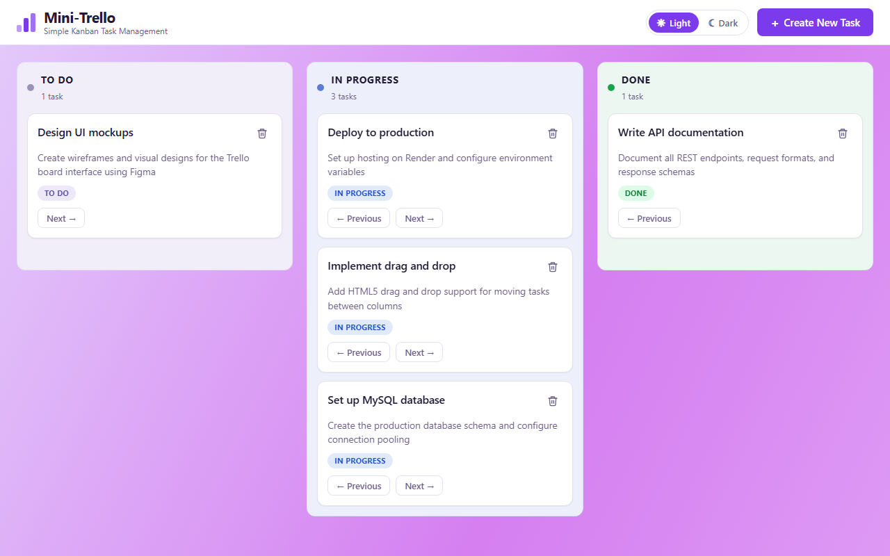
Figure 1 — Main board (Light theme)
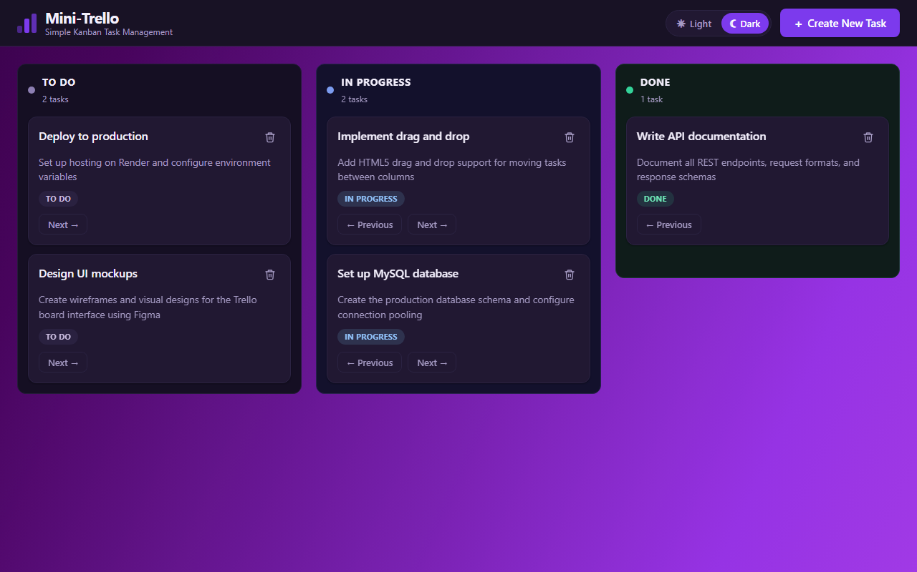
Figure 2 — Main board (Dark theme, signature)
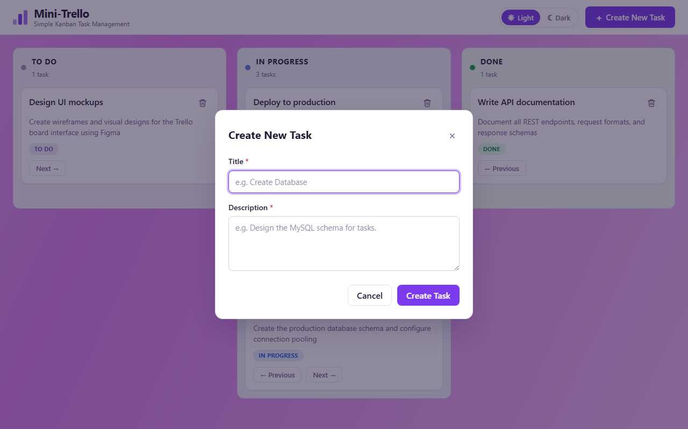
Figure 3 — Create New Task modal (Light)
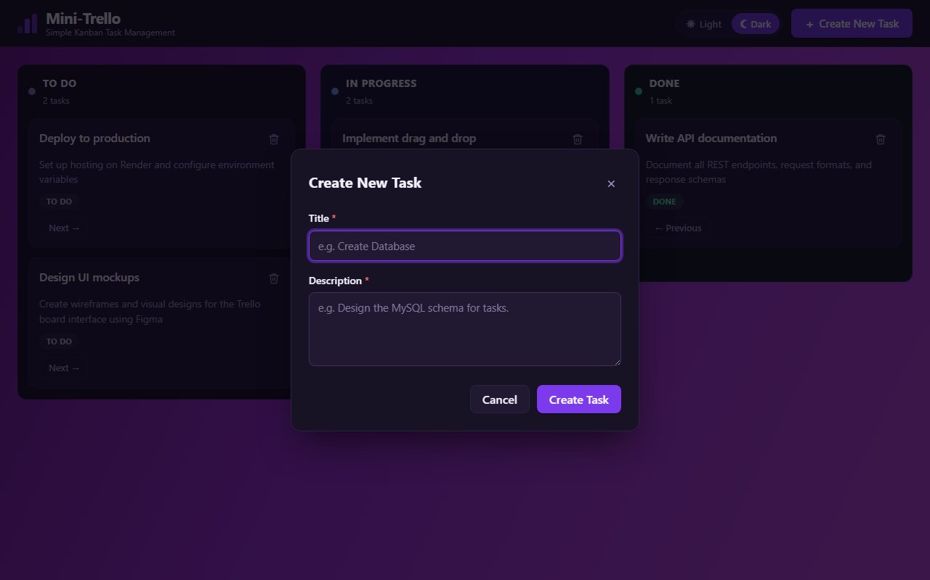
Figure 4 — Create New Task modal (Dark)
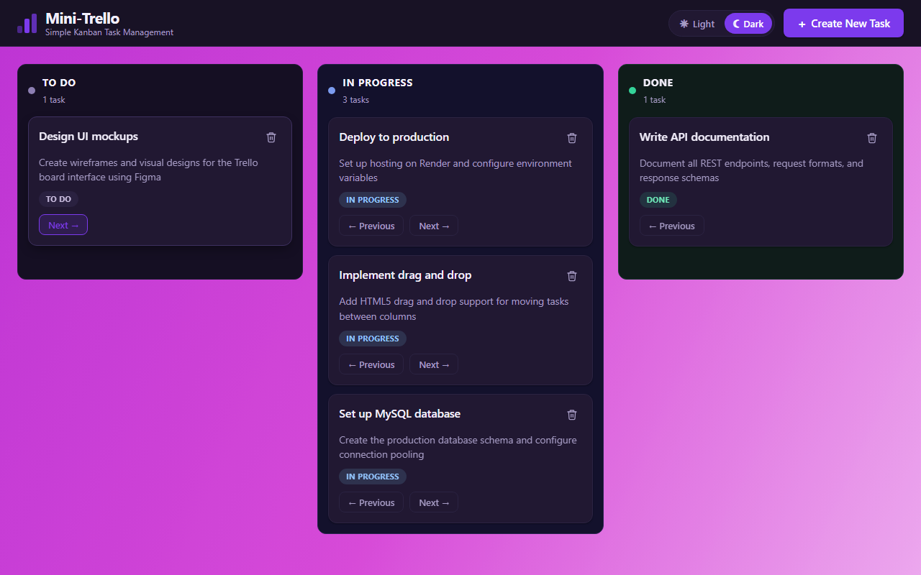
Figure 5 — Task moved between columns (animated transition)
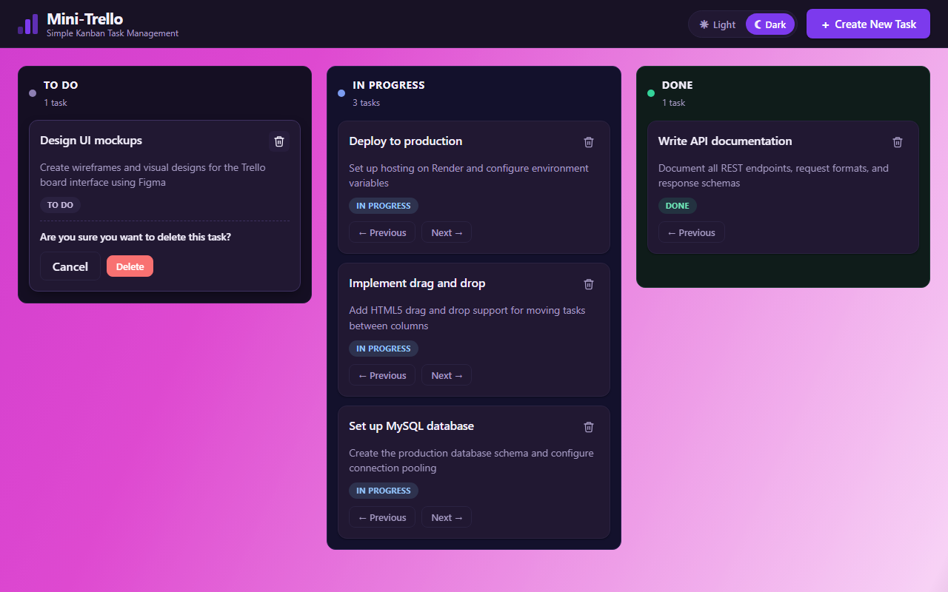
Figure 6 — Delete confirmation dialog
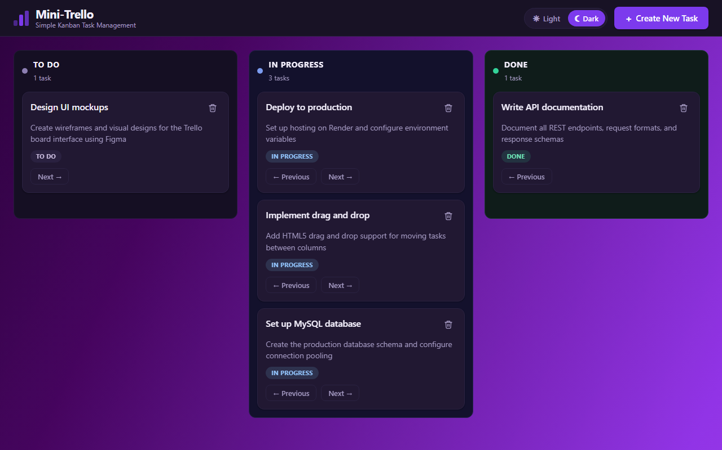
Figure 7 — Board with tasks across all columns
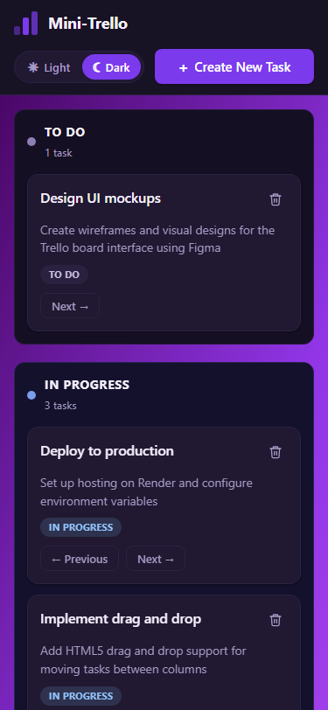
Figure 8 — Responsive mobile layout (Dark theme)
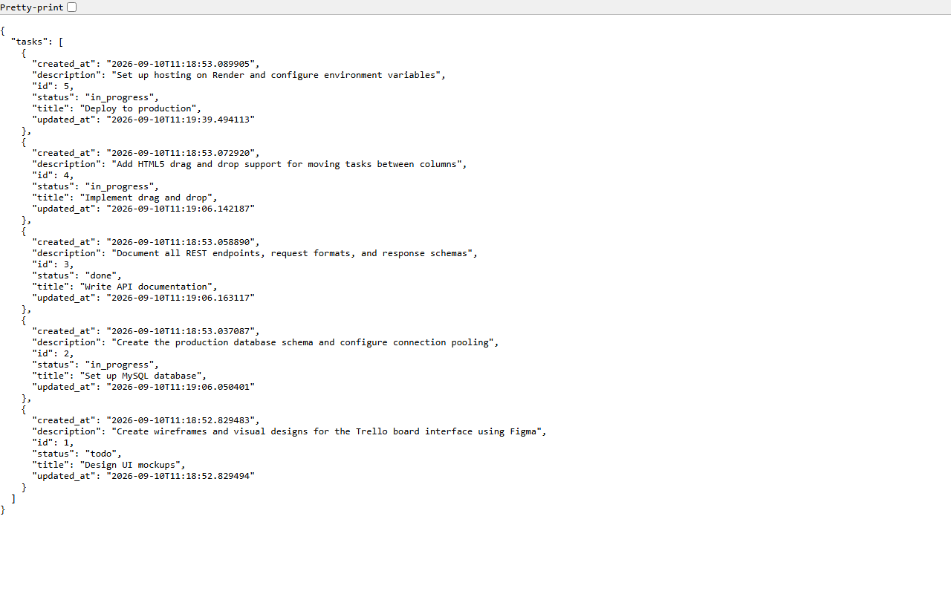
Figure 9 — REST API JSON response (live data)

13. Agile Execution Summary
The project followed two one-week sprints with planning, daily stand-ups, a sprint review, and a sprint retrospective.
 | Sprint 1 | Sprint 2
Duration | Week 1 | Week 2
Goal | Foundation: schema, APIs, static UI | Integration: DnD, animations, themes, testing
Deliverables | GET/POST APIs, React board, DB schema | Full app: CRUD, DnD, themes, 26+23 tests, report

14. How to Run the Project

Option A: One-Click (Windows)
- Prerequisites: Python 3.9+ (check 'Add Python to PATH') and Node.js 18+.
- Double-click INSTALL.bat (first time only — installs all dependencies).
- Double-click START.bat (starts both servers and opens the browser).
- The browser opens automatically at http://localhost:5173.

Option B: Manual (Two Terminals)
Terminal 1 — Backend:
cd backend
pip install -r requirements.txt
python run.py
Terminal 2 — Frontend:
cd frontend
npm install
npm run dev
Both servers must be running simultaneously. The frontend on port 5173 proxies API requests to the Flask backend on port 5000.

15. Future Improvements
- In-place card editing (edit title/description without reloading).
- Optional assigned_to field and assignee filters.
- Search, filters and pagination.
- Drag-and-drop reordering within the same column.
- Deployment to free hosting platforms (Render/Railway for backend, Vercel/Netlify for frontend).

16. Conclusion
Mini-Trello successfully delivers a full-stack Kanban task management application. The React frontend provides a polished, responsive UI with Light/Dark theme support, an animated gradient background, drag-and-drop task management, and smooth card transition animations. The Flask backend exposes a clean RESTful API backed by SQLAlchemy ORM and a relational database. Automated testing (26 pytest + 23 Playwright checks) validates the entire stack. The project was executed following Agile/Scrum methodology across two sprints, and ships with one-click startup scripts for easy deployment on any Windows machine.

