Table of Contents

1. Executive Summary: 1

2. Objective 1

3. Data Source: 1

4. Tools and Techniques: 2

5. Predictive Analysis: 3

4.1 Data Preparation 3

4.2 Data Understanding 4

4.3 Estimate Generation: 5

4.3.1 Simple Moving Average 5

4.3.2 Exponential Smoothing Using Holt Winters 6

4.3.3 ARIMA Model 7

4.4 Evaluating Models & Estimates: 9

6. Conclusion: 10

7. References: 11

# Executive Summary:

The report serves purpose of understanding the nature of various factors/sectors with respect to Nominal GDP and generate timely estimates of nominal GDP at the same level of industry. We are using the historical dataset which provides important indicators of production efficiency and business performance in Canadian industries given by statistics Canada to analyze the contribution proportion of the factors/sectors to GDP so that the future value can be predicted and acted.

# Objective

The timely estimates of Nominal GDP for Canada include narrowing down our approach and focusing on GDP values from the list of multi productivity factors available in the dataset. The data we are dealing involves a timely measure (year), hence considering to be “Time-Series data”. While the time component adds additional information, it also makes time series problems more difficult to handle compared to many other prediction tasks.

We will be implementing time-series forecasting techniques on the given data as they help us in making predictions. There are several types of models that can be used for time-series forecasting. For this study, we are using three types of techniques namely Simple Moving Average, Exponential Smoothing and Arima. The error values are later compared between the 3 techniques and decide the better fit with smaller error and wrapping by forecasting Nominal GDP for 10 years i.e. 2016-2025.

# Data Source:

We initiated the study with the datasets provided by statistics Canada, which provides essential indicators of production efficiency and business performance in industries.

<https://www150.statcan.gc.ca/t1/tbl1/en/tv.action?pid=3610020801>

Statistics Canada has provided the "Multifactor productivity, value-added, capital input and labour input in the aggregate business sector and major sub-sectors, by industry" data for 1961-2015.

The data metrics used to analyse this pattern is as under:

|  |  |
| --- | --- |
| **Metric Name** | **Definition** |
| REF_DATE | Reference year for GDP measurement |
| Multifactor productivity and related variables | Different factors related to GDP |
| North American Industry Classification System (NAICS) | Various Industry Sectors |
| SCALAR_FACTOR | Reference units corresponding to values |
| VALUE | Scale or measure of each variable |

Table 1: Data Metrics

# Tools and Techniques:

Our prediction analysis adopts the below tools and techniques including data preparation and preprocessing using Excel, timeseries forecasting using different algorithms like ARIMA, simple moving average in R studio (R language) and finally visualizing the results to get the timely estimates.

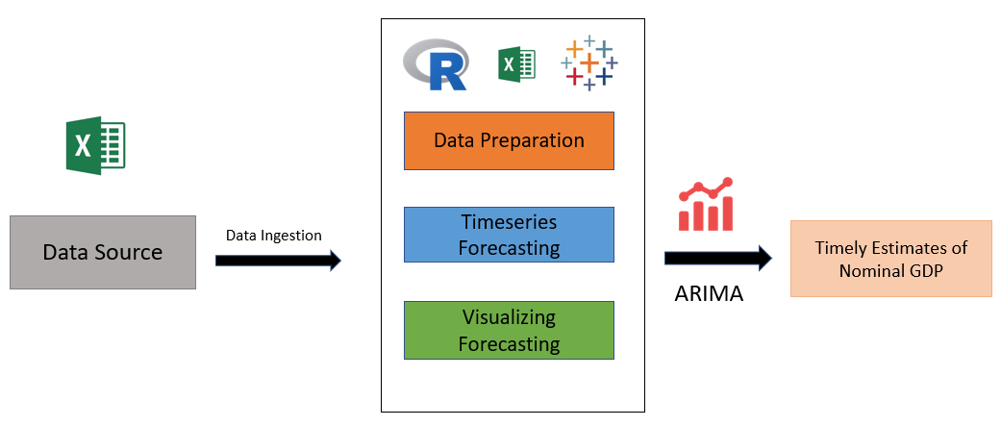

Figure 1 Tools and Techniques

# Predictive Analysis:

## 4.1 Data Preparation

As a part of preparing data to generate timely estimates of Nominal GDP, we aggregated the yearly GDP values for all sectors resulting in the total Nominal GDP for a given year.

**Data before aggregation:**

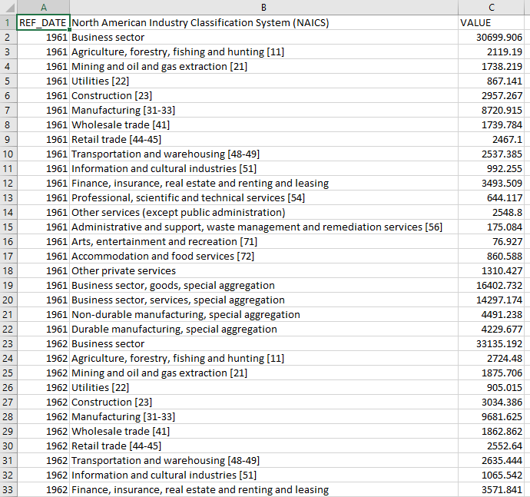

Figure 2 Data before aggregation

**Data after aggregation:**

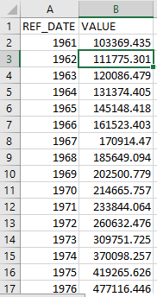

Figure 3 Data after aggregation

**Null Value Imputation**

As a part of data preparation, we have substituted the **Null Values** with the mean of total values if there were any.

## 4.2 Data Understanding

To better understand the data provided we visualize the data point to find the trend. In the below graph it can be clearly observed that the GDP value (in Dollars) has increased from year 1961 till 2015, however, it was not a linear increase.

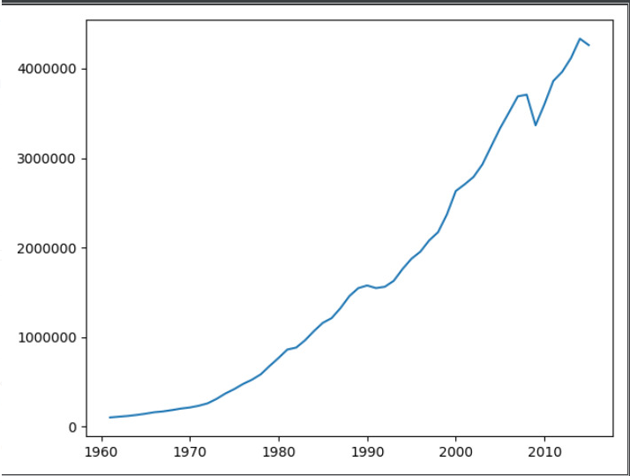

Figure 4 GDP in Dollars VS Time in Years

## 4.3 Estimate Generation:

Now given that the data ready is ready to be used for forecasting, we implemented various Time Series Algorithms using R on the dataset.

### 4.3.1 Simple Moving Average

To start with, we implemented a **Simple Moving Average** algorithm to see the trend and generate estimates for GDP for the next 10 years i.e. 2016 to 2025.

As an initial step, we created a time series object using the ‘ts’ function in R, and we have specified the frequency=1 as the data has yearly patterns, furthermore, we specify the start and end year in our time-series object as below:   


Next, we move on creating a Simple Moving Average model for the given time-series object and forecasted the GDP values for the next 10 years.

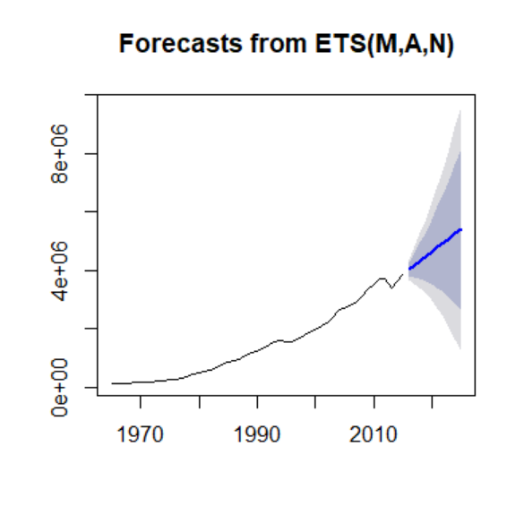

Figure 5 Simple Moving Average Forecast

**Accuracy** for the Simple Moving Average model is defined as below:

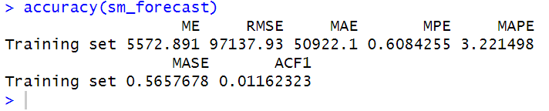

Figure 6 Training accuracy for Simple Moving Average

### 4.3.2 Exponential Smoothing Using Holt Winters

The next approach we implemented is Exponential Smoothing which is performed using **Holt Winters function** in R.

Like the Simple Moving Average approach, we have defined a time-series object for the function to operate on. Further, we made the model using ‘hw’ function in R, and below is the forecast we achieved:

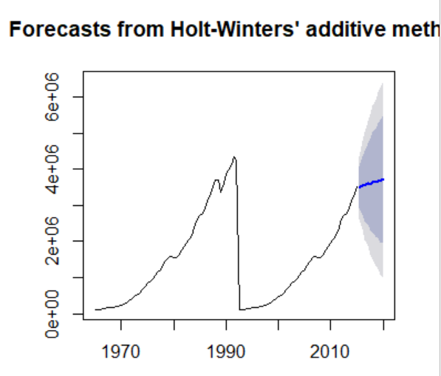

Figure 7 Exponential Smoothing Forecast

**Accuracy** for Exponential Smoothing using Holt Winters can be seen below:

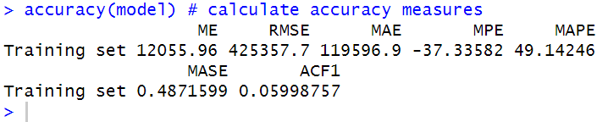

Figure 8 Training accuracy for Exponential Smoothing

### 4.3.3 ARIMA Model

As our next step of analysis, we implemented ARIMA model on the time-series data to generate timely estimates on the GDP data.

For modelling, we have used the ‘auto.arima’ function in the ‘forecast’ library in R which performs operations with different order levels in ARIMA model and return the best ARIMA model for the given set of data.



Auto Arima tries with different variations of ARIMA models and it can be clearly observed best ARIMA model came to be with the order of (0,2,3)

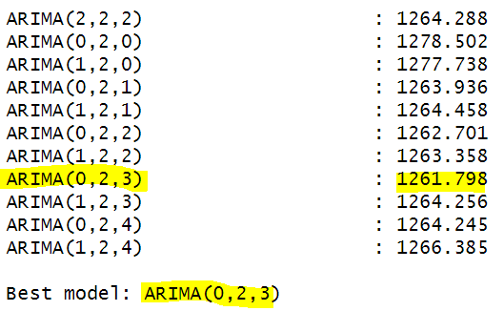

Figure 9 Different ARIMA models

Using the generated ARIMA model, we created the forecasting for the next 10 years and the results are as follows:

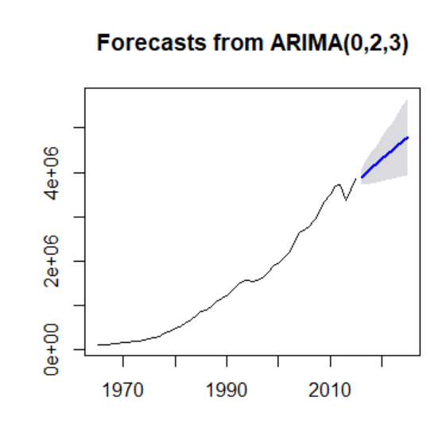

Figure 10 ARIMA model Forecast

**Accuracy** for the ARIMA model can be seen below:

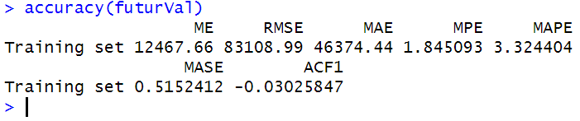

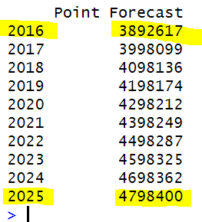

Figure 11 GDP Forecasts in Dollars

From the above forecast we got that in 2016 Nominal GDP is estimated to be around $ 3892617 whereas it is expected **to grow by 2025 to $ 4798400**.

## 4.4 Evaluating Models & Estimates:

We have compared multiple parameters of errors (‘RMSE’, ‘MAE’, ‘MAPE’, ‘MASE’ and ‘ACF1’) from the training accuracy of the generated models and **Arima Model** performs better in almost each training accuracy comparison.

|  |  |  |  |  |  |  |  |
| --- | --- | --- | --- | --- | --- | --- | --- |
| **Model/Accuracy** | **ME** | **RMSE** | **MAE** | **MPE** | **MAPE** | **MASE** | **ACF1** |
| **Simple Moving Average** | 5572.89 | 97137.93 | 50922.1 | 0.60 | 3.22 | 0.56 | 0.01 |
| **Holt Winters** | 12055.96 | 425357.7 | 119596.9 | -37.33 | 49.14 | 0.48 | 0.05 |
| **Arima** | 12467.66 | 83108.99 | 46374.44 | 1.84 | 3.32 | 0.51 | -0.03 |

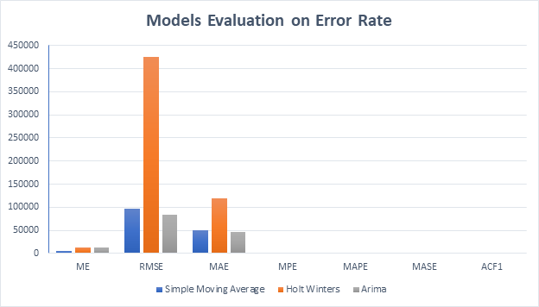

Figure 12 Training Errors VS Time Series Techniques used

# Conclusion:

Among the 3 time series algorithms that we have implemented, ARIMA performed better among others. Overall the error rate for ARIMA was minimum.

It can be concluded from ARIMA forecasting results that in 2016 Nominal GDP is estimated to be around $ 3892617 whereas it is expected to grow by 2025 to $ 4798400.

# References:

[1] <https://www150.statcan.gc.ca/t1/tbl1/en/tv.action?pid=3610020801>

<https://www.investopedia.com/terms/g/gdp.asp>

<https://www.oecd.org/g20/topics/employment-and-social-policy/The-Labour-Share-in-G20-Economies.pdf>

<https://en.wikipedia.org/wiki/Capital_cost>

<https://www.immigration.ca/ten-factors-affecting-canada-s-economic-performance-in-2015>