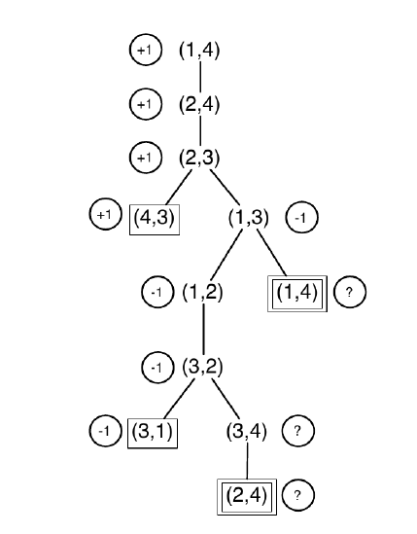**Tutorial 2**

1)

2) The “?” nodes can be set a value of 0, choosing the loop state will not benefit either player. If there is a win for a player from a loop state, then they will choose the moves that lead to the win, rather than ending up in it.

3) Standard minimax is depth-first and would go into an infinite loop. It can be fixed by comparing the current state against the stack; and if the state is repeated, then return a “?” value. Propagation of “?” is handled as above. Although it works in this case, it does not always work.

(a) Greedy best-first search should find the following route Arad -> Sibiu -> Fagaras -> Bucharest, which is 450km. However, the route Arad -> Sibiu -> Rimnicu Vilcea -> Pitesti -> Bucharest is 418km.

(b) Greedy best-first search should loop between Neamt and Iasi as the heuristic value of Neamt is less than the heuristic value of Vaslui.

(c) A* search should find the route Arad -> Sibiu -> Rimnicu Vilcea -> Pitesti -> Bucharest for part (a), and the route Iasi -> Vaslui -> Urziceni -> Bucharest -> Fagaras for part (b).