PROJECT REPORT OF INDUSTRY ORIENTED HANDS ON EXPERIENCE (IOHE)

On
HealthHub (A Web-Based Healthcare Management Platform)
submitted in partial fulfilment of the requirements for the award of degree of BACHELOR OF ENGINEERING
In
COMPUTER SCIENCE AND ENGINEERING

Submitted By:
- Jatin Thakur (2211981182)
- Naimish Sharma(2211981232)

Supervised By:
Dr. Ajay Katiyar (9467116866) Assistant Professor
Chitkara University, Rajpura



DEPARTMENT OF COMPUTER SCIENCE AND ENGINEERING CHITKARA UNIVERSITY INSTITUTE OF ENGINEERING AND TECHNOLOGY
CHITKARA UNIVERSITY, PUNJAB, INDIA

CONTENTS

S.No. Title Page No.

Acknowledgement | iv
Abstract | v
1. Introduction to Project | 6
2. Methodology | 9
3. Design | 12
4. Implementation and Results | 16
5. Coding | 17
6. Prototype Photographs for User Side | 19
7. Conclusion and Future Work 21
8. Bibliography and References 22

DECLARATION
I hereby certify that the work presented in the project report entitled “HealthHub” in partial fulfilment of the requirements for the award of the degree of Bachelor of Engineering in Computer Science and Engineering submitted to the Department of Computer Science and Engineering, Chitkara University Institute of Engineering and Technology, is an authentic record of my own work carried out under the supervision of Dr. Ajay Katiyar.
The matter embodied in this project report has not been submitted elsewhere for the award of any other degree or diploma to the best of my knowledge.
.

Place: Rajpura Date: 14-05-2026
Naimish Sharma
University Roll No: 2211981232

This is to certify that the above statement made by the candidate is correct to the best of my knowledge and belief.

Dr. Ajay Katiyar
Assistant Professor
Department of Computer Science and Engineering
Chitkara University Institute of Engineering and Technology, Chitkara University, Punjab, India

ACKNOWLEDGEMENT

I take this opportunity to express my heartful gratitude to the Department of Computer Science and Engineering for giving me an opportunity to work on this project “HealthHub – Web Based HealthCare Management Platform”. The department’s support, encouragement and academic environment were key factors in the successful completion of this work. The knowledge gained during the course of study and guidance received from the department helped in developing a clear understanding of the concepts needed for this project.

I would like to thank my project guide Dr. Ajay Katiyar for his guidance, constant encouragement and technical support in development of this project. His advice, encouragement and expertise helped me overcome challenges and deliver the project successfully.

I am also thankful to all the faculty members of the Department of Computer Science and Engineering for sharing their valuable knowledge and providing continuous academic support throughout the tenure of this project. Their lectures, discussions and guidance were instrumental in strengthening the technical knowledge needed to design and implement this healthcare platform.

I am grateful to Chitkara University for providing the necessary facilities, resources and infrastructure which enabled the development of this project. The availability of laboratories, technical resources and supportive learning environment enabled me to work effectively and obtain practical experience in web development, database management and real-time communication systems.

I would also like to thank my project teammates for their support and cooperation whose ideas, suggestions and teamwork contributed greatly to the successful completion of this project. Working together helped solve technical challenges and made the system better overall in terms of functionality and quality .

We are grateful to the technical staff and laboratory assistants for giving us access to the needed systems and resources whenever needed. We thank them for their support during the development and testing phases.

Finally I would like to thank my family and friends for their continuous encouragement, motivation and moral support during the development of this project. Their understanding and support always motivated me to be focused and dedicated to achieve this milestone.

I would like to sincerely thank and appreciate everyone who directly or indirectly contributed to the successful completion of this project. Their support and encouragement were important in making this work a success.

ABSTRACT

HealthHub is a web-based healthcare platform that uses modern technology to make it easier to get medical care and make it work better. People who use traditional healthcare systems often have trouble making appointments, not being able to talk to their doctors very much, waiting a long time, and not being able to get help right away in an emergency. Because of these issues, the healthcare system is slow, disorganized, and hard to use. HealthHub's main goal is to bring patients, doctors, and donors together in one place so they can talk to each other. Users can sign up, log in, look at profiles of doctors, and make appointments based on when they are free and what they are good at. It also has chat and video consultation features that let patients talk to doctors in real time, so they don't have to go to the doctor's office.

One of the most important parts of the platform is the emergency blood request module. It lets people quickly ask for blood and get in touch with people who might be able to give it. This feature makes it easier to handle medical emergencies. The system also has dashboards that help users stay organized and open by letting them see their appointments, consultations, and request status.

React.js is used to build the front end of HealthHub, Node.js and Express.js are used to build the back end, and MongoDB/Appwrite is used to safely store data and log in. The platform is built to be safe, flexible, and responsive, so it works well on all devices. The platform also improves healthcare coordination as a whole by reducing the number of people who have to do things by hand and speeding up decision-making through digital workflows. It keeps users interested by giving them updates in real time, making it easy for them to get medical information safely, and making it easy for them to use. HealthHub brings together many different healthcare services into one system, making things easier, more reliable, and more efficient for both patients and healthcare providers.

HealthHub is a helpful and effective way to fix problems in today's healthcare system by making it easier to get medical care, speeding up communication, and cutting down on wait times. It helps run healthcare better and makes the healthcare ecosystem more connected and digital.

Introduction to Project

Project Background
Digital healthcare platforms and online medical services have recently become an important part of modern healthcare management. Patients and health care providers are increasingly using web-based systems and applications to book appointments, manage medical records, communicate with doctors and access health care services remotely. These digital platforms provide convenience, faster access to medical support, and better communication between patients and health care professionals. Despite the availability of a variety of healthcare applications, patients still face several challenges to access medical services efficiently and manage healthcare activities in a smooth and organized way.

Traditional healthcare systems are often manual, with physical appointment booking, hospital visits, paperwork and minimal doctor-patient interaction. These processes can be time consuming, less organized and difficult to manage effectively. Patients often cite long wait times, trouble booking an appointment, delays in communication with the doctor and access to emergency support services. In many cases, people living in remote areas also have problems in getting timely medical consultation and healthcare assistance.

Another major challenge in the healthcare sector is handling emergency healthcare needs such as blood donations or urgent medical support. In emergencies, hospitals and patients often have difficulty locating suitable blood donors or communicating urgent healthcare needs efficiently.The lack of a centralised platform to deal with such services can lead to delay in medical treatment and a drop in healthcare efficiency.

Rapid advancement of modern web technologies, cloud computing and real-time communication systems generated new opportunities to enhance the healthcare management platforms. Real-time chat systems, video consultation services, secure authentication, and cloud-based databases are technologies that can enable instant communication between patients and doctors, efficient appointment management, and more convenient access to healthcare services. The combination of these technologies in a single healthcare platform will make the medical services more accessible, organized, secure and efficient thus greatly improving the healthcare experience.

The proposed project “HealthHub-Web-Based Healthcare Management Platform” will address these challenges by providing a centralized system to patients, doctors, and donors. The platform focuses on simplifying appointment management, real-time communication, emergency blood request services, and overall healthcare coordination in a secure and user-friendly digital environment.

Problem Statement
Despite the presence of digital healthcare platforms and online medical services, patients and healthcare providers still experience various challenges in managing healthcare activities. “Appointment making, accessing medical consultations and health records often require considerable time and manual effort, which is among the major problems. Patients struggle to make appointments, communicate effectively with physicians, and get timely medical care.

Another big problem is the absence of integrated healthcare management capabilities. The majority of existing healthcare platforms are focused on limited services like appointment booking or hospital information and offer very little support for real-time communication, emergency assistance, blood donation services or centralized healthcare management. As a consequence, patients are forced to use a number of applications to book appointments, consult doctors, receive notifications and handle medical information. Switching from one system to another makes healthcare management less organized and less convenient for both patients and healthcare providers.

Also, in medical emergencies, patients and hospitals find it difficult to find blood donors and communicate urgent healthcare requirements quickly. Treatment and patient care can be negatively affected by communication delays and the absence of a centralized emergency support system. Patients living in remote areas may also find it difficult to get immediate medical consultation and healthcare services.

The above limitations highlight the need for a unified healthcare management system that integrates appointment scheduling, doctor-patient communication, emergency blood request services, notifications and centralized healthcare management on a secure and user-friendly platform.

Objective of the Project
The main objective of the HealthHub project is to develop a web-based healthcare management platform that helps patients, doctors, and donors manage healthcare services more efficiently and communicate in a more organized manner.
The specific objectives of the project are:
• To allow patients to book, manage, and track medical appointments through a single platform
• To help patients connect with doctors based on their specialization and availability.
• To provide secure user authentication and profile management for patients, doctors, donors, and administrators.
• To enable real-time communication between patients and doctors using chat and video consultation features.
• To provide an emergency blood request and donor management system for urgent medical situations.
• To support appointment scheduling and consultation management for better healthcare coordination.

• To provide notifications and real-time updates regarding appointments, consultations, and emergency requests.
• To provide dedicated dashboards for managing appointments, medical activities, and healthcare information.
• To ensure secure data management and easy access to healthcare services through a centralized platform.
By achieving these objectives, HealthHub aims to simplify healthcare management, improve doctor-patient communication, and provide a more convenient, accessible, and efficient healthcare experience
The platform also helps improve emergency healthcare support by connecting blood donors and patients quickly during critical situations. By integrating multiple healthcare services into one system, HealthHub reduces the need for using separate applications and improves overall healthcare management efficiency.

System Overview

HealthHub is a web-based healthcare management system that brings together appointment management, doctor-patient communication, and emergency healthcare services into one organized and user-friendly system. The platform is built on the MERN stack (MongoDB, Express.js, React.js, and Node.js). Secure user authentication is ensured using JSON Web Tokens (JWT), which enables safe and authorized access to the system.

After logging into the platform, patients can conveniently book and manage appointments, while doctors can handle their schedules and patient consultations.The platform also allows users to see doctor profiles, their specialties and availability.

The system also has real-time communication features like chat and video consultation by using Socket.io and WebRTC, so that patients and doctors can communicate instantly and also receive live updates and notifications. Also, there is a module for emergency blood requests so that patients can find blood donors in a hurry in case of medical emergencies.

All user information, appointments, consultation details, chat records and emergency requests are securely stored in the MongoDB database. The platform also offers dashboards to help users organize and manage their healthcare activities, appointments, notifications and information.

HealthHub is a smart, efficient solution for the management of modern healthcare. This platform combines multiple healthcare services into a single system to cut down on manual work, enhance communication, and deliver healthcare services to patients, doctors, and donors more quickly and comfortably.

Expected Benefits

The HealthHub platform seeks to improve healthcare management by integrating various healthcare-related features into a unified platform. By unifying appointment management, doctor-patient communication, emergency blood request services, and real-time updates in a single platform, the system reduces the number of applications required for healthcare activities and coordination.

The platform helps patients to save their time when they book appointments, consult with doctors and manage healthcare activities. Tools like real-time chat, video consultation, and notifications improve communication between patients and doctors. The emergency blood request feature also helps patients to get in touch with blood donors quickly in critical situations.

The dashboard gives users easy access to appointments, consultations, notifications and healthcare activities so they can stay organized. Secure authentication and centralized data management enhances the overall user experience and provides safe access to medical information.

Overall HealthHub provides modern web based solution for managing health care making the health care services more organized, accessible, efficient and convenient for patients, doctors and donors.

2.Methodology

The HealthHub system is built with a modular architecture that integrates various components for efficient healthcare management and communication services. The architecture of system is divided into multiple modules like authentication, appointment management, doctor-patient communication, emergency blood request management, notifications, dashboards. Each module is responsible for a single task and it helps to improve the system efficiency, scalability and maintainability.

Its modular design also makes it easier to update or improve individual components without affecting the whole system. This method ensures that the HealthHub platform works in a systematic and well-organized way, while providing reliable healthcare services and communication functionalities to users.

The system is based on a client-server architecture in which the front-end handles the user interaction and the back-end handles the business logic, database operations and real-time communications. The frontend is built using React.js and Tailwind CSS for a responsive and user-friendly interface, and the backend is built using Node.js and Express.js. MongoDB is used to store user information, appointments, chat records, details of doctor and emergency blood requests safely. Socket.io and WebRTC integration allows real-time chat and video consultation between patients and doctors.

2..1 System Approach

The system is designed in a web-based architecture where the frontend can talk to the backend server using APIs. The backend handles the requests, stores user data and allows real-time communication between patients and doctors. The platform is built using MERN stack, which provides a scalable and efficient environment for managing healthcare services and user interactions.

The frontend shows the doctor’s information, appointment details, chat interfaces, blood request information and dashboard activities to the user. Backend deals with authentication, appointment management, notifications, emergency blood requests, and database operations. User details, appointment details, chat messages, doctor details and blood request details are maintained securely in MongoDB. Socket.io and WebRTC support real time communication and live consultation between the users.

The platform integrates all essential healthcare management functionalities into a single entity, designed to deliver a seamless and well-organized healthcare experience. All modules interact with the backend server using secure APIs to guarantee proper data processing and system efficiency. The modular architecture of the platform also improves the maintainability and allows for future enhancements without affecting the existing system functionality.

The platform also focuses on accessibility improvements and reducing manual healthcare processes by implementing digital workflows. Patients can get healthcare services from home easily without going to hospitals for minor consultation. The centralized system makes it easy for doctors to handle appointments, schedules and patient interactions. This leads to improved overall healthcare coordination and less time lost in communication.

The system also incorporates secure data handling and role-based access control, ensuring privacy and protection of healthcare information. Real time updates, notifications and dashboard activities keep users informed about appointments, consultations and emergency requests. The scalable architecture of the platform provides the opportunity to add more healthcare services and advanced features as per the system requirements in future.

The main modules of the system are

• User Authentication Module
• Appointment Booking & Management Module
Communication Module for Patients and Doctors
• Emergency Blood Request Module.
• Real Time Video and Chat Consultation Module
• Module for Notification and Healthcare Updates• Activity Dashboard & Monitoring Module
• User & Database Management Module

Tools and Technologies

The following technologies were used to develop the HealthHub platform.

• Frontend: React.js and Tailwind CSS are used to build a dynamic, responsive, and user-friendly interface.

• Backend: Node.js and Express.js are used to handle server operations and API development.

• Database: MongoDB is used to securely store user information, appointments, chat records, doctor details, and blood request data.

• Real-Time Communication: Socket.io and WebRTC are used to support live chat and video consultation features.

• Authentication: JSON Web Tokens (JWT) are used to provide secure login and user authentication.

• User Interface: Shadcn UI and Tailwind CSS are used to design a modern and responsive interface.

• Development Environment: Visual Studio Code is used as the primary development tool.

Flow of the System
The workflow of the HealthHub system is as follows:

- User registers and logs into the system securely.
- The patient can view doctor profiles, specialties, and availability on the platform.
- The patient books appointments and manages healthcare activities through the system.
- Doctors can manage appointments, schedules, and consultation requests.
- Users can communicate through real-time chat and video consultation features.
- The system manages notifications, appointment updates, and emergency blood requests.
- Patients and donors can connect during emergency blood requirement situations.
- Users can view appointments, consultations, notifications, and healthcare activities through the dashboard.

Design

Use Case Diagram:

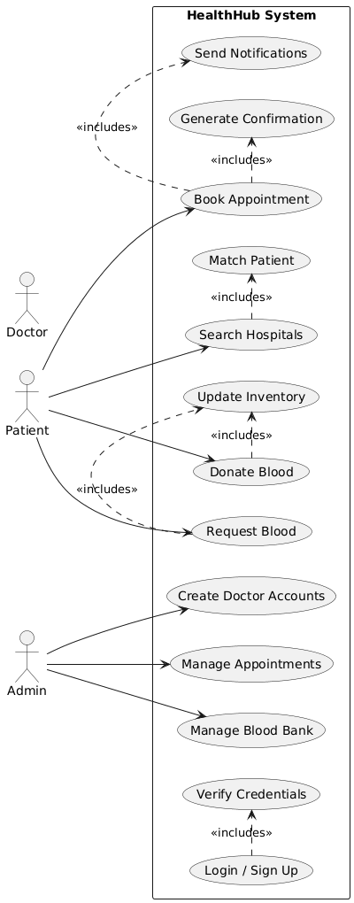
Fig: 3.1

3.2) SEQUENCE DIAGRAM:

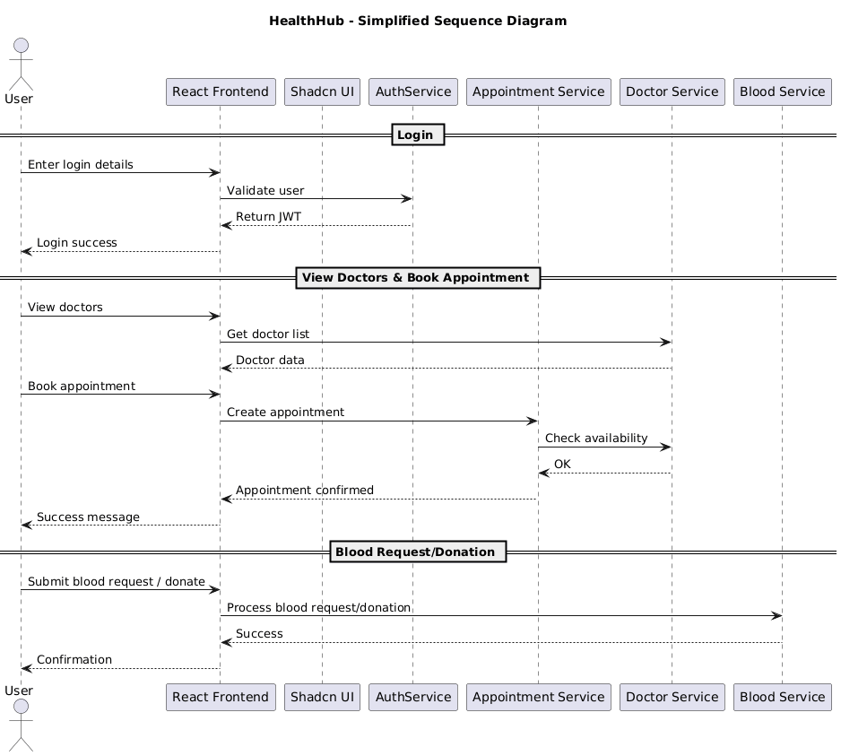
Fig: 3.2

3.3)System Flowchart Diagram:

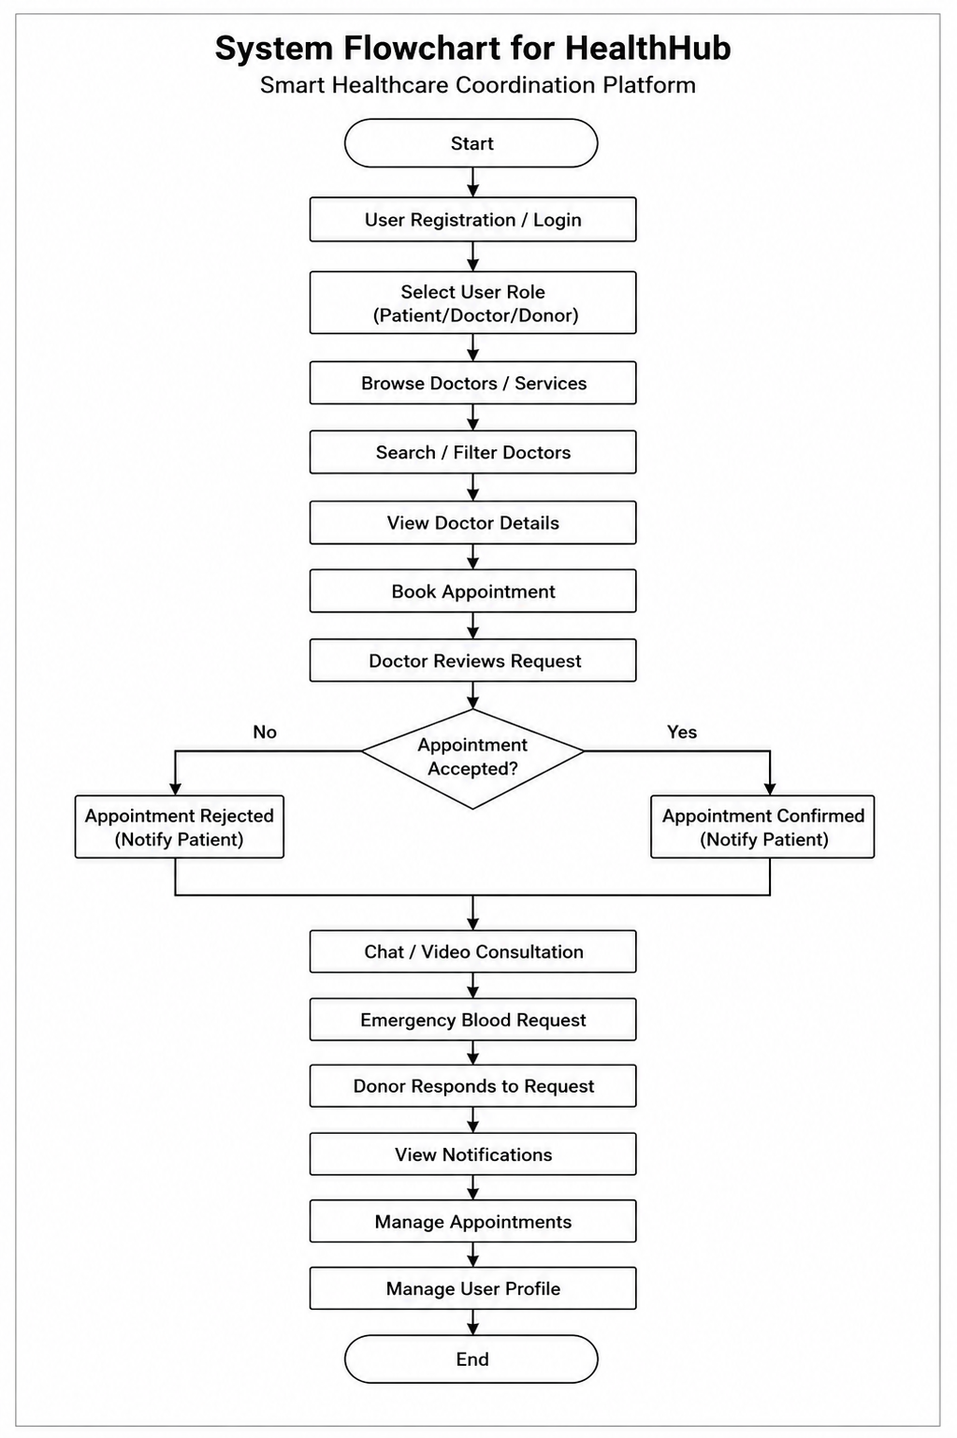
Fig: 3.3

3.4) UML Class Diagram:

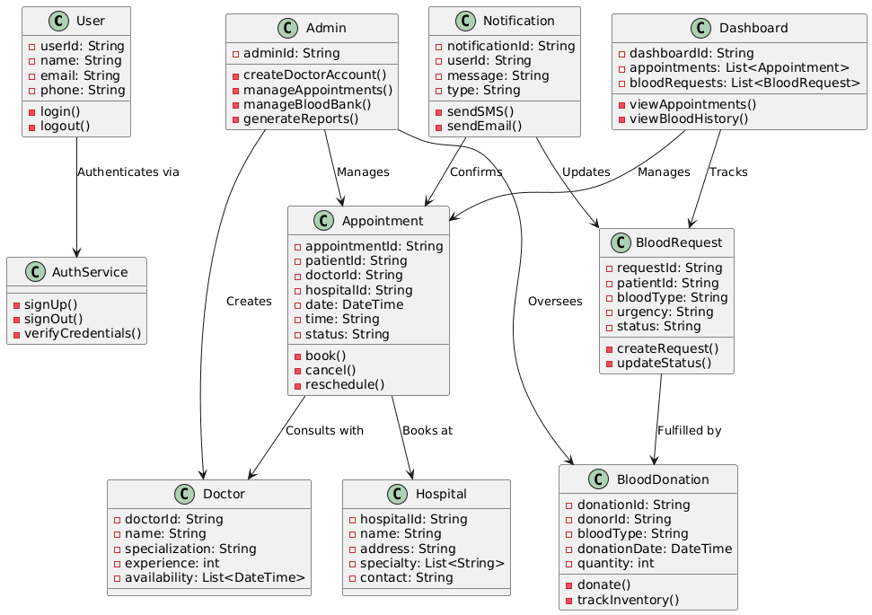
Fig: 3.4

Implementation and Results

The HealthHub platform was successfully implemented using modern web development technologies.

4.1 Implementation

The system includes several modules:

• User Authentication: Secure login and registration are implemented using JWT authentication.

• Appointment Booking and Management: Patients can book, manage, update, and cancel appointments easily.

• Doctor Management System: Doctors can manage schedules, appointments, and patient consultation requests.

• Doctor-Patient Communication: Users can communicate through real-time chat and video consultation features.

• Emergency Blood Request System: Patients can create emergency blood requests, and donors can respond to them quickly.

• Real-Time Chat System: Patients and doctors can communicate instantly using Socket.io-based real-time chat.

• Video Consultation Module: The platform supports live video consultation using WebRTC technology.

• Notification System: The platform provides real-time healthcare updates and appointment notifications.

• Dashboard: The dashboard displays appointments, consultations, blood requests, notifications, and healthcare activities.

4.2. Results

The system is a good example of how modern web technologies can be integrated with healthcare management and communication features.
The platform helps patients to book appointments, get in touch with the doctors and manage healthcare activities in a more efficient and organized way. Doctors can book appointments, offer consultations, and talk with patients using real-time chat and video consultation features. Emergency blood request module also enables patients and donors to connect with each other swiftly in critical situations.
The screenshots of working system include Login page, Dashboard, Appointment booking, Doctor management, Real time chat, Video consultation and Emergency blood request modules.
The results validate HealthHub as a functional, interactive, secure and user-friendly healthcare management platform.

5.Coding

5.2. App.jsx :

import { useState, useEffect } from 'react'
import { useDispatch, useSelector } from 'react-redux'
import authServices from './appwrite/auth'
import docService from './services/doctors'
import './App.css'
import { login, logout, switchRole } from './store/authSlice'
import { Header, Footer } from './components'
import IncomingCallListener from './components/IncomingCallListener.jsx'
import { Outlet, useLocation, useNavigate } from 'react-router-dom'

function App() {
const [loading, setLoading] = useState(true)
const dispatch = useDispatch();
const auth = useSelector((state) => state.auth)
const location = useLocation()
const navigate = useNavigate()

useEffect(() => {
const fetchData = async () => {
try {
const [userResult, doctorResult] = await Promise.allSettled([
authServices.getCurrentUser(),
docService.getCurrentDoctor(),
]);

const userData = userResult.status === 'fulfilled' ? userResult.value : null;
const doctorData = doctorResult.status === 'fulfilled' ? doctorResult.value : null;

if (userData) {
dispatch(login({ userData, role: 'user' }));
}
if (doctorData) {
const docUserData = {
id: doctorData._id || doctorData.id,
name: doctorData.name,
email: doctorData.email,
role: 'doctor',
doctorData: doctorData
};
dispatch(login({ userData: docUserData, role: 'doctor' }));
dispatch(switchRole('doctor'));
}
if (!userData && !doctorData) {
dispatch(logout({}));
}
} catch (error) {
console.error("Error fetching user data:", error);
} finally {
setLoading(false);
}
};

fetchData();
}, [dispatch]);

useEffect(() => {
if (loading) return

const doctorLoggedIn =
auth.currentRole === 'doctor' ||
auth.userData?.role === 'doctor' ||
!!auth.doctorSession ||
!!localStorage.getItem('doctor_token')

if (doctorLoggedIn && location.pathname === '/') {
navigate('/doctor-home', { replace: true })
}
}, [auth, loading, location.pathname, navigate])

const hideFooter =
location.pathname.startsWith('/video') ||
location.pathname.startsWith('/video-call')

return !loading ? (
<div className="flex min-h-screen min-h-[100dvh] w-full max-w-[100vw] flex-col overflow-x-hidden scroll-smooth bg-transparent">
<Header />
<main className="flex min-h-0 flex-1 flex-col">
<Outlet />
</main>
<IncomingCallListener />
{!hideFooter && <Footer />}
</div>
)
: (
<div className="flex min-h-screen w-full flex-col items-center justify-center gap-4 bg-slate-50">
<div className="h-10 w-10 animate-spin rounded-full border-4 border-slate-200 border-t-sky-600" />
<h1 className='text-base font-medium text-slate-600'>Loading HealthHub...</h1>
</div>
);
}

export default App

5.2. Main.jsx
import React from 'react'
import ReactDOM from 'react-dom/client'
import App from './App.jsx'
import './index.css'
import store from './store/store.js'
import { Provider } from 'react-redux'
import { ToastContainer, Bounce } from 'react-toastify'
import 'react-toastify/dist/ReactToastify.css';
import { RouterProvider, createBrowserRouter } from 'react-router-dom'
import { Home, About, AllReq, ReqPage, Blood, Contact, Login, Signup, AuthLayout, Location, Doctors } from './components/index.js'
import {
AddDoc,
AllDoc,
EditDoc,
Doctor,
Room,
Video,
DoctorLogin,
DoctorDashboard,
DoctorHome,
AdminComplaints,
} from "./pages/index.js"
import VideoCall from './pages/VideoCall.jsx'
import DoctorEmail from "./pages/DoctorEmail.jsx"
import AdminApplications from './pages/AdminApplications.jsx'

const router = createBrowserRouter([
{
path: '/',
element: <App />,
children : [
{
path: "/",
element: <Home />
},
{
path: '/doctor-login',
element: <DoctorLogin />
},
{
path: '/doctor-dashboard',
element: (
<AuthLayout authentication doctorOnly>
<DoctorDashboard />
</AuthLayout>
)
},
{
path: '/doctor-home',
element: (
<AuthLayout authentication doctorOnly>
<DoctorHome />
</AuthLayout>
)
},
{
path: '/doctor-email/:doctorId',
element: (
<AuthLayout authentication doctorOnly>
<DoctorEmail />
</AuthLayout>
)
},
{
path: '/admin/applications',
element: (
<AuthLayout authentication>
<AdminApplications />
</AuthLayout>
)
},
{
path: '/admin/complaints',
element: (
<AuthLayout authentication>
<AdminComplaints />
</AuthLayout>
)
},
{
path: "/about",
element: (
<AuthLayout authentication>
<About />
</AuthLayout>
)
},
{
path: "/contact",
element: (
<AuthLayout authentication>
<Contact />
</AuthLayout>
)
},
{
path: '/login',
element: (
<AuthLayout authentication={false}>
<Login />
</AuthLayout>
)
},
{
path: '/signup',
element: (
<AuthLayout authentication={false}>
<Signup />
</AuthLayout>
)
},
{
path: '/room',
element: (
<AuthLayout authentication>
<Room />
</AuthLayout>
)
},

{
path: '/video/:roomid',
element: (
<AuthLayout authentication>
<Video />
</AuthLayout>
)
},
{
path: '/video-call/:token',
element: (
<AuthLayout authentication>
<VideoCall />
</AuthLayout>
)
},
{
path: "doctors",
element: (
<AuthLayout authentication>
<Doctors />
</AuthLayout>
)
},
{
path: "all-doctors",
element: (
<AuthLayout authentication>
<AllDoc />
</AuthLayout>
)
},
{
path: '/doc-cr',
element: <AddDoc />
},
{
path: '/doc-ud/:slug',
element: (
<AuthLayout authentication doctorOnly>
<EditDoc />
</AuthLayout>
)
},
{
path: '/doctor/:slug',
element: (
<AuthLayout authentication>
<Doctor />
</AuthLayout>
)
},
{
path: "blood",
element: (
<AuthLayout authentication>
<Blood />
</AuthLayout>
)
},
{
path: '/blood-req',
element: (
<AuthLayout authentication>
<AllReq />
</AuthLayout>
)
},
{
path: '/blood-req/:slug',
element: (
<AuthLayout authentication>
<ReqPage />
</AuthLayout>
)
},
{
path: '/location',
element: (
<AuthLayout authentication>
<Location />
</AuthLayout>
)
},
]
}
]);

ReactDOM.createRoot(document.getElementById('root')).render(
<React.StrictMode>
<Provider store={store}>
<RouterProvider router={router}/>
</Provider>
<ToastContainer
position="top-right"
autoClose={3000}
hideProgressBar={false}
newestOnTop={false}
closeOnClick
rtl={false}
pauseOnFocusLoss
draggable
pauseOnHover
theme="light"
transition={Bounce}
/>
</React.StrictMode>,
)

6.Prototype Photographs for User Side

Landing Page
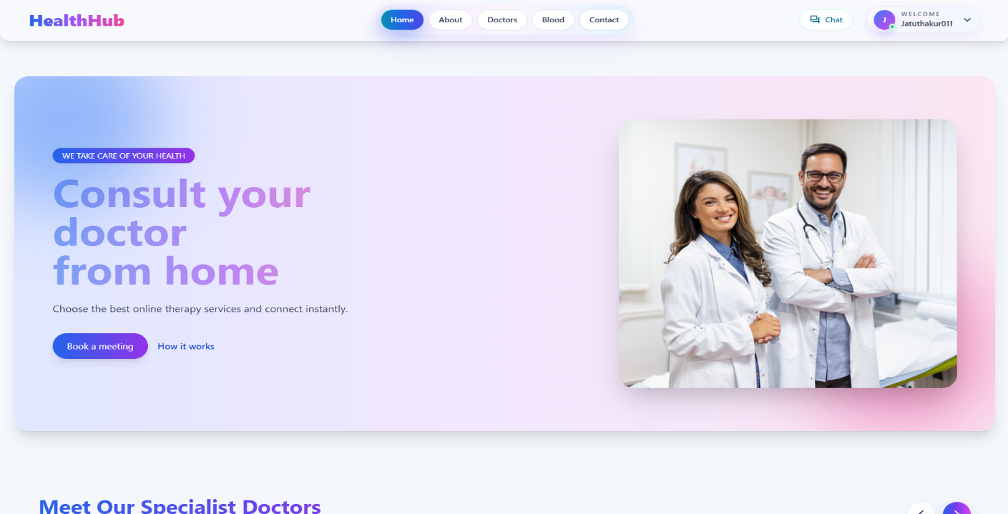

Blood Donation Page:

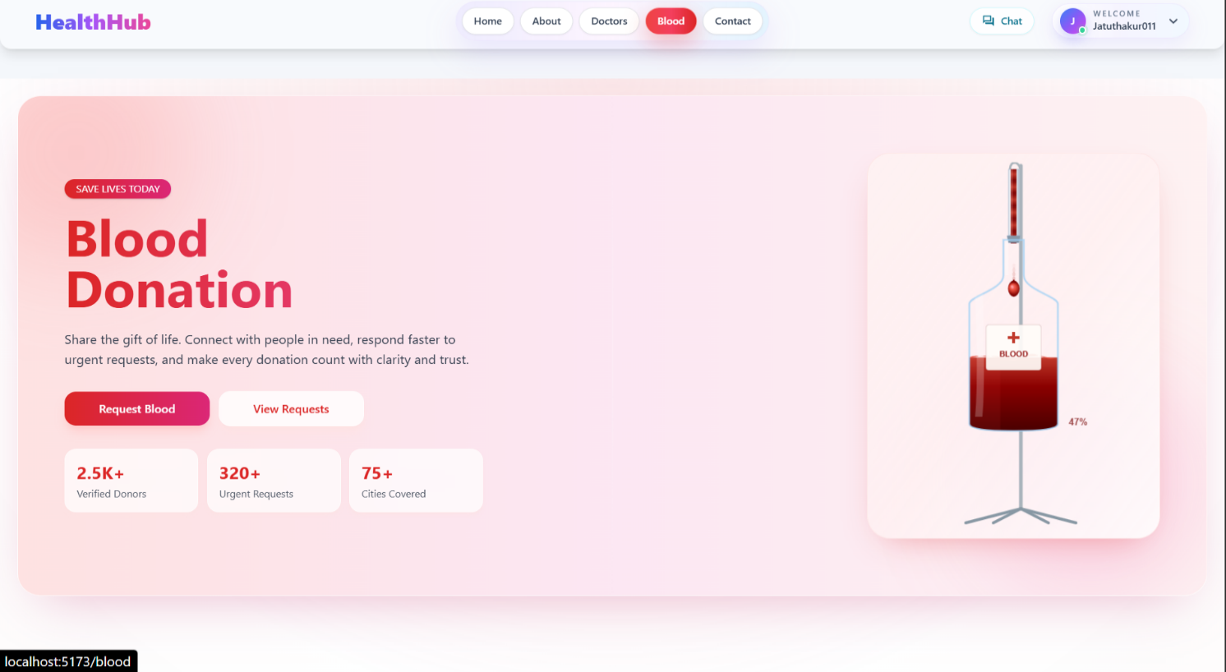

DOCTOR PAGE:

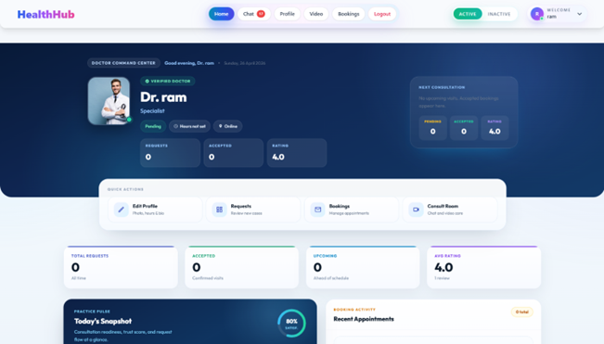

DOCTOR BOOKING PAGE:
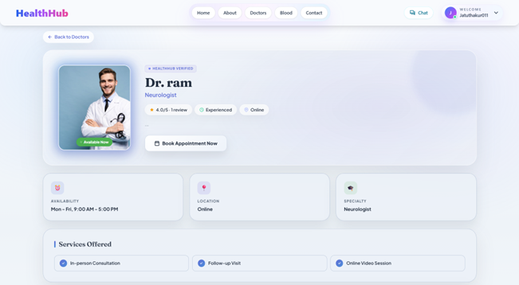

Conclusion and Future Work

Conclusion

The HealthHub project is a successful example of how modern web technologies can be used in the management and communication systems of healthcare. The system involves appointment management with features like doctor-patient communication, real-time chat, video consultation, emergency blood requests and notification for better and organized experience to the users in healthcare domain.

The platform allows patients to access healthcare services, communicate with the doctors and manage healthcare activities within one centralized system. HealthHub can provide a secure, user-friendly and reliable healthcare management solution using modern web technologies and real-time communication services.

7.2 Future Work

Several improvements can be implemented in future versions of the system. Possible future enhancements include:

7.2.1 AI-based health recommendations.
7.2.2 Integration with wearable health devices.
7.2.3 Advanced healthcare analytics dashboard.
7.2.4 Mobile application deployment.
7.2.5 Online medicine ordering system.
7.2.6 Multi-language support.
7.2.7 Cloud scalability improvements.
7.2.8 AI chatbot for healthcare assistance.

These improvements can further enhance the effectiveness, accessibility, and usability of the HealthHub platform.

Bibliography and References

8.1 Websites

1 https://react.dev/ – Official React documentation for building user interfaces.

2 https://nodejs.org/en/docs – Official Node.js documentation for backend development.

3 https://expressjs.com – Express.js framework documentation for building web APIs.

4 https://tailwindcss.com/docs – Tailwind CSS documentation for responsive UI design.

5 https://socket.io/docs/v4/ – Documentation for implementing real-time communication features.

6 https://webrtc.org/ – Official WebRTC documentation for video and audio communication.

7 https://developer.mozilla.org – MDN Web Docs for JavaScript and web development reference.

8 https://vercel.com/docs – Vercel deployment documentation for hosting web applications.

8.2 Books

8.2.1 Learning React by Kirupa Chinnathambi, Addison-Wesley (2nd Edition) – Provides guidance on building modern web applications using React.

8.2.2 JavaScript: The Good Parts by Douglas Crockford, O’Reilly Media – Explains important concepts of JavaScript used in frontend and backend development.

8.2.3 Web Development with Node and Express by Ethan Brown, O’Reilly Media – Describes backend development using Node.js and Express.
.

8.3 Journals

8.3.1 “Modern Healthcare Management Systems Using Web Technologies,” International Journal of Computer Applications, 2023.

8.3.2 “Real-Time Communication in Healthcare Applications Using WebRTC and Socket.io,” IEEE Access, 2022.

8.3.3 “Secure Web-Based Healthcare Platforms and Digital Health Services,” International Journal of Advanced Computer Science and Applications, 2023.

