AGRIBUSINESS OPERATIONS
SQL Evaluation & Performance Analysis
A Relational Database and KPI-Based Analytical Study

Prepared by
Jatin Kumar
B.Tech – Computer Science & Engineering
Babu Banarasi Das University, Lucknow
September 2026

Dataset status: SYNTHETIC / ACADEMIC DEMONSTRATION

1. Executive Summary
This project evaluates agribusiness operations through a relational database and SQL-based performance analysis. The model represents farms, fields, crops, planting cycles, harvests, labour, equipment, procurement, sales, markets, price history, weather observations, and expenses. The analytical objective is to transform operational records into decision-oriented KPIs covering production efficiency, yield, operational cost, revenue, profitability, sales trends, weather relationships, and expense concentration.
The dataset used in this study is synthetic and was prepared for academic/project demonstration because no real-world dataset was supplied. Consequently, all numerical findings are simulated results and should not be interpreted as actual commercial farm performance.
The completed SQL analysis shows that total production is highest for Rice, while the GVF South Field records the highest yield efficiency among the analysed fields. At farm level, Green Valley Farms has the highest estimated profit in the synthetic scenario. Cost-per-kg analysis also provides a direct production-efficiency measure, while monthly sales data shows pronounced revenue peaks in March.
Highest Total Crop Production | Rice — 15,700 kg
Highest aggregate harvested quantity in the synthetic dataset.
Highest Field Yield Efficiency | GVF South Field — 1,440 kg/ha
Highest production per hectare among the six analysed fields.
Highest Estimated Farm Profit | Green Valley Farms — ₹4,73,950
Revenue less recorded operational costs in the synthetic scenario.
Lowest Cost per Kg | Green Valley Farms — ₹10.79/kg
Farm-level operational cost divided by total harvested production.

2. Business Scenario
The simulated agribusiness organization manages multiple farms and fields and grows several crops across planting cycles. Operational records are generated for harvesting, labour, machinery usage, procurement, sales, market prices, weather, and general expenses. Management needs a structured analytical view to understand where production is strong, where land is being used efficiently, what drives operating costs, how much revenue is generated, and how environmental observations relate to yield.

3. Problem Statement
Operational data in an agribusiness environment is distributed across many activities. Without a normalized relational model and analytical SQL layer, it is difficult to connect crop cycles with harvest outcomes, labour usage, procurement spend, sales revenue, and farm-level profitability. The project therefore develops a self-contained database and applies SQL transformations to produce measurable KPIs and business narratives.

4. Objectives
- Measure total production and average harvest yield by crop.
- Calculate yield efficiency in kilograms per hectare at field level.
- Aggregate input, labour, and recorded general expenses into farm-level operational cost.
- Calculate production cost per kilogram as a unit-cost KPI.
- Measure crop-wise sales revenue and monthly revenue trends.
- Examine the relationship between recorded temperature observations and average yield.
- Identify major expense categories and their contribution to recorded spending.
- Estimate farm-level profit using revenue minus recorded operational costs.
- Provide clear business insights and recommendations from SQL outputs.

5. Dataset and Database Design
The database contains 16 related entities. Planting is the central crop-cycle entity: a planting record connects a field to a crop, while harvest, labour, and equipment usage can be connected back to that planting cycle. This design supports roll-up analysis by crop, field, and farm.
- Farm
- Field
- Crop
- Planting
- Harvest
- Employee
- Labor
- Equipment
- Equipment_Usage
- Supplier
- Input_Purchase
- Market
- Sale
- Price_History
- Weather_Log
- Expense

5.1 Data Volume
Entity | Rows
Farm | 3
Field | 6
Crop | 6
Planting | 12
Harvest | 14
Employee | 6
Labor | 24
Equipment | 5
Equipment_Usage | 16
Supplier | 4
Input_Purchase | 13
Market | 3
Sale | 24
Price_History | 48
Weather_Log | 30
Expense | 15

5.2 Core Relationships
- Farm → Field: a farm contains multiple physical fields.
- Field → Planting: a field can host multiple crop cycles.
- Crop → Planting: a crop can be grown in multiple planting cycles.
- Planting → Harvest: a crop cycle can generate one or more harvest records.
- Planting → Labor and Equipment_Usage: operational activities are tied to the crop cycle.
- Farm → Input_Purchase and Expense: procurement and general expenses roll up to farm level.
- Harvest → Sale → Market: harvested output can be associated with sales and market destinations.
- Crop/Market → Price_History: historical market prices are tracked independently of actual sales.
- Farm → Weather_Log: temperature and rainfall are recorded at farm level.

6. Analytical Methodology
The analysis follows a practical SQL analytics workflow: extract records through relational joins, aggregate operational measures, transform raw values into KPIs, validate the returned result sets, and translate the numerical outputs into business observations.
Stage | Method
1. Extraction | Join operational tables through primary-key/foreign-key relationships.
2. Transformation | Use SUM, AVG, COUNT, ROUND, DATE_FORMAT, COALESCE and arithmetic expressions.
3. KPI construction | Calculate production, yield/ha, operating cost, cost/kg, revenue, profit and trends.
4. Aggregation | Roll detailed transactions to crop, field, month, category and farm levels.
5. Interpretation | Convert SQL outputs into operational and financial insights.
6. Visualization | Present selected KPIs using tables and charts for easier interpretation.

6.1 KPI Definitions
KPI | Definition
Total Production | SUM of harvested quantity in kg.
Average Yield per Harvest | AVG harvested quantity per harvest event.
Yield per Hectare | Total harvested kg divided by field area in hectares.
Operational Cost | Input cost + labour cost + recorded general expenses.
Cost per Kg | Operational cost divided by total harvested kg.
Sales Revenue | SUM(quantity sold × sale price per kg).
Estimated Profit | Revenue minus recorded operational cost.
Monthly Revenue | Revenue grouped by sale month.
Expense Concentration | Total recorded expense amount grouped by category.

Cost limitation: the current schema does not contain an equipment hourly cost/rate and Input_Purchase is not linked directly to Planting. Therefore, the report's operational-cost KPI is farm-level and consists of input purchases, labour, and recorded general expenses. Equipment utilization is represented separately rather than assigned a fabricated monetary cost.

7. Production and Yield Analysis

7.1 Production and Average Yield by Crop
Crop | Total Production (kg) | Average Yield/Harvest (kg) | Harvests
Rice | 15,700 | 7,850 | 2
Potato | 14,400 | 4,800 | 3
Maize | 12,100 | 6,050 | 2
Wheat | 11,550 | 3,850 | 3
Tomato | 7,500 | 3,750 | 2
Mustard | 4,350 | 2,175 | 2

Rice has the highest total production at 15,700 kg, followed by Potato at 14,400 kg and Maize at 12,100 kg. The average-yield column shows the typical harvested quantity per recorded harvest event, while the harvest count indicates how many harvest records contribute to the crop total.
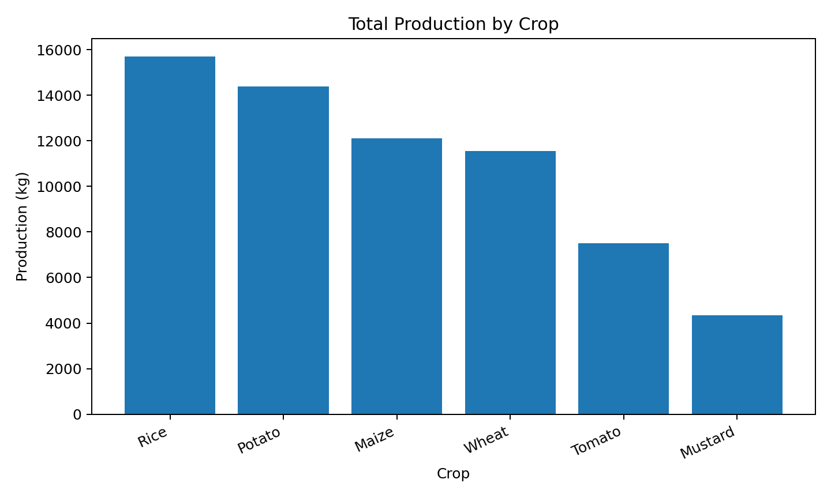
Figure 1. Total harvested production by crop.

7.2 Yield Efficiency by Field
Farm | Field | Crop | Area (ha) | Production (kg) | Yield (kg/ha)
Green Valley Farms | GVF South Field | Potato | 10 | 14,400 | 1,440.00
Shivam Organic Farms | SOF Organic Field B | Tomato | 6 | 7,500 | 1,250.00
Sunrise Agro Farm | SAF East Field | Rice | 15 | 15,700 | 1,046.67
Green Valley Farms | GVF North Field | Wheat | 12 | 11,550 | 962.50
Sunrise Agro Farm | SAF West Field | Maize | 13 | 12,100 | 930.77
Shivam Organic Farms | SOF Organic Field A | Mustard | 8 | 4,350 | 543.75

Yield per hectare normalizes production by land area and therefore provides a more comparable field-efficiency measure than total production alone. The GVF South Field records 1,440 kg/ha, while SOF Organic Field A records 543.75 kg/ha.
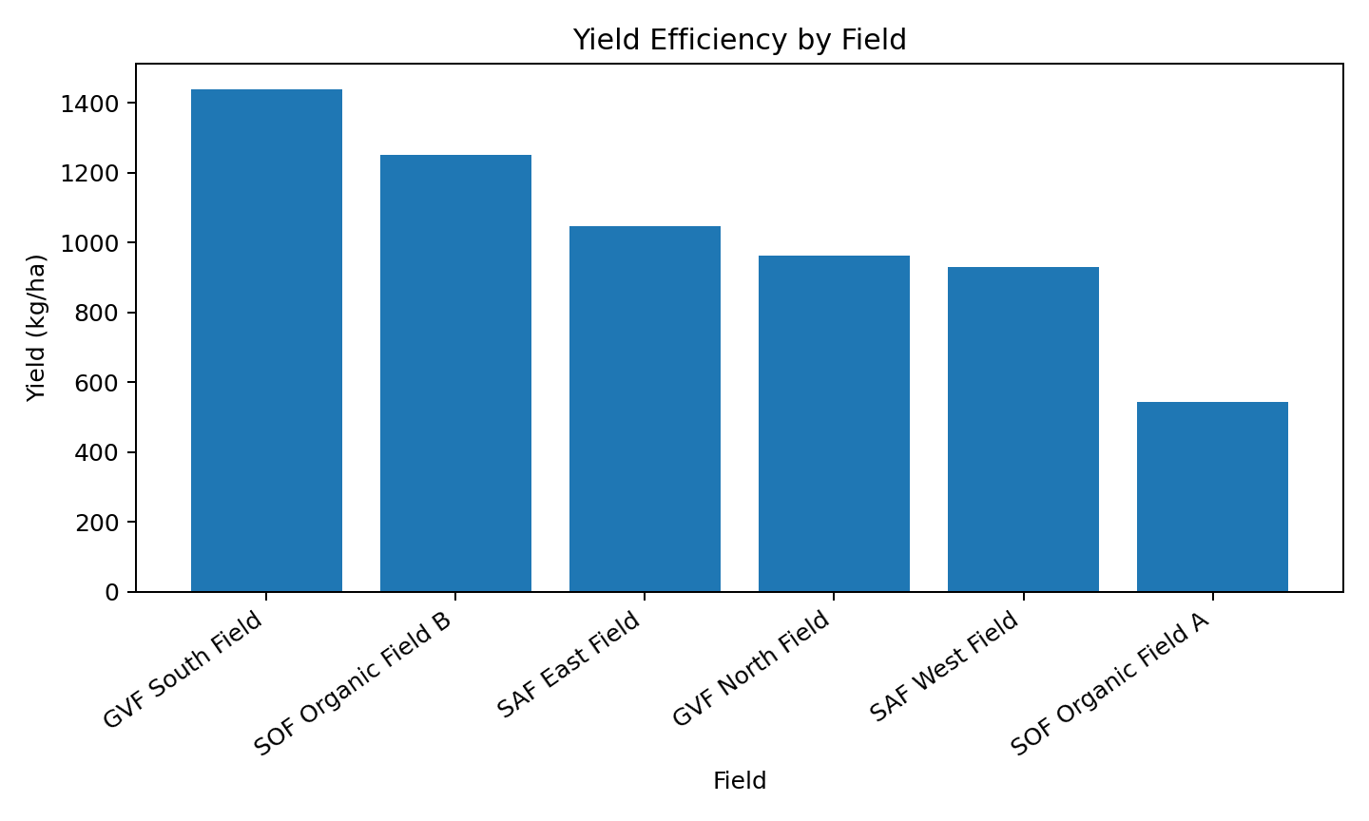
Figure 2. Yield efficiency by field.

8. Cost and Financial Performance

8.1 Operational Cost by Farm
Farm | Input Cost (₹) | Labour Cost (₹) | Other Expenses (₹) | Operational Cost (₹)
Sunrise Agro Farm | ₹94,375.00 | ₹139,080.00 | ₹91,000.00 | ₹324,455.00
Green Valley Farms | ₹91,950.00 | ₹114,000.00 | ₹74,000.00 | ₹279,950.00
Shivam Organic Farms | ₹43,600.00 | ₹95,600.00 | ₹47,500.00 | ₹186,700.00

Sunrise Agro Farm records the highest total operational cost at ₹3,24,455. Its largest component is labour cost, followed by other recorded expenses and input purchases. Green Valley Farms records ₹2,79,950, while Shivam Organic Farms records ₹1,86,700.

8.2 Cost per Kilogram
Farm | Operational Cost (₹) | Production (kg) | Cost per Kg (₹)
Green Valley Farms | ₹279,950.00 | 25,950 | ₹10.79
Sunrise Agro Farm | ₹324,455.00 | 27,800 | ₹11.67
Shivam Organic Farms | ₹186,700.00 | 11,850 | ₹15.76

Cost per kilogram provides a unit-efficiency view. In this synthetic dataset, Green Valley Farms has the lowest calculated cost per kg at ₹10.79, followed by Sunrise Agro Farm at ₹11.67 and Shivam Organic Farms at ₹15.76.

8.3 Revenue, Operational Cost and Estimated Profit
Farm | Revenue (₹) | Operational Cost (₹) | Estimated Profit (₹)
Green Valley Farms | ₹753,900.00 | ₹279,950.00 | ₹473,950.00
Shivam Organic Farms | ₹551,300.00 | ₹186,700.00 | ₹364,600.00
Sunrise Agro Farm | ₹616,300.00 | ₹324,455.00 | ₹291,845.00

Green Valley Farms records ₹7,53,900 in sales revenue and ₹2,79,950 in recorded operational costs, resulting in an estimated profit of ₹4,73,950. Shivam Organic Farms records ₹5,51,300 revenue and ₹1,86,700 cost, while Sunrise Agro Farm records ₹6,16,300 revenue and ₹3,24,455 cost.
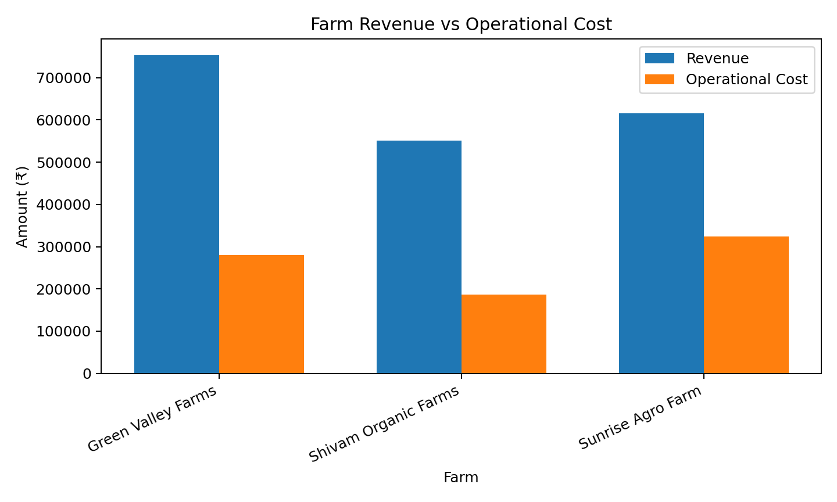
Figure 3. Farm-level revenue compared with operational cost.

9. Sales and Market Analysis

9.1 Crop-wise Revenue
Crop | Quantity Sold (kg) | Revenue (₹)
Potato | 14,050 | ₹441,750.00
Rice | 15,300 | ₹357,100.00
Tomato | 7,500 | ₹333,500.00
Wheat | 11,550 | ₹312,150.00
Maize | 12,100 | ₹259,200.00
Mustard | 4,350 | ₹217,800.00

Potato generates the highest crop-wise recorded sales revenue at ₹4,41,750, followed by Rice at ₹3,57,100 and Tomato at ₹3,33,500. This measure reflects realized sales in the synthetic sales table rather than broader market potential.

9.2 Monthly Sales Revenue Trend
Month | Revenue (₹)
2024-09 | ₹126,700.00
2024-10 | ₹181,300.00
2025-03 | ₹457,400.00
2025-05 | ₹154,400.00
2025-09 | ₹132,500.00
2025-10 | ₹175,800.00
2026-03 | ₹514,300.00
2026-05 | ₹179,100.00

The monthly revenue series shows strong peaks in March. March 2025 records ₹4,57,400 and March 2026 records ₹5,14,300, both materially above the other recorded months. This pattern can be useful for planning harvesting, sales capacity, and working-capital requirements, although the synthetic dataset does not establish causality.
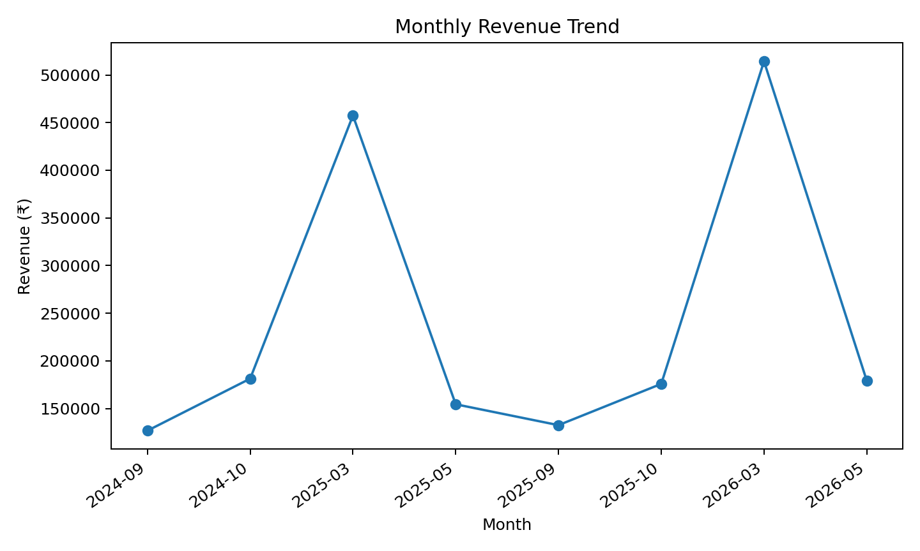
Figure 4. Monthly sales revenue trend.

10. Expense and Weather Analysis

10.1 Expense Category Analysis
Category | Total Spent (₹)
Fuel | ₹111,500.00
Utilities | ₹58,000.00
Maintenance | ₹36,000.00
Organic Certification | ₹7,000.00

Fuel is the largest recorded expense category at ₹1,11,500, followed by Utilities at ₹58,000 and Maintenance at ₹36,000. Organic Certification is the smallest recorded category at ₹7,000. The distribution highlights fuel as the most visible general-expense driver in the synthetic data.

10.2 Weather and Yield Relationship
Temperature (°C) | Average Yield (kg)
16.00 | 3,984.38
17.00 | 2,962.50
18.00 | 3,780.00
19.00 | 4,325.00
20.00 | 3,780.00
21.00 | 3,780.00
22.00 | 3,546.43
24.00 | 4,325.00
25.00 | 3,546.43
26.00 | 6,950.00
27.00 | 6,950.00

The weather query groups recorded yield observations by rounded temperature. The returned SQL result contains 16 yield-related rows across the temperature groups. The relationship should be interpreted as descriptive rather than causal because the synthetic dataset does not control for crop type, field area, planting date, rainfall, or other confounding factors.
The analysis demonstrates how environmental records can be connected to production outcomes. A production system could extend this approach by joining weather observations specifically across each planting-to-harvest period and by modelling rainfall, temperature ranges, crop type, and field characteristics together.

11. SQL Query Documentation

KPI 1 — Production by Crop
Answers which crops contribute the most harvested quantity. Uses Harvest → Planting → Crop with SUM, AVG and COUNT.

KPI 2 — Yield per Hectare
Answers which fields produce the most output per unit of land. Uses Harvest → Planting → Field and divides production by field area.

KPI 3 — Operational Cost by Farm
Combines input purchases, labour cost using employee wage rate, and general expenses at farm level.

KPI 4 — Cost per Kg
Divides farm operational cost by harvested production to create a unit-cost efficiency KPI.

KPI 5 — Crop-wise Revenue
Connects Sale → Harvest → Planting → Crop and calculates quantity sold and realized sales revenue.

KPI 6 — Monthly Sales Trend
Groups sale revenue by YYYY-MM using DATE_FORMAT to reveal time-based revenue patterns.

KPI 7 — Weather Impact
Connects farm weather records with production through Farm → Field → Planting → Harvest and summarizes average yield by temperature.

KPI 8 — Expense Categories
Groups Expense by category and ranks total recorded spending.

KPI 9 — Farm Revenue, Cost and Estimated Profit
Combines farm-level revenue with operational cost to estimate profit as revenue minus recorded operational cost.
The executable SQL is provided separately in performance_analysis.sql in the GitHub repository. The script uses the actual schema column names, including wage_rate, quantity_sold_kg, unit_cost, and growing-season terminology where applicable.

12. Key Business Insights
- Rice has the highest total harvested production (15,700 kg), making it the largest contributor to aggregate output in the synthetic dataset.
- GVF South Field has the highest calculated yield efficiency at 1,440 kg/ha among the analysed fields.
- Sunrise Agro Farm has the highest operational cost (₹3,24,455), driven particularly by labour and other recorded expenses.
- Green Valley Farms has the lowest cost per kg (₹10.79/kg) among the three farms in the simulated results.
- Green Valley Farms records the highest estimated profit (₹4,73,950) under the report's revenue-minus-recorded-cost calculation.
- Potato produces the highest crop-wise recorded sales revenue (₹4,41,750).
- March is the strongest recorded sales month in the synthetic time series, with March 2026 reaching ₹5,14,300.
- Fuel is the largest recorded general-expense category at ₹1,11,500.
- Weather analysis provides a framework for identifying yield patterns, but the synthetic results should not be treated as proof of a causal temperature effect.

13. Recommendations
- Investigate the field-level practices associated with higher yield per hectare and assess whether they can be replicated on lower-performing fields.
- Track input and labour costs at planting-cycle level in future schema versions to support true crop-cycle profitability.
- Add an equipment hourly operating-cost field or equipment expense table so machinery can be incorporated into full production-cost calculations.
- Monitor fuel consumption and fuel-related spending because fuel is the largest recorded expense category.
- Use monthly sales trends to improve harvest-to-market scheduling and sales-capacity planning.
- Compare realized sale prices with Price_History by crop and market to assess whether sales are occurring above or below observed market levels.
- For weather analysis, use planting-to-harvest date windows and include rainfall alongside temperature for more meaningful agronomic modelling.

14. Limitations and Data Quality Notes
- The dataset is synthetic and intended for academic demonstration; results are simulated.
- Input purchases are linked to farms rather than individual planting cycles, limiting crop-level cost allocation.
- The current Equipment table does not provide an hourly cost/rate, so equipment utilization is not monetized in operational cost.
- The weather analysis is descriptive and does not establish causation.
- The profit measure is an estimated farm-level figure based on recorded sales revenue minus recorded operational costs; it is not an audited accounting profit.
- The monthly sales dataset contains selected recorded months rather than a continuous monthly time series.

15. Conclusion
This project demonstrates how a normalized agribusiness relational model can support practical SQL performance analysis. By connecting crop cycles with harvest, labour, procurement, sales, expenses, and environmental observations, the database provides a foundation for production and financial decision support.
The completed KPIs quantify production, land-use efficiency, operational costs, unit cost, revenue, profitability, sales trends, expense concentration, and weather-related patterns. The combination of SQL queries, structured tables, and charts turns raw operational records into a coherent analytical report suitable for an academic data-analytics project.

Appendix A — Repository Deliverables
File | Purpose
schema.sql | Database schema and table definitions.
agribusiness_sample_data.sql | Synthetic sample records used for analysis.
performance_analysis.sql | Executable KPI and performance-analysis SQL queries.
README.md | Project overview, scope, technologies, and data note.
Agribusiness_Data_Model_Report.docx | Original relational data-model documentation.
Agribusiness_Performance_Analysis_Final_Report.docx | Final integrated performance-analysis report.

Appendix B — Core SQL Techniques Used
- INNER JOIN and LEFT JOIN for relational data integration.
- SUM and AVG for production, cost and revenue aggregation.
- COUNT for harvest-event measurement.
- ROUND for presentation-ready KPI values.
- COALESCE for handling missing aggregate values.
- DATE_FORMAT for monthly trend analysis.
- NULLIF for safe cost-per-unit division.
- GROUP BY and ORDER BY for analytical summarization and ranking.

Appendix C — Reproducibility
To reproduce the analysis, create the agro schema using schema.sql, load the synthetic records using agribusiness_sample_data.sql, and execute performance_analysis.sql in MySQL Workbench. The result sets can then be exported or reproduced for validation.

