DATA ANALYTICS WITH POWER BI
(Project Semester October - December 2025)

CRIME ANALYTICS & INSIGHTS DASHBOARD
Submitted by
Jatin Vohra

Registration No. 12306952

Programme: B. Tech CSE
Section: K23BG
Course Code: INT374

Under the Guidance of
Vikas Mangotra
UID: 31488

Discipline of CSE/IT
Lovely School of Computer science and Engineering

Lovely Professional University, Phagwara

DECLARATION

I, Jatin Vohra student of Computer science and Engineering under CSE/IT Discipline at, Lovely Professional University, Punjab, hereby declare that all the information furnished in this project report is based on my own intensive work and is genuine.

Date: 09-12-2025
Registration No.: 12306952 Name of the student: Jatin Vohra

CERTIFICATE

This is to certify that Jatin Vohra bearing Registration no. 12306952 has completed INT374 project titled, “CRIME ANALYTICS & INSIGHTS DASHBOARD” under my guidance and supervision. To the best of my knowledge, the present work is the result of his original development, effort and study.

Signature and Name of the Supervisor
Designation of the Supervisor
School of Computer science and Engineering
Lovely Professional University
Phagwara, Punjab.

Date: 09-12-2025

Acknowledgement

I would like to express my sincere gratitude to my faculty, Vikas Mangotra , for his continuous guidance, valuable feedback, and consistent support throughout this project.
I would also like to thank Lovely Professional University for providing the resources and academic environment that allowed me to complete this project successfully.
Last but not least, I extend my thanks to my friends for their encouragement and support during the course of this work.

Jatin Vohra

Table of Contents

Introduction 6
Source of Dataset 6
Dataset Preprocessing 7
3.1 Handling Missing Values
3.2 Data Cleaning
3.3 Feature Engineering
3.4 Merging Datasets
Analysis on Dataset 8
4.1 Crime Distribution by Month
4.2 Crime Hotspots by Area
4.3 Crimes by Time of Day
4.4 Victim Age-wise Crime Distribution
4.5 Crime Breakdown by Category
4.6 YOY Crime Trend Comparison (optional – based on your KPI card)
Conclusion 15
Future Scope 16
References 16

Introduction
Crime analysis plays a crucial role in supporting law enforcement agencies, government bodies, and public safety organizations. With the increasing availability of open-source crime datasets, data analytics has become a powerful tool to identify crime patterns, detect hotspots, study victim demographics, and evaluate trends across time and geography.
This project, Crime Analytics & Insights Dashboard, aims to transform a large crime dataset into meaningful and actionable insights using Microsoft Power BI. The dashboard provides a unified and interactive view of crime trends across months, areas, time periods, and crime categories. It supports data-driven decision-making by allowing users to visualize:
- Crime intensity by region
- Time-of-day crime patterns
- Age-wise victim distribution
- Crime category prevalence
- YOY crime comparisons
- Interactive filtering for deeper analysis
By leveraging Power BI’s intuitive visualizations and analytical capabilities, this project demonstrates how public safety insights can be enhanced using modern Business Intelligence tools.

Source of Dataset
- The dataset used in this project was sourced from publicly available crime records published by the Los Angeles Open Data Portal.

Dataset Name: Crime Data from 2020 to Present.
- Source Link : https://catalog.data.gov/dataset/crime-data-from-2020-to-present
Time Range: 2020 – Present
Key Columns Include:
- DATE OCC (Date of occurrence)
- TIME OCC (Time of occurrence)
- AREA NAME (Police district)
- Crm Cd & Crm Cd Desc (Crime category)
- Vict Age, Vict Sex, Vict Descent
- Weapon Used Code & Description
The dataset is highly detailed and captures both temporal and spatial aspects of criminal activities, making it suitable for building an exploratory analytics dashboard.

3.Dataset Preprocessing
Since Power BI primarily handles preprocessing internally, the dataset required several cleaning steps to ensure consistency, accuracy, and usability.
3.1 Handling Missing Values
Missing or incomplete entries were identified, particularly in fields such as victim age, weapon description, or incident time. The following steps were taken:
- Rows with essential missing fields (e.g., DATE OCC) were removed.
- Non-essential missing values were replaced with placeholders ("Unknown").
- Duplicate entries were checked and removed to avoid skewed analysis.
  - Data Cleaning
- DATE OCC was converted into usable Month, Year, and Day fields.
- TIME OCC (given in HHMM format) was transformed into Time-of-day buckets.
- Crime categories were standardized by grouping similar descriptions.
- Area names were formatted uniformly for mapping and hotspot analysis.
3.3 Feature Engineering
To support better visualization:
- Month Name and Month Number were extracted for trend charts.
- Time Buckets (e.g., Early Morning, Afternoon, Night) were created.
- Age groups (0–10, 11–20, 21–30, etc.) were derived for demographic insights.
- Crime category groups were created for clearer donut/pie charts.
- 3.4 Data Modeling in Power BI
- DAX measures were added for:
  - Total Crimes
  - YOY Crime % Change
  - Top N Crime Categories
  - Age Distribution Counts
  - Hotspot Area Ranking
This ensured smooth interactivity across filters and visuals.

4. Analysis on Dataset
4.1 Crime Distribution by Month
i. General Description
Monthly crime trends help understand seasonal spikes and recurring cycles throughout the year.
ii. Objective
- To observe how crime occurrences vary across months.
- To identify peak and low-crime months.
iii. Findings
- Crimes remain consistently high throughout the year, with slight peaks in early and mid-year months.
- No drastic seasonal drop, indicating crime patterns in Los Angeles are relatively stable month-to-month

iv. Visualization
A multi-color pie chart representing month-wise distribution.
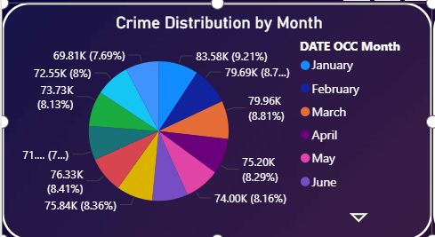

4.2 Crime Hotspots by Area
i. General Description
Different police districts experience varying crime intensity
ii. Objective
- Identify top hotspots with highest crime frequency.
- Understand area-specific crime loads
iii. Findings
- Central, 77th St., Pacific, Newton, and Southeast divisions recorded the highest crime counts.
- These areas consistently remain high-risk zones year after year.
- Residential and densely populated districts show higher crime clustering.
iv. Visualization
A bar chart ranking top 15 police areas by total crimes.
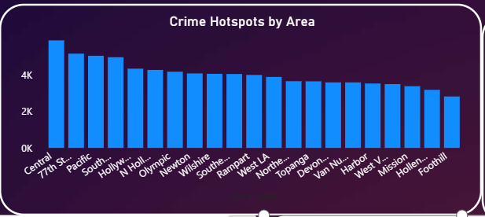
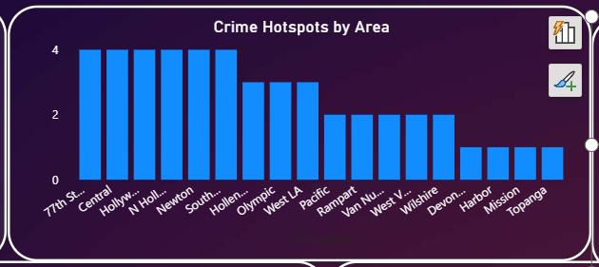

4.3 Crimes by Time of Day
i. General Description
Crime timing patterns indicate when criminal activity peaks.
ii. Objective
- Analyze crime counts across each hour of the day.
- Identify high-risk times for preventive action.
iii. Findings
- Crime frequency increases steadily throughout the day.
- Peak activity occurs during late afternoon to night (3 PM – 10 PM).
- Slight dips occur during early morning hours (3 AM – 6 AM).
iv. Visualization
Hourly bar chart showing crime volume against time.

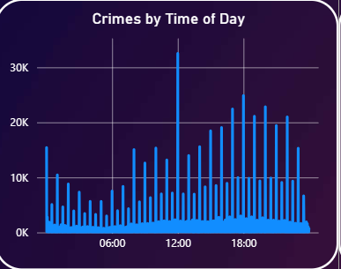
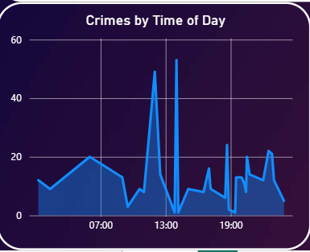

4.4 Victim Age-wise Crime Distribution
i. General Description
Demographic analysis helps understand which age groups are most vulnerable.
ii. Objective
- Identify age groups with highest victimization rates.
- Spot potential risk clusters.
iii. Findings
- A major spike around ages 20–30, indicating young adults face the highest incidence.
- Children and elderly populations show minimal involvement.
iv. Visualization
Line chart representing victim age vs crime count.
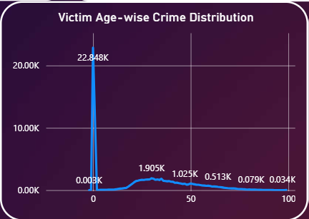
4.5 Crime Breakdown by Category
i. General Description
Crime types vary widely — theft, assault, burglary, fraud, etc.
ii. Objective
- Identify the most common crime categories.
- Compare proportion of different crime types.
iii. Findings
- Vehicle Theft is the most frequent category (~12%).
- Assault, Burglary, Vandalism, and Theft-related crimes also feature prominently.
- Most categories hold small percentages, indicating high category diversity.
iv. Visualization
A detailed donut chart showing all categories with color-coded legend.
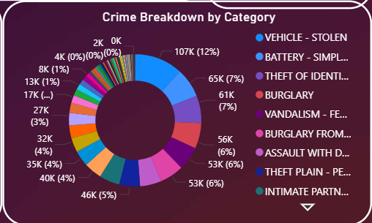

Dashboard
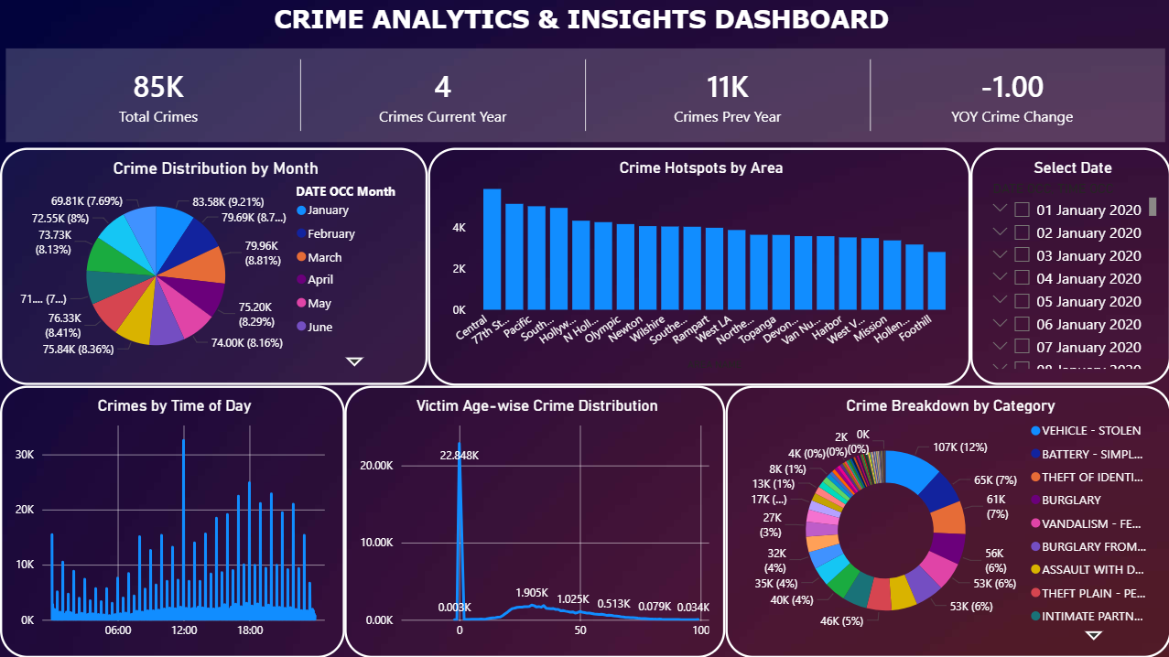

Conclusion
This project successfully demonstrates how crime data can be transformed into meaningful and actionable insights using Power BI. The dashboard clearly highlights:
- Crime hotspots across major LA districts
- Monthly and hourly crime patterns
- Victim demographic trends
- Frequency of major crime types
- YOY crime comparison
The interactive nature of the dashboard enables effective exploration and supports data-driven decision-making for law enforcement, policymakers, and researchers.
Overall, the project strengthened skills in data cleaning, DAX, data modeling, visualization design, and analytical storytelling.

Future Scope
This dashboard can be significantly extended with additional analytical layers:
🔹 1. Predictive Crime Modeling
Using machine learning to forecast crime hotspots or likely crime times.
🔹 2. Advanced Geo-Analytics
Integrating detailed maps (ArcGIS, Shape Maps) for street-level crime clustering.
🔹 3. Crime Severity Index
Creating severity scores to prioritize serious incidents.
🔹 4. Integration with Real-Time Data
Automatically updating the dashboard as new cases are recorded.
🔹 5. Adding Socioeconomic Factors
Correlating crime with income, unemployment, or population density.

References
Dataset Link: https://catalog.data.gov/dataset/crime-data-from-2020-to-present

