

Report

Expenditure Management System

**Submitted by:**

Asit Kumar

Section - B

University Roll No. - 2018250

Semester – 4

**Under The Guidance of:**

Dr. Prateek Srivastava

(Assistant Professor)

GRAPHIC ERA HILL UNIVERSITY, DEHRADUN

CERTIFICATE

Certified that Mr. Asit Kumar (Roll No.-2018250) has developed mini project on “**Expenditure Management System**” for the CS IV Semester Mini Project in Graphic Era Hill University, Dehradun. The project carried out by student is their own work as best of my knowledge.

Date: 16th July, 2022

Dr. Prateek Shrivastava

CSE-B-IV-SEM

(CSE Department)

GEHU Dehradun

ACKNOWLEDGEMENT

This Project becomes a reality with the kind support and help of many individuals. I would like to extend my sincere thanks to all of them.

Foremost, I want to offer this endeavour to our GOD Almighty for the wisdom he bestowed upon me, the strength, peace of mind, and good health in order to finish this project.

I would like to express my gratitude towards my family and friends for the encouragement which helped me in the completion of the project.

I would like to thank particularly my project mentor Dr. Prateek Srivastava sir for his patience, support, and encouragement throughout the completion of this project and for having faith in me.

At last but not least, I am greatly indebted to all other persons who directly or indirectly helped me during this work.

Asit Kumar

Section - B

2018250

ABSTRACT

We are developing a website named as “**Expenditure Management System**” and this website is used to manage the user’s daily expenses in a more efficient and manageable way.

By using this web application we can reduce the manual calculations for their daily expenses and keep the track of the expenditure. In this application, user can provide his income to calculate his total expenses per day

MOTIVATION

When you don’t keep a watch on your spending, you will be short of money, always. This will stress you out. With a daily expense manager, you will be able to allocate money to different priorities and this will also help you cut down on unnecessary spending. As a result, you will be able to save and be able to keep worried at bay.

A daily money tracker website helps you budget your money so that you use it wisely. If you find that every month your expenses are more than what you earn, it is time to put your house in order and get a money manager app that keeps track of your money without any problem.

INDEX

* Problem Statement
* Methodology
* Languages Required
  + HTML
  + CSS
  + JS
* About the System
* Requirements
* Features
  + Basic GUI
  + Automatic Calculations
  + User Friendly Interface
  + Remembering Details
* Working
* Website Layout
* Conclusion
* Reference

PROBLEM STATEMENT

Basically, we can see that today everyone seek towards his savings. He wants that in this era of inflation how he can control his expenses and save money for future use. Obviously, they are seeking towards such an application which guides them how they can meet their expenses in efficient manner and also save their money for future use.

METHODOLOGY

The various methods used to complete this project are:

Entering daily earnings and expenses

Completion of project

Back-end(JS)

Front-end(HTML,CSS)

Get the tools (VS code)

Understanding the need

LANGUAGES REQUIRED

* **HTML**

(Hyper Text Markup Language)

* **CSS**

(Cascading Style Sheets)

* **JS**

(JavaScript)

HTML

**HTML, or HyperText Markup Language, allows web users to create and structure sections, paragraphs, and links using elements, tags, and attributes. However, it’s worth noting that HTML is not considered a programming language as it can’t create dynamic functionality.**

CSS

**CSS is what’s called a Cascading Style Sheet language, and is used to stylize elements written in a markup language such as HTML. It separates the content from the visual representation of the site.**

JAVASCRIPT

**JavaScript is a scripting language for creating dynamic web page content. It creates elements for improving site visitors’ interaction with web pages, such as dropdown menus, animated graphics, and dynamic background colors.**

About the System

The **Expense Tracker App** was created in a HTML web browser that use JavaScript to give user a great interactive experience when using an app. The app can be use through any web browser that only contains buttons and textboxes. The user can enter any amount of expenses in order to calculate the total amount of expense.

The user can either input a (positive number will be treated as a saving, negative number will be treated as expense). Try to explore the app and see what you will do to properly manage your daily expenses. The **Expense Tracker App** was built by using basic JavaScript coding structure that is easily understandable.

**REQUIREMENTS**

* **Basics of HTML (Hyper Text Markup Language).**
* **Basics of CSS (cascading Style Sheets).**
* **Basics of JS (JavaScript).**
* **Understanding the importance of this project.**
* **VS code (Visual Studios Code).**

**FEATURES:**

* **Basic GUI**
  + The project contains basic UI such as buttons and textboxes.
* **Auto Calculations**
  + This project uses an automatic features that automatically calculate your inputted number.
* **User-friendly Interface**
  + This project was design in a simple user-friendly interface web application so that your easily modified
* **Remembering details**
  + It remembers your last entered details (the amount you withdrawn or the amount you deposited).

**Working**

* **This project shows you:**

1. **Your current balance**
2. **Your expenses**
3. **Your income**

* **It also takes input as:**

1. **Description (Reason of spending/income)**
2. **Amount**

* **This website remembers the previously entered data i.e. amount, description and your current balance) using a method named**

localStorage.getItem()

“Local storage allows developers to store and retrieve data in the browser. The data stored in local storage will not expire. This means the data will persist even if the tab or the browser window is closed.”

* **It uses DOM event listener for updating the list (function name used in project given below):**

addTransactionDOM(transaction);

HTML DOM events allow JavaScript to register different event handlers on elements in an HTML document.

Events are normally used in combination with functions, and the function will not be executed before the event occurs (such as when a user clicks a button).

**WEBSITE LAYOUT**

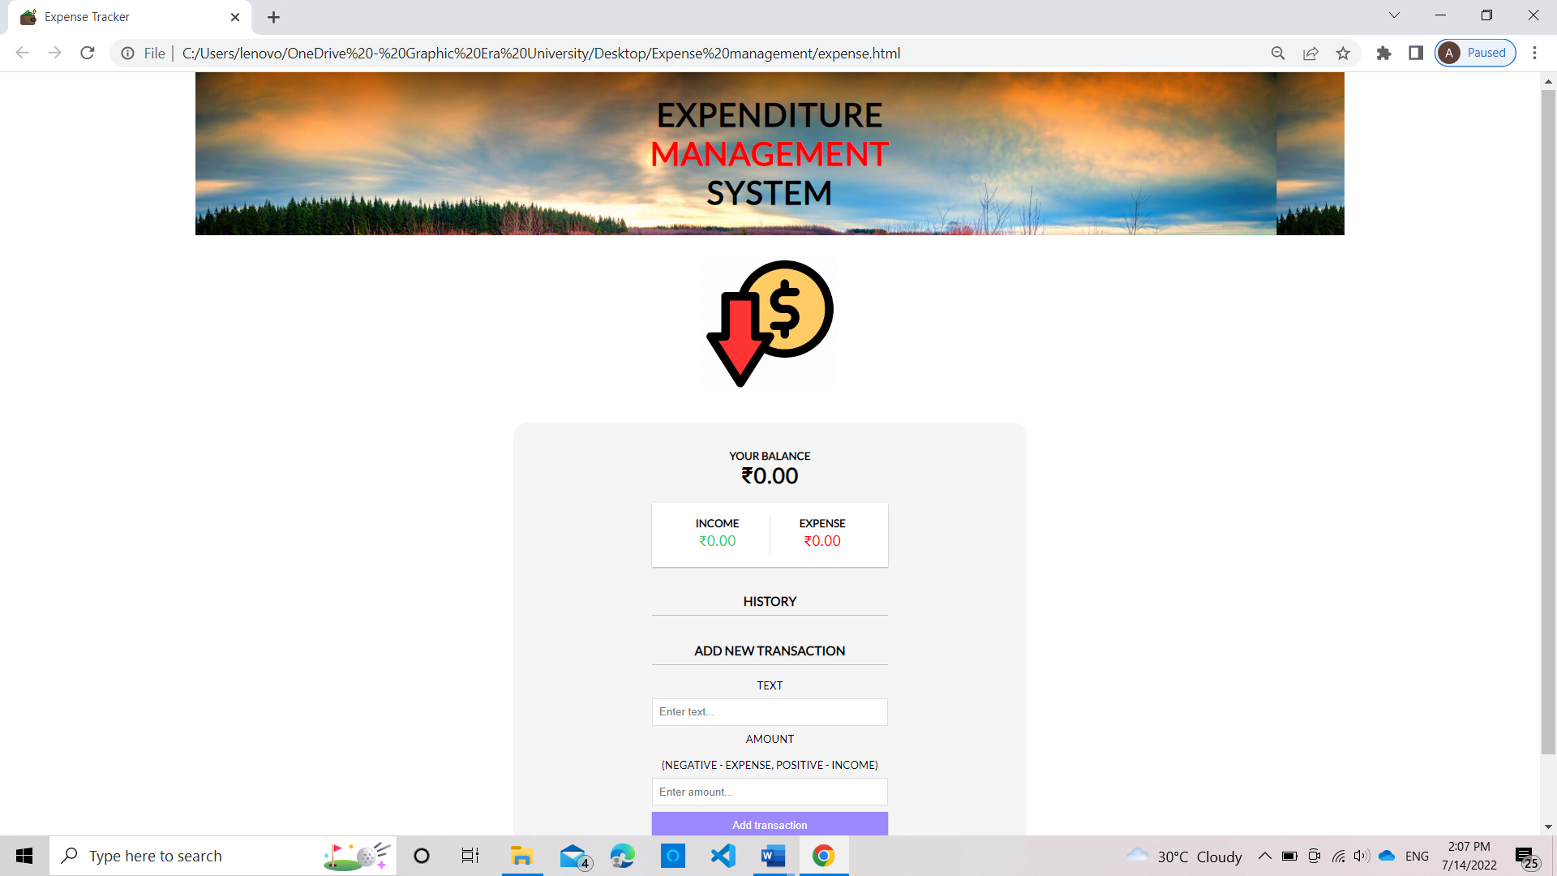

CONCLUSION

This project is aimed as a one-stop solution for management of someone’s expenses. This website provides a faster and more efficient ways to managing the expenses. This system eliminates majority of manual work and thereby reducing the risk of false expense approvals.

The system has a simple user interface and easy to use. We can also extend some functionality in the project, which I will do in the upcoming time.

This project will help in controlling the expenses and stop one from doing wasteful expenditure and maintain monthly expense limits.

REFERENCE

1. https://www.udemy.com/
2. [https://www.youtube.com/](https://www.youtube.com/watch?v=Up6KLx3m2ww)
3. Visual Studios
4. https://scholarworks.calstate.edu/