**Sentiment Analysis of Donald Trump’s Tweets**

Comparative study of sentiment

before, during, and after his campaign

Jesse A Smith III for DS745

Table of Contents

Problem Description and Objective ……....**2**

Dataset Description ………………………...**3**

Methodology ………………………………...**4**

Findings ……………………………………...**5**

Raw Results …………………………**5-6**

Visualizations and Comments:

Sentiments …………………………..**6-8**

Emotions …………………………….**8-15**

References ………………………………….**16**

Problem Description and Objectives

Often politicians shift tone depending on what stage of a campaign they are in. They might use a more aggressive tone in the campaign and then back off of that rhetoric once elected. With Donald Trump, we have a rare opportunity to see a transition from a non-political life, to campaign, to president. To see this transition I will use a set of Trump’s tweets that has content from before he started his campaign, during his campaign and after his election as 45th president. I will perform sentiment analysis on each time period and chart the sentiment over time. In this way, we can see how the content of his tweets changed over time and whether the campaign and his successful election bid changed his tone.

Dataset Description

The dataset I will analyze is from a data.world visualization competition. It was gathered using the Twitter API. The variables in the set are listed below (Highlighted variables were used in the analysis):

|  |  |
| --- | --- |
| Variable | Description |
| **Created_at** | Timestamp including month, day, and time indicating when the tweet was posted |
| Favorite_count | Integer value that indicates how many times users favorited the tweet |
| Id_str | Integer value with the unique identifier for the tweet |
| In_reply_to_user_id_str | The user id if the tweet was a reply to another user |
| Is_retweet | Boolean value indicating whether the tweet was a retweet |
| Retweet_count | Integer value giving a count of how many times the tweet was retweeted |
| Source | How the post was made (Tweetdeck, Iphone, Android) |
| **Text** | Character data including the content of the tweet |

Methodology

The methodology is described in the following steps:

1. Loaded the dataset in RStudio
2. Label the data as being before, during, or after the campaign based on the timestamp.
   1. “Before” ranged from May 4th 2009 to the tweet just before Trump’s campaign announcement
   2. “During” ranged from June 16th 2015 to November 8th 2016
   3. “After” ranged from Election Day to April 21st 2017
3. Removed stop words and weblinks from the tweets as they are not relevant for analysis
4. Used a regular expression pattern to extract the words, and then they were tokenized to prepare for comparison to the sentiment analysis lists
5. Used the “National Resource Council Canada Emotion Lexicon” as the list to perform the sentiment analysis. It has the following sentiment categories:
   1. **sentiments:** negative, positive
   2. **emotions:** anger, anticipation, disgust, fear, joy, sadness, surprise, trust
6. Using the NRC list, words were labeled according to emotion/sentiment and a count was performed for each for each campaign group

Visualizations were generated to highlight the trend before, during and after the campaign

Findings

Significant differences were found for each of the ten emotions/sentiment categories. The raw data is shown below for reference. The best way to show these differences is to chart them. I will go through each of the ten categories and comment on the possible reasons for the differences observed. For each visualization, I chose to make the “before” value the minimum value displayed on the y axis instead of zero. This decision was made because the “before campaign” tweets serve as the baseline for Trump’s twitter habits. These visualizations chart the proportion of words vs. the total as a percentage for each group in the before, during, and after stages of Trump’s campaign.

Raw Results

|  |  |  |  |  |
| --- | --- | --- | --- | --- |
| **Campaign Groups** | **Sentiment / Emotion** | **Total Words** | **Words in each** | **Portion of Campaign Group as %** |
| before | anger | 99667 | 3731 | 3.7434657409 |
| before | anticipation | 99667 | 6230 | 6.2508152147 |
| before | disgust | 99667 | 2598 | 2.6066802452 |
| before | fear | 99667 | 4188 | 4.2019926355 |
| before | joy | 99667 | 5604 | 5.6227236698 |
| before | negative | 99667 | 7355 | 7.3795739814 |
| before | positive | 99667 | 12052 | 12.0922672499 |
| before | sadness | 99667 | 3839 | 3.8518265825 |
| before | surprise | 99667 | 4052 | 4.0655382423 |
| before | trust | 99667 | 7079 | 7.1026518306 |
| during | anger | 39723 | 1895 | 4.7705359615 |
| during | anticipation | 39723 | 2087 | 5.2538831407 |
| during | disgust | 39723 | 1196 | 3.0108501372 |
| during | fear | 39723 | 1666 | 4.194043753 |
| during | joy | 39723 | 1655 | 4.1663519875 |
| during | negative | 39723 | 3333 | 8.3906049392 |
| during | positive | 39723 | 4382 | 11.0313923923 |
| during | sadness | 39723 | 1843 | 4.6396294338 |
| during | surprise | 39723 | 1310 | 3.2978375249 |
| during | trust | 39723 | 2939 | 7.3987362485 |
| after | anger | 6678 | 336 | 5.0314465409 |
| after | anticipation | 6678 | 453 | 6.7834681042 |
| after | disgust | 6678 | 231 | 3.4591194969 |
| after | fear | 6678 | 366 | 5.4806828392 |
| after | joy | 6678 | 356 | 5.3309374064 |
| after | negative | 6678 | 615 | 9.209344115 |
| after | positive | 6678 | 878 | 13.1476489967 |
| after | sadness | 6678 | 325 | 4.8667265648 |
| after | surprise | 6678 | 217 | 3.249475891 |
| after | trust | 6678 | 612 | 9.1644204852 |

Sentiments: Negative and Positive

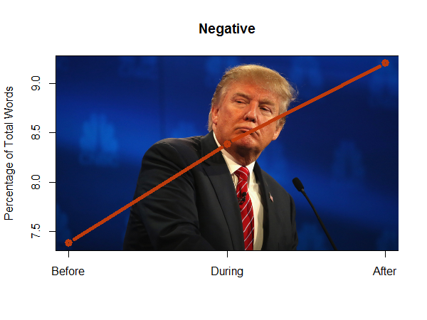

Trump’s tweets showed an increasingly negative sentiment. This makes sense when going from before to during as the campaign was highly negative. The continued increase into the presidency does make sense considering the rocky nature of his first 100 days, but one might assume that he would have become less negative once he won the presidency.

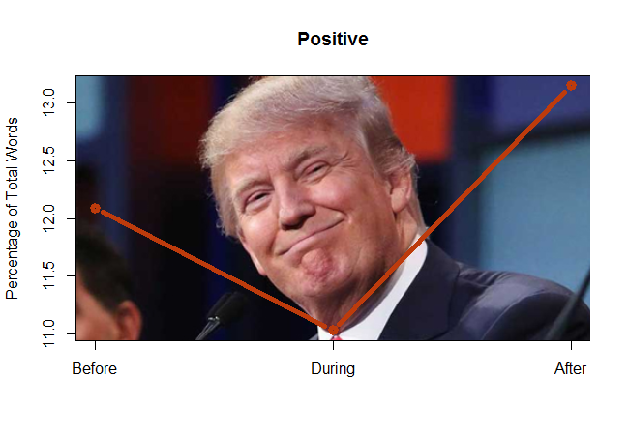

The positive sentiment drops compared to Trump’s private life. It is interesting to see that the positive sentiment increased after winning the presidency as we might have expected, but the previous chart shows that he also had more negative sentiment. So, he was both more positive and more negative once he was elected.

Emotions: anger, anticipation, disgust, fear, joy, sadness, surprise, trust

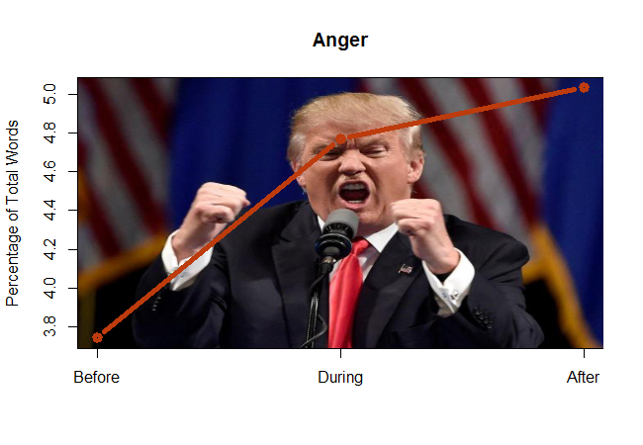

There is a dramatic increase in angry words once Trump starts his campaign. His campaign was largely fueled by populist anger so this makes sense. Into the presidency his anger only increases slightly.

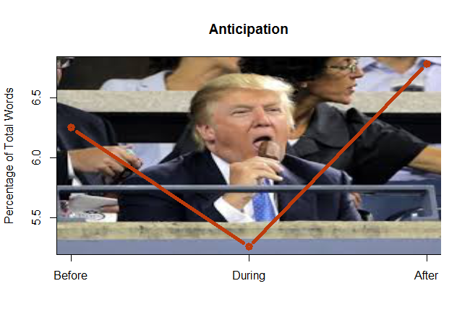

Trump’s sense of anticipation was lower during the campaign but reached it’s highest level once elected. This does make intuitive sense as he was obviously tweeting a lot about what he was about to do once inaugurated.

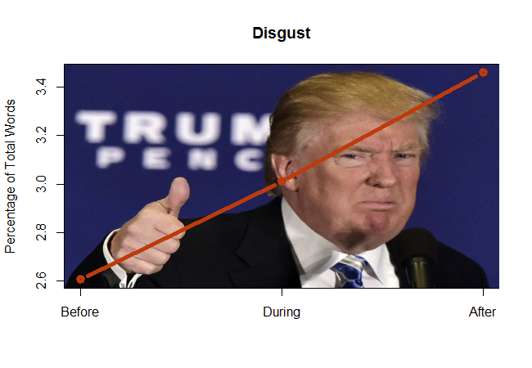

Trump’s tweets indicating disgust increased steadily. This likely is associated with the overall negative sentiment.

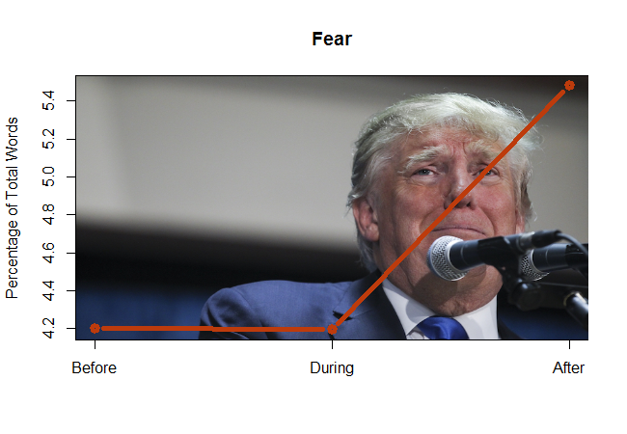

This was an interesting one. Trump doesn’t indicate much fear before or during the campaign without a significant change. The fear-associated words increase once he wins the election and becomes president.

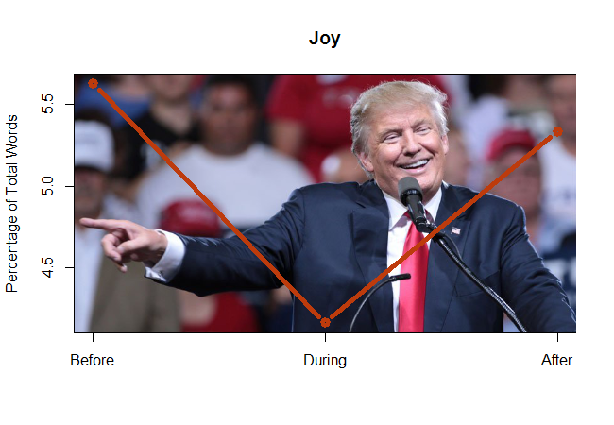

Trump’s joyful words decrease once he decides to run. They rebound once he wins the election, which is obviously something to be joyful about on a personal level.

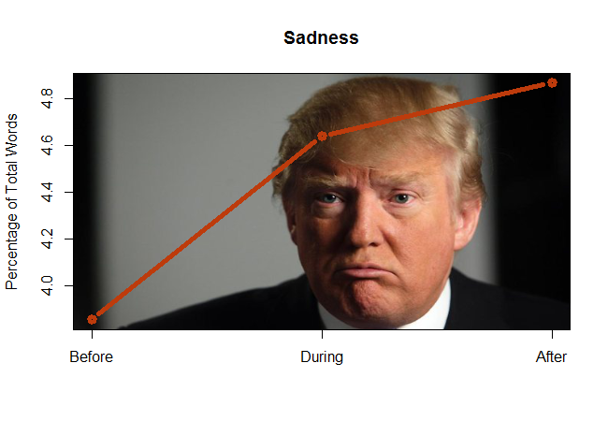

Words indicating sadness increase a fairly large amount and then continue to slightly increase into the presidency. Considering that one of Trump’s signature comments is “SAD!” this is not at all surprising.

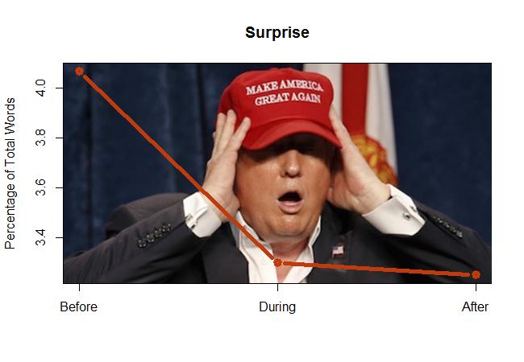

Words indicating surprise decreased during and after the campaign. I cannot think of a possible reason for this except Trump’s promotional tweets for his business and television show decreased.

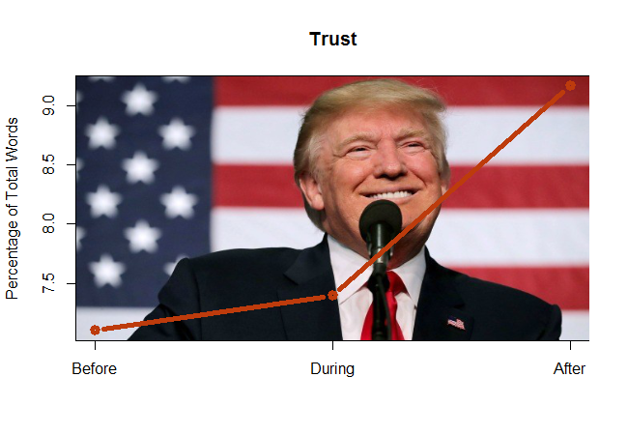

Trump’s words associated with trust slightly increased for the campaign and then went much higher once he was elected. This make sense as the electorate wants to be able to trust the President and he wants to portray himself as trustworthy.

References

Data.World “Every Donald Trump Tweet”

<https://data.world/datacrunch/every-donald-trump-tweet?utm_source=autopilot&utm_medium=email&utm_content=170421&utm_campaign=data_digest>

National Resource Council Canada Emotion Lexicon

<http://saifmohammad.com/WebPages/NRC-Emotion-Lexicon.htm>