CJ - Home
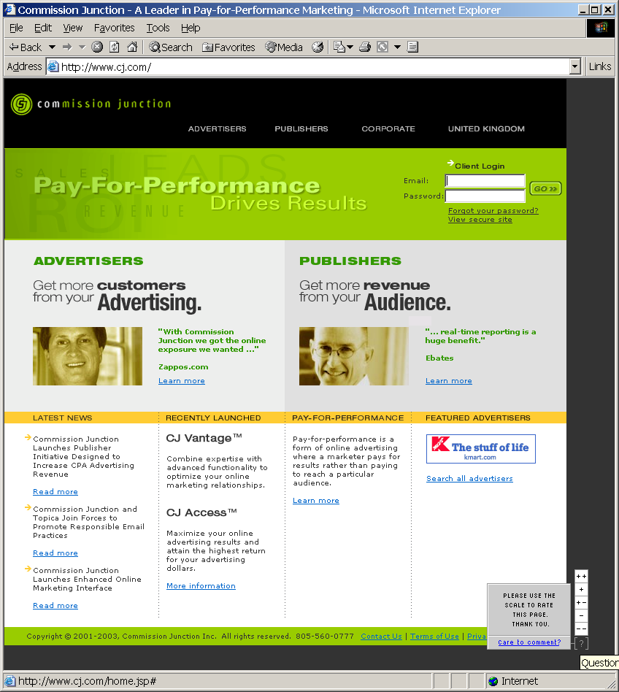

CJ – Advertisers -- Home
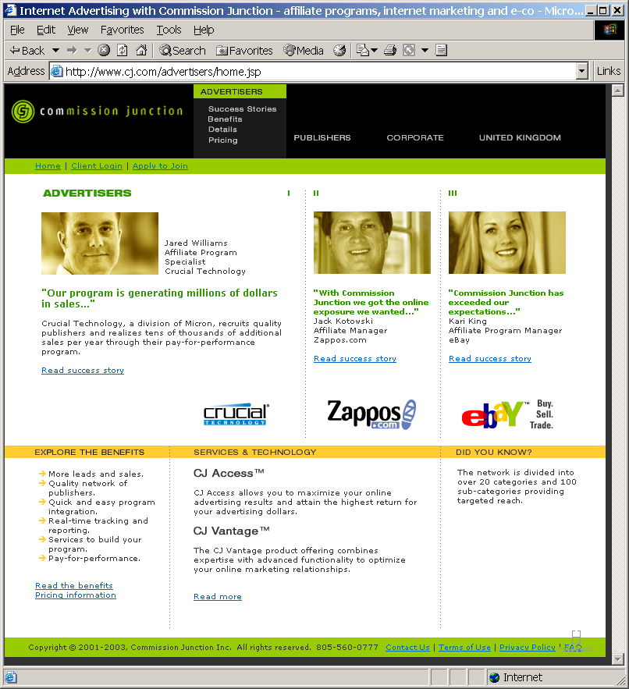

CJ – Advertisers -- Success Stories
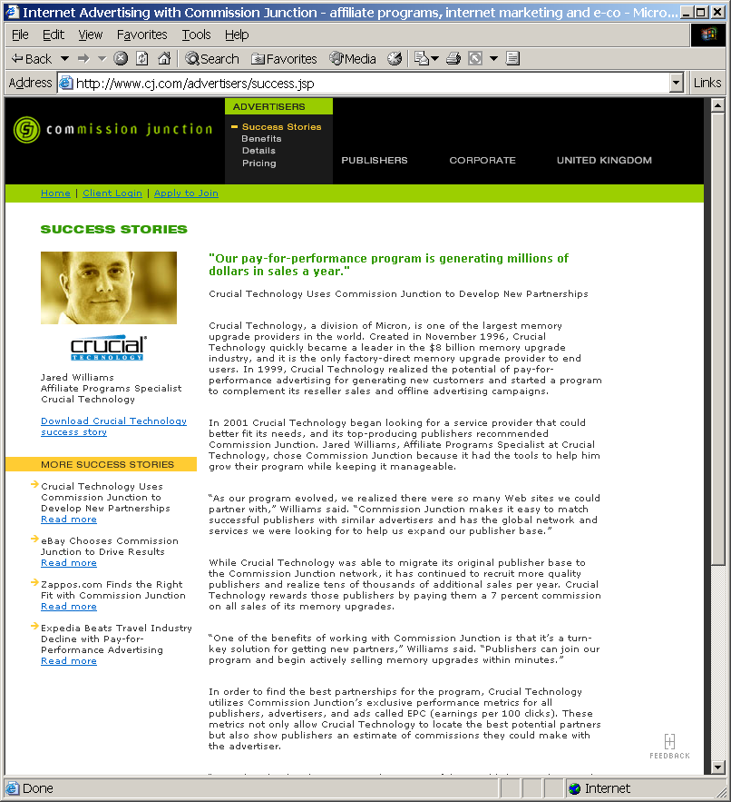

CJ - Advertisers – Benefits
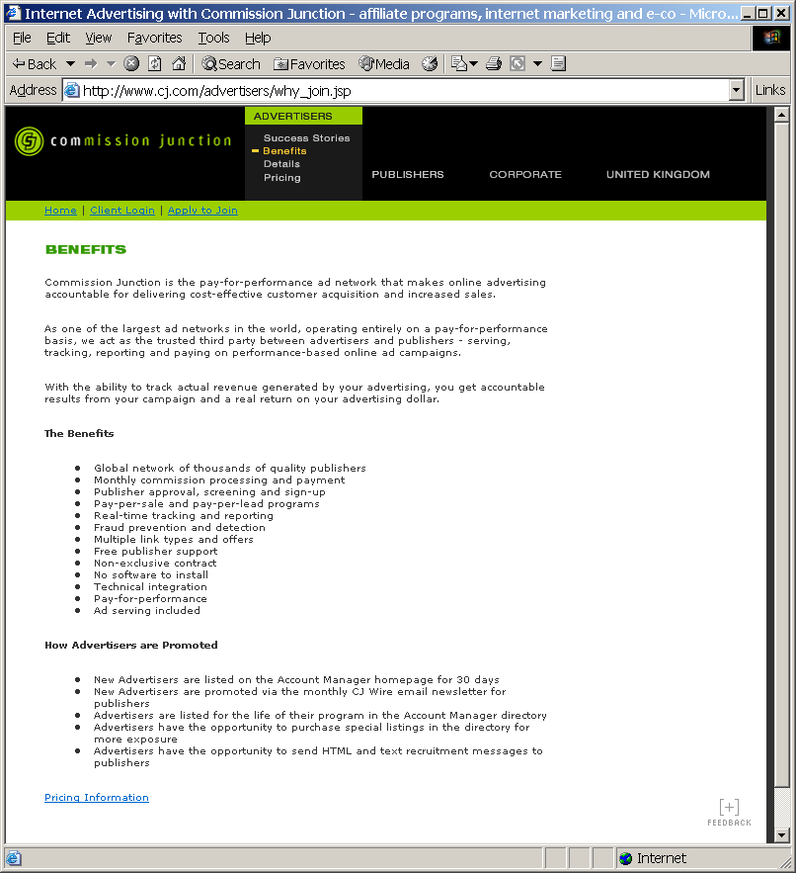

CJ – Advertisers – Details – Network
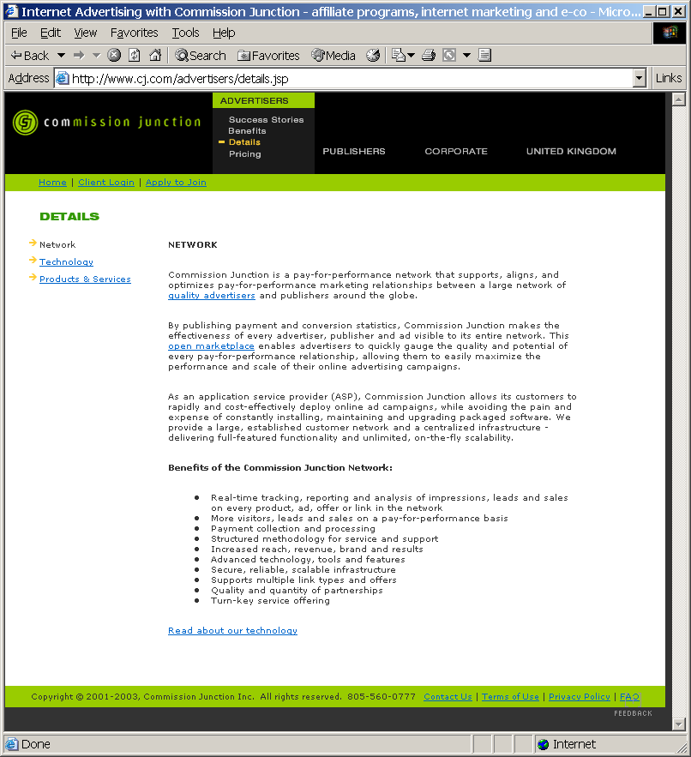

CJ – Advertisers – Details – Technology
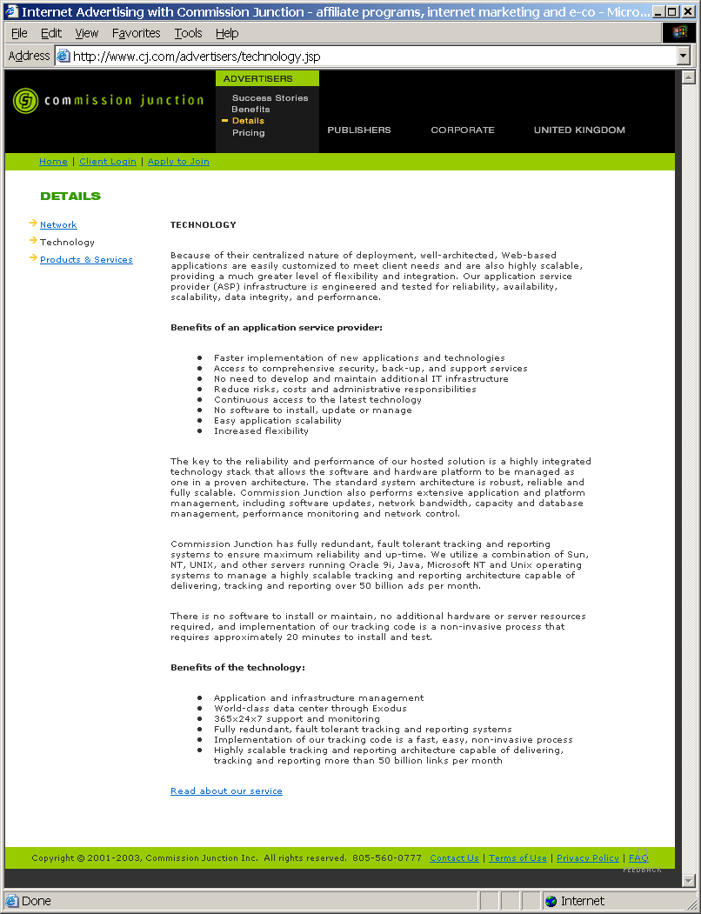

CJ – Advertisers – Details – Products & Services
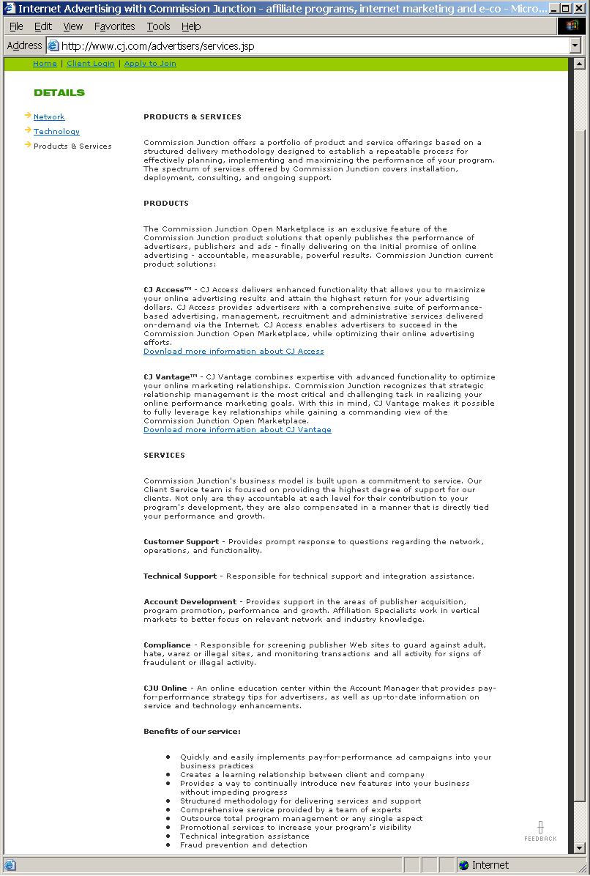

CJ – Advertisers – Pricing
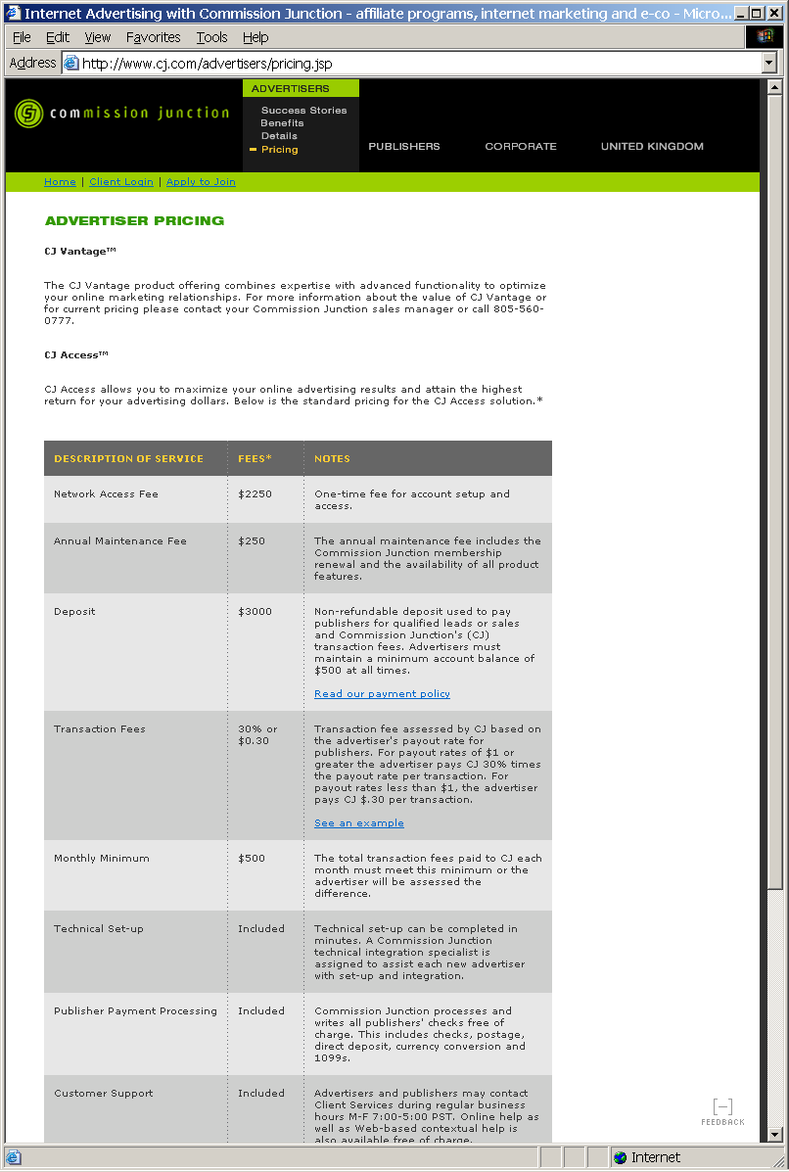
CJ – Advertiser – Apply to Join
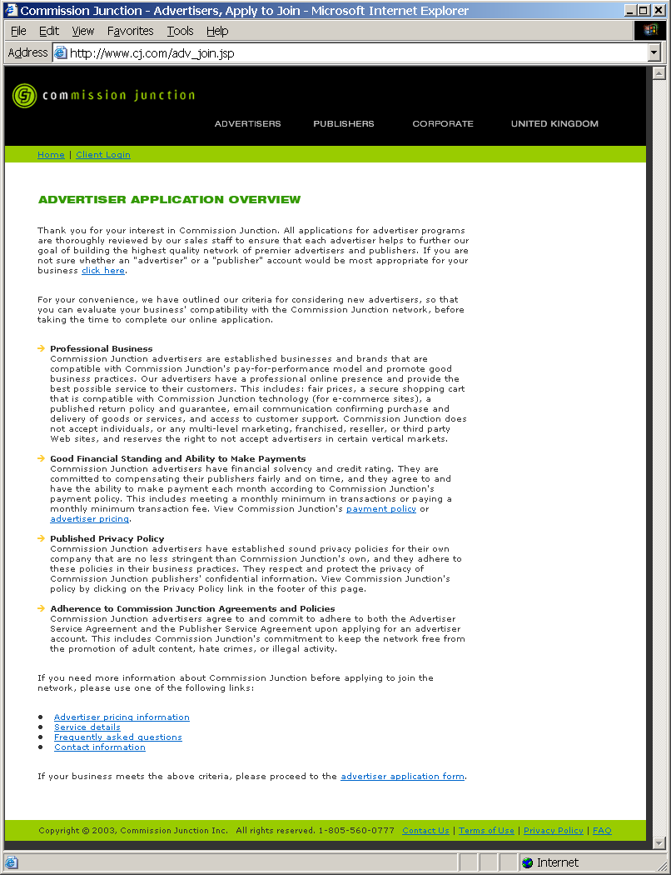

CJ – Advertiser – Advertiser Application Overview – Advertiser/Publisher Popup
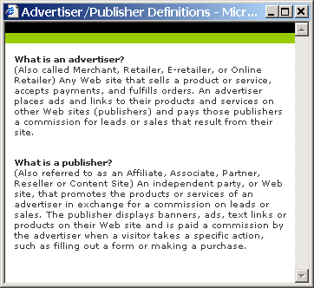

CJ – Advertiser – Advertiser Application Overview – Payment Policy Popup
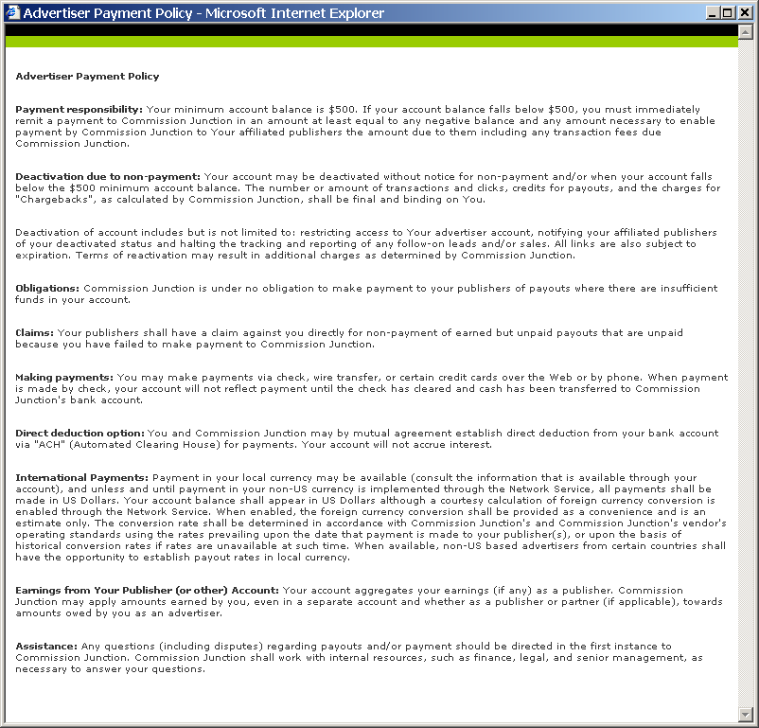

CJ – Advertiser – Advertiser Application Overview – Pricing Policy Popup
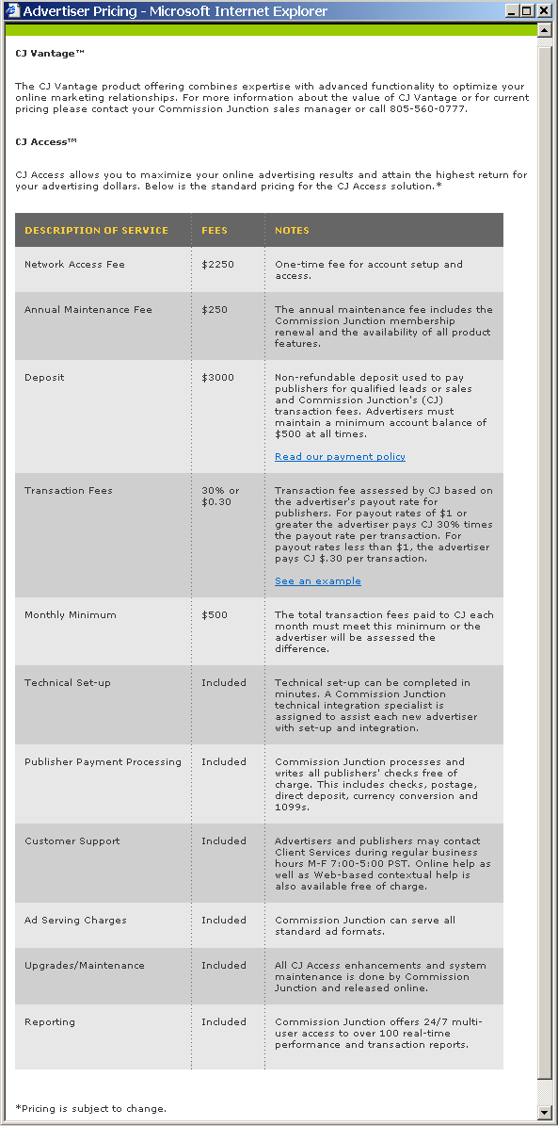
CJ – Advertiser – Application Form
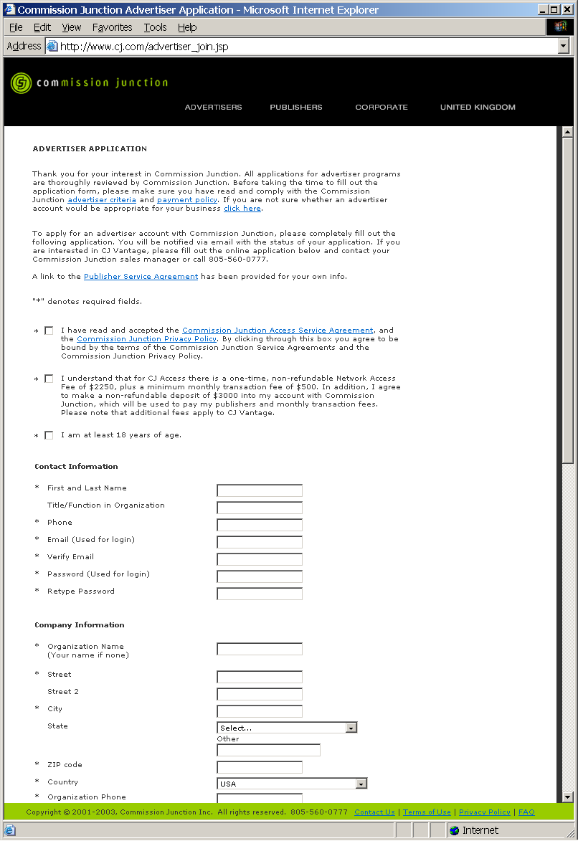

CJ – Advertiser – FAQ
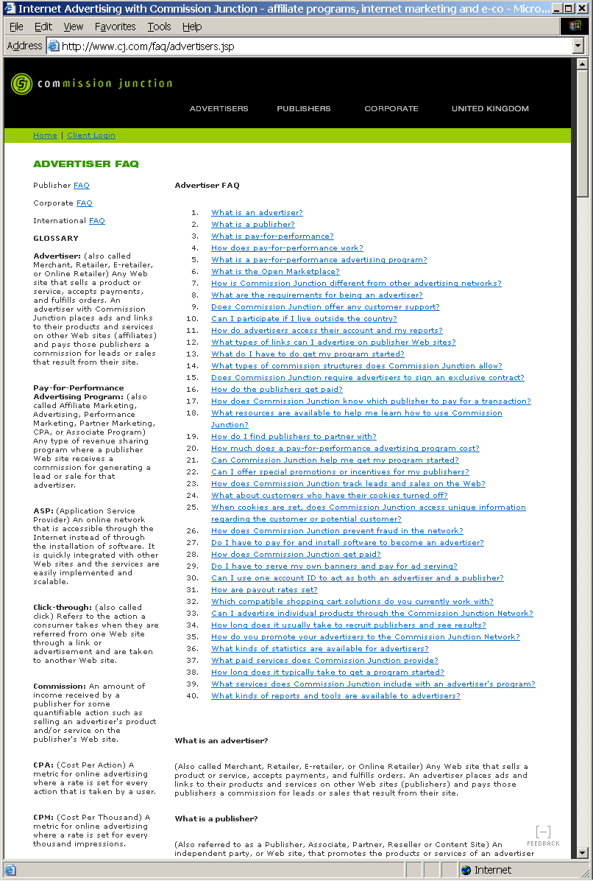

CJ – Client Login
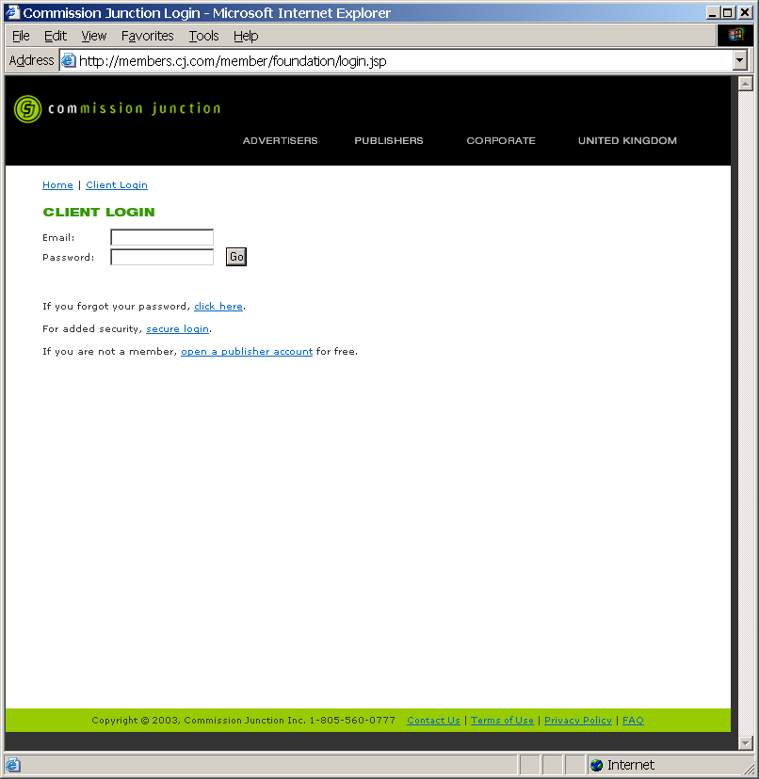

CJ – Client Login – Forgot Password
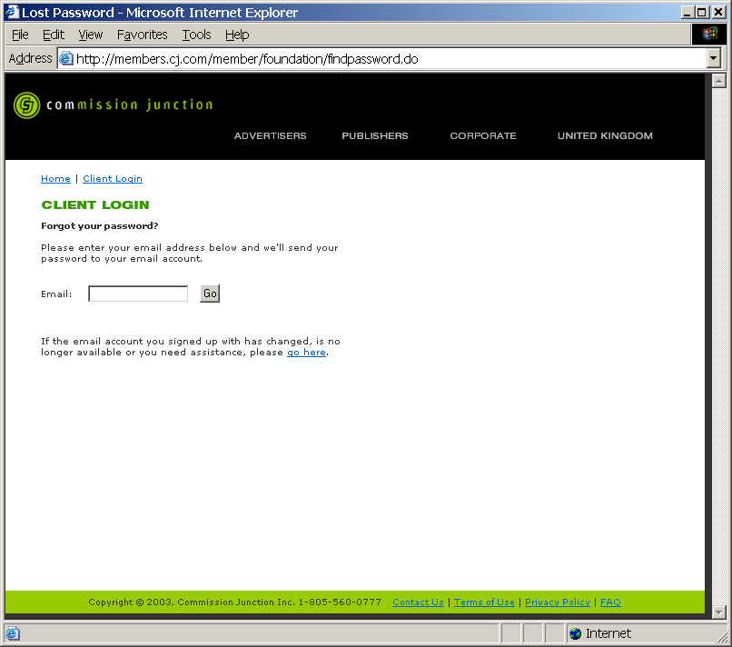

CJ – Client Login – Contact Commission Junction
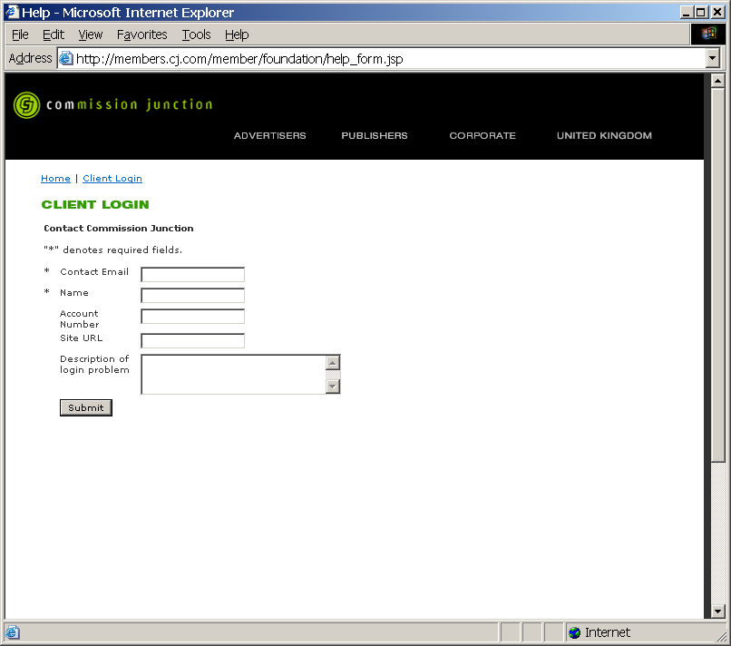

CJ – Publishers – Home
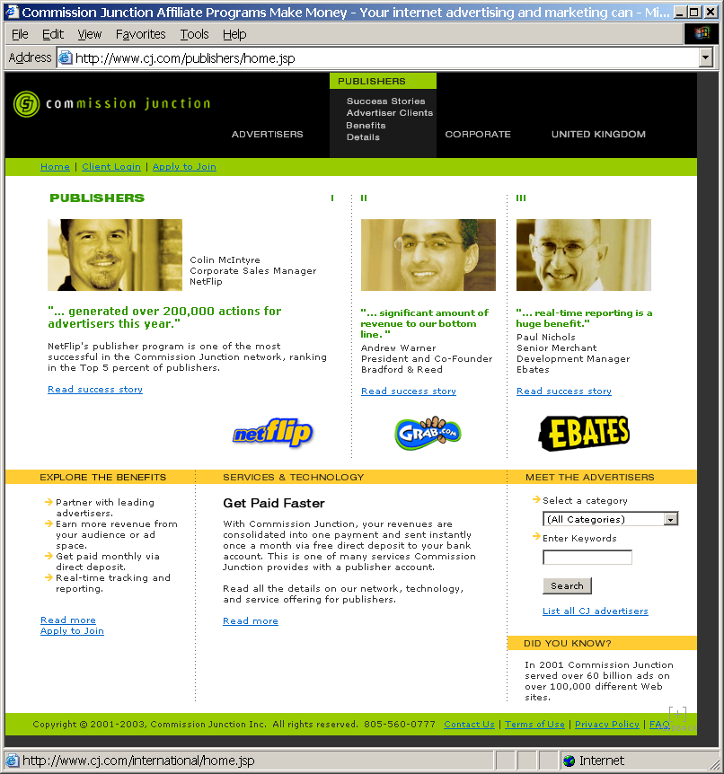

CJ – Publishers – Success Stories


CJ – Publishers – Advertiser Clients
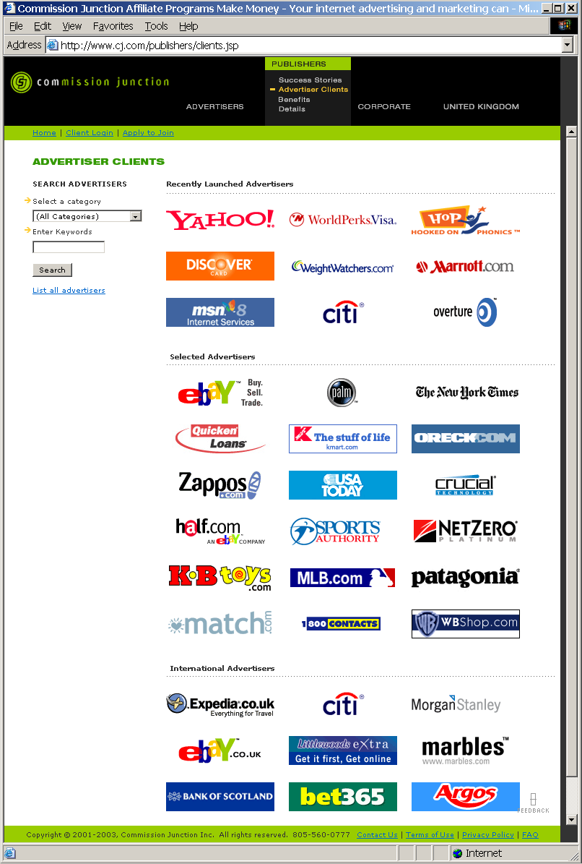
CJ – Publishers – Benefits
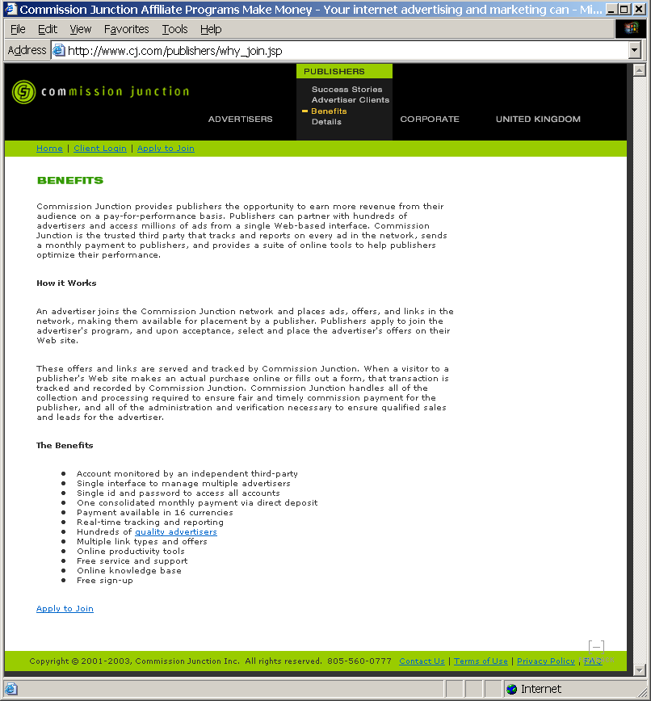

CJ – Publishers – Details – Network
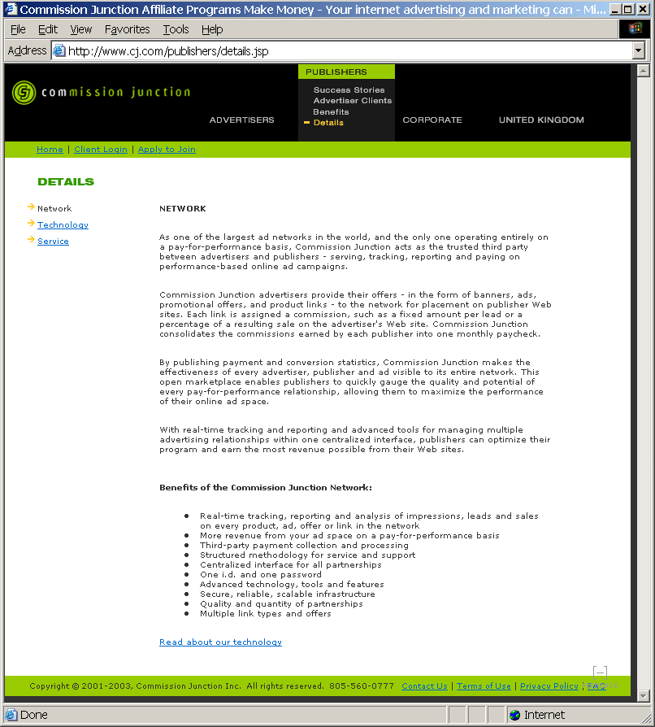

CJ – Publishers – Details – Technology
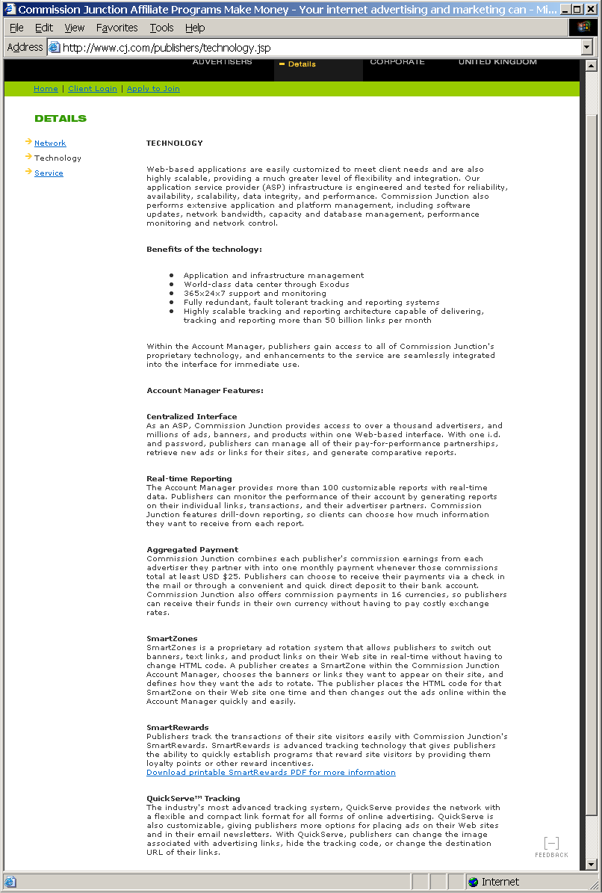
CJ – Publishers – Details – Service
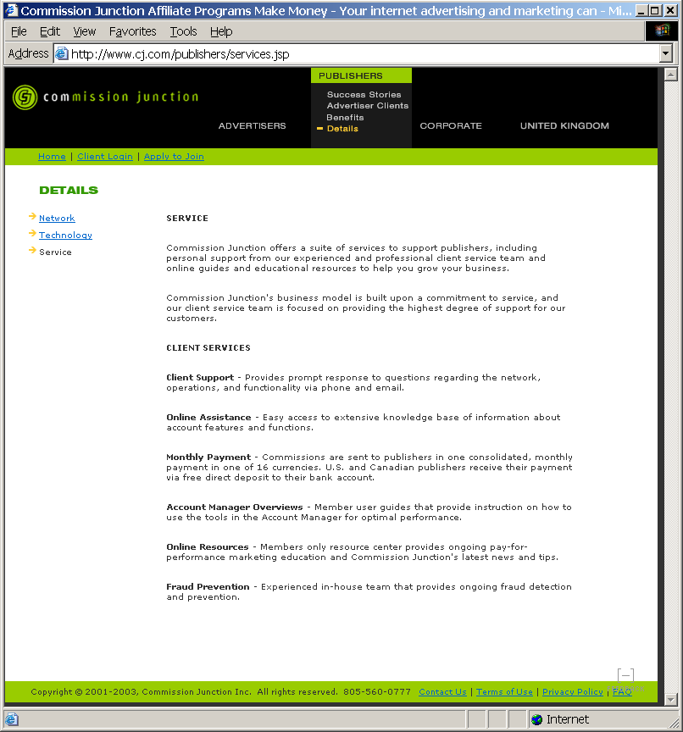

CJ – Publishers – Apply to Join – Publisher Application
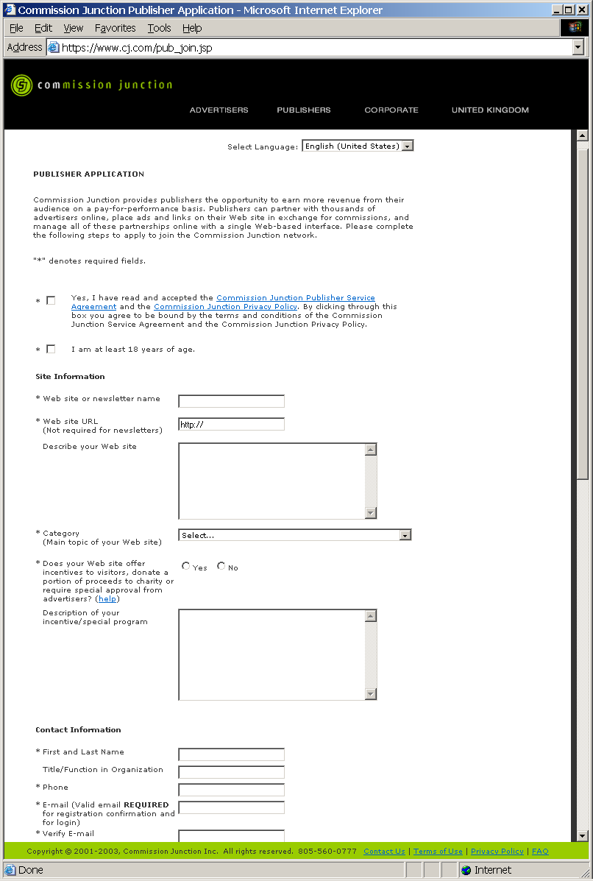

CJ – Publishers – Apply to Join – Warning Popup
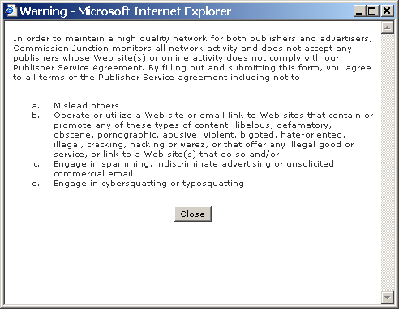

CJ – Corporate – Home
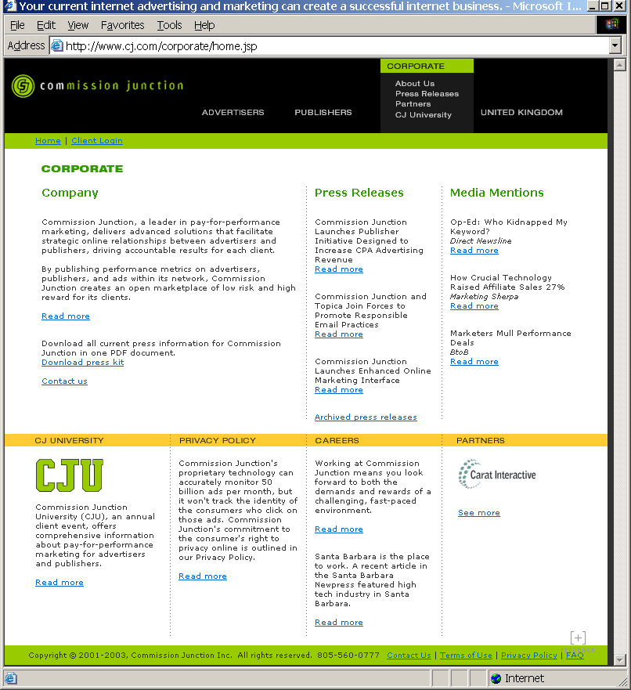

CJ – Corporate – Press Releases
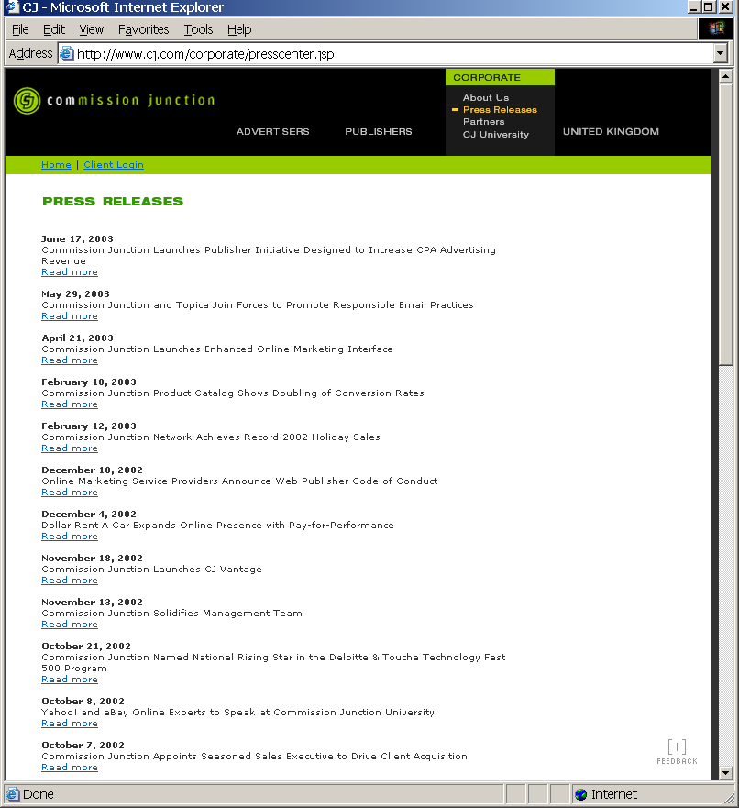

CJ – Corporate -- About Us


CJ – Corporate – Partners
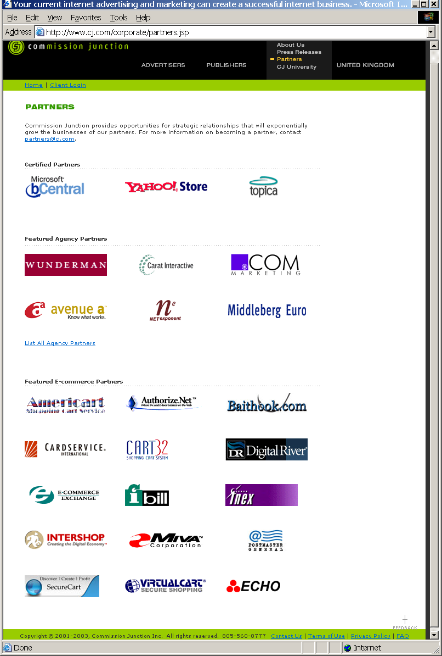
CJ – Corporate – CJ University
