CJ – Publisher – Logged In – Home
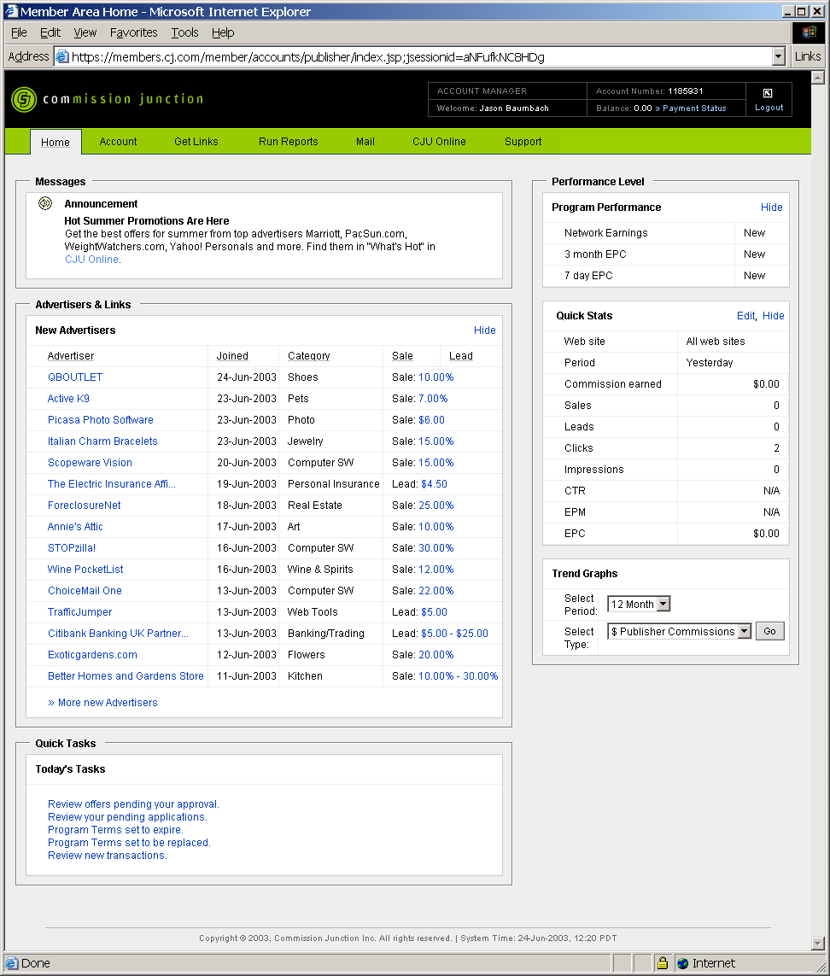
CJ – Publisher – Logged In – Account – Administrative Settings
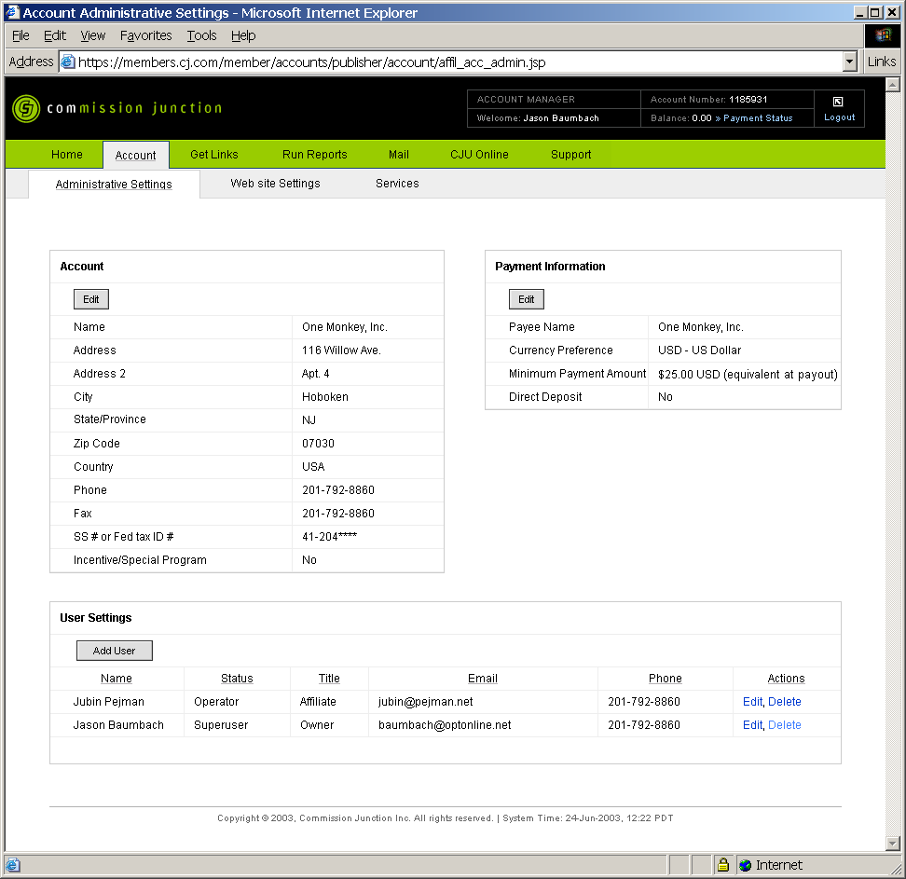

CJ – Publisher – Logged In – Account – Website Settings
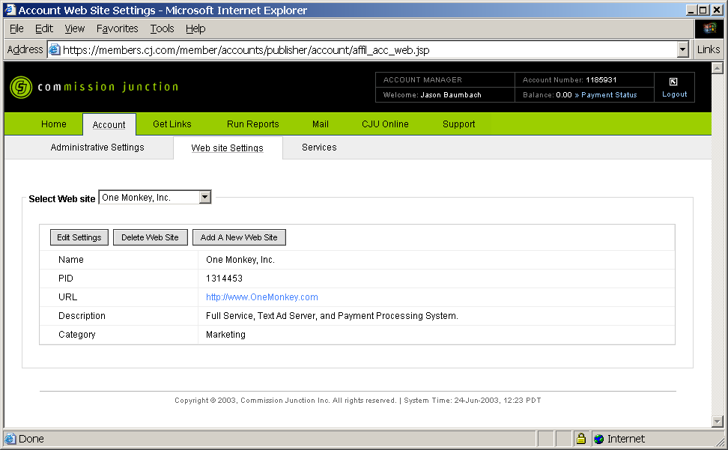

CJ – Publisher – Logged In – Account – Services
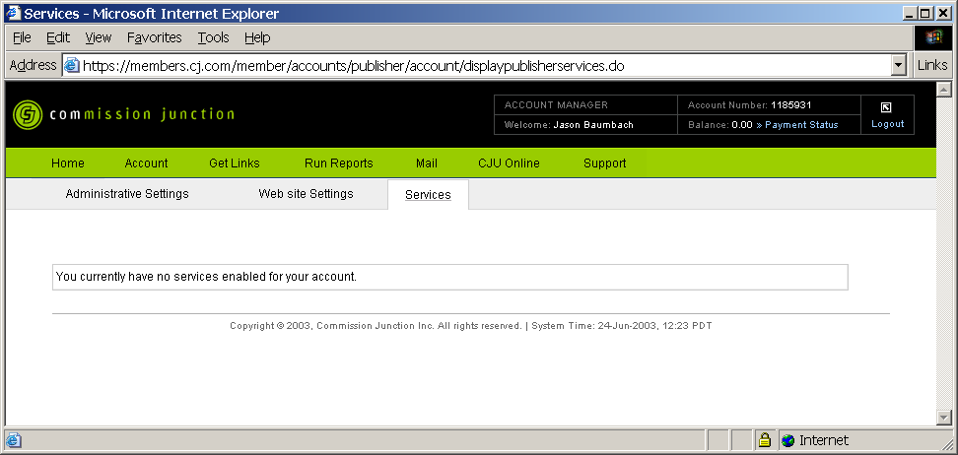

CJ – Publisher – Logged In – Get Links – General Categories
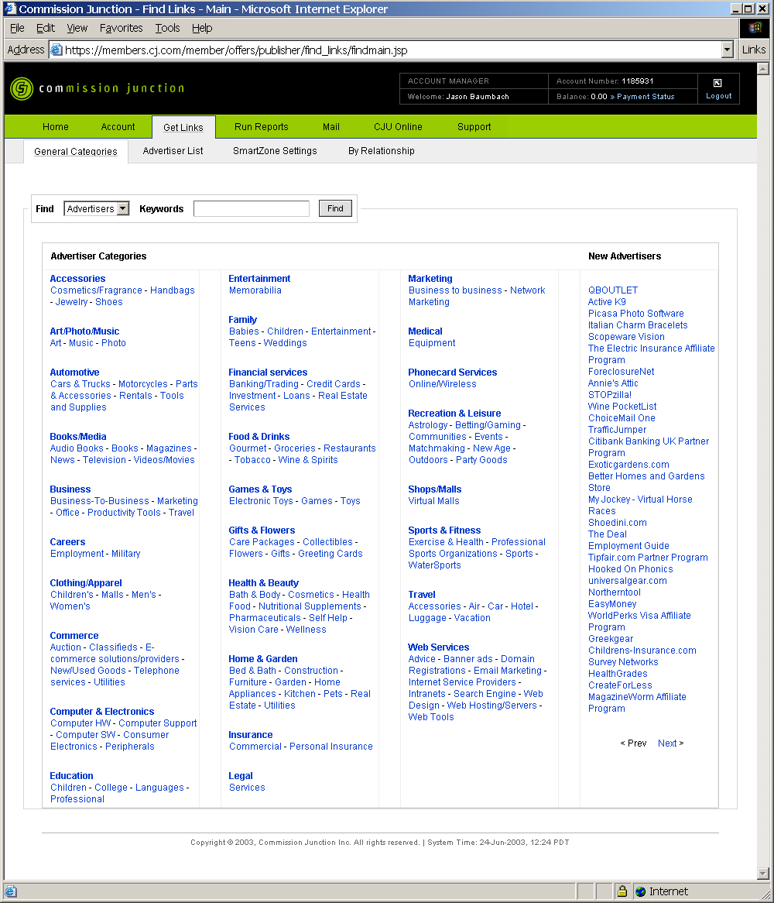
CJ – Publisher – Logged In – Get Links – General Categories
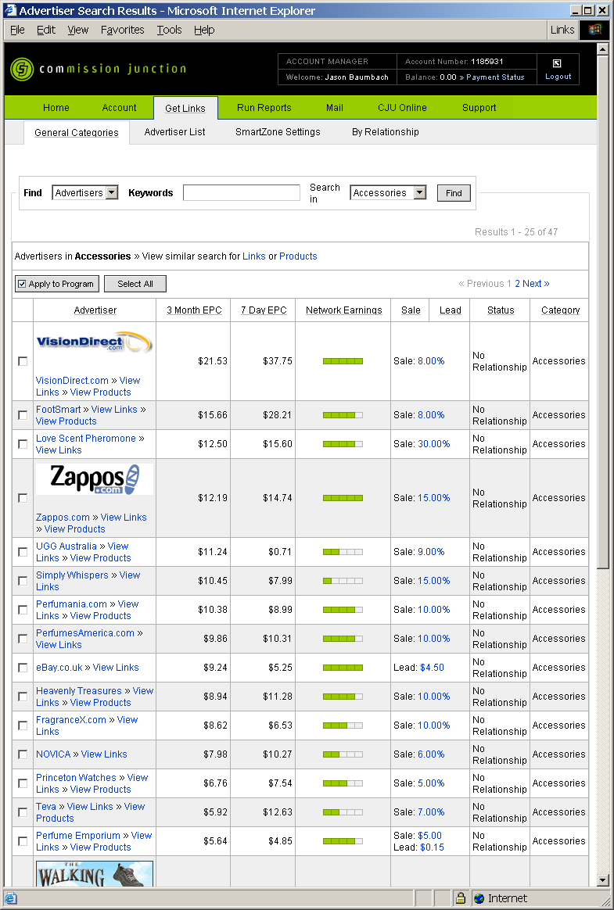
CJ – Publisher – Logged In – Get Links – Advertiser List
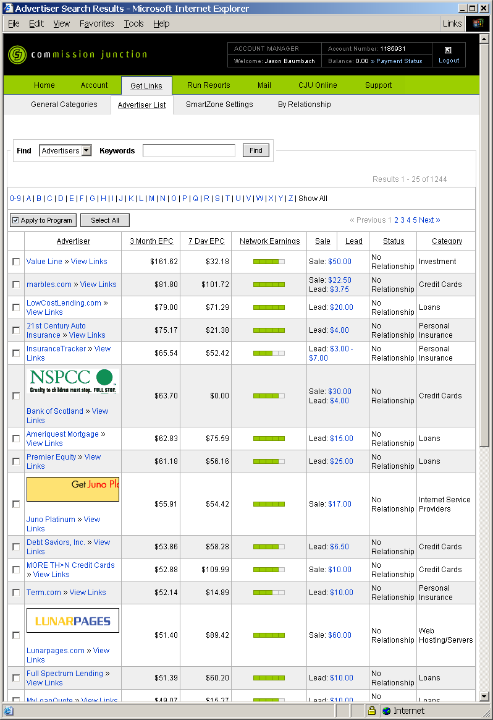
CJ – Publisher – Logged In – Get Links – Advertiser Detail
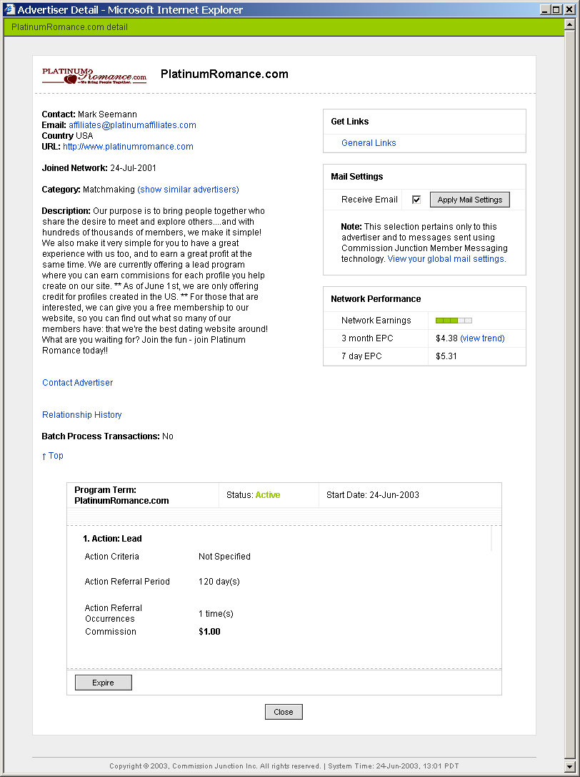
CJ – Publisher – Logged In – Get Links – View Links
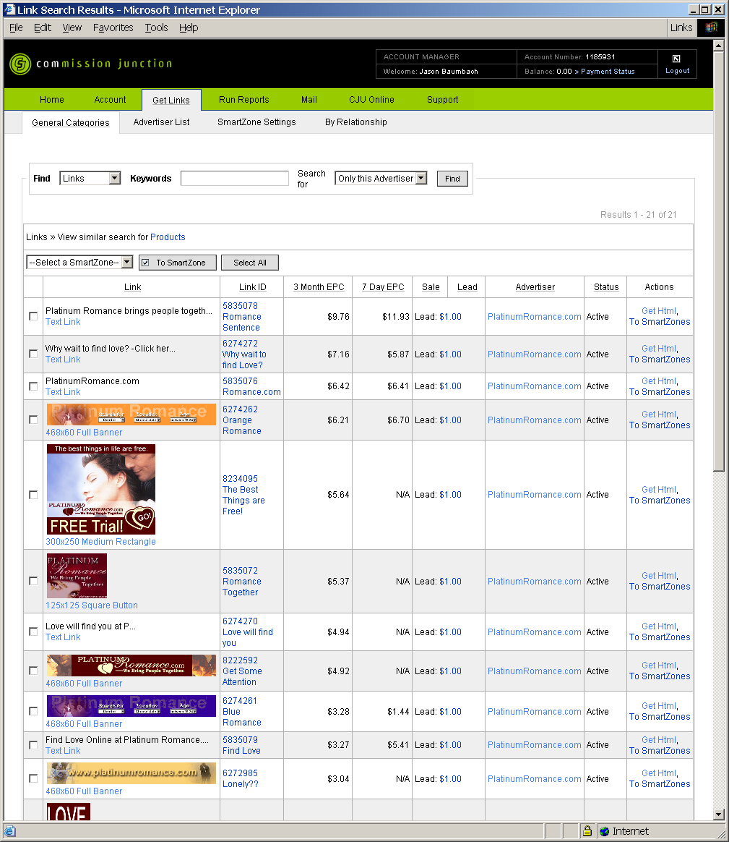
CJ – Publisher – Logged In – Get Links – Link Detail
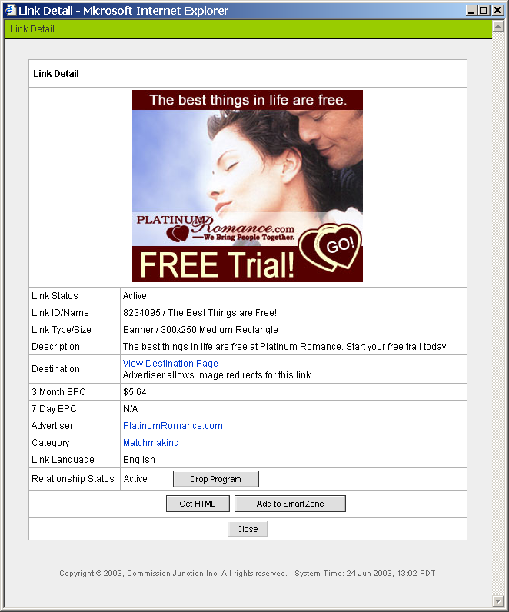
CJ – Publisher – Logged In – Get Links – Link Detail – Get HTML
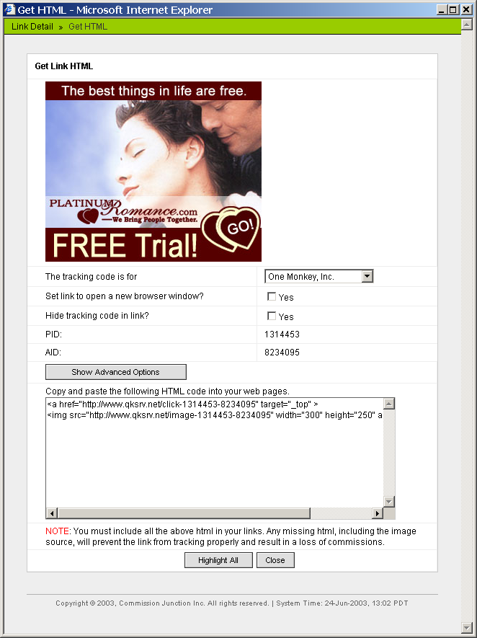
CJ – Publisher – Logged In – Get Links – Advertiser List
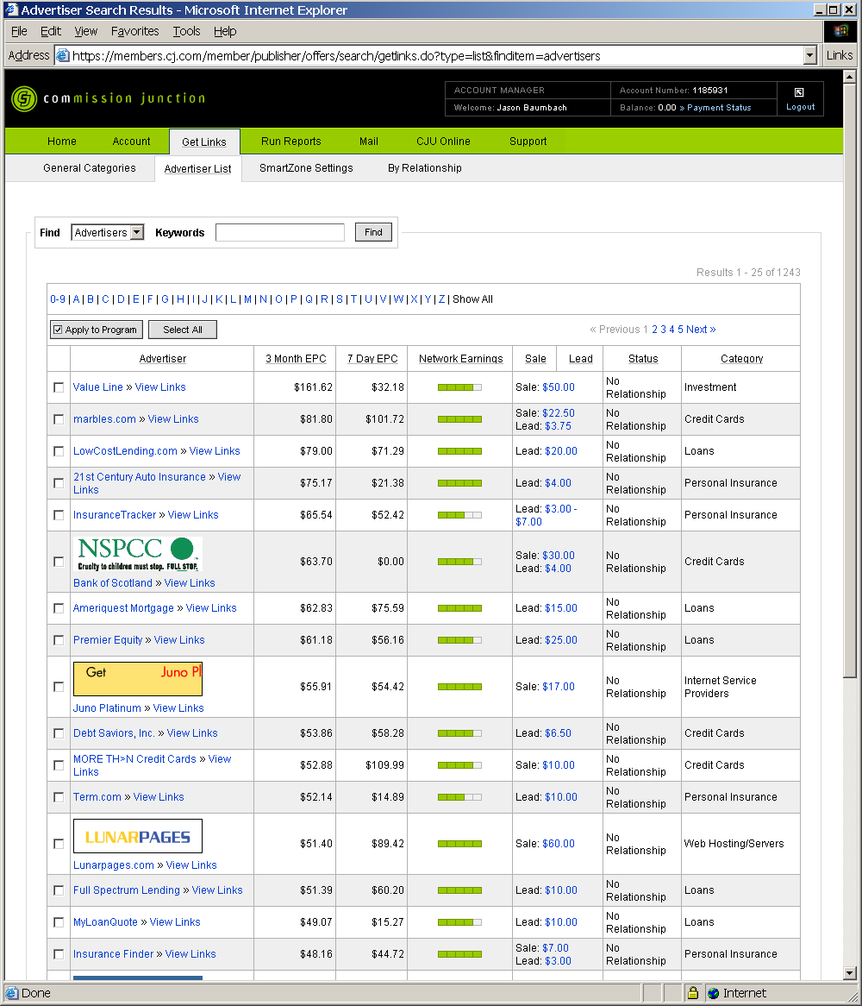
CJ – Publisher – Logged In – Get Links – SmartZone Settings
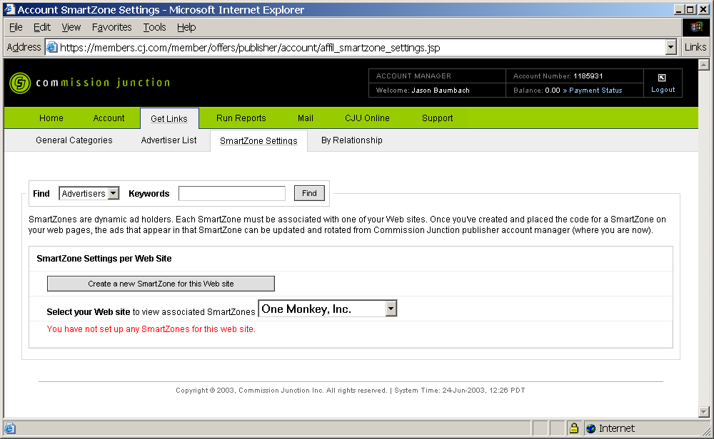

CJ – Publisher – Logged In – Get Links – By Relationship – My Advertisers
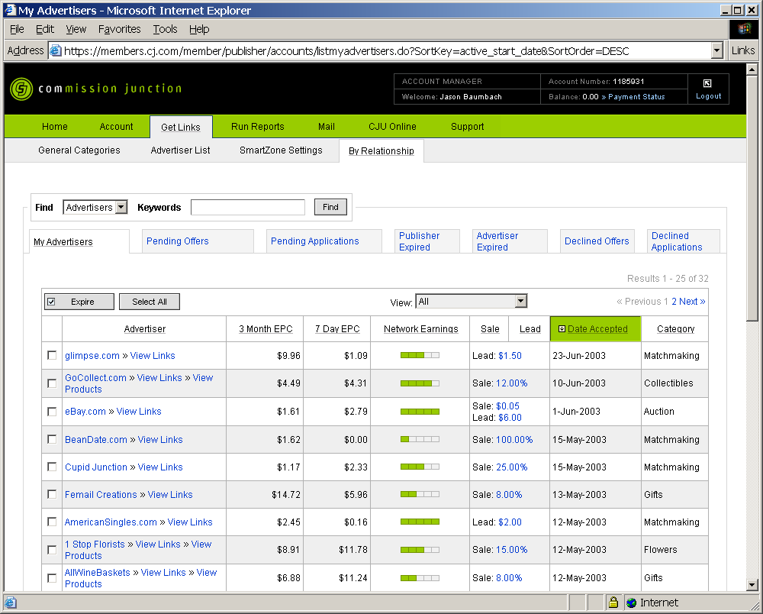

CJ – Publisher – Logged In – Get Links – By Relationship – Pending Offeres
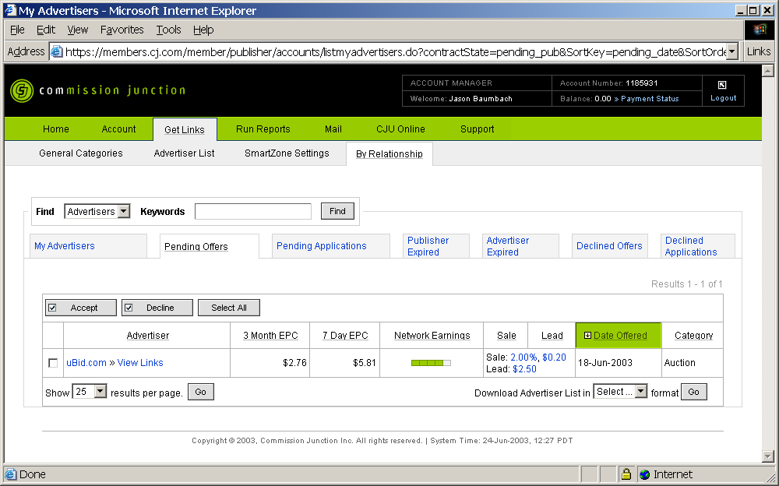

CJ – Publisher – Logged In – Get Links – By Relationship – Pending Applications
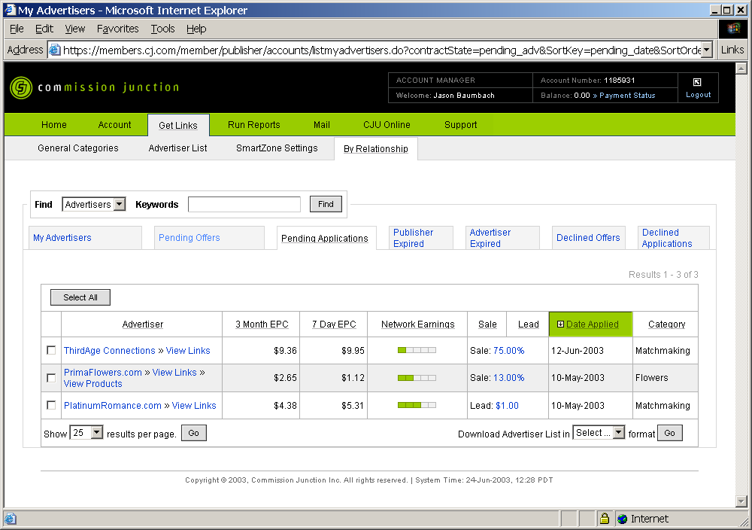

CJ – Publisher – Logged In – Get Links – By Relationship – Publisher Expired
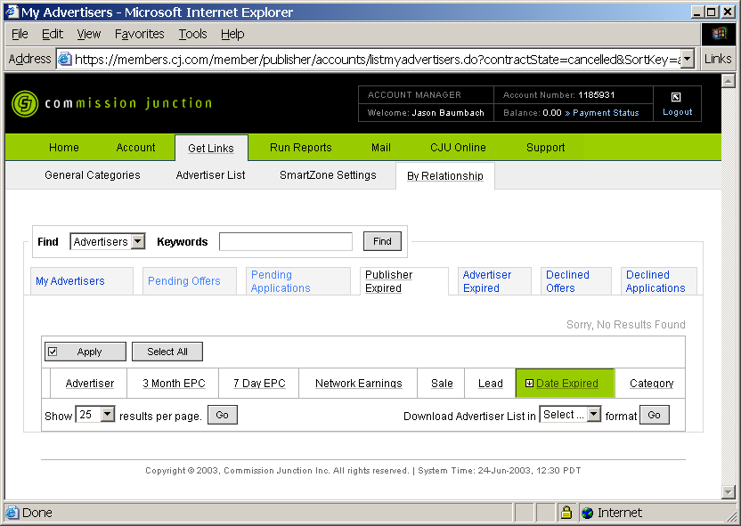

CJ – Publisher – Logged In – Get Links – By Relationship – Advertiser Expired
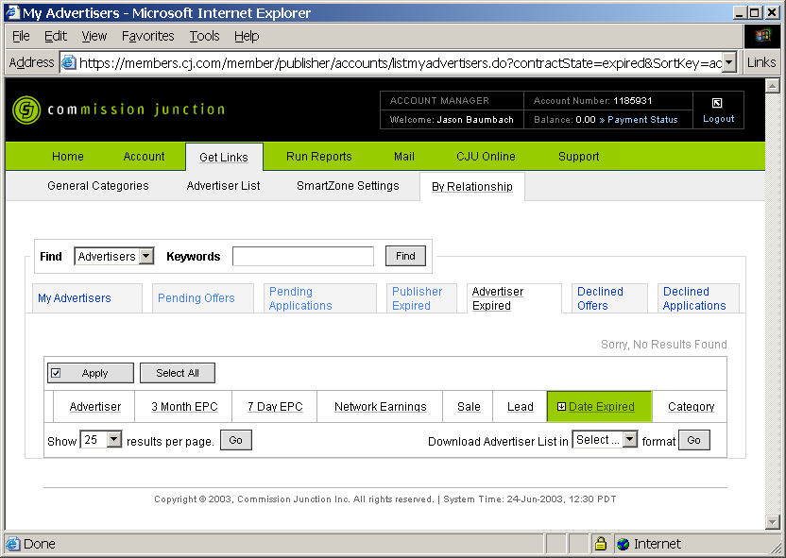

CJ – Publisher – Logged In – Get Links – By Relationship – Declined Offers
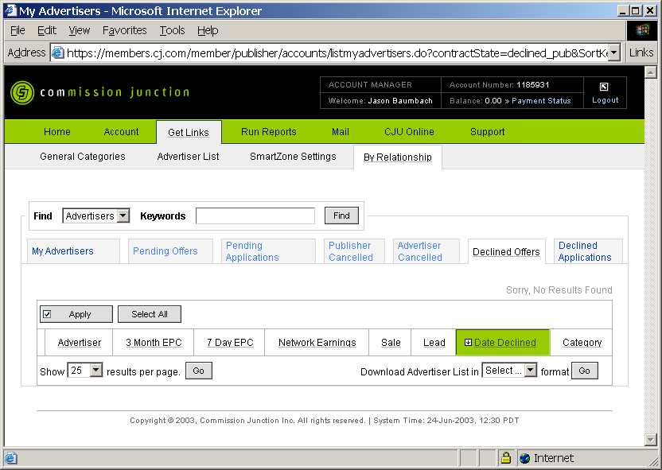
CJ – Publisher – Logged In – Get Links – By Relationship – Declined Applications
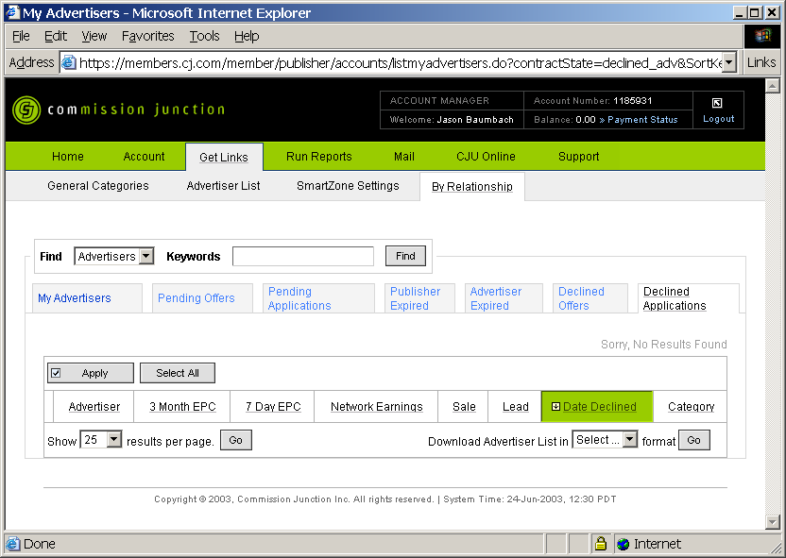

CJ – Publisher – Logged In – Run Reports
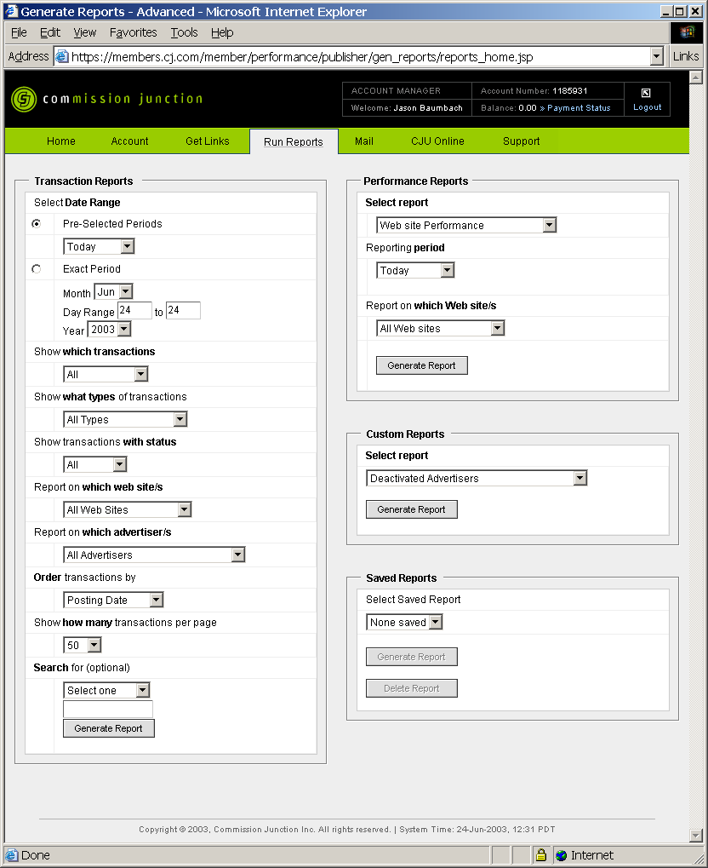
CJ – Publisher – Logged In – Run Reports – Performance Reports
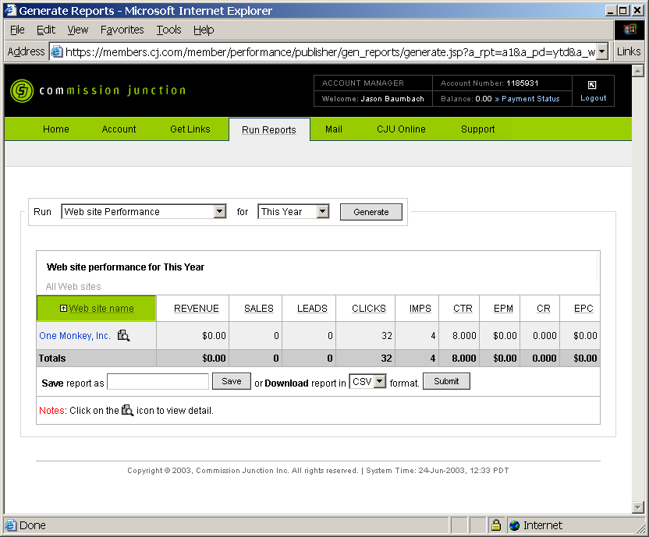

CJ – Publisher – Logged In – Run Reports – Custom Reports – Deactivated Advertisers
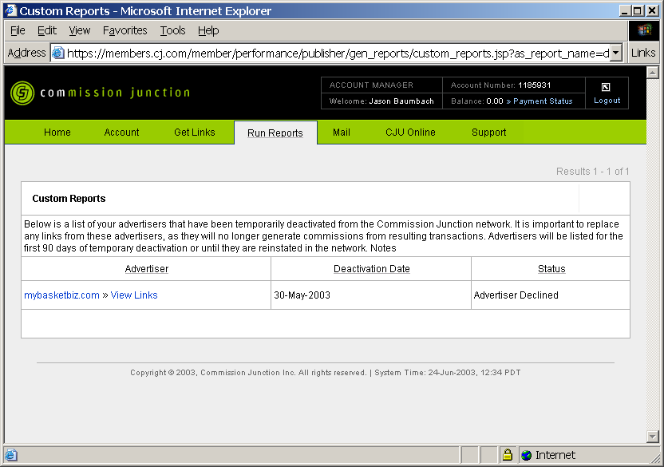

CJ – Publisher – Logged In – Mail – Messages
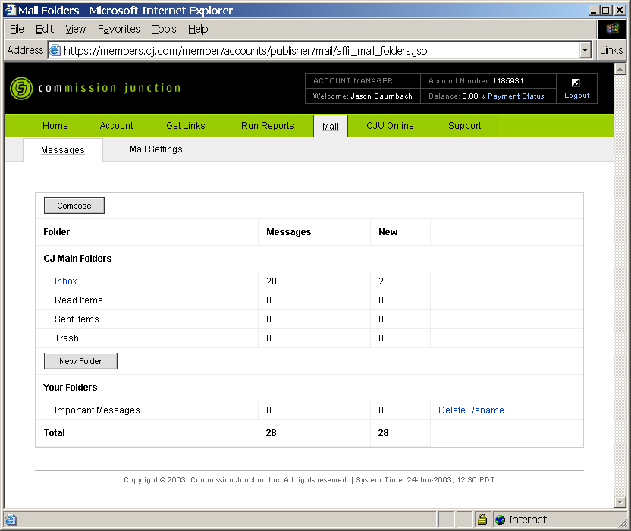
CJ – Publisher – Logged In – Mail – Messages – Compose
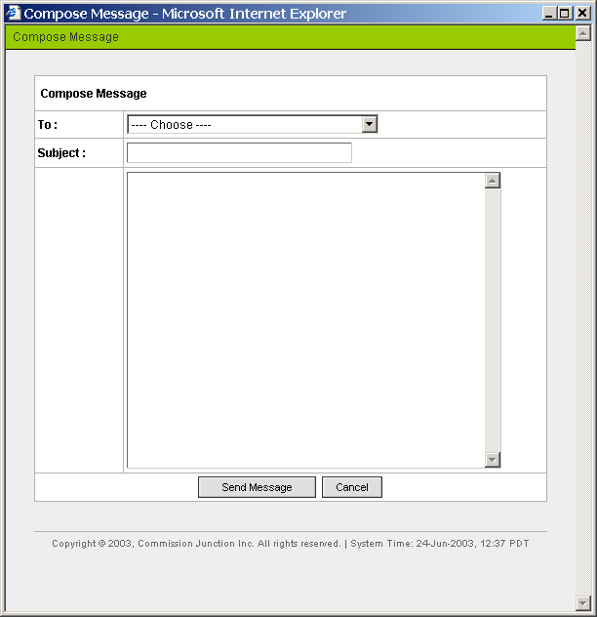

CJ – Publisher – Logged In – Mail – Messages – New Folder
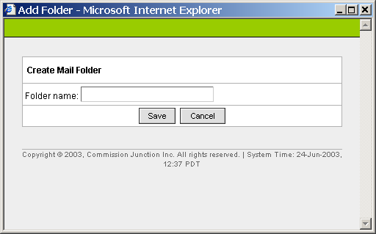

CJ – Publisher – Logged In – Mail – Messages – Inbox
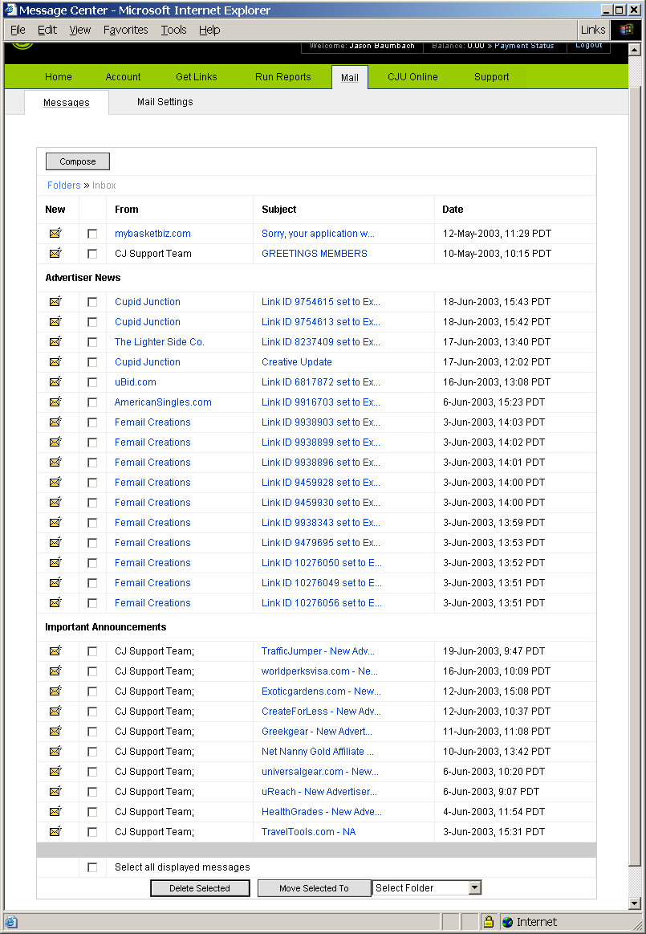
CJ – Publisher – Logged In – Mail – Messages – Inbox – From
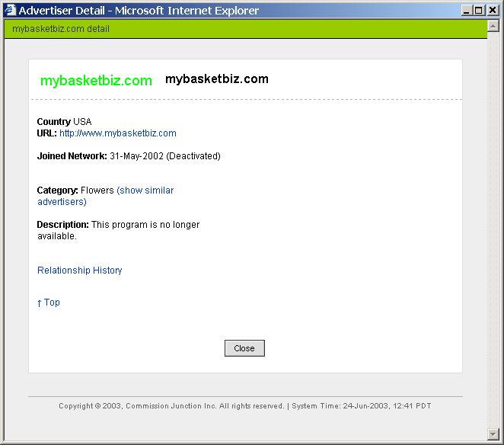
CJ – Publisher – Logged In – Mail – Messages – Inbox – Subject
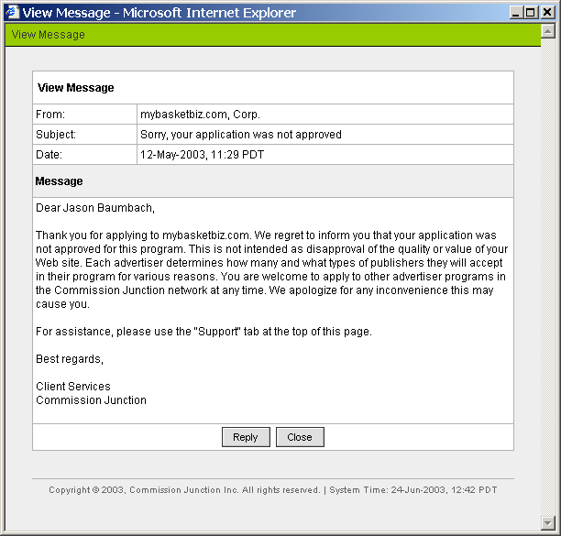
CJ – Publisher – Logged In – Mail – Mail Settings
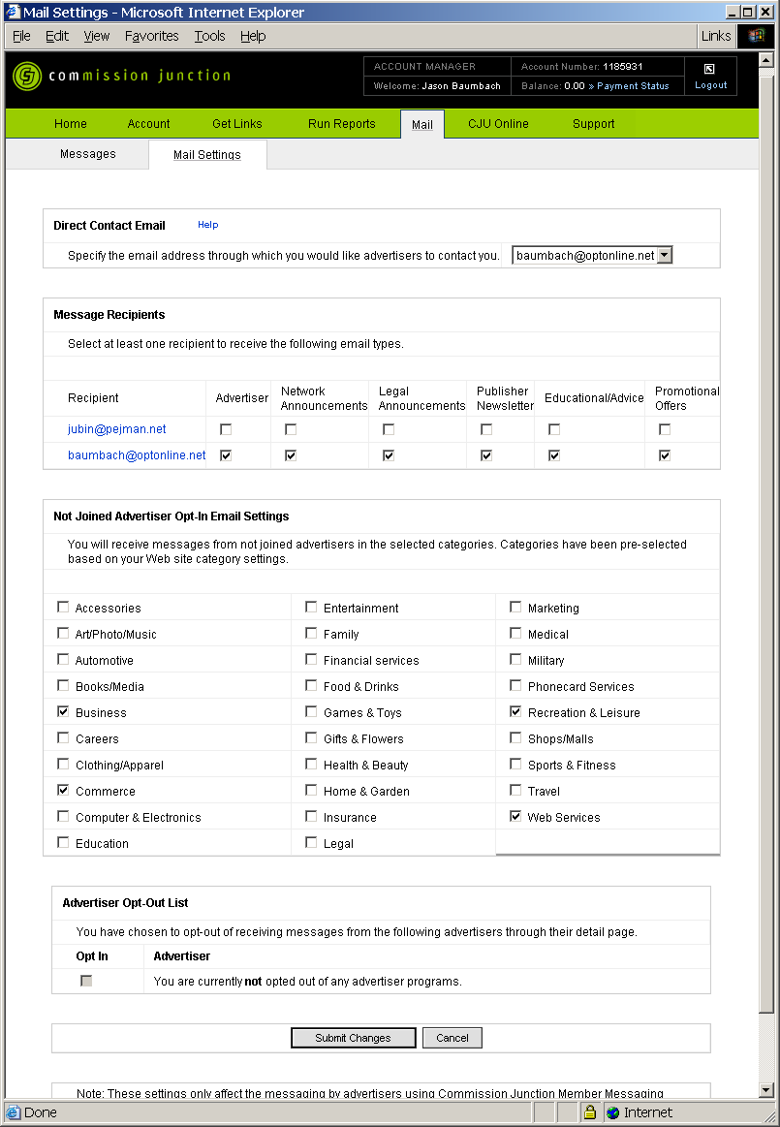
CJ – Publisher – Logged In – CJUonline – Home
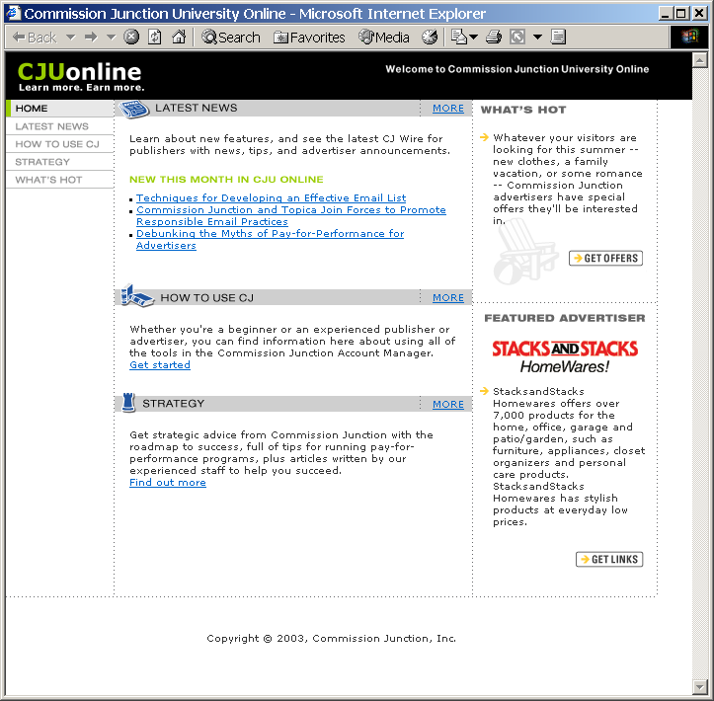
CJ – Publisher – Logged In – CJUonline – Latest News
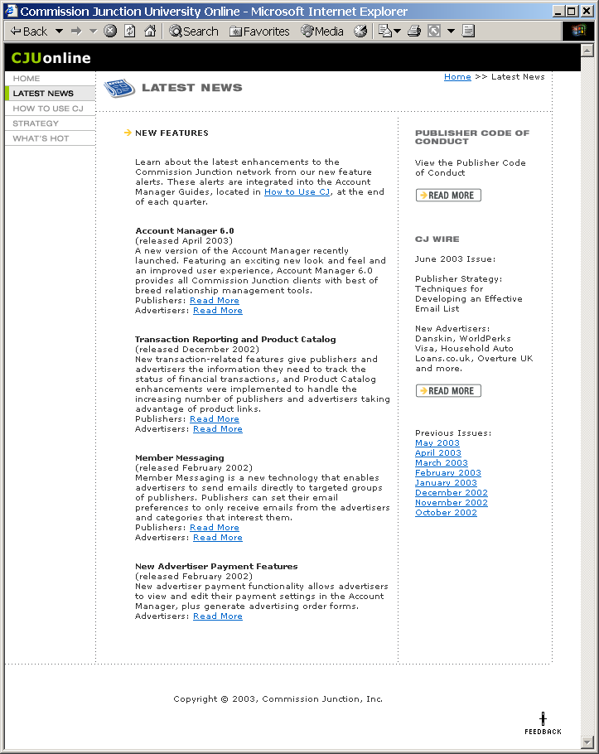
CJ – Publisher – Logged In – CJUonline – How To Use CJ
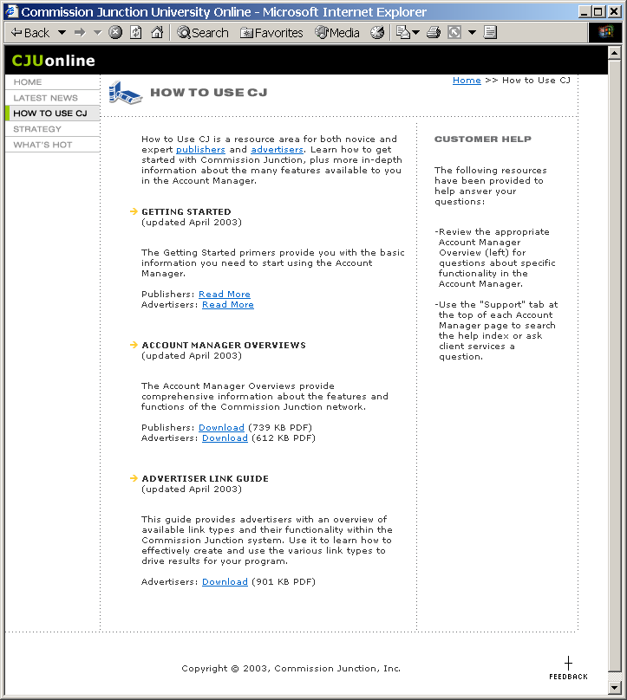
CJ – Publisher – Logged In – CJUonline – Strategy
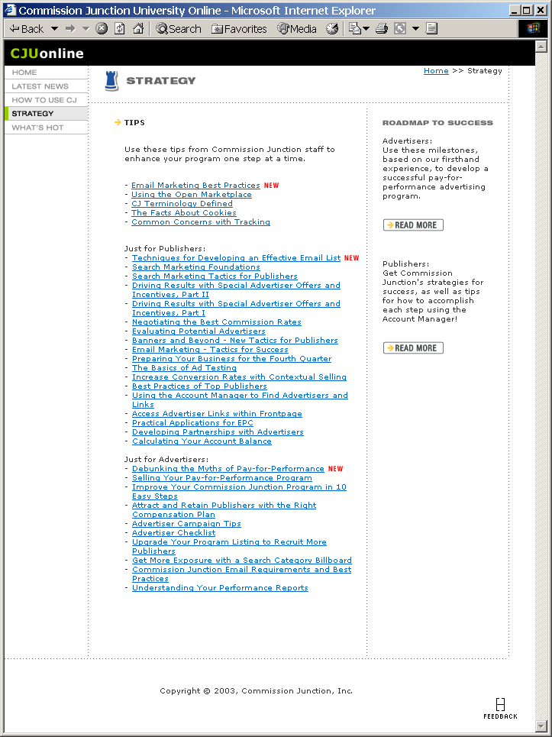
CJ – Publisher – Logged In – CJUonline – What’s Hot
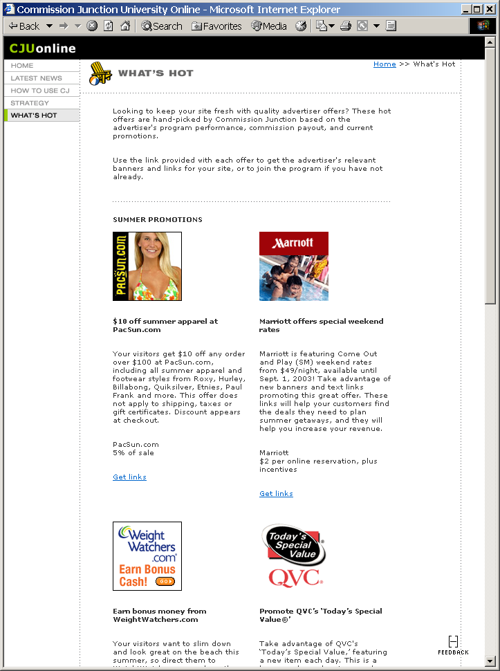
CJ – Publisher – Logged In – Support – Help Home
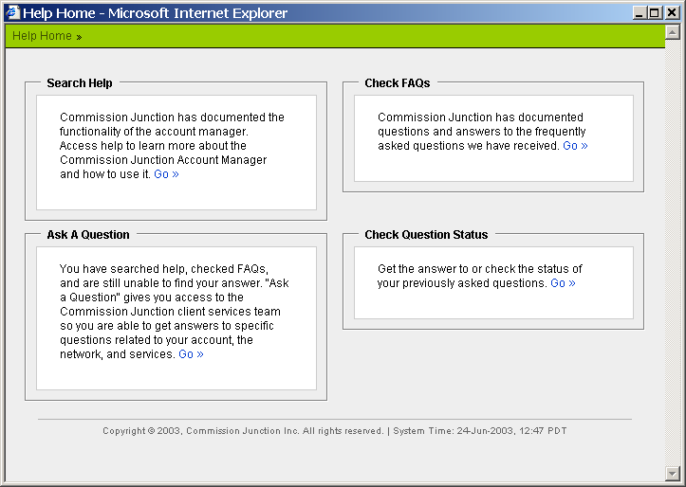

CJ – Publisher – Logged In – Support – Help Home – Search Help
(Created with RoboEditor)
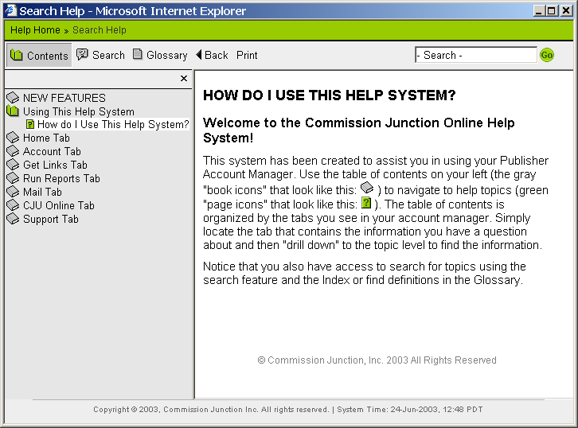
CJ – Publisher – Logged In – Support – Help Home – Ask A Question
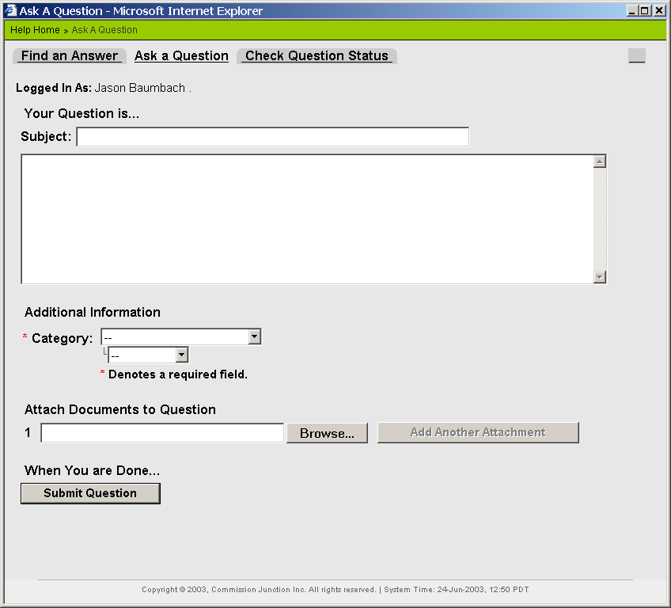
CJ – Publisher – Logged In – Support – Help Home – Check FAQ
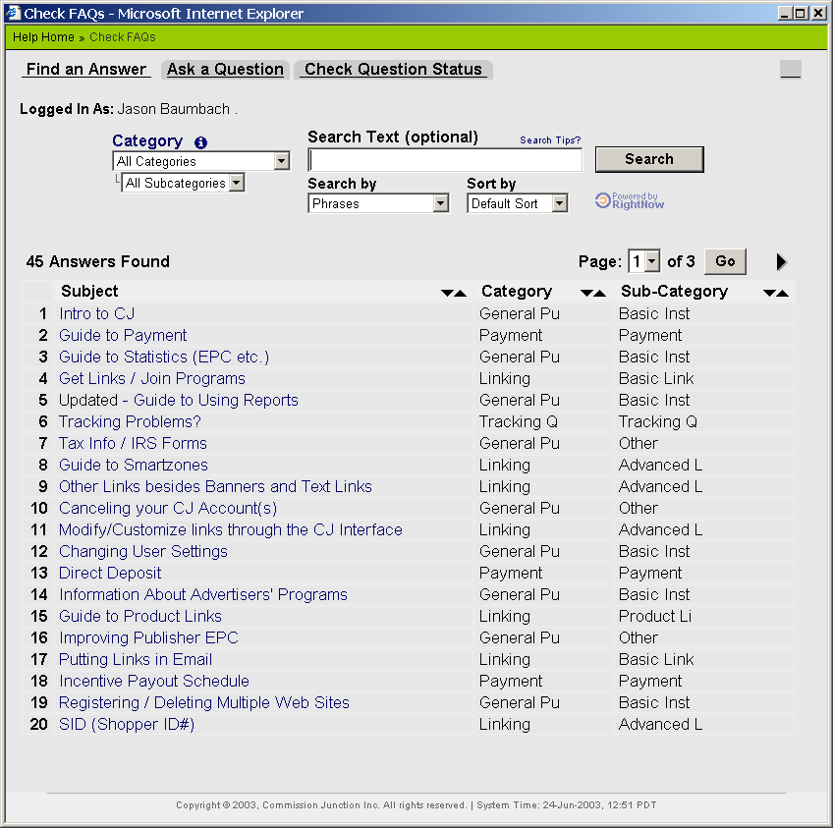
CJ – Publisher – Logged In – Support – Help Home – Check Question Status
Powered by RightNow
http://www.rightnow.com/poweredbyrnt.html
