Analysis of Community Relayed Location Trackers

Jakub Samuel Hlavatý

Abstract
This report summarizes a technical analysis of movement data collected from custom OpenHaystack-compatible location trackers. The analysis pipeline imports encrypted tracker reports from a MySQL backend, converts them into SQLite for final processing, filters noisy position reports, classifies location transport modes, and enriches locations with elevation data. The report provides static visualizations. The main findings include the quality of the filtered data, daily mobility statistics, and the feasibility of using community relayed trackers for basic transport and interaction analytics.

1. Introduction
The proliferation of crowdsourced Bluetooth tracking networks, such as Apple's Find My network, has created new opportunities for low-cost, decentralized location tracking. This project explores the analytical potential of such systems by examining movement data collected from a set of custom, OpenHaystack-compatible location trackers. Because these devices rely on community relays, pinging nearby smartphones to report their position, the resulting data is inherently sparse, noisy, and irregularly sampled. The primary goal of this project is to develop a robust data processing pipeline capable of transforming these raw, fragmented tracker reports into clear mobility information.
To achieve this, the analysis aims to reconstruct individual tracker journeys, classify probable transport modes, identify significant stationary places, and enrich the spatial data with elevation data. By systematically addressing the challenges of low-confidence observations, duplicate records, and incomplete temporal coverage, this report evaluates the feasibility of using community-relayed trackers to derive meaningful insights into daily mobility patterns and spatial interactions.

2. Data Description
2.1 Data collection
The location data was collected from up to 5 different trackers over a period of 40 days. OpenHaystack trackers present a specific set of challenges. The trackers, also called tags, act as Apple AirTags, they advertise their tracking information via Bluetooth, which is picked up by nearby iPhones and sent to Apple. They advertise their tracking information periodically to preserve battery life, and each observation includes metadata such as latitude, longitude, accuracy and confidence. Because the standard OpenHaystack interface provides only seven days of history, a custom backend with a MySQL database was used to collect and archive tracker reports over longer periods.
Since acquiring data from Apple servers is usually only possible from Apple devices, a special version of OpenHaystack called Macless-haystack was used. Macless-haystack, as the name suggests, runs the original OpenHaystack on an emulated Apple computer via Anisette. The data fetched from Apple was decrypted via individual private keys and saved to the MySQL database. After collection, data was exported to SQLite to enable portable analysis.
Alongside location data, elevation data was used as well. The project is compatible with any data in the correct GeoTiff format. For simplicity a local area of SRTM 90m was used from the European Commission.

2.2 Data structure
The table tags contains columns id, name and hashed_key. Id is the row id, name is the name of the tag and hashed_key is the unique identifier of a tag, which is used in other tables.
Each raw collected data is saved in the table location_data. It contains raw location records, also called pings, for each individual tracker. Its columns are id, time, hashed_key, latitude, longitude, accuracy and confidence. time is the date and time of a row in format YYYY-MM-DD hh:mm:ss. Hashed_key is the unique identifier of a tracker, as mentioned regarding the table tags. Latitude and longitude are GPS coordinates of the ping. Accuracy is the accuracy of the reporting device position, in meters. Confidence is a numerical value representing Apple‘s confidence that the tracker position is accurate, either 1, 2 or 3, with 3 being the most confident and 1 being the least. We use this value in data filtering.
This data was filtered, cleaned, aggregated and then analysed. The output is saved in three different tables: trips, places and daily_stats. The table trips represents individual location points, meaning each row is a single location point for a single tracker. It has the columns id, time, hashed_key, latitude and longitude, velocity, distance, motion_state, transport_mode, time_spent and elevation. Id is the identification number of a row, time is the date and time of the latest aggregated ping. Velocity is the minimum average velocity in km/h between two pings. Distance is the distance in meters between two pings. Motion_state is either „INIT“ (initial ping after 30 minutes of no pings), „STATIONARY“ if the tracker has not moved since the previous ping or „MOVING“ if the tracker has moved since the previous ping. Similarly, transport_mode is either „INIT“, „STATIONARY“ or depending on the velocity „WALKING“, „RUNNING/CYCLING“ or „DRIVING/TRAIN“. Time_spent is either 0 when the ping is the first after 30 minutes or the time difference between the previous ping and the current ping. In practice it means how long has a tracker been stationary or how long has it moved since the previous movement ping.
The table places contains individual places, where any tracker has been stationary for any amount of time. There are columns id, latitude and longitude, significance (total minutes spent stationary in that place), unique_tags (number of tags that have ever stayed at that place) and is_overnight (boolean, whether a tag has ever stayed overnight at that place).
The table daily_stats contains aggregated daily statistics for each tag separately. Each row is a single day for a single tag. Its columns are id, hashed_key, date, max_speed (maximum speed between during that day), min_elevation and max_elevation (minimum and maximum elevation of that tracker during the day), elevation_gain (total elevation gain during the day), minutes_stationary (total number of minutes the tag has been stationary during the day) and pings, valid, rejected (total number of raw records from that day, how many were kept and mow many were removed during data filtering).

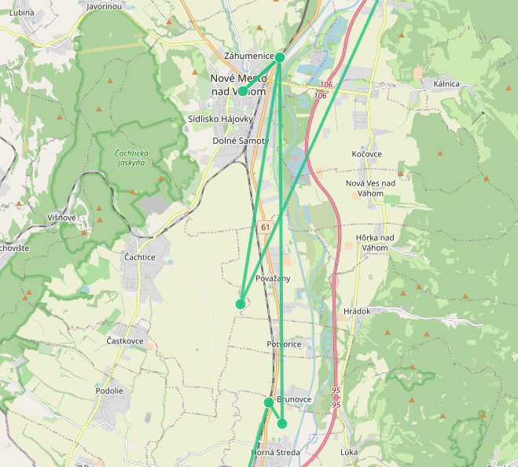
2.3 Data quantity and quality
The dataset includes five registered trackers and 26 758 location pings over the period of over 40 days. The raw data quality is, however, mixed. Some rows have very low confidence and are generally inaccurate, as shown in Figure 1. The table places contains 174 rows. This data is relatively high quality, since the place locations are the average locations all nearby pings. The table daily_stats contains 191 records. The table trips contains 2220 records.
Figure 1: Low quality data during a train ride

3. Method Overview
The filtering analysis pipeline is designed as a sequence of stages that convert raw tracker reports into interpretable mobility records. The data is first filtered, then aggregated and expanded with elevation and travel categorisation and finally analysed on a daily basis.
The raw location_data is filtered sequentially for each tag separately. Data is sorted by time in ascending order. The processing is done batch by batch, a batch being a group of pings from a single bluetooth advertising. There can be at most one true point in a batch.
The algorithm works by comparing the current batch with the previous true location point, also called anchor. If the time difference between the anchor and the current group is larger than 30 minutes or there is no anchor, a new anchor is selected. This point is an init point. The anchor is chosen as the ping with the highest score above a minimum threshold, set as 1800. If no new anchor is chosen, a new batch is loaded until an anchor is successfully selected. This filters out inaccurate starting points. The score is calculated in the following way:
$score= α * confidence - β * accuracy$
where $α = 1000, β = 1$
After selecting an anchor, batches of pings are loaded, until a batch has a ping with a confidence level of 3. If there are more of these points in the batch, the first one is selected. This point acts as a new anchor. Then close points within a group are merged and the most probable path between the previous anchor and the new anchor is chosen. This is done by creating a layered graph of nodes, where transitions between batches represent forward progression of time. Edges have a the movement penalty between two nodes, calculated as

$$edge cost = distance cost + accuracy cost + sharp turn penalty$$

An edge is ommited, if the travel speed would be unrealistic or if the sharp turn would be unrealistic given a fast travel speed. Then the path with minimal penalty cost is calculated using Dijkstra‘s algorithm. When adding each point, it is determined whether it is a moving or a stationary point based on the distance between previous and current point. If the distance is less than 150 meters, it is classified as a stationary point.
Afterwards, stationary points are aggregated and moving points are categorised by their movement velocity. Points, that are moving at a minimum average velocity of less than 5km/h are classified as walking, between 5 and 15 kilometers per hour as running/cycling and above as driving/train. Every stationary point is compared with existing places or added to the list. The location of a place is calculated by the average of its stationary points. The daily stats metrics are calculated by either averaging, summing or taking the minimum/maximum values from the aggregated and categoriesed data on a daily and per tracker basis.

4. Results and Discussion
4.1 Initial exploration
The data was first manually validated by creating a simple web-based viewer. The majority of pings were recorded during a two week window from April 28th to May 31st, as shown in Figure 2. The x axis represents the individual days, while the y axis represents total sum of valid pings of all trackers in any given day.
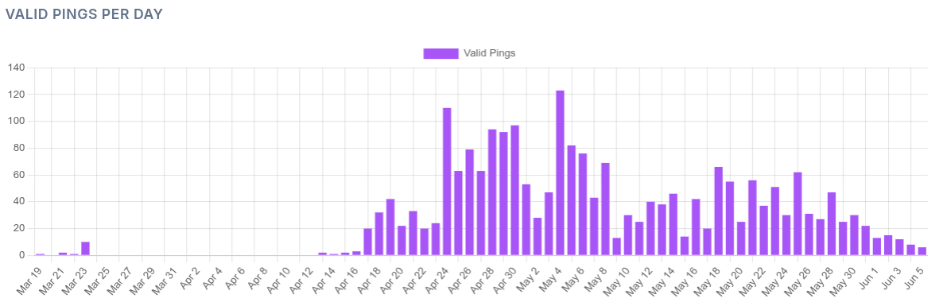
Figure 2: Daily activity

4.2 Data cleaning results
From a total of over 26,000 pings that were recorded, only 47% or around 12,500 were kept after filtering. Many pings were removed for being duplicates, although the biggest reduction was due to low accuracy. This was further aggregated into slightly above 2 thousand records, since many pings were stationary at the same place. As shown in Figures 3 and 4, there was a substantial amount of data lost, especially on long distance travels. However, on short travels within the city, there was almost no loss of data. The process was not perfect, as there are still some anomalies, for instance in the upper middle part of Figure 4.
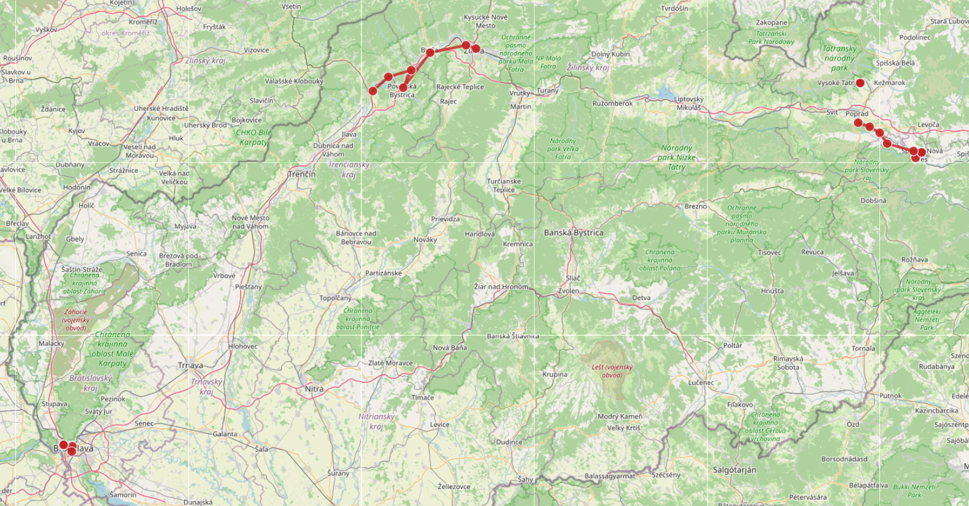
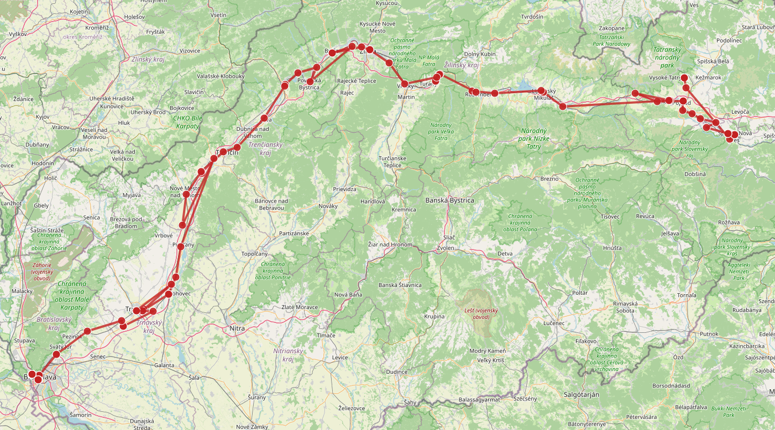
Figure 3: Clean data
Figure 4: Raw data

4.3 Transport classification, places and daily statistics
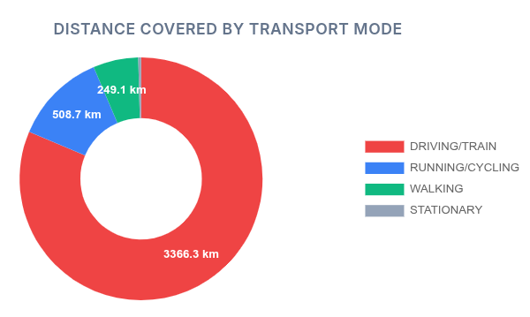
Out of a total of 2220 points, 620 were classified as stationary, 398 as initial, 557 as walking, 553 as driving/train and 372 as running/cycling. As can be seen on Figure 5, the majority of 3950 recorded kilometers travelled were done by car/train (3366 km), followed by running/cycling (508 km) and then by walking (almost 250 km). Another 5831 kilometers were travelled between initial pings, therefore they were not recorded. The maximum distance between two pings was 1067 kilometers between Paris and Vienna.
The maximum average speed between two pings was 167 km/h, achieved on 24th of April on a train ride in Slovakia. However the total maximum travel speed between two pings was 509 km/h, which was on the same flight from Paris to Vienna. The highest elevation was 1304 meters above sea level on the 3rd of May and the lowest elevation was 26 meters above sea level on the 18th of May. Total elevation gain was almost 22 kilometers, while the biggest elevation gain in one day was 1777 meters, on the 24th of April. The longest a tag was continuously stationary was 31 hours, from the 28th to the 30th of May.
Figure 5: Distance covered by transport mode
Out of 160 places, only 14 were overnight while 146 were not. When looking at significant places (places, where trackers have stayed at least one hour), there were only 50 non-overnight places. Out of 10 of the most frequented places, 8 were overnight. The most popular place was UK Mlyny dormitories, with a total of almost 517 hours spent at the place. It was followed by the origin home of all trackers with 386 hours and by three other homes, with 84, 64 and 63 hours respectively. The two most popular non overnight places were the Pavilion of Mathematics and Physics of the Faculty of Mathematics, Physics and Informatics, Comenius university. The only place, where all tags met was the place they were created.
Figure 6 shows the empirical kernel density estimation of multiple daily metrics per tracker. Each subplot shows an empirical density for a given metric in blue, and a dashed red curve shows the fitted normal distribution. It includes metrics valid pings, max speed, minimum and maximum elevation, elevation gain and minutes stationary. Out of these only valid pings per day and minutes stationary per day do not have major outliers. The mean number of pings per day per tracker was 78 with a standard deviation of 55 pings. The mean minutes stationary was 637 with a standard deviation of 440. All elevation metrics show major outliers on the right side of the curve. Maximum speed has also a larger right side of the curve.
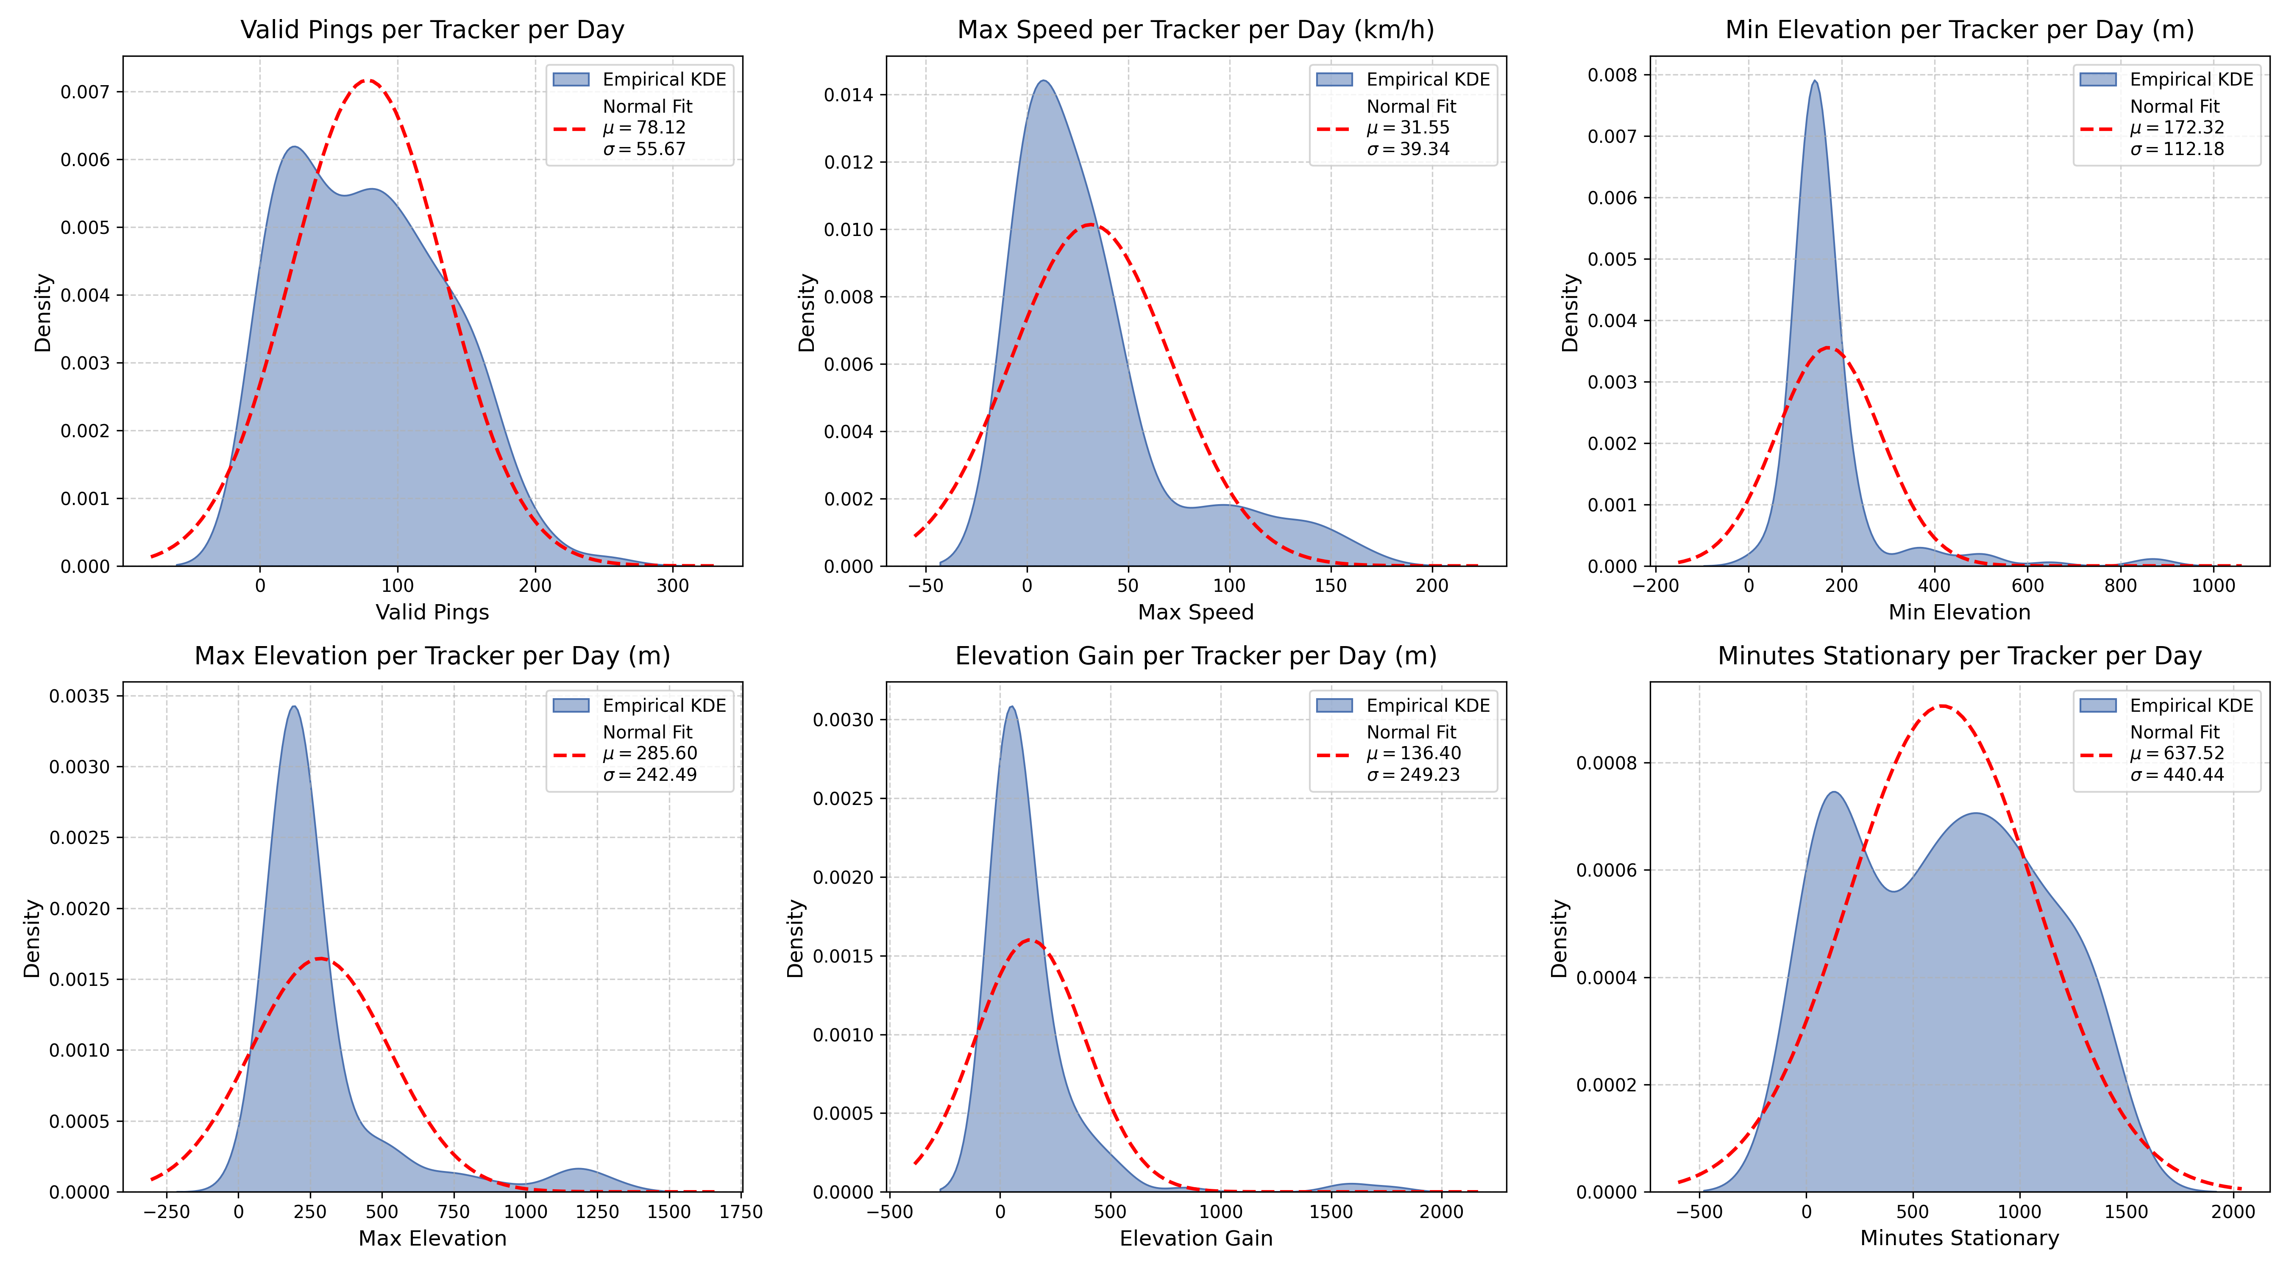
Figure 6: Daily distribution of metrics per tracker

4.5 Discussion of findings
The majority of activity was recorded in the week following April 22nd, when all trackers started operating. After two weeks, some trackers ran out of battery, which explains the gradual drop of active trackers starting from May 6th and then again from the start of June. During this time, every tracker belonged to a student. Because of this, during the exam season (late May – early June), most trackers remained stationary.
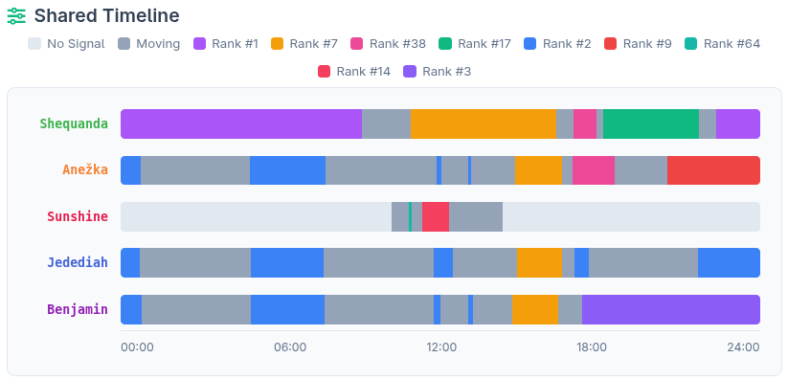
As shown in Figure 7, four of five trackers have spent considerable time at a single place on the same lecture. Tracker named „Sunshine“ spent time at two different lectures, one in the morning and one during lunch. It also shows Trackers „Anežka“, „Jedediah“ and „Benjabin“ leaving the same home in the morning, but „Anežka“ and „Benjamin“ returning to a different place. A more detailed view can be seen on Figure 8, which shows the movement on a map on the same day. A similar trend has been observed on multiple days, showing a similar daily rhytm of students.
Figure 7: Timeline of April 28th (Tuesday)
Another notable observation is, that the reported average speed between two trackers must be strictly lower than the actual average speed, since in reality the path between two points is longer than a straight line.
Figure 9 showcases the technical limitation of using OpenHaystack trackers as a source of location data. The raw location data was often either sparse or generally inaccurate and does therefore it was difficult to deduce a clear path between two anchor points. This problem is much less visible on the trackers, that belonged to a person owning an iPhone, or travelling with such a person. These tags reported significantly more pings compared to other trackers, as can be seen in Figure 10.

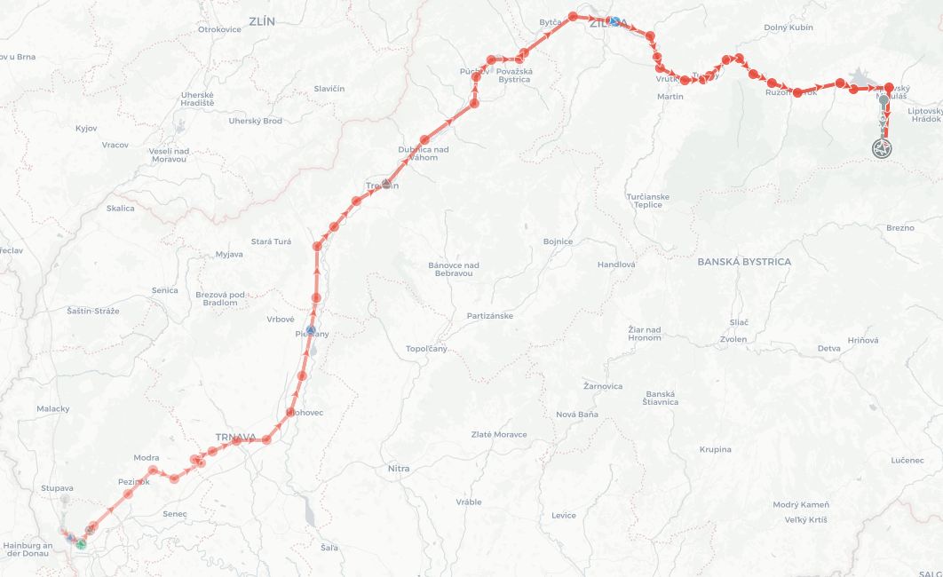
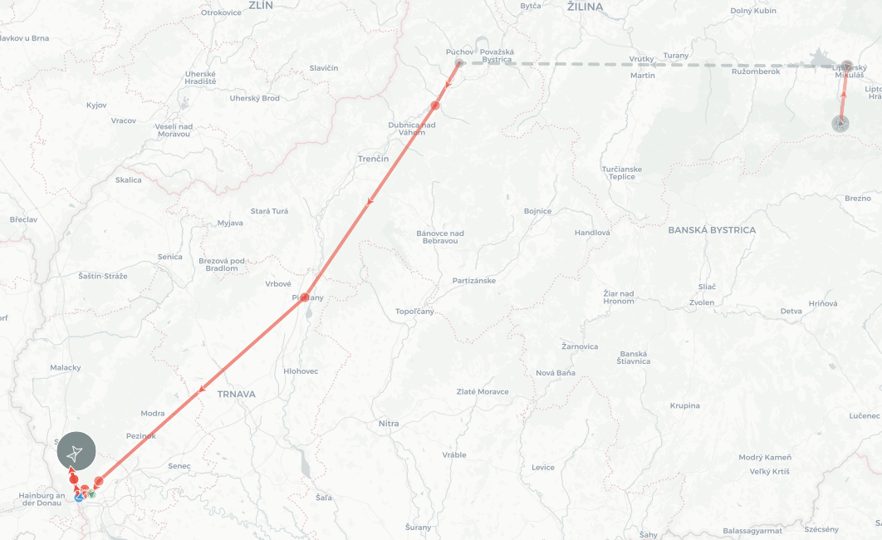
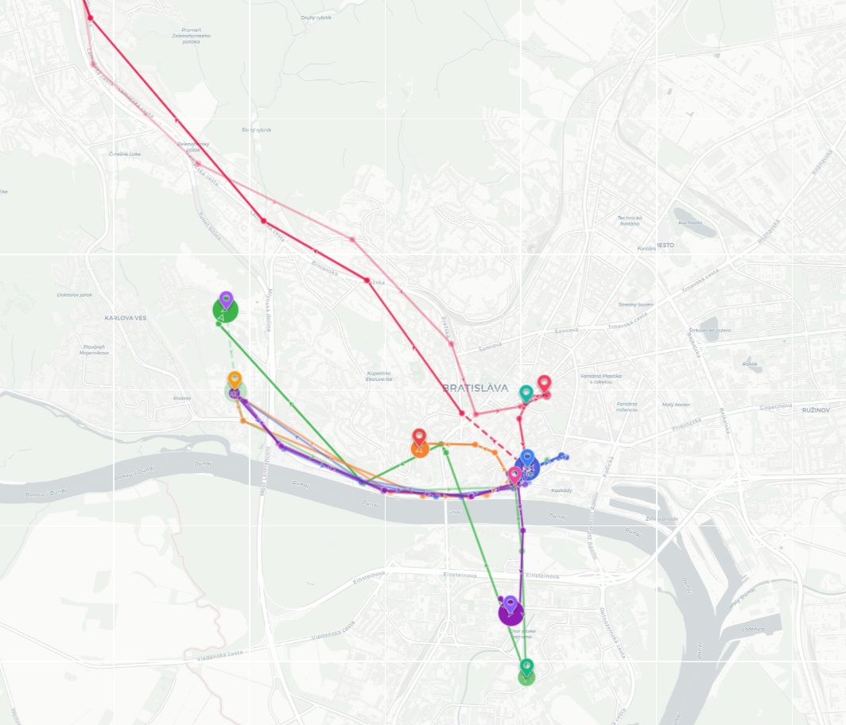
Figure 10: High quality travel data
Figure 8: Map of movement on April 28th
Figure 9: Sparse data

5. Conclusion
5.1 Achievements
This project successfully developed an end-to-end data processing pipeline capable of importing raw, encrypted OpenHaystack tracker reports from a MySQL backend into a portable SQLite database. The implementation included a robust filtering mechanism that effectively distilled over 26,000 raw pings into cleaned location points, enabling the logical reconstruction of individual trips. Additionally, the spatial data was successfully enriched by integrating a GeoTIFF Digital Elevation Model (DEM) to append accurate elevation data to the records. Finally, the project synthesized this cleaned data to produce comprehensive daily mobility statistics and generated empirical distribution plots for key metrics.

5.2 Challenges
Several technical challenges emerged during the data processing phase, primarily driven by the inherently noisy and sparse nature of the location reports. Establishing reliable criteria for selecting anchor points and accurately merging stationary data required extensive algorithmic tuning to prevent the loss of valid movement tracking. Furthermore, classifying transport exclusively on average velocity between sparse pings proved to be a weak signal, resulting in transport categorizations that are fundamentally approximate rather than definitive.

5.3 Lessons learned and future recommendations
A critical takeaway from this analysis is the necessity of implementing more advanced spatial filtering and map matching techniques to handle the unique sparsity and GPS noise of locaiton data. Because OpenHaystack trackers produce irregular and often distant pings, relying on simple linear interpolation or basic shortest-path graphing between anchor points consistently underestimates the true distance traveled and distorts trajectory reconstruction. Future iterations of this work should integrate map matching tools. By snapping raw coordinate data to valid physical travel paths, linear interpolation can be replaced with network-constrained interpolation, yielding a much more accurate representation of the actual routes taken and significantly improving the accuracy of velocity and transport mode classifications. While the data filtering script is structurally adapted for this approach, it would require significantly more time to implement correctly, which would be out of the scope of this already extensive project.
Furthermore, computing social interactions, such as detecting shared locations or meetings should be treated as an entirely separate analytical pass after this map-matched trip reconstruction is fully complete, rather than entangling it with the initial noise-cleaning phase. That again would, however, also significantly overextend the required time and effort.
Ultimately, this project demonstrates that while community-relayed trackers can yield meaningful mobility analytics, maximizing their utility requires treating the sparse observations not merely as independent points in space, but as events constrained by physical geography and actual transportation networks.

