Draft Report: Analysis of Community Relayed Location Trackers
Title page
- Project title: Analysis of community relayed location trackers
- Author: Jakub Samuel Hlavatý
- Date: June 2026
- Institution: [Your school / faculty name]

Abstract
This report summarizes a technical analysis of movement data collected from custom OpenHaystack-compatible location trackers. The analysis pipeline imports encrypted tracker reports from a MySQL backend, converts them into SQLite for final processing, filters noisy position reports, reconstructs trips, estimates transport modes, and enriches locations with elevation data. The report also documents the command-line scripts used for each stage and provides static visualizations as required by the course. The main findings include the quality of the filtered data, daily mobility statistics, and the feasibility of using community relayed trackers for basic transport and interaction analytics.

1. Introduction
The goal of this project is to analyze movement data obtained from a set of community relayed location trackers. These trackers use the OpenHaystack ecosystem and are carried by volunteers who hand them off to other participants. The analysis aims to reconstruct each tracker’s journey, detect interaction events such as meetings or frequently visited places, classify transport modes, and calculate vertical altitude changes.
In this project, the focus is on how to transform raw tracker pings into actionable mobility information while handling noise, duplicate observations, and incomplete coverage.

2. Data Description
2.1 Data collection
The source of location data was collected from up to 5 different trackers over a period of 40 days. OpenHaystack trackers present a specific set of challenges. The trackers, also called tags, act as Apple AirTags, they advertise their tracking information via bluetooth, which is picked up by nearby iPhones and sent to Apple. They advertise their tracking information periodically to preserve battery life, and each observation includes metadata such as latitude, longitude, accuracy and confidence. Because the standard OpenHaystack interface provides only seven days of history, a custom backend with a MySQL database was used to collect and archive tracker reports over longer periods.
Since acquiring data from Apple servers is usually only possible from Apple devices, a special version of OpenHaystack called Macless-haystack was used. Macless-haystack as the name suggests runs the original OpenHaystack on an emulated Apple computer via Anisette. The data fetched from Apple was decrypted via individual private keys and saved to the MySQL database. After collection, data was exported to SQLite to enable portable analysis.
Alongside location data, elevation data was used as well. The project is compatible with any data in the correct GeoTiff format. For simplicity a local area of SRTM 90m was used from the European Comission.

2.2 Data structure
The table tags columns id, name and hashed_key. Id is the row id, name is the name of the tag and hashed_key is the unique idenfier of a tag, which is used in other tables.
Each raw collected data is saved in the table location_data. It contains raw location records, also called pings, for each individual tracker. Its columns are id, time, hashed_key, latitude, longitude, accuracy and confidence. time is the date and time of a row in format YYYY-MM-DD hh:mm:ss. Hashed_key is the unique identifier of a tracker, as mentioned regarding the table tags. Latitude and longitude are GPS coordinates of the ping. Accuracy is the accuracy of the reporting device position, in meters. Confidence is a numerical value representing Apple‘s confidence that the tracker position is accurate, either 1, 2 or 3, with 3 being the most confident and 1 being the least. We use this value in data filtering.
This data is filtered, cleaned, aggregated and then analysed. The output is saved in three different tables: trips, places and daily_stats. The table trips represents individual location points, meaning each row is a single location point for a single tracker. It has the columns id, time, hashed_key, latitude and longitude, velocity, distance, motion_state, transport_mode, time_spent and elevation. Id is the identification number of a row, time is the date and time of the latest aggregated ping. Velocity is the minimum average velocity in km/h between two pings. Distance is the distance in meters between two pings. Motion_state is either „INIT“ (initial ping after 30 minutes of no pings), „STATIONARY“ if the tracker has not moved since the previous ping or „MOVING“ if the tracker has moved since the previous ping. Similarly, transport_mode is either „INIT“, „STATIONARY“ or depending on the velocity „WALKING“, „RUNNING/CYCLING“ or „DRIVING/TRAIN“. Time_spent is either 0 when the ping is the first after 30 minutes or the time difference between the previous ping and the current ping. In practice it means how long has a tracker been stationary or how long has it moved since the previous movement ping.
The table places contains individual places, where any tracker has been stationary for any amount of time. There are columns id, latitude and longitude, significance (total minutes spent stationary in that place), unique_tags (number of tags that have ever stayed at that place) and is_overnight (boolean, whether a tag has ever stayed overnight at that place).
The table daily_stats contains aggregated daily statistics for each tag separately. Each row is a single day for a single tag. Its columns are id, hashed_key, date, max_speed (maximum speed between during that day), min_elevation and max_elevation (minimum and maximum elevation of that tracker during the day), elevation_gain (total elevation gain during the day), minutes_stationary (total number of minutes the tag has been stationary during the day) and pings, valid, rejected (total number of raw records from that day, how many were kept and mow many were removed during data filtering).
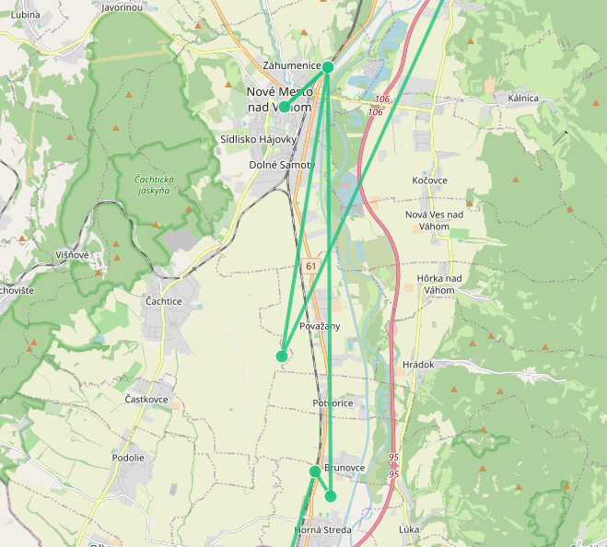
2.3 Data quantity and quality
The dataset includes five registered trackers and 26 758 location pings over the period of over 40 days. The raw data quality is howerver mixed. Some rows have very low confidence and are generally inaccurate, as shown in Figure 1. The table trips contains 2220 records, tha table places contains 174 rows. This data is relatively high quality, since the place locations are the average locations all nearby pings. The table daily_stats contains 191 records.
After further aggregation the table trips contains 2220 records. This is because of the fact, that many records pings were stationary in the same place. In total there have been 174 such places in the table places. This data is of very high quality, since the place locations are the average locations all nearby stationary pings.
Figure 1: Low quality data during a train ride

3. Method Overview
The filtering analysis pipeline is designed as a sequence of stages that convert raw tracker reports into interpretable mobility records. The data is first filtered, then aggregated and expanded with elevation and travel categorisation and finally analysed on a daily basis.

- Data ingestion and conversion: Raw MySQL data is copied into SQLite to support local analysis and to ensure reproducibility on school hardware.
- Data filtering: The data-filtering.py script groups reports within minute-long windows, selects the most reliable anchor points, and removes noisy or implausible observations. This step produces a clean_location_data table with motion states and estimated travel distance.
- Trip reconstruction: The generate-trips.py script aggregates cleaned points into a timeline of trips and stationary segments, assigns transport modes based on speed thresholds, and computes elevation at each point using a GeoTIFF DEM through ElevationLookup.
- Daily analytics: The daily_analysis.py script computes per-day statistics such as ping counts, max/min elevation, elevation gain, and stationary time, storing results in daily_stats.
- Distribution analysis: The analyze_distributions.py script produces graphs of key statistics and fits them with normal distributions to assess the empirical shape of mobility metrics.
Most processing is implemented as command-line Python scripts, which supports the course emphasis on shell-based workflows. Visualizations are also produced as static figures suitable for inclusion in the final PDF report.
This workflow is justified by the need to reduce raw noise before any transport or social inference can be trusted. Aggregation into trips and daily summaries avoids over-interpreting individual noisy GPS pings.

4. Results and Discussion
4.1 Initial exploration
Begin this section by describing how the raw dataset was inspected and validated. Useful tables and figures include:
- A table of tag counts and ping counts per tracker.
- A histogram of ping timestamps, showing the time coverage of the dataset.
- A scatter plot or count of accuracy values to demonstrate measurement quality.
Explain the axes and how to interpret the plots. For example: "The x-axis shows time in days and the y-axis shows the number of pings recorded per day. This plot demonstrates periods of active reporting and gaps in collection."
4.2 Data cleaning results
Summarize how raw data was filtered:
- Count of raw vs filtered pings
- Number of INIT, STATIONARY, and MOVING points in clean_location_data
- Any outlier removal rules applied (e.g. velocity cutoff at 160 km/h)
A table such as Raw pings | Clean points | Stationary segments | Moving segments will help readers understand the effect of cleaning.
Discuss whether the filtered data appears consistent, and whether any anomalies remain.
4.3 Trip reconstruction and transport classification
Present the main mobility metrics from trips and daily_stats:
- Daily valid ping counts
- Max speed per day
- Min/max elevation per day
- Estimated elevation gain per day
- Total stationary minutes per day
A chart produced by analyze_distributions.py should be described in detail: explain that each subplot shows an empirical density for a given metric, and a dashed red curve shows the fitted normal distribution.
If available, include a short summary table of transport mode counts. If transport mode classification is based on velocity thresholds, explain the thresholds and what each mode means.
4.4 Social interaction potential
Describe the intended method for finding meetings and handoff events, even if the current implementation does not fully compute them. Explain that social interaction detection is based on spatial proximity in a time window and that the report should contain examples of tracker co-location events if available.
4.5 Discussion of findings
Interpret the results in a technical way:
- Which tracker behaviors are clearly visible?
- Does the data show long stationary periods, regular travel corridors, or abrupt jumps?
- What can be inferred from elevation gain and transport mode classification?
- Are there signs that the filtering pipeline is successful or that additional filtering is required?
Also mention limitations:
- GPS noise and low confidence values
- Irregular tracker broadcast intervals
- Dependence on a single DEM source for elevation
- The absence of a validated ground truth for transport mode
4.6 Project compliance and reproducibility
This project follows the course requirements by using command-line scripts for data acquisition, preprocessing, and analysis. The submitted protocol should document the exact commands used to run each stage, the locations of scripts, and the external resources required. The final report includes static figures derived from the analysis and explains the meaning of each table and graph, including axes, color coding, and units.

5. Conclusion
Summarize the completed work and reflect on the project.
5.1 Achievements
- Built a pipeline that imports raw OpenHaystack tracker data from MySQL into SQLite.
- Implemented data filtering to produce cleaned location points and reconstructed trips.
- Added elevation lookup using a GeoTIFF DEM and produced daily mobility statistics.
- Generated analysis plots demonstrating the distribution of key metrics.
5.2 Challenges
- Handling noisy and sparse location reports was difficult.
- Establishing robust criteria for choosing anchor points and merging stationary data required careful tuning.
- Transport mode classification is only approximate because speed alone is a weak signal.
5.3 Lessons learned and recommendations
- In hindsight, building an explicit data validation step earlier would help catch anomalies sooner.
- It may be better to compute social interactions as a separate pass after trip reconstruction instead of mixing it with cleaning.
- Future work should include geospatial index support and better temporal interpolation for missing pings.
- The project demonstrates that community relayed trackers can be analyzed in a meaningful way, but their usefulness depends strongly on reporting density and quality.

Appendix / Notes for writing
- Use the report’s results section to reference actual numbers once you have them from the database.
- Replace generic statements with exact metrics from daily_stats, trips, and the generated plots.
- In tables, always include column definitions and units.
- In figure captions, explain the axes, any color coding, and the data source.
- Mention any use of AI code generation or external tools in the protocol and report if applicable.
- If the project is done in a pair, describe the division of responsibilities; otherwise state that the work is individual.

Suggested report structure in Markdown or PDF
- Title page
- Abstract
- Introduction
- Data Description
- Method Overview
- Results and Discussion
- Conclusion
- Appendix / References
Each section should be written in complete paragraphs, with technical clarity and no informal language.

