Aura Farming (PVT) LTD.
Aazar – The Aura Farmer. (Just Kidding 😁)
_________________________________________________________________________________
Date: {{DATE}}
INTERNSHIP OFFER LETTER
Dear {{NAME}},
We are pleased to offer you an internship opportunity at Aura Farming . We were impressed with your background and believe that your skills and enthusiasm would be a great addition to our team.
You will be joining our {{DEPARTMENT}} department as an Intern. Your internship will commence on {{START_DATE}} and will continue for {{DURATION}}, concluding on {{END_DATE}}.
During your internship, you will have the opportunity to work on real-world projects, learn from our experienced team, and contribute to our mission of building technology that empowers modern farming.
Please find the key details of your internship below:
💼 Role / Position | {{ROLE}}
🏢 Department | {{DEPARTMENT}}
📅 Start Date | {{START_DATE}}
📅 End Date | {{END_DATE}}
🕒 Working Hours | {{WORKING_HOURS}}
📍 Work Location | {{WORK_LOCATION}}
Please note that this internship is a learning opportunity and does not constitute an employment agreement. We expect you to uphold our company values and maintain confidentiality of our projects and data.
We are confident that your time with us will be rewarding and enriching. We look forward to having you on board!
Best regards,
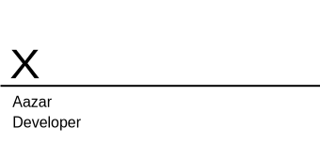

{{HR_NAME}}
{{HR_DESIGNATION}}
Aura Farming (PVT) LTD.

