<http://206.189.126.187/yair/public/admin/reports>

* Select Time Period drop down box. Change the options to these: DONE
  + Last Week DONE
  + Last Month DONE
  + Year to Date DONE
  + Last Year DONE
* Specific Period date fields. Allow the person to type the date, numbers only with automatic slashes added. DONE
* Make the date format MM/DD/YYYY DONE
* Replace Notifications for admin with the activity stream.
* The second specific date field should not be able to precede the first field

<http://206.189.126.187/yair/public/admin/sales> and <http://206.189.126.187/yair/public/agent/sales>

* Processing should be yellow. Remove Pending as an option. It is replaced by Processing. Done
* The Processing status should just say Processing. Remove “(Default instead of Pending)” that was supposed to be just for clarification. Done  
    
   http://206.189.126.187/yair/public/admin/sales_detail/1
* For clarification, these are the statuses and their colors. done
  + Processing done
    - Yellow
  + Waiting on Funds done
    - Yellow
  + Action Required done
    - Red
  + Company Signing done
    - Grey
  + Pending Fee Payment done
    - Green
  + Completed done
    - Green
  + Cancelled done
    - Grey

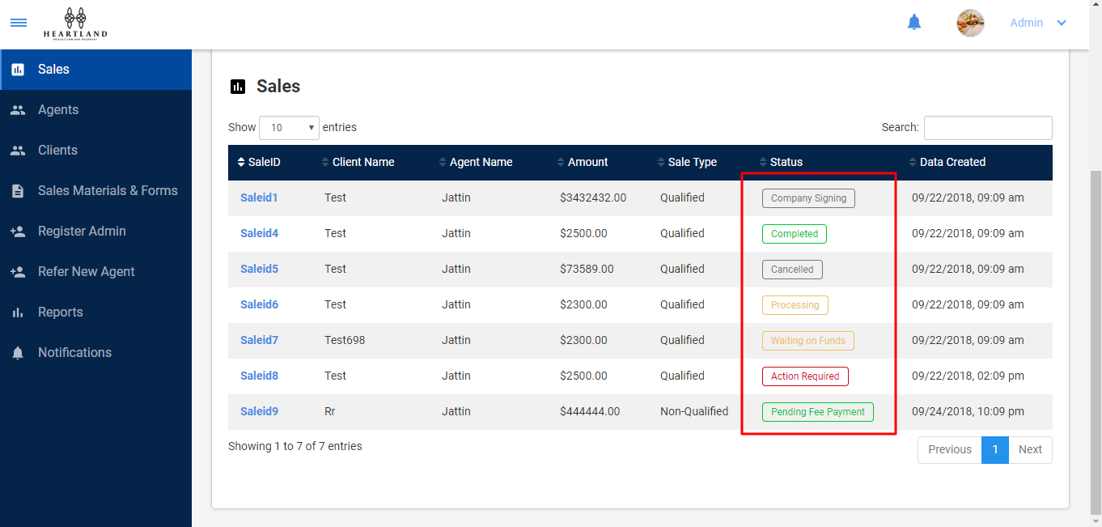

* In the color boxes for the Overview, don’t include the total, cancelled or completed for admin. done

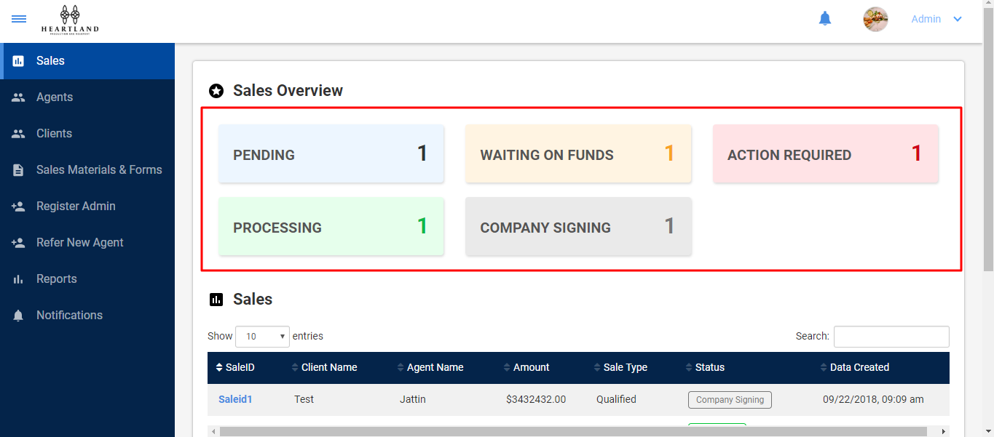

<http://206.189.126.187/yair/public/agent/home>

* The Birthday field only allows future dates. Make it allow typing of dates. No calendar pop-up needed because it is a past date. Done
* On step 3, I uploaded a document, then pressed the back arrow, then pressed the forward arrow to get back to the upload screen. The original file I uploaded did not show there, so I uploaded a file again. When I submitted the sale, both files showed in the Uploaded Documents. Please make the third step show what has been uploaded even if the back button is pressed.

DONE

<http://206.189.126.187/yair/public/agent/referral>

* Change “Cancel” to “Clear” and have it clear the fields done

<http://206.189.126.187/yair/public/agent/notification>

* The agent was notified of their own sale. They should only get notifications when their downline is contracted and when one of their sales’ status is changed.
* We want there to be an option to have notifications sent by email. This can go in the Profile drop-down Menu under Profile and above Logout. It would say Preferences and it will have notification preferences that they can receive by email.

This point is pending   
I am working on it