Use [no-reply@heartlandpar.com](mailto:no-reply@heartlandpar.com) for notifications and referrals. Ask Yair for the configuration.

<http://206.189.126.187/yair/public/admin/login> and <http://206.189.126.187/yair/public/agent/login>

* Make the logo take up 70% of the width of the box.
* When an email is not in use, change the error message to say “Your email address is not in use.”

<http://206.189.126.187/yair/public/admin/sales>

* Remove “Pending” there is no pending. Processing replaces pending.
* Please add commas to dollar amounts

Refer New Agent

* Refer new agent confirmation pop-up:
  + Change “close” to “Cancel”
  + Remove “Back to refer new agent page” button
  + Remove the X in the top right corner
  + Change the icon to match the Refer New Agent icon
* Success pop-up should say: “Referral email sent to new agent”

New Agent Sign Up

* I filled out some of the fields then clicked Sign Up. It did not go to the next screen. It didn’t keep any of what I entered and it didn’t tell me what was wrong. Make sure it specifies why it did not work.

<http://206.189.126.187/yair/public/admin/sales_detail/1>

* Allow the drop down box to go past the square so there is no scroll bar on the drop down menu.

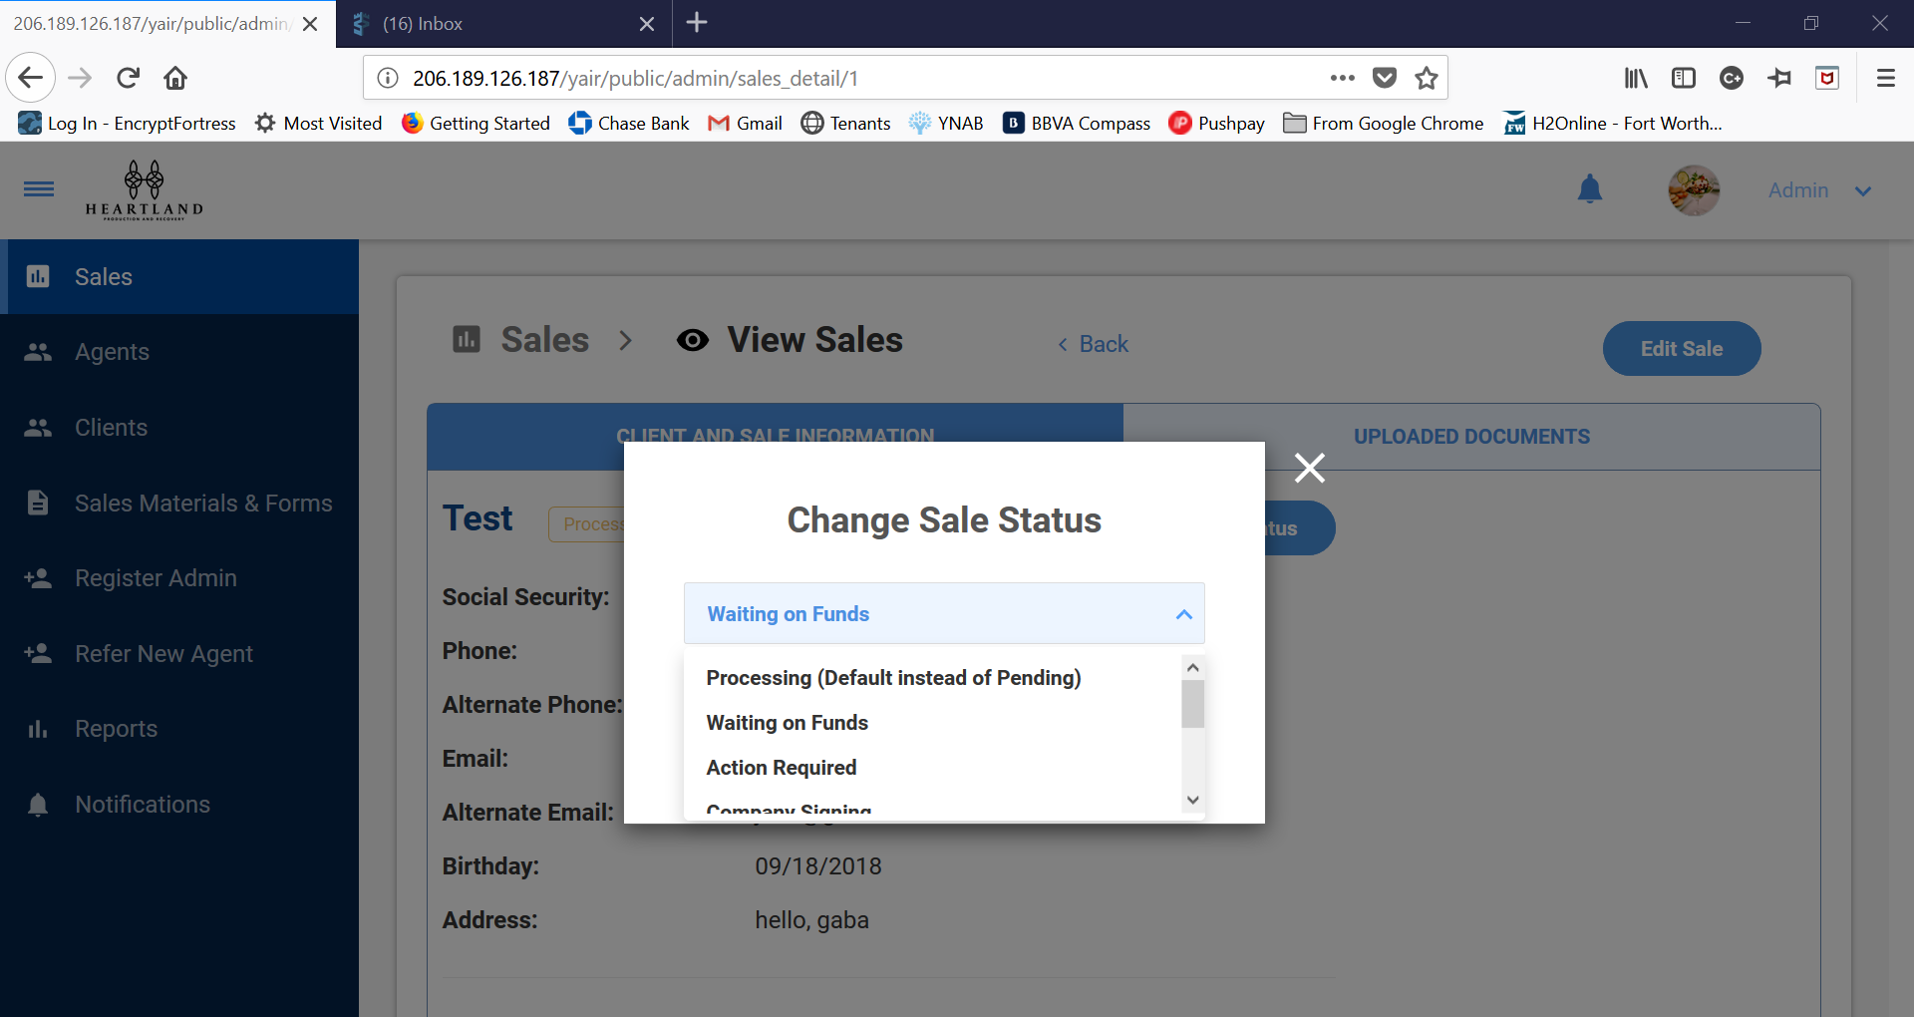

* Remove “(Default instead of Pending)”

<http://206.189.126.187/yair/public/admin/salesmaterials>

* Expand the document box to the full width of the page.

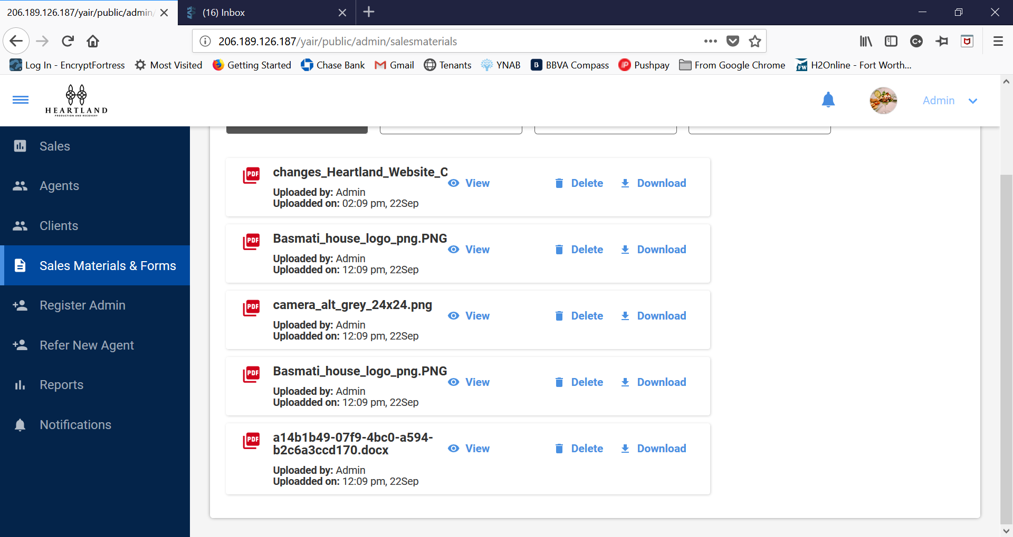

Reports

* This is what happens when I clicked on the number for the month:

