• When the remember me button has been selected, the site will remember

both password and email even when it is closed out. It should be changed to only remember the email when it is selected and it should remember nothing when remember me is not selected.  
  
  
I am work on it. Its done in agent side but issue in google chrome browser when we save the username or password in google chorme then its automatically fill the form.

<http://206.189.126.187/yair/public/admin/agent_detail/23>

· Capitalize both letters in ID for Agent ID  
  
Its points done because I thought we want only dynamic agent id letter capital.  
  
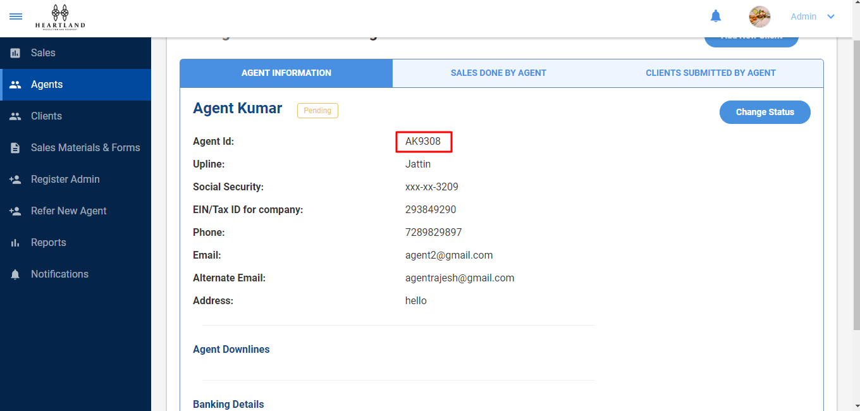

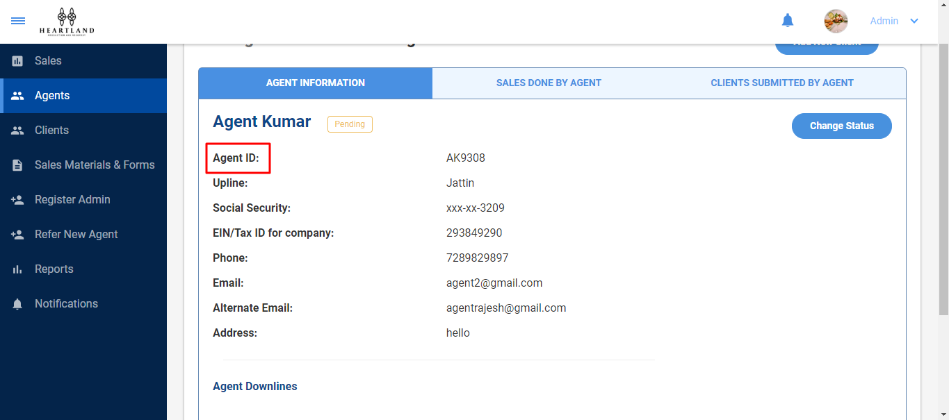  
  
now if you want agent id label capital so now its point done.

· Both of the Downlines say Downline 1. Is that because both of them are

directly under him? When those downlines have a downline will a Downline 2 show up here?   
  
its point done  
can you elaborate this point?

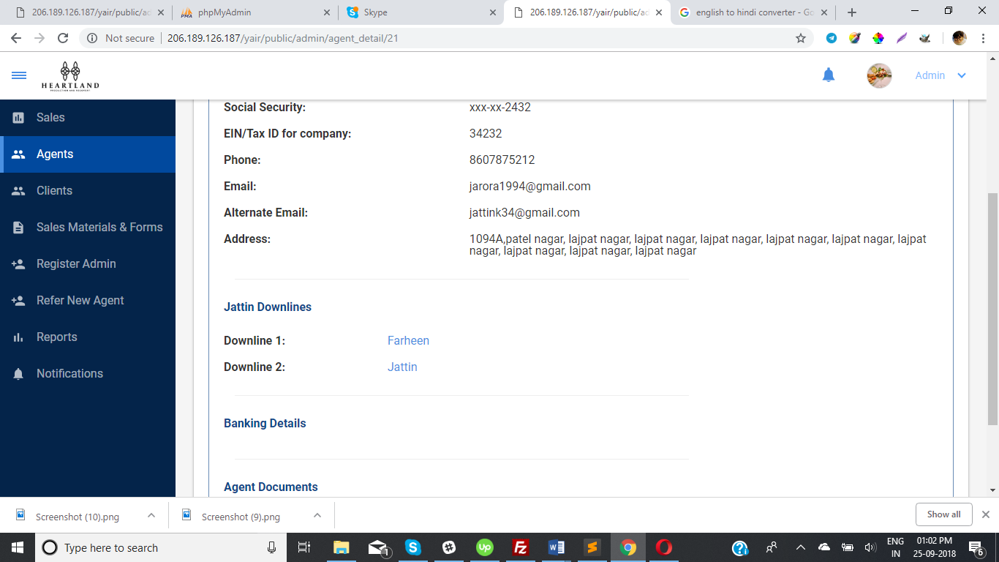

· Change Agent Status: make sure the status that is displayed is the one

that is currently selected. \*MAKE SURE THIS THIS WORKS IN SALES TOO\*   
this point new

· Change “Uploadded on” to “Uploaded on” under the document name

its point done

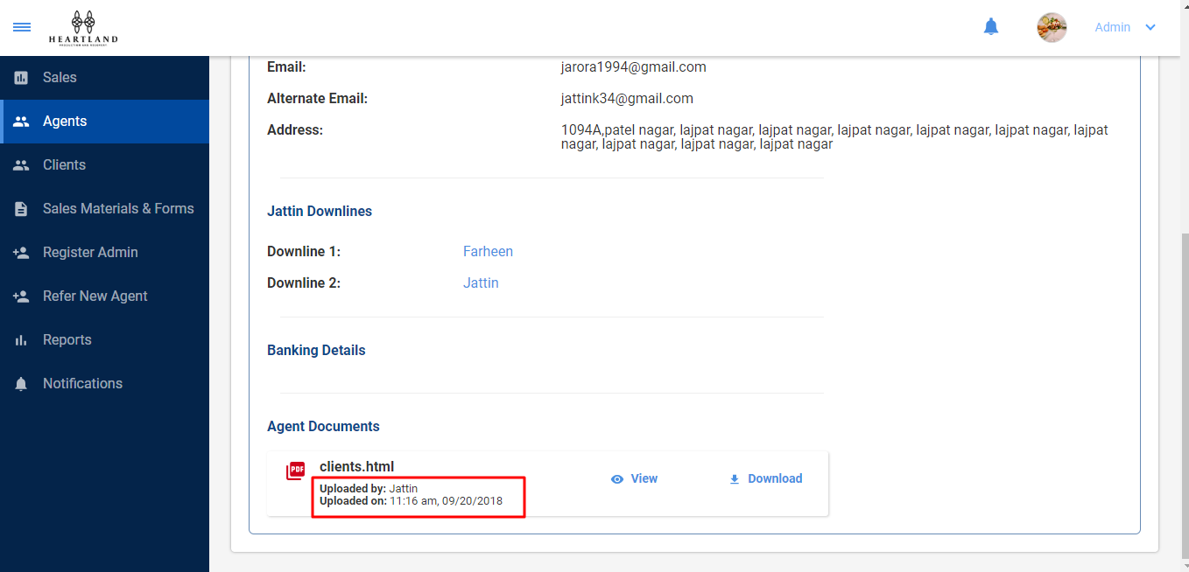

· The date format should be Month/Date/Year for the time stamp under

the document name

its point also done, date format(month/Date/Year) show in this link.

· What time zone does the time stamp show? Is it possible to have the

time show based on the time zone the person is in when they are viewing it? (for now it should all just be Central Time)

o Example: Sam in California uploads a document at 2 pm his time. When

Sam views, it shows he uploaded it at 2 pm. When Dave looks at the document in Texas, it shows Sam uploaded it at 4 pm. Pending

This point was pending, I did not fill this point.

· (Add the “Add New Sale” button to the Agent Profiles like the Client profiles so we can add clients for an agent if we need to.) pending

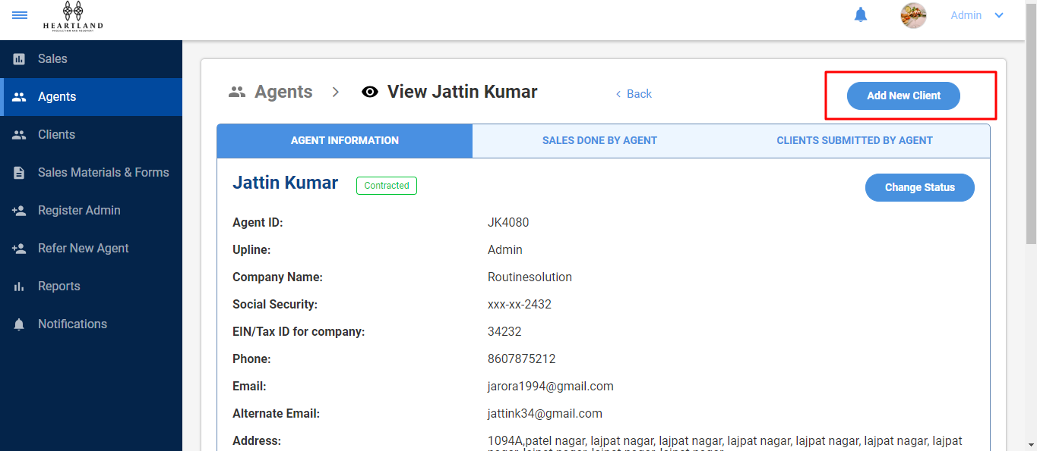  
  
this point is already done

<http://206.189.126.187/yair/public/admin/clients>

· Remove the Overview section since clients do not have statuses.

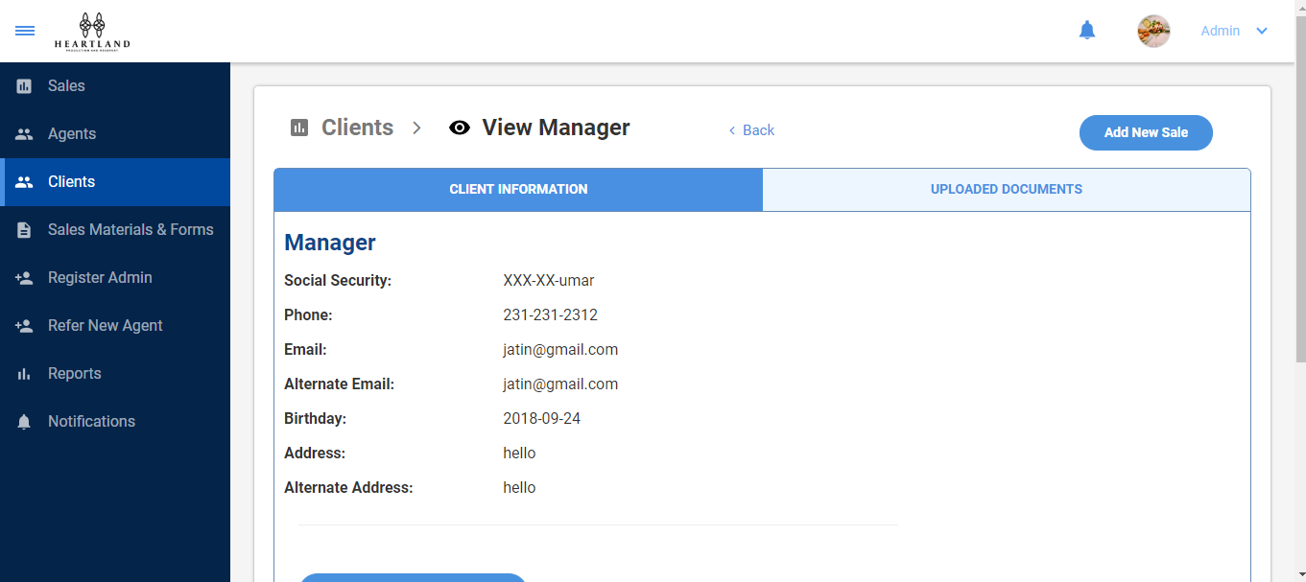

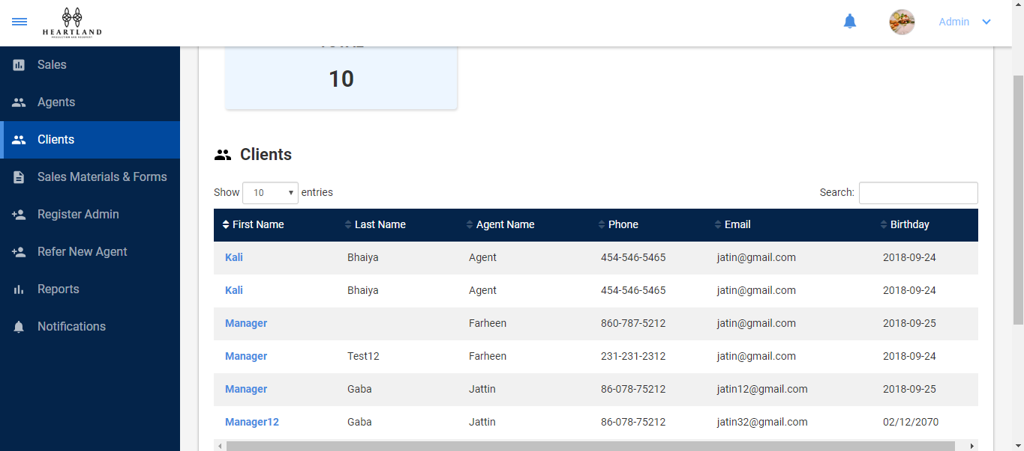  
  
  
  
On both pages, the status is not show

· When client data is being entered, if it is already in the system then it should make a notification appear telling them that the client already exists and it should not allow them to enter it. This should exclude agent’s info being the same due to agent having more than one client.

which criteria(name, email id, social id) used for find out the client is already exist?  
I have done this point on email bases. when we fill the client information after submit we check the email id if this email id exist in database with agent id then client information not add on database.  
  
if Another agent add the same client with own id then agent can add client successfully.  
if client id is not exist on agent id.

If you want change this procedure please elaborate this or discuss us.

· When an agent types information in a field, it should not auto-fill(appear visable) for a client that does not belong to that agent.

New point

· Under Phone number (add automatic dashes as a function)

