12/08/2026 – Feedback
Peer 1:
- Mentioned that it was difficult to know when the program had finished loading.
- Suggested that I may want to add a loading screen on the initial open of the app.
- I will find and use an animated loading icon from google.
Peer 2:
- Received feedback on my aesthetics.
- I showed her 4 different colour schemes, and she initially suggested that I should use a cool-blue scheme.
- I told her about the vibe I was looking for, and she agreed that my current scheme was suitable.
- I will keep my current scheme

Date: 13/08/2026
What’s being tested: Testing that Python is sending MIDI commands as expected. This is a core function of the webapp, so it is important to make sure it works as smoothly as possible.
Pass/Fail: Fail, the MIDI commands are sent but there is something causing it to have excessive latency between the mouth moving and the MIDI changing.
Changes made:
The issue was caused by the location of the line which opens the MIDI port. Originally, it was under a loop which made it reopen every frame. This introduces extra lag which caused the latency.
I fixed it by opening the MIDI port before everything, so that it only does it once. The MIDI commands are now a lot more responsive than before.
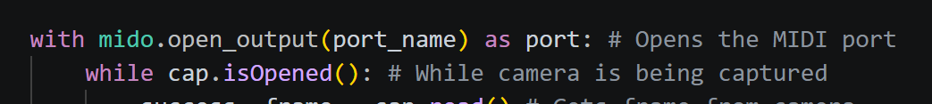

Date:
What’s being tested:
Pass/Fail:
Changes made:

