Potential Ideas:
Study planning app
- Help students schedule what to study and when to study.
- Would be immediately useful to myself and students alike.
- Pre-defined selection of various subjects + Ability to name and add your own subjects.
- Drag and drop subjects into spaces on a calendar-like interface.
- Able to assign notes to planned subjects
- The problem is that there is already a large selection of free study planners that can be found online.

Computer vision
- Track a facial feature to control the sound of your guitar playing.
- Allows the use of a guitar pedal without your foot (which is how it’s usually controlled)
- Helpful for guitarists that don’t have a pedal or are unable to control one with their legs.
- Ability to calibrate the tracking according to the user’s facial features.
- Have not seen a similar idea online yet.

Game development
- Create a game

Educational crypto investment app
- App to help students learn how investments work in Bitcoin, Ethereum, and other cryptocurrencies change over time without risk of losing money.
- Uses an API to fetch real time stock data.
- Able to invest fake money.
- Able to see and compare investment values from various times.
- Although websites/apps that do this already exist, the market is not that large.

Specifications for computer vision guitar pedal project:
- Able to track landmarks on the face mesh, specifically top and bottom lips.
- Able to send a MIDI CC(control change) signal to a guitar plugin.
- Able to translate the distance between the top and bottom lips into a MIDI CC value from 0 to 127.
- Simple, modern looking GUI.
- Navigation bar on the bottom of the screen with a settings button, calibration button, and a homepage button.
- User can calibrate the mouth wideness to suit their preferences.
- User can drag a slider in the settings page to manually calibrate the mouth detection.
15/06/2026 - Setting up Mediapipe for face-tracking:
- I will be using Mediapipe tasks with the face landmarker model to allow the tracking of the lips.
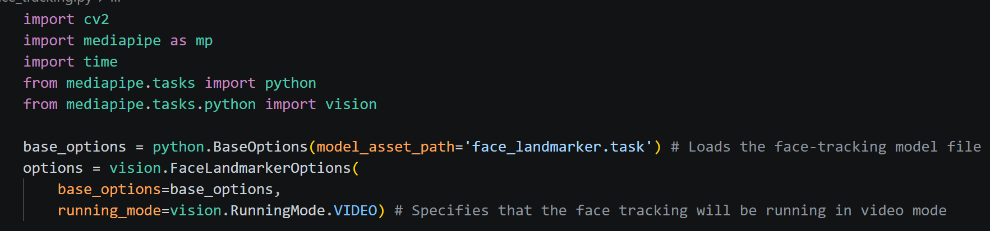
- Set up camera:
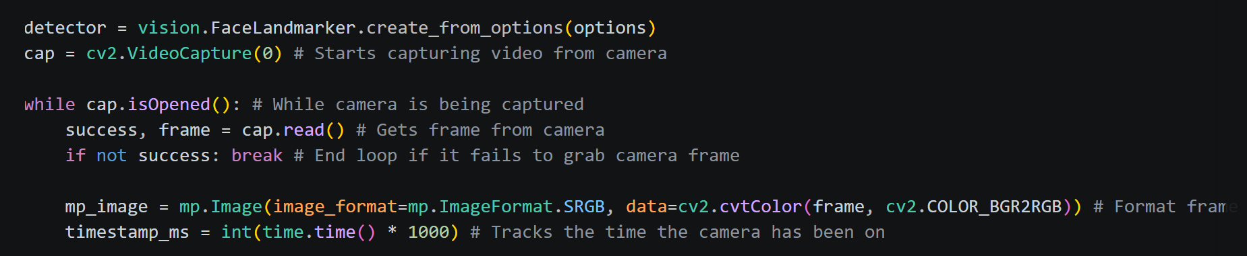
- Take the positions of the top and bottom lips:
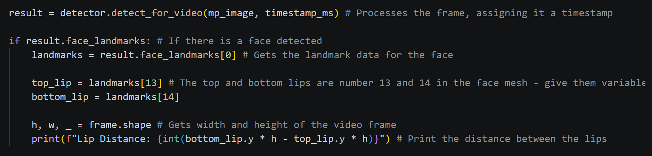

16/06/2026 - Learning how to send MIDI commands from python:
- There are a few ways to do this that I discovered during my research.
  - Mido in combination with python-rtmidi
  - Just with python-rtmidi
  - Pygame’s built in MIDI function

- Mido still uses python-rtmidi, it just acts as a wrapper to make python-rtmidi easier to work with. This and Pygame MIDI are the simplest to use, but Pygame is less suited for my use case because it is primarily for game windows. So, I will use Mido and python-rtmidi to send MIDI signals to my guitar plugin.
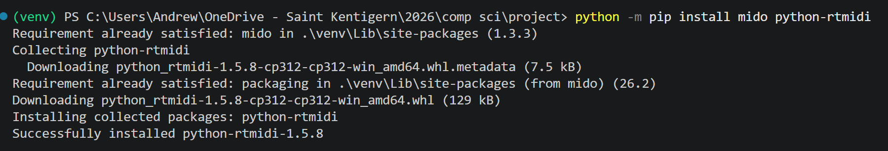

- Reaper(the audio software I’m using) cannot receive MIDI signals straight from Python, it has to pass through a virtual MIDI cable first. For the virtual MIDI cable, I will be using loopMIDI.
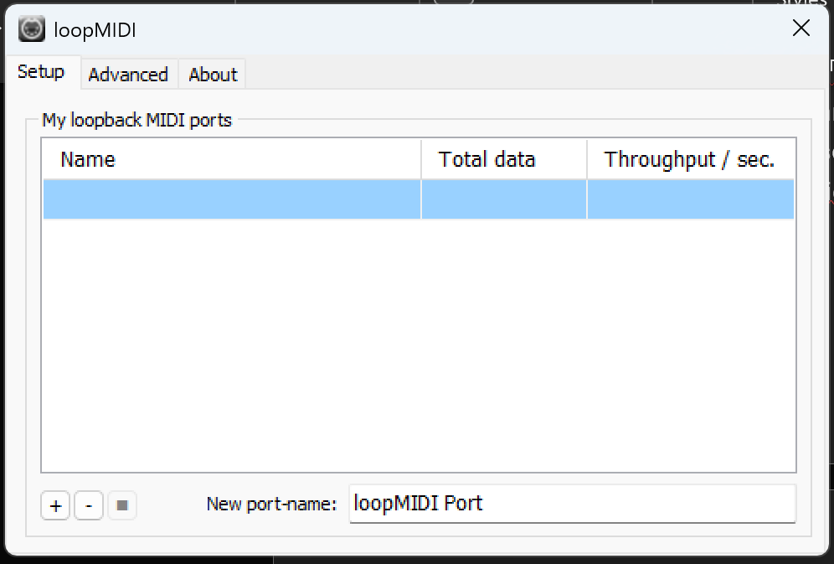

- Code to test that python can send signals through the virtual MIDI cable.
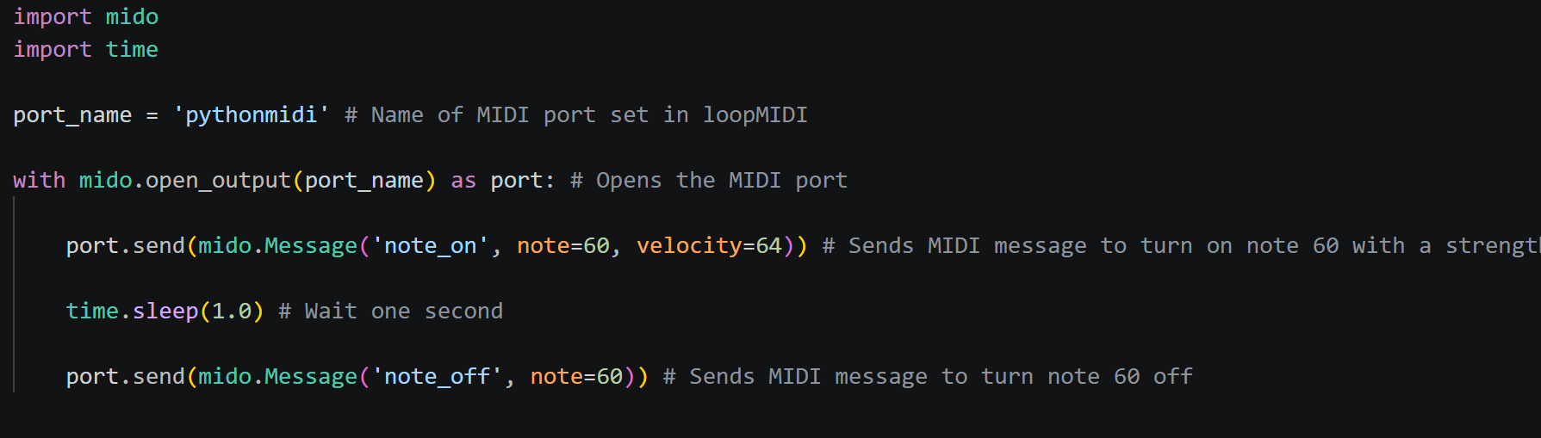
- Issue:
Having an issue where it says there is no port named ‘pythonmidi’ even though it is exactly what I named the virtual MIDI cable.
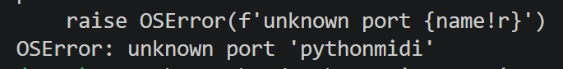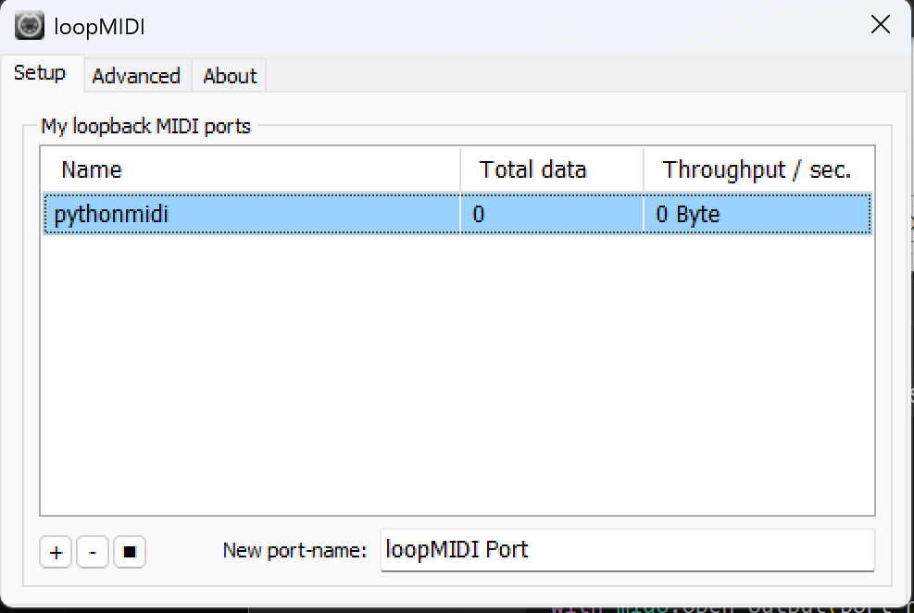
- Got Mido to the name of every open MIDI port on my laptop. And it turns out that the port is actually named ‘pythonmidi 1’
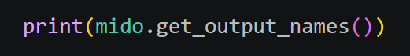

- Fixed the code and now it does send the MIDI signal.
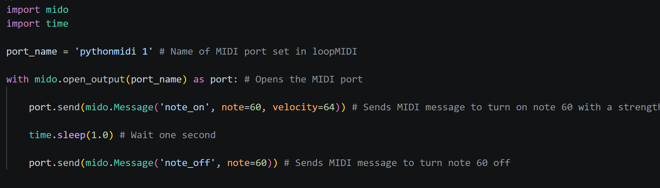

- Picture showing loopMIDI detecting the MIDI messages being sent through the virtual MIDI port:
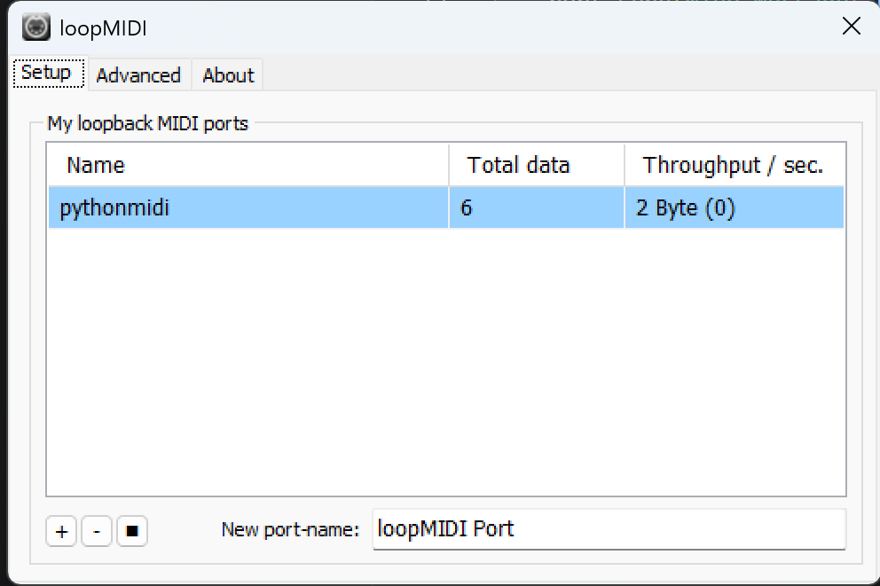

18/06/2026 – Continuing with Python MIDI
- Modifying test code to send MIDI CC (control change) messages:
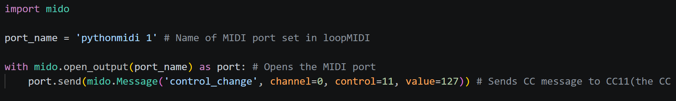

- Working on having Reaper(my guitar software) receive the MIDI signals so that I can control a parameter inside the guitar plugin from Python.

- Issue:
The guitar plugin should automatically detect the message and map it to the pedal I have chosen, however, it is not detecting it.
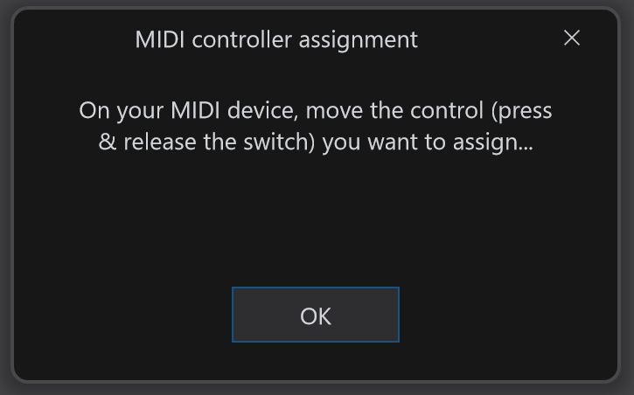

- I missed a whole setup step inside of Reaper, which was most likely why the plugin wasn’t detecting the MIDI messages.
- Enabling the MIDI input:
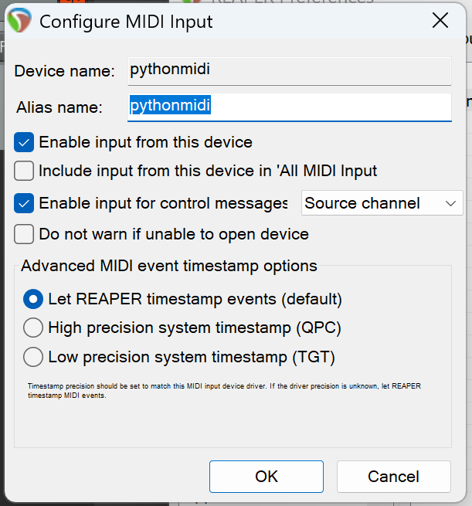
- Routing the MIDI signal to the guitar track: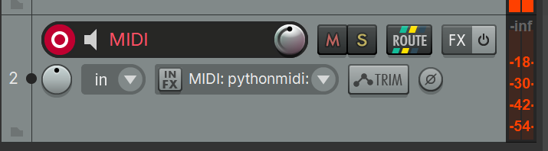
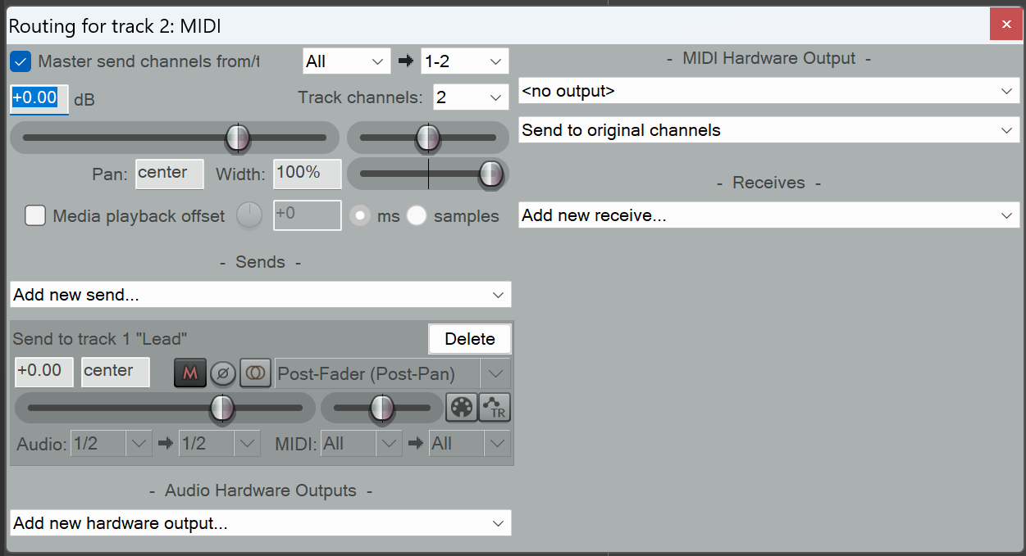

- After going through these steps to set up MIDI inside of Reaper, the MIDI message can now be received by the guitar plugin
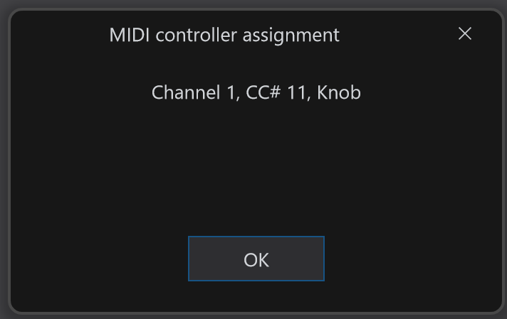
- Because the ‘value’ function inside the send MIDI message line is set to 127, it will max out the pedal position. Changing the value from 0 to 127 will change the pedal position accordingly.
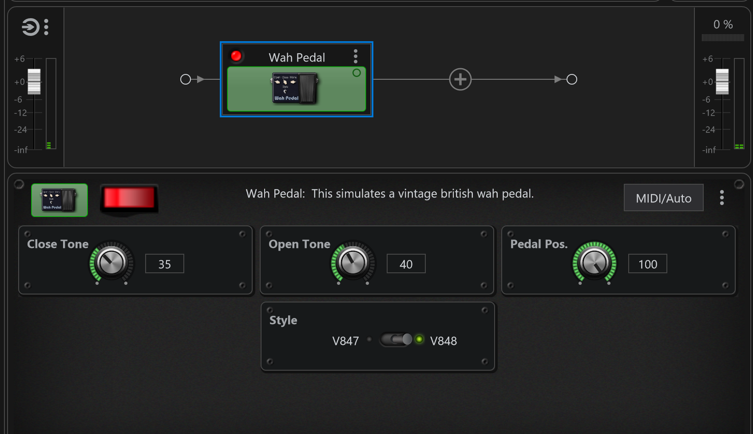

22/06/2026 – Continuing to work on the face tracking
- Duplicated the Python file with mediapipe, I will use the new file to incorporate Mido into the face tracking code.

- Trying to turn the distance between the user’s lips into a percentage so that it is easier to convert into a CC value of 0 to 127 later.
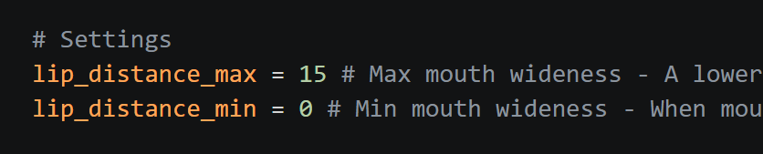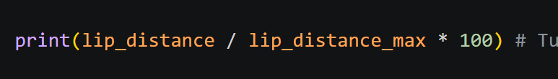

- Issue:
Current code only finds the percentage out of the max lip distance. It goes over 100 percent if I open my mouth wider, and it is not affected by the minimum lip distance. So it’s not very helpful.
I need it to turn the distance into a percentage out of the max and minimum lip distances.
Found this formula on Stack Overflow:
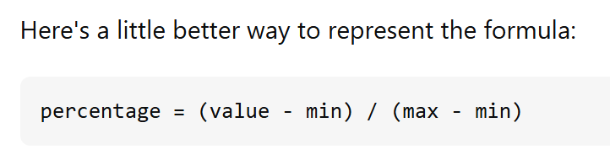
Implemented the formula into my code:
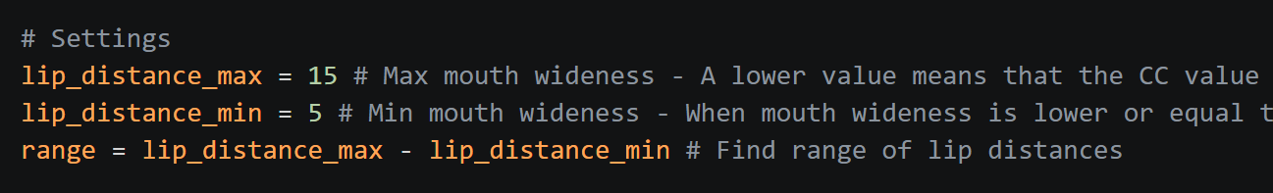
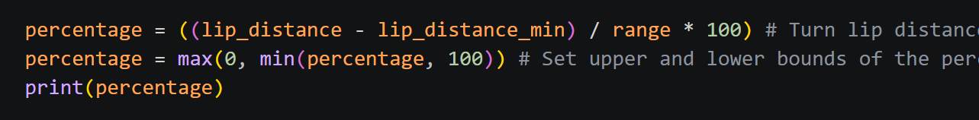
Now the distance between the lips is printed as a percentage of the range from 0 to 100.

25/06/2026
- Make Mido send CC message according to the mouth wideness percentage.
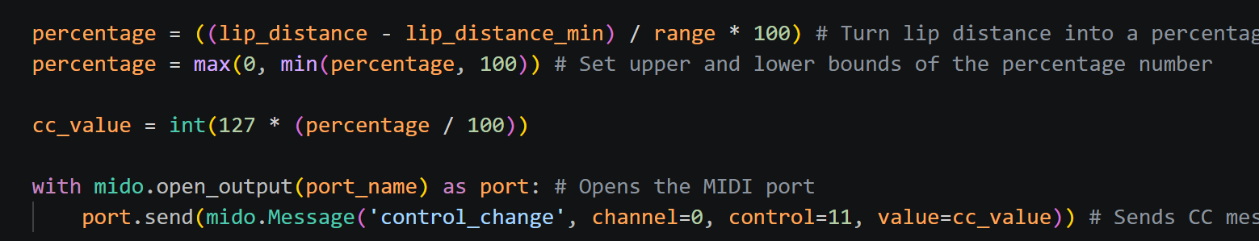

- Wah pedal position now changes when you open or close your mouth
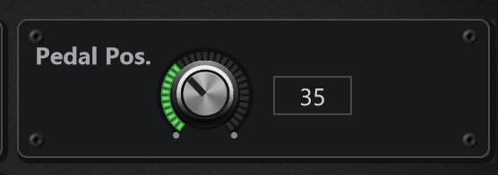

25/06/2026 - Beginning work on the UI
- I will make the mobile layout first.

- Made a navigation bar on the bottom of the screen.
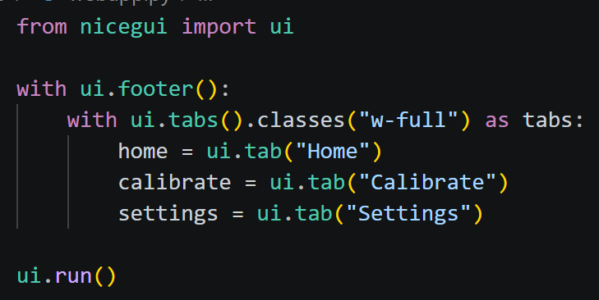
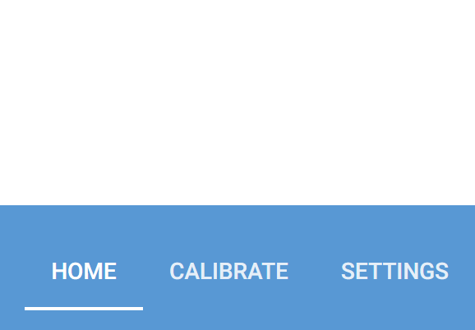

- Using ui.tabs doesn’t quite give me the look I want, I’m going to switch to using buttons so I can have more control over how they look.

