15/06/2026 - Setting up Mediapipe for face-tracking:
- I will be using Mediapipe tasks with the face landmarker model to allow the tracking of the lips.
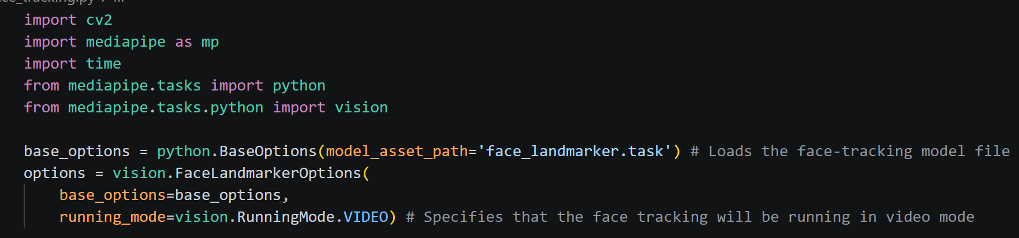
- Set up camera:
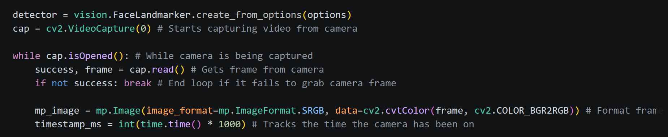
- Take the positions of the top and bottom lips:
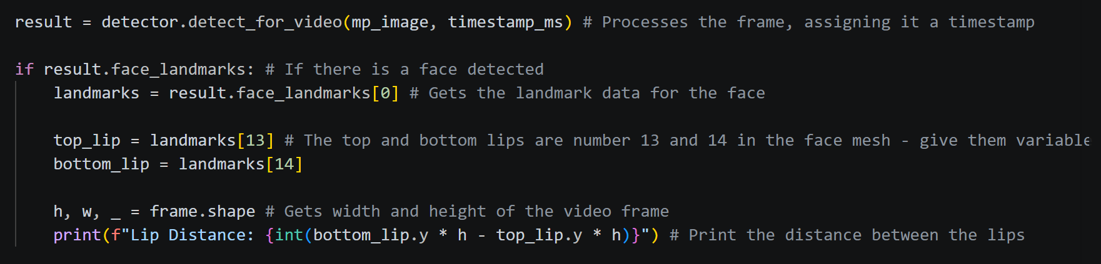

16/06/2026 - Learning how to send MIDI commands from python:
- There are a few ways to do this that I discovered during my research.
  - Mido in combination with python-rtmidi
  - Just with python-rtmidi
  - Pygame’s built in MIDI function

- Mido still uses python-rtmidi, it just acts as a wrapper to make python-rtmidi easier to work with. This and Pygame MIDI are the simplest to use, but Pygame is less suited for my use case because it is primarily for game windows. So, I will use Mido and python-rtmidi to send MIDI signals to my guitar plugin.
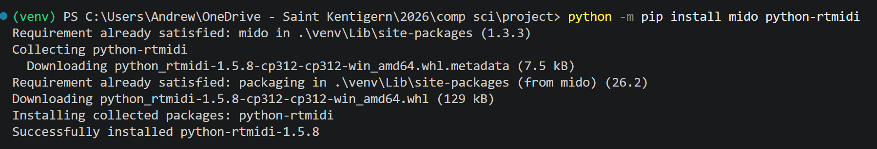

- Reaper(the audio software I’m using) cannot receive MIDI signals straight from Python, it has to pass through a virtual MIDI cable first. For the virtual MIDI cable, I will be using loopMIDI.
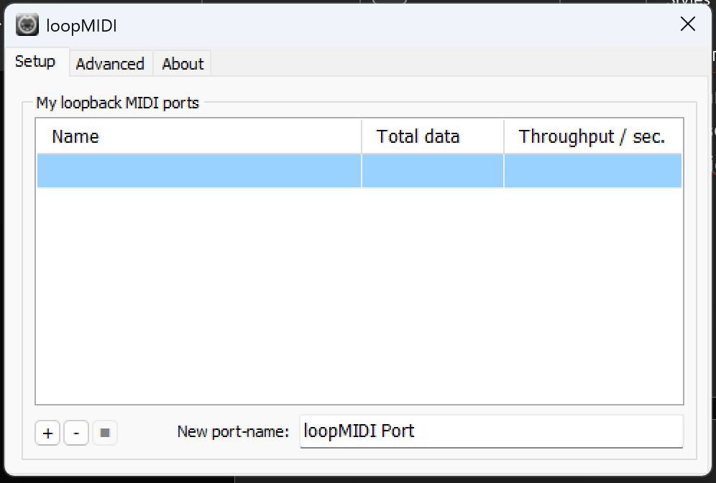

- Code to test that python can send signals through the virtual MIDI cable.
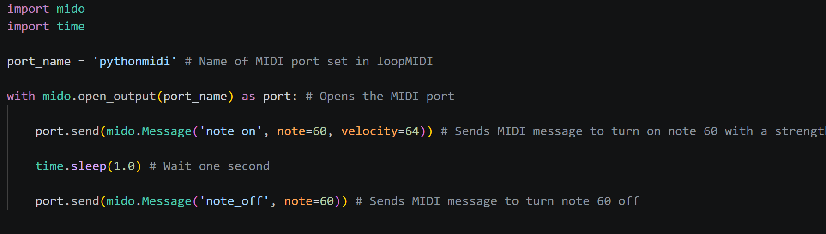
- Issue:
Having an issue where it says there is no port named ‘pythonmidi’ even though it is exactly what I named the virtual MIDI cable.
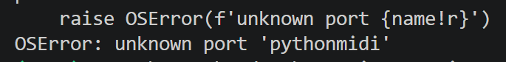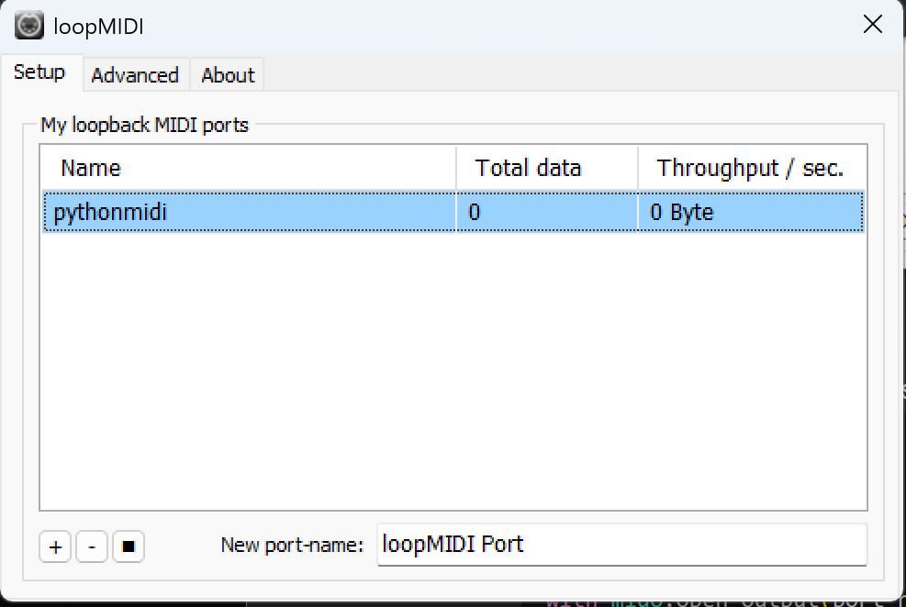
- Got Mido to the name of every open MIDI port on my laptop. And it turns out that the port is actually named ‘pythonmidi 1’
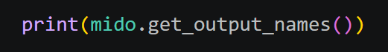

- Fixed the code and now it does send the MIDI signal.
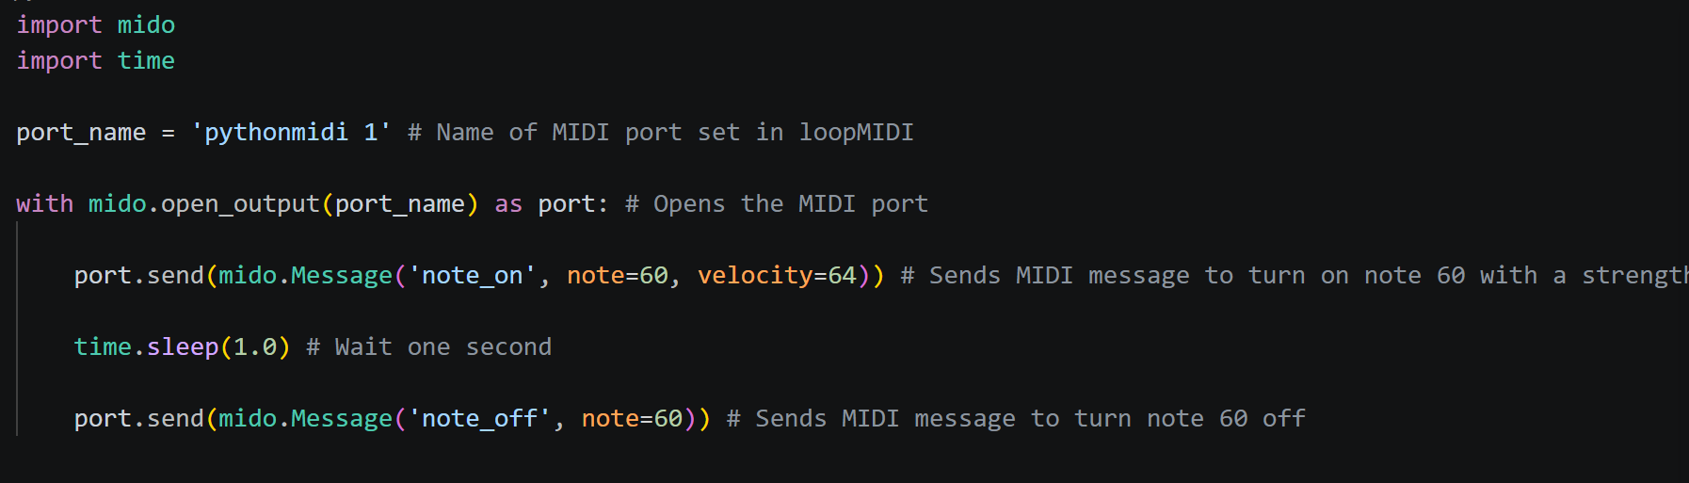

- Picture showing loopMIDI detecting the MIDI messages being sent through the virtual MIDI port:
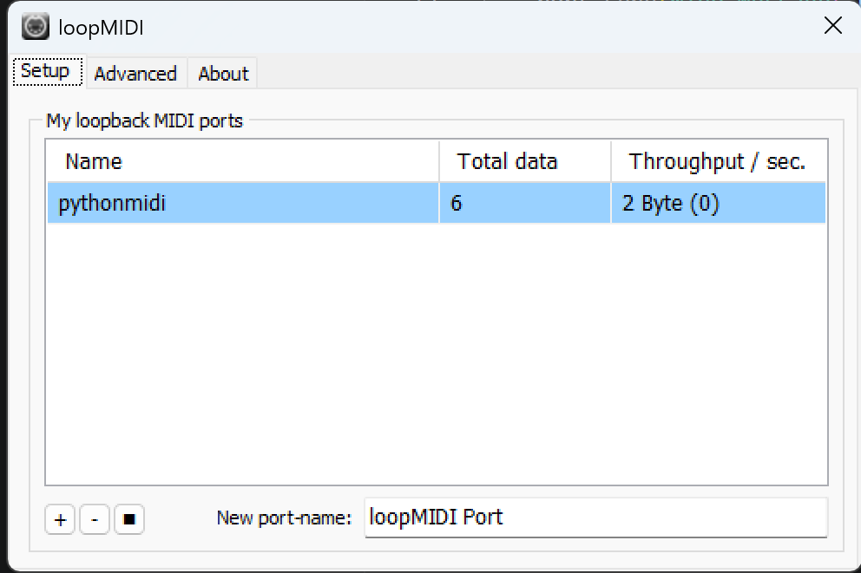

18/06/2026 – Continuing with Python MIDI
- Modifying test code to send MIDI CC (control change) messages:
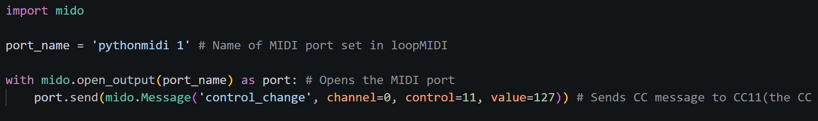

- Working on having Reaper(my guitar software) receive the MIDI signals so that I can control a parameter inside the guitar plugin from Python.

- Issue:
The guitar plugin should automatically detect the message and map it to the pedal I have chosen, however, it is not detecting it.
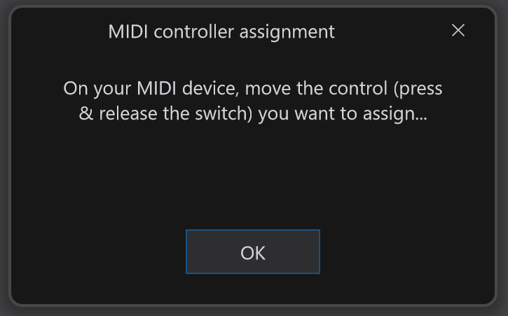

- I missed a whole setup step inside of Reaper, which was most likely why the plugin wasn’t detecting the MIDI messages.
- Enabling the MIDI input:
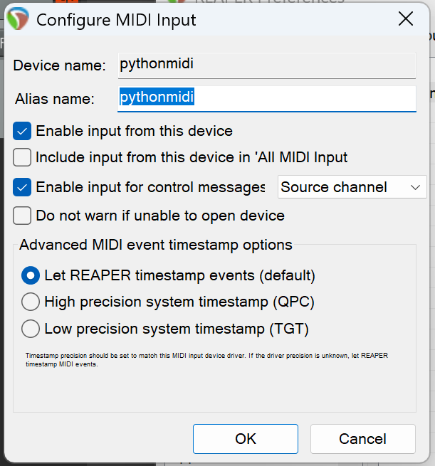
- Routing the MIDI signal to the guitar track: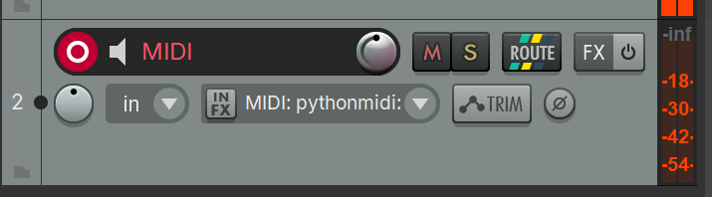
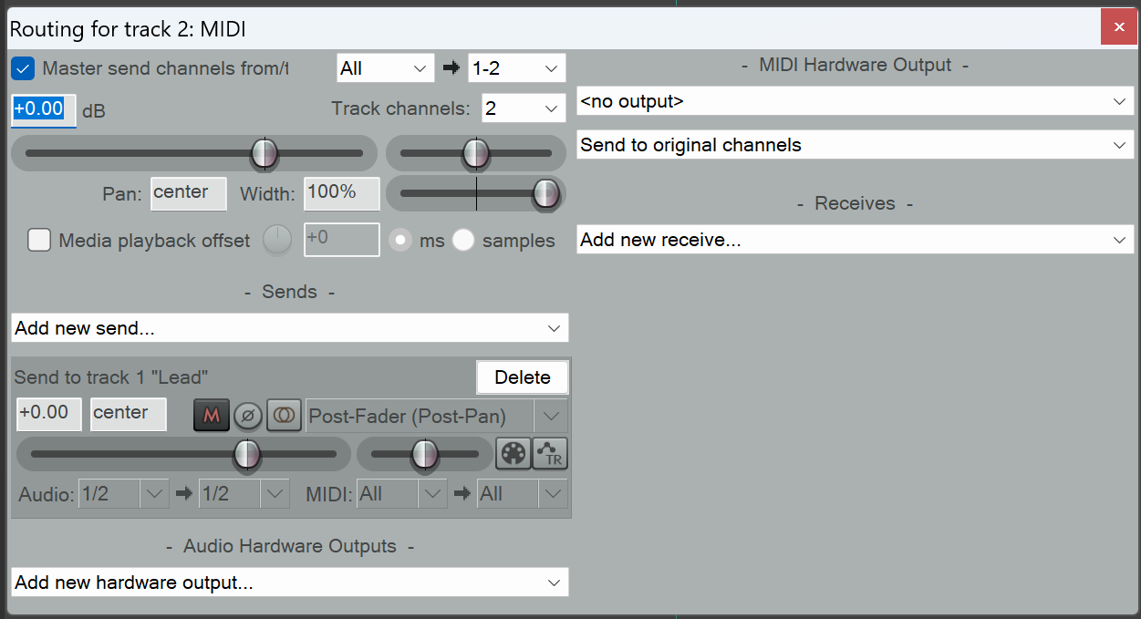

- After going through these steps to set up MIDI inside of Reaper, the MIDI message can now be received by the guitar plugin
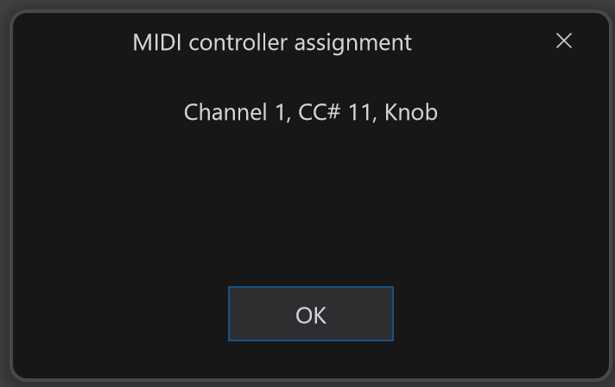
- Because the ‘value’ function inside the send MIDI message line is set to 127, it will max out the pedal position. Changing the value from 0 to 127 will change the pedal position accordingly.
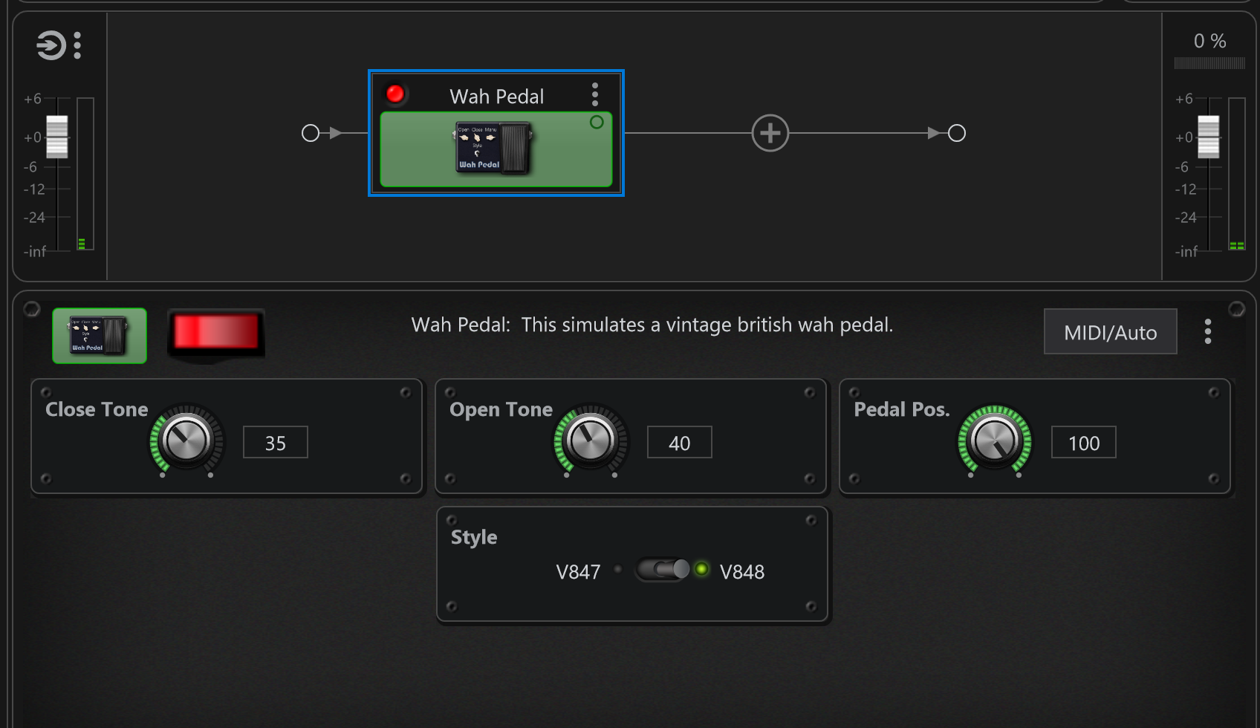

22/06/2026 – Continuing to work on the face tracking
- Duplicated the Python file with mediapipe, I will use the new file to incorporate Mido into the face tracking code.

- Trying to turn the distance between the user’s lips into a percentage so that it is easier to convert into a CC value of 0 to 127 later.
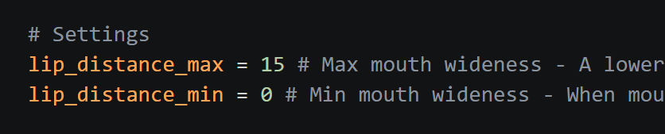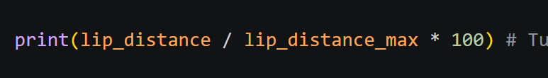

- Issue:
Current code only finds the percentage out of the max lip distance. It goes over 100 percent if I open my mouth wider, and it is not affected by the minimum lip distance. So it’s not very helpful.
I need it to turn the distance into a percentage out of the max and minimum lip distances.
Found this formula on Stack Overflow:
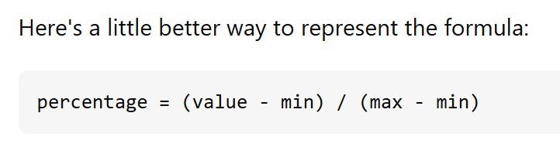
Implemented the formula into my code:
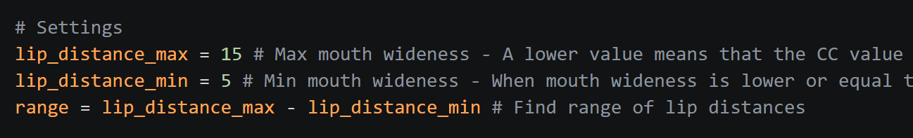
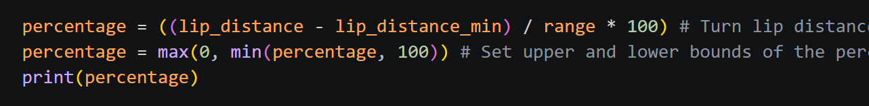
Now the distance between the lips is printed as a percentage of the range from 0 to 100.

25/06/2026
- Make Mido send CC message according to the mouth wideness percentage.
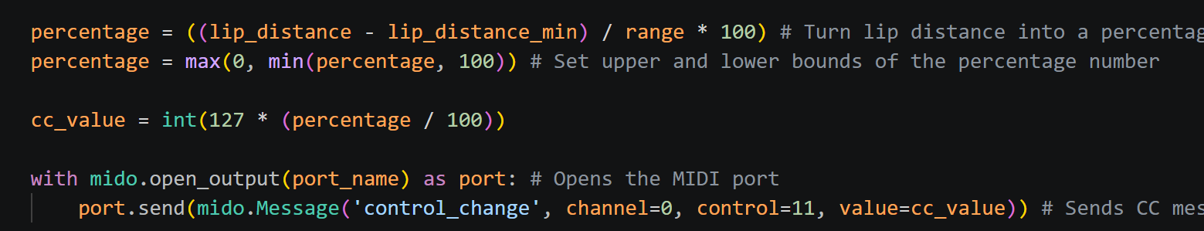

- Wah pedal position now changes when you open or close your mouth
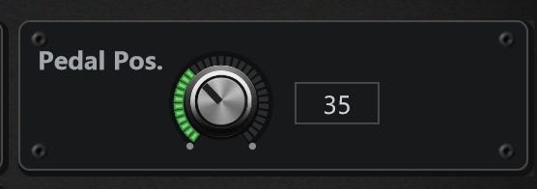

25/06/2026 - Beginning work on the UI
- I will make the mobile layout first.

- Made a navigation bar on the bottom of the screen.
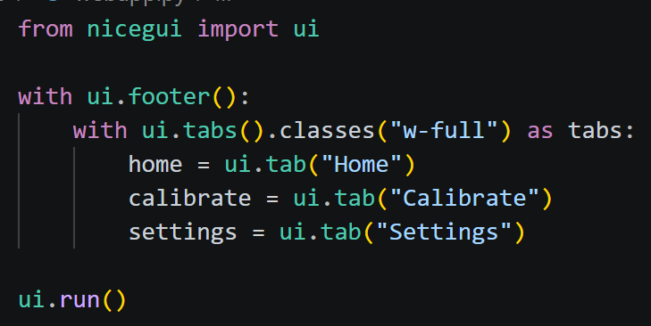
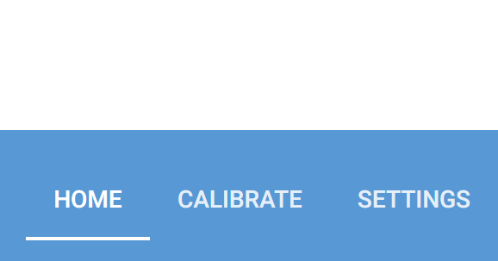

- Using ui.tabs doesn’t quite give me the look I want, I’m going to switch to using buttons so I can have more control over how they look.
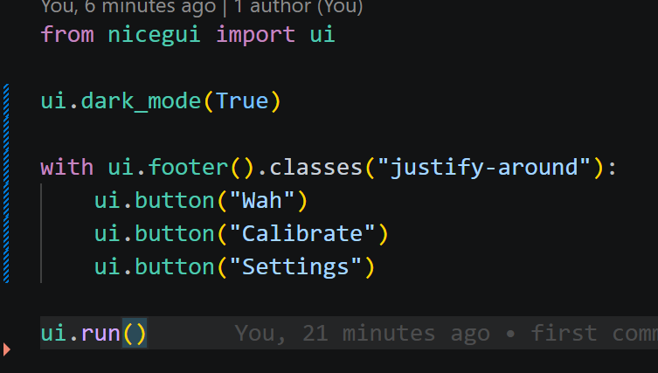

- Utilising flexbox grid to get buttons to fill up the navigation bar
https://tailwindcss.com/docs/grid-column

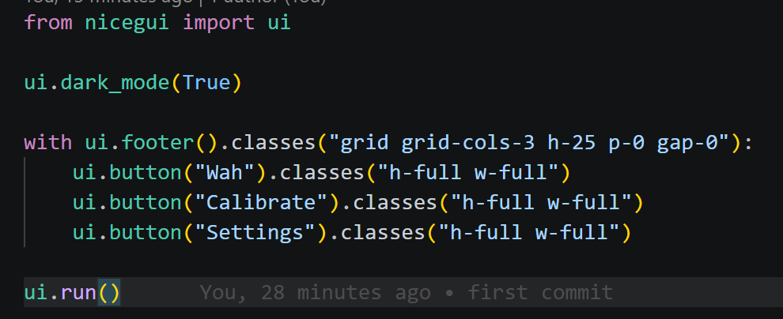
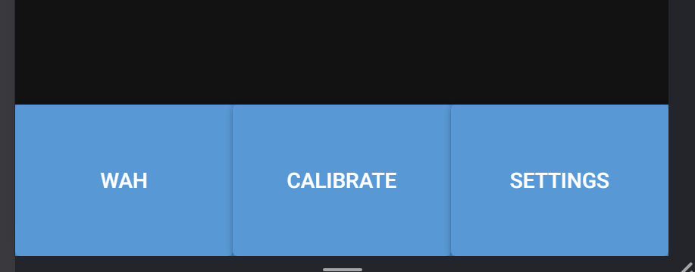

3/07/2026 – Finalising the basic UI layout
- Picked a color scheme and changed the background color:
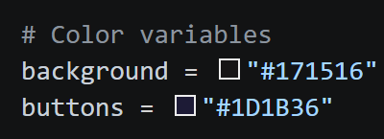
- Styled the buttons – removed drop shadow, changed the color, rounded only the top right and left button corners.
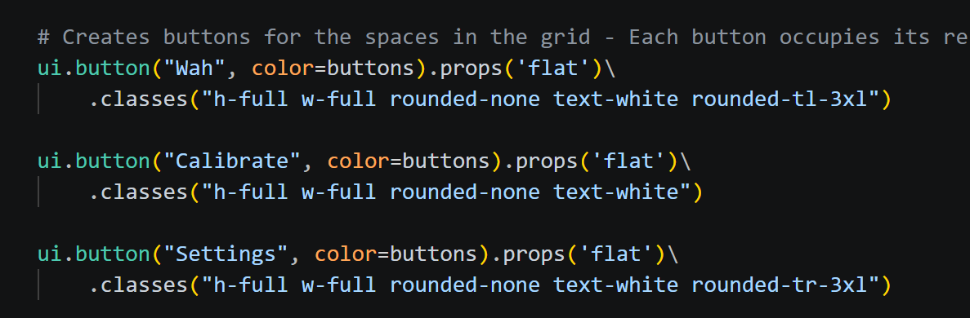
- The navigation bar now looks like this:
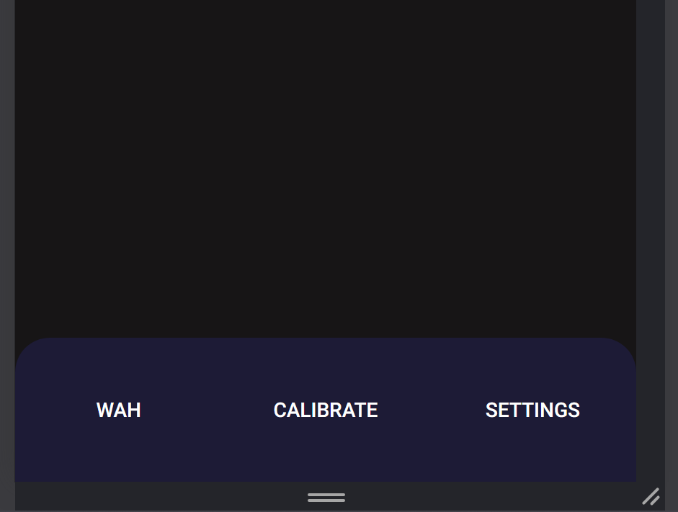

- The bar icons have not been finished yet so I have not added them to the nav bar.

2/07/2026 – Beginning to create the individual pages
- I believe it would be best that I use one page for all the functions rather than a separate page for each. This means that my app wouldn’t have to load a complete new webpage, and it will hopefully run smoothest.
- I can do this by creating a container to show the content, then clearing it and then showing new content when another tab is selected.

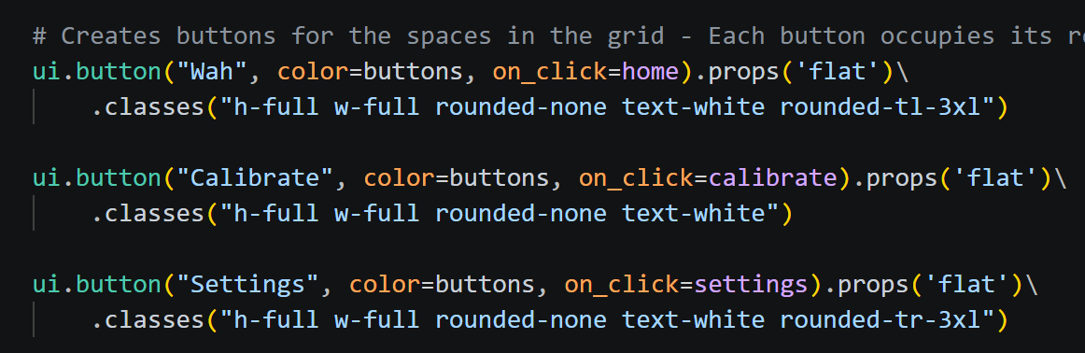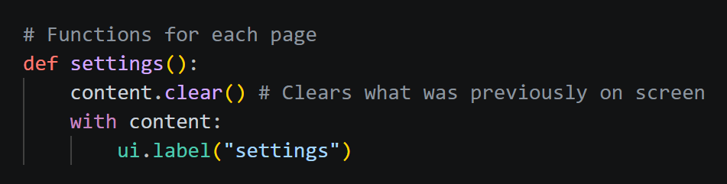

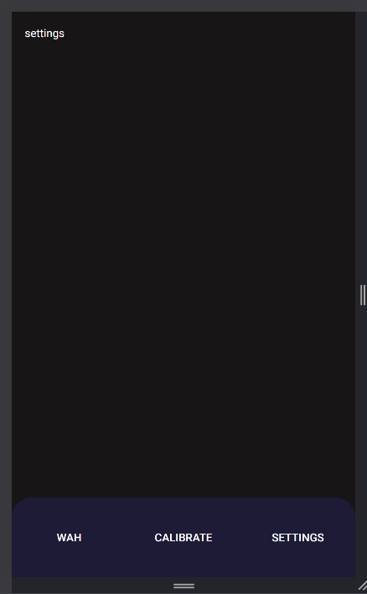
- Clicking on each button in the nav bar will cause the text to change accordingly. I will create UI for each tab in their respective function shown above.

29/07/2026 – Working on the main page
- I’m not sure how I should create the gauge I want. It should be a semi-circular bar that updates depending on the percent of the wah, however, the built-in displays such as ui.highchart and ui.echart don’t look how I want them to look.
- Making it a semi-circle was too difficult for me, I’m going to use a full circle for the status bar to make it manageable.
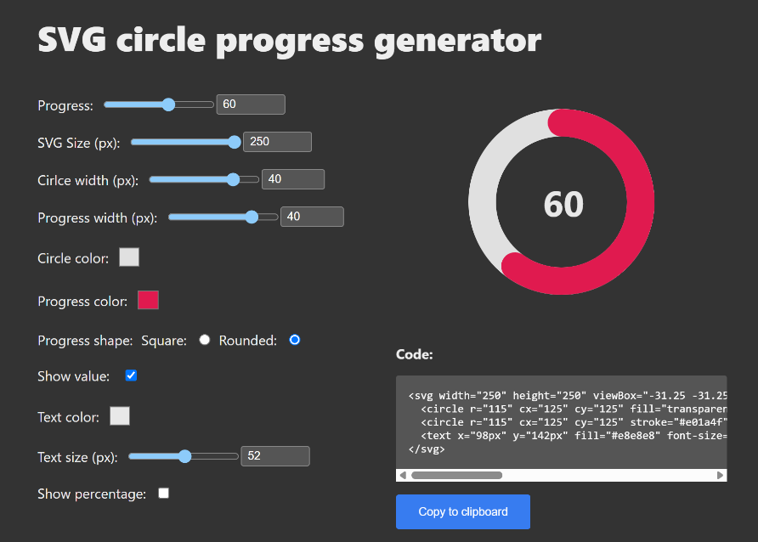
- I will use this website to generate a gauge: https://nikitahl.github.io/svg-circle-progress-generator/

- Testing it separately, and trying to update the value in real time.
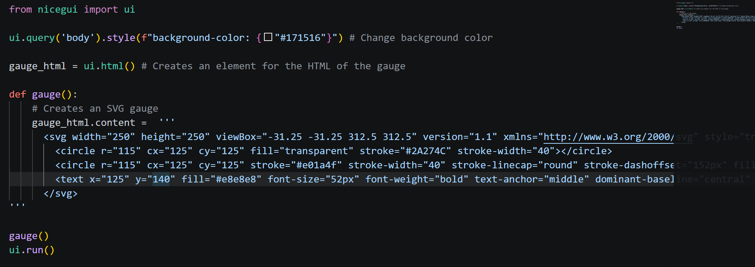
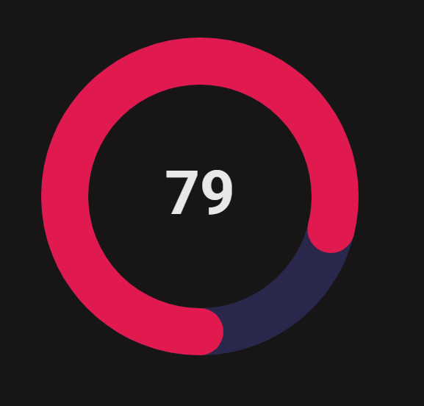

- The lines that control the value of the gauge are “stroke-dashoffset”, the line that displays the value in the middle of the gauge.
- Stroke-dashoffset has a range of 0 to 722, so I will need to make sure a value of 100 corresponds to 722.
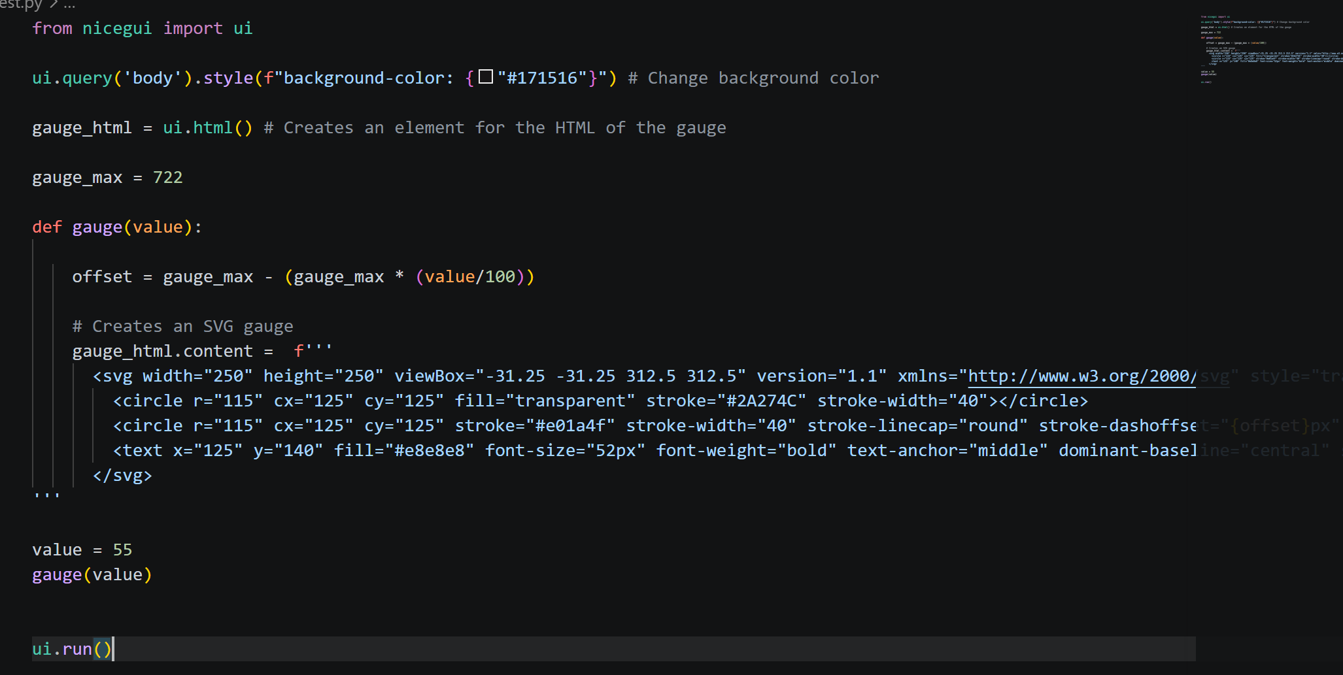
- Gauge now updates according to the value variable.

5/08/2026 – Adding the gauge onto the actual UI
Since the line of code to create the element for the gauge is inside the homepage function, the gauge function (which is outside) can’t access it. I fixed this by adding an extra parameter in the gauge function.
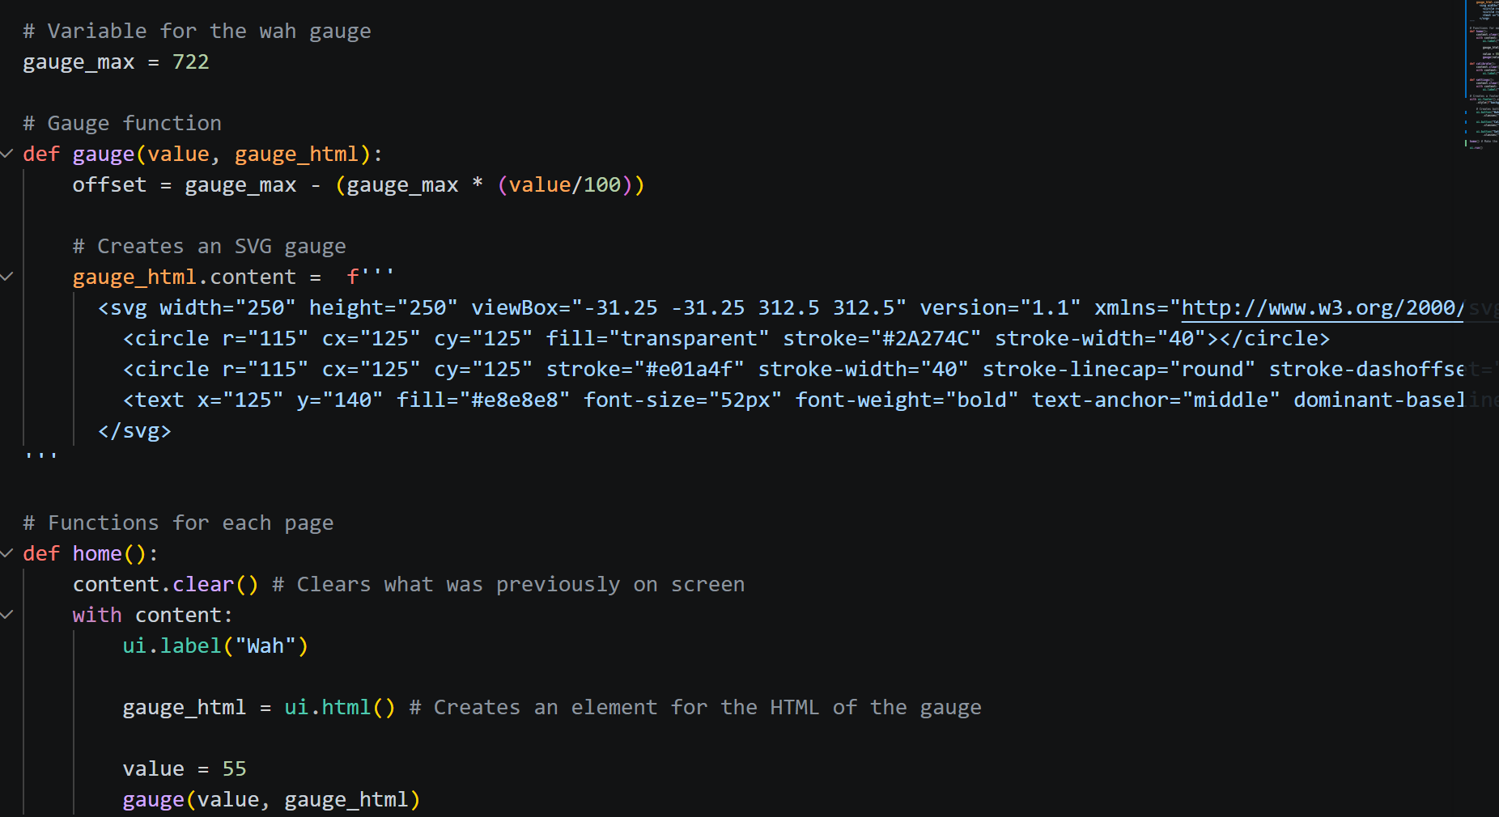

- Created a proper header
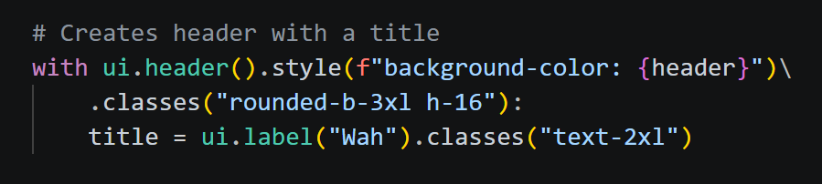
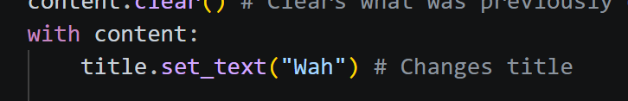
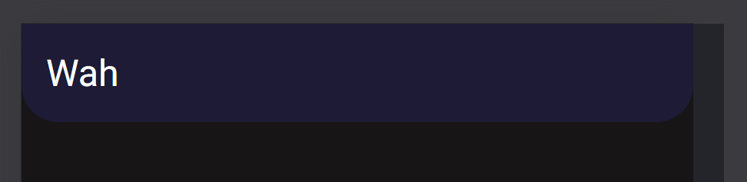
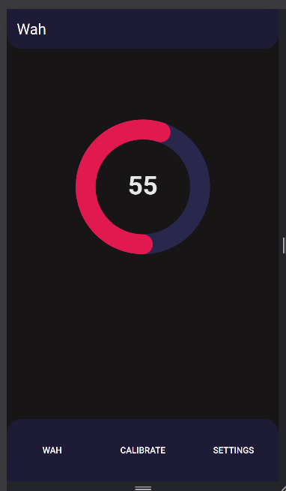
- The home page of the webapp now looks like this:

6/08/2026 – Working on the settings page
- Added sliders for the settings using the example shown in the NiceGUI documentation
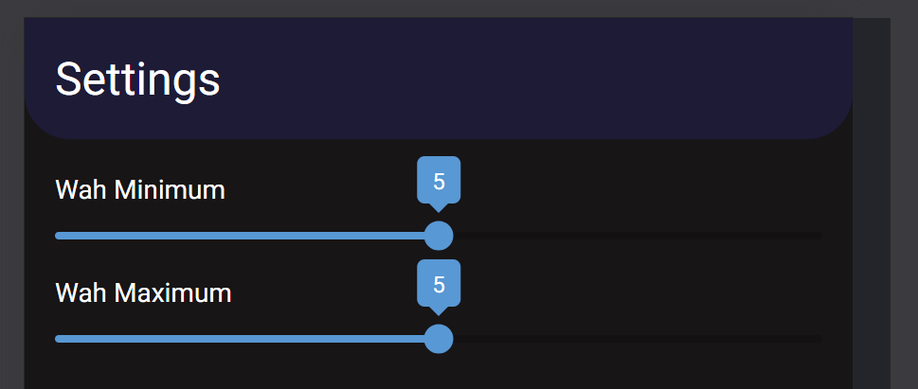
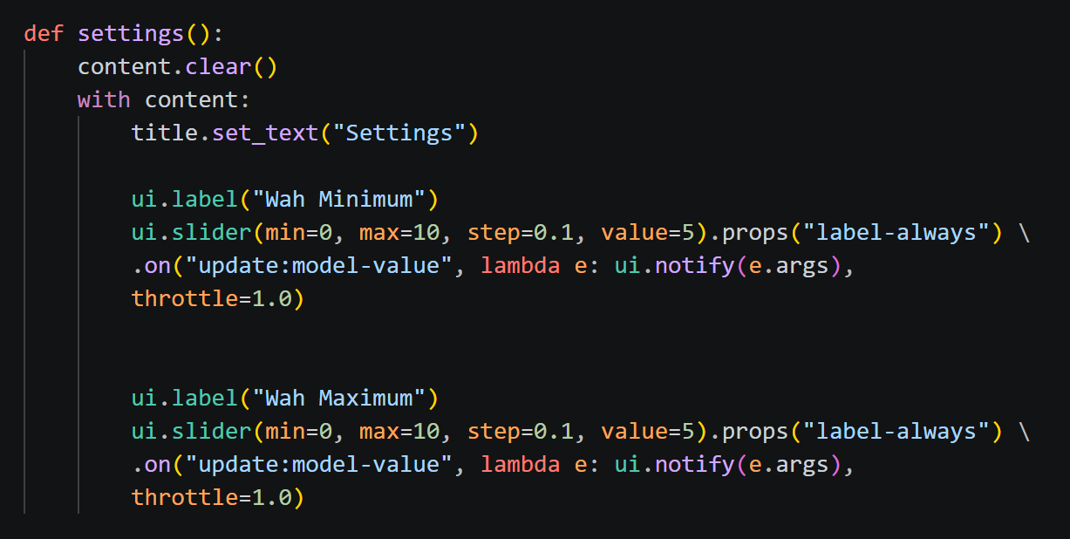
- These sliders currently do not do anything so I will make them save their values to a JSON file.
- I have created a function to update the JSON file but I’m unsure how to save the slider number.

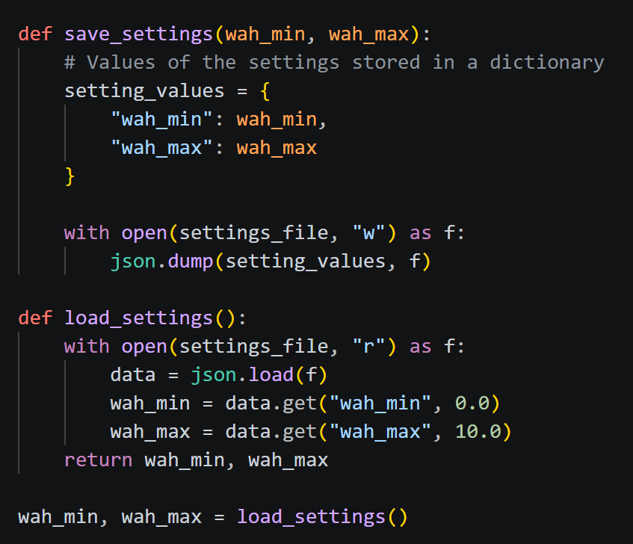

- I’ve encountered an issue with my variable for min and max wah being immutable, this means that I won’t be able to update it real time with my slider, so the wah settings wouldn’t actually change.
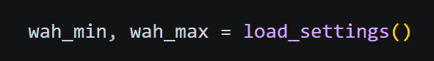
- To fix this, I’m using a dictionary to store the values because a dictionary is mutable.
- Starting by changing the function that loads the setting values
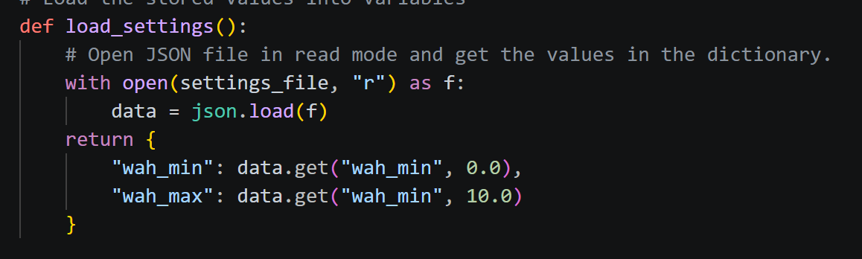
- Now it returns a dictionary instead of a tuple

7/08/2026
- Working on getting the value of the slider in real time
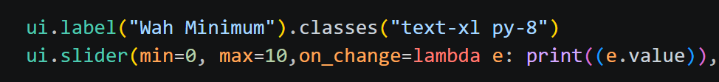
- I realised that it prints the updated value very frequently, while I only need it to update when the user releases the slider. I have to change it or else it might introduce unnecessary lag while changing the settings because of all the updates that are being done to the settings.

10/08/2026
- I’m finding it hard to make the settings without the actual wah program code, so I will put the settings menu on hold for now to combine the webapp with the wah.
- I’m told by google that I will need to utilise threading since the while look for the face tracking will block the rest of the webapp from running.
- The face tracking and MIDI code will be put into a function which (through the help of threads), will be constantly running in the background.

- Webapp GUI now works while the face tracking runs. The function contains all of the code for the face tracking and MIDI
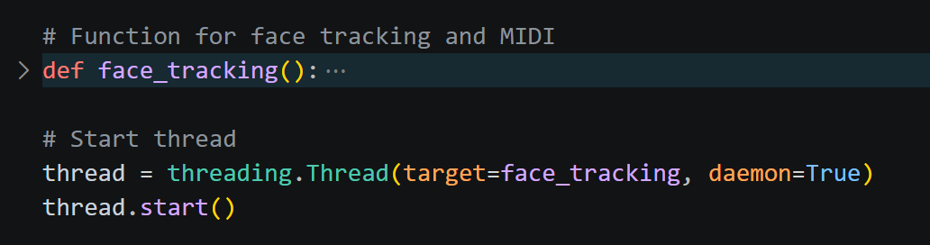

- Working on connecting the wah percentage to the gauge.
- Once again, I have to use a dictionary to store the value of the gauge so that it is mutable.
- It feels like no matter what I do, my timer to update the gauge just can’t reach the updated values, so it always uses the original one I set.

Implementing media queries
- I want the three pages to be put side by side with each other when it is on a wide, desktop screen.
- I will be doing this with Tailwind CSS media queries

- Started by hiding the navigation bar on desktop screens: 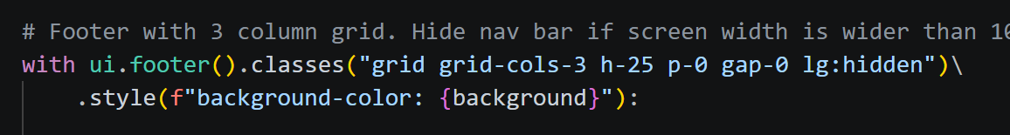

- On mobile screens, the main container will have one column. And on desktop screens, the main container will have three columns for the pages.

- Renders all the pages just once and hide/unhide them to switch. Since the main container has three columns, it will naturally stack side by side when on a desktop screen.
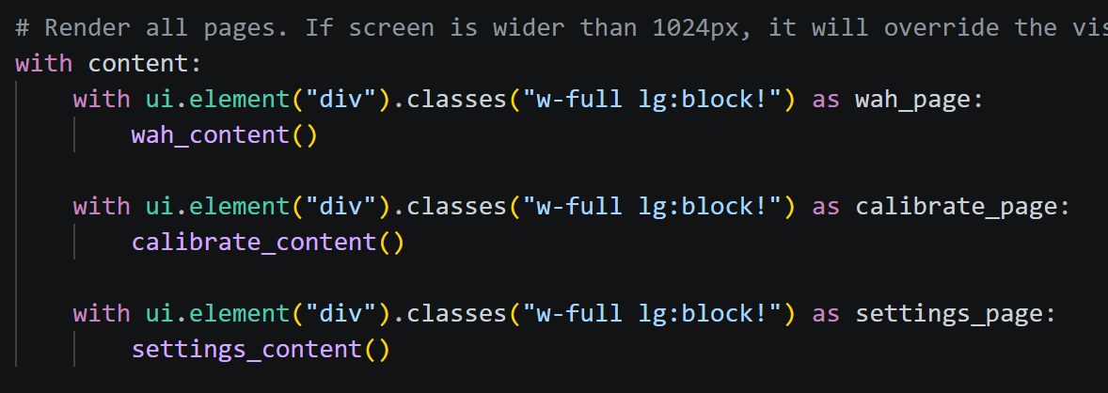
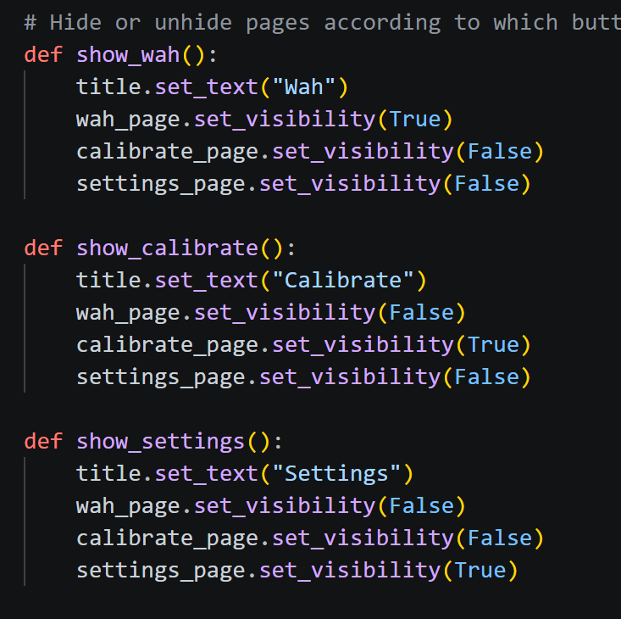
5/09/2026 – Adding a loading screen
NiceGUI has loading icons built in, so I will be using them to create the loading screen.
https://nicegui.io/documentation/spinner
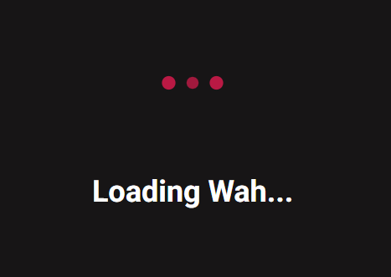
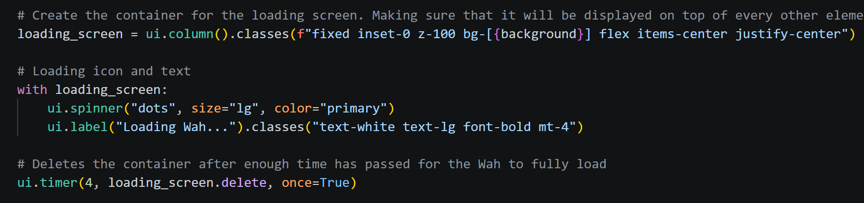
For 4 seconds when the app starts, a loading screen will be shown to allow time for the Wah to initialise.

14/09/2026 – Creating calibration feature
While trying to create the calibration feature, I encountered the same issue where I could not access a changing value inside the thread. This prompted the thought that threading might be the issue, and I’m looking for alternative ways to run the face tracking code in the background.
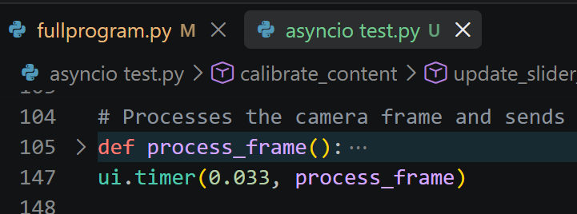
I found something called asyncio that also does what I need. Asyncio is apparently what NiceGUI runs on, so I think there won’t be any issues with values not being accessible in the NiceGUI loop.I may be able to just use a ui.timer line to run the face tracking loop. To test this, I will create a new file.
I removed the while loop that housed the frame processing code and put it in a function so that I could use ui.timer to run it. This did indeed fix all of my issues with accessing values inside of the thread from other functions outside of it.
I can continue to work on the calibration feature.
