

**INCISION ROBOT CLASS PROJECT REPORT**EGBE481 INTRODUCTION TO MEDICAL ROBOTICS

**BY**

JATURA LIKITRATANAPORN 6013150 EGBE

**SUBMITTED TO**ASST.PROF. DR. JACKRIT SUTHAKORN  
DEPARTMENT OF BIOMEDICAL ENGINEERING  
FACULTY OF ENGINEERING, MAHIDOL UNIVERSITY

**Contents**

**Robot Description** 1

**Incision Process** 2

**Programming Code** 4

**Incision Result** 10

**Discussion and Future Development** 12

# **Robot Description**

The robot is simulated incision robot with 4 degree of freedom, which contains 3 rotary joints and 1 gripper as end-effector, grab pen instead of scalpel for surgical. The first rotary joint locates at bottom of the robot, between base and other parts of robot. This joint movement rotate total robot body from right to left side. The second rotary joint locate at right side of robot. This joint attach to wooden rods which fix with gripper. Functions of second joint is move gripper up or down. The third rotary joint locate at left side of the robot. This joint and the second joint was link with 3 wooden rods. Gripper was attached to this joint via another wooden rod. Third joint affect gripper to move forward or backward. The last joint is gripper as end-effector. Gripper was forced to open or close when the fourth motor is running, this use for grabbing pen.

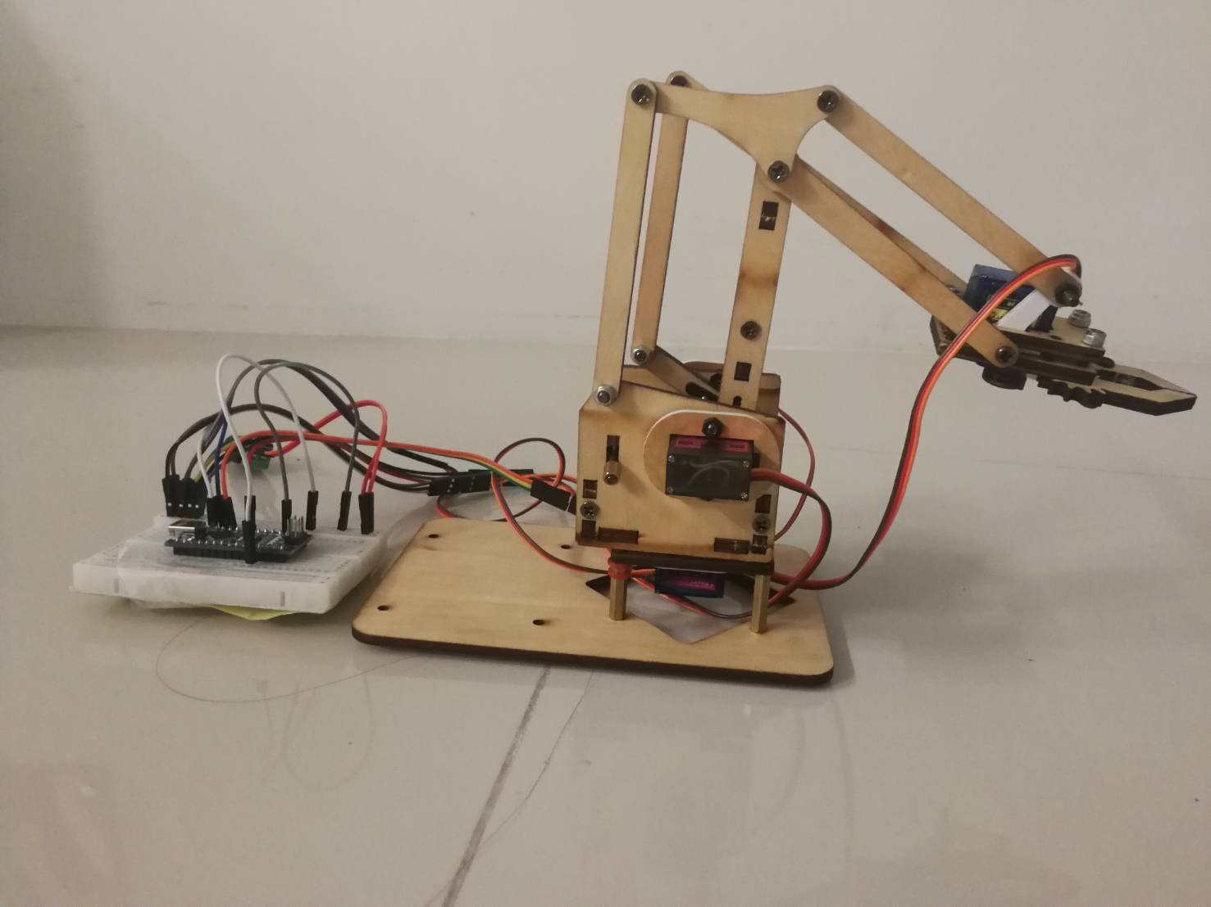

**Motor 3**

**Motor 1**

**Motor 4**

**Motor 2**

Figure 1: Position of motor 1, 2, 3, 4 on simulated incision robot.

# **Incision Process**

For Midline vertical incision from position 1 to 2 is straight line which need only 2 end position to make incision.

By random value of each motor angle until tip of pen reach position 1. After that do the same with position 2. Next, programming to control robot to move gripper with pen to create line from position 1 to 2.

Figure 2: Midline vertical incision on Caesarean section.

For Midline incision from position 1 to 2 is straight line with curve in the middle which need 5 position to make precise incision.

By random value of each motor angle until tip of pen reach position 1. After that do the same with position A, B, C and 2. Next, programming to control robot to move gripper with pen to create line from position 1 to A, A to B, B to C and C to 2.

C

B

A

Figure 3: Midline incision with markers and other basic abdominal incisions.

# **Programming Code**

Programming code for Midline vertical incision.

#include <Servo.h>

Servo servo1; // base servo motor

Servo servo2; // right side servo motor

Servo servo3; // left side servo motor

Servo servo4; // gripper servo motor

int i,j,m1,m2;

float s1=106; // angle of base servo motor for position 1

float s2=179; // angle of right side servo motor for position 1

float s3=175; // angle of left side servo motor for position 1

float l1=88; // angle of base servo motor for position 2

float l2=172; // angle of right side servo motor for position 2

float l3=165; // angle of left side servo motor for position 2

float d1=s1-l1;

float d2=s2-l2;

float d3=s2-l2;

void setup()

{

// set initial position before start

servo1.write(s1);

servo2.write(s2-20);

servo3.write(s3);

Serial.begin(9600);

servo1.attach(10);

servo2.attach(6);

servo3.attach(11);

servo4.attach(9);

// Serial.println(0);

servo4.writeMicroseconds(0); // สั่งให้ Servo หมุนวนขวา

delay(70); // หน่วงเวลา 2000ms

// Serial.println("Motor4");

// servo4.writeMicroseconds(1450); // สั่งให้ Servo หยุด

// delay(2000); // หน่วงเวลา 2000ms

// Serial.println(1000);

// servo4.writeMicroseconds(3000); // สั่งให้ Servo หมุนวนขวาซ้าย

// delay(50); // หน่วงเวลา 2000ms

// Serial.println(300);

// myservo.writeMicroseconds(1450); // สั่งให้ Servo หยุด

// delay(2000); // หน่วงเวลา 2000ms

//

// Serial.println("Motor1");

// servo1.write(89);

//

// Serial.println("Motor2");

// servo2.write(173);

//

// Serial.println("Motor3");

// servo3.write(160);

for (j=0;j<3;j++){

for (i = 20; i>0; i--){

servo2.write(s2-i);

servo3.write(s3+i);

delay(100);

}

for (i = 0; i < d1; i++) {

servo1.write(s1-i);

Serial.print("motor1 : ");

Serial.println(s1-i);

m1=d2*i/d1;

servo2.write(s2-m1);

Serial.print("motor2 : ");

Serial.println(s2+m1);

m2=d3*i/d1;

servo3.write(s3+m2);

Serial.print("motor3 : ");

Serial.println(s3+m2);

delay(100);

}

for (i = 0; i<40; i++){

servo2.write(160-i);

servo3.write(175+i);

delay(100);

}

for (i = 0; i < 23; i++) {

servo1.write(l1+i);

delay(100);

}

}

}

void loop()

{

}

Serial.begin(9600);

servo1.attach(10);

servo2.attach(6);

servo3.attach(11);

servo4.attach(9);

servo4.writeMicroseconds(0); // set gripper to grab pen tightly

delay(70);

for (j=0;j<3;j++){ // set loop to repeat 3 times

for (i = 20; i>0; i--){ // slightly move pen to position 1

servo2.write(s2-i);

servo3.write(s3+i);

delay(100);

}

for (i = 0; i < d1; i++) { // move pen from position 1 to position 2

servo1.write(s1-i);

m1=d2*i/d1;

servo2.write(s2-m1);

m2=d3*i/d1;

servo3.write(s3+m2);

delay(100);

}

for (i = 0; i<40; i++){ // slightly move pen out from position 2

servo2.write(160-i);

servo3.write(175+i);

delay(100);

}

for (i = 0; i < 23; i++) {

servo1.write(l1+i);

delay(100);

}

}

}

void loop()

{

}

for (i = 0; i < 23; i++) { // move pen to start at position 1 again

servo1.write(l1+i);

delay(100);

}

}

}

void loop()

{

}

Programming code for Midline incision.

#include <Servo.h>

Servo servo1; // base servo motor

Servo servo2; // right side servo motor

Servo servo3; // left side servo motor

Servo servo4; // gripper servo motor

int i,j,m1,m2;

float h1=90; // angle of base servo motor for position 1

float h2=145; // angle of right side servo motor for position 1

float h3=140; // angle of left side servo motor for position 1

float k1=95; // angle of base servo motor for position between 1 and middle

float k2=140; // angle of right side servo motor for position between 1 and middle

float k3=130; // angle of left side servo motor for position between and middle

float l1=123; // angle of base servo motor for position 2

float l2=153; // angle of right side servo motor for position 2

float l3=147; // angle of left side servo motor for position 2

float s1=113; // angle of base servo motor for position between 2 and middle

float s2=146; // angle of right side servo motor for position between 2 and middle

float s3=134; // angle of left side servo motor for position between 2 and middle

float n1=109; // angle of base servo motor for middle position

float n2=160; // angle of right side servo motor for middle position

float n3=147; // angle of left side servo motor for miidle position

float k1=95; //point near 1

float k2=140;

float k3=130;

float h1=90; //point 1

float h2=145;

float h3=140;

float d11=k1-h1; //1 n1

float d12=k2-h2;

float d13=k3-h3;

float d21=n1-k1; //n1 m

float d22=n2-k2;

float d23=n3-k3;

float d31=s1-n1; //m n2

float d32=s2-n2;

float d33=s3-n3;

float d41=l1-s1; //n2 2

float d42=l2-s2;

float d43=l3-s3;

float d=d11+d21+d31+d41;

void setup()

{

Serial.println("Motor1");

servo1.write(h1);

Serial.println("Motor2");

servo2.write(h2-30);

Serial.println("Motor3");

servo3.write(h3);

Serial.begin(9600);

servo1.attach(10);

servo2.attach(6);

servo3.attach(11);

servo4.attach(9);

// Serial.println(0);

servo4.writeMicroseconds(0); // สั่งให้ Servo หมุนวนขวา

delay(70); // หน่วงเวลา 2000ms

// Serial.println("Motor4");

// servo4.writeMicroseconds(1450); // สั่งให้ Servo หยุด

// delay(2000); // หน่วงเวลา 2000ms

// Serial.println(1000);

// servo4.writeMicroseconds(3000); // สั่งให้ Servo หมุนวนขวาซ้าย

// delay(50); // หน่วงเวลา 2000ms

// Serial.println(300);

// myservo.writeMicroseconds(1450); // สั่งให้ Servo หยุด

// delay(2000); // หน่วงเวลา 2000ms

//

// Serial.println("Motor1");

// servo1.write(89);

//

// Serial.println("Motor2");

// servo2.write(173);

//

// Serial.println("Motor3");

// servo3.write(160);

for (j=0;j<3;j++){

for (i = 20; i>0; i--){

servo2.write(h2-i);

servo3.write(h3+i);

delay(100);

}

for (i = 0; i < d11; i++) {

servo1.write(h1+i);

Serial.print("motor1 : ");

Serial.println(h1+i);

m1=d12*i/d11;

servo2.write(h2+m1);

Serial.print("motor2 : ");

Serial.println(h2+m1);

m2=d13*i/d11;

servo3.write(h3+m2);

Serial.print("motor3 : ");

Serial.println(h3+m2);

delay(100);

}

for (i = 0; i <= d22; i++) {

m1=d21*i/d22;

servo1.write(k1+m1);

Serial.print("motor21 : ");

Serial.println(k1+i);

servo2.write(k2+i);

Serial.print("motor22 : ");

Serial.println(k2+m1);

m2=d23*i/d22;

servo3.write(k3+m2);

Serial.print("motor23 : ");

Serial.println(k3+m2);

delay(100);

}

for (i = 0; i < d31; i++) {

servo1.write(n1+i);

Serial.print("motor1 : ");

Serial.println(n1+i);

m1=d32*i/d31;

servo2.write(n2+m1);

Serial.print("motor2 : ");

Serial.println(n2+m1);

m2=d33*i/d31;

servo3.write(n3+m2);

Serial.print("motor3 : ");

Serial.println(n3+m2);

delay(100);

}

for (i = 0; i < d41; i++) {

servo1.write(s1+i);

Serial.print("motor1 : ");

Serial.println(s1+i);

m1=d42*i/d41;

servo2.write(s2+m1);

Serial.print("motor2 : ");

Serial.println(s2+m1);

m2=d43*i/d41;

servo3.write(s3+m2);

Serial.print("motor3 : ");

Serial.println(s3+m2);

delay(100);

}

for (i = 0; i<40; i++){

servo2.write(160-i);

servo3.write(l3+i);

delay(100);

}

for (i = 0; i < d; i++) {

servo1.write(l1-i);

delay(100);

}

}

}

void loop()

{

}

float n1=109; // angle of base servo motor for middle position

float n2=160; // angle of right side servo motor for middle position

float n3=147; // angle of left side servo motor for midle position

float s1=113; // angle of base servo motor for position between 2 and middle

float s2=146; // angle of right side servo motor for position between 2 and middle

float s3=134; // angle of left side servo motor for position between 2 and middle

float l1=123; // angle of base servo motor for position 2

float l2=153; // angle of right side servo motor for position 2

float l3=147; // angle of left side servo motor for position 2

float d11=k1-h1; //1 n1

float d12=k2-h2;

float d13=k3-h3;

float d21=n1-k1; //n1 m

float d22=n2-k2;

float d23=n3-k3;

float d31=s1-n1; //m n2

float d32=s2-n2;

float d33=s3-n3;

float d41=l1-s1; //n2 2

float d42=l2-s2;

float d43=l3-s3;

float d=d11+d21+d31+d41;

void setup()

{

servo1.write(h1);

servo2.write(h2-30);

servo3.write(h3);

Serial.begin(9600);

servo1.attach(10);

servo2.attach(6);

servo3.attach(11);

servo4.attach(9);

// Serial.println(0);

servo4.writeMicroseconds(0); // สั่งให้ Servo หมุนวนขวา

delay(70); // หน่วงเวลา 2000ms

// Serial.println("Motor4");

// servo4.writeMicroseconds(1450); // สั่งให้ Servo หยุด

// delay(2000); // หน่วงเวลา 2000ms

// Serial.println(1000);

// servo4.writeMicroseconds(3000); // สั่งให้ Servo หมุนวนขวาซ้าย

// delay(50); // หน่วงเวลา 2000ms

// Serial.println(300);

// myservo.writeMicroseconds(1450); // สั่งให้ Servo หยุด

// delay(2000); // หน่วงเวลา 2000ms

//

// Serial.println("Motor1");

// servo1.write(89);

//

// Serial.println("Motor2");

// servo2.write(173);

//

// Serial.println("Motor3");

// servo3.write(160);

for (j=0;j<3;j++){

for (i = 20; i>0; i--){

servo2.write(h2-i);

servo3.write(h3+i);

delay(100);

}

for (i = 0; i < d11; i++) {

servo1.write(h1+i);

Serial.print("motor1 : ");

Serial.println(h1+i);

m1=d12*i/d11;

servo2.write(h2+m1);

Serial.print("motor2 : ");

Serial.println(h2+m1);

m2=d13*i/d11;

servo3.write(h3+m2);

Serial.print("motor3 : ");

Serial.println(h3+m2);

delay(100);

}

for (i = 0; i <= d22; i++) {

m1=d21*i/d22;

servo1.write(k1+m1);

Serial.print("motor21 : ");

Serial.println(k1+i);

servo2.write(k2+i);

Serial.print("motor22 : ");

Serial.println(k2+m1);

m2=d23*i/d22;

servo3.write(k3+m2);

Serial.print("motor23 : ");

Serial.println(k3+m2);

delay(100);

}

for (i = 0; i < d31; i++) {

servo1.write(n1+i);

Serial.print("motor1 : ");

Serial.println(n1+i);

m1=d32*i/d31;

servo2.write(n2+m1);

Serial.print("motor2 : ");

Serial.println(n2+m1);

m2=d33*i/d31;

servo3.write(n3+m2);

Serial.print("motor3 : ");

Serial.println(n3+m2);

delay(100);

}

for (i = 0; i < d41; i++) {

servo1.write(s1+i);

Serial.print("motor1 : ");

Serial.println(s1+i);

m1=d42*i/d41;

servo2.write(s2+m1);

Serial.print("motor2 : ");

Serial.println(s2+m1);

m2=d43*i/d41;

servo3.write(s3+m2);

Serial.print("motor3 : ");

Serial.println(s3+m2);

delay(100);

}

for (i = 0; i<40; i++){

servo2.write(160-i);

servo3.write(l3+i);

delay(100);

}

for (i = 0; i < d; i++) {

servo1.write(l1-i);

delay(100);

}

}

}

void loop()

{

}

Serial.begin(9600);

servo1.attach(10);

servo2.attach(6);

servo3.attach(11);

servo4.attach(9);

servo4.writeMicroseconds(0); // สั่งให้ Servo หมุนวนขวา

delay(70); // หน่วงเวลา 2000ms

for (j=0;j<3;j++){

for (i = 20; i>0; i--){ // slightly move pen to position 1

servo2.write(h2-i);

servo3.write(h3+i);

delay(100);

}

for (i = 0; i < d11; i++) { // move pen from position 1 to position 1 middle

servo1.write(h1+i);

m1=d12*i/d11;

servo2.write(h2+m1);

m2=d13*i/d11;

servo3.write(h3+m2);

delay(100);

}

for (i = 0; i <= d22; i++) { // move pen from position 1 middle to position middle

m1=d21*i/d22;

servo1.write(k1+m1);

servo2.write(k2+i);

m2=d23*i/d22;

servo3.write(k3+m2);

delay(100);

}

for (i = 0; i < d31; i++) {

servo1.write(n1+i);

Serial.print("motor1 : ");

Serial.println(n1+i);

m1=d32*i/d31;

servo2.write(n2+m1);

Serial.print("motor2 : ");

Serial.println(n2+m1);

m2=d33*i/d31;

servo3.write(n3+m2);

Serial.print("motor3 : ");

Serial.println(n3+m2);

delay(100);

}

for (i = 0; i < d41; i++) {

servo1.write(s1+i);

Serial.print("motor1 : ");

Serial.println(s1+i);

m1=d42*i/d41;

servo2.write(s2+m1);

Serial.print("motor2 : ");

Serial.println(s2+m1);

m2=d43*i/d41;

servo3.write(s3+m2);

Serial.print("motor3 : ");

Serial.println(s3+m2);

delay(100);

}

for (i = 0; i<40; i++){

servo2.write(160-i);

servo3.write(l3+i);

delay(100);

}

for (i = 0; i < d; i++) {

servo1.write(l1-i);

delay(100);

}

}

}

void loop()

{

}

for (i = 0; i < d31; i++) { // move pen from position middle to position 2 middle

servo1.write(n1+i);

m1=d32*i/d31;

servo2.write(n2+m1);

m2=d33*i/d31;

servo3.write(n3+m2);

delay(100);

}

for (i = 0; i < d41; i++) { // move pen from position 2 middle to position 2

servo1.write(s1+i);

m1=d42*i/d41;

servo2.write(s2+m1);

m2=d43*i/d41;

servo3.write(s3+m2);

delay(100);

}

for (i = 0; i<40; i++){ // slightly move pen out from position 2

servo2.write(160-i);

servo3.write(l3+i);

delay(100);

}

for (i = 0; i < d; i++) { // move pen to start at position 1 again

servo1.write(l1-i);

delay(100);

}

}

}

void loop()

{

}

# **Incision Result**

The simulated midline vertical incision was repeat 3 times. From Figure 4, the result line is strong, accurate at both end and high precision, repeat 3 times are almost the same line. However, the line contains spotted near position 1, and slightly curve in the middle.

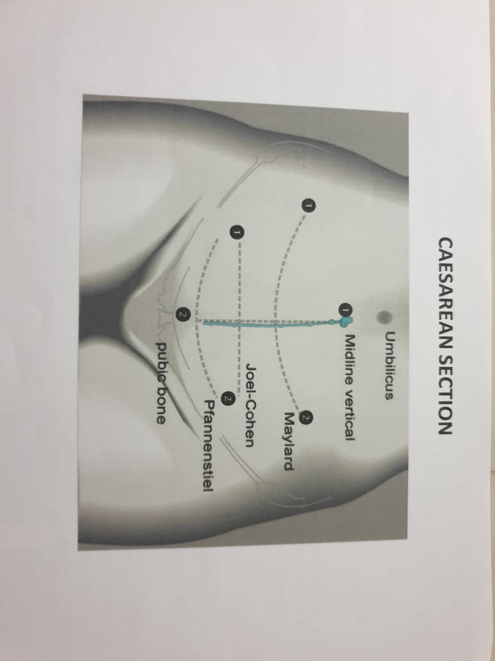

Figure 4: Midline vertical incision result.

The simulated midline incision was repeat 3 times. From Figure 5, the result line is similar to actual Midline incision. Even so, line contains spotted near position 1 and 2, fade, distorted between position 1 and middle position, and have difference among repeated line.

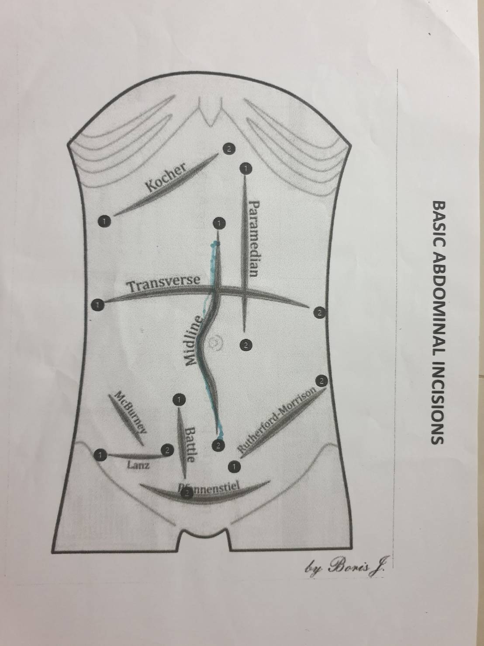

Figure 5: Midline incision result.

# **Discussion and Future Development**

This simulated incision robot has small size, not sufficient degree of freedom, not precise motors, only integer degree and cannot be floating point, and too large wooden rods hole. All reason causes robot cannot move to make accurate incision, can reach only incision in A4 paper which is not far enough, cannot make soothing line and always shake from motor.

All problem needs to adjust and improve, to develop this simulated incision robot to become practical incision robot. By increasing motors and joints number, to rise number of position that robot can reach. Next, change motor type from servo motor to high quality DC or AC motor, to help robot move more precise and accurate. And change wooden rods to precise hole plastic plates which do not affect from humidity and fit size with other parts.