I have created three heuristic functions. I noticed when I was playing the game I always sought to be in the middle of the board as possible. I avoided the edges. This is because since there are no wraparounds at the edges, I felt myself to have fewer choices there. So at the end of the search I try to prioritize square that are away from the edges. I also take into account the legal_moves left for both myself and my opponent as well. All three of my heuristic functions are based on this concept but measure it differently.

The first function is within_radius, it basically calculates the distance using how far the player square is from the center. If it is one of the adjacent squares to the midpoint then it has level one, if it is on the outer square it has level 2, and so on. Here is a visualization of it:
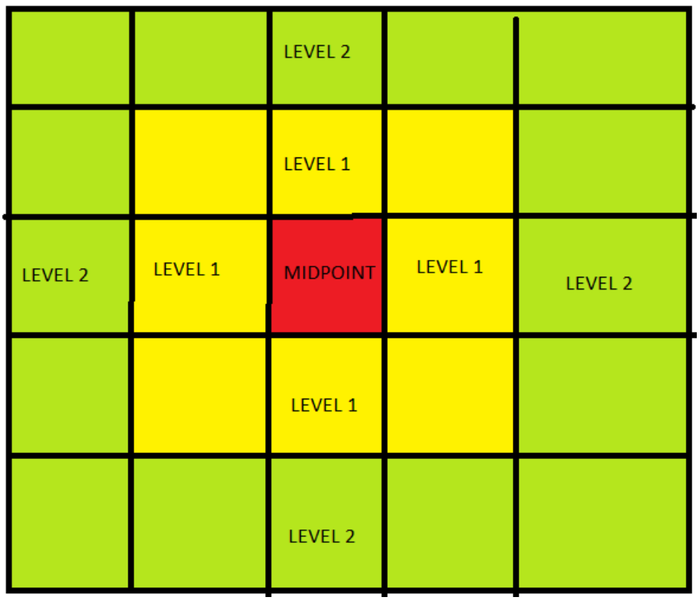

Again we are aiming for as close to the center as possible. To do this we use the following function:

return float(own_moves - opp_moves) + float(1/level)

The next function is own_distance_from_mid, it uses the Distance formula which is derived from the Pythagorean formula to calculate the distance from the mid square.

The last function is the diff_distance_from_mid, it uses the difference between the player position to mid and the opponent position to mid, it again uses the Distance formula to calculate the distance

Below are the performance of the three functions using tournament.py:

within_radius:

*************************
Evaluating: ID_Improved
*************************

Playing Matches:
----------
Match 1: ID_Improved vs Random Result: 19 to 1
Match 2: ID_Improved vs MM_Null Result: 18 to 2
Match 3: ID_Improved vs MM_Open Result: 18 to 2
Match 4: ID_Improved vs MM_Improved Result: 14 to 6
Match 5: ID_Improved vs AB_Null Result: 13 to 7
Match 6: ID_Improved vs AB_Open Result: 12 to 8
Match 7: ID_Improved vs AB_Improved Result: 11 to 9

Results:
----------
ID_Improved 75.00%

*************************
Evaluating: Student
*************************

Playing Matches:
----------
Match 1: Student vs Random Result: 19 to 1
Match 2: Student vs MM_Null Result: 19 to 1
Match 3: Student vs MM_Open Result: 13 to 7
Match 4: Student vs MM_Improved Result: 13 to 7
Match 5: Student vs AB_Null Result: 16 to 4
Match 6: Student vs AB_Open Result: 16 to 4
Match 7: Student vs AB_Improved Result: 12 to 8

Results:
----------
Student 77.14%

own_distance_from_mid:

*************************
Evaluating: ID_Improved
*************************

Playing Matches:
----------
Match 1: ID_Improved vs Random Result: 19 to 1
Match 2: ID_Improved vs MM_Null Result: 17 to 3
Match 3: ID_Improved vs MM_Open Result: 13 to 7
Match 4: ID_Improved vs MM_Improved Result: 14 to 6
Match 5: ID_Improved vs AB_Null Result: 17 to 3
Match 6: ID_Improved vs AB_Open Result: 10 to 10
Match 7: ID_Improved vs AB_Improved Result: 11 to 9

Results:
----------
ID_Improved 72.14%

*************************
Evaluating: Student
*************************

Playing Matches:
----------
Match 1: Student vs Random Result: 20 to 0
Match 2: Student vs MM_Null Result: 18 to 2
Match 3: Student vs MM_Open Result: 14 to 6
Match 4: Student vs MM_Improved Result: 14 to 6
Match 5: Student vs AB_Null Result: 16 to 4
Match 6: Student vs AB_Open Result: 13 to 7
Match 7: Student vs AB_Improved Result: 13 to 7

Results:
----------
Student 77.14%

diff_distance_from_mid:

*************************
Evaluating: ID_Improved
*************************

Playing Matches:
----------
Match 1: ID_Improved vs Random Result: 19 to 1
Match 2: ID_Improved vs MM_Null Result: 19 to 1
Match 3: ID_Improved vs MM_Open Result: 14 to 6
Match 4: ID_Improved vs MM_Improved Result: 12 to 8
Match 5: ID_Improved vs AB_Null Result: 15 to 5
Match 6: ID_Improved vs AB_Open Result: 14 to 6
Match 7: ID_Improved vs AB_Improved Result: 14 to 6

Results:
----------
ID_Improved 76.43%

*************************
Evaluating: Student
*************************

Playing Matches:
----------
Match 1: Student vs Random Result: 20 to 0
Match 2: Student vs MM_Null Result: 20 to 0
Match 3: Student vs MM_Open Result: 14 to 6
Match 4: Student vs MM_Improved Result: 12 to 8
Match 5: Student vs AB_Null Result: 14 to 6
Match 6: Student vs AB_Open Result: 15 to 5
Match 7: Student vs AB_Improved Result: 16 to 4

Results:
----------
Student 79.29%

I decided to use the third function i.e. the diff_distance_from_mid, this is because it takes into account both our own and our opponents distance from the mid as well as the legal moves available to each. This way we can optimize the heuristics so that the player is near the midpoint while the opponent is near the edge along with the opponent having lesser legal moves then the player. This allows for generally a better heuristics function as shown in the performance above.

