STRAMGT 202
Strategic Leadership — Study Guide

1. Value Creation & Value Capture
Core Definitions
Value Creation: "Making the pie bigger." The total surplus generated in a transaction, calculated as the gap between the Buyer's Willingness to Pay (WTP) and the Supplier's Opportunity Cost (OC). A collaborative effort to generate benefit.
Value Capture: "Claiming your slice." Making money from the value created by overcoming external obstacles — competition (rivalry) and vertical power (bargaining) — to retain a greater share of surplus as profit.
Key distinction: Value creation and value capture are NOT the same thing. Value creation is about the size of the pie (WTP minus OC). Value capture is about who gets the slice. Price changes, competitive dynamics, and bargaining all affect value capture — not value creation.
Cost-Quality Frontier
The frontier is defined by firms with the best tradeoffs between cost and quality. Being on the frontier is table stakes — firms inside it face a real competitive disadvantage.
- Firms at the frontier have a Value Creation Advantage over those not on the frontier
- Two approaches: raise perceived quality (drives up WTP) or reduce cost (lowers Supplier OC)
- More expensive does NOT necessarily mean more value captured. Lowest OC does NOT mean more value captured — both are about creation, not capture
- When a new entrant joins at the same PQ/LC position as an incumbent (e.g. 'Louisy Lisa' vs 'Shady Sandy'), the two go head-to-head and price competition begins

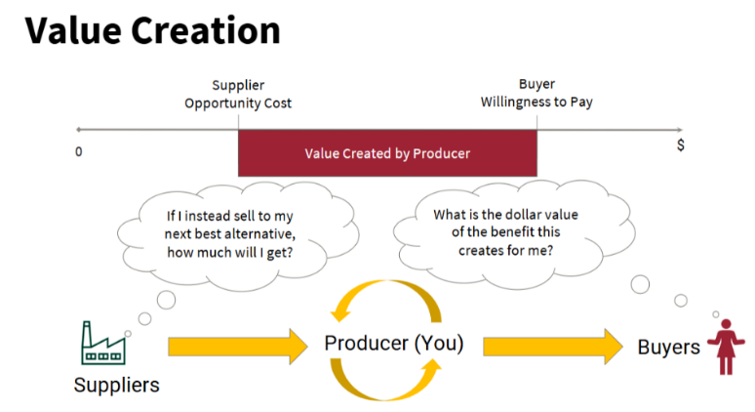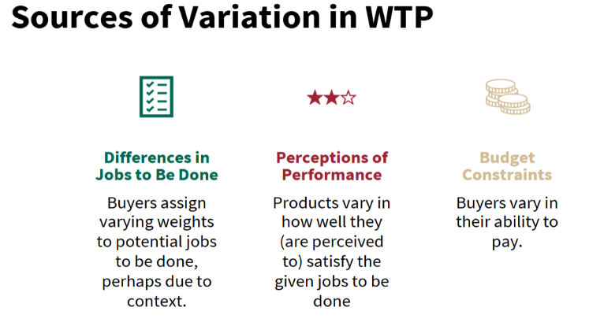
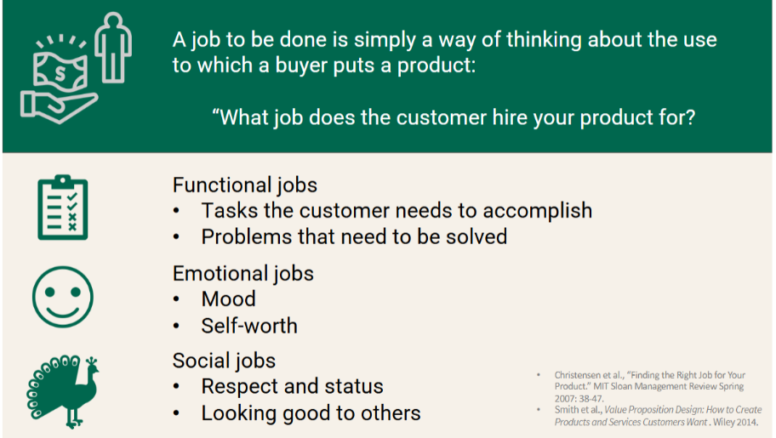
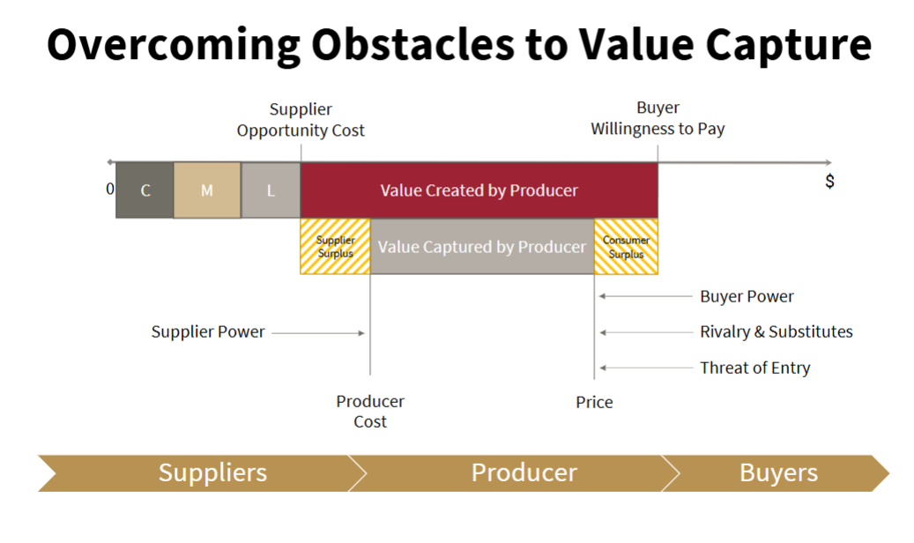

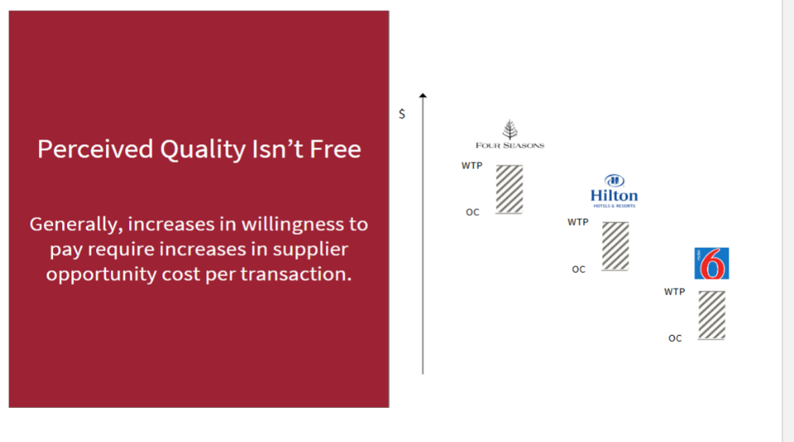

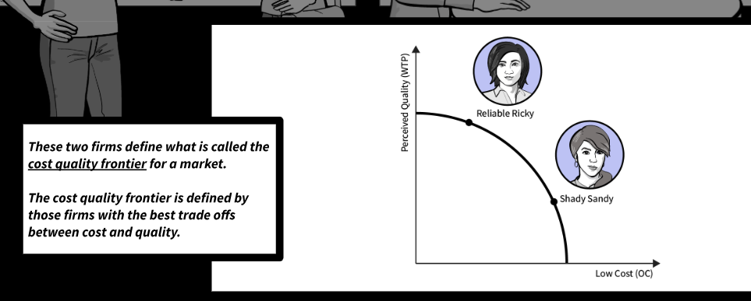

2. Porter's Five Forces
Michael Porter: profitability of an industry is determined by five sources of competitive pressure. Three horizontal (substitutes, entrants, rivals) + two vertical (buyer power, supplier power).

Horizontal Forces (3)
Substitutes
Price that customers are willing to pay is dictated by how available substitutes are.
- Low substitutability → consumers are insensitive to price (e.g. gasoline, cigarettes — few options to replace them)
- High substitutability → consumers will switch based on price (close substitutes)
First step in analyzing market-level obstacles to capturing value: identify the products and services that could be used for the same purpose — substitutes that satisfy the same drivers of WTP.
Rivalry and Substitutes — Extended
Buyers seek to maximize their consumer surplus: the delta between WTP and the actual price paid. Buyers push price down away from their WTP; producers push price up toward WTP.
This struggle manifests in two ways:
- 1 — Market structure / comparison shopping: Buyers access alternatives who satisfy the same drivers of WTP. e.g. People do not walk into Walmart and haggle over the price of detergent. They seek out the store that has the lowest price.
- 2 — Bargaining power (covered separately below)
Firms in the same industry do not necessarily compete with each other in a meaningful way. Example: Osteria Francescana vs. a local trattoria — same production mechanisms but different use cases; they do not compete. Competition is also not exclusive to the same industry: Netflix competes with Fortnite, even though offerings are entirely different.
Obstacles to capturing value increase when a buyer can accomplish the job-to-be-done with other products or services — including those made using fundamentally different production technologies. Buyers are often indifferent to how a product was made.
Every firm has a distinct set of rivals, depending on which customers they choose to target and what drivers of WTP their products satisfy. Level of competition depends on the extent to which offerings satisfy the same drivers of WTP to the same customers.
Niche Overlap Approach: Companies compete more based on how much their niches overlap. Do not compare 'rideshare in general' — compare the job people need accomplished and the different ways to get it done.
Threat of Entry
An industry with no barriers to entry is contestable — threat of entry drives prices/profits toward competitive levels regardless of number of firms. The size of the new entrant's disadvantage = height of barrier to entry.
Principal sources of barriers to entry:
- Capital requirements
- Economies of scale
- Absolute cost advantages (e.g. ownership of low-cost raw material sources)
- Product differentiation
- Access to channels of distribution
- Governmental and legal barriers
- Fear of retaliation by incumbents
Rivalry Between Established Competitors
- Seller concentration — number and size of competitors. Concentration ratio = combined market share of leading producers (e.g. top 4 soda companies, top 2 airline manufacturers)
- Diversity of competitors — ability to avoid price competition depends on differentiation in origins, objectives, costs, strategies, target customers, geographies
- Product differentiation — the more similar the product, the higher the price competition
- Excess capacity and exit barriers — unused capacity encourages price cuts. Excess capacity can be cyclical (seasonal, boom-bust) or structural (declining industry, overinvestment). Barriers to exit trap suppliers in market and make entry less appealing.

Vertical Forces (2) — Bargaining Power
Power is the inverse of dependence — the more dependent you are on an actor, the more power that actor can exercise over you.
Supplier Power Increases When:
- Small number of potential suppliers of a necessary input, able to act as one
- A supplier's input is critical to the producer's product
- A supplier can credibly threaten to forward integrate at lower cost
- It is costly for the producer to switch between suppliers (sunk investments, supplier-specific components)
- Supplier can ascertain the producer's true WTP and a secondary market for the good does not exist
- Suppliers of commodities tend to lack bargaining power relative to customers
Buyer Power Increases When:
- Small number of buyers for the producer's output, able to act as one
- A buyer purchases a large share of the producer's output
- A buyer can credibly threaten to backward integrate at lower cost
- A buyer can easily switch between producers or do without the product
- The input is a large proportion of the buyer's total cost
- Monopolies reduce buyer power — no choice means no leverage
- Increased price transparency increases buyer price sensitivity
Managing Power & Dependence
Minimize their power: Develop alternative exchange partners (pathways); change production process to use substitute inputs; cultivate new buyers and spread sales evenly; business model innovations that avoid powerful value chain segments; vertical integration.
Increase your power: Create switching costs for buyers; achieve scale to account for a nontrivial share of supplier volume; consolidate to become one of few exchange partners.

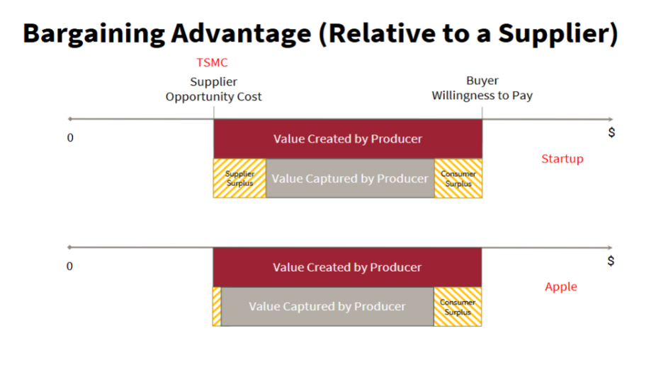
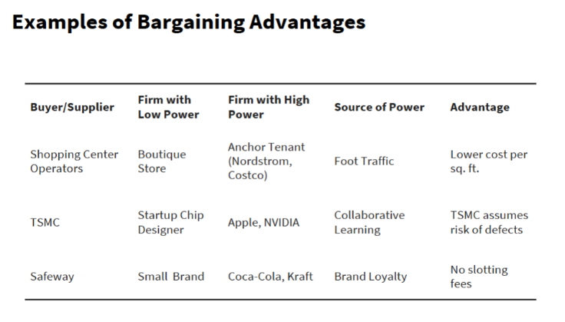

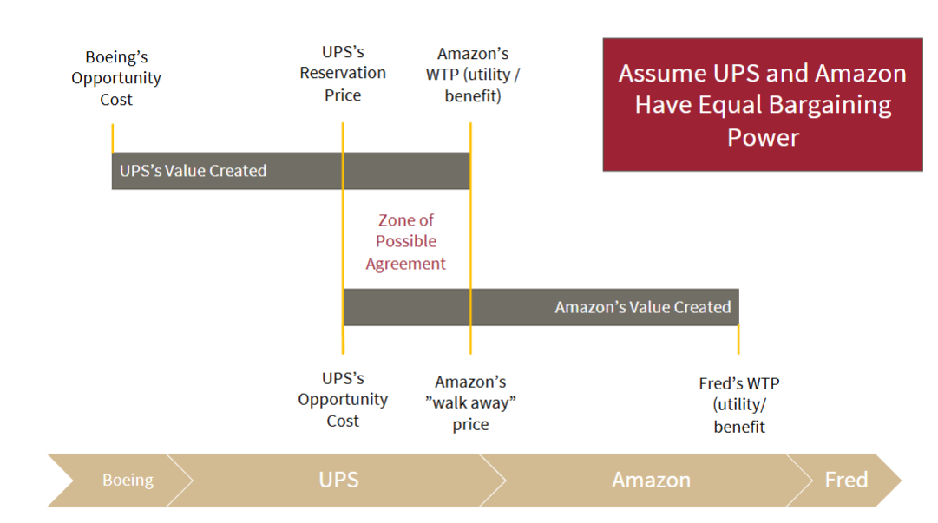

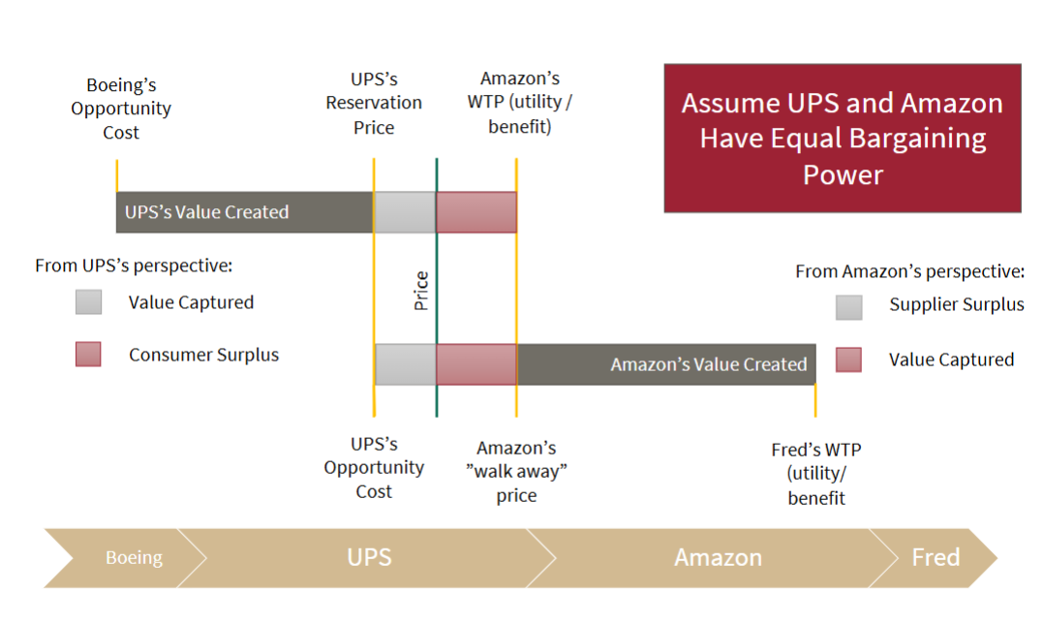

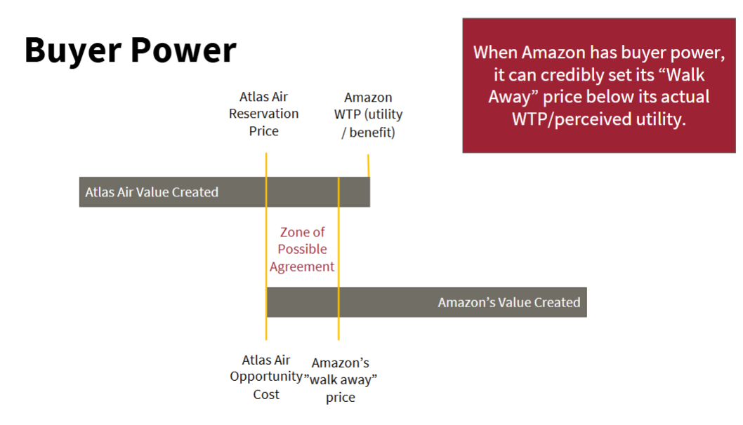

3. Positioning Advantages & Moats
Positioning Advantage — Core Concept
Downward price pressure increases when two or more firms offer the same value propositions to the same customers — i.e. they try to satisfy the same drivers of WTP for the same buyers. The greater the overlap in positioning, the more likely buyers capture value through price competition.
Firms create a value capture advantage by reducing market overlap. A positioning advantage exploits differences in the distribution of customer tastes or geographic distribution of consumers to secure a market niche where competition is reduced.
Positioning advantage allows a firm to capture more value in each transaction without necessarily creating more value. The advantage comes not from explicit negotiation power or actual value created, but from a reduction in price competition — allowing the firm to price closer to buyers' WTP.
Two Ways to Achieve Positioning Advantage
1. Product differentiation: Products of different firms are seen as imperfect substitutes. Depends on the existence of relatively stable differences in consumer preferences. Accomplished via (a) actual differences in the product or (b) perceived differences through marketing and storytelling. Example: AbInBev can brew a taste similar to microbreweries, but customers perceive it as inauthentic — an imperfect substitute for craft beer.
2. Geographic/demographic differentiation: Differentiate on the populations being targeted rather than the product. Example: Walmart started in rural towns; Target focused on rapidly growing suburbs. Both discount retailers had high WTP overlap on products, but differentiated on the populations they served.
Moats — Barriers Protecting a Niche
Market differentiation only creates sustainable advantage if there is a moat protecting the firm's position. High returns attract new entrants; without barriers, price competition increases and the advantage is eroded.
- Economies of Scale / MES: Minimum Efficient Scale = point where costs no longer fall with increased volume. When MES is high relative to market size (MES/market → 1), entry is economically unviable. Example: explains why small cities have only one bike-share provider; larger cities can support multiple.
- Learning Economies: Cost reductions from cumulative production experience. Example: semiconductor manufacturing — firms see production yields increase as they work out kinks. Rivals must accumulate equivalent experience to replicate.
- Product Differentiation: Strong brand loyalty forces entrants to spend heavily on marketing to overcome existing loyalties. Entry requires overcoming both the product gap and the perception gap.
- Network Effects: Entrant without installed base faces a serious value creation disadvantage (detailed in Section 5).
- Government / Patents / Regulation: Legal barriers to entry.
- Fear of Retaliation: Credible threat of incumbent competitive response deters entry.

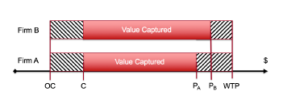

4. The Five Value Creation Advantage Mechanisms

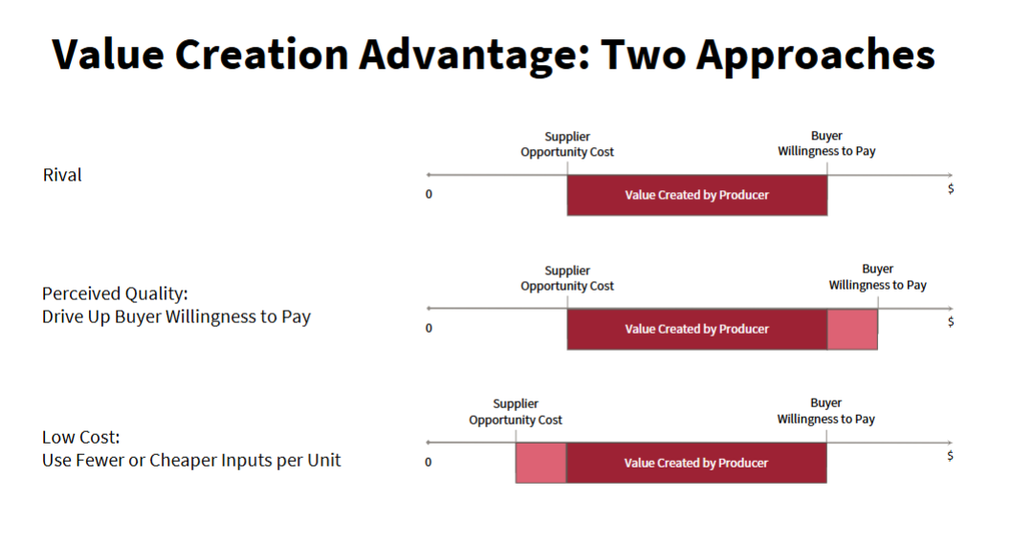

Exam approach: For any firm, run through ALL five mechanisms. For each: (1) does it apply? and (2) does it actually create a value creation advantage, and why/why not? Be specific to the vignette.

1. Economies of Scale
High fixed costs + near-zero variable costs = lower average cost at scale. The firm with a scale advantage will have the lowest average costs, everything else equal.
- Relevant when: significant fixed cost investments (servers, equipment, R&D, brand, docking stations)
- Key question: where is the firm relative to MES? Is a rival above or below MES?
- If MES/market approaches 1, the incumbent at MES faces no viable entry threat — the entrant's cost disadvantage makes it uneconomical to enter

2. Network Effects
See Section 5 for full treatment. Key point for VCA analysis: network benefits account for large portions of WTP, so an entrant without an installed base faces a serious value creation disadvantage. This is the most compelling source of positioning advantage from network effects.

3. Distinctive Capabilities
Sometimes firms create value because they possess distinct organizational capabilities — they figure out how to do something other firms cannot do as well. Examples: more innovative processes, more efficient distribution systems, consistently better customer service.
Such capabilities can be a sustainable basis of value creation advantages — provided they are carefully nurtured and maintained by firm leaders.
Capability advantages = value creation advantages. A firm with superior capabilities can deliver the same quality at lower cost, or higher quality at the same cost — directly expanding the WTP-OC gap. But these are creation advantages, not capture advantages: they expand the pie before determining who gets the slice.
- Typically arises through learning from experience (learning economies) and/or distinctive organizational design (PARC model)
- Distinct from resource advantages (brand, patents, installed base) — having a resource doesn't mean you can exploit it effectively
- Durability depends on rivals' inability to imitate or replicate — but firms often don't know exactly what in their org design generates the advantage and may inadvertently undermine it
- Success requires: (1) identifying your 'special sauce' and (2) knowing how to scale it productively
Key exam point: Capability advantages can degrade when (a) a rival gains equivalent experience/learning, or (b) the leading firm changes the PARC elements that created the advantage without realizing it.

4. Unique Resources
Assets the firm controls that others don't: brand reputation, patents, data, installed user base. Distinct from capabilities — having a resource doesn't guarantee you can exploit it effectively.
- Brand: assurance value for new buyers; deters entry by forcing entrants to spend heavily on recognition
- Data: targeting advantage for advertisers (e.g. Spotify user data for Streaming Ad Insertion)
- Installed base: foundation for network effects and switching cost creation

5. Economies of Scope
Value spillovers from running two businesses under one umbrella. Test: Profit(A+B) > Profit(A) + Profit(B). Spillovers can flow in both directions — always evaluate both.
Positive spillovers: Shared infrastructure lowers costs; shared brand raises WTP across product lines (Disney characters → films + theme parks); shared data/capabilities; lower customer acquisition cost by converting existing users; scale/bargaining advantages (Amazon distribution network creates barrier to entry).
Negative spillovers: Identity confusion for external constituencies (buyers, analysts) — e.g. Stanford GSB + Veterinary Medicine would change how you perceive the school. Distraction from core strategic challenges (Scoot/Singapore Airlines). Organizational constraints from having to serve two different markets simultaneously.
Coordination: Different business units benefit from shared activities across BUs that either lower costs or increase willingness to pay (value creation). To realize these benefits, BUs will have to coordinate. Elements of organizational design — people, culture, structure, incentives — are the main levers. However, internal structure must also remain congruent with how each market expects to be served and the strategic imperatives of that market.
Exam trap: Always address scope spillovers in BOTH directions. The exam rewards students who identify negative spillovers and distraction costs, not just positive ones.

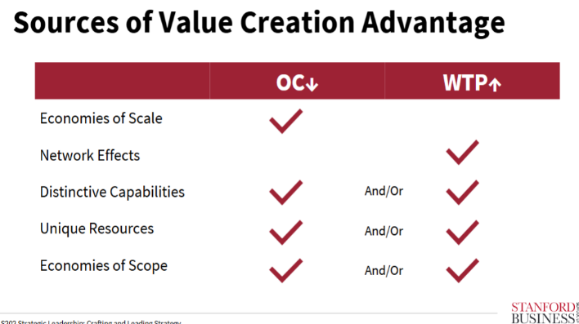

5. Network Effects
Core Concept
Demand for products and services is self-reinforcing: every new user makes the product more valuable to every other user. Each addition further increases appeal to other users.
Because appeal of the product increases with users, WTP increases non-linearly with number of users — this is called demand-side increasing returns. Over time, the value of the average transaction grows.
Examples where network effects have defined enterprise success: communication channels (WhatsApp, WeChat), marketplace business models (Etsy, The RealReal), technology platforms (Microsoft, Apple).
Utility Split: Intrinsic Benefit vs. Network Benefit
Intrinsic Benefit: Benefit derived from the features and functionality of the product alone — independent of whether other people use it. Example: a blood pressure machine. More people using the same blood pressure machine does not make it better. The product's value is standalone.
Network Benefit: Utility derived from other people's use of the product, either directly or indirectly. In cases of network effects, buyers base WTP on two things: (1) size of the actual or projected installed base of users (e.g. choose messaging app based on who else is on it), and (2) size of actual or projected availability of complementary products (e.g. choose mobile OS based on app availability).
Many organizations occupy the middle ground — both intrinsic benefits and network effects contribute to the value proposition.
Viral Growth ≠ Network Effect
Viral growth exists when existing customers influence others to become new customers, rather than the firm persuading new customers to join. Virality = Contagiousness + Susceptibility of influence.
Example distinction: Poppi (beverage brand) vs. TikTok. Poppi went viral on social media — awareness spread person-to-person. But more people buying Poppi does not make Poppi more valuable to each buyer. TikTok: more users means more content, more creators, more time-on-platform — each new user genuinely increases value for others.
Drivers of viral growth: Increased Awareness (word of mouth), Social Proof (reduces purchase uncertainty), Actual network benefits.
Test for viral growth vs. network effect: Could the same awareness be generated through paid advertising? If yes — it is viral growth, not a network effect. Viral growth can drive customer acquisition but does not create the same durable moat as true network effects.
Types of Network Effects
Direct Network Effects: Functionality/utility of the item itself increases with number of users — often because there is value in connecting users with each other. Two types: (a) different roles — two-sided marketplace like The RealReal (buyers & sellers); (b) same role — photo sharing app where value comes from connecting friends.
Indirect Network Effects: Appeal of the product increases with the availability of complementary products. Example: video game console — value increases as more games (Sony, third-party developers) are available. Must pay special attention to (1) incentives for producers of complementary goods and (2) maintaining quality of those complementary goods.
Three Advantages Firms with Network Effects Enjoy
- Value creation advantages — economies of scale with user base scale; higher WTP as user base grows
- Bargaining advantages — derived from scale. Example: Apple and Google charging 30% fees for apps on app store
- Positioning advantage (most compelling) — because network benefits account for a large portion of WTP, an entrant without an installed base faces a serious value creation disadvantage. Strong barriers to entry.
Network effects create value capture advantages primarily through positioning — not through direct bargaining. The installed base raises WTP for existing users while simultaneously raising the cost of entry for rivals. This is a value creation advantage (higher WTP) that translates into a value capture advantage (barriers to entry reduce price competition).
What Weakens Network Effect Moats
- Demographic churn or turnover — user base turns over, creating 'uncommitted' users an entrant can attract. Example: dating apps — most users leave once they find a long-term partner, replaced by new users with no existing platform loyalty.
- Low switching costs / multi-homing — users can use multiple platforms simultaneously with low friction. Nothing (except signup hassle) prevents someone from using multiple apps at once.
- Intrinsic benefits dominate — when a platform serves a niche with specific needs (religion, ethnicity, LGBTQ+), users care more about concentration of relevant people than total installed base. Reduces network value, increases role of intrinsic benefits.
- Lack of engagement — users present but not active; network value is not realized
Cold Start / Getting to Scale
- Lean on intrinsic benefits first to attract initial users; allow network effects to help scale later
- Marketing to build perception of scale (even projected scale matters for WTP)
- Low pricing where business model permits to attract initial customer base
- For community-based products, focus acquisition on users who most unlock network benefits
- Focus on pre-existing communities with unmet needs (Facebook at Harvard, Tinder at USC)
- Due to positive feedback, markets with strong NE are prone to 'tipping' — quick shift to market dominance if one player gets a small lead
Chicken and Egg / Cold Start: When users occupy different roles (e.g. RealReal: buyers & sellers), balance of parties is critical. Often solved by subsidizing one side of the market — limiting value capture from them in order to capture value from the other side. Example: OpenTable subsidized restaurants to build supply, enabling demand-side growth.

6. Diversification & Corporate Strategy
The Role of Headquarters — HQ Involvement Continuum
Corporate strategy requires choosing a leadership approach somewhere between two extreme models:
Financial Control (low HQ involvement): Business units have high autonomy — they devise strategy with little consideration of other units. Resource allocation is the chief means of corporate management. Loss prevention is the main function of HQ. Example: classic conglomerate (Berkshire Hathaway).
Strategic Planning (high HQ involvement): Low business unit autonomy — strategy is devised together with HQ. Corporate strategy is managed through organizational design. HQ oversees loss prevention AND generation of positive spillovers. Example: Clorox.
In the middle sits Strategic Control — example: Disney under Iger.
The right position on the continuum depends on whether positive spillovers across BUs are large enough to justify the coordination costs and the HQ capabilities required to manage them.
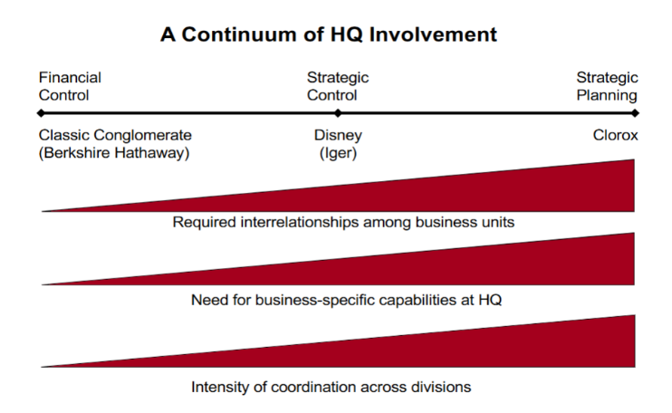
Core Test of whether Diversification Good Idea
Diversification is only justified if: Profit(A+B) > Profit(A) + Profit(B). Good when it allows firms to create and/or capture more value together than separately.
Sources of Value Spillovers
- Shared infrastructure and fixed costs → lower unit costs for both BUs
- Brand spillovers → raise WTP across product lines (Disney animated characters increase WTP for films AND theme parks)
- Shared capabilities → joint ownership enables specialization rivals can't match. Example: Kaiser-Permanente — clinics + insurance share knowledge, enabling better risk pricing and lower costs to customers
- Lower customer acquisition cost → convert existing customers from one BU to another
- Scale / bargaining advantages → Example: Amazon spreads fixed cost investments in distribution centers across a wide range of products, creating a barrier to entry for other online retailers
Two Levers to Increase Spillovers
Investment: Financial capital — smarter capital allocation across BUs. Human capital — deployment of workers with superior skills.
Coordination: Different BUs benefit from shared activities that either lower costs or increase WTP (value creation). To realize benefits, BUs must coordinate. Elements of organizational design — people, culture, structure, incentives — are the main levers. Internal structure must remain congruent with how each market expects to be served.
Benefits of Relatedness
The more related two businesses are, the better the firm can realize the benefits of diversification:
Internal processes: When making investment decisions, a corporate manager can execute better than the external market if she has superior information about both businesses — and that comes from shared understanding of the two sub-industries. Relatedness drives this informational advantage.
External perceptions: Diversification can create challenges in how a firm is perceived by external constituencies — buyers, investment analysts, partners. Organizational identity is an important frame of reference. Example: Stanford GSB and a Veterinary Medicine school would change how you perceive the institution — the combination is perceived with confusion, and identity directly affects assessment of competence and quality.
Problem arises when: (1) the combination is perceived with confusion, or (2) the organization's identity directly affects assessments of competence or quality.
When Diversification Destroys Value
- Acquisition bidding wars → buyer likely overpays
- CEO empire-building → diversification satisfies desire to operate a larger company, not shareholder value
- Information asymmetry → like buying a house, you do not know the problems until you own it
- Identity confusion for external constituencies
- Distraction from core strategic challenges (Scoot/Singapore Airlines — entering a new segment does not address the fundamental challenges of the core business)

7. Capabilities & Organizational Design
What Organizational Capabilities Are
Sometimes firms create value because they possess distinct organizational capabilities — they figure out how to do something other firms cannot do as well. Examples: more innovative processes, more efficient distribution systems, consistently better customer service.
Such capabilities can be a sustainable basis of value creation advantages — provided they are carefully nurtured and maintained by firm leaders.
Capability advantages = value creation advantages. A firm with superior capabilities can deliver the same quality at lower cost, or higher quality at the same cost — directly expanding the WTP-OC gap. This is about creating more value (bigger pie), not just capturing more of an existing pie. However, the value creation advantage can translate into a value capture advantage if competitors cannot replicate the capability.
Distinct from resource advantages (advantages from assets controlled by the firm — brand reputation, patents, installed user base). Having a resource doesn't mean you can exploit it effectively.
PARC Model
Capability-based advantages live inside the PARC model — in the alignment of its elements with each other and with the firm's Critical Tasks. Organizations coordinate and motivate people's activity through authority (vs. markets, which do so through voluntary contract).
- P — People
- A — Architecture
- R — Routines
- C — Culture
- Critical Tasks — the final element: what the organization must accomplish to succeed and deliver on its competitive advantage
As you move from People → Architecture → Routines → Culture, ease of change decreases and impact of change increases. Culture is the hardest element to change but has the highest impact when changed. People are the easiest to change but have the lowest individual impact.
Organizational alignment requires two things: (1) the elements of org design (PARC) must be consistent with each other internally, and (2) the elements must be aligned with the firm's strategy through their alignment with Critical Tasks. If different components conflict, the performance of the system as a whole will suffer.
PARC and Competitive Advantage
Capability-based advantages exist within the PARC model — in the alignment of elements with each other and with Critical Tasks. Firms may have competitive advantage simply because they have more internal alignment on PARC than rivals.
When firms continue to have organizational problems, the root cause almost always traces to some level of misalignment in PARC. Firms with capability advantages often don't know exactly which PARC element generates the advantage — and may inadvertently undermine it by changing elements without understanding the consequences.

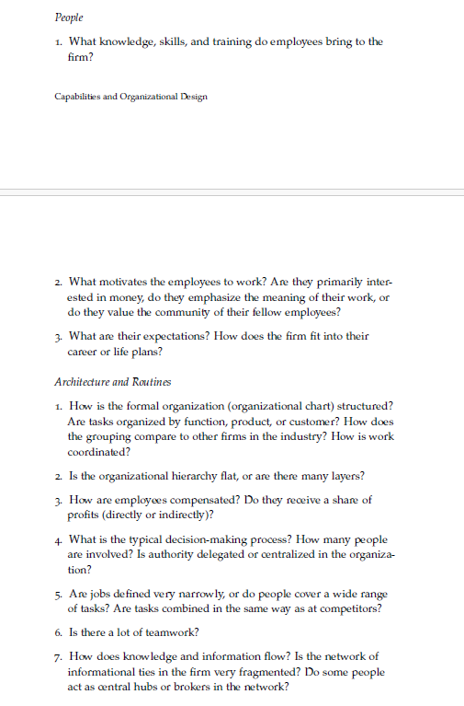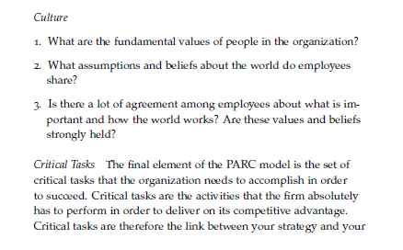

8. Exploration vs. Exploitation
Definitions
The capacity for innovation is rooted in the design of your organization.
Exploitation: Learning geared toward improving upon the things you already know how to do — getting more out of your existing knowledge base. Best when the environment is stable and existing knowledge will remain valuable. The key to winning is continuous improvement.
Exploration: Learning that results in discovering new things to do — moving away from existing knowledge into uncharted territory. Best when key success factors in your industry may change substantially, or when you need a hedge against disruptive innovation. Example: Google's Android was a hedge against future changes in how consumers access the Internet (desktop vs. mobile).
The Exploration vs. Exploitation Tension
- Orgs optimized for exploitation (improving existing strengths) struggle to embrace ideas that deviate from current practice — the PARC alignment that makes them excellent at executing the existing model actively resists deviation
- Orgs optimized for exploration (constant search for new ideas) struggle to execute and fend off focused competitors who are better aligned around a single model
- These orientations are in direct tension — alignment for one undermines the other
Firms must strike a deliberate tradeoff between coordination (alignment around current model) and innovation (deviation from current model). This tradeoff must be resolved through thoughtful organizational design — there is no neutral default.
VSR Framework — Innovation in Established Firms
Variation — How are new ideas generated?: R&D groups, new hires with outside experience, industry conferences, consultants. Key question: how many ideas, and how diverse?
Selection — How does the org choose which ideas to pursue?: Formal (NPV/ROI hurdles, brainstorming votes) and informal (self-censorship of 'wild' ideas to avoid looking bad). Critical: criteria matter as much as process. Example: pharma R&D head judging on profitability vs. scientific importance will greenlight entirely different projects. Capital One: evaluated experiments via NPV.
Retention — How does the org disseminate and execute chosen ideas?: Formal: Six Sigma, SOPs, training, manuals. Cultural: stories and practices. Example: IDEO displays all failed prototypes so employees remember what has been tried. Key question: what does the org remember, and how reliably?

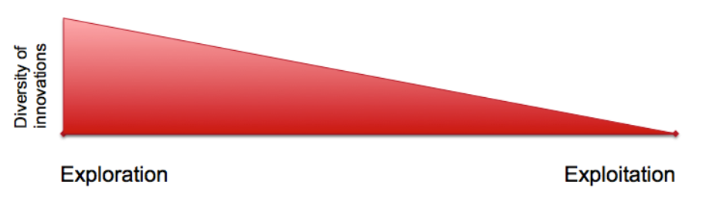
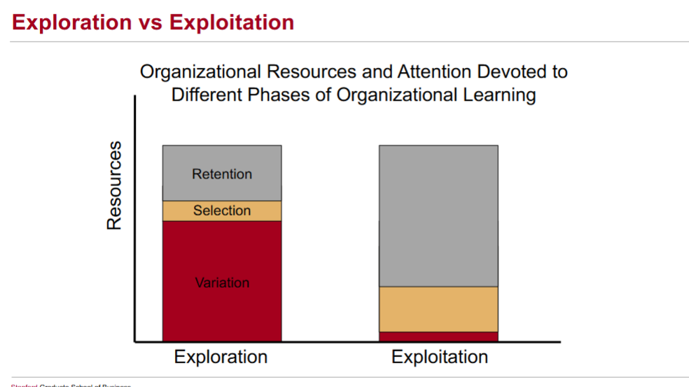

9. Value Chain Analysis
Idea 1: All firms in a value chain are bound together. The amount of value created across the full value chain is lower if firms in one segment fail to identify and take advantage of opportunities to create value.
Example: if retailers do a poor job timing sales, managing inventory, or displaying products, soft drink sales will be lower. Less value is created because fewer people buy soda. This affects Coke and its upstream syrup producers. This is why soft drink producers devote resources to helping retailers downstream.

Idea 2:
Value capture and value creation interact across the chain: The more value captured by a monopolist in one specific segment, the less total value is created overall. A monopolist charges higher than the WTP of some consumers — those transactions never happen, destroying surplus that could have existed. In contrast, perfect competition across segments allows more consumers to be served. Example: K-pop — coordinated value chain innovation across artist development, production, and distribution created outsized total value for the industry.

10. Innovation, Disruption & Structural Inertia
Discontinuous Innovation Theory
Continuous innovation: Incremental improvements to technology.
Discontinuous innovation: Order-of-magnitude improvements that can either (a) retrench the status quo, giving incumbents a massive advantage over upstarts, OR (b) render existing assets/capabilities irrelevant or counterproductive — 'competence-destroying discontinuities.'
Drivers of Disruption

Demand-Side Drivers
- A new technology is initially inferior and largely serves an unattractive part of the market
- Incumbents (seemingly) rationally concede the unattractive part of the market to the entrant — they can make more money serving the rest
- The new technology improves, and entrants move into more attractive market segments
- Disruption comes from not forecasting the technology trajectory correctly and allowing the entrant to gain a foothold
Challenge: New technologies often do not improve enough to be disruptive — so ignoring them is optimal. And you cannot tell in advance which will tip.

Supply-Side Drivers
- Disruption can occur even if leaders recognize that a new technology puts them inside the cost-quality frontier — thanks to inertia
- The most well-aligned firms are often the most vulnerable: alignment increases the process effects of change (the J-curve drop)
- Disruption is more likely to the extent that the new technology requires fundamentally new activities and new relationships between activities — since this requires greater org change
- Inertia does not mean incumbents will be wiped out — but they need a resource buffer (positioning advantage) to navigate the change process
Structural Inertia Theory
Explains why well-aligned, successful organizations struggle to adapt to change.
The Reliability Paradox: Society rewards reliable and accountable firms, which require reproducible, routinized structures. These same structures make a firm inert and unable to change quickly.
The J-Curve of Change: Process Effect: initial, dramatic drop in performance caused by the 'integration tax' of cascading PARC misalignments during a transition. Content Effect: eventual performance gain once the new strategy is fully implemented and better aligned with the environment.

11. Good Strategy — Validity and Soundness
Great strategies sit at the intersection of two requirements:
Internal consistency (Validity): Does the conclusion follow logically from the premises? This is what we can assess today — it is within our knowledge and control. Logical validity = whether the strategy holds together as an argument.
External consistency (Soundness): Is the truth value of the assumptions about the world correct? This depends partly on what we cannot know until tomorrow — how the environment will actually evolve. Soundness = validity + true premises.
Validity today, Soundness tomorrow. A strategy can be perfectly valid (logically consistent) but unsound if its premises turn out to be false. The goal is to identify which premises are most consequential and most uncertain — and actively monitor or test them.
Offramps: a set of criteria that define when it is time to abandon or pivot a strategy. Build these in advance.
When evaluating the key premises of a strategic argument, focus on:
- Criticality — to what extent does the option depend uniquely on that assumption? How much does the strategy break if this premise is wrong?
- Uncertainty — how confident are we that the assumption will be true in the future?
Focus analytical energy on premises that are both highly critical and highly uncertain — these are the ones worth testing, monitoring, or building offramps around.

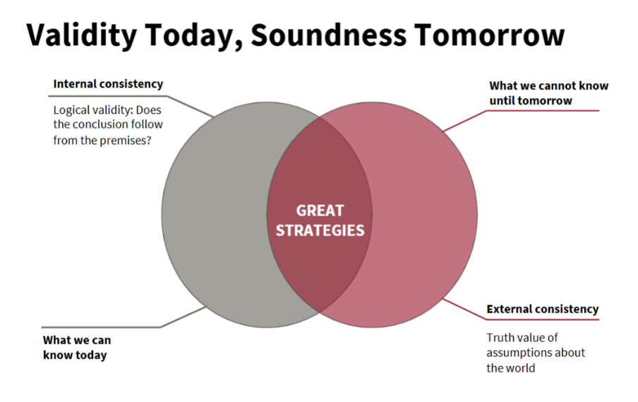

STRAMGT 202 Study Guide

