PERSONAL INFORMATION
Name: Jaume Sala Tantinyà
DNI: 39356383-W
Birth date and birth place: 26/09/1982, Manresa (Spain)
Address: 2 Costa Rodona Street, Sant Joan de Vilatorrada
Postal Code: 08250, St. Joan de V., Barcelona, Spain
Phone number: +34 609254370 / +34 938728795
E-mail: tm09432@salleurl.edu, xaume@redmagazine.net
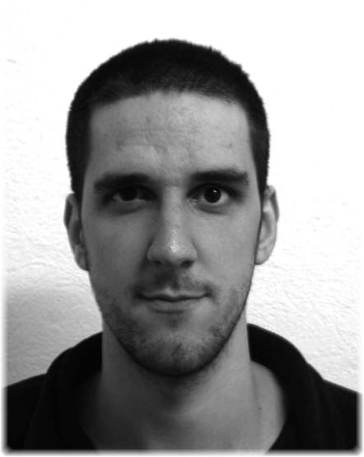

STUDIES
Computer Engineering: La Salle - Ramon LLull University; 2 Quatre Camins Street, 08022, Barcelona, Spain. 2005-2006

Multimedia Engineering: La Salle - Ramon LLull University; Idem. 2000-2005

Elementary school and Bachelor: IES Quercus; 91-95 Montserrat Street, 08250, Sant Joan de Vilatorrada. 1988-2000

LANGUAGES
Catalan Native
Spanish Native
English Medium

KNOWLEDGE AREAS
Programming languages and Technologies:
- C, C++, Java, Basic (high)
- HTML, DHTML, XHTML, JavaScript, Actionscript, CSS (high)
- LINGO, LINGO-3D, OpenGL (médium/high)
- PHP (high) , ASP (medium), JSP and SERVLETS (high)
- SQL, XML, DDT, RSS (high)

Software:
- Flash (high), Flash Video (high), DreamWeaver (high)
- MySQL (high), phpmyadmin (high), SQLServer (medium)
- Director (medium)
- Photoshop (medium)
- FreeHand (medium)
- 3D Studio MAX (medium)
- Visual Studio (medium)
- Adobre Premiere PRO (medium)
- Microsoft Office (high)
- Microsoft Windows (high), Microsoft Windows 2003 Server (basic)

Global Knowledge:
- Knowledge of Webmaster tasks (high)
- Knowledge of photography and digital image processing (basic)
- Usability (high)
- Network (assembly and installation) (medium)
- Hardware (high)
- Linux (medium)

PERSONAL PROJECTS
2006 I took part on the development of the website devoted to a “Salvador”, a film which has been short-listed for the European Academy Awards and was presented at the Cannes Film Festival. In this project I develop flash, flash video and back office parts. www.salvadorfilm.com
2005 Implemented a generic CMS using PHP and MySQL. This CMS is nowadays used in several websites, for example www.projecteaura.org.
2004 Working with the Redmagazine.net team as flasher/designer/programmer/webmaster (www.redmagazine.net). I implemented the Redmagazine.Player (www.redmagazine.net/player). I’m still working on this project.
2004 Developing an amateur website: www.calfania.com.

2003 Member of the Java department’s in La Salle - Ramon LLul University. We developed several projects using Java and J2ME.

2002 Creation of a tv spot for a quiz. It received a mention for the best modelling.
2002 With the aid of two friends we created a small company dedicated to assembling and repairing computers.
2000 Developing an amateur video game using Open GL and C++.

WORKING EXPERIENCE
2004 Working in the multimedia department of the Ramon Llull University, developing and managing several projects; using Flash, Director, Photoshop and Dreamweaver. For example www.fess.salleurl.edu
2003 Working as the computer responsible in Cola Dairy Products España S.L (www.codap.it), where I’m still working occasionally nowadays.
2001 Giving private mathematics and physics lessons.

SKILLS & HOBBIES
Ease in learning new technologies and programming language.
Designing skills. Responsible and constant. Ability for working in a group.

In my leisure time I enjoy reading, watching films, swimming, taking pictures and playing the guitar.

