RBiblioscape 3.72. Research Information Manager – Professional edition $299.00 (with academic discount $199.00)
CG Information, 740 Granbury Way, Alpharetta, GA 30022, USA
www.biblioscape.com Contact info: support@biblioscape.com

More and more electronic tools for Biblical Studies become available to Biblical Scholars on a daily basis. Databases, electronic ancient texts, digital concordances and complex search engines help even the digitally not so versed student or professor to accomplish tasks in a fraction of the time that it would have taken years one or two generations ago. Biblioscape, officially described as a “Research Information Manager”, is one of those useful tools. As the name implies, the makers of Biblioscape envision its product not only as a bibliographic reference manager, but rather as an information manager. Information in the digital age can mean quotes, book references, excerpts of articles, dictionary entries, web pages, html data gleaned from a web page and many more. All this kind of information can be handled by Biblioscape – and more. The roots of the program go back to bibliographic reference manager (such as Citation, EndNote, Library Master, Bibliographica, ProCite, etc.), which focus predominantly upon storing, managing and formatting of bibliographic references. The process is easily explained. As a student, pastor or professor bibliographic information concerning a book, journal article or any other written or printed material needs to be handled on a regular basis. A bibliographic reference manager will help in this enterprise, since it requires only one entry of the data. Once inputted, the data can be searched, retrieved and formatted according to likes and necessity. Thus, when writing an article for a journal using Turabian’s referencing style, the footnote or bibliographic references (whatever is chosen) is quickly formatted without the strain of trying to remember the particular characteristics of that style. Biblioscape offers a tremendous range of styles, however, most of them belong to the field of natural sciences and cannot be applied to theological, archaeological or humanities styles. Other programs, such as Citation, are more targeted toward research in these disciplines and thus have styles such as JBL, JNES, HTR, etc. Fortunately, Biblioscape includes a very powerful style editor which allows the user to change styles or create new ones based on present styles. Writing the style for Andrews University Seminary Studies took me between 30-40 minutes, but that included the learning curve of the program itself. Once the style has been written and tested it can be shared with other users of Biblioscape without any problems. Additionally – as most of the competitive packages also offer – Biblioscape is capable of finding in a MS Word or Word Perfect document the references that one included while writing the paper or thesis with a special abbreviated format (for example, [Combs, W. W. 1989 #93] which can then be formatted automatically once the document is finished as a footnote with the following information: W. W. Combs, “The Transmission-History of the Septuagint,” Bibliotheca Sacra 146/583 [1989], 255-269). If one chooses instead the bibliography output style (at the end of a research paper), the result would obviously be different. Utilizing MS Word 2000 I sometimes had problems with Biblioscape scanning the document that needed to be formatted. But it worked well under Office 97 and seems to be a problem with some additional formatting that Microsoft might have introduced, although I must confess that my working style is generally different since I copy the correctly formatted references directly into a footnote or bibliography.
However, that is only one aspect of Biblioscape’s capabilities. As the title of the program indicates, Biblioscape aspires to be much more than just a convenient way of storing and formatting bibliographic references. In contrast to most of its competitors, Biblioscape is based upon a real database engine instead of just text-limited ASCII files. This has some advantages as well as disadvantages. On the positive side, the data is much more secure and the maintenance tools are more robust. It also permits storage of huge databases. On the negative side, the fixed-length structure of the data fields make the database much bigger than in other products. My personal Ancient Near Eastern database (which was imported from a self-written MS Access database in text limited format) contains roughly 2000 entries and occupies between 12-13 MB of space under Biblioscape. In the MS Access format it was only 1.3 MB and in a text-based format it would be even less. While storage space is no big issue in modern computing (storage being very cheap), transport of the data files and the sharing of databases presents a problem. A possible solution to this problem could be the use of compression technology. My 13 MB data files compressed to a 500 kb zip-file without any trouble, which in turn fits comfortably on the traditional floppy disk.
The following figure represents a screenshot of the main window of Biblioscape, involving three main windows. On the left side the different main- and sub-folders (depending upon the required organization) of the bibliographic database are located. One could opt for a project focus (as in “legal texts OT” in my database) or for a chronological focus (as in “New Stuff”). Next to it on the right side, taking most of the screen estate are the actual records, each one with a special icon, indicating journal article, book, article in book, etc. Below this in a smaller windows can be seen the preview bar which – when selected – shows the formatted preview (according to the elected style).
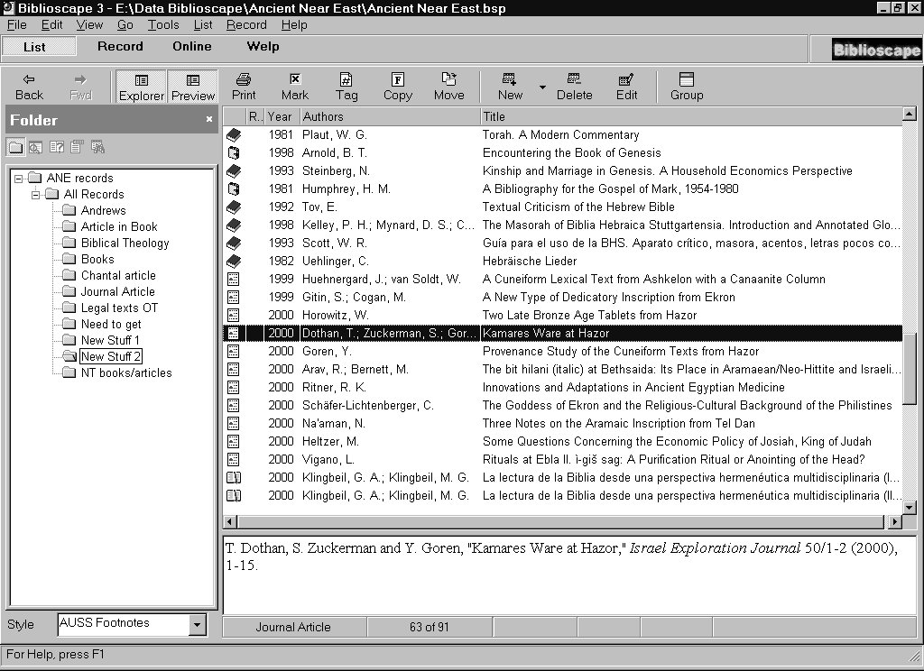
The following screenshot shows the main entry tab when one is adding a new record. If additional fields are needed they can be accessed on the detail tab. One important feature can be found in the keywords field where one can add an unlimited amount of descriptions pertaining to the record. These descriptions can be chosen from a pop-up list (to force uniformity and thus validity of the database) and are separated by “;”. In this way a topical bibliography can quickly be compiled that can be taken as a starting point for research in a specific area.

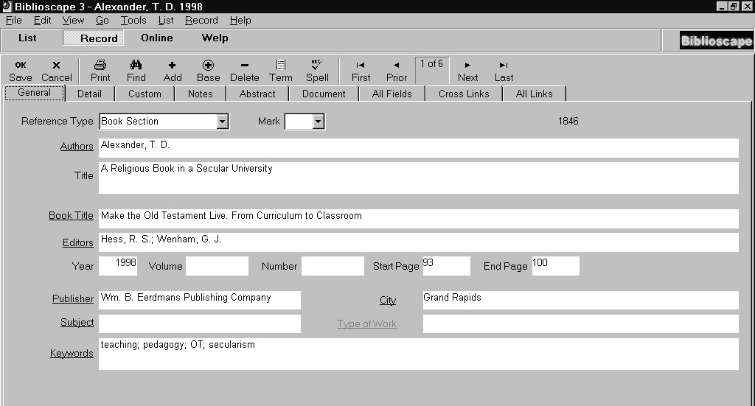
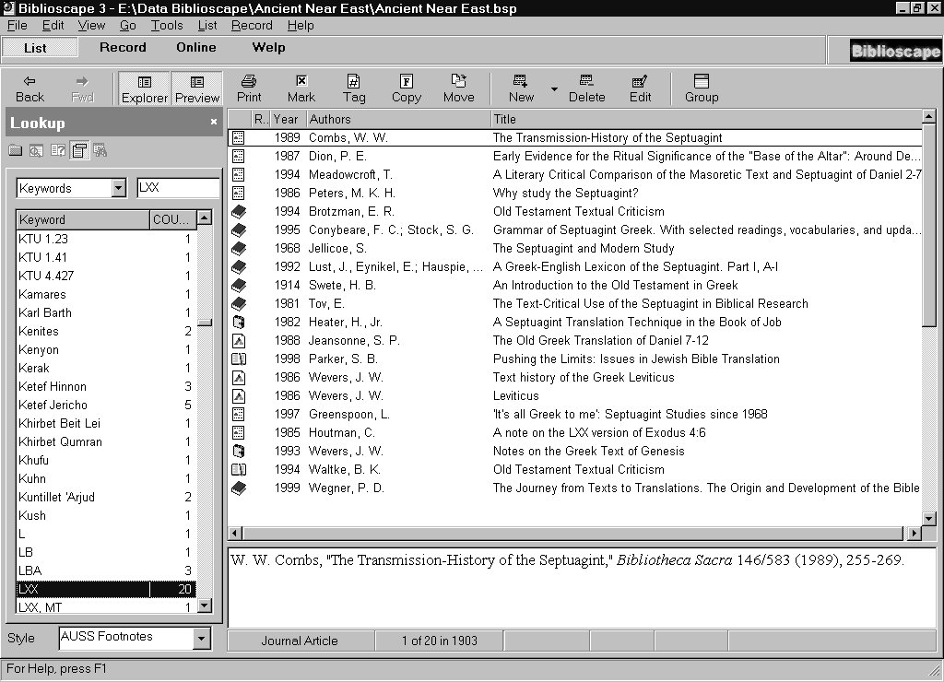
Following below an example of a keywords search. In this example I chose to look for the keyword “LXX” (=Septuagint) which gave me 20 hits. The main window now displays all these records, regardless of their origin and location. The search is basically instant, since all records are pre-indexed. Thus, even huge amounts of data can be easily handled – a feature which is very useful for busy record collectors.
But the usefulness of Biblioscape does not end here. The program also includes an internet module which allows the user to search specific keywords in selected internet bibliographic databases. Most services pre-installed show again a bias towards the natural sciences, but there are some useful databases for the humanities as well. However, a lot of these are subscription based (usually connected to a specific university) which would make this feature not very accessible for third world customers. In the Professional edition Biblioscape also offers a complete “live” webserver which can publish the actual data of a database maintained on one’s computer onto the Internet. Thus, a professor could provide students access to his personal (or at least specific areas) bibliographic database. This feature is extremely useful and will play an important role in future handling of bibliographic data.
The folks that publish Biblioscape belong to a new breed of software developers. I found their customer support very helpful and also very prompt. The program does not come shrink-wrapped and nicely boxed, but rather must be downloaded from the Internet at www.biblioscape.com. By the time this review appears in print, version 4 will already be out on the market and promises more additional features, such as a library module, an integrated word processor, a task manager and a chart module. One of the problematic aspect of Biblioscape for the use in theological bibliographic databases lies in its lack of support for foreign languages, such as Hebrew or Aramaic. The developers have tried to provide a workaround via special commands, but its use is rather complicated. Seeing that important publications of our field are published in Hebrew or mention transliterated or actual foreign language terms, this is a distinct problem, although – in defense of Biblioscape – the same problem can also be found in other competitive products. I very much liked its ability to import comma-limited data from conventional databases – once the order and field names had been adapted. Also, Biblioscape provides sufficient space and potential to grow with changing tasks. The program can be downloaded from the website and tried without any limitations for 30 days, which – I think – is a fair deal. By that time one should know if the program meets one’s needs. There are four distinct flavors of Biblioscape, namely the Lite Edition (regular price: $79, academic price: $49), the Standard Edition (regular price: $139, academic price: $99), the Professional Edition (regular price: $299, academic price: $199), and the Librarian Edition (regular price: $699, academic price: $499). Special licensing fees are included if one wants to use the BiblioWeb feature included in the Professional and Librarian Editions. All in all, this is a valuable investment for every student, pastor or scholar who has not yet begun his/her own bibliographic database. In a digital world, easy and reliable access and management of data will become more and more important. For this kind of future Biblioscape is definitely a worthwhile option and contender.

Dr. Gerald A. Klingbeil
Universidad Adventista del Plata
Professor of Old Testament and Ancient Near Eastern Studies
Director of Research Institute of Theology Faculty

