“Junior”

Introduction
The Junior Toolset is a low-cost, easy to integrate middleware solution for message passing in distributed, heterogeneous networks. It represents an encapsulation of supported transport methods, such that applications may use a single common interface to access desperate communications channels. The toolset includes both header files that define the API for accessing the transport, as well as the compiled libraries (dll’s and shared objects).

The Junior Toolset provides the following services:

- Abstraction from common transport methods, such as UDP, Serial, Berkley sockets, Zigbee, and DSRC (Wave).
- Multi-platform interoperability: Windows XP, CE, Vista, and Mobile. Red Hat Linux v????. Future updates to include vxWorks and LynxOS.
- Multi-language API, including C and Java.
- Automatic discovery of Junior compatible devices.

In effect, the Transport API provides common behavior and interface abstraction for all supported hardware:

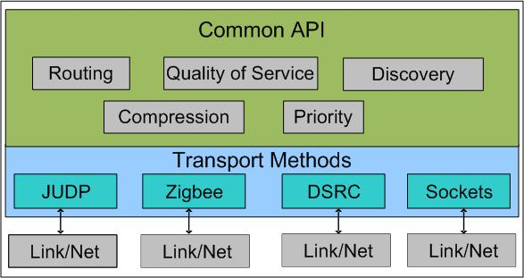
Figure 1. 'Transport Abstraction provided by the Junior Toolset'

Note that Version 1 is expected to support a limited number of transports (JUDP, JSerial, Sockets, Bluetooth). Future versions will add additional transport mechanisms, including JTCP, Zigbee, and JSRC.

Requirements for the Junior Toolset
The Junior Toolset encapsulates a set of capabilities that is independent of the specific communication medium being used. As such, it is the primary interface between the Application and the underlying network. The following services are provided by the Junior Toolset, with minimum intervention required from the operator or the application (some configuration may be required to compensate for particular network environments):
- Effort of Delivery: Handling for guaranteed-delivery messages is defined by the Messaging Specification. Note that this also includes messaging over TCP, since the intrinsic “guaranteed delivery” provided by the protocol may not be sufficient.
- Large Message Handling: Some transports limited packet sizes to certain maximum data sizes, such as 4096 bytes per message for JAUS implementations. While the application is better served by segmenting large messaging in a manner that makes sense for the data, the Transport Layer must provide this service in the event that the Application Layer violates this constraint. Note that segmentation and subsequent reconstruction on the receiving end must be completely transparent to the Application Layer.
- Transport Discovery: The Transport Layer is responsible for static and/or dynamic discovery of other compliant entities available for communication. The discovery is based only on their availability for communication; no attempt is made to determine the services or domain specific capabilities of the discovered entity. Note that the result of the discovery process is a list of accessible entities, based on their identifiers, reachable by any of the available communications medium.
- Cross Transport Relay: The Junior Toolset will enable 3rd party routing across different communication media. As a result, instances of the Junior toolset may receive and resend message traffic to enable communication between entities which are not directly connected (either due to disparate networking capabilities or physical distance). All relay behavior is independent of the application, although this functionality can be disabled through configuration to reduce latency of the local node.

Relay Networking
The Junior toolset must provide relay services to nearby entities that wish to communicate but cannot due so directly due to network incompatibilities or physical distance. This relay capabilities, however, introduces new complexities into the design of Junior. Throughout the design, the following requirements must be addressed:

- How is automatic routing through the ad hoc network managed when a relay node becomes unavailable?
- If multiple pathways exist to reach the same node, how is the “optimum” path selected?
- How many “hops” should the system permit? What impact does increasing the maximum hop count have on the latency and bandwidth utilization of the system?

Note that these conditions impact design decisions; they also represent test cases for the completed system.

Extensions to the Junior Toolset
Once this core library is in place, additional packages can be developed for target markets. For example, a “JAUS Core Services” library would build on Junior to offer additional functionality:
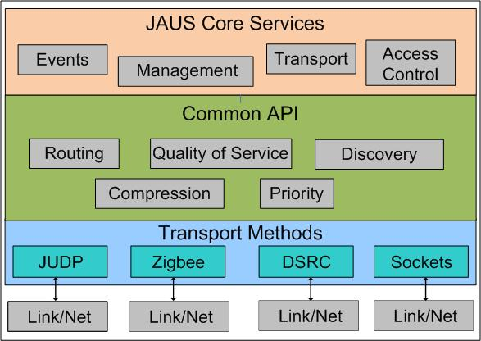
Figure 2. 'Junior Toolset with JAUS Extensions'

Design Overview
The following section provides a high-level overview of the system architecture for the Junior toolset. Where appropriate, the usability and functionality of the system is stressed. Subsequent sections will detail the software implementation, including class diagrams, message sets and protocols, and driver implementations.

Component Analysis
The Junior Toolset consists of two primary pieces:

- Application Programmer’s Interface: The Junior API provides applications written in C, C++ or Java access to the toolset’s features. Header files are provided in the development kit to define the interface. This also includes the library which provides compiled code for each function call. Note that this code is executed in the same process (thread) as the calling application.

- Run-Time Engine: The Junior Run-Time Engine executes as a separate process (note: Service? Daemon?) for handling all incoming and outgoing message traffic. A unique instances of the Run-Time Engine is required for each computing platform (node) in a system. (note: check on handling on dual-core processors. Does normal IPC work? If that’s true, the dual core is transparent to Junior). All messages to and from any application must flow through the Run-Time Engine.

The purpose of the run-time engine is to serve as a single point of control for all messaging. This allows multiple applications to use the same communications medium, with the Junior toolset acting as the mediator. For example, the JAUS port (3794) may be used by several JAUS components (processes) running on the same node. If each component had it’s own transport thread, these multiple applications may collide in trying to control the same port. Junior allows each of these components to communicate in a seamless way with a single instance of the run-time engine.

Since each application running on the node is represented by a different process, an intra-process communication mechanism is used to send messages between the application and the Run-Time Engine. For the initial implementation, Berkley sockets will be used for both Windows and Linux environments. Note that the design will attempt to encapsulate this code as much as possible so that additional IPC mechanisms may be adopted in the figure (note: Does QNX support Berkley sockets?).

User Application 1
Junior API
User Application 2
Junior API
Junior
Run-Time Engine
JUDP
JSerial
Bluetooth
Zigbee
IPC Comms
JUNIOR TOOLSET

The design of Junior allows for independent development of the low-level interfaces with the different transport media (JUDP, JSerial, Bluetooth, etc). While this interface is completely hidden to the user, proper encapsulation allows for expansion as the Junior toolset develops.

API Functionality
From the user’s perspective, the existence of the Junior Run-Time Engine is irrelevant. The single point of interface with the user’s application is through the Junior API.

The API provides a set of functions for accessing the send and receive capabilities of the Toolset over all available transport media. The following table lists the basic functions of the Junior API, along with mandatory and optional parameters:

Function | Inputs | Outputs | Optional Parameters
sendto() | Destination ID  Buffer length  Pointer to data buffer | Return success or error code | Priority  Quality of Service
broadcast() | Buffer length  Pointer to data buffer | Return success or error code | Priority
recvfrom() | Maximum Buffer Size  Pointer to data buffer | Return number of bytes received or error code.  (Values in data buffer will be updated) | Sender ID  Priority
initialize() | Unique identifier | Return success or error code

Identifiers and Addresses
The Junior Toolset intentionally abstracts the transport address of the underlying domain into a more generalized identifier. As a result, messages are sent to destinations (and received from sources) using this unique identifier rather than a particular address. As such, the application will not deal with ip addresses, ports, etc.

Before executing calls to the Junior API, the Application must initialize the library by passing in a unique identifier. This identifier could be a string (“GPS_on_Robot5”) or a 4-byte unsigned long value. This becomes the address by which all remote entities will access this application, e.g. sendto(“GPS_on_Robot5”, data[]).

Internally, however, any string identifiers will be mapped to a unique unsigned long alias. Rather than the original string, this 4 byte alias will be passed with every message, in order to reduce bandwidth consumption. The Junior RTE on the receiving side will map this alias back to the original identifier before passing the message to the application.

In order to support the needs of the JAUS community, as well as those running network packet sniffers, application writers can forego the use of the string identifier and assign the 4-byte identifier directly. It is the responsibility of the application, then, to ensure that the 4-byte identifier matches the structure imposed by JAUS (sid.nid.cid.iid).

Broadcast
The Junior Toolset supports one-to-one and one-to-many communication. While one-to-one messages are handled through direct addressing as noted in the previous section, one-to-many messages are implemented through broadcast and multicast.

For IP-based transport, the Junior Toolset uses a run-time configuration parameter that defines the multicast address used for all broadcasts. This provides maximum flexibility to the end user and network designer since broadcast traffic can be scoped by configuration or network switches to the desired subset. This is also consistent with JAUS best practices, as published by AIR 5645, and should allow for interoperability with systems which also adhere to this guidance.

All multicast traffic will use the JAUS port (3794) as assigned by the IANA.

Guaranteed delivery is not supported for broadcast and multicast traffic.

Discovery
Discovery is the process of determining the identifiers (both string names and aliases) of communication endpoints. This allows Junior to map identifiers (“GPS_on_Robot5”) to aliases (0x3D23F105) and transport addresses (192.168.0.1/3794).

While discovery is supported by the Junior Toolset, it is performed on a run-time, need-to-know basis. When the application requests a message to be sent to an unknown identifier, the Junior Run-Time Engine issues a broadcast with a special “QueryIdentity” message. All receiving RTEs match this string against their registered applications, and send a ReportIdentity response only if they match. While this need-to-know query/response mechanism will introduce some delay during the first transmission to a new destination, it significantly reduces network usage compared to “query every X seconds for every endpoint” solutions.

In addition to a response from the desired endpoint itself, the QueryIdentity message can also be answered by a ReportRelay if a Junior RTE is able to act as an intermediary between the sender and the destination. Note that relay is currently supported over a single “hop”; that is, the source and destination can use only a single intermediary relay node to reach each other.

When possible, direct addressing will be given preference to a relay channel.

Interface Design
The following section outlines the interaction of key components of the Junior Toolset. The goal is to describe the cohesive behavior of the overall system, focusing on functional interfaces, message flow, and threads of execution. Detailed specifications and implementations are provided in Section 4.

Data Flow
Because of the distributed nature of the Toolset, the internal behavior of Junior is best described by a series of sequence diagrams. Several common use cases are provided as example of how the design satisfies the needs of the Application.

Initialization
Before using the send and receive functions from the Junior API, the Application must call the initialize() function. This function prepares the library for communicating with the Junior Run-Time Engine, and establishes the unique identifier that is to be associated with that application.

Note that a single application may call “initialize” multiple times if it wishes to support multiple identifiers, e.g. an application may own more than one communication endpoint.

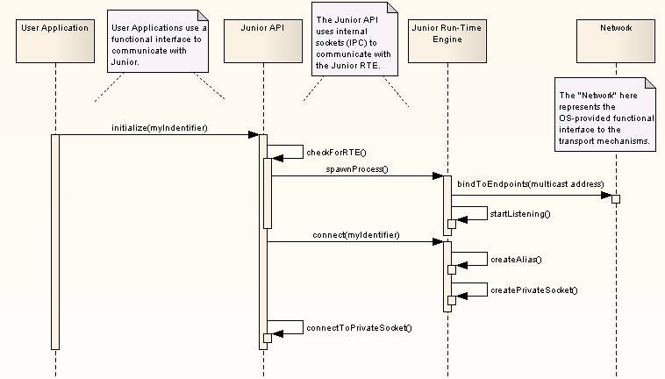
Figure 3. 'Data Flow during Junior Initialization'

Figure 3 shows a representative data flow sequence during application start-up. The application starts by calling initialize() and passing in a unique string identifier. This identifier will be used by other entities to access the services and capabilities of this application.

Inside the Junior API, the library checks to see if the Junior Real-Time Engine process has already been started; if not, the new process is spawned. The Junior RTE is responsible for managing the network connections for all incoming and outgoing communication. Once started, the Junior RTE supports incoming connection requests from the Junior API using a public (unix) socket. The connection request passes in the unique identifier proposed by the application. This string then becomes the name of the private (unix) socket that is used for future inter-process communication between the Junior API and Run-Time Engine.

Note that the Junior RTE is also responsible for creating an alias that will be used in place of the string identifier for all on-the-wire message passing. The identifier is based on an amalgamation of the CPU cycle counter and the current time. As such, it is not guaranteed to be unique, but conflicts should be rare and can be managed at run-time.

Sending a Message
In this use case, an application wishes to send a message to a remote entity. We examine multiple cases:

- The endpoint identifier and transport address are known to the sender’s Junior Run-Time Engine
- The endpoint has not yet been discovered, but does exist.
- The endpoint has not yet been discovered, and must be accessed through a relay node.
- The endpoint has not yet been discovered and does not exist.
- The message is a broadcast to be sent to multiple endpoints.

Sending a Message: Known Destination
In the simplest case, the application needs to send a message to a known destination. The application simply calls the “sendto” function offered by the Junior API, passing in the required information and an optional parameters. The Junior API serializes this data, passing it to the Junior Run-Time Engine.

The Run-Time Engine is responsible for looking up the source and destination identifiers, and converting them to aliases for reduced bandwidth consumption. The Run-Time Engine then sends the message directly to the destination using the corresponding transport channel. If multiple transport channels exist for the same destination, the highest capacity channel is used first (wired Ethernet, wireless Ethernet, wired serial, wireless serial).

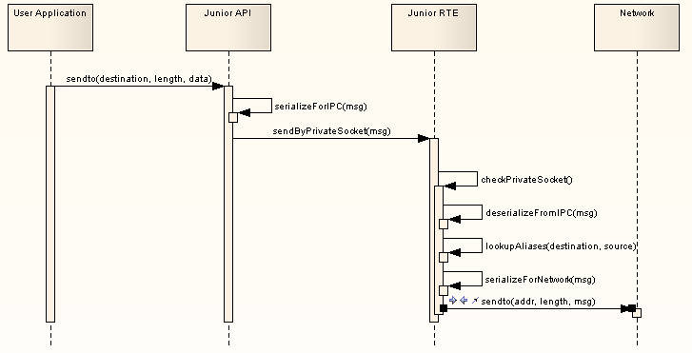
Figure 4. 'Data Flow for Outgoing Messages'

Note that this process requires the message to be serialized twice using slightly different forms. In the first case, the message is to the passed by an inter-process communication channel (unix socket) from the Junior API to the Run-Time Engine. At this point, the destination identifier is still the full name of the end-point, e.g. “GPS_on_Robot5”. In addition, no attempt is made to split large messages into smaller packets.

Once the Run-Time Engine receives and deserializes the message, it converts the source and destination identifiers into their alias equivalents. This process significantly reduces the bandwidth utilization for frequent messages. Once the aliases are determined, the message is serialized again for transmission over the network. This encoding, however, does not include the string name of the destination and source; it is the responsibility of the receiver to convert the supplied aliases into the original identifiers.

Sending a Message: Unknown Destination
It is possible for the sending application to request a destination identifier for which the Junior Run-Time Engine does not have an alias or a transport address. In this case, the discovery process must be used to determine the correct destination before the original message can be sent. The following sequence diagram demonstrates this process:
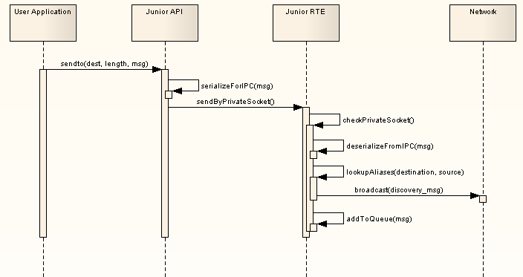
Figure 5. 'Sending Message to Unknown Destination'

In this case, the Junior Run-Time Engine must use discovery to determine the alias and address of the target destination. This is performed on a need-to-know basis, and therefore requires that the original message is stored in a temporary queue until the discovery process is complete. Once the desired destination responds with ReportIdentification, the outgoing message is pulled from the queue, serialized, and sent via the network.

Sending a Message: Using a Relay
In some cases, the target destination is not directly accessible by a sender. This could be the result of physical distance preventing the wireless signal from reaching the remote entity, or physical networking not providing a direct interface (sender is IP-based, but destination is on a serial link). For these situations, the Junior Toolset will attempt to route a message though an intermediary relay node that provides an interface between the source and destination.

Relay routes are determined during the discovery process. When a Junior Run-Time Engine receives a broadcast (multicast) searching for a particular identifier, it may provide one of three responses:

- A “ReportIdentification” message if the destination is a local address.
- A “ReportRelay” message if the destination is not a local address, but is an address that the local node is aware of.
- No response in all other cases.

Note that relaying a message is currently only support for single “hop”; that is, only a single intermediary node may be used to connect a sender and receiver.

If multiple relay channels exist for the same destination, only the highest capacity channel is used (wired Ethernet, wireless Ethernet, wired serial, wireless serial).

Since the data flow is the same for sending a direct message or a relay message, the sequence diagram will not be repeated here. The only exception in a relay message is that the destination alias encoded in the header of the message will not match the transport address. It is the responsibility of the receiver to detect this discrepancy, and forward the message to the appropriate destination.

Sending a Message: Unreachable Destination
In some cases, the application may request a message to be sent to a destination that either does not exist or is not reachable. The data flow for such a case is similar to the sequence provided in 3.1.2.2; however, the discovery process will not return a successful match.

In order to prevent a deadlock, if the desired destination is not found within TBD milliseconds, the send operation times-out and the message cannot be delivered. If the message was marked for guaranteed delivery, an error condition is returned to the sending application. Otherwise, no action is taken.

((Author’s Note: I’m not happy about not returning an error if no acknowledgement is requested; however, I don’t want the calling application to pend if it doesn’t have to…))

Sending a Message: Broadcast
Junior supports sending of a single message to multiple destinations through broadcast (multicast). For IP-based transport channel, the message is sent to a single multicast address that is user configurable. For on-the-wire messages, the destination identifier is given a special value (0xFFFFFFFF) while the sender alias is encoded normally.

The data flow for multicast message is similar to Section 3.1.2.1, and will not be repeated here.

((Need more details on broadcast for serial connections))

Receiving a Message
When the Junior Run-Time Engine receives a message from the network, there are three possible cases:

- The message is a point-to-point message intended for a local destination.
- The message is a point-to-point message intended for a remote destination, with the local node acting as a relay.
- The message is a broadcast (multicast).
- The message is point-to-point message with guaranteed delivery (ACK/NAK).

The following section provides analysis for each of these cases.

Receiving a Message: Local Destination
In the most common scenario, the Junior Run-Time Engine receives a message on one of the polled transport channels that is addressed to a local (connected) application using the appropriate alias. The RTE must convert the alias of the source and destination to their full unique string identifiers before passing the message back to the application using the private socket. The User Application must then poll the socket regularly using the recvfrom() function provided by the Junior API. This sequence is represented by the following diagram:
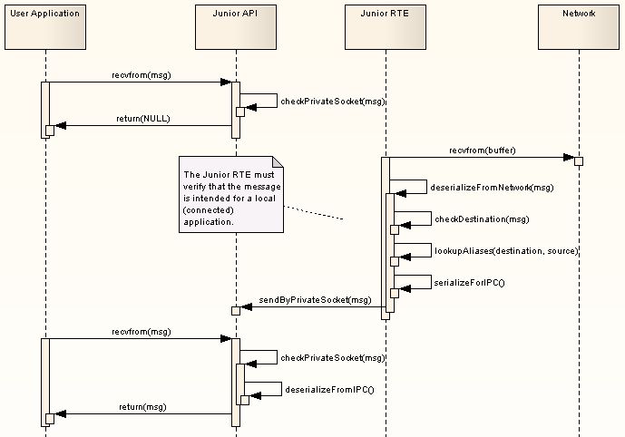
Figure 6. 'Receiving a Message: Local Destination'

Note that in Version 1.0, the Junior RTE and API will both support polling mechanisms only. Future versions may add support for event-based processing through a callback registration mechanism.

Receiving a Message: Relay Behavior
In the case of a Junior Run-Time Engine instance acting as an intermediary relay, the destination alias encoded in the message will not match a local (connected) application. In this case, the RTE simply forwards the message on to the given destination without changing the encoded message. As a result, the sender and receiver aliases remain intact. The user application and Junior API are not involved in this process:

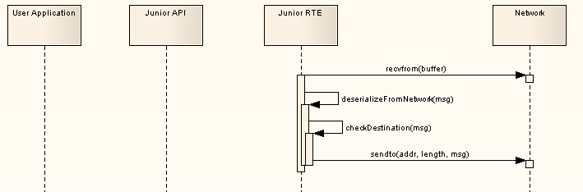
Figure 7. 'Junior as a Relay Node'

Receiving a Message: Broadcast
The Junior Run-Time Engine represents a single point of entry for all network traffic. As such, it must distribute any broadcast (or multicast) traffic to all connected applications. The exception to this, however, are messages created specifically for Junior to discovery remote entities (QueryIdentification, ReportIdentification, ReportRelay). These special messages are for internal use only, and are never passed on to the user application.

The data flow for receipt and processing of a broadcast message is the same as a point-to-point (unicast) as shown in Section 3.1.3.1. Rather than sending to a single private socket, however, the incoming message is delivered to all sockets. Note that the destination address for a broadcast message is a special alias (0xFFFFFFFF) which is decoded to an identifier string of “BROADCAST”.

Broadcasted messages are never forwarded by relay nodes.

Receiving a Message: Guaranteed Delivery (ACK/NAK)
If the sending application requests an acknowledgement notification, the receiving RTE must reply back with a ReportMessageReceived notification. This response message is sent to the source of the message and includes the unique identifier (sequence number) that was encoded in the header.

Internal Design
The following section outlines the internal design of the Junior toolset.

Message Structure
The core data element of the Junior toolset is the Message class. A Message represents a buffer of data that is to be transferred to a remote destination over one or more networks. The Message class augments the user data with additional message passing parameters, such as:

- Destination ID: The unique identifier for the intended recipient of the message.
- Source ID: The unique identifier for the sender of the message.
- Destination Alias: The unique 4-byte alias of the destination.
- Source Alias: The unique 4-byte alias of the source.
- Priority: The numeric representation of the message importance.
- Quality of Service: An enumerated value representing the delivery options (best effort versus guaranteed delivery).
- Data Length: Size (in bytes) of the user data.
- Buffer[]: A variable length buffer for the user data. Note that this buffer is completely opaque to the Junior Toolset, and it’s meaning and use are neither defined nor restricted by the Toolset.

In addition to the normal accessors expected for the data elements, the Message class offers serialize() and deserialize() functionality. The serialize() function packetizes the data in the object for transmission. Note that that in-band message delivery data, such as priority, is included in the header that precedes the user data. A message therefore has the following structure “on the wire”:

Transport Header | Messaging Header  (QoS, source, dest, priority) | Application Data | Transport Footer
Figure 8. 'Complete On-the-Wire Message Format'

Note that while the transport header and footer vary based on the needs of the underlying communications medium, the Messaging Header is constant for every message:

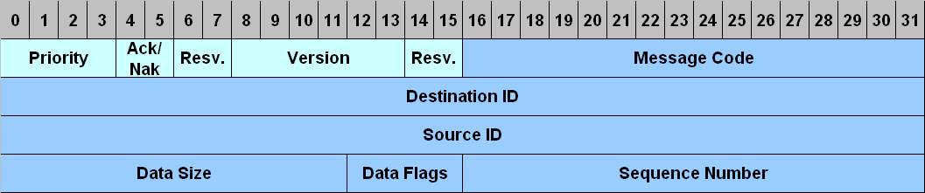

Note that this structure is intentionally borrowed from the Joint Architecture for Unmanned Systems (JAUS) Standard, and the definition of individual fields is available in those documents.

In addition to the generic “Message” class that is encapsulated user-defined data, several child classes are defined. These derived classes are used for specific functionality internal to the Junior toolset, such as discovery and guaranteed delivery (ack/nak).
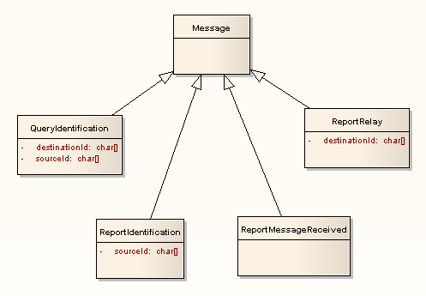
Figure 9. 'Message Heirarchy for Junior Implementation'

Note that the existence of this class is completely transparent to the user application. When a message is passed to/from the Junior API, a raw data buffer (char array of specified length) is used. Hence the application data is completely transparent to Junior, and it will not be modified in anyway.

A message factory class exists to deserialize an incoming packet of data into its object equivalent.

Transport Structures
The underlying communication channels are encapsulated in a Transport class. The top-level Transport is implemented as an interface class; since it cannot be instantiated directly, child classes are derived from it to support the needs of individual transport mechanisms:

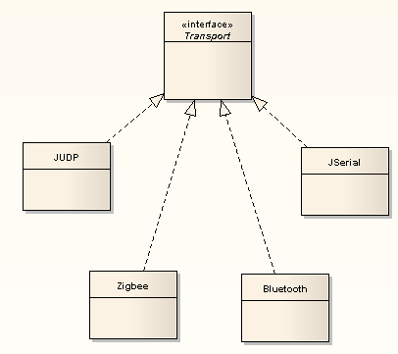
Figure 10. 'Heirarchy of Transport Encapsulation'

Once an individual transport is instantiated, the common interface defined by the Transport class allows the Junior Run-Time Engine to interact with the different communication channels in a consistent way. The needs of individual communication types, such as on-the-wire header bits and addressing, are encapsulated in the child classes such that the RTE is not directly aware of the differences.

The Transport interface provides the following basic functionality:

- recvfrom(): Checks the underlying transport channel for an incoming message, and deserializes it into its object equivalent.
- sendto(): Sends a message to the specified destination.

Each supported transport type must implement these two functions. The underlying transport type is also responsible for maintaining an up-to-date mapping between identifier aliases and their transport address.

