“Junior”

Introduction
The Junior Toolset is a low-cost, easy to integrate middleware solution for message passing in distributed, heterogeneous networks. It represents an encapsulation of supported transport methods, such that applications may use a single common interface to access desperate communications channels. The toolset includes both header files that define the API for accessing the transport, as well as the compiled libraries (dll’s and shared objects).

The Junior Toolset provides the following services:

- Abstraction from common transport methods, such as UDP, Serial, Berkley sockets, Zigbee, and DSRC (Wave).
- Multi-platform interoperability: Windows XP, CE, Vista, and Mobile. Red Hat Linux v????. Future updates to include vxWorks and LynxOS.
- Multi-language API, including C and Java.
- Automatic discovery of Junior compatible devices.

In effect, the Transport API provides common behavior and interface abstraction for all supported hardware:

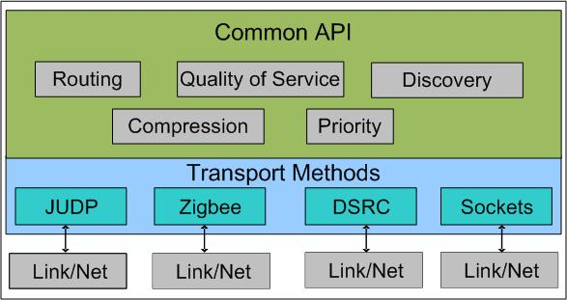
Figure 1. 'Transport Abstraction provided by the Junior Toolset'

Note that Version 1 is expected to support a limited number of transports (JUDP, JSerial, Sockets, Bluetooth). Future versions will add additional transport mechanisms, including JTCP, Zigbee, and JSRC.

Requirements for the Junior Toolset
The Junior Toolset encapsulates a set of capabilities that is independent of the specific communication medium being used. As such, it is the primary interface between the Application and the underlying network. The following services are provided by the Junior Toolset, with minimum intervention required from the operator or the application (some configuration may be required to compensate for particular network environments):
- Effort of Delivery: Handling for guaranteed-delivery messages is defined by the Messaging Specification. Note that this also includes messaging over TCP, since the intrinsic “guaranteed delivery” provided by the protocol may not be sufficient.
- Large Message Handling: Some transports limited packet sizes to certain maximum data sizes, such as 4096 bytes per message for JAUS implementations. While the application is better served by segmenting large messaging in a manner that makes sense for the data, the Transport Layer must provide this service in the event that the Application Layer violates this constraint. Note that segmentation and subsequent reconstruction on the receiving end must be completely transparent to the Application Layer.
- Transport Discovery: The Transport Layer is responsible for static and/or dynamic discovery of other compliant entities available for communication. The discovery is based only on their availability for communication; no attempt is made to determine the services or domain specific capabilities of the discovered entity. Note that the result of the discovery process is a list of accessible entities, based on their identifiers, reachable by any of the available communications medium.
- Cross Transport Relay: The Junior Toolset will enable 3rd party routing across different communication media. As a result, instances of the Junior toolset may receive and resend message traffic to enable communication between entities which are not directly connected (either due to disparate networking capabilities or physical distance). All relay behavior is independent of the application, although this functionality can be disabled through configuration to reduce latency of the local node.

Relay Networking
The Junior toolset must provide relay services to nearby entities that wish to communicate but cannot due so directly due to network incompatibilities or physical distance. This relay capabilities, however, introduces new complexities into the design of Junior. Throughout the design, the following requirements must be addressed:

- How is automatic routing through the ad hoc network managed when a relay node becomes unavailable?
- If multiple pathways exist to reach the same node, how is the “optimum” path selected?
- How many “hops” should the system permit? What impact does increasing the maximum hop count have on the latency and bandwidth utilization of the system?

Note that these conditions impact design decisions; they also represent test cases for the completed system.

Extensions to the Junior Toolset
Once this core library is in place, additional packages can be developed for target markets. For example, a “JAUS Core Services” library would build on Junior to offer additional functionality:
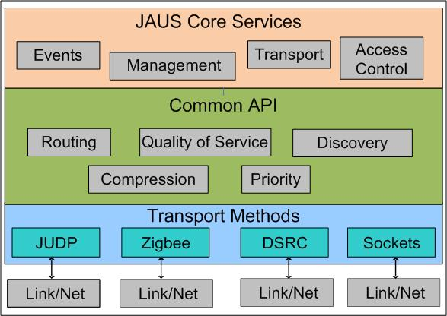
Figure 2. 'Junior Toolset with JAUS Extensions'

Design Overview
The following section provides a high-level overview of the system architecture for the Junior toolset. Where appropriate, the usability and functionality of the system is stressed. Subsequent sections will detail the software implementation, including class diagrams, message sets and protocols, and driver implementations.

Component Analysis
The Junior Toolset consists of two primary pieces:

- Application Programmer’s Interface: The Junior API provides applications written in C, C++ or Java access to the toolset’s features. Header files are provided in the development kit to define the interface. This also includes the library which provides compiled code for each function call. Note that this code is executed in the same process (thread) as the calling application.

- Run-Time Engine: The Junior Run-Time Engine executes as a separate process (note: Service? Daemon?) for handling all incoming and outgoing message traffic. A unique instances of the Run-Time Engine is required for each computing platform (node) in a system. (note: check on handling on dual-core processors. Does normal IPC work? If that’s true, the dual core is transparent to Junior). All messages to and from any application must flow through the Run-Time Engine.

The purpose of the run-time engine is to serve as a single point of control for all messaging. This allows multiple applications to use the same communications medium, with the Junior toolset acting as the mediator. For example, the JAUS port (3794) may be used by several JAUS components (processes) running on the same node. If each component had it’s own transport thread, these multiple applications may collide in trying to control the same port. Junior allows each of these components to communicate in a seamless way with a single instance of the run-time engine.

Since each application running on the node is represented by a different process, an intra-process communication mechanism is used to send messages between the application and the Run-Time Engine. For the initial implementation, Berkley sockets will be used for both Windows and Linux environments. Note that the design will attempt to encapsulate this code as much as possible so that additional IPC mechanisms may be adopted in the figure (note: Does QNX support Berkley sockets?).

User Application 1
Junior API
User Application 2
Junior API
Junior
Run-Time Engine
JUDP
JSerial
Bluetooth
Zigbee
IPC Comms
JUNIOR TOOLSET

The design of Junior allows for independent development of the low-level interfaces with the different transport media (JUDP, JSerial, Bluetooth, etc). While this interface is completely hidden to the user, proper encapsulation allows for expansion as the Junior toolset develops.

API Functionality
From the user’s perspective, the existence of the Junior Run-Time Engine is irrelevant. The single point of interface with the user’s application is through the Junior API.

The API provides a set of functions for accessing the send and receive capabilities of the Toolset over all available transport media. The following table lists the basic functions of the Junior API, along with mandatory and optional parameters:

Function | Inputs | Outputs | Optional Parameters
sendto() | Destination ID  Buffer length  Pointer to data buffer | Return success or error code | Priority  Quality of Service
recvfrom() | Maximum Buffer Size  Pointer to data buffer | Return number of bytes received or error code.  (Values in data buffer will be updated) | Sender ID  Priority
initialize() | Configuration file name | Return success or error code

Internal Design
The following section outlines the internal design of the Junior toolset.

Message Structure
The core data element of the Junior toolset is the Message class. A Message represents a buffer of data that is to be transferred to a remote destination over one or more networks. The Message class augments the user data with additional message passing parameters, such as:

- Destination ID: The unique identifier for the intended recipient of the message.
- Source ID: The unique identifier for the sender of the message.
- Priority: The numeric representation of the message importance.
- Quality of Service: An enumerated value representing the delivery options (best effort versus guaranteed delivery).
- Data Length: Size (in bytes) of the user data.
- Buffer[]: A variable length buffer for the user data. Note that this buffer is completely opaque to the Junior Toolset, and it’s meaning and use are neither defined nor restricted by the Toolset.

In addition to the normal accessors expected for the data elements, the Message class offers serialize() and deserialize() functionality. The serialize() function packetizes the data in the object for transmission. Note that that in-band message delivery data, such as priority, is included in the header that precedes the user data. A message therefore has the following structure “on the wire”:

