“About” Page
Welcome to IEEE ETCM 2026
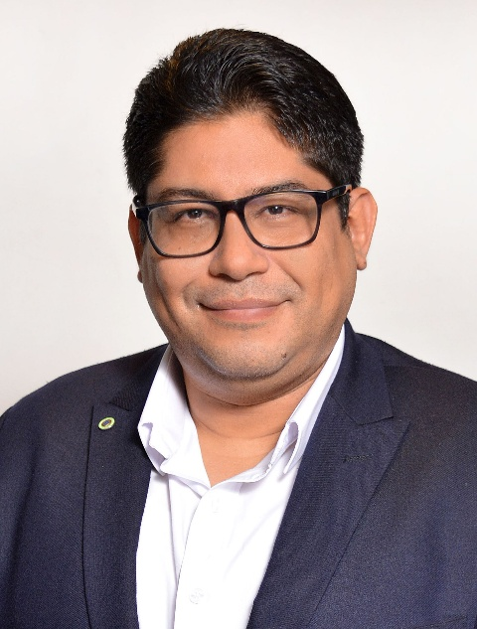 | On behalf of the IEEE ETCM 2026 Organizing Committee and IEEE Ecuador Section, it is a pleasure to welcome the scientific, academic, professional, and technological community to the 10th edition of the Ecuador Technical Chapters Meeting. This milestone edition will bring together researchers, practitioners, students, industry representatives, and IEEE volunteers to exchange knowledge, present high-quality research, and strengthen collaboration in engineering, computing, energy, robotics, communications, education, and emerging technologies.  As General Chair of IEEE ETCM 2026 and Chair of IEEE Ecuador Section, I extend a cordial invitation to our national and international community to be part of this commemorative edition in Guayaquil. The conference represents not only a technical meeting, but also a decade-long effort to promote scientific excellence, professional networking, and the visibility of research developed in Ecuador and the region.

About the Ecuador Technical Chapters Meeting

IEEE ETCM is one of the most relevant technical and scientific meetings promoted by IEEE Ecuador Section. Since its first edition, the conference has served as a platform for the dissemination of research, the articulation of IEEE technical chapters, and the creation of bridges between academia, industry, and society.
The conference encourages multidisciplinary dialogue and welcomes contributions aligned with current technological challenges, including artificial intelligence, data science, communications, electronics, power and energy systems, robotics and automation, education technologies, humanitarian technologies, and innovation for sustainable development.

Why ETCM Matters for Ecuador

Over the years, IEEE ETCM has contributed to strengthening Ecuador’s scientific and technological ecosystem. By connecting universities, research centers, companies, professionals, and students, the conference has supported the development of high-impact research communities and has helped increase the international visibility of Ecuadorian and Latin American scientific production.

The 10th edition is an opportunity to recognize the work of previous organizing teams, technical chapters, authors, reviewers, volunteers, and co-host institutions that have made ETCM a sustained IEEE conference in Ecuador. This anniversary also invites us to look ahead and continue building a stronger, more collaborative, and internationally connected research community.

A Decade of IEEE ETCM
This historical record is prepared as part of the 10th anniversary edition of IEEE ETCM. The information is based on available IEEE, institutional, proceedings, and conference records. Some early-edition fields may be updated as additional archival documentation becomes available.

ETCM 2026: Celebrating the 10th Edition
IEEE ETCM 2026 will celebrate a decade of technical and scientific contributions under the leadership of IEEE Ecuador Section, with the support of the Instituto Superior Universitario Bolivariano de Tecnología (ITB) and Universidad Bolivariana del Ecuador (UBE) as co-organizing institutions. The conference will take place in Guayaquil, a strategic city for academic, technological, and professional exchange in Ecuador.
This edition invites the community to celebrate the achievements of the past ten years while contributing to the next stage of IEEE ETCM as a reference event for engineering and technology in Ecuador and Latin America.
Join Us in Guayaquil
We warmly invite authors, researchers, students, professionals, IEEE members, industry partners, and sponsors to participate in IEEE ETCM 2026. Your contributions and engagement will help make this 10th anniversary edition a meaningful space for scientific exchange, collaboration, and innovation.
- Submit and present your research.
- Participate in technical sessions, keynote talks, workshops, and networking activities.
- Join the celebration of ten editions of IEEE ETCM in Ecuador.
INSERTAR LOS LOGOS DE LOS CAPÌTULOS TECNICOS

LOGO DE SECCIÒN Ecuador (Organizador)

Logos de ITB – UBE (Co-organizador)

