1. 更改es-parent中依赖，es-parent只是用来管理所有的依赖，并不直接引用依赖；es-common,es-web引用具体依赖；与我们目前项目依赖管理方式一致
2. Es-web启动时，运行一下便卡死问题解决

更改jdk版本-1.7；更改spring版本4.1.4；与当前项目保持一致

1. Es-web启动报错：

2016-01-01 15:50:56.176:WARN::Nested in org.springframework.beans.factory.BeanCreationException: Error creating bean with name 'org.springframework.context.annotation.internalAsyncAnnotationProcessor': Initialization of bean failed; nested exception is java.lang.NoSuchMethodError: org.springframework.aop.interceptor.AsyncExecutionInterceptor: method <init>(Ljava/util/concurrent/Executor;Lorg/springframework/aop/interceptor/AsyncUncaughtExceptionHandler;)V not found:

java.lang.NoSuchMethodError: org.springframework.aop.interceptor.AsyncExecutionInterceptor: method <init>(Ljava/util/concurrent/Executor;Lorg/springframework/aop/interceptor/AsyncUncaughtExceptionHandler;)V not found

at org.springframework.scheduling.annotation.AnnotationAsyncExecutionInterceptor.<init>(AnnotationAsyncExecutionInterceptor.java:60)

at org.springframework.scheduling.annotation.AsyncAnnotationAdvisor.buildAdvice(AsyncAnnotationAdvisor.java:150)

at org.springframework.scheduling.annotation.AsyncAnnotationAdvisor.<init>(AsyncAnnotationAdvisor.java:99)

at org.springframework.scheduling.annotation.AsyncAnnotationBeanPostProcessor.setBeanFactory(AsyncAnnotationBeanPostProcessor.java:105)

at org.springframework.beans.factory.support.AbstractAutowireCapableBeanFactory.invokeAwareMethods(AbstractAutowireCapableBeanFactory.java:1585)

at org.springframework.beans.factory.support.AbstractAutowireCapableBeanFactory.initializeBean(AbstractAutowireCapableBeanFactory.java:1553)

at org.springframework.beans.factory.support.AbstractAutowireCapableBeanFactory.doCreateBean(AbstractAutowireCapableBeanFactory.java:539)

at org.springframework.beans.factory.support.AbstractAutowireCapableBeanFactory.createBean(AbstractAutowireCapableBeanFactory.java:476)

at org.springframework.beans.factory.support.AbstractBeanFactory$1.getObject(AbstractBeanFactory.java:303)

at org.springframework.beans.factory.support.DefaultSingletonBeanRegistry.getSingleton(DefaultSingletonBeanRegistry.java:230)

at org.springframework.beans.factory.support.AbstractBeanFactory.doGetBean(AbstractBeanFactory.java:299)

at org.springframework.beans.factory.support.AbstractBeanFactory.getBean(AbstractBeanFactory.java:199)

at org.springframework.context.support.PostProcessorRegistrationDelegate.registerBeanPostProcessors(PostProcessorRegistrationDelegate.java:220)

at org.springframework.context.support.AbstractApplicationContext.registerBeanPostProcessors(AbstractApplicationContext.java:615)

at org.springframework.context.support.AbstractApplicationContext.refresh(AbstractApplicationContext.java:465)

at org.springframework.web.context.ContextLoader.configureAndRefreshWebApplicationContext(ContextLoader.java:403)

at org.springframework.web.context.ContextLoader.initWebApplicationContext(ContextLoader.java:306)

at org.springframework.web.context.ContextLoaderListener.contextInitialized(ContextLoaderListener.java:106)

at org.mortbay.jetty.handler.ContextHandler.startContext(ContextHandler.java:549)

at org.mortbay.jetty.servlet.Context.startContext(Context.java:136)

at org.mortbay.jetty.webapp.WebAppContext.startContext(WebAppContext.java:1282)

at org.mortbay.jetty.handler.ContextHandler.doStart(ContextHandler.java:518)

at org.mortbay.jetty.webapp.WebAppContext.doStart(WebAppContext.java:499)

at org.mortbay.component.AbstractLifeCycle.start(AbstractLifeCycle.java:50)

at org.mortbay.jetty.handler.HandlerWrapper.doStart(HandlerWrapper.java:130)

at org.mortbay.jetty.Server.doStart(Server.java:224)

at org.mortbay.component.AbstractLifeCycle.start(AbstractLifeCycle.java:50)

at runjettyrun.Bootstrap.main(Bootstrap.java:97)

由于es中重写了AsyncExecutionInterceptor，与spring4中的原生AsyncExecutionInterceptor存在差异，前者只支持一个参数的构造，为低版本中的类，故一直报改错。现先用spring-aop-4.1.4中的进行替换，保证能正常运行，后续需注意升级后的类是不是会对ES有影响。保留原有的，更名为AsyncExecutionInterceptorDeprecated

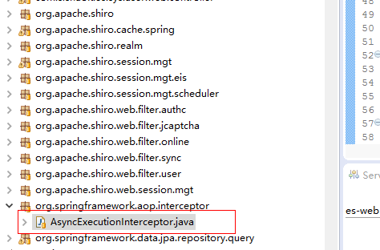

1. 如下报错解决

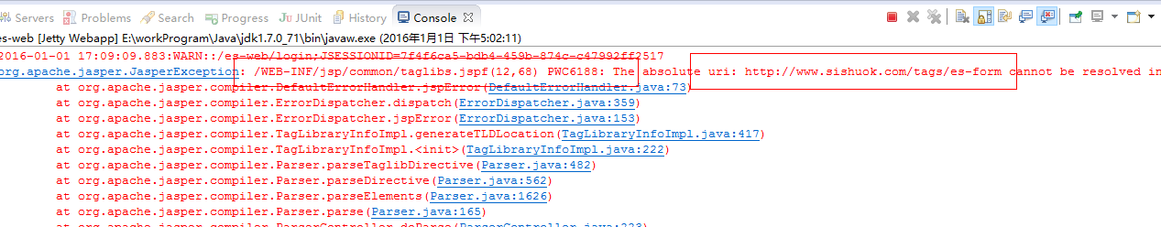

S:注释如下文件

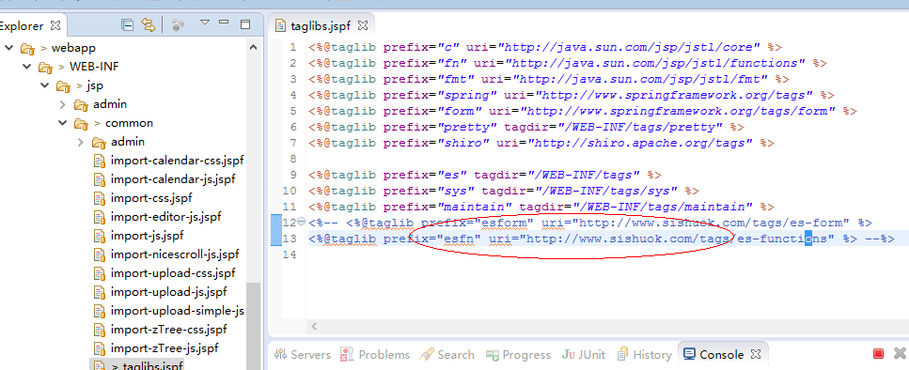

1. 个人消息推送报错

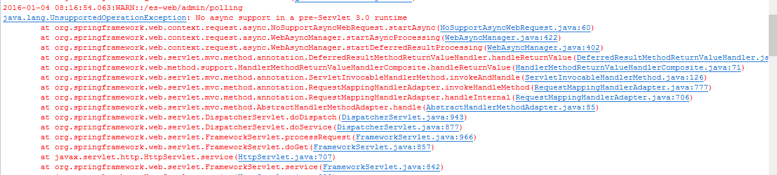

S:由于es-parent中定义的依赖scop为provided，只对编译的时候有用，打包的时候并不会进入到lib中。provided 明了dependency 由JDK或者容器提供。

将部署的容器改为jetty-8即可

