1. Go to <https://www.hitachivantara.com/en-us/products/pentaho> platform/dataintegrationanalytics/pentaho-community-edition.html site and click on download.

2.Select Pentaho Database Integration(base install).

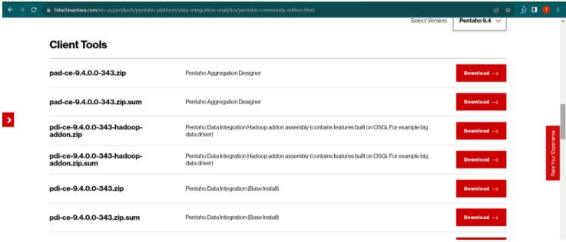

Change environmental variables of the system.

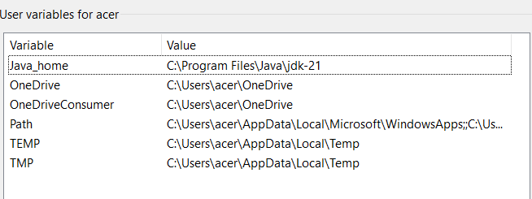

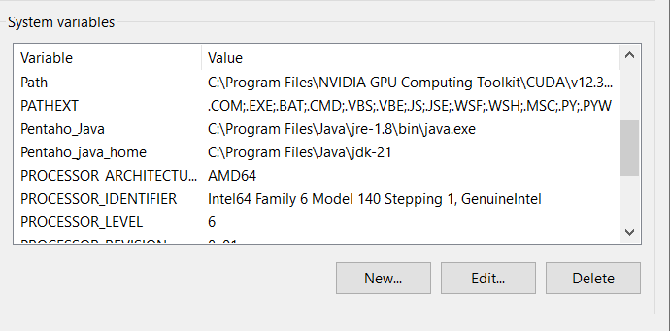

3.Download Mysql-connecter and paste it into the lib folder

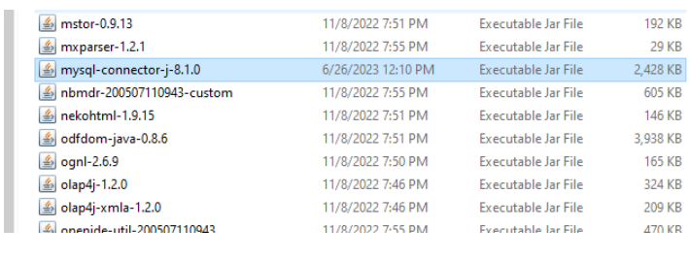

**Prac4.1**

**Step 1:** firstly create a database in mysql and table named students.

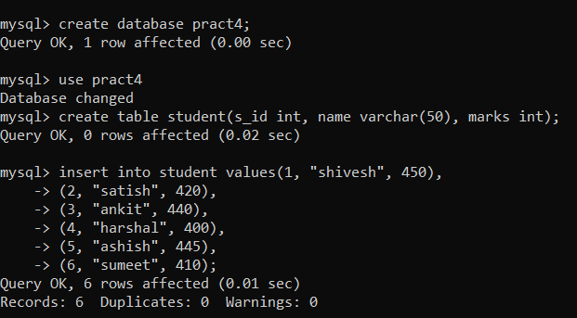

**Step 2**: Now go to your pentaho and drag and drop table input from input (in design tab) and excel output from the design tab.

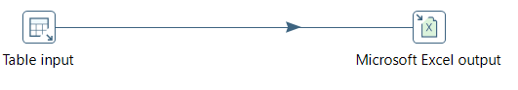

**Step 3:** Create a database connection

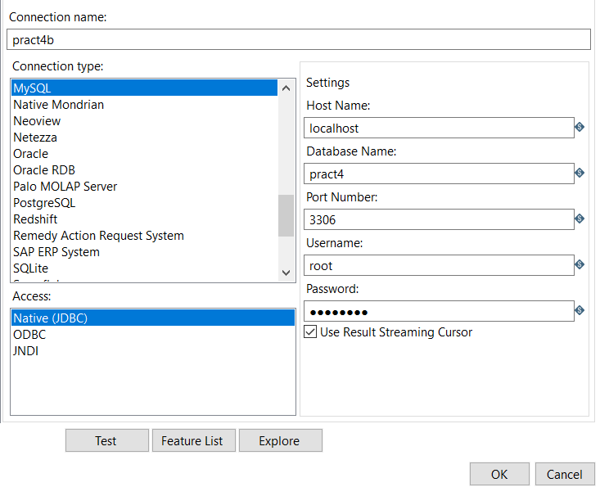

**Step 4:** Inside the table input give your sql connection and select Get sql select statement. After this all the columns you have created will be shown in a sql statement.

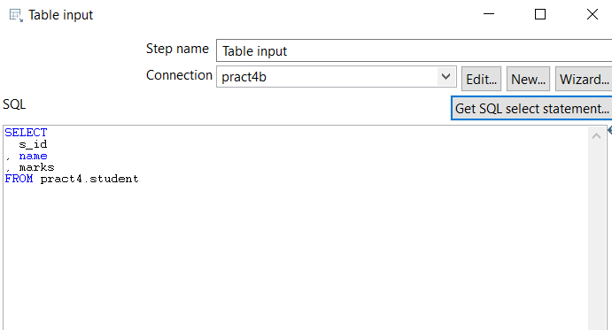

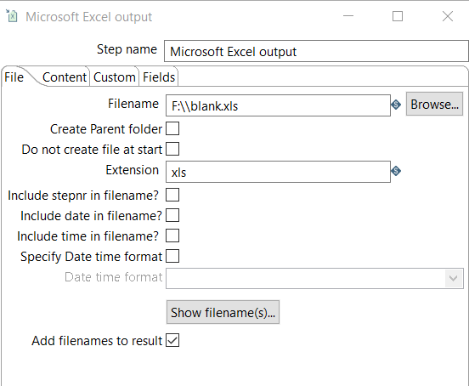

**Step 5:** Then run the transformation which is located in the right corner of the page.

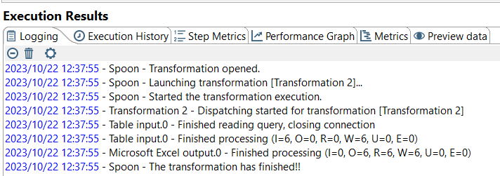

**The mysql table which you made will successfully get exported in the excel file**

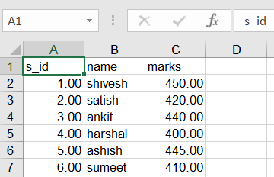

**Pract 4.2**

**Step 1:** Open Batch file then new transformation then from the design tab drag Microsoft excel from input and table output. Which should look like below diagram.

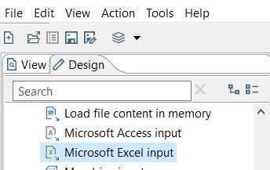

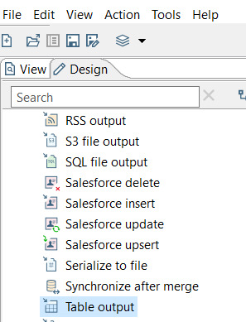

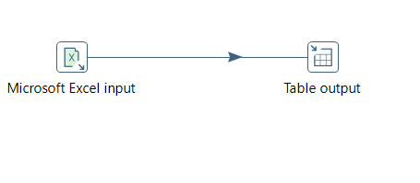

**Insert data into the excel files.**

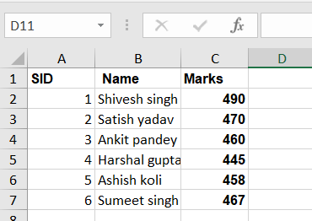

**Step 2:** double click on Microsoft excel input .In file or directory browse the path of your .xsl file and add it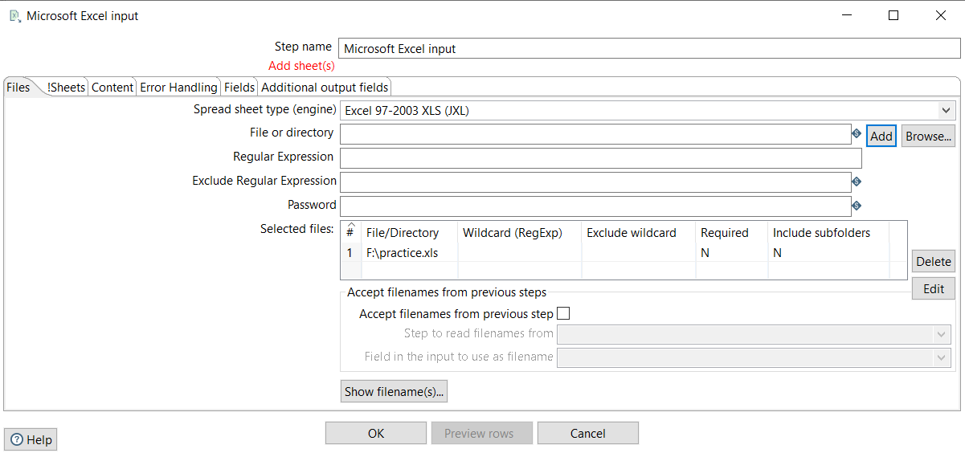

**Step 3:** select fields option and click on Get fields from header row button .

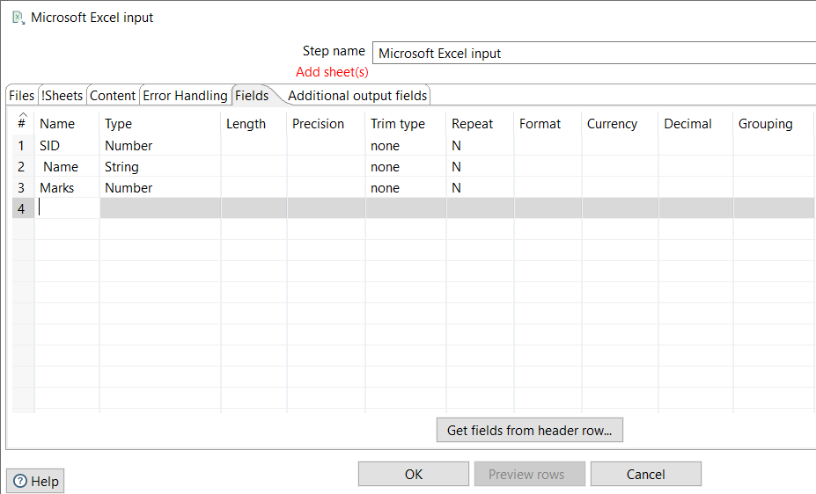

**Step 4:** Setup the database connection of table output by creating a new connection.

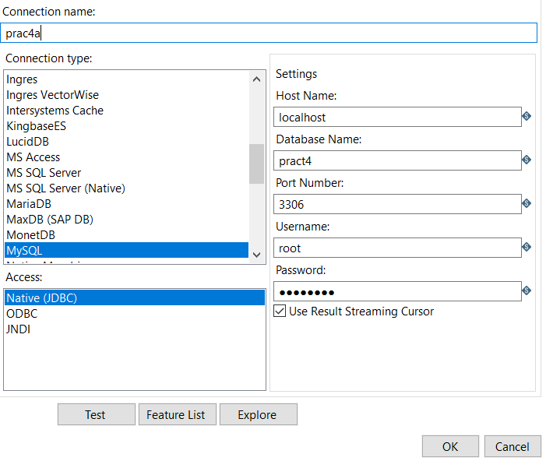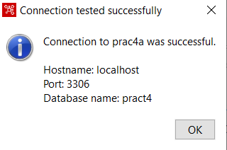

**Step 5:** Then fill the appropriate target schema and table name and click on SQL button and then click on Execute.

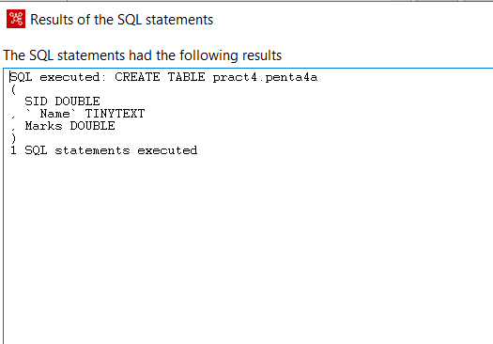

**Step 6**: Then run your transformation You will be able to see your excel table in your mysql command prompt

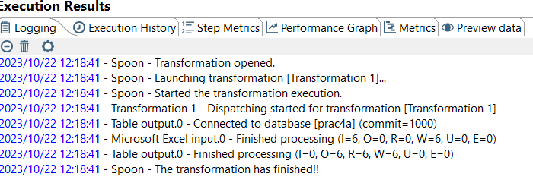

MYSQL output:

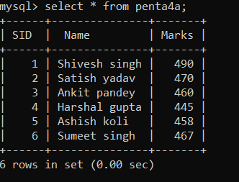

**Pract4.3**

**Step 1:** From input drag Table input and from transform drag add sequence and from output drag Microsoft excel .and connect everything as shown below.

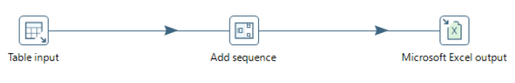**Step 2**: Double click on table input then give connections and test the connections properly.

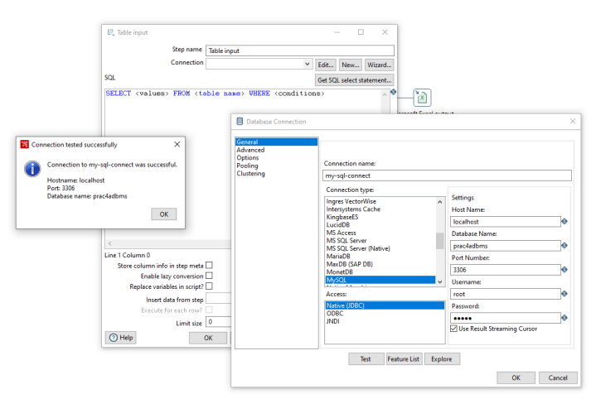

**Step 3**: Then Click on Select SQL Statement button and then select your table and then press on OK

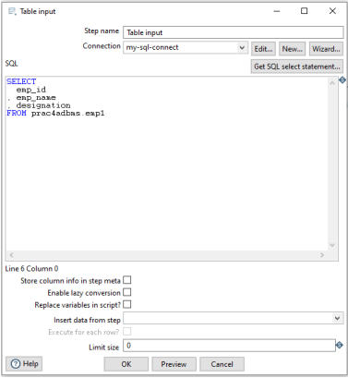

**Step 4:** Then double click on add sequence à give the value name and then press ok

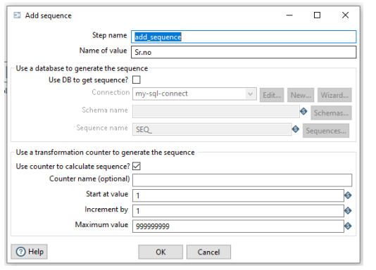

**Step 5**: Then Double click on Microsoft excel à give the path of your new created file with its name in filename. And click OK.

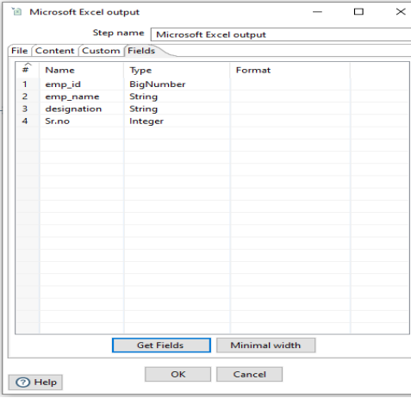

**Step 6:** After all the above steps are successfully executed. Click on Run

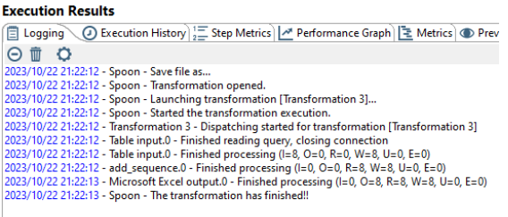

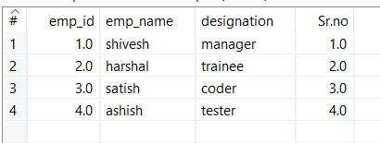

**Prac4.4:**

**Step 1**: First Create a table called employee and insert values as per the question given.

**Step 2**: Open Spoon batch file and create a new file Transformation. Then from input drag table input, from transform drag split fields and from output drag table output and connect all the 3 as shown below.

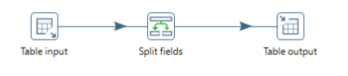

**Step 3**: Double click on table input and click on new. Then give your sql connection details. Like hostname, database name, port number and password and give your connection a name and click on Test button. If sql collection is successful then come out and click on Get Sql select Statement. The table which you have selected will be displayed as query on SQL textbox. And then click on OK

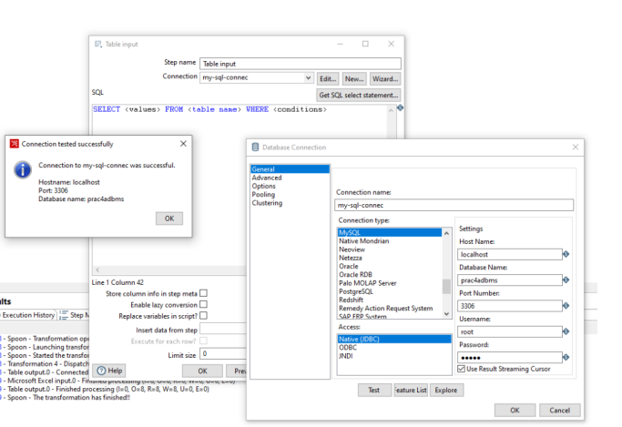

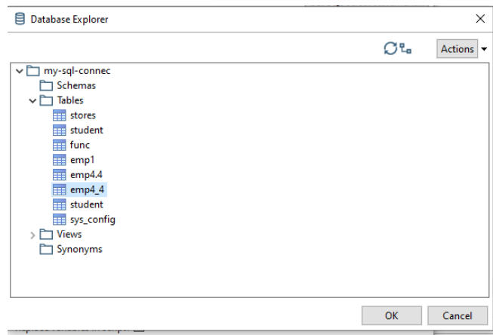

**Step 4** : Double click on split fields .inside Field to split write the name of the column you want to split i.e full_name then inside delimiter give single space (it will split after space).then add 2 field name f_name and l_name and specify its type as string . -->OK

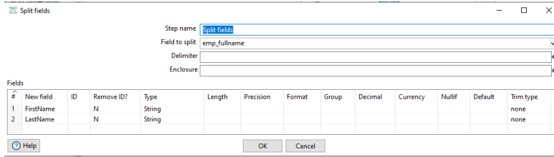

**Step 5:** Double click on table output give the connection as usual and execute the SQL queries

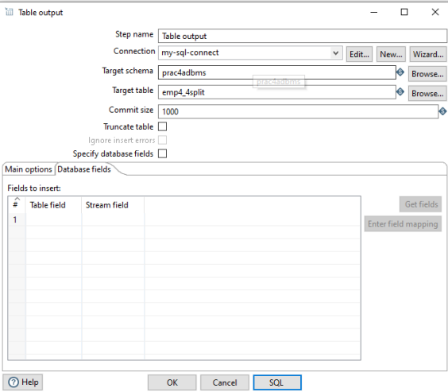

**Step 6:** After completing all the above steps properly click on Run

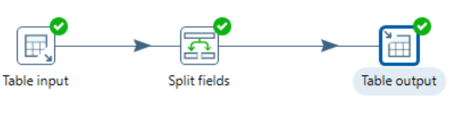

Before splitting

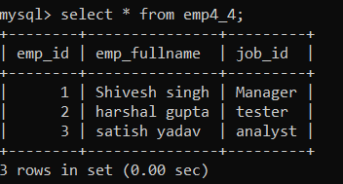

**After splitting**

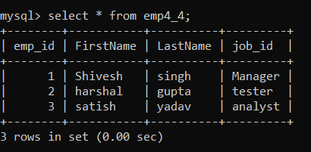

**Pract4.5:**

**Step 1:** Open Spoon. Then take 2 input Microsoft excel and name it as data 1 and data 2.

**Step 2:** Double Click on input excel and browse the data 1 file and select it after selecting click on add.

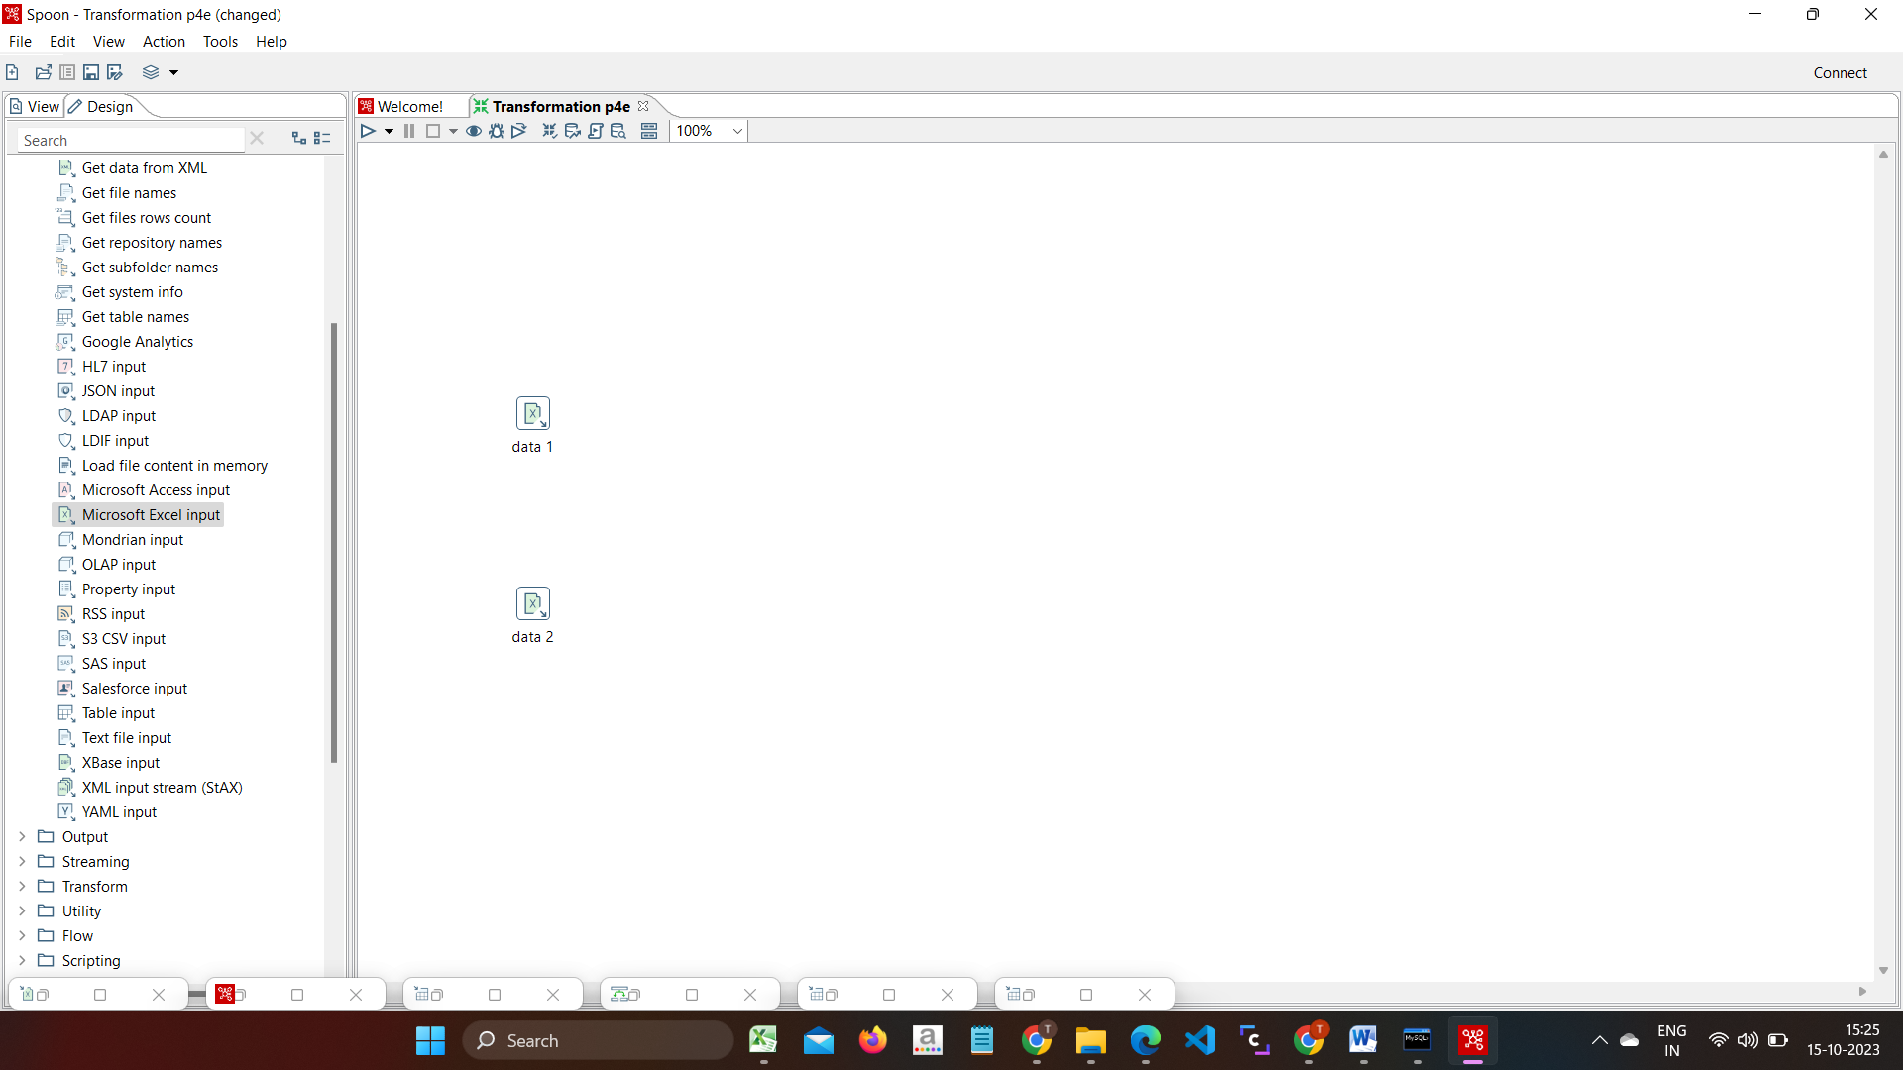

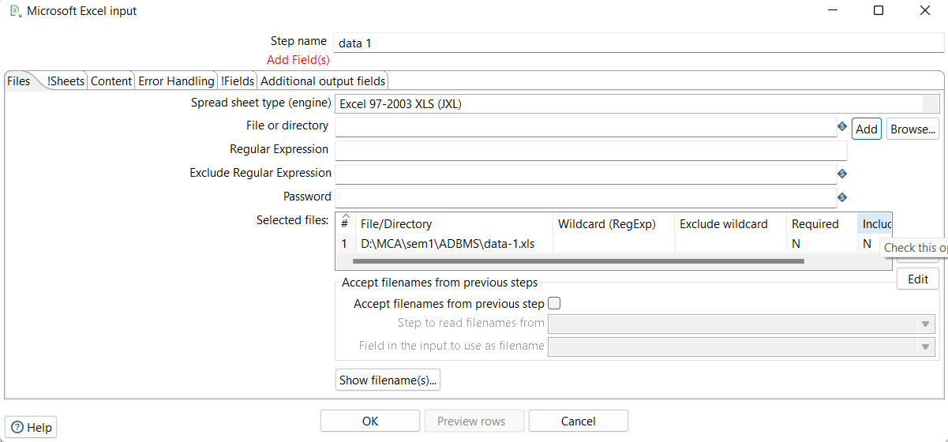

**Step 3:** Then click on field option and select Get field from header row button. Do The same steps for Data 2 excel file.

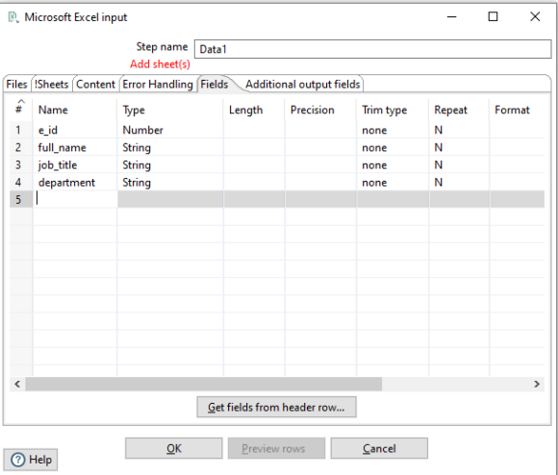

**Step 4**: Double click on sort rows and click on Fields button. This will display the headers of the columns in that particular excel that you imported

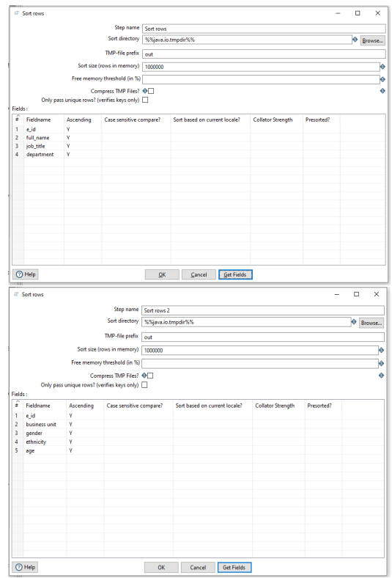

**Step 5:** From join drag merge join and connect both sort rows with merge join as shown below

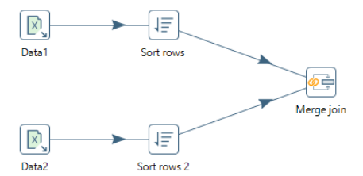

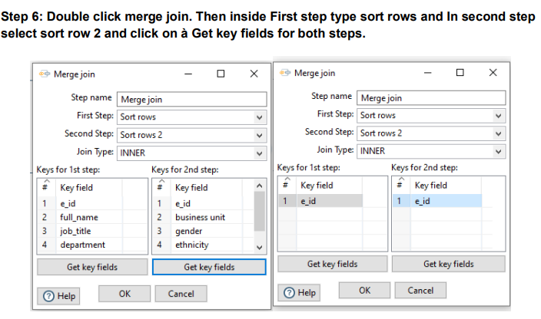

**Step 7**: Then from transform drag select values as shown below

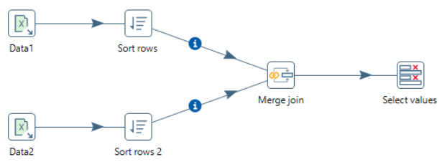

**Step 8:** Double click on select values and click on get fields to select . we will be able to see 2 e_id. Then we have to delete Eid_1 from the fields section and click on OK.

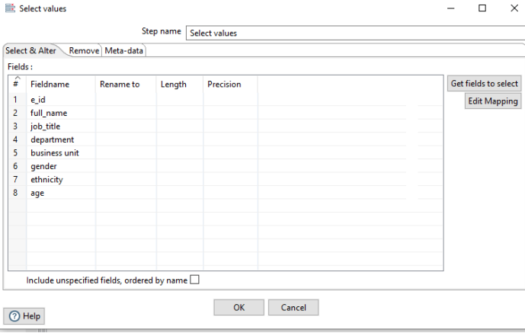

**Step 9:** Drag table output from output session as shown below.

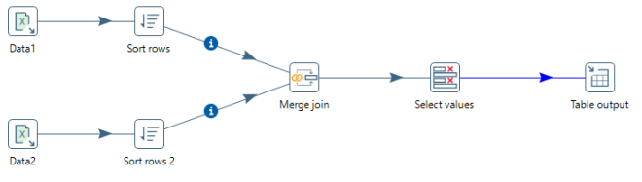

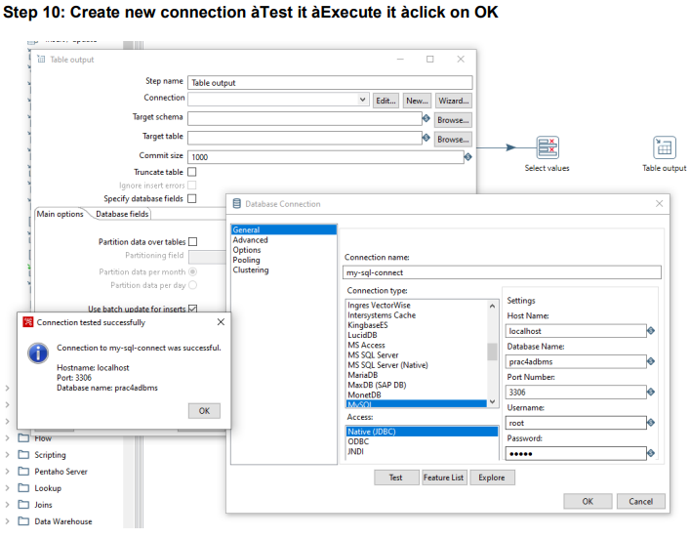

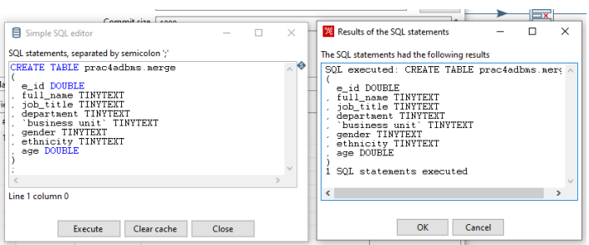

**Step 11:** Then if all the above steps are completed click on RUN

If all the above steps are executed properly then you’ll get this output.

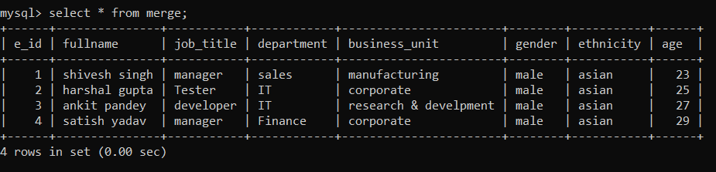

**8.2**

**Click on explorer**

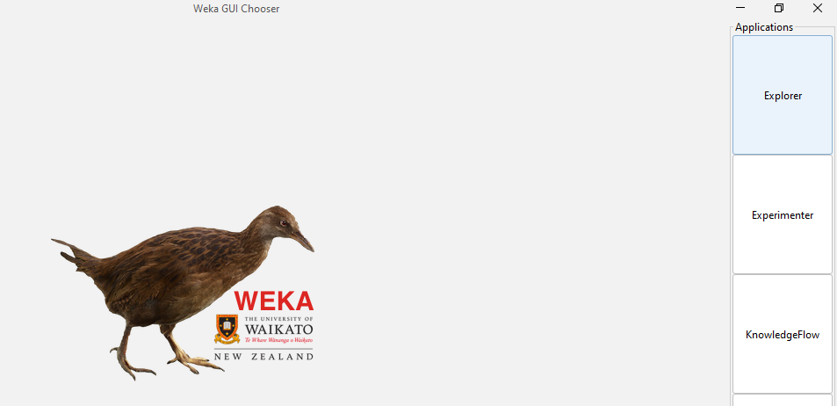

**Then click on open file**

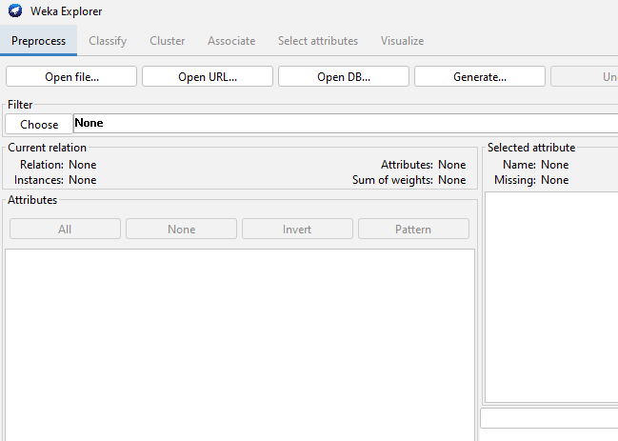

**Then go to program files and select weka -> then select data**

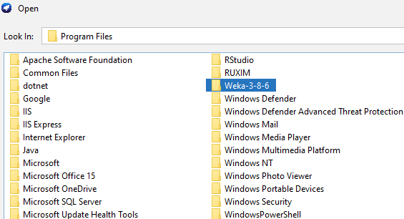

**Then from data select values for-eg: Diabetes**

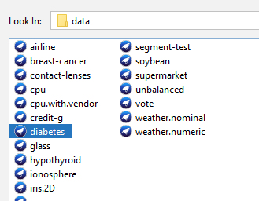

**Select attributes- Insu,pedi,age,skin**

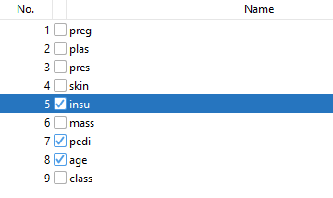

**The visuals of all the attributes**

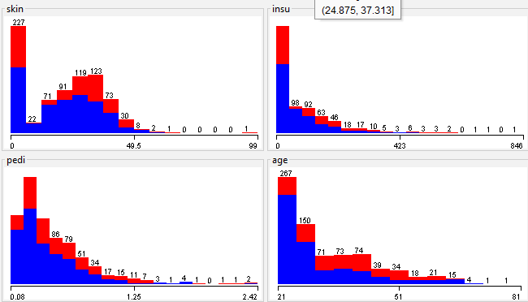

**Then click on classify and then choose lazy->IBK**

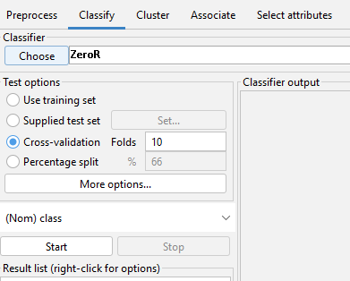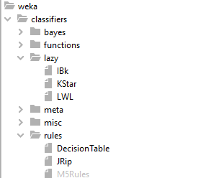

**Then click on start**

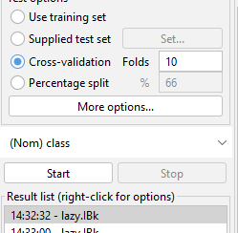

**Output of the classify window**

