Week 03 Lab
I Am Someone
Capability: Identity
Technology: Java Object Modeling · DTO (beginner) · GET JSON · Git/GitHub

Course | Web Programming (AI Native)
Project | MyBlog
Week | 03 — I Am Someone / Mission 03: My Blog Knows Who I Am
Estimated Time | approximately 65 minutes

Student Name: 周子涵
Student ID: 25281E121
Date: 10/10

Contents
Table of contents — open in Word, right-click here, choose “Update Field”.

ABOUT THIS LAB MANUAL
This is your hands-on laboratory manual. Complete it during and after the teacher's live demonstration.
Source: lab.md (Week03 baseline). This expanded manual adds an explicit overview, starting-state verification, evidence map, and completion checklist; the full Level 1 → 2 → 3 chain, all three bug exercises, all AI prompts, and the Git/GitHub growth-record thread from the baseline are preserved.
Companion files: mission.md (requirements) · assessment.md (evaluation) · common-bugs.md (fixes) · prompts/ (AI templates) · reflection.md, homework.md (submission).
Week06-pilot conventions applied: capability-shaped evidence, hypothesis-first AI loop, experience-before-explanation.

1. Lab Overview
Field | This Lab
Weekly capability | Identity — MyBlog has a personal, designed self-description, published as a growth record
Core question | Who is my application?
Technology | Java object modeling (PersonalProfile) · DTO (beginner concept) · GET endpoints returning JSON · Git/GitHub as growth record
Starting state | Your Week02 project: running app, GET /hello (text), GET /profile (basic JSON voice), GET /me (JSON)
Ending state | Same project evolved: GET /profile returns a richer personal identity (≥5 meaningful fields); GET /me stays consistent; Week03 growth recorded as a commit visible on GitHub
Time | ~65 min in class
Evidence | §7 — identity JSON screenshot, GitHub link + Week03 commit you can point to, AI debugging/understanding records, reflection

The transformation
Week 02: { "name": "MyBlog", "owner": "Student", "message": "Nice to meet you." }
(a voice — but it could belong to anyone)
↓
Week 03: { "blogName": "...", "owner": "...", "introduction": "...",
"interests": "...", "vision": "..." }
(an identity — unmistakably yours)

Keep asking "Why does MyBlog need this?" before "How do I implement this?"
Full story: story.md · mission.md.

What proves success this week
The capability is identity. A valid JSON response is not proof — {"vision": "test"} is valid JSON and proves nothing (you will demonstrate this yourself in Bug 1). Your proof is recognition:
Action: open GET /profile
Observable: browser shows ≥5 fields with real personal meaning
Verification: the Recognition Test — a classmate reads only your JSON
and can tell it is yours; /me stays consistent with /profile
Contrast: Week02 generic profile vs Week03 personal identity — same project
Evidence: §7 map — identity screenshot + GitHub Week03 commit + AI records + reflection

KEY IDEA
[KEY: Valid JSON proves the Web can carry your data.
Recognition proves the data is you. Only the second is this week's capability.]

Estimated lab time
Section | Time
Mission intro + environment check | 5 min
Level 1 — Make identity work | 20 min
Level 2 — Understand + AI debug | 20 min
Level 3 — Personalize + publish | 15 min
Deliverables + reflection | 5 min
Total | ~65 min

2. Starting Point & Environment Check
The important check this week is the starting state of the project — identity is built on top of Week02's voice, not beside it.

Task 2.1 — Open your Week02 project
Open the Spring Boot project you have been growing since Week01.
Do NOT create a brand-new unrelated project.
MyBlog is evolving. It is not restarting.

(Only if your teacher tells you to recover a lost project may you start fresh.)

Task 2.2 — Verify the baseline still runs
Run the application. Confirm:
- http://localhost:8080/profile returns your Week02 JSON (e.g. name / owner / message)
- http://localhost:8080/me returns your Week02 JSON introduction
Then confirm Git is available:
git --version

If /profile does not return JSON, fix Week02 first (weeks/week02/common-bugs.md). Do not build identity on a broken voice.

Checkpoint — Starting state
☐ Week02 project opens in IDEA
☐ Application runs (Tomcat on 8080)
☐ GET /profile returns my Week02 JSON
☐ GET /me returns my Week02 JSON
☐ git --version works

EVIDENCE — capture this
[EVIDENCE: Starting state — record before changing anything]
GET /profile (Week02 version) returns: 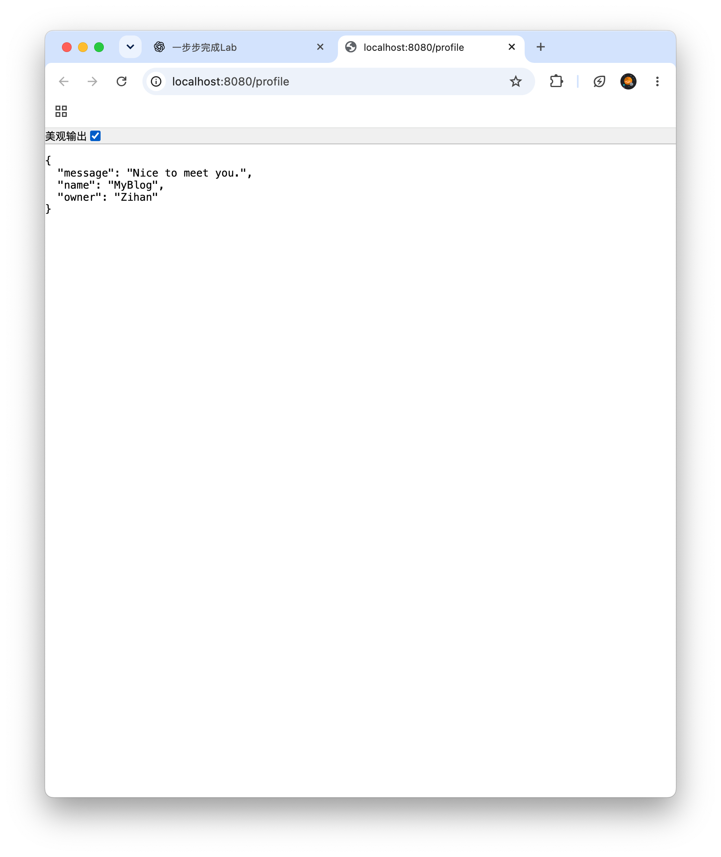________________________________
GET /me (Week02 version) returns: 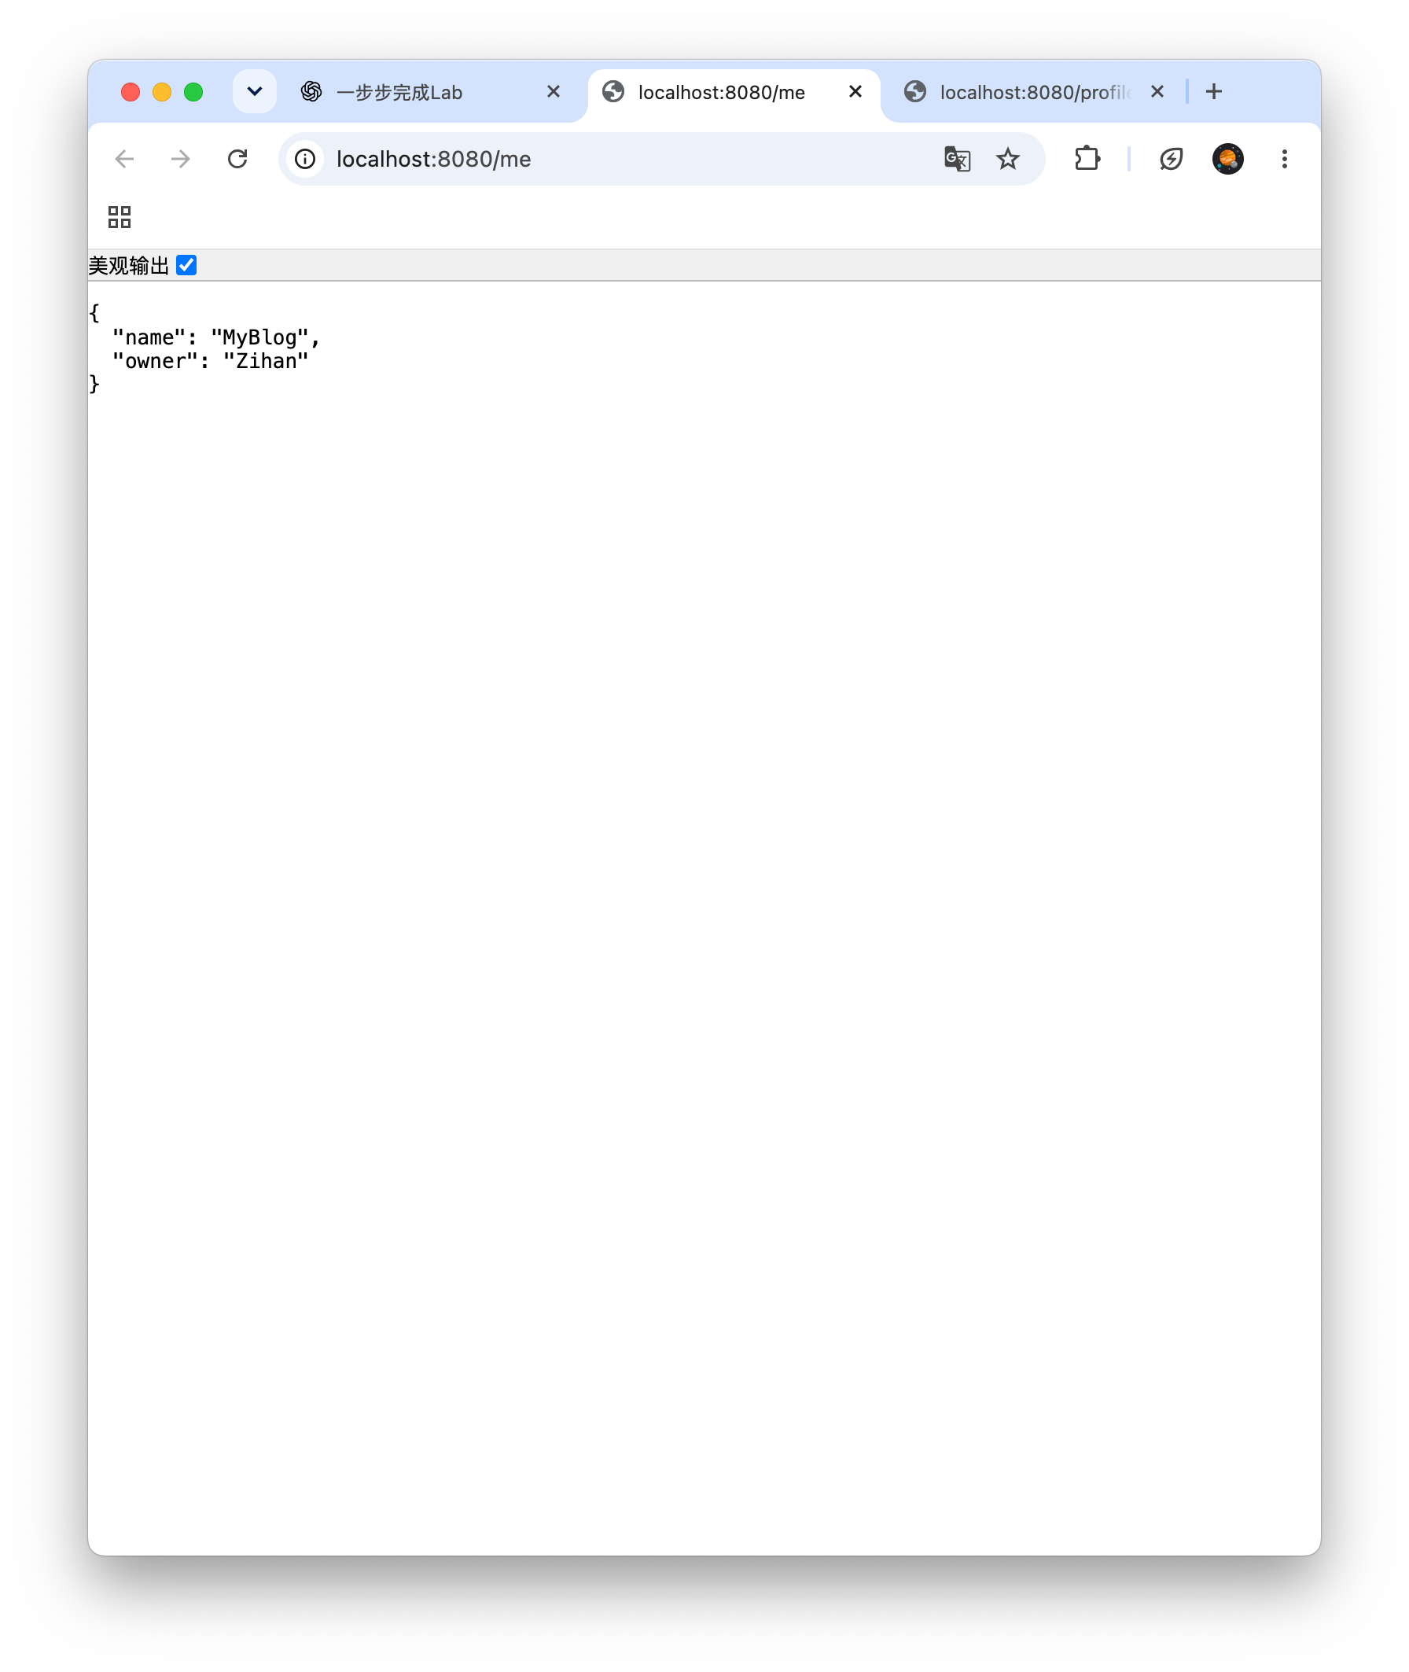________________________________
Git version: 2.39.5
______________________________________________________________________________
______________________________________________________________________________

3. Level 1 — Make It Work
Goal: create a richer identity model and return it through /profile. Keep /me working as personal JSON.

Task 3.1 — Observe the identity gap
Open http://localhost:8080/profile and look at it as a stranger would.
What feels generic?
The current profile only contains basic information and does not show my personality or interests.
________________________________________________

What personal truth is missing?
My personal interests, background, future goals and vision are missing.
________________________________________________
This observation is not filler — it is your design brief. The two lines you just wrote decide your fields.

Task 3.2 — Design identity fields
Choose fields that answer:
Who am I?
How do I introduce myself?
What do I care about?
What am I becoming?

Recommended minimum:
blogName
owner
introduction
interests
vision

Names may vary. Meaning is required. (Example shape in mission.md §1.)

Task 3.3 — Create PersonalProfile
Create src/main/java/com/myblog/model/PersonalProfile.java (keep your own package style if different):
package com.myblog.model;

public class PersonalProfile {
public String blogName;
public String owner;
public String introduction;
public String interests;
public String vision;
}

This class can be called a DTO in Week03:
a data shape for communication
Not a database table. Not a service. Just the shape of who MyBlog is, ready to travel as JSON.

Task 3.4 — Return richer /profile
Update your controller:
@GetMapping("/profile")
public PersonalProfile profile() {
PersonalProfile profile = new PersonalProfile();
profile.blogName = "Your Blog Name";
profile.owner = "Your Name";
profile.introduction = "Your introduction";
profile.interests = "Your interests";
profile.vision = "Your vision";
return profile;
}

Replace every placeholder with something true about you.
Run and verify: restart the application, open http://localhost:8080/profile — expected: JSON with your five fields. DevTools → Network → confirm Content-Type: application/json (Week02 skill).
EVIDENCE — capture this
[EVIDENCE: Screenshot — /profile richer identity JSON in the browser]
Recommended: DevTools open, application/json visible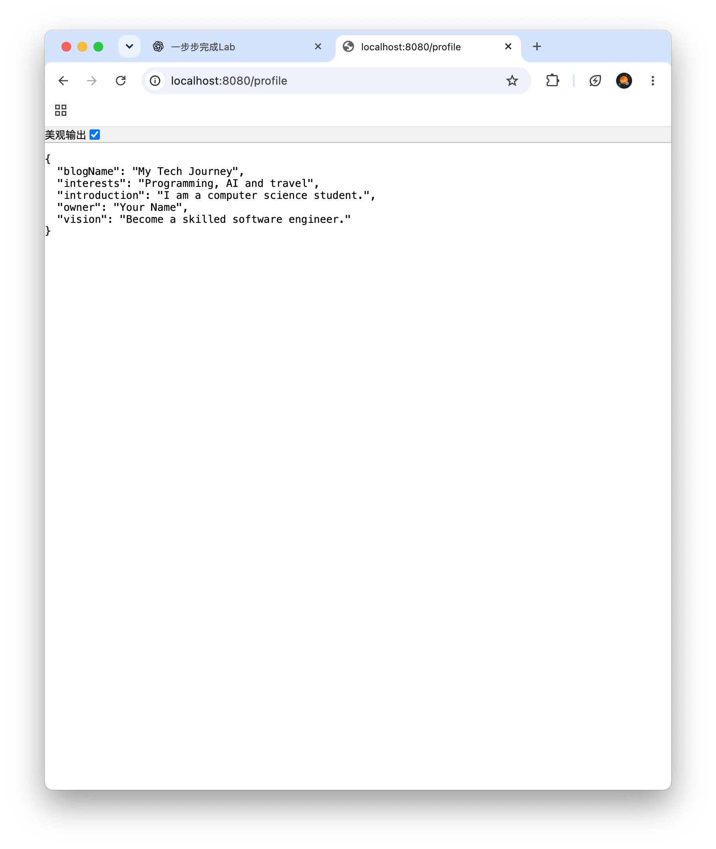
______________________________________________________________________________
______________________________________________________________________________

Task 3.5 — Evolve /me
Update /me so it remains personal and consistent with your new identity.
/hello → existence (Week01, still alive)
/profile → identity (this week, richer)
/me → personal intro (evolved, consistent with /profile)

Do not abandon Week02 work — evolve it. If /profile says you love photography, /me should not introduce a stranger.

Checkpoint — Level 1
☐ PersonalProfile created
☐ GET /profile returns richer identity JSON (≥5 meaningful fields)
☐ GET /me still works as JSON, consistent with my identity
☐ Project is continued from Week02

Pause and look. Read your JSON once as if you had never met yourself. Is this someone?

4. Level 2 — Understand It
Goal: understand identity modeling — not only make JSON appear.

Task 4A.1 — Exploration questions (own words first)
Question 1
What is the difference between Week02 voice and Week03 identity?
My answer:
Week02 focused on giving MyBlog a basic voice to introduce itself, while Week03 focuses on creating a unique identity by adding meaningful personal information, such as interests, background and future goals.
Question 2
Why design PersonalProfile before we have a database?
My answer:
We design PersonalProfile before using a database because it helps us organize personal information into a clear structure. We can create Java objects and return JSON without a database. A database can be added later to store the information.
Question 3
What does DTO mean in this week?
My answer:
DTO stands for Data Transfer Object. In this lab, PersonalProfile is a simple DTO that organizes personal information into fields and allows Spring Boot to return the data as JSON to the browser.
________________________________________________
Question 4
For one field you chose, why does it belong to your MyBlog?
Field: interests
Why: I chose the interests field because it shows my personal hobbies and passions, such as programming, AI and travel. It makes MyBlog more personal and helps visitors understand who I am.
Task 4A.2 — AI understanding prompt
Ask only after your own answers exist:
AI PROMPT — copy, fill in the [brackets], verify the answer
[PROMPT: Understanding — modeling before database, DTO at beginner level]
I am a beginner building MyBlog in Spring Boot.
I created a PersonalProfile class and return it as JSON from GET /profile.
We do not use a database yet.

Please explain at a beginner level:
1. Why modeling identity before database matters
2. What DTO means in this simple context
Do not introduce service layer, JPA, or advanced architecture.

Record:
What AI said that helped: AI helped me understand that data modeling defines the structure of information before using a database, and a DTO is used to transfer structured data.
What I can explain without AI: I can explain that PersonalProfile organizes my personal information into fields, and Spring Boot converts the Java object into JSON without requiring a database.
Task 4B — Debugging with AI (required)
Break things on purpose. Repair them with understanding. For each bug, record: Problem → Hypothesis → AI Question → Solution → Learning.
AI debugging rules: hypothesis before asking · ask with context (expected + actual + code) · verify in the browser · write the learning in your own words.

Bug 1 — Generic Identity
Replace your personal vision with "test". Reload the JSON.
Question: why is this JSON valid but identity-weak? (Notice: it still returns 200, still parses — this is why validity alone never proves this week's capability.)
AI PROMPT — copy, fill in the [brackets], verify the answer
[PROMPT: Bug 1 investigation — hypothesis first, then ask, then verify]
My GET /profile returns valid JSON, but one field is "test".
Why is this technically fine but pedagogically weak for an identity model?

Record:
Problem: The vision field contains "test" instead of a meaningful personal goal, although the JSON is still valid.
Hypothesis (before asking AI): I think the JSON is technically valid because "test" is a valid string, but it does not describe my personal identity or future goals.
AI Question (paste your prompt): My GET /profile returns valid JSON, but one field is "test".
Why is this technically fine but pedagogically weak for an identity model?

Solution: I replaced "test" with a meaningful personal vision that describes my future career goal.
Learning: I learned that valid JSON does not always mean meaningful data. Personal identity fields should contain real and specific information.
Restore a meaningful value before continuing.

Bug 2 — Null Identity Field
Leave one field unassigned. Observe the JSON null.
AI PROMPT — copy, fill in the [brackets], verify the answer
[PROMPT: Bug 2 investigation — hypothesis first, then ask, then verify]
My PersonalProfile returns JSON with one null field.
What does that say about incomplete identity modeling?
How should I fix it at beginner level?

Record:
Problem: The interests field returns null in the JSON response because it has not been assigned a value.
Hypothesis (before asking AI): I think the field returns null because Java gives uninitialized String instance fields a default value of null.
AI Question (paste your prompt): My PersonalProfile returns JSON with one null field.
What does that say about incomplete identity modeling?
How should I fix it at beginner level?
Solution: I fixed the problem by assigning a meaningful value to the interests field in the. Controller.
Learning: I learned that an uninitialized String field has a default value of null in Java. All important identity fields should be assigned meaningful values.
Bug 3 — Restart Temptation / Continuity Break
If you almost created a new project this week, stop and ask AI:
AI PROMPT — copy, fill in the [brackets], verify the answer
[PROMPT: Bug 3 investigation — continuity, not restart]
I already have a Week02 Spring Boot MyBlog project with JSON endpoints.
Why should I continue that project for Week03 identity instead of creating a new one?

Record:
Problem: Creating a new Spring Boot project for Week03 could break the continuity of MyBlog and lose previous features.
Hypothesis (before asking AI): I think continuing the existing project is better because it preserves previous features and allows MyBlog to grow step by step.
AI Question (paste your prompt): I already have a Week02 Spring Boot MyBlog project with JSON. endpoints.
Why should I continue that project for Week03 identity instead of creating a new one?
Solution: I continued using my existing MyBlog project and added the PersonalProfile class while keeping the previous endpoints working.
Learning: I learned that software development is an incremental process. Reusing and improving an existing project helps maintain functionality and track development progress.Then continue the existing project.

Checkpoint — Level 2
☐ I can explain identity vs voice
☐ I can explain modeling before database
☐ I can explain DTO simply
☐ I completed 3 AI debugging/understanding records
☐ I can justify my identity fields

5. Level 3 — Make It Yours
Goal: make MyBlog unmistakably yours, then publish the growth record.
Git/GitHub is a growth record of how you changed the project.
It is not MyBlog's memory. Memory comes in Week 06.

Task 5.0 — Observe the current project
Before you personalize further, look at the project as it is now.
git status
git log --oneline

What does git status show right now?
Git status shows modified and untracked files in my MyBlog project.
What is the latest commit (if any)?
ad02181 (HEAD -> main) Complete Week 01 Spring Boot lab

If git log is empty, that is OK. This may be your first recorded growth step.
Do not explain Git internals. Just notice the current state.

Task 5.1 — Personal truth check
Read your JSON aloud. Ask:
Does this sound like me?
What one field still feels fake?
What one field would make it more honest?
Update at least one field based on your answers.
WARNING — forbidden pattern
❌ Avoid meaningless values: Student · test · asdf · Hello world

Task 5.2 — The Recognition Test (this week's proof)
Swap screens with a classmate for 30 seconds — or imagine one reading only your JSON:
EVIDENCE — capture this
[EVIDENCE: Recognition Test — the week's capability-shaped proof]
Classmate's guess ("whose blog is this / what kind of person"): The blog belongs to a computer science student who is interested in programming, artificial intelligence and travel.
What gave me away (or what didn't): My introduction, interests and career vision helped the reader understand my background and personal goals.
One field I changed because of this test: I improved the vision field to describe my future career goal more specifically.
______________________________________________________________________________

If nobody can tell it is you, your identity is still generic — return to Task 5.1.

Task 5.3 — Optional AI design critique
AI PROMPT — copy, fill in the [brackets], verify the answer
[PROMPT: Design critique — AI suggests, you decide what stays]
Here is my identity JSON:
[paste]

Please critique which fields feel generic vs personal.
Suggest 2 improvements.
Do not rewrite my whole project.
I will decide what to keep.

Keep authorship. Accepting zero suggestions is a valid outcome — if you can say why.

Task 5.4 — Publish the growth record
MyBlog changed because you changed it.
Before you record that growth, look at the actual change.
git diff

Name one meaningful Week03 change you can see:
One change I made:
I created the PersonalProfile class and updated the /profile endpoint to return five meaningful personal identity fields.
Example: I added PersonalProfile and changed /profile.
You do not need to understand every line of the diff. You only need to see what changed.
If AI helped change any code, confirm this diff matches what you already ran and tested before you commit.
Then record this week's growth:
git add .
git commit -m "Week03: MyBlog knows who I am"

This commit records this Week03 identity growth step.
Observe the updated history:
git log --oneline

I can see this Week03 commit:
a1b2c3d Week03: MyBlog knows who I am
Publish the growth record:
git push

Open your GitHub repository commit history — not only the home page.
Confirm the Week03 commit is visible there.
EVIDENCE — capture this
[EVIDENCE: Week03 growth record]
GitHub repository link: https://github.com/java1-droid/myblog
Week03 commit I can point to: Week03: MyBlog knows who I am
One change this commit records: I created the PersonalProfile class and updated the /profile endpoint to return five meaningful personal identity fields. ______________________________________________________________________________

If push is blocked in class, complete the commit locally and finish the push before the submission deadline.

Checkpoint — Level 3
☐ Identity JSON sounds like me (Recognition Test passed)
☐ I named one real change from git diff
☐ Meaningful Week03 commit created
☐ Week03 commit visible in git log and on GitHub

6. Optional Extension
Only after L1–L3 are complete:
- Challenge A — GET /identity: add an explicit identity endpoint
- Challenge B — Identity README: write 5 lines in your project README describing who MyBlog is
- Challenge C — Field refinement: replace one generic field after AI critique
Same Week03 idea. No new technology required. (Details: challenge.md, mission.md §9.)

7. Evidence & Submission

The Week03 evidence map
Capability claim | Evidence that proves it
MyBlog has a designed identity | Screenshot: /profile JSON with ≥5 meaningful personal fields
The identity is mine | Recognition Test record (§5.2) — a reader can tell whose blog this is
The project evolved (not restarted) | Same project; /hello, /me, /profile all live; before/after note
I understand modeling before database | Level 2 answers: "I designed PersonalProfile before a database because…"
I debug with a hypothesis-first AI loop | Bug 1–3 records in your AI collaboration log
My growth has a public record | GitHub repository link + Week03 commit I can point to, with one named change

Submit
1. Source code — the continued MyBlog project: PersonalProfile (or equivalent), richer GET /profile, evolved GET /me
2. Screenshot — identity JSON from /profile
3. GitHub repository link, plus the Week03 commit you can point to and one change it records
4. AI collaboration log — Bug 1–3 records + at least one Level 2A explanation interaction
5. Reflection — "What did MyBlog learn this week?" (see reflection.md, homework.md). Minimum closing lines:
Before Week 03, my MyBlog was...
After Week 03, my MyBlog is...
I designed identity by...
I published growth by...
Next, MyBlog needs to...

8. Completion Checklist
☐ Starting state verified: Week02 project ran before I changed anything
☐ L1: PersonalProfile created; /profile returns richer identity JSON
☐ L1: /me evolved and stays consistent with /profile
☐ L2: identity vs voice + modeling-before-database + DTO explained in my words
☐ L2: Bugs 1–3 recorded with Problem / Hypothesis / AI Question / Solution / Learning
☐ L3: Recognition Test passed — a reader can tell it is me
☐ L3: named one real change from git diff; Week03 commit visible in git log and on GitHub
☐ Evidence map §7 complete
☐ AI log + reflection complete
☐ No Database / POST / Service / Vue introduced
☐ Project continued from Week02

9. Bridge to Week04
MyBlog knows who it is.
But a voice with identity still mostly speaks. A visitor who wants to say something back has nowhere to go — yet.
Week 01: I Exist
Week 02: I Speak
Week 03: I Am Someone
Week 04: I Can Listen

Your application knows who it is. Next, it learns to hear someone else.
Detailed troubleshooting: `common-bugs.md` · Mission and evaluation: `mission.md`, `assessment.md` · AI templates: `prompts/`.

