**BookMyShow**

**Users-service**: provides users information.

**Movie-service**: provides information like movie ratings, title, etc.

**Booking-service**: provides booking information.

**Main-service**: User will interact with this service and urls will be redirected to respective services

create*

get*

delete*

GET localhost:8989/newBooking/{userId}/{movieId}

GET

restTemplate -> /users/{id}

userId

restTemlate -> /movies/{id}

movieId

POST

restTemplate -> /bookings

{

Userid, [movieId],

}

Taken from: https://dzone.com/articles/microservices-an-example-with-docker-go-and-mongod#:~:text=introduction,isolate%20and%20deploy%20the%20ecosystem.

**Notes:**

Each service must have its own database (mongodb)

Each service must be dockerised

Create a small documentation file on

* how to start database
* how to start services
* how to use the application
* showing screenshots

ExceptionHandling is must

**User-service**

* get http://localhost:8081/users

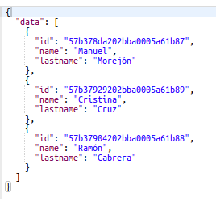

* get http://localhost:8081/users/{id}
* post http://localhost:8081/users
* delete http://localhost:8081/users/{id}

**movie-service**

* get http://localhost:8082/movies

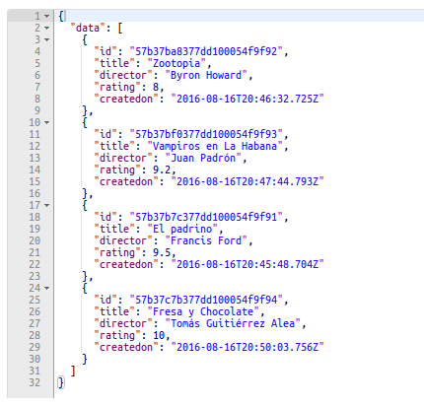

* get - http://localhost:8082/movies/{id}
* post - http://localhost:8082/movies
* delete - http://localhost:8082/movies/{id}

**booking-service**

* get http://localhost:8084/bookings

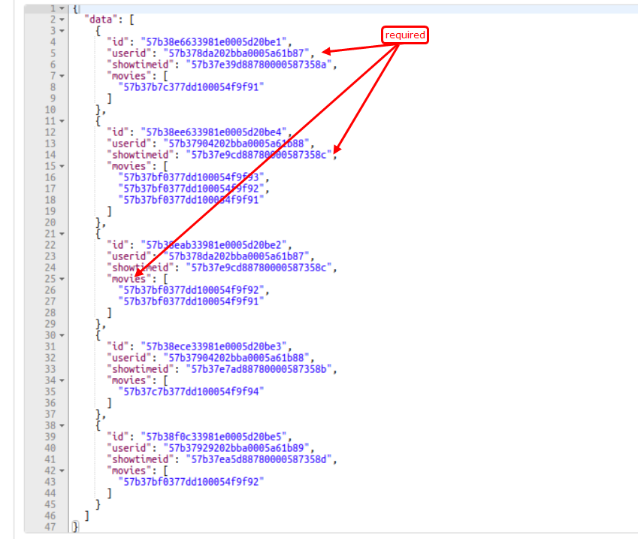

* post - http://localhost:8084/bookings