RDBMS: Relational Data Base Management System

ACID Properties:

Automacity :

Consistency:

Isolation:

Durability:

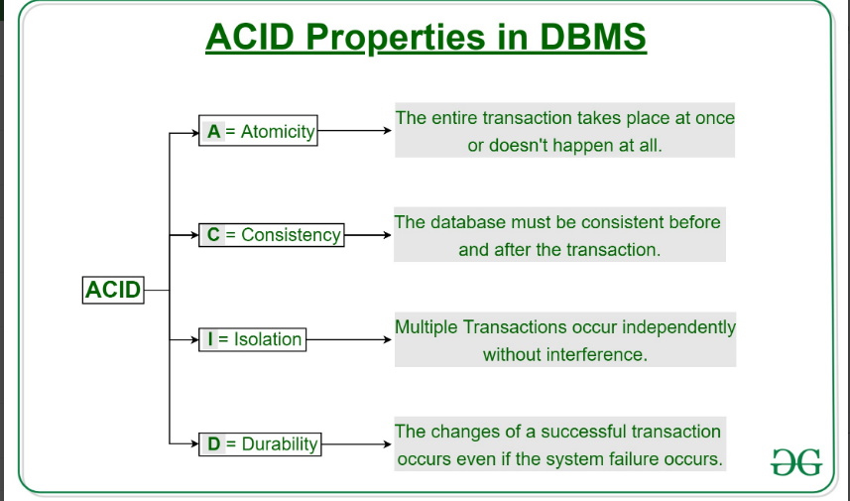

How to see the database;

Show databases;

How to create data base;

Create database databasename;

If we want to save the data in RDBMS we have to create table;

MySQL uses many different data types broken into three categories −

* Numeric
* Date and Time
* String Types.

Let us now discuss them in detail.

Numeric Data Types

MySQL uses all the standard ANSI SQL numeric data types, so if you're coming to MySQL from a different database system, these definitions will look familiar to you.

The following list shows the common numeric data types and their descriptions −

* **INT** − A normal-sized integer that can be signed or unsigned. If signed, the allowable range is from -2147483648 to 2147483647. If unsigned, the allowable range is from 0 to 4294967295. You can specify a width of up to 11 digits.
* **TINYINT** − A very small integer that can be signed or unsigned. If signed, the allowable range is from -128 to 127. If unsigned, the allowable range is from 0 to 255. You can specify a width of up to 4 digits.
* **SMALLINT** − A small integer that can be signed or unsigned. If signed, the allowable range is from -32768 to 32767. If unsigned, the allowable range is from 0 to 65535. You can specify a width of up to 5 digits.
* **MEDIUMINT** − A medium-sized integer that can be signed or unsigned. If signed, the allowable range is from -8388608 to 8388607. If unsigned, the allowable range is from 0 to 16777215. You can specify a width of up to 9 digits.
* **BIGINT** − A large integer that can be signed or unsigned. If signed, the allowable range is from -9223372036854775808 to 9223372036854775807. If unsigned, the allowable range is from 0 to 18446744073709551615. You can specify a width of up to 20 digits.
* **FLOAT(M,D)** − A floating-point number that cannot be unsigned. You can define the display length (M) and the number of decimals (D). This is not required and will default to 10,2, where 2 is the number of decimals and 10 is the total number of digits (including decimals). Decimal precision can go to 24 places for a FLOAT.
* **DOUBLE(M,D)** − A double precision floating-point number that cannot be unsigned. You can define the display length (M) and the number of decimals (D). This is not required and will default to 16,4, where 4 is the number of decimals. Decimal precision can go to 53 places for a DOUBLE. REAL is a synonym for DOUBLE.
* **DECIMAL(M,D)** − An unpacked floating-point number that cannot be unsigned. In the unpacked decimals, each decimal corresponds to one byte. Defining the display length (M) and the number of decimals (D) is required. NUMERIC is a synonym for DECIMAL.

Date and Time Types

The MySQL date and time datatypes are as follows −

* **DATE** − A date in YYYY-MM-DD format, between “1000-01-01” and 9999-12-31. For example, December 30th, 1973 would be stored as “1973-12-30”.
* **DATETIME** − A date and time combination in YYYY-MM-DD HH:MM:SS format, between 1000-01-01 00:00:00 and 9999-12-31 23:59:59. For example, 3:30 in the afternoon on December 30th, 1973 would be stored as 1973-12-30 15:30:00.
* **TIMESTAMP** − A timestamp between midnight, January 1st, 1970 and sometime in 2037. This looks like the previous DATETIME format, only without the hyphens between numbers; 3:30 in the afternoon on December 30th, 1973 would be stored as 19731230153000 ( YYYYMMDDHHMMSS ).
* **TIME** − Stores the time in a HH:MM:SS format.
* **YEAR(M)** − Stores a year in a 2-digit or a 4-digit format. If the length is specified as 2 (for example YEAR(2)), YEAR can be between 1970 to 2069 (70 to 69). If the length is specified as 4, then YEAR can be 1901 to 2155. The default length is 4.

String Types

Although the numeric and date types are fun, most data you'll store will be in a string format. This list describes the common string datatypes in MySQL.

* **CHAR(M)** − A fixed-length string between 1 and 255 characters in length (for example CHAR(5)), right-padded with spaces to the specified length when stored. Defining a length is not required, but the default is 1.
* **VARCHAR(M)** − A variable-length string between 1 and 255 characters in length. For example, VARCHAR(25). You must define a length when creating a VARCHAR field.
* **BLOB or TEXT** − A field with a maximum length of 65535 characters. BLOBs are "Binary Large Objects" and are used to store large amounts of binary data, such as images or other types of files. Fields defined as TEXT also hold large amounts of data. The difference between the two is that the sorts and comparisons on the stored data are **case sensitive** on BLOBs and are **not case sensitive** in TEXT fields. You do not specify a length with BLOB or TEXT.
* **TINYBLOB or TINYTEXT** − A BLOB or TEXT column with a maximum length of 255 characters. You do not specify a length with TINYBLOB or TINYTEXT.
* **MEDIUMBLOB or MEDIUMTEXT** − A BLOB or TEXT column with a maximum length of 16777215 characters. You do not specify a length with MEDIUMBLOB or MEDIUMTEXT.
* **LONGBLOB or LONGTEXT** − A BLOB or TEXT column with a maximum length of 4294967295 characters. You do not specify a length with LONGBLOB or LONGTEXT.
* **ENUM** − An enumeration, which is a fancy term for list. When defining an ENUM, you are creating a list of items from which the value must be selected (or it can be NULL). For example, if you wanted your field to contain "A" or "B" or "C", you would define your ENUM as ENUM ('A', 'B', 'C') and only those values (or NULL) could ever populate that field.

How to connect database;

* Use database_name;

How to see the tables in database?

* Show tables;

Why we have to create a table?

To store the data in any RDBMS(MYSQL, Oracle, Postgresql etc) we will create a table.

Table contains the columns.

How to create a table?

Student

(s_id,s_name,s_gender,s_dob, s_grade,s_father_name,s_school,s_joining_date)

Create table student

(s_id varchar(20),

s_name varchar(20),

s_gender char,

s_dob date,

s_grade varchar(10),

s_father_name varchar(20),

s_school varchar(50)

,s_joining_date date);

How to see the columns from a particular table?

* Show columns from table_name;

How to insert the values in to the table?

Insert into table_name (column_names) values (values);

Ex for Student table:

* Insert into student (s_id, s_name, s_gender, s_dob) values (‘1001’, ‘Naresh’, ‘M’, ‘1992-04-17’);

How to see the table data?

* Select * from student;