20 – 12-2021

Conditional Statements -> if,else, else if,switch

Auto Increment and Auto Decrement

Int number = 1;

Number++;

Number --;

We have 2 types in auto increment

Pre increment (++number)

Post increment(number++)

Logical Operators( &&, ||, ==, !=)

Looping Statements

For loop

While loop

Do while

For loop

Syntax

1 2 4

For(initialization;condition;increment or decrement) {

3

}

For(int i=1; i < 11; i++ ) {

System.out.println(i);// 1,2,3,4,5,6,7,8,9,10

}

21-12-2021

Examples on for loop

Examples on nested for loops

Find the factorial for given number

WAP to achieve below output

22-12-2021

WAP to find given number is palindrome or not

121 -> 121 polindrome

123 -> 321 not palindrome

WAP to find given number is Abundant or not

12 -> 1+2+3+4+6

9 -> 1+3 = 4

15 -> 1+3+5 =

20 -> 1+2+4+5+10

18 -> 1+3+6+9

25 -> 1+5 = 6

6 -> 1+2+3 = 6

WAP to find given number is Arm Strong or not

153 -> 1\*1\*1+5\*5\*5+3\*3\*3 = 153

125 -> 1\*1\*1+2\*2\*2+5\*5\*5 = 134

24-12-2021

Triangle Stars Example

While Loop

Syntax:

Step 1 -> true it will go to loop otherwise it will exit from the loop

While(condition) {

Step 2

}

Int i = 1;

While( i <=10) {

System.out.println(i);

i++;

}

25-12-2021

Do while

Syntax for do while:

do {

}while(condition);

WAP to print 1 to 10 using do while.

Int num = 1;

1 do{

2 System.out.println(num);

3 num++;

4 } while(num <=10);

Diff b/w for loop, while loop and do while.

for ->

1 2 4

for(initialization;condition;increment or decrement) {

3

}

while ->

Step 1 -> true it will go to loop otherwise it will exit from the loop

While(condition) {

Step 2

}

Do while ->

do {

}while(condition);

Ternary Operator

Int num = 10;

If(num % 2 == 0) System.out.println(“Even”);

Else System.out.println(“Odd”);

By using ternary operator

1 2 3

Condition true false

(num % 2 == 0) ? “Even” : “Odd’;

Syntax: (condition) ? (condition)? true:false : (condition)? true:false;

Arrays

Arrays []->

If we want to store multiple values into a single variable we can create an array.

How can we create an array?

First we should define data type.

We have to mention the array symbol;

We have to give name to the array.

Ex: int[] numbers = new int[5];

Tasks

Ternary Operator Practice

While practice

Do while practice

Int[] practice

String[] days

27-12-2021

There is a 2 ways to create an array.

1. While creating array we will give size or length,later we will initialize the values.

Ex: int[] numbers = new int[5];

1. While creating array itself we can give array values.

Ex: int[] numbers = {10,20,30,45,50,65};

Task for the day-> find the indexes in a given array to match the target number

Ex: int[] numbers = {10,20,30,45,50,65}; target = 70;

o/p: 1,4

28-12-2021

WAP to sort the given Array(ascending)

WAP to sort the given Array(descending)

WAP to get only Unique values from given Array

{10,20,30,50,10,20} -> {30,50}

4-1-2022

IDE -> Integrated Development Environment

Oops -> Object Oriented Programming Structure

In oops we have 6 principles

1. Class
2. Object
3. Inheritance
4. Abstraction
5. Encapsulation
6. Polymorphism

Class

To represent group of entities we can use class.

Class is nothing but a blueprint or model.

Class is user defined data type.

Class doesn’t have physical existence.

We have 2 types of classes.

1. POJO(plain old java object)
2. Business class

class Humans {

String name;

Int age;

Char gender;

}

class Animals {

String type;

String domestic;

}

class Mens {

String name;

Float height;

Int age;

Float weight;

}

Class Women {

String name;

Float height;

Int age;

Float weight;

}

Class Plants {

String plantType;

Double cost;

String color;

}

class Contries {

String countryName;

String continent;

Long population;

Float width;

Float distance;

}

class States {

String name;

Long population;

Float width;

Float distance;

}

05-01-2022

Object

Object is an instance of class

It has physical existence

How Can we create an object?

ClassName referenceVariable = new ClassName();

Ex:

Humans h = new Humans();

Method: It contains piece of code or certain logic, until we call method won’t execute.

Purpose of method is reusability.

Method Syntax:

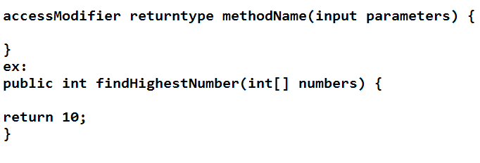

What is the method signature?

Method signature is nothing but a access modifier, return type, method name and input parameters.