1.Git

2. Core Java ->

2.1 -> Conditional Statements i.e if else if else

Current Bill Generation

10 units -> 10 per unit = 10*10 =100

15 units -> 15 per unit

20 units -> 20 per unit

Above -> 30 per unit

3. Looping Statements

For loop -> for( int i=1;i<=5;i++ ) {

// statements

for(int j=1;j<=5;j++) {

}

}

For Each => we can discuss later.

While Loop =>

While(condition) {

}

Do while loop:

Do {

}while(condition);

4.Arrays.

Int I = 250;

Int []a = {1,2,3,4,5}; a.length = 5;

Int []a = new int[5];

a[0] = 1;

a[1] = 2;

a[2] = 3;

a[3] = 4;

a[4] = 5;

Arrays tasks:

int arr[] = {1,5,3,2,4};

asc = [1,2,3,4,5];

des = [5,4,3,2,1];

String arr[] = {“Naresh”, “Triveni”,”Veera”, “Sai”};

asc = [“Naresh”, “Sai”, “Triveni”, “Veera”];

desc = [“Veera”, “Triveni”,”Sai”,”Naresh”];

5. Packages

6. Object

If we want to create the memory and save some values we can create object.

7.Methods

Syntax For Method

accessModifier returnType methodName(Parameters) {}

Create Arithmetic class and create methods with return types.

OOPS Concepts:

1.Class

2.Object

3.Inheritence

4.Polymorphism

5.Encapsulation

6.Abstraction

1.Class

Class is Template or Bluprint Or UserDefined datatype => class Human {

String name;

String color;

String gender;

float height;

int weight;

}

2.Object

Object is a instance of class

It is physically exist.

Human h = new Human();

h.name = “naresh”;

h.color = “white”;

h.gender = “m”;

h,height = 5.8;

h.weight = 70;

3.Inheritence

Class Arithmetic {

Addition();

Substraction();

Multiplication();

Division();

}

Class Arithmetic2 extends Arithmetic {

Reminder();

}

Access Modifiers:

1.public: It is acceptable from one package to another package.it contains global access.public we can use at class level, method level and variable level.

2.private: private modifier we can access within the class only. private only methods and variables.

3.protected: protected modifier we can access within the same package and sub class. protected we can use at method level and variable level.

4.default: default modifier within the same package only. default we can use at class level, method level and variable level.

Encapsulation

Encapsulation is nothing but a properties and behaviours we can take as single unit or we can combine both.

26/11/2020

Abstraction:

Abstraction is nothing hiding internal implementation.

Abstraction we can achieve by 2 ways.

1. Interfaces -> 100%
2. Abstract classes -> 0 – 100%

Is it possible to create concrete methods in interface?NO

Is it possible to create concrete methods in abstract classes?Yes

Is it possible to create abstract methods in abstract classes?Yes

Task: Payroll task

Constructors

Constructor is used for to initialize the values into the object we can constructor.

Syntax for constructor:

accessModifier classname(){}

Access Modifiers for Constructor

We can private, protected, default and public as accessmodifiers.

static vs non-static, string

static is a key word, we can use static as a variable, method and block.

Static Variable

* Static variable -> The static variable can be used to refer to the common property of all objects (which is not unique for each object), for example, the company name of employees, college name of students, etc.
* The static variable gets memory only once in the class area at the time of class loading.
* Advantages of static variable
* It makes your program **memory efficient** (i.e., it saves memory).

Static Block

* Is used to initialize the static data member.
* It is executed before the main method at the time of classloading.

### Q) Can we execute a program without main() method?

Ans) No, one of the ways was the static block, but it was possible till JDK 1.6. Since JDK 1.7, it is not possible to execute a Java class without the [main method](https://www.javatpoint.com/java-main-method).

Static methods

## 2) Java static method

If you apply static keyword with any method, it is known as static method.

* A static method belongs to the class rather than the object of a class.
* A static method can be invoked without the need for creating an instance of a class.
* A static method can access static data member and can change the value of it.

### Example of static method

1. //Java Program to demonstrate the use of a static method.
2. **class** Student{
3. **int** rollno;
4. String name;
5. **static** String college = "ITS";
6. //static method to change the value of static variable
7. **static** **void** change(){
8. college = "BBDIT";
9. }
10. //constructor to initialize the variable
11. Student(**int** r, String n){
12. rollno = r;
13. name = n;
14. }
15. //method to display values
16. **void** display(){System.out.println(rollno+" "+name+" "+college);}
17. }
18. //Test class to create and display the values of object
19. **public** **class** TestStaticMethod{
20. **public** **static** **void** main(String args[]){
21. Student.change();//calling change method
22. //creating objects
23. Student s1 = **new** Student(111,"Karan");
24. Student s2 = **new** Student(222,"Aryan");
25. Student s3 = **new** Student(333,"Sonoo");
26. //calling display method
27. s1.display();
28. s2.display();
29. s3.display();
30. }
31. }

Output:111 Karan BBDIT

222 Aryan BBDIT

333 Sonoo BBDIT

### Another example of a static method that performs a normal calculation

1. //Java Program to get the cube of a given number using the static method
3. **class** Calculate{
4. **static** **int** cube(**int** x){
5. **return** x*x*x;
6. }
8. **public** **static** **void** main(String args[]){
9. **int** result=Calculate.cube(5);
10. System.out.println(result);
11. }
12. }

Output:125

### Restrictions for the static method

There are two main restrictions for the static method. They are:

1. The static method can not use non static data member or call non-static method directly.
2. this and super cannot be used in static context.
3. **class** A{
4. **int** a=40;//non static
6. **public** **static** **void** main(String args[]){
7. System.out.println(a);
8. }
9. }

Output:Compile Time Error

### Q) Why is the Java main method static?

Ans) It is because the object is not required to call a static method. If it were a non-static method, [JVM](https://www.javatpoint.com/jvm-java-virtual-machine) creates an object first then call main() method that will lead the problem of extra memory allocation.

HashCode

Hashcode is a method it will return address of the object.

String class

# Java String

In [Java](https://www.javatpoint.com/java-tutorial), string is basically an object that represents sequence of char values. An [array](https://www.javatpoint.com/array-in-java) of characters works same as Java string. For example:

1. **char**[] ch={'n’,’a’,’r’,’e’,’s’,’h’};
2. String s=**new** String(ch);

is same as:

1. String s="naresh";

**Java String** class provides a lot of methods to perform operations on strings such as compare(), concat(), equals(), split(), length(), replace(), compareTo(), intern(), substring() etc.

The java.lang.String class implements Serializable, Comparable and CharSequence [interfaces](https://www.javatpoint.com/interface-in-java).

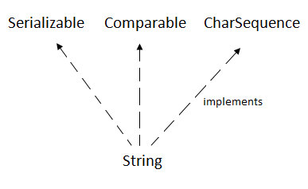

## CharSequence Interface

The CharSequence interface is used to represent the sequence of characters. String, [StringBuffer](https://www.javatpoint.com/StringBuffer-class) and [StringBuilder](https://www.javatpoint.com/StringBuilder-class) classes implement it. It means, we can create strings in java by using these three classes.

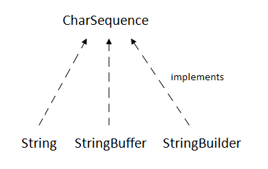

The Java String is immutable which means it cannot be changed. Whenever we change any string, a new instance is created. For mutable strings, you can use StringBuffer and StringBuilder classes.

We will discuss immutable string later. Let's first understand what is String in Java and how to create the String object.

### What is String in java

Generally, String is a sequence of characters. But in Java, string is an object that represents a sequence of characters. The java.lang.String class is used to create a string object.

### How to create a string object?

There are two ways to create String object:

1. By string literal
2. By new keyword

### 1) String Literal

Java String literal is created by using double quotes. For Example:

1. String s="welcome";

Each time you create a string literal, the JVM checks the "string constant pool" first. If the string already exists in the pool, a reference to the pooled instance is returned. If the string doesn't exist in the pool, a new string instance is created and placed in the pool. For example:

1. String s1="Welcome";
2. String s2="Welcome";//It doesn't create a new instance

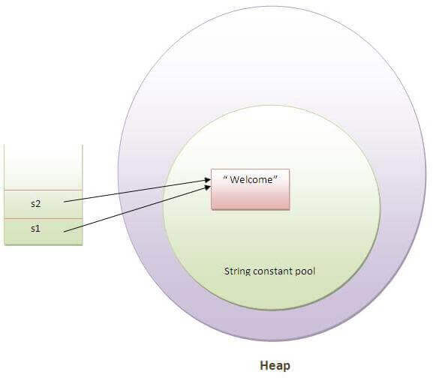

In the above example, only one object will be created. Firstly, JVM will not find any string object with the value "Welcome" in string constant pool, that is why it will create a new object. After that it will find the string with the value "Welcome" in the pool, it will not create a new object but will return the reference to the same instance.

#### Note: String objects are stored in a special memory area known as the "string constant pool".

### Why Java uses the concept of String literal?

To make Java more memory efficient (because no new objects are created if it exists already in the string constant pool).

### 2) By new keyword

1. String s=**new** String("Welcome");//creates two objects and one reference variable

In such case, [JVM](https://www.javatpoint.com/jvm-java-virtual-machine) will create a new string object in normal (non-pool) heap memory, and the literal "Welcome" will be placed in the string constant pool. The variable s will refer to the object in a heap (non-pool).

### Java String Example

1. **public** **class** StringExample{
2. **public** **static** **void** main(String args[]){
3. String s1="java";//creating string by java string literal
4. **char** ch[]={'s','t','r','i','n','g','s'};
5. String s2=**new** String(ch);//converting char array to string
6. String s3=**new** String("example");//creating java string by new keyword
7. System.out.println(s1);
8. System.out.println(s2);
9. System.out.println(s3);
10. }}

java

strings

example

Type Casting

## Java Type Casting

Type casting is when you assign a value of one primitive data type to another type.

(or)

The process of converting the value of one data type (int, float, double, etc.) to another data type is known as typecasting.

In Java, there are two types of casting:

* **Widening Casting** (automatically) - converting a smaller type to a larger type size  
  byte -> short -> char -> int -> long -> float -> double
* **Narrowing Casting** (manually) - converting a larger type to a smaller size type  
  double -> float -> long -> int -> char -> short -> byte

## Widening Casting

Widening casting is done automatically when passing a smaller size type to a larger size type:

### Example

public class Main {

public static void main(String[] args) {

int myInt = 9;

double myDouble = myInt; // Automatic casting: int to double

System.out.println(myInt); // Outputs 9

System.out.println(myDouble); // Outputs 9.0

}

}

## Narrowing Casting

Narrowing casting must be done manually by placing the type in parentheses in front of the value:

### Example

public class Main {

public static void main(String[] args) {

double myDouble = 9.78;

int myInt = (int) myDouble; // Manual casting: double to int

System.out.println(myDouble); // Outputs 9.78

System.out.println(myInt); // Outputs 9

}

}

Upcasting and Downcasting

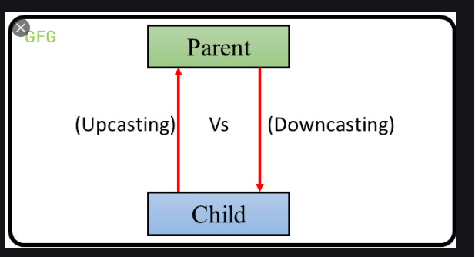

Converting an object from one type to another is a very important aspect of Java which is popularly known as Typecasting. Let’s understand the concepts of Upcasting and Downcasting in Java in the following manner:

## ****What are Upcasting and Downcasting in Java?****

Upcasting (Generalization or Widening) is casting to a parent type in simple words casting individual type to one common type is called upcasting while downcasting (specialization or narrowing) is casting to a child type or casting common type to individual type.



Upcasting can be done but for downcasting, we need to check the types or else we may get

ClassCastException

## ****Hierarchy Example****

Let’s take this example.

**Food -> Fruit -> Apple, Orange**

Food is the interface which is at the topmost level

|  |  |
| --- | --- |
| 1  2  3  4 | public interface Food {     public float getTotalCalories();     public String getOrigin();  } |

The fruit is the abstract class

|  |  |
| --- | --- |
| 1  2  3  4  5  6 | public abstract class Fruit implements Food {  public float getTotalCalories(){        return 0.50f;  }     public String getOrigin();  } |

Apple and Orange are the two concrete subclasses

|  |  |
| --- | --- |
| 1  2  3  4  5  6  7  8  9  10  11  12  13  14  15  16 | public class Apple extends Fruit {  public float getTotalCalories() {      return 0.40f  }  public String getOrigin() {      return "someCity";    }  }  public class Orange extends Fruit {  public float getTotalCalories() {      return 0.30f  }  public String getOrigin() {      return "someOtherCity";  }  } |

In your case, a cast from an Apple to a Fruit is an upcast, because of an Apple is-a Fruit. whenever there is an inheritance i.e is-a relationship between two classes we can do upcasting.

For example, if we cast Apple to Fruit it is upcasting because Apple is of type Fruit here we are generalizing from child type to parent type. So, if there is an is-a relationship (inheritance) between two classes we can upcast.

Let’s look at a downcasting example:

Here we are narrowing the type of object i.e we are converting common type to individual type.

|  |  |
| --- | --- |
| 1  2 | Fruit fruit = new Apple();  Apple castedApple = (Apple) fruit; |

Here we are casting common type to individual type i.e superclass to subclass which is not possible directly in Java so we explicitly do the casting and tell the compiler that what the runtime type of the object. It is possible in this case because the fruit is Apple even if the reference type is Fruit.

Now, Suppose if you do this:

|  |  |
| --- | --- |
| 1  2 | Fruit fruit = new Fruit();  Apple notApple = (Apple) Fruit; |

Above code will throw an exception because fruit’s runtime object is Fruit but not Apple it is not possible to cast superclass to subclass so, this will end up with ClassCastException.

If we want to invoke the method of superclass we can simply do this using super keyword as super.methodName() or we can upcast the object.

If we want to invoke subclass’s method then we will need to downcast the object but we can run into ClassCastException so, if you want to avoid this exception you can use a keyword instanceof which will check the runtime type of the object before we cast the object as in below code.

|  |  |
| --- | --- |
|  | Fruit fruit = getSomeFruit(); #we dont really know what getSomeFruit is returning so we can check the type of fruit using instanceof  if (fruit instanceof Apple) {      // the object can be casted and the code won't fail      Apple castedApple = (Apple) fruit;  } |

As a Java developer, you will come across this usually, you may need to cast objects depending on the requirements so, now you know how to do a casting. And it isn’t really that hard to do.

## ****Why do we need Upcasting in Java?****

Generally, upcasting is not necessary. We need upcasting when we want to write code that deals with only the parent class. Consider the following class

|  |  |
| --- | --- |
| 1  2  3  4  5 | public class CalorieMeter{       public void readCalorie(Fruit fruit){            print("Calorie:" + fruit.getTotalCalories());       }  } |

Here we can pass any subtype of Fruit to readCalorie() method, thus it accepts both the objects of Apple and Orange class as they are the subtype of Fruit class.

|  |  |
| --- | --- |
| 1  2  3  4  5 | Apple apple = new Apple();  Orange orange = new Orange();  Caloriemeter caloriemeter = new CalorieMeter();  caloriemeter.readCalorie(apple);  caloriemeter.readCalorie(orange); |

## ****Why do we need Downcasting in Java?****

We use downcasting whenever we want to access behaviors of the subtypes. This is used more frequently than that of upcasting. Consider the following example:

|  |  |
| --- | --- |
| 1  2  3  4  5  6  7  8  9  10 | public class CalorieMeter{       public void readCalorie(Fruit fruit){            print("Calorie:" + fruit.getTotalCalories());            //if the fruit is orange the object should print city            if(fruit instanceof Orange){               Orange orange = (Orange) fruit;               System.out.println("City:"+fruit.getOrigin());            }       }  } |

Here in readCalorie() method, we have checked the object which is passed if that object is of type Orange we have to downcast it and invoke the method getOrigin() which will give the origin of that fruit.

## ****Important Topics****

* When we cast object only the reference type of the object is changed but not the actual object type.
* Upcasting is safe and it does not fail.
* We need to check the instance of the object when we downcast the object using instanceof operator or we might get ClassCastException.

In this article, we covered what is upcasting and downcasting in Java. What is the hierarchy needed so that the object can be upcasted and downcasted also, how to use instanceof operator in order to check the type of object while downcasting so that we can avoid getting ClassCastException. Few import points like while casting only reference of object are changed and while downcasting we should check the type of object and upcasting is safe.